Senior Analyst

Te Kāhui Kāhu (Social Services Accreditation)

Our purpose
Manaaki tangata, Manaaki whānau
We help New Zealanders to be safe, strong and independent

Our commitment to Māori
As a Te Tiriti o Waitangi partner we are committed to supporting and enabling Māori, whānau, hapū, Iwi and communities to realise their own potential and aspirations.

Our strategic direction
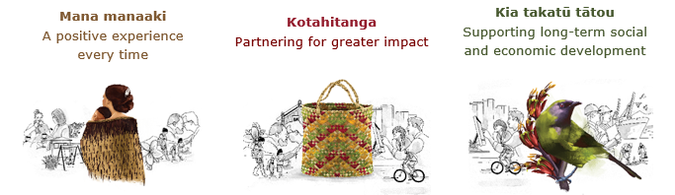

Our Values
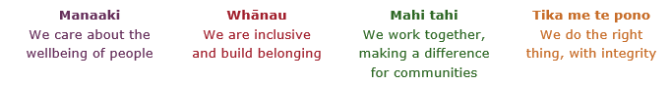

Working in the Public Service
Ka mahitahi mātou o te ratonga tūmatanui kia hei painga mō ngā tāngata o Aotearoa i āianei, ā, hei ngā rā ki tua hoki. He kawenga tino whaitake tā mātou hei tautoko i te Karauna i runga i āna hononga ki a ngāi Māori i raro i te Tiriti o Waitangi. Ka tautoko mātou i te kāwanatanga manapori. Ka whakakotahingia mātou e te wairua whakarato ki ō mātou hapori, ā, e arahina ana mātou e ngā mātāpono me ngā tikanga matua o te ratonga tūmatanui i roto i ā mātou mahi.
In the public service we work collectively to make a meaningful difference for New Zealanders now and in the future. We have an important role in supporting the Crown in its relationships with Māori under the Treaty of Waitangi. We support democratic government. We are unified by a spirit of service to our communities and guided by the core principles and values of the public service in our work.

The outcomes we want to achieve
New Zealanders get the support they require | New Zealanders are resilient and live in inclusive and supportive communities | New Zealanders participate positively in society and reach their potential

We carry out a broad range of responsibilities and functions including
- Employment, income support and superannuation
- Community partnerships, programmes and campaigns
- Advocacy for seniors, disabled people and youth
- Public Housing assistance and emergency housing
- Resolving claims of abuse and neglect in state care
- Student allowances and loans

He whakataukī*
Unuhia te rito o te harakeke  Kei hea te kōmako e kō?  Whakatairangitia, rere ki uta, rere ki tai;  Ui mai ki ahau,  He aha te mea nui o te ao?  Māku e kī atu,  He tangata, he tangata, he tangata* | If you remove the central shoot of the flaxbush  Where will the bellbird find rest?  Will it fly inland, fly out to sea, or fly aimlessly;  If you were to ask me,  What is the most important thing in the world?  I will tell you,  It is people, it is people, it is people
* We would like to acknowledge Te Rūnanga Nui o Te Aupōuri Trust for their permission to use this whakataukī

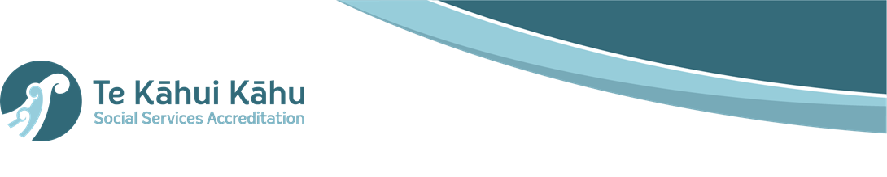

Position detail

Overview of position

The role of the Senior Systems Analyst is to:
- contribute to the design and strategy of Te Kāhui Kāhu-Social Services Accreditation digital platform
- contribute to the development of digital workflows, approval processes and performance dashboards and reports
- assist the team with required system analytic reporting
- assist the General Manager and other relevant staff in the enhancement of the digital platform supported the Social Service Accreditation service delivery
- contribute to the continual improvement of the Social Service Accreditation function
- work closely with internal and external IT teams to lead key project deliverables
- develop and test a range of potential solutions and innovations that will deliver effective business systems enhancements
- ensure that information being presented manually and digitally to the relevant agencies is clearly understood at all levels.
- manage and maintain user admin access (jointly or individually) to Social Service Accreditation’s digital platform
- ensure that new and existing staff have the appropriate user access and profile.
- ensure that user access and user licences are kept current
- participate in developing strategies to improve the service development lifecycle and governance processes.
- complete regular internal system audits and prepare for upgrades.

Location

National Office

Reports to

National Manager Policy Practice and Business Enablement

Key responsibilities
Technology Platform Management
- Manage the key relationship with the vendor
- Manage the key relationships that support the technology solution with the hosted IT group (MSD)
- Ensure on boarding and off boarding is completed accurately and observing standard information security protocols
- Serve as a key contributor and liaison between Business Analysts, Developers and Project Management team on technical and operational issues.
- Assess and map business processes and procedures to identify system or workflow improvements.
- Contribute to use cases and functional specifications to provide direction to vendors, designers and developers.
- Produce artefacts, designs, workflows and processes working alongside project members and Solutions Architects for input and validation
- Manage and prioritise incident requests and enhancements using approved digital tools.
- Serve as a central reference by staying well-versed on new release functionality on SSA’s digital platform, including release updates and high-priority fixes that are installed by default.
- Manage system issues, including identifying the root cause, and putting in place best practice to prevent further issues from occurring.
- Provide input into test plans and test scripts
- Ensure the highest quality and accuracy application support and training documentation are available to staff

Data Analytics and Reporting
- Lead research and analysis on developing best practice and future state solution strategies.
- Lead the development of a data retention strategy, perform data imports, data exports, and provide ongoing auditing of records to meet our risk and compliance obligations.
- Design and develops databases for collecting and organising data and information.
- Gather, collate and analyse data and information to contribute to evidence-based advice to guide Social Services Accreditation programmes and services.
- Build and Develop ad-hoc reports into dashboard to provide holistic overview of the business.
- Use available information to identify trends and issues impacting programmes and services.

Communication
- Effectively deliver ideas, processes, and outcomes

Quality Assurance
- Ensure timely monitoring of plans and reports take place with potential issues raised and feedback provided to relevant managers.
- Ensure the accuracy of Social Services Accreditation’s performance data and information by thorough scrutiny and examination before reporting.

Risk Management
- Develop a network of key internal and external contacts.
- Represent the Social Service Accreditation unit at various meetings as required
- Contribute positively to the team environment to allow individual and Social Services Accreditation to meet its organisational goals.
- Take a leadership role at internal and external meetings
- Build and maintain strong communication channels between business and key IT contacts
- Regularly update stakeholders on progress
- Contribute positively to the team environment to facilitate both individual and team goals

Advice and Support
- Provide accurate advice to others around complex issues
- Add value to reporting and written communication within the team
- Develop and present advice to management
- Have a high-level view of organisational issues
- Understand the key imperatives of other agencies
- Provide digital platform training and support to staff within the Social Service Accreditation team

Analysis and Reporting
- Develop strategies to facilitate documentation and reporting processes
- Creates succinct, easy to read documents appropriate to the audience, that addresses business requirements and clearly explain complex issues or technical aspects.

Embedding te ao Māori
- Provide a culturally responsive service to providers
- Contribute to the promotion of the principles of Treaty of Waitangi
- Embedding Te Ao Māori (te reo Māori, tikanga, kawa, Te Tiriti o Waitangi) into the way we do things.
- Building more experience, knowledge, skills and capabilities to confidently engage with whānau, hapū and iwi.

Health, safety and security
- Understand and implement your Health, Safety and Security (HSS) accountabilities as outlined in the HSS Accountability Framework.
- Ensure you understand, follow and implement all Health, Safety and Security and wellbeing policies and procedures.

Emergency management and business continuity
- Remain familiar with the relevant provisions of the Emergency Management and Business Continuity Plans that impact your business group/team.
- Participate in periodic training, reviews and tests of the established Business Continuity Plans and operating procedures.

Skills and Know-how
- Ability to quickly become familiar with emerging technologies.
- Understanding of CRM functionalities.
- Strong critical thinking and problem-solving skills.
- Excellent knowledge of System Analysis.
- Strong understanding and know-how of collaboration tools.
- Excellent understanding of systems integration, patterns, techniques, and related challenges.
- Proven Data analytics and Reporting skills.
- Knowledge and experience in Accreditation
- Demonstrated ability to understand and analyse data
- Proven ability in critical thinking, analysis and the development of business or IT solutions
- An affinity for building and maintaining positive working relationships with both internal and external stakeholders
- An understanding of government strategy and how Social Service Accreditation aligns with this

Attributes
- Highly developed conceptual and analytical thinking skills.
- Excellent verbal, written and communication skills (including WORD, EXCEL, and PowerPoint).
- Sensitivity towards Maori, Pacific Peoples, and other cultures.
- Understands the governance arrangements and public sector context within which Social Services Accreditation works and applies it to judgement and decision making.
- Ability to resolve problems and make decisions with limited information.
- Shows enthusiasm and “buy-in” to the Social Service Accreditation vision
- Is flexible and agile in their work ethos
- Takes ownership of issues and works through them to find solutions
- Is willing to work with others to develop and implement solutions to deliver outcomes
- Assist others in developing a greater understanding of their role
- Is an achiever – demonstrates resourcefulness and a positive, can-do attitude
- Welcomes and values diversity, and contributes to an inclusive working environment where differences are acknowledged and respected
- Demonstrates strong communication skills, both oral and written – can communicate technical information to a variety of stakeholders in meetings and through presentation
- Has excellent analytical skills – can analyse information from a range of sources and to make sound judgements based on this
- Shows strong self-management skills – can prioritise, meet deadlines, track tasks and expectations, work methodically towards outcomes, and work effectively under pressure
- Has good relationship management skills – can establish, build and maintain effective working relationships with stakeholders, both internal and external
- Is committed to delivering continual project improvements and milestones
- Understands frontline accreditation practices and the strategic direction of Social Service Accreditation

Key relationships

Internal
- National Manager Policy Practice and Business Enablement
- SSA Managers and team
- Digital Platform SaaS providers and licencing suppliers
- Other Ministry staff, as required

External
- Relevant government agencies, including but not limited to: Ministry of Social development, Ministry of Pacific Peoples, Ministry of Housing and Urban Development, Ministry for Children, Oranga Tamariki, Ministry of Business, Innovation and Employment (MBIE); Ministry of Health (MoH); Ministry of Justice (MoJ); Department of Corrections (Corrections);
- Providers of social services

Other

Delegations
- Financial – No
- Human Resources - No

Direct reports - No

Security clearance - No

Children’s worker - No
Limited adhoc travel may be required

