Senior Administrator

About us
Our agency’s purpose is to shift the system using data and evidence, so that the system invests earlier and more effectively to improve the lives of New Zealanders.

Our values – how we do things around here

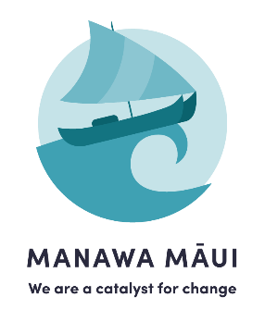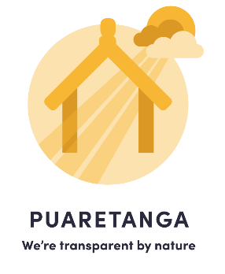

About working in the Public Service
Ka mahitahi mātou o te ratonga tūmatanui kia hei painga mō ngā tāngata o Aotearoa
i āianei, ā, hei ngā rā ki tua hoki. He kawenga tino whaitake tā mātou hei tautoko i te Karauna i runga i āna hononga ki a ngāi Māori i raro i te Tiriti o Waitangi. Ka tautoko mātou i te kāwanatanga manapori. Ka whakakotahingia mātou e te wairua whakarato ki ō mātou hapori, ā, e arahina ana mātou e ngā mātāpono me ngā tikanga matua o te ratonga tūmatanui i roto i ā mātou mahi.
In the public service we work collectively to make a meaningful difference for New Zealanders now and in the future. We have an important role in supporting the Crown in its relationships with Māori under the Treaty of Waitangi. We support democratic government. We are unified by a spirit of service to our communities and guided by the core principles and values of the public service in our work.

About the position

The purpose of this position
The Senior Administrator provides high-quality business administration, coordination and operational support across the organisation. The role supports governance activities, people and capability initiatives, programme delivery, risk and assurance processes, and organisational administration to ensure the efficient and effective functioning of the Agency.
The position works closely with leaders, managers and teams across the Agency and serves as a trusted coordination point, enabling business activities, reporting, decision-making processes and organisational priorities to be delivered effectively.

Team and location | Transformation, Technology and Enabling Services
Reporting to | Manager Risk, Assurance and Governance
Salary band | Band 13 - $64 223 - $75 556 - $90 667  Starting salaries are negotiated based on relevant skills and experience, with offers generally made between $64 223 to $75 556.

What you will do to contribute
Governance Support
- Provide administration and coordination support to Executive Leadership Team, Board, Committee and governance meetings.
- Organise and schedule meetings, including venue booking, technology setup, travel arrangements and logistics.
- Assist in maintaining governance documentation, policies, procedures and governance records.
- Support continuous improvement of governance processes and meeting administration practices.

People and Capability Support
- Provide administrative and coordination support to the People and Capability team.
- Assist with recruitment processes, including advertisement coordination, interview scheduling, candidate communications and onboarding activities.
- Coordinate induction and orientation activities for new staff.
- Support learning and development initiatives, training registrations and organisational capability programmes.
- Maintain people-related records, documentation and systems in accordance with organisational policies and privacy requirements.
- Support the administration of performance and development processes.

Programme Coordination Support
- Provide coordination support across organisational programmes, projects and initiatives as required.
- Assist with tracking programme dependencies, issues, decisions and actions and support preparation of programme reports to governance groups.
- Support cross-functional coordination to ensure programme activities are integrated and information is shared effectively.

Risk and Assurance Support
- Provide administrative and coordination support to the Risk, Assurance and Governance function.
- Assist with the maintenance of organisational risk registers and risk reporting processes.
- Coordinate risk review activities and facilitate updates from risk owners.
- Help ensure organisational records and reporting are maintained accurately and in a timely manner.

Business Administration Support
- Support business planning, corporate reporting and organisational administration activities.
- Collaborate with Executive Assistants and other administration staff to share best practice and provide organisational resilience during peak periods.
- Identify opportunities to improve systems, processes and administrative efficiency.

Risk Management
- Actively identify, monitor and escalate operational risks and issues where appropriate.
- Promote effective risk management practices and continuous improvement.

Health and Safety
- Support organisational health and safety initiatives and reporting activities.
- Contribute to the maintenance of a healthy, safe and inclusive workplace.

About you – what you will bring to the role

Qualifications, skills and experience
Experience and Knowledge
- Demonstrated experience in a senior administration, business support or coordination role.
- Experience supporting senior leaders and multiple stakeholders simultaneously.
- Experience providing coordination support for programmes, projects or organisational initiatives.
- Experience preparing high-quality business documentation and maintaining registers, records, action logs and reporting frameworks.
- Understanding of governance, risk management and assurance practices would be advantageous.
- Knowledge of human resources or people and capability processes would be advantageous.
- Strong working knowledge of Microsoft 365 applications, including Teams, Outlook, Word, Excel, PowerPoint and SharePoint.
- Ability to manage competing priorities and meet deadlines in a dynamic environment.
- Strong organisational and planning skills with excellent attention to detail.
- High level of discretion and ability to manage confidential and sensitive information appropriately.

Characteristics
- Engaging and collaborative.
- Organised and delivery focused.
- Proactive and solutions orientated.
- Curious and committed to continuous improvement.
- Honest, professional and trustworthy.
- Resilient and adaptable.
- Self-aware and committed to learning.
- Demonstrates cultural awareness and understanding of Te Tiriti o Waitangi, tikanga Māori and mātauranga Māori.

Capabilities
- Communicates clearly and professionally.
- Builds strong relationships across teams and stakeholder groups.
- Coordinates multiple workstreams and priorities effectively.
- Demonstrates sound judgement and initiative.
- Supports organisational performance and continuous improvement.
- Works collaboratively across functions and disciplines.
- Maintains high standards of accuracy, confidentiality and professionalism.
- Contributes positively to team culture and organisational objectives.

Other Requirements
- Willingness to take on responsibilities outside the prescribed position description where appropriate.
- Commitment to supporting organisational priorities and contributing to a high-performing public service.

