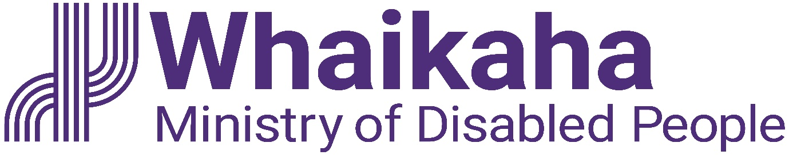

**Summer Intern**

Contents

About Whaikaha - Ministry of Disabled People 1

Our Purpose 1

Working in the Public Service 1

Te Tiriti o Waitangi 1

All-of-Government Summer Internship Programme 2

About the role 2

How you will contribute 2

What you will bring 4

## About Whaikaha - Ministry of Disabled People

### Our Purpose

At Whaikaha, we want an Aotearoa New Zealand where disabled people and tāngata whaikaha Māori are thriving.

We work with Deaf, disabled people, tāngata whaikaha Māori and Turi Māori, their families, whānau and communities, to drive real and meaningful change.

We can achieve more impact by working with others, so collaboration and relationship building across central and local government, businesses, iwi and hapū, is key.

### Working in the Public Service

In the public service we work collectively to make a meaningful difference for New Zealanders now and in the future. We have an important role in supporting both the current Government and successive governments to develop and implement their policies, as well as with its relationships with Māori under the Treaty of Waitangi.

### Te Tiriti o Waitangi

Te Tiriti o Waitangi (the Treaty of Waitangi) underpins our work and we are committed to giving effect to Te Tiriti through kāwanatanga, rangatiratanga, and ōritetanga. Whaikaha values and supports the voices of tāngata whaikaha Māori, Turi Māori and recognises them in the context of their whānau, hapū and iwi.  Our team works alongside tāngata whaikaha Māori, Turi Māori, whānau, hapū, iwi and communities to affirm their aspirations and work together to give effect to Te Tiriti.

## All-of-Government Summer Internship Programme

Whaikaha is offering an all-of-government summer internship programme for current tertiary students or recent graduates, who want to gain public sector work experience.

There are placement opportunities across the public sector. While we’re still confirming the agencies for this year’s pilot programme, there are lots of possibilities. Government agencies cover business, culture, education, emergency, environment, health, housing, international and trade, justice, national security, populations and communities, social services and transport sectors.

Should you be successful, you will be matched to a role that aligns with your skills, experiences, and interests.

You’ll have regular opportunities to connect and share your experiences with other interns, even if you are working at different agencies. You will also have an assigned mentor and buddy to support you during your internship.

Interns will get to take part in formal learning and development sessions, meet senior public service leaders, and the Minister for Disability Issues. At the end of the programme, you’ll present on your experiences and get career support.

The programme will run from November 2025 to February 2026.

## About the role

Summer interns will undertake projects and assigned work to gain knowledge and work experience within a public sector environment.

Whaikaha is committed to supporting host agencies to meet the accessibility needs of interns.

## How you will contribute

#### Undertake assigned tasks

* Undertake tasks as assigned by your manager, or their nominated delegate.
* Work with colleagues using fresh perspectives and new thinking, to achieve work objectives.
* Build productive professional relationships with colleagues, and external stakeholders where required.
* Provide your manager with a reflective journal on your personal learnings, transferable skills developed, and ideas for business improvement at the end of the internship.

#### Projects

Lead or contribute to projects to develop or improve the business. Projects may include:

* Organising documents, policies or procedures into an easy-to-use library or structure.
* Preparing presentations or reports.
* Reviewing an existing policy or procedure and conducting research to update or amend it.
* Conducting a peer-led informal evaluation or survey.
* Developing communications such as social media, film, or written documents.
* Organising work or social events.
* Other projects or tasks assigned by the manager or their nominated delegate.

**Embedding te ao Māori**

* Build more experience, knowledge, skills and capabilities (te reo Māori, tikanga, kawa, Te Tiriti) to engage with whānau, hapū and iwi.

#### Relationship Management

* Build and maintain collaborative and positive relationships across your host agency.
* Where required, establish and maintain sound working relationships with key contacts at relevant government agencies, non-government organisations, or other key stakeholders.

#### Risk Management

* Keep your manager informed of any issues that may impact the success of the organisation.

#### Contribute to your team

* Champion and contribute to a safe, respectful and accessible workplace culture. Embrace your role as a good team player by showing genuine care for your team, mahi and the communities we serve.
* Take personal responsibility for the wellbeing, health and safety of yourself and others. Follow safe working practices, report all incidents, hazards, and near misses, and familiarise yourself with how to respond in case of an emergency.
* Stay informed about emergency management and business continuity plans relevant to your business unit and team. Understanding these plans will help you respond appropriately in critical situations.
* Familiarise yourself and comply with all organisational policies, procedures, and guidelines.

## What you will bring

While this section contains guidance as to the potential requirements for the role, it is not determinative or a complete list. We value the unique skills, strengths, perspectives and experiences that a diverse range of people may bring and will work with our people to make any reasonable accommodations needed to ensure they have a work arrangement suited to their specific needs.

To undertake this role successfully the incumbent will:

* Be a disabled person, tangata whaikaha Māori or have lived experience as whānau, or be able to establish credibility and trust with the disability community, as well as having empathy and a deep understanding of the unique and diverse experiences of disabled people.
* Bring disability perspectives and a passion for equity to their work.

**Qualifications, experience, and knowledge**

* Be in your final year of tertiary studies or have completed your tertiary studies in the last two years.
* Able to manage tasks and meet deadlines with support or strategies that work best for you.
* An interest in the public service and a willingness to learn and gain experience.
* Open to collaboration and building positive relationships.
* Openness to participating in group discussions and working with colleagues to achieve team goals.
* Curiosity, self-awareness, and openness to feedback.
* Familiarity with Microsoft Office products such as Excel, Word, PowerPoint and Outlook.

#### Internal

* Group and team managers
* Kaimahi across the organisation

#### External

* Non-government organisations, and other key stakeholders
* Government agencies including the Ministry of Disabled People – Whaikaha

**Position Description** **Updated:** July 2025