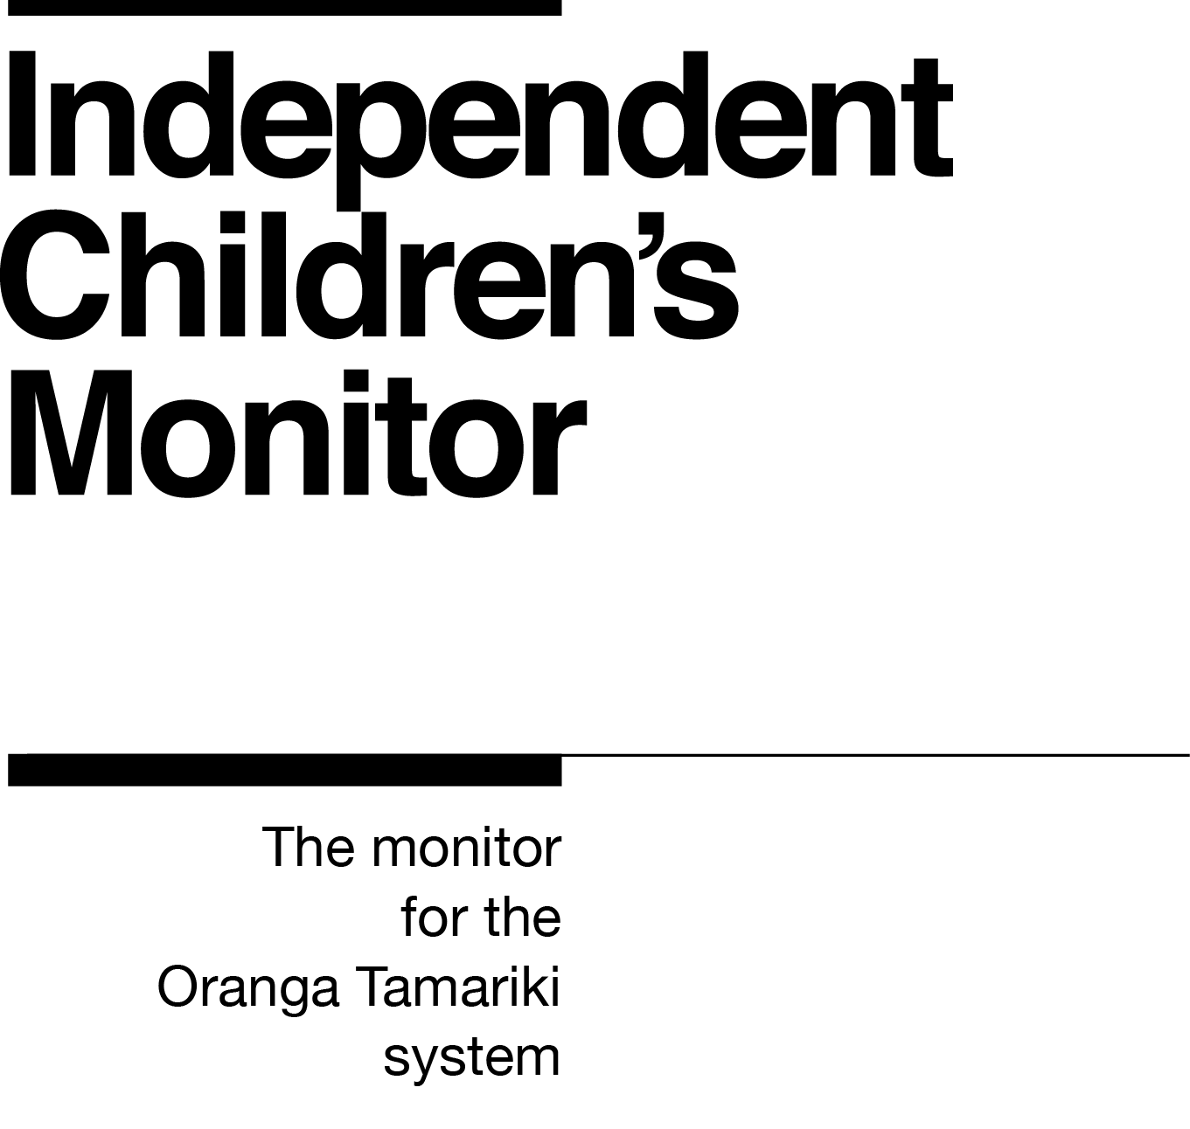

Kairuruku Tira
Team Coordinator Monitoring

Our purpose
The purpose of Te Mana Whakamaru Tamariki Motuhake, the Independent Children’s Monitor (the Monitor) is to provide a credible view of the Oranga Tamariki System, highlighting areas that will drive continuous improvement and support improving outcomes for children and young people, particularly tamariki Māori.

How we do this
The Monitor has oversight of the Oranga Tamariki System and its work will reflect the broad spectrum of monitoring from compliance, to practice quality, through to outcomes. Monitoring each of these interrelated areas enables us to assess if outcomes are being achieved for tamariki (children) and rangatahi (youth). Our review, analysis and reporting functions drive improvement and give us the opportunity to provide accurate information to a range of audiences including Ministers, government agencies, iwi, non-government agencies, whānau and individuals on the performance of the System.
We strive to always work in a way that is family-led and child-centred, embeds te ao Māori, is insight-driven and builds on our reputation as a trusted and credible influencer.
Our values

Our values have been developed within the context of our work and reflect our principles of being child centred with a te ao Māori lens across all that we do. Our values are how we behave every day, with each other and with those we are working with.
Kia Māia – Courageous: We are brave, bold, capable and confident.
Kia Pono, Kia Tika – Trustworthy: We are honest and genuine.
Manaaki – Respectful: We show respect and care for others.
Kia Huritao – to be Reflective: We are considered and reflective.
Our commitment to Māori
As a Te Tiriti o Waitangi partner to we are committed to supporting and enabling Māori,
whānau, hapū, Iwi and communities to realise their own potential and aspirations.
Position detail
Overview of position
The Kairuruku Tira - Team Coordinator Monitoring is part of the support function for the Independent Children’s Monitor’s front-line teams. This role works across the monitoring teams and has responsibility for ensuring the efficient and effective operational functioning of the team. They work with the Managers Monitoring to plan, manage and coordinate team activities. They provide a high level of administrative support to the Managers and the Advisors.
Location
Tāmaki (Auckland)
Reports to
Kaiwhakahaere Ā-rohe – Regional Manager Monitoring, Tāmaki (Auckland)

Key responsibilities
Administrative support
- Providing timely and accurate administrative support services to the Managers and Monitoring team including producing documentation such as memorandum, presentations and letters as necessary.
- Assisting with the production of the regular cycle of the Monitor’s reports.
- Making calendar appointments and travel arrangements as required.
- Coordinating events, seminars and conferences including booking venues, catering and travel/accommodation requirements.
- Ensuring that the confidentiality of documentation and information is maintained.
- Where required coordinating recruitment, on-boarding and induction processes for contract and permanent staff.
- Identifying continuous improvement opportunities in systems and processes and implementing where appropriate.
- Bringing urgent issues to the attention of the Manager.
Team coordination
- Setting up and maintaining effective electronic and paper filing systems.
- Providing direction and guidance to the team in the processing of day-to-day transactions arising from requests for action.
- Prioritising, escalating and following up issues from external stakeholders and/or team members.
- Providing support to the team for managing work flow.
Training and Support
- Planning, developing, coordinating and assisting in the delivery of induction and core Monitor training to new team members.

Contract support
- Assisting with request for proposal (RFP) and tender processes as required.
- Assisting the Managers and teams with Contract for Service and Variation to Contracts documents.
- Liaising with Legal Services and Finance to ensure compliance with contract policies and procedures.
- Liaising with providers.
- Maintaining contract records.
Account/financial administrative support
- Providing financial/budgeting administrative support to the Managers, including preparation of AP1s, monthly accruals, input of invoice details into financial systems, and attending finance meetings as required.
- Liaising with the Finance team on matters relating to the purchasing system and providing information where required.
- Undertaking purchase order processing transactions including:
- Inputting purchase requisitions for office supplies, equipment, stationery, and travel in a timely manner
- Receipting purchases
- Following up on goods on back-order/travel bookings
- Monitor asset administration.
Relationship Management
- Contributing in a positive way to the Monitor team, with a ‘can-do’ attitude and working with others to assist them achieve their targets.
- Establishing and maintaining relationships with the team and internal and external customers to resolve any issues.
Embedding child-centred practice
- Understanding the importance of child-centred practice and supporting the Monitor to embed children’s participation and the voice of tamariki into all aspects of the Monitor’s work.
Embedding Te Ao Māori
- Building knowledge, experience, capability and understanding of tikanga Māori and te reo to confidently engage with whānau, hapū and iwi.
- Embedding te ao Māori into the status quo of the Monitor.
- Seeking advice and using empathy and judgement to adapt to the context and circumstances.
- Learning about and respecting cultural similarities and differences and appreciating diversity.

Health, Safety and Security
- Understanding and implementing Health, Safety and Security (HSS) accountabilities as outlined in the HSS Accountability Framework.
- Ensuring all health, safety and security and wellbeing policies and procedures are understood, followed and implemented.
Emergency Management and Business Continuity
- Remaining familiar with the relevant provisions of the Emergency Management and Business Continuity Plans that impact the Monitor.
- Participating in periodic training, reviews and tests of the established Business Continuity Plans and operating procedures.
Other duties as required such as assisting with projects, attending events etc.

Know-how
Coordination experience - experience in managing day to day operational activities in a team environment.
Administration systems - significant knowledge of and continuous upskilling in administrative processes, systems and technology.
Software - advanced level of technical proficiency in the Microsoft office suite of applications and experience with electronic diary management and travel booking tools.
Communication – strong written and oral communication skills.
Prioritisation – the proven ability to effectively prioritise and schedule work to meet competing deadlines and maintain the quality of services delivered.
Details –notices detail and fixes or communicates problems/mistakes.
Relationship management - the ability to mix professionally and build effective relationships at all levels both within the Monitor and with outside agencies and clients.
Teamwork - the ability to work in a team environment, coordinating workloads, being adaptable, sharing responsibility and coping with continuing change.
Initiative – good judgement and initiative in addressing issues and problems arising in the role.
Context – demonstrated awareness of the environment we work in and some understanding of the workings of central Government - the role of Parliament, Ministers and public service agencies is preferable.

Attributes
- Resilient
- Responsive
- Detail oriented
- Problem solver
- Team player
- Initiative

Key Relationships
Internal
- Independent Children’s Monitor colleagues
- Ministry of Social Development colleagues
External
- Relevant employees at Oranga Tamariki
- Relevant NGO provider employees
- Relevant Office of the Children’s Commissioner employees
- Relevant Māori provider employees
- Other government agency colleagues

Other
Delegations
Financial – None
Human Resources – No
People – None
Direct reports – No
Security clearance – Yes
Children’s worker - No
Some travel may be required.
May require after-hours work occasionally to accommodate travel or events.

Our future
The Ministry of Social Development (MSD) has been given the job of building the Independent Children’s Monitor (the “Monitor") and the initial phases of monitoring operations. The Government has proposed to transfer the monitoring function to the Education Review Office (ERO) This means that the Monitor is currently part of MSD, however it is likely that it will transfer to be part of another organisation in the future.

