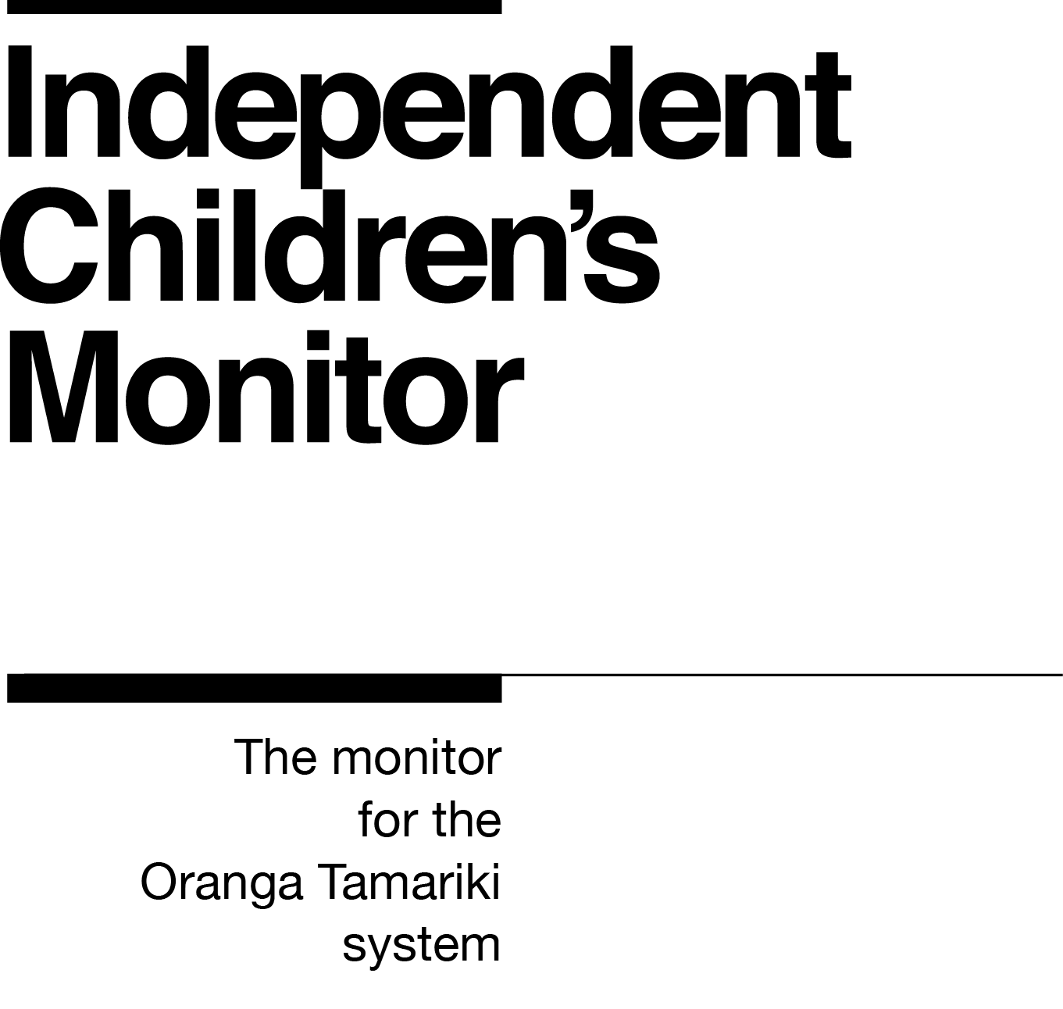

Kaitātari Raraunga Mātāmua
Senior Analyst Data and Insights

Our purpose
The purpose of the Independent Children’s Monitor (the Monitor) is to provide a credible view of the Oranga Tamariki System, highlighting areas that will drive continuous improvement and support improving outcomes for children and young people, particularly tamariki Māori.

How we do this
The Monitor has oversight of the Oranga Tamariki System and its work reflects the broad spectrum of monitoring from compliance, to practice quality, through to outcomes. Monitoring each of these interrelated areas enables us to assess if outcomes are being achieved for tamariki (children) and rangatahi (youth). Our review, analysis and reporting functions drive improvement and give us the opportunity to provide accurate information to a range of audiences including Ministers, government agencies, iwi, non-government agencies, whānau and individuals on the performance of the System.
We strive to always work in a way that is child-centred, embeds te ao Māori, is insight-driven and builds on our reputation as a trusted and credible influencer.
Our values

Our values have been developed within the context of our work and reflect our principles of being child centred with a te ao Māori lens across all that we do. Our values are how we behave every day, with each other and with those we are working with.
Kia Māia – Courageous: We are brave, bold, capable and confident.
Kia Pono, Kia Tika – Trustworthy: We are honest and genuine.
Manaaki – Respectful: We show respect and care for others.
Kia Huritao – to be Reflective: We are considered and reflective.

Our commitment to Māori
As a Te Tiriti o Waitangi partner to we are committed to supporting and enabling Māori,
whānau, hapū, iwi and communities to realise their own potential and aspirations.

Position detail
Overview of position
The Kaitātari Raraunga Mātāmua - Senior Analyst Data and Insights works with a small team of data and insights colleagues to provide analysis, insights and reporting on both quantitative and qualitative data. They manage regular data downloads from external agencies and ensure this information is packaged to support monitoring visits. They provide support to the monitoring teams to ensure the data they collect is captured and coded so that it is available for analysis. Their work supports the Monitor to identify areas of deeper focus, enable well-informed decision making, drive continuous improvement and provide accurate information on the performance of the Oranga Tamariki System.
Location
Wellington
Reports to
Kaiwhakahaere Rangatōpu, Rautaki me te Mōhiotanga - Manager Corporate, Strategy and Insights

Key responsibilities
Data analysis and reporting
- Working closely with the Principal Analyst Data and Insights to carry out analysis and identify key themes, insights and patterns.
- Identifying opportunities to improve qualitative data collection in NVivo.
- Working with the team and monitored agencies to develop and enhance core data sets.
- Developing and maintaining a suite of visual analytics through Excel and PowerBI for use in reports.
- Developing and enhancing data strategy, frameworks and methodologies.
Advice and support
- Understanding the Monitor’s operational processes and work programme to support the Monitoring team with relevant and timely data as required.
- Understanding the System participant’s operational and data collection processes to inform data requests and to identify opportunities to enhance data quality.
- Providing advice on the best use of available data to address different reporting requirements.
- Providing advice and training to the monitoring team to support qualitative analysis.
- Working with the monitoring team to scope, develop and document the information and data requirements in relation to specific monitoring activities such as deep dive investigations.
- Actively providing and responding to peer reviews.
- Supporting the Monitor to respond to enquiries from internal and external sources.
- Understanding the limitations of data available, providing advice on its reliability and its appropriateness for the purpose.
- Facilitating sessions with external organisations to understand and clarify datasets.
- Researching and evaluating other organisations to identify opportunities for improvement.
- Providing coaching and mentoring to up-skill and develop others within the team.
Systems and information
- Evaluating data tools against business requirements and providing recommendations.
- Maintaining and reviewing the integrity of data held by the Monitor.
- Investigating and reporting faults.
- Managing data security, ethics and privacy provisions.
- Assessing the impact of operational change on data collection and reporting and raising issues with the Manager Corporate, Strategy and Insights.
Embedding Te Ao Māori
- Building knowledge, experience, capability and understanding of tikanga Māori and te reo to confidently engage with whānau, hapū and iwi.
- Embedding te ao Māori into the status quo of the Monitor.
- Seeking advice and using empathy and judgement to adapt to the context and circumstances.
- Learning about and respecting cultural similarities and differences and appreciating diversity.
Health, Safety and Security
- Understanding and implementing Health, Safety and Security (HSS) accountabilities as outlined in the HSS Accountability Framework
- Understanding, following and implementing all health, safety and security and wellbeing policies and procedures.
Emergency Management and Business Continuity
- Remaining familiar with the relevant provisions of the Emergency Management and Business Continuity Plans that impact the Monitor.
- Participating in periodic training, reviews and tests of the established Business Continuity Plans and operating procedures.
Other duties as required such as supporting special projects or deep dive investigations.

Know-how
Qualification - relevant tertiary qualification such as Economics, Social Sciences, Computer Science, Maths, Statistics, or Operations Research or equivalent experience.
Data manipulation – advanced ability to manipulate and analyse data and generate reports using the appropriate tools (MS Excel, NVivo, PowerBI, Statistical Packages and modelling tools, web-based applications and publication skills).
Data and analysis – significant experience working with complex and diverse data with proven experience in data analysis, integration and reporting.
Information communication – proven ability to translate information and analysis into outputs which are readily interpreted by operational areas.
Business processes – the ability to quickly build sound knowledge of the Monitor’s business processes, the dynamics of the delivery activities and the issues they face.
Conceptual thinking – the ability to think conceptually, and to translate new and emerging themes into evidence-based insights and analysis.
Collaborative – successful experience in working collaboratively with internal customers and other stakeholders to determine requirements, obtain data and information, develop methodologies and communicate results.
Writing skills –proven ability to write clear, concise reports, memos and other professional documents.

Attributes
- Analytical
- Collaborative
- Growth mindset
- Respectful
- Trustworthy

Key Relationships
Internal
- Independent Children’s Monitor colleagues
- Ministry of Social Development colleagues
External
- Data/analytics contact at Oranga Tamariki
- Data/analytics contact at NGOs
- Data/analytics contact at Office of the Children’s Commissioner
- Data/analytics contact at Māori provider employees
- Other government agency colleagues
- Government Insight Group

Other
Delegations
Financial – No
Human Resources – No
People – No
Direct reports – No
Security clearance – Yes
Children’s worker – No
Limited ad hoc travel may be required to attend Monitor events.
May require after-hours work to accommodate travel or special projects.

Our future
The Ministry of Social Development (MSD) has been given the job of building the Independent Children’s Monitor (the “Monitor") and the initial phases of monitoring operations. However, once the necessary legislation is passed, the Monitor will leave MSD and become its own departmental agency with our own Chief Executive, who will also be a Statutory Officer. We will be hosted by the Education Review Office (ERO), and although there will be clear separation between the Monitor and ERO, it will allow the two agencies to cooperate and learn from one another.

