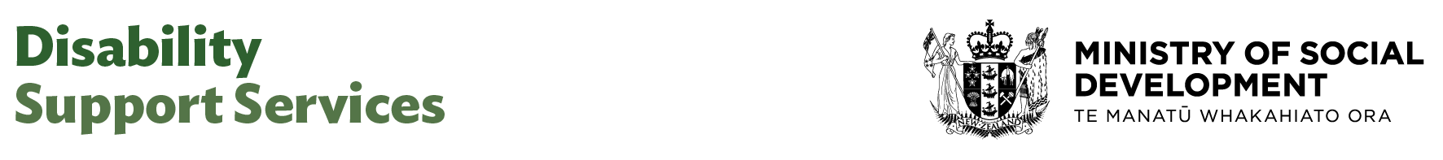

Senior Business Advisor Planning & Reporting

Our purpose
Manaaki tangata, Manaaki whānau
We help New Zealanders to be safe, strong and independent

Our commitment to Māori
As a Te Tiriti o Waitangi partner we are committed to supporting and enabling Māori, whānau, hapū, Iwi and communities to realise their own potential and aspirations.

Our strategic direction
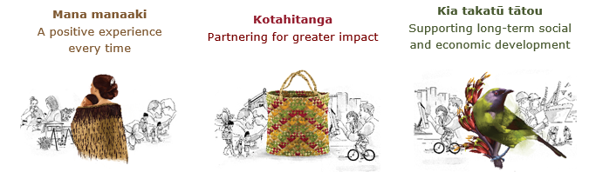

Our Values
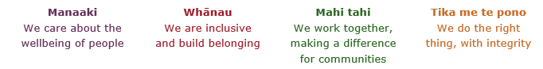

Working in the Public Service
Ka mahitahi mātou o te ratonga tūmatanui kia hei painga mō ngā tāngata o Aotearoa i āianei, ā, hei ngā rā ki tua hoki. He kawenga tino whaitake tā mātou hei tautoko i te Karauna i runga i āna hononga ki a ngāi Māori i raro i te Tiriti o Waitangi. Ka tautoko mātou i te kāwanatanga manapori. Ka whakakotahingia mātou e te wairua whakarato ki ō mātou hapori, ā, e arahina ana mātou e ngā mātāpono me ngā tikanga matua o te ratonga tūmatanui i roto i ā mātou mahi.
In the public service we work collectively to make a meaningful difference for New Zealanders now and in the future. We have an important role in supporting the Crown in its relationships with Māori under the Treaty of Waitangi. We support democratic government. We are unified by a spirit of service to our communities and guided by the core principles and values of the public service in our work.

The outcomes we want to achieve
New Zealanders get the support they require | New Zealanders are resilient and live in inclusive and supportive communities | New Zealanders participate positively in society and reach their potential

We carry out a broad range of responsibilities and functions including
- Employment, income support and superannuation
- Community partnerships, programmes and campaigns
- Advocacy for seniors and youth
- Public Housing assistance and emergency housing
- Resolving claims of abuse and neglect in state care
- Student allowances and loans

He whakataukī*
Unuhia te rito o te harakeke  Kei hea te kōmako e kō?  Whakatairangitia, rere ki uta, rere ki tai;  Ui mai ki ahau,  He aha te mea nui o te ao?  Māku e kī atu,  He tangata, he tangata, he tangata* | If you remove the central shoot of the flaxbush  Where will the bellbird find rest?  Will it fly inland, fly out to sea, or fly aimlessly;  If you were to ask me,  What is the most important thing in the world?  I will tell you,  It is people, it is people, it is people
* We would like to acknowledge Te Rūnanga Nui o Te Aupōuri Trust for their permission to use this whakataukī

Position detail

Overview of position
The Senior Business Advisor Planning & Reporting provides subject matter expert supports to the planning and reporting functions across DSS. This role leads the coordination of planning cycles, delivers high-impact reporting and analysis, and provides strategic advice that informs decision-making across DSS and the wider Ministry.

The Senior Business Advisor Planning & Reporting works closely with leaders to ensure plans are aligned with organisational objectives, prepares high-quality reports, and identifies opportunities for process improvement. This role requires a blend of analytical skills, technical knowledge, project management, and stakeholder engagement, as well as the ability to communicate complex information clearly to diverse audiences.

Location
National Office, Wellington

Reports to
Manager Business Support

Key responsibilities
- Provide insights and recommendations to inform strategic and operational decision-making through data interpretation and trend analysis.
- Lead the implementation of planning and reporting cycles, ensuring the alignment with strategic objectives and DSS-wide frameworks, providing robust analysis, reporting and coordination.
- Identify and develop process improvements that enhance the efficiency, accuracy, and impact of planning and reporting activities.
- Preparing high-quality and analytical reports, dashboards, and performance report for Senior leadership decision-making.
- Provide expert advice and support to internal stakeholders to ensure alignment of planning and reporting outputs with organisational goals.
- Monitor progress against key performance indicators and contribute the development of meaningful performance narratives.
- Lead the development and implementation of planning tools, templates, and guidance materials.
- Undertake the resolution of complex activities and issues and provide subject matter expertise to the team.
- Support the Manager on business planning and workflow management.
- Contribute to cross-functional initiatives, supporting alignment across DSS and MSD through collaborative planning and reporting efforts.
Actively identify and manage organisational risks by embedding risk considerations into planning and reporting processes
- Champion the Ministry and its values, demonstrate leadership across the Ministry, and build strong internal and external relationships.

Embedding te ao Māori
- Embedding Te Ao Māori (te reo Māori, tikanga, kawa, Te Tiriti o Waitangi) into the way we do things at MSD.
- Building more experience, knowledge, skills and capabilities to confidently engage with whānau, hapū and iwi.

Health, safety and security
- Understand and implement your Health, Safety and Security (HSS) accountabilities as outlined in the HSS Accountability Framework.
- Ensure you understand, follow and implement all Health, Safety and Security and wellbeing policies and procedures.

Emergency management and business continuity
- Remain familiar with the relevant provisions of the Emergency Management and Business Continuity Plans that impact your business group/team.
- Participate in periodic training, reviews and tests of the established Business Continuity Plans and operating procedures.

Know-how
- Relevant tertiary qualification and or equivalent experience in developing and working with reporting systems
- Strong knowledge of business planning, performance frameworks, developing and working with reporting systems and understanding of project management frameworks and reporting methodologies.
- Demonstrated experience advising senior leaders and influencing decision-making through strategic analysis and performance insights.
- Advanced proficiency in data analysis, interpretation, and visualisation using tools such as Excel, Plan view, Power BI, Microsoft Teams or similar platforms.
- Strong understanding of organisational strategy and how planning and reporting support its execution.
- Proven ability to manage complex planning cycles and coordinate cross-functional inputs
- Able to communicate effectively and support business groups to input data and information effectively.
- Excellent time management and the ability to manage competing priorities and objectives.
- Knowledge of and experience in public sector reporting requirements and governance expectations.
- Knowledge of disability issues an advantage.
- Skilled in working with teams across an organisation, able to foster excellent working relationships and deliver together on common goals.
- Ability to translate complex data into meaningful insights and recommendations.
- Knowledge of continuous improvement principles and their application in business support functions.

Attributes
- Analytical and methodical with a focus on clarity alongside for detail being well
- Collaborative and communicates effectively including written.
- Ability to influence others without authority.
- Proven ability to establish and build effective cohesive relationships and partnerships with a variety of stakeholders to achieve mutually beneficial outcomes.
- Curious and eager to learn.
- Proactive in solving problems.
- Adaptable to shifting priorities.
- Results-driven and accountable.

Key relationships

Internal
- ADCE
- Director Business Services
- Senior Managers and Programme Leads across DSS
- Office of the Chief Executive
- Colleagues in corresponding functions across MSD –eg MAES, IM

External
- Counterparts at other agencies

Other

Delegations
- Financial – No
- Human Resources - No

Direct reports - No

Security clearance - No

Children’s worker - No
Limited adhoc travel may be required

Position Description Updated: July 2025

