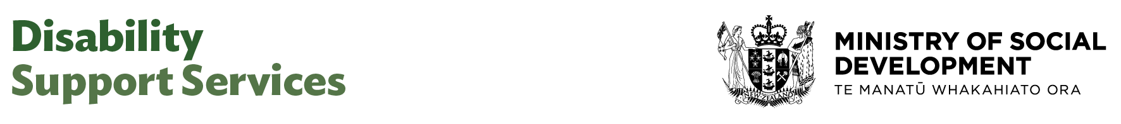

Senior Advisor (DSS Advisory)

Our purpose
Manaaki tangata, Manaaki whānau
We help New Zealanders to be safe, strong and independent

Our commitment to Māori
As a Te Tiriti o Waitangi partner we are committed to supporting and enabling Māori, whānau, hapū, Iwi and communities to realise their own potential and aspirations.

Our strategic direction
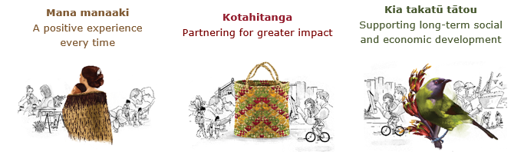

Our Values
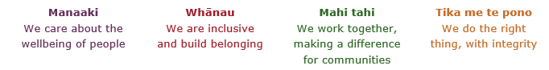

Working in the Public Service
Ka mahitahi mātou o te ratonga tūmatanui kia hei painga mō ngā tāngata o Aotearoa i āianei, ā, hei ngā rā ki tua hoki. He kawenga tino whaitake tā mātou hei tautoko i te Karauna i runga i āna hononga ki a ngāi Māori i raro i te Tiriti o Waitangi. Ka tautoko mātou i te kāwanatanga manapori. Ka whakakotahingia mātou e te wairua whakarato ki ō mātou hapori, ā, e arahina ana mātou e ngā mātāpono me ngā tikanga matua o te ratonga tūmatanui i roto i ā mātou mahi.
In the public service we work collectively to make a meaningful difference for New Zealanders now and in the future. We have an important role in supporting the Crown in its relationships with Māori under the Treaty of Waitangi. We support democratic government. We are unified by a spirit of service to our communities and guided by the core principles and values of the public service in our work.

The outcomes we want to achieve
New Zealanders get the support they require | New Zealanders are resilient and live in inclusive and supportive communities | New Zealanders participate positively in society and reach their potential

We carry out a broad range of responsibilities and functions including
- Employment, income support and superannuation
- Community partnerships, programmes and campaigns
- Advocacy for seniors, disabled people and youth
- Public Housing assistance and emergency housing
- Resolving claims of abuse and neglect in state care
- Student allowances and loans

He whakataukī*
Unuhia te rito o te harakeke  Kei hea te kōmako e kō?  Whakatairangitia, rere ki uta, rere ki tai;  Ui mai ki ahau,  He aha te mea nui o te ao?  Māku e kī atu,  He tangata, he tangata, he tangata* | If you remove the central shoot of the flaxbush  Where will the bellbird find rest?  Will it fly inland, fly out to sea, or fly aimlessly;  If you were to ask me,  What is the most important thing in the world?  I will tell you,  It is people, it is people, it is people
* We would like to acknowledge Te Rūnanga Nui o Te Aupōuri Trust for their permission to use this whakataukī

Position detail

Overview of position
The Senior Advisor provides high-quality advice, analysis, and support on matters relating to strategic partnerships, specialist advice, and the High and Complex Framework.

This role also leads or contributes to projects, policy development, assurance, and review activities, ensuring effective implementation and continuous improvement.

This role is responsible for helping build and maintain relationships with key stakeholders to support the team’s objectives and contribute to the development of best practice approaches for people with high and complex needs.

Location
Various

Reports to
Director DSS Advisory

Key responsibilities
- Deliver high-quality advice and analysis on operational and strategic issues across the team’s remit.
- Lead work projects and initiatives relating to the High and Complex Framework, assurance, and review functions.
- Ensures rigorous standards of analysis and risk assessment are achieved.
- Develop and maintain effective relationships with internal and external stakeholders, including agency partners.
- Support the review panel and assurance processes through research, reporting, and recommendations.
- Contribute to the development of policies, procedures, and best practice guidance.
- Mentor and support less experienced team members and contribute to team capability building.
- Guide the development of strategic advice on cross agency matters.
- Have an overview of organisational issues and an understanding of the key imperatives of other agencies.
- Prepare and develop high-level reports for leadership and across the sector.
- Proven ability in analysing and interpreting complex data and information and the ability to translate it into reports and other written material tailored to the intended audience.
- Strong ability to meet tight deadlines and deliver timely advice and highly professional support on various work projects.
- Communicate and disseminate information relating to initiatives, interagency projects and timeframes within the Ministry and other key agencies.

Embedding te ao Māori
- Embedding Te Ao Māori (te reo Māori, tikanga, kawa, Te Tiriti o Waitangi) into the way we do things at MSD.
- Building more experience, knowledge, skills and capabilities to confidently engage with whānau, hapū and iwi.

Health, safety and security
- Understand and implement your Health, Safety and Security (HSS) accountabilities as outlined in the HSS Accountability Framework.
- Ensure you understand, follow and implement all Health, Safety and Security and wellbeing policies and procedures.

Emergency management and business continuity
- Remain familiar with the relevant provisions of the Emergency Management and Business Continuity Plans that impact your business group/team.
- Participate in periodic training, reviews and tests of the established Business Continuity Plans and operating procedures.

Know-how
- Relevant tertiary qualification and or equivalent experience
- Strong analytical and policy development skills.
- Proven ability to work collaboratively and responsively in both government and non-government settings
- Knowledge of the disability sector and high and complex needs frameworks is preferred but not essential.
- Proven experience in project management, assurance, and stakeholder engagement.
- Highly effective level of communication and influencing skills and demonstrated ability to build and maintain strong stakeholder networks and relationships
- Highly effective level of communication and influencing skills and demonstrated ability to build and maintain strong stakeholder networks and relationships
- Extensive understanding of the relevant environment and issues facing the Ministry and the Government
- Proven extensive experience in strategy and policy development or implementation of projects and initiatives
- Demonstrated ability to provide high quality written advice to decision makers.
- A proven record of managing strategies and projects in a complex and demanding environment
- Clear and articulate communicator demonstrated by high levels of presentations, including written
- Organisational and environmental awareness with the ability to identify potential risks and issues, evaluate information and apply discretion to make quality judgements, decisions and appropriate responses

Attributes
- Analytical and solutions-focused.
- Collaborative and supportive.
- Detail-oriented and organised.
- Adaptable and proactive.
- Exercises sound judgement and political sensitivity
- Critical thinking and problem-solving skills
- Ability to influence others without authority
- Proven ability to establish and build effective cohesive relationships and partnerships with a variety of stakeholders to achieve mutually beneficial outcomes
- Advanced planning and organisational skill with the ability to multi-task, escalate as appropriate, and prioritise work on a daily basis while ensuring follow-up on other issues continues as necessary
- Proven ability to develop trust and credibility and handle confidential and privileged information sensitively
- Resilient and able to stay calm under pressure, demonstrate resourcefulness and a proactive approach to problem solving
- Ability to relate to people at all levels, demonstrate active listening skills and manage difficult conversations confidently, with the ability to exercise diplomacy and discretion
- Willingly shares knowledge and contributes to a supportive environment based on co-operation and commitment to achieve goals
- Ability to work efficiently in a close, busy team environment
- Strong communication skills
- Flexible, adaptable and pragmatic
- (Strong) client focus (with the ability to understands clients’ needs and is able to anticipate and respond to these)
- Welcomes and values diversity, and contributes to an inclusive working environment where differences are acknowledged and respected

Key relationships

Internal
- DSS leadership Team
- DSS Legal Team

External
- Key cross agency partners, including but not limited to, Ministry of Health, Health New Zealand, Corrections - Te Ara Poutama, Oranga Tamariki, Ministry of Justice, Police and Housing

Other

Delegations
- Financial – No
- Human Resources - No

Direct reports - No

Security clearance - No

Children’s worker - No
Limited adhoc travel may be required

Position Description Updated: July 2025

