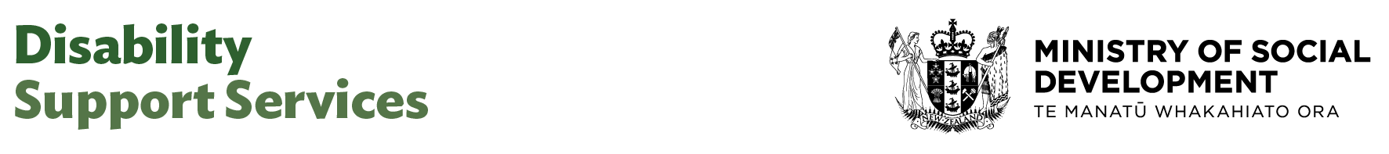

Senior Advisor Communications

Our purpose
Manaaki tangata, Manaaki whānau
We help New Zealanders to be safe, strong and independent

Our commitment to Māori
As a Te Tiriti o Waitangi partner we are committed to supporting and enabling Māori, whānau, hapū, Iwi and communities to realise their own potential and aspirations.

Our strategic direction
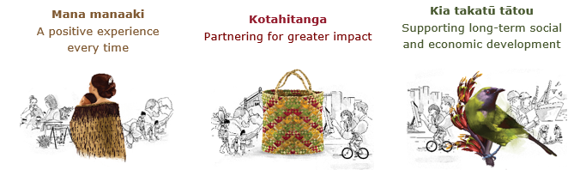

Our Values
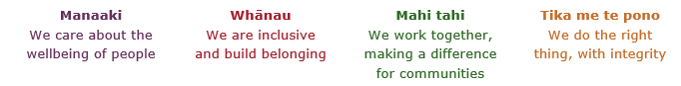

Working in the Public Service
Ka mahitahi mātou o te ratonga tūmatanui kia hei painga mō ngā tāngata o Aotearoa i āianei, ā, hei ngā rā ki tua hoki. He kawenga tino whaitake tā mātou hei tautoko i te Karauna i runga i āna hononga ki a ngāi Māori i raro i te Tiriti o Waitangi. Ka tautoko mātou i te kāwanatanga manapori. Ka whakakotahingia mātou e te wairua whakarato ki ō mātou hapori, ā, e arahina ana mātou e ngā mātāpono me ngā tikanga matua o te ratonga tūmatanui i roto i ā mātou mahi.
In the public service we work collectively to make a meaningful difference for New Zealanders now and in the future. We have an important role in supporting the Crown in its relationships with Māori under the Treaty of Waitangi. We support democratic government. We are unified by a spirit of service to our communities and guided by the core principles and values of the public service in our work.

The outcomes we want to achieve
New Zealanders get the support they require | New Zealanders are resilient and live in inclusive and supportive communities | New Zealanders participate positively in society and reach their potential

We carry out a broad range of responsibilities and functions including
- Employment, income support and superannuation
- Community partnerships, programmes and campaigns
- Advocacy for seniors, disabled people and youth
- Public Housing assistance and emergency housing
- Resolving claims of abuse and neglect in state care
- Student allowances and loans

He whakataukī*
Unuhia te rito o te harakeke  Kei hea te kōmako e kō?  Whakatairangitia, rere ki uta, rere ki tai;  Ui mai ki ahau,  He aha te mea nui o te ao?  Māku e kī atu,  He tangata, he tangata, he tangata* | If you remove the central shoot of the flaxbush  Where will the bellbird find rest?  Will it fly inland, fly out to sea, or fly aimlessly;  If you were to ask me,  What is the most important thing in the world?  I will tell you,  It is people, it is people, it is people
* We would like to acknowledge Te Rūnanga Nui o Te Aupōuri Trust for their permission to use this whakataukī

Position detail

Overview of position
The Senior Advisor, Communications provides internal and external communications and engagement advice to DSS and contributes to communications planning, web and digital content development, stakeholder engagement, responding to media enquiries and developing and implementing plans and strategies to ensure the success of initiatives.

The Senior Advisor works alongside business teams to provide advice and develops and delivers engagement and communication plans and initiatives that support the delivery of the work programme, undertakes content management processes and digital and website updates, and produces fit for purpose speeches and presentations to support our leaders aligned with wider organisational objectives and direction.

Location
National Office, Wellington

Reports to
Manager Communications

Key responsibilities
- Develop and deliver internal and external communication and engagement plans, projects, digital and web updates, and initiatives that align with government and DSS communication strategies.
- Provide high quality engagement and communication services and advice to the Manager Communications and the team
- Lead the development and implementation of communication and engagement projects in line with business needs supporting business groups across DSS with their communication products and projects.
- Contribute to the development of the communications work programme and frameworks for the communications team.
- Identify issues that present engagement and communication risks or opportunities. Design and implement mitigation strategies to minimise risks.
- Ensure all engagement and communication plans, projects and initiatives are aligned with the overall DSS communication and engagement strategy.
- Ensure communications content is accurate and adheres to our standards for language, style, layout, structure, accessibility, to provide the best possible experience to users.
- Provide and draft speeches for DSS leaders and kaimahi and provide communications plans that support DSS Leaders to connect effectively with staff and external stakeholders across regular fora and as required.
- Upload and update content using the Content Management System (CMS), ensuring accuracy, plain language and consistency with MSD guidelines.
- Work collaboratively to maintain and improve webpages and digital materials, supporting the team’s digital presence.
- Follow agreed processes and standards for publishing, accessibility and approvals.
- Assist with peer review and participate in quality assurance processes to help grow the capability, knowledge and skills in the team.
- Build positive working relationships across the organisation and work closely with colleagues in MSD communications to ensure alignment and consistency across all activities.

Embedding te ao Māori
- Embedding Te Ao Māori (te reo Māori, tikanga, kawa, Te Tiriti o Waitangi) into the way we do things at MSD.
- Building more experience, knowledge, skills and capabilities to confidently engage with whānau, hapū and iwi.

Health, safety and security
- Understand and implement your Health, Safety and Security (HSS) accountabilities as outlined in the HSS Accountability Framework.
- Ensure you understand, follow and implement all Health, Safety and Security and wellbeing policies and procedures.

Emergency management and business continuity
- Remain familiar with the relevant provisions of the Emergency Management and Business Continuity Plans that impact your business group/team.
- Participate in periodic training, reviews and tests of the established Business Continuity Plans and operating procedures.

Know-how
- Relevant tertiary qualification and or equivalent experience.
- Extensive experience in professional writing, plain English editing and proof-reading.
- Excellent technical proficiency and experience in the development and implementation of digital strategies and channels.
- Proven ability to grasp complex concepts quickly and translate them into compelling communications using a variety of channels.
- Excellent knowledge of wider communications tools and methods such as media, digital communication tools and techniques, and the public sector and the political environment
- Able to use a Content Management System (CMS) to upload and update website content. Confident making simple changes to webpages, ensuring content is accurate, accessible and aligned with MSD style guidelines.
- Good knowledge of relevant legislation affecting communications in New Zealand, including the Official Information Act and the Privacy Act.
- A proven record of delivering consistent, high quality strategic engagement and communications advice.
- Knowledge of disability issues an advantage
- Able to foster strong working relationships with others and an ability to work closely and advise senior leaders
- Experience with working with different sectors and tailoring deliverables for specific audiences and stakeholders.
- Experience in delivering both external and internal communications and working to support engagement activity as required.
- A good understanding of publication and production processes.
- Demonstrable relationship building and interpersonal skills, with the ability to exercise diplomacy and discretion.
- Experience of delivering communication services in the public sector an advantage.

Attributes
- Ability to remain calm and exercise sound judgement when under pressure.
- Make clear and astute decisions about issues and risks, and escalates decisions where appropriate, with clear recommendations.
- Excellent attention to detail - ability to produce quality outputs at a rapid rate whilst maintaining accuracy.
- Exercises sound judgment and political sensitivity (high degree of political nous)
- Strong partnership builder, able to establish, build and maintain effective working relationships at all levels of an organisation
- Constructive, positive and energetic.
- Enjoys working as part of a team.
- Ability to quickly build trust, rapport and credibility with senior leaders.
- Can prioritise and plan a varied workload and meet competing demands.
- Keeps abreast of changing communication channels, including social media.
- Effective persuasion and influencing skills.
- Excellent relationship management skills.

Key relationships

Internal
- DCE DSS
- ADCE DSS
- Senior Managers and staff across DSS
- MSD Corporate Communications Group
- CEs Office
- Ministers office

External
- Counterparts at other government agencies as required

Other

Delegations
- Financial – No
- Human Resources - No

Direct reports - No

Security clearance - No

Children’s worker - No
Limited adhoc travel may be required

Position Description Updated: July 2025

