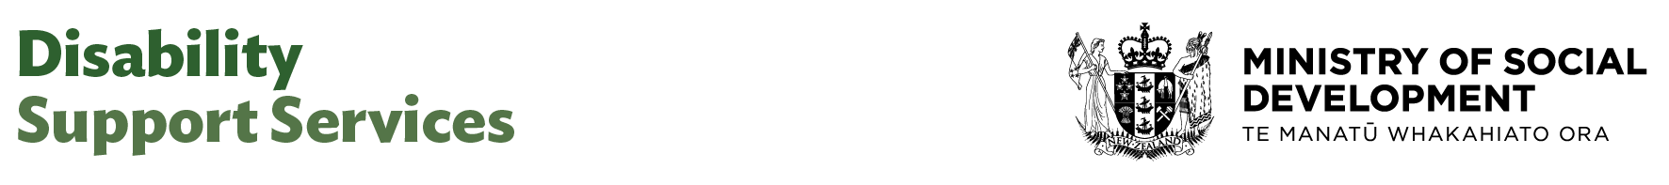

Principal Analyst

Our purpose
Manaaki tangata, Manaaki whānau
We help New Zealanders to be safe, strong and independent

Our commitment to Māori
As a Te Tiriti o Waitangi partner we are committed to supporting and enabling Māori, whānau, hapū, Iwi and communities to realise their own potential and aspirations.

Our strategic direction
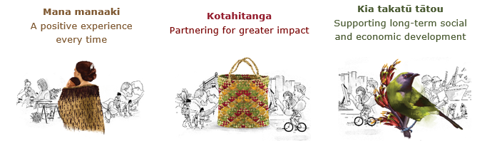

Our Values
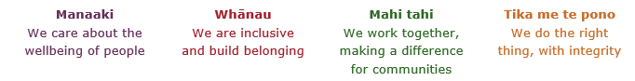

Working in the Public Service
Ka mahitahi mātou o te ratonga tūmatanui kia hei painga mō ngā tāngata o Aotearoa i āianei, ā, hei ngā rā ki tua hoki. He kawenga tino whaitake tā mātou hei tautoko i te Karauna i runga i āna hononga ki a ngāi Māori i raro i te Tiriti o Waitangi. Ka tautoko mātou i te kāwanatanga manapori. Ka whakakotahingia mātou e te wairua whakarato ki ō mātou hapori, ā, e arahina ana mātou e ngā mātāpono me ngā tikanga matua o te ratonga tūmatanui i roto i ā mātou mahi.
In the public service we work collectively to make a meaningful difference for New Zealanders now and in the future. We have an important role in supporting the Crown in its relationships with Māori under the Treaty of Waitangi. We support democratic government. We are unified by a spirit of service to our communities and guided by the core principles and values of the public service in our work.

The outcomes we want to achieve
New Zealanders get the support they require | New Zealanders are resilient and live in inclusive and supportive communities | New Zealanders participate positively in society and reach their potential

We carry out a broad range of responsibilities and functions including
- Employment, income support and superannuation
- Community partnerships, programmes and campaigns
- Advocacy for seniors, disabled people and youth
- Public Housing assistance and emergency housing
- Resolving claims of abuse and neglect in state care
- Student allowances and loans

He whakataukī*
Unuhia te rito o te harakeke  Kei hea te kōmako e kō?  Whakatairangitia, rere ki uta, rere ki tai;  Ui mai ki ahau,  He aha te mea nui o te ao?  Māku e kī atu,  He tangata, he tangata, he tangata* | If you remove the central shoot of the flaxbush  Where will the bellbird find rest?  Will it fly inland, fly out to sea, or fly aimlessly;  If you were to ask me,  What is the most important thing in the world?  I will tell you,  It is people, it is people, it is people
* We would like to acknowledge Te Rūnanga Nui o Te Aupōuri Trust for their permission to use this whakataukī

Position detail.

Overview of position
The Principal Analyst leads strategic analytics and insight generation across Disability Support Services (DSS), supporting evidence-informed system improvements for disabled people and their whānau. This role sits within the Data team in the Design, Delivery & Data Group and works closely with the wider Disability Support Services (DSS). It involves leading and participating in projects and policy initiatives within the team or across the Group or Ministry. The Principal Analyst also provides mentoring and supports the professional development of less experienced analysts.

The Principal Analyst will lead on specific initiatives according to the Group’s work programme and any other Ministry-driven or other projects or priorities. In their work, the Principal Analyst is expected to form sound working and collaborative relationships with colleagues and staff throughout the Ministry, as well as building networks with teams across other social sector agencies to support service monitoring and improve outcomes for disabled people and their whānau.

Location
Various

Reports to
Director Data and Evidence

Key responsibilities

Analysis, advice and support
- Provide intellectual leadership within the Group.
- Deliver high-quality insights and evidence-based recommendations to senior management for decision-making
- Provide high quality advice on complex issues without the need for guidance from others.
- Lead analysis and reporting of trends, systemic issues, and root causes arising from quality issues, informing organisational learning, continuous improvement, and policy development.
- Provide insightful advise management and/or the Government on the findings including trends, risks, and strategic developments.
- Have a breadth of view of organisational issues and an understanding of the key imperatives of other agencies.
- Champion quality assurance, including peer review and mentoring across the Data and Evidence team
- Represent the Ministry externally at significant interagency meetings as required.
- Take a leadership role in internal or external meetings as appropriate.
- Articulate the Ministry’s position and strategy on issues (and related rationale) with accuracy and persuasion.

System and information development
- Represent the Ministry by taking part in inter-departmental working groups
- Develop professional expertise in areas of priority to the Ministry.
- Support the development and integration of analytical frameworks of cross-sectoral and ‘whole of Government’ policies in conjunction with other government agencies as required.
- Develop and maintain effective relationships with appropriate Government research and evaluation, policy and service delivery staff and information sources.
- Maintain a high standard of personal integrity in all matters and ensure Ministry processes and protocols are followed.

Ministry or sector driven projects supporting operational and policy development.
- Lead complex analysis of existing policies, processes, products and services and make evidence-based recommendations in line with operational standards, policies, organisational requirements.
- Lead complex analysis that informs the Ministry’s policies and practices and contributes towards the Ministry’s strategic business plans/outcomes.
- Consult with internal and external stakeholders to gain support and input for proposed initiatives, identifying and overcoming barriers as appropriate.
- lead projects that shape DSS policy and practice as required.

Work programme
- Provide analytical leadership to other areas of the work programme as required in accordance with the needs of the Ministry, your professional areas of expertise, and your personal development plan.
- Apply project management methodology to ensure work meets business requirements and business standards.

Methodologies and process development
- Make a significant contribution to the development of methodologies, techniques and procedures used within the team/Group.

Relationship management
- Maintains networks and relationships with policy, research and evaluation experts both within New Zealand and overseas.

Mentoring
- Mentor and guide staff and providers to strengthen local capability and consistent practices in handling of issues, escalation and response, with a focus on engagement with disabled people and whānau.

Project management
- Lead substantial work programmes on a broad range of issues.
- Coordinate input from team members and other contributors.
- Assist sponsors to operationalise their information needs.

Advice/QA/peer review
- Provide specialist advice and analytical input to the work of managers and analysts, including quality assurance through peer review.

Embedding te ao Māori
- Embedding Te Ao Māori (te reo Māori, tikanga, kawa, Te Tiriti o Waitangi) into the way we do things at MSD.
- Building more experience, knowledge, skills and capabilities to confidently engage with whānau, hapū and iwi.

Health, safety and security
- Understand and implement your Health, Safety and Security (HSS) accountabilities as outlined in the HSS Accountability Framework
- Ensure you understand, follow and implement all Health, Safety and Security and wellbeing policies and procedures.

Emergency management and business continuity
- Remain familiar with the relevant provisions of the Emergency Management and Business Continuity Plans that impact your business group/team.
- Participate in periodic training, reviews and tests of the established Business Continuity Plans and operating procedures.

Know-how
- Relevant tertiary qualification and/or equivalent experience in an operational role
- Significant expertise in qualitative and/or quantitative methodologies
- Substantial experience in influencing and leading behaviour change, using data and evidence to guide and support decisions and actions
- Confident working with administrative data, delivering evidence-based insights at both operational and policy levels
- Advanced analytical and technical skills, with experience using tools such as Excel, SAS, Enterprise Guide, SPSS
- Extensive experience at a senior level analytical role, with strong judgement skills
- Comprehensive knowledge of one or more areas of social policy (e.g. support services, income support, child and youth, family, employment, communities)
- Comprehensive knowledge of stakeholder management with an ability to develop, maintain and strengthen trusting and respectful relationships.
- Demonstrated commitment to developing and maintaining specialist analytical skills and expertise.
- Proven ability to produce high-quality insights and provide peer support to build team capability.
- Demonstrated ability to lead projects.
- Familiarity with relevant legislation, public sector processes, and best practice in the disability sector
- Understanding of Te Tiriti o Waitangi and its application in outcomes measurement and public service delivery

Attributes
- Demonstrates integrity, honesty and professionalism in all aspects of work.
- Conscientious, self-motivated and committed to delivering high-quality analysis and advice.
- Reflective and forward-thinking, continuously seeking opportunities to learn and improve.
- Pragmatic and adaptable, able to navigate complexity and shifting priorities with resilience.
- Constructive and open-minded, contributing positively to team culture and outcomes.
- Enjoys working collaboratively and builds strong relationships across teams and agencies.
- Makes a positive contribution to shared goals and supports others to do the same.
- Champions Te Tiriti o Waitangi in all aspects of outcomes work.
- Communicates clearly and effectively, tailoring insights to diverse audiences.
- Demonstrates analytical rigour and uses evidence to inform decisions and drive improvement.

Key relationships

Internal
- Principal Advisors/Analysts
- The wider Design, Delivery & Data team
- The wider DSS Team and Taskforce

External
- Counterparts at other Government agencies
- Key representatives across the disability sector

Other

Delegations
- Financial – No
- Human Resources - No

Direct reports - No

Security clearance - No

Children’s worker - No
Limited ad hoc travel may be required

Position description updated: July 2025

