# Ministry of Social Development logo

# Principal Advisor

## Disability Support Services

## Our purpose

**Manaaki tangata, Manaaki whānau**

We help New Zealanders to be safe, strong and independent

## Our commitment to Māori

As a **Te Tiriti o Waitangi** partner we are committed to supporting and enabling Māori, whānau, hapū, Iwi and communities to realise their own potential and aspirations.

## Our strategic direction

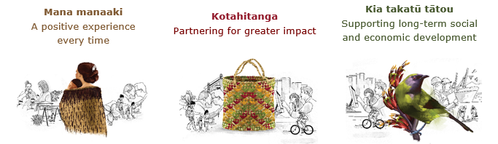

## Our Values

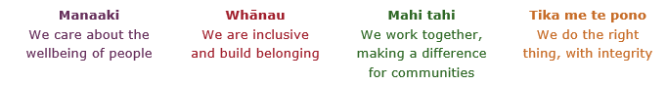

## Working in the Public Service

Ka mahitahi mātou o te ratonga tūmatanui kia hei painga mō ngā tāngata o Aotearoa i āianei, ā, hei ngā rā ki tua hoki. He kawenga tino whaitake tā mātou hei tautoko i te Karauna i runga i āna hononga ki a ngāi Māori i raro i te Tiriti o Waitangi. Ka tautoko mātou i te kāwanatanga manapori. Ka whakakotahingia mātou e te wairua whakarato ki ō mātou hapori, ā, e arahina ana mātou e ngā mātāpono me ngā tikanga matua o te ratonga tūmatanui i roto i ā mātou mahi.

In the public service we work collectively to make a meaningful difference for New Zealanders now and in the future. We have an important role in supporting the Crown in its relationships with Māori under the Treaty of Waitangi.  We support democratic government. We are unified by a spirit of service to our communities and guided by the core principles and values of the public service in our work.

## The outcomes we want to achieve

|  |  |  |
| --- | --- | --- |
| New Zealanders get the support they require | New Zealanders are resilient and live in inclusive and supportive communities | New Zealanders participate positively in society and reach their potential |

## We carry out a broad range of responsibilities and functions including

* Employment, income support and superannuation
* Community partnerships, programmes and campaigns
* Advocacy for seniors, disabled people and youth
* Public Housing assistance and emergency housing
* Resolving claims of abuse and neglect in state care
* Student allowances and loans

## **He whakataukī\***

|  |  |
| --- | --- |
| Unuhia te rito o te harakeke  Kei hea te kōmako e kō?  Whakatairangitia, rere ki uta, rere ki tai;  Ui mai ki ahau,  He aha te mea nui o te ao?  Māku e kī atu,  He tangata, he tangata, he tangata* | If you remove the central shoot of the flaxbush  Where will the bellbird find rest?  Will it fly inland, fly out to sea, or fly aimlessly;  If you were to ask me,  What is the most important thing in the world?  I will tell you,  It is people, it is people, it is people |

* We would like to acknowledge Te Rūnanga Nui o Te Aupōuri Trust for their permission to use this whakataukī

## Position detail

### Overview of position

The role of the Principal Advisor, Disability Support Services will be to provide high quality strategic, technical, analytical and thought leadership for the Commissioning and Capability Uplift team and across the Disability Support Services Business Unit.

This role will support the Director Commissioning and have oversight of strategic projects and pieces of work as determined by the Director. These may be related to both the functional responsibilities of the team and the continuous improvement of the teams operating model, including connections across DSS and the wider MSD. This will include understanding and contributing to commissioning Framework and strategic direction.

### Location

National Office, Wellington

### Reports to

Director Commissioning

## Key responsibilities

### Leadership and Strategy

* Represent the Director, as requested, by way of gathering information and viewpoints, and/or presenting the Director’s viewpoint and/or priorities on relevant issues and intentions.
* Work with the wider team to ensure assigned priority pieces of work are designed implemented and evaluated to meet the objectives of the organisation.
* Ability to lead and influence within the Ministry (MSD).

### Policy and Service Development

* Provide timely and relevant advice to the Director on commissioning, strategy, policy, service design and relationship management issues.
* Develop strategies/initiatives to ensure the priority pieces of work are well positioned to achieve targets and contribute to the Commissioning / Capability Uplift Management team and wider DSS Business Unit.
* Produce high standard of reports and other written work (for both internal and external audiences) as required by the Director.

### Commissioning

* Establish, build and maintain effective, constructive and collaborative relationships with all key stakeholders.
* Manage constructive working relationships with work colleagues and external stakeholders to enhance the understanding and co-operation needed to achieve desired results.
* Develop and maintain appropriate levels of understanding of government protocols and requirements.
* Develop and implement processes and practice that supports the successful implementation of key initiatives
* Support the Director to provide the necessary strategic advice.
* Take a lead role in communications and engagement channels and collateral to ensure consistency of message around priority pieces of work.

### Innovation

* Take a lead role to develop innovative options in partnership with others to solve complex problems.
* Ability to challenge status quo and seek innovative options as related to the functions of the Commissioning/Capability Uplift team.

## Embedding te ao Māori

* Demonstrates commitment to the values of MSD and to implementation of the actions within Te Pae Tata.
* Embedding Te Ao Māori (te reo Māori, tikanga, kawa, Te Tiriti o Waitangi) into the way we do things at MSD.
* Building more experience, knowledge, skills and capabilities to confidently engage with whānau, hapū and iwi.

## Health, safety and security

* Understand and implement your Health, Safety and Security (HSS) accountabilities as outlined in the HSS Accountability Framework.
* Ensure you understand, follow and implement all Health, Safety and Security and wellbeing policies and procedures.

## Emergency management and business continuity

* Remain familiar with the relevant provisions of the Emergency Management and Business Continuity Plans that impact your business group/team.
* Participate in periodic training, reviews and tests of the established Business Continuity Plans and operating procedures.

**Know-how**

* Proven experience in providing leadership through influencing and relationship management
* Extensive experience working with stakeholders around programmes that look to address complex social issues
* Experience and knowledge of commissioning including contracted services and procurement
* Proven experience in relationship management
* Demonstrated skills in reporting and evaluating
* Extensive knowledge in government policy
* Organisation agility coupled with political savvy to be able to influence without direct management control
* Proven experience in providing thought leadership to assist others to progress work to achieve the desired outcome, on time and to a high quality.
* Ability to analyse information and provide robust defensible recommendations and develop policy

## Attributes

* Influential thought leader
* Excellent Planning and Organisational Skills
* Client Focus
* Decision making skills – Analytical
* Teamwork and Ethics
* Excellent Communication – both written and oral
* Professionalism at the highest standard
* Welcomes and values diversity, and contributes to an inclusive working environment where differences are acknowledged and respected

## Key relationships

### Internal

* Director Commissioning
* Commissioning/Capability Uplift Team
* DSS Operations Team
* DSS Design Team
* DSS Taskforce
* Health New Zealand Sector Operations

### External

* Key stakeholders
* Third party commissioned providers
* Other Ministries

## Other

### Delegations

* Financial – No
* Human Resources - No

### Direct reports - No

### Security clearance - No

### Children’s worker - No

Limited adhoc travel may be required

**Position Description Updated:** July 2025