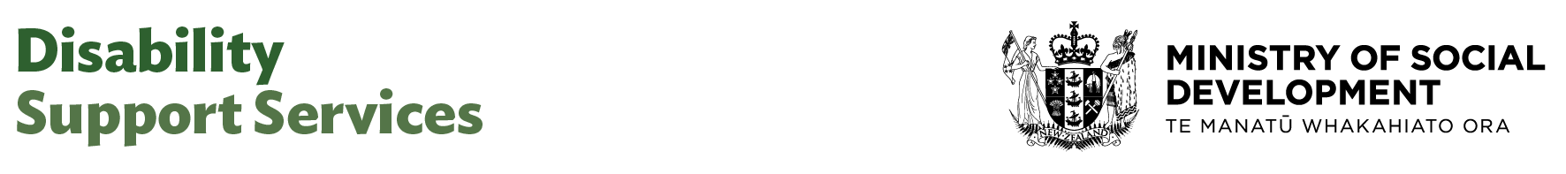

Principal Advisor (Design, Delivery and Data)

Our purpose
Manaaki tangata, Manaaki whānau
We help New Zealanders to be safe, strong and independent

Our commitment to Māori
As a Te Tiriti o Waitangi partner we are committed to supporting and enabling Māori, whānau, hapū, Iwi and communities to realise their own potential and aspirations.

Our strategic direction
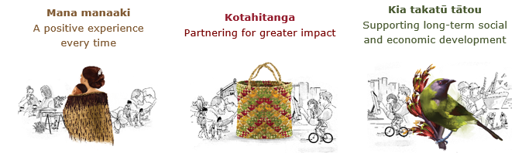

Our Values
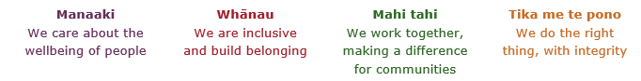

Working in the Public Service
Ka mahitahi mātou o te ratonga tūmatanui kia hei painga mō ngā tāngata o Aotearoa i āianei, ā, hei ngā rā ki tua hoki. He kawenga tino whaitake tā mātou hei tautoko i te Karauna i runga i āna hononga ki a ngāi Māori i raro i te Tiriti o Waitangi. Ka tautoko mātou i te kāwanatanga manapori. Ka whakakotahingia mātou e te wairua whakarato ki ō mātou hapori, ā, e arahina ana mātou e ngā mātāpono me ngā tikanga matua o te ratonga tūmatanui i roto i ā mātou mahi.
In the public service we work collectively to make a meaningful difference for New Zealanders now and in the future. We have an important role in supporting the Crown in its relationships with Māori under the Treaty of Waitangi. We support democratic government. We are unified by a spirit of service to our communities and guided by the core principles and values of the public service in our work.

The outcomes we want to achieve
New Zealanders get the support they require | New Zealanders are resilient and live in inclusive and supportive communities | New Zealanders participate positively in society and reach their potential

We carry out a broad range of responsibilities and functions including
- Employment, income support and superannuation
- Community partnerships, programmes and campaigns
- Advocacy for seniors, disabled people and youth
- Public Housing assistance and emergency housing
- Resolving claims of abuse and neglect in state care
- Student allowances and loans

He whakataukī*
Unuhia te rito o te harakeke  Kei hea te kōmako e kō?  Whakatairangitia, rere ki uta, rere ki tai;  Ui mai ki ahau,  He aha te mea nui o te ao?  Māku e kī atu,  He tangata, he tangata, he tangata* | If you remove the central shoot of the flaxbush  Where will the bellbird find rest?  Will it fly inland, fly out to sea, or fly aimlessly;  If you were to ask me,  What is the most important thing in the world?  I will tell you,  It is people, it is people, it is people
* We would like to acknowledge Te Rūnanga Nui o Te Aupōuri Trust for their permission to use this whakataukī

Position detail

Overview of position
The Principal Advisor serves as a key strategic advisor to the General Manager and Director in Design Delivery & Data providing high-level expertise on strategic, technical, and analytical leadership for the Group. As a trusted advisor, this role brings deep subject matter expertise, systems thinking and a broad cross-functional perspective to support the effective design and delivery of services within the business unit.
The Principal Advisor maintains a comprehensive understanding of the group’s work programmes and strategic priorities, supporting the development of insightful and future planning. The Principal Advisor plays a pivotal role in shaping strategy, identifying opportunities, and mitigating risks across the team.
They will work closely with the General Manager and others in the team, contributing to the planning and delivery of the overall work programme. They will share their skills and experience in a way that adds value to the group, ensuring achievement in both strategic and operational objectives.

Location
Various

Reports to
General Manager/Director

Key responsibilities

Strategic Leadership
- Supports GM or Director with the strategic direction and business planning activities of the group and contributes to the wider strategic planning of DSS.
- Contribute to the development of strategic initiatives, frameworks, and policies that support organisational transformation and improved outcomes.
- Work across DSS to ensure strong and appropriate linkages with and between projects, programmes, implementation, planning, funding, and monitoring.
- Ensure all work reflects the responsibilities, accountability and objectives of DSS.
- Represent DSS in external forums and meetings where appropriate.

Work programme delivery
- Lead essential core thought leadership for the Business Group and associated work programmes.
- Provide senior technical advice, expertise, and direction to enable the Group to achieve strategic objectives, operational activities and expected performance outcomes.
- Lead and support DSS wide approaches that align with the principals of Enabling Good Lives
- Provide leadership for programmes and projects for DSS, working with others to ensure that projects are well planned and monitored using tools and methods which includes taking strategic and tactical approaches to achieve results through high quality advice.
- Identify issues and opportunities emerging from the disability community and internally and make recommendations to integrate into the work programme.
- Enhance the capability of others through providing coaching and mentoring and quality improvement advice to team members during their day-to-day work.
- Provide analysis and advice to other teams throughout DSS who are working on related issues and contribute to the effective integration and coordination of related policies.
- Represent DSS in inter-agency discussions and on inter-agency groups relating to the work programme, including connections with the health sector and social sector and other agencies as required.

Research, evaluation, and analysis
- Apply advanced system, strategic and critical thinking, clear and logical reasoning, and sound judgement to analyse evidence and issues.
- Conduct high-quality research and analysis to support decision-making, strategic planning, and policy development.
- Develop innovative, practical, effective, and durable analytical approaches and research and evaluation solutions to achieve desired outcomes for disabled people and tāngata whaikaha Māori.
- Produce clear, accurate, well-reasoned and insightful written analysis to effectively communicate issues, options, and recommendations.
- Lead engagement with other agencies, disabled people and tāngata whaikaha Māori organisations, service providers and other significant stakeholders to ensure the advice provided is practical and effective.

Relationship Management
- Build and maintain collaborative and positive relationships across DSS and stakeholders across all sectors.
- Establish and maintain sound working relationships with key contacts at relevant government departments and agencies, the disability community, other key stakeholders.
- Motivate and influence leaders and stakeholders to achieve strategic objectives, operational activities and expected performance outcomes.
- Act as a trusted advisor to leaders by providing credible and expert advice on compliance with statutory/regulatory obligations and implementing government decisions.
- Work proactively with partners in ways that are most likely to deliver tangible benefits for disabled people and tāngata whaikaha Māori.
- Recognise and value the voice of the disability community. Work collaboratively with community groups, disabled people, tāngata Whaikaha Māori, whānau and providers reflecting their concerns and aspirations.
- Partner with key stakeholders to ensure the work programme reflects the Crown’s relationship with Māori and improves outcomes and reflects our Te Tiriti o Waitangi obligations.
Risk Management
- Identify any organisational risks and act and or seek support to minimise their impact and escalate as appropriate.
- Keep your manager informed of any risk issues that may impact on the success of DSS.

Embedding te ao Māori
- Embedding Te Ao Māori (te reo Māori, tikanga, kawa, Te Tiriti o Waitangi) into the way we do things at MSD.
- Building more experience, knowledge, skills and capabilities to confidently engage with whānau, hapū and iwi.

Health, safety and security
- Understand and implement your Health, Safety and Security (HSS) accountabilities as outlined in the HSS Accountability Framework.
- Ensure you understand, follow and implement all Health, Safety and Security and wellbeing policies and procedures.

Emergency management and business continuity
- Remain familiar with the relevant provisions of the Emergency Management and Business Continuity Plans that impact your business group/team.
- Participate in periodic training, reviews and tests of the established Business Continuity Plans and operating procedures.

Know-how
- Relevant tertiary qualification and or equivalent experience.
- Demonstrate expertise in navigating the complexities of the public sector and community service ecosystems, with a deep understanding of government structures, policy environments and cross-sector initiatives.
- Successful experience providing technical leadership or senior expertise on system design and associated work programmes.
- Significant knowledge and experience of working in the disability sector.
- Proven experience working across operational and strategic work programmes.
- Successful experience leading the design and implementation of mechanisms to gather evidence to inform improvements, including evidence from the experiences of disabled people, evaluations, audits, data, and other information.
- Experience and Knowledge of a range of research, evidence, and analytical methods, including emerging and innovative approaches and frameworks.
- Experience in applying critical thinking and using sound judgement to provide strategic advice.
- Experience and a high degree of proficiency in writing documents suited to a wide range of audiences.
- knowledge and understanding of operational policy and delivery processes.
- Experience influencing and engaging stakeholders.
- Experience providing technical leadership or senior advice to others.
- Understanding of the Machinery of government (desired but not essential).
- Understanding of Te Tiriti o Waitangi.

Attributes
- Strong influencing skills.
- Strong mathematical and statistical analysis analytical skills with a focus on quality and accuracy
- Ability to think strategically with a view of future requirement, think strategically and systemically, connecting the work of the team to broader organisational and service outcomes.
- Builds trust and credibility through sound judgment, deep expertise, and a commitment to public value.
- Communicates clearly and persuasively, adapting style and content to suit different audiences.
- Collaborates effectively across teams and disciplines, fostering alignment between deliverables.
- Champions equity, inclusion, and Te Tiriti o Waitangi in all aspects of policy work.
- Supports and develops others, contributing to a strong, capable, and values-driven policy team.
- Adapts confidently to complexity and change, maintaining focus, resilience, and a solutions mindset.
- High level of organisational and environmental awareness.
- Strong problem solving and decision-making skills.
- Ability to think strategically with a view of future requirement.
- Demonstrates curiosity, critical thinking, and a commitment to continuous learning and improvement.
- Welcomes and values diversity and contributes to an inclusive working environment where differences are acknowledged and respected

Key relationships

Internal
- General Managers
- Managers
- Principal Advisors/Analysts
- Staff across DSS
- Staff and managers across the Ministry

External
- Disability community partnership groups
- Disability support providers
- Office of the Health and Disability Commissioner
- Ministry of Health
- Health New Zealand – Te Whatu Ora
- Ministry of Social Development
- Ministry of Justice
- Regulatory bodies
- Other government agencies

Other

Delegations
- Financial – No
- Human Resources - No

Direct reports - No

Security clearance - No

Children’s worker - No
Limited adhoc travel may be required

Position Description Updated: July 2025

