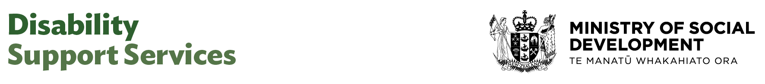

Principal Advisor

Our purpose
Manaaki tangata, Manaaki whānau
We help New Zealanders to be safe, strong and independent

Our commitment to Māori
As a Te Tiriti o Waitangi partner we are committed to supporting and enabling Māori, whānau, hapū, Iwi and communities to realise their own potential and aspirations.

Our strategic direction
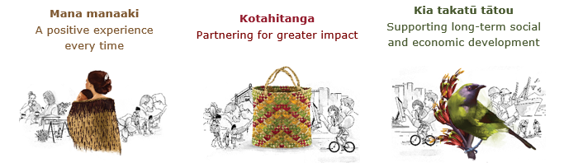

Our Values
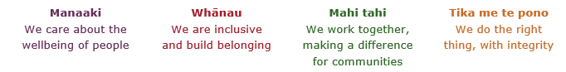

Working in the Public Service
Ka mahitahi mātou o te ratonga tūmatanui kia hei painga mō ngā tāngata o Aotearoa i āianei, ā, hei ngā rā ki tua hoki. He kawenga tino whaitake tā mātou hei tautoko i te Karauna i runga i āna hononga ki a ngāi Māori i raro i te Tiriti o Waitangi. Ka tautoko mātou i te kāwanatanga manapori. Ka whakakotahingia mātou e te wairua whakarato ki ō mātou hapori, ā, e arahina ana mātou e ngā mātāpono me ngā tikanga matua o te ratonga tūmatanui i roto i ā mātou mahi.
In the public service we work collectively to make a meaningful difference for New Zealanders now and in the future. We have an important role in supporting the Crown in its relationships with Māori under the Treaty of Waitangi. We support democratic government. We are unified by a spirit of service to our communities and guided by the core principles and values of the public service in our work.

The outcomes we want to achieve
New Zealanders get the support they require | New Zealanders are resilient and live in inclusive and supportive communities | New Zealanders participate positively in society and reach their potential

We carry out a broad range of responsibilities and functions including
- Employment, income support and superannuation
- Community partnerships, programmes and campaigns
- Advocacy for seniors, disabled people and youth
- Public Housing assistance and emergency housing
- Resolving claims of abuse and neglect in state care
- Student allowances and loans

He whakataukī*
Unuhia te rito o te harakeke  Kei hea te kōmako e kō?  Whakatairangitia, rere ki uta, rere ki tai;  Ui mai ki ahau,  He aha te mea nui o te ao?  Māku e kī atu,  He tangata, he tangata, he tangata* | If you remove the central shoot of the flaxbush  Where will the bellbird find rest?  Will it fly inland, fly out to sea, or fly aimlessly;  If you were to ask me,  What is the most important thing in the world?  I will tell you,  It is people, it is people, it is people
* We would like to acknowledge Te Rūnanga Nui o Te Aupōuri Trust for their permission to use this whakataukī

Position detail

Overview of position
The Principal Advisor works directly with the General Manager or Director in Commissioning & Funding in a key advisory role providing high-level expertise and advice on strategic, technical, and analytical leadership for the Commissioning & Funding Group.
The Principal Advisor develops and maintains broad knowledge across all aspects of the Group’s work programmes to provide strategic advice and guidance to the teams to ensure they can achieve strategic and operational objectives. The role provides assurance and identifies group level risk, issues and opportunities to the General Manager or Director to support them in delivering on accountabilities and requirements.
They will support the General Manager and others in the team to advice on plan and deliver its strategic direction, work programme including the Commissioning Framework, and contributing to DSS performance measures and progress reporting sharing their skills and experience in a way that adds value to the group.

Location
Various

Reports to
General Manager or Director in Commissioning & Funding

Key responsibilities
Strategic Leadership
- Support GM or Director in Commissioning and Funding with the strategic direction and business planning and reporting activities of your group and contribute to the wider strategic planning of your business unit.
- Work across DSS to ensure strong and appropriate linkages with and between projects, programmes, design, implementation, planning, funding, and monitoring, reporting on outcomes, sharing and disseminating results.
- Ensure all work reflects the responsibilities of DSS to the priority of equity and meeting Te Tiriti o Waitangi obligations.
- Support the Commissioning & Funding leadership team and the DSS leadership team with the provision of subject matter expertise.
Work programme delivery
- Lead essential core thought leadership for the Business Group and associated work programmes.
- Provide senior technical advice, expertise, and direction to enable the Group to achieve strategic objectives, operational activities and expected performance outcomes.
- Provide leadership for programmes and projects for DSS, working with others to ensure that projects are well planned and monitored using tools and methods which includes taking strategic and tactical approaches to achieve results through high quality advice.
- Provide quality commissioning oversight, including senior advice on the implementation of the commissioning framework
- Identify issues and opportunities to improve commissioning systems, procedures and processes
- Lead capability uplift initiatives related to commissioning activity across the Group. This includes working closely with the Procurement & Commercial team to implement capability uplift activities and provide coaching, mentoring and quality improvement advice to team members during their day-to-day work.
- Provide analysis and advice to other teams throughout DSS who are working on related issues and contribute to the effective integration and coordination of related policies.
- Represent the Group in change projects including being part of working groups and provide advice on Commissioning requirements and considerations.
- Represent DSS in inter-agency discussions and on inter-agency groups relating to the work programme, including connections with the health sector and social sector and other agencies as required.
Analysis & critical thinking
- Apply advanced system, strategic and critical thinking, clear and logical reasoning, and sound judgement to analyse evidence and issues.
- Develop innovative, practical, effective, and durable analytical approaches and commissioning solutions to achieve desired outcomes for disabled people and tāngata whaikaha Māori.
- Produce clear, accurate, well-reasoned and insightful written analysis to effectively communicate issues, options, and recommendations.
- Lead analysis and critical thinking across the Commissioning & Funding Group and contribute across DSS leadership Groups
- Support ongoing continuous quality improvement work of the Commissioning & Funding Group
Relationship Management
- Build and maintain collaborative and positive relationships across DSS, MSD and stakeholders across all sectors. This includes sharing insights, knowledge and commissioning impacts to build best practice across the disability sector nationally and internationally.
- Establish and maintain sound working relationships with key contacts at relevant government departments and agencies, the disability community, non-government organisations, interest groups and other key stakeholders.
- Motivate and influence leaders and stakeholders to achieve strategic objectives, operational activities and expected performance outcomes.
- Act as a trusted advisor to our leaders by providing credible and expert advice on commissioning practice.
- Recognise and value the voice of the disability community. Work collaboratively with partners and/or DSS Design, Delivery & Data to engage with community groups, disabled people, tāngata Whaikaha Māori, whānau and providers.
- Partner with key stakeholders to ensure the work programme reflects the Crown’s relationship with Māori and improves outcomes and equity and reflects our Te Tiriti o Waitangi obligations.
Risk Management
- Identify any organisational risks and act and or seek support to minimise their impact.
- Keep your manager informed of any risk issues that may impact on the success of DSS.

Embedding te ao Māori
- Embedding Te Ao Māori (te reo Māori, tikanga, kawa, Te Tiriti o Waitangi) into the way we do things at MSD.
- Building more experience, knowledge, skills and capabilities to confidently engage with whānau, hapū and iwi.

Health, safety and security
- Understand and implement your Health, Safety and Security (HSS) accountabilities as outlined in the HSS Accountability Framework.
- Ensure you understand, follow and implement all Health, Safety and Security and wellbeing policies and procedures.

Emergency management and business continuity
- Remain familiar with the relevant provisions of the Emergency Management and Business Continuity Plans that impact your business group/team.
- Participate in periodic training, reviews and tests of the established Business Continuity Plans and operating procedures.

Know-how
- Relevant tertiary qualification and or equivalent experience.
- Successful experience providing technical leadership or senior expertise on commissioning (including procurement and contract management) and associated work programmes.
- Knowledge and experience of working in the disability sector.- Desirable
- Proven experience working across commissioning in both operational and strategic work.
- Experience leading and implementing capability uplift programmes.
- Successful experience leading solutions that includegathering evidence to inform improvements in systems and processes.
- Experience and knowledge of a range of research, evidence, and analytical methods, including emerging and innovative approaches and frameworks.
- Experience in applying critical thinking and using sound judgement to provide strategic advice in a commissioning environment.
- Experience and a high degree of proficiency in writing documents and reports suited to a wide range of audiences.
- Knowledge and understanding of key commissioning activities and resources/tools required to implement commissioning for outcomes
- Experience influencing and engaging stakeholders.
- Experience providing technical commissioning leadership or senior advice to others.
- Understanding of the Machinery of government (desired but not essential).
- Understanding of Te Tiriti o Waitangi.

Attributes
- Strong influencing skills.
- Strong relationship and engagement skills.
- Excellent skills in critical thinking and problem solving skills.
- High level of organisational and environmental awareness.
- Strong mathematical and statistical analysis skills with a focus on quality and accuracy
- Strong problem solving and decision-making skills.
- Exercises sound judgement and political sensitivity.
- Excellent research, numerical, planning and organisational skills
- Organisational and environmental awareness
- Ability to think strategically with a view of future requirement
- Highly effective communication skills.
- Flexible, adaptable and pragmatic
- Strong client focus
- Establishes a high-performing culture
- Welcomes and values diversity, and contributes to an inclusive working environment where differences are acknowledged and respected

Key relationships

Internal
- DSS Commissioning & Funding Team
- DSS Design Delivery & Data Team
- DSS Quality Assurance & Improvement Team
- DSS Business Support Team
- DSS Shared Services Team
- DSS Taskforce
- DSS Finance team
- DSS Legal team
- MSD Policy
- MSD Māori, Community & Partnerships

External
- Other Government Agencies
- Crown Entities (other Commissioners)
- Third party commissioned providers

Other

Delegations
- Financial – No
- Human Resources - No

Direct reports - No

Security clearance - No

Children’s worker - No
Limited adhoc travel may be required

Position Description Updated: July 2025

