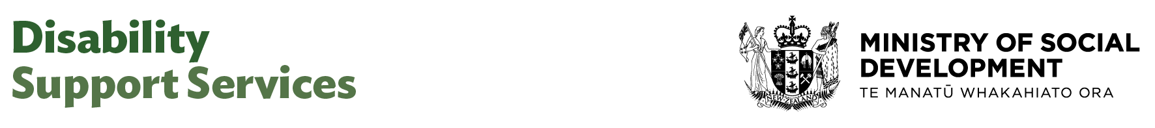

Lead Advisor Records Management

Our purpose
Manaaki tangata, Manaaki whānau
We help New Zealanders to be safe, strong and independent

Our commitment to Māori
As a Te Tiriti o Waitangi partner we are committed to supporting and enabling Māori, whānau, hapū, Iwi and communities to realise their own potential and aspirations.

Our strategic direction
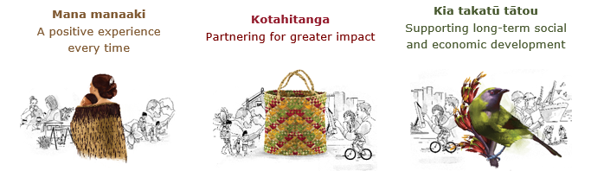

Our Values
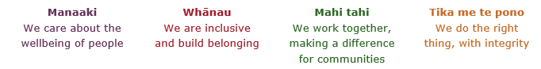

Working in the Public Service
Ka mahitahi mātou o te ratonga tūmatanui kia hei painga mō ngā tāngata o Aotearoa i āianei, ā, hei ngā rā ki tua hoki. He kawenga tino whaitake tā mātou hei tautoko i te Karauna i runga i āna hononga ki a ngāi Māori i raro i te Tiriti o Waitangi. Ka tautoko mātou i te kāwanatanga manapori. Ka whakakotahingia mātou e te wairua whakarato ki ō mātou hapori, ā, e arahina ana mātou e ngā mātāpono me ngā tikanga matua o te ratonga tūmatanui i roto i ā mātou mahi.
In the public service we work collectively to make a meaningful difference for New Zealanders now and in the future. We have an important role in supporting the Crown in its relationships with Māori under the Treaty of Waitangi. We support democratic government. We are unified by a spirit of service to our communities and guided by the core principles and values of the public service in our work.

The outcomes we want to achieve
New Zealanders get the support they require | New Zealanders are resilient and live in inclusive and supportive communities | New Zealanders participate positively in society and reach their potential

We carry out a broad range of responsibilities and functions including
- Employment, income support and superannuation
- Community partnerships, programmes and campaigns
- Advocacy for seniors, and youth
- Public Housing assistance and emergency housing
- Resolving claims of abuse and neglect in state care
- Student allowances and loans

He whakataukī*
Unuhia te rito o te harakeke  Kei hea te kōmako e kō?  Whakatairangitia, rere ki uta, rere ki tai;  Ui mai ki ahau,  He aha te mea nui o te ao?  Māku e kī atu,  He tangata, he tangata, he tangata* | If you remove the central shoot of the flaxbush  Where will the bellbird find rest?  Will it fly inland, fly out to sea, or fly aimlessly;  If you were to ask me,  What is the most important thing in the world?  I will tell you,  It is people, it is people, it is people
* We would like to acknowledge Te Rūnanga Nui o Te Aupōuri Trust for their permission to use this whakataukī

Position detail

Overview of position
The Lead Advisor (Records Management) will lead the Disability Support Services (DSS) input into a cross-agency initiative to uplift care record keeping to support new systems and improve access and management. This initiative is part of the Government response to the Royal Commission of Inquiry into Abuse in Care.

DSS is working with Archives NZ and Ministry of Education to develop guidance and resources to uplift care record keeping practices across the public sector. The Lead Advisor (Records Management) will lead the development of guidance and resources to help disability support providers to better understand their record keeping and management obligations, and to give best practice guidance to support them to meet these obligations.

The Lead Advisor (Records Management) will also lead the development and management of cohesive working relationships with key agency partners, ensuring effective collaboration and alignment across the sector. This will include the development of a provider reference group to seek direct input and feedback from DSS-funded providers on what they want the disability sector-specific guidance to cover.

Location
Wellington

Reports to
General Manager Quality Assurance and Improvement

Key responsibilities
- Provide expert advice on the development and implementation of care records management practices aligned with the Care Records Framework, including documentation standards, retention and disposal protocols, and privacy considerations, to support responsible practice for creating and handling care records across the disability support sector.
- Lead the design of practical tools and interim guidance that enable providers to manage care records in a way that aligns with legal obligations and sector expectations.
- Lead the development and implementation of training materials to support the interim guidance, that will help to embed responsible care records management into provider operations and service delivery.
- Collaborate with disability support providers to develop best practice resources that reflect real-world service environments and client needs.
- Provide mentoring and support to team members and providers on care records practices, ensuring consistency, quality, and compliance with relevant legislation (eg, Privacy Act 2020, Health Information Privacy Code).
- Promote a culture of continuous improvement in care records management, with a focus on client dignity, data protection, and service transparency.
- Strengthen strategic partnerships by building and maintaining high-trust relationships with key agency partners, fostering collaboration and shared accountability across the sector.
- Provide guidance and mentorship to team members in stakeholder engagement and partnership management.

Embedding te ao Māori
- Embedding Te Ao Māori (te reo Māori, tikanga, kawa, Te Tiriti o Waitangi) into the way we do things at MSD.
- Building more experience, knowledge, skills and capabilities to confidently engage with whānau, hapū and iwi.

Health, safety and security
- Understand and implement your Health, Safety and Security (HSS) accountabilities as outlined in the HSS Accountability Framework.
- Ensure you understand, follow and implement all Health, Safety and Security and wellbeing policies and procedures.

Emergency management and business continuity
- Remain familiar with the relevant provisions of the Emergency Management and Business Continuity Plans that impact your business group/team.
- Participate in periodic training, reviews and tests of the established Business Continuity Plans and operating procedures.

Know-how
- Relevant tertiary qualification and/or equivalent experience.
- Knowledge and experience in care records management principles, privacy obligations, and sector-specific documentation standards
- Understanding of relevant legislation, such as the Privacy Act 2020 and Health Information Privacy Code, and how it applies to care records in the disability sector.
- Understanding and familiarity with the Royal Commission of Inquiry into Abuse in Care and its recommendations.
- Familiarity with the Care Records Framework developed by the Crown Response Office in partnership with government agencies and other stakeholders to help care records holders look after records and support care experienced people who want to access them.
- Experience working with disability support providers, particularly in developing or implementing documentation and information handling practices.
- Ability to translate policy and compliance requirements into practical tools and guidance for frontline service providers.
- Strong experience in stakeholder engagement and collaboration across government and non-government sectors, with the ability to build trusted relationships and contribute to shared outcomes.
- Knowledge and experience of the disability, social services sector would be an advantage.
- Exceptional communication skills with the ability to build and maintain effective and cohesive working relationships across diverse stakeholder groups.
- Experience in supporting and mentoring team members, fostering a culture of continuous learning and development within the team.

Attributes
- Strong influencing and communication skills.
- Extensive relationships and engagement skills.
- Excellent written communication skills.
- Relationship-focused and diplomatic.
- Strategic and innovative thinker.
- Exercises sound judgement and political sensitivity.
- Influential, credible, and respected by peers.
- Collaborative and committed to shared outcomes.
- Excellent skills in critical thinking, problem-solving and decision-making.
- Ability to think strategically with a view of future requirements.
- High level of organisational and environmental awareness.
- Flexible, adaptable and pragmatic.
- Establishes a high-performing culture.
- Welcomes and values diversity and contributes to an inclusive working environment where differences are acknowledged and respected.

Key relationships

Internal
- DSS Quality Assurance and Improvement
- DSS Leadership Team

External
- Key cross-agency partners, including but not limited to, Archives New Zealand (DIA), Ministry of Education and the Crown Response Office.
- Disability support providers.

Delegations
- Financial – No
- Human Resources - No

Direct reports - No

Security clearance - No

Children’s worker - No
Limited adhoc travel may be required

Position Description Updated: October 2025

