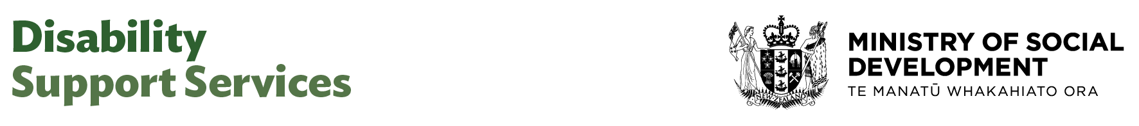

Executive Assistant

Our purpose
Manaaki tangata, Manaaki whānau
We help New Zealanders to be safe, strong and independent

Our commitment to Māori
As a Te Tiriti o Waitangi partner we are committed to supporting and enabling Māori, whānau, hapū, Iwi and communities to realise their own potential and aspirations.

Our strategic direction
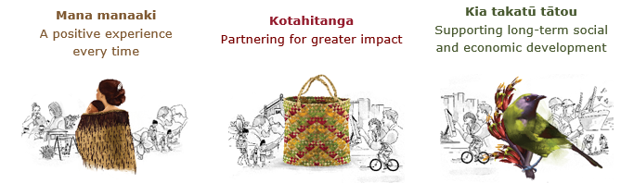

Our Values
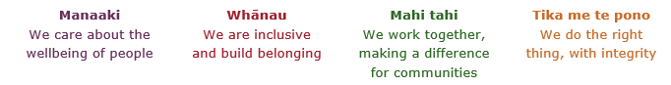

Working in the Public Service
Ka mahitahi mātou o te ratonga tūmatanui kia hei painga mō ngā tāngata o Aotearoa i āianei, ā, hei ngā rā ki tua hoki. He kawenga tino whaitake tā mātou hei tautoko i te Karauna i runga i āna hononga ki a ngāi Māori i raro i te Tiriti o Waitangi. Ka tautoko mātou i te kāwanatanga manapori. Ka whakakotahingia mātou e te wairua whakarato ki ō mātou hapori, ā, e arahina ana mātou e ngā mātāpono me ngā tikanga matua o te ratonga tūmatanui i roto i ā mātou mahi.
In the public service we work collectively to make a meaningful difference for New Zealanders now and in the future. We have an important role in supporting the Crown in its relationships with Māori under the Treaty of Waitangi. We support democratic government. We are unified by a spirit of service to our communities and guided by the core principles and values of the public service in our work.

The outcomes we want to achieve
New Zealanders get the support they require | New Zealanders are resilient and live in inclusive and supportive communities | New Zealanders participate positively in society and reach their potential

We carry out a broad range of responsibilities and functions including
- Employment, income support and superannuation
- Community partnerships, programmes and campaigns
- Advocacy for seniors and youth
- Public Housing assistance and emergency housing
- Resolving claims of abuse and neglect in state care
- Student allowances and loans

He whakataukī*
Unuhia te rito o te harakeke  Kei hea te kōmako e kō?  Whakatairangitia, rere ki uta, rere ki tai;  Ui mai ki ahau,  He aha te mea nui o te ao?  Māku e kī atu,  He tangata, he tangata, he tangata* | If you remove the central shoot of the flaxbush  Where will the bellbird find rest?  Will it fly inland, fly out to sea, or fly aimlessly;  If you were to ask me,  What is the most important thing in the world?  I will tell you,  It is people, it is people, it is people
* We would like to acknowledge Te Rūnanga Nui o Te Aupōuri Trust for their permission to use this whakataukī

Position detail

Overview of position

The role of the Executive Assistant is to provide general administrative and secretarial support to the Manager. The Executive Assistant will also work as part of an effective team to develop and maintain administrative services for the team.

Location
Various

Reports to
National Director EGL

Key responsibilities

Secretarial Services/ Management Support
- Provide timely and accurate secretarial services for the team, including word-processing, spread sheeting, photocopying and other document processing duties as may be necessary to support the efficient functioning of the team.
- Develop presentation materials using appropriate design packages, as required.
- Respond to and compose letters and memoranda.
- Collate papers for meetings, prepare and circulate agendas, take minutes and dictation.
- Provide a reception service, take messages, answer queries and redirect queries as appropriate, screen telephone calls, mail, and visitors.
- Maintain diaries, make appointments, and travel arrangements.
- Maintain confidentiality of documentation and information as required and as appropriate.
- Liaise with key stakeholders to understand their service requirements.
- Ensure that high level support services are provided.
- Co-ordinate meetings – including scheduling, arranging resources, venues and catering, production of agendas, collation of papers, minute-taking and dissemination as required.
Administrative Support
- Set up and maintain effective electronic and paper filing systems and procedures and develop new systems as required enabling quick access to information.
- Develop and maintain electronic and paper information bases relevant to the team.
- Compile statistics and information as required.
- Undertake one-off projects, compile and process data for the Manager or team where required.
- Index, catalogue, and store current and non-current information.
- Maintain appropriate supply of stationery for the team.
- Co-ordinate with and assist other administration staff as necessary.
- Document all procedures within desk files.

Accounts Support
- Provide financial/budgeting support as required.
- Liaise with National Accounting Centre on matters relating to purchasing system/requisitions.
- Undertake purchase order processing transactions including:
o Input purchase requisitions for office supplies, equipment, stationery, and travel in a timely manner
o Follow up on goods on back-order/travel bookings
- Prepare invoices for payments.

Administration Services, Systems and Procedures
- Participate in the development and maintenance of standards for administrative support.
- Contribute to improvements in the internal procedures performed by executive support staff.
- Contribute ideas for improvement to systems and process simplification to effectively deliver administrative support services.
- Operate systems and procedures in such a manner as to meet the group’s requirements.
- Provide administrative support and advice to members of the team and wider team and DSS as required.
- Co-ordinate with and assist other executive support staff such that best practice is shared, and overload situations can be managed efficiently.

Human Resource Functions
- Co-ordinate advertising and recruitment procedures.

Team and Individual Performance
- Participate in the development and operation of projects which include team members and others.
- Contribute to team communication activities.
- Participate in peer review of own and others work.
- Identify and act on personal learning and development opportunities.

Embedding accessibility
• Embed a culture of genuine accessibility within teams where people work actively to identify and remove barriers and recognise individual strengths and needs.

Embedding te ao Māori
- Embedding Te Ao Māori (te reo Māori, tikanga, kawa, Te Tiriti o Waitangi) into the way we do things at MSD.
- Building more experience, knowledge, skills and capabilities to confidently engage with whānau, hapū and iwi.

Health, safety and security
- Understand and implement your Health, Safety and Security (HSS) accountabilities as outlined in the HSS Accountability Framework.
- Ensure you understand, follow and implement all Health, Safety and Security and wellbeing policies and procedures.

Emergency management and business continuity
- Remain familiar with the relevant provisions of the Emergency Management and Business Continuity Plans that impact your business group/team.
- Participate in periodic training, reviews and tests of the established Business Continuity Plans and operating procedures.

Know-how
- Demonstrated experience with the provision of high-level administration and secretarial support activities.
- Advanced level of word processing, computer and keyboard skills, including knowledge of spreadsheet, email, electronic diary management, internet, graphics, presentation and/or desktop publishing packages is desirable.
- Previous experience in accounts administration.
- Excellent knowledge of administration policies, systems, procedures and technology.
- Previous experience in an executive assistant or administrative support role.
- Attention to detail.
- Effective relationship management.
- Ability to mix professionally and build effective relationships at all levels both within the ministry and with outside agencies and clients.
- Ability to prioritise.
- Ability to work as part of a team.
- Excellent communication skills.

Attributes
- Integrity – High level of integrity, diligence, and ability to build trusting relationships.
- Collaborative – Facilitate collaboration and communication, through tools, and behavioural norms to improve the quality and number of collaborative discussions thereby enabling efficient completion of tasks and complex problems to be solved.
- Accountable – Delivers on their promises and holds themselves accountable.
- Pride in delivering value – Take pride in the development and delivery of work towards a shared goal that delivers value to the client.
- Ability to adapt to change – Be comfortable with ambiguity, and flexible adapting to changing demands and priorities.
- Engaged – Display a genuine interest in your team and their individual requirements around their support, care, and development.
- Welcomes and values diversity – Leads and contributes to an inclusive working environment where differences are acknowledged and respected.
- Effective change agent – communicates and manages change well, adaptable.
- Authenticity – Our people are real, pragmatic and down to earth. We are genuine in our approach, with each other and our clients.
- Excellence in everything we do – all client (external and internal) interactions.

Key relationships

Internal
- Manager and staff across the team
- Executive Assistants and Administrative team across DSS and MSD

External
- Other government agencies
- Minister’s office
- Client Service organisations, including travel agents, equipment suppliers and customer representatives

Other

Delegations
- Financial – No
- Human Resources - No

Direct reports - No

Security clearance - No

Children’s worker - No
Limited ad hoc travel may be required.

Position Description Updated: October 2025

