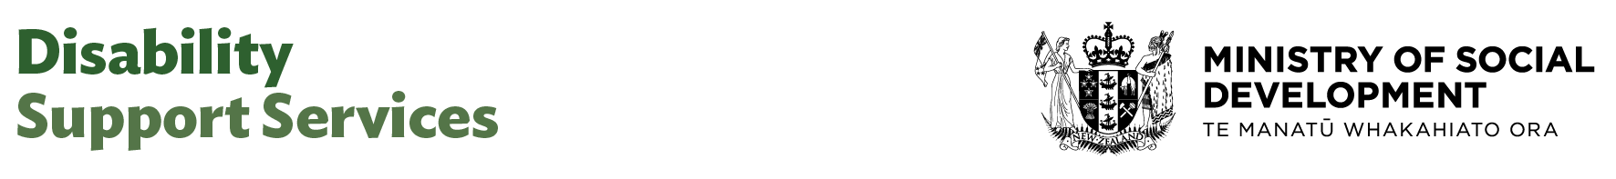

Design and Change Lead

Our purpose
Manaaki tangata, Manaaki whānau
We help New Zealanders to be safe, strong and independent

Our commitment to Māori
As a Te Tiriti o Waitangi partner we are committed to supporting and enabling Māori, whānau, hapū, Iwi and communities to realise their own potential and aspirations.

Our strategic direction
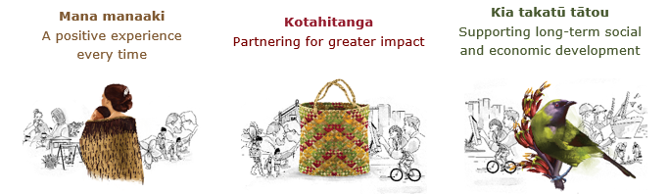

Our Values
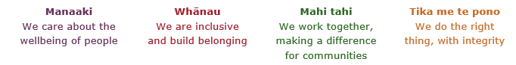

Working in the Public Service
Ka mahitahi mātou o te ratonga tūmatanui kia hei painga mō ngā tāngata o Aotearoa i āianei, ā, hei ngā rā ki tua hoki. He kawenga tino whaitake tā mātou hei tautoko i te Karauna i runga i āna hononga ki a ngāi Māori i raro i te Tiriti o Waitangi. Ka tautoko mātou i te kāwanatanga manapori. Ka whakakotahingia mātou e te wairua whakarato ki ō mātou hapori, ā, e arahina ana mātou e ngā mātāpono me ngā tikanga matua o te ratonga tūmatanui i roto i ā mātou mahi.
In the public service we work collectively to make a meaningful difference for New Zealanders now and in the future. We have an important role in supporting the Crown in its relationships with Māori under the Treaty of Waitangi. We support democratic government. We are unified by a spirit of service to our communities and guided by the core principles and values of the public service in our work.

The outcomes we want to achieve
New Zealanders get the support they require | New Zealanders are resilient and live in inclusive and supportive communities | New Zealanders participate positively in society and reach their potential

We carry out a broad range of responsibilities and functions including
- Employment, income support and superannuation
- Community partnerships, programmes and campaigns
- Advocacy for seniors, disabled people and youth
- Public Housing assistance and emergency housing
- Resolving claims of abuse and neglect in state care
- Student allowances and loans

He whakataukī*
Unuhia te rito o te harakeke  Kei hea te kōmako e kō?  Whakatairangitia, rere ki uta, rere ki tai;  Ui mai ki ahau,  He aha te mea nui o te ao?  Māku e kī atu,  He tangata, he tangata, he tangata* | If you remove the central shoot of the flaxbush  Where will the bellbird find rest?  Will it fly inland, fly out to sea, or fly aimlessly;  If you were to ask me,  What is the most important thing in the world?  I will tell you,  It is people, it is people, it is people
* We would like to acknowledge Te Rūnanga Nui o Te Aupōuri Trust for their permission to use this whakataukī

Position detail

Overview of position

The Design and Change Lead contributes to the operational delivery of the organisation’s design function by applying human-centered, inclusive, and systems design practices across programmes and initiatives. It is also responsible for overseeing and embedding change across the group and with sector partners as a result of changes to direction, new programmes or initiatives.

The role supports the translation of strategic direction into practice, helping to ensure design outputs are high-quality, user-informed, and aligned with organisational priorities and Te Tiriti o Waitangi. It oversees changes to practice, ways of working and processes.
The Design and Change Lead will work collaboratively with leaders across DSS to identify and co-ordinate, operational policy development, change support and training activities needed as a result of change initiatives with a strong focus on an effective and integrated change management approach that supports both the sector and our people to readily accept and adapt to and adopt new business changes.

As a member of the Delivery, Design and Data team, the Design and Change Lead supports the strengthening of design and change capability across the organisation and contributes to a culture of innovation, collaboration, and continuous improvement.

Location
Various

Reports to
Director Design

Key responsibilities
- Coordinate and lead day-to-day operations of the team, including work planning, coordinating resource allocation, and overseeing team performance and delivery.
- Lead and oversee the delivery of design projects and initiatives, ensuring they reflect user insights, co-design principles, and systems thinking, and support the adoption of new practices and processes.
- Lead and co-ordinate business change activity across the disability sector and DSS, ensuring appropriate implementation plans, change strategy and deliverables are in place and that teams are ready to receive and adapt to changes to ways of working or processes.
- Provide leadership in applying the organisation’s design strategy by using frameworks, tools, and processes to support consistent, high-quality design practice.
- Facilitate discovery, ideation, prototyping, and testing activities, ensuring that outputs are inclusive, accessible, and responsive to user needs.
- Collaborate with internal stakeholders, including policy, delivery, data, and operational teams, to help enable integrated and effective solutions that support DSS change initiatives.
- Work with DSS Communications team to design and embed strong communication and change frameworks for DSS that align with the strategic direction of the government.
- Provide leadership and support to design team members through coaching, mentoring and contributing to a positive team culture.
- Monitor and report on the progress, risks, and impact of design work, using feedback and evidence to inform continuous improvement.
- Contribute to the implementation of new initiatives by supporting the adoption of updated practices, processes, and ways of working.
- Lead the development of design capability by contributing to training, communities of practice, and knowledge-sharing initiatives.
- Provide strategic support and expertise to projects and business process improvement activities so they integrate change management activities into their project plans from the outset
- Identify opportunities for continuous improvement and regularly review standards and practices
- Use strong influencing skills to increase opportunities for staff and key stakeholders to ‘buy in’ or support change programmes.
- Ensure that all activities reflect Te Tiriti o Waitangi, uphold cultural safety, and promote equity and inclusion.
- Represent the team, where appropriate, in cross-functional working groups, governance forums, and external engagements as required.
- Lead and contribute to relevant governance entities for required reporting and associated governance, including Change Requests and progress reports to relevant stakeholders.
Embedding te ao Māori
- Embedding and building on Te Ao Māori within your leadership role.
- Create the conditions for Te Ao Māori and Te Tiriti o Waitangi in all decisions to ensure Te Pae Tata is delivered and embedded in your business group.

Health, safety and security
- Understand and implement your manager accountabilities as outlined in the HSS Accountability Framework.
- Ensure health, safety, security and wellbeing policies and procedures are understood, followed and implemented by all employees.

Emergency management and business continuity
- Take responsibility for emergency management and business continuity confirming management of the critical functions that satisfy legislative, regulatory and client obligations are in place during and after a disruptive event.
- Ensure that policies and procedures encompassing emergency management, business continuity and crisis management arrangements are understood, followed and implemented by employees.

Know-how
- Relevant tertiary qualification and/or equivalent experience in design or related fields.
- Strong working knowledge of service design, person-centered design, and systems thinking methodologies.
- Practical experience in supporting design projects from discovery through to delivery, including facilitation of co-design and participatory processes.
- Significant experience in business change management and enterprise wide portfolio management in a large and complex environment
- Advanced expertise and experience in the use of change management methodologies, tools and principles within major projects and programme
- Excellent communication skills, with the ability to translate complex concepts for diverse audiences
- Highly Experienced in advising senior leaders with the ability to influence and establish credibility and trust quickly
- Understanding of public sector service delivery, policy development, and the role of design in improving outcomes for people and communities.
- Experience of agile and iterative delivery approaches, including sprint planning, prototyping, and user testing.
- Knowledge of accessibility standards, inclusive design principles, and digital design practices.
- Ability to manage competing priorities, coordinate multiple workstreams, and deliver results in a fast-paced environment.
- Skilled in stakeholder engagement, collaboration, and cross-functional relationships.
- Experience contributing to projects involving the adoption of new practices or changes to systems and processes.
- Demonstrated success in leading the implementation of change and change adoption in client service organisations
- Strong experience in strategic planning and a structured approach to risk identification and management for complex, multi-stakeholder initiatives
- Understanding of Te Tiriti o Waitangi and its application in public sector design and service delivery.
- Experience in mentoring and supporting others, and contributing to team capability and cohesion.

Attributes
- Contributes to team clarity and purpose, helping to foster a positive and inclusive culture.
- Maintains a strong user-centered focus, ensuring design solutions reflect real-world needs.
- Strong influencing skills
- uperior relationship and engagement skills.
- Excellent skills in critical thinking and problem solving skills.
- High level of political savvy, organisational and environmental awareness.
- Builds trust through integrity, transparency, and consistent delivery.
- Navigates complexity with confidence, applying systems thinking to challenges.
- Champions equity and cultural responsiveness in design practice.
- Takes initiative and ownership, driving continuous improvement.
- Collaborates across teams, valuing diverse perspectives and shared goals.
- Demonstrates curiosity and a growth mindset, seeking opportunities to learn.
- Upholds Te Tiriti o Waitangi principles in all aspects of work.
- Strong planning and time management skills, with flexibility to respond to shifting priorities.
- Acts with integrity and accountability.
- Supports team direction with clarity and consistency, showing sound judgment.
- Exercises good judgement and displays organisational awareness.
- Flexible, adaptable and pragmatic.
- Brings a strong client focus to design decisions and interactions.
- Welcomes and values diversity and actively contributes to an inclusive working environment where differences are acknowledged and respected.
- Contributes positively during periods of significant change, helping others adapt to updated practices and priorities.

Key relationships

Internal
- DSS Leadership Team
- The wider Design, Delivery & Data Team

External
- Disability sector providers and representative groups
- Disability non-government organisations
- Other government agencies

Other

Delegations
- Financial – Yes level 5
- Human Resources - Yes level 5

Direct reports - Yes

Security clearance - No

Children’s worker - No
Limited adhoc travel may be required

Position Description Updated: June 2025

