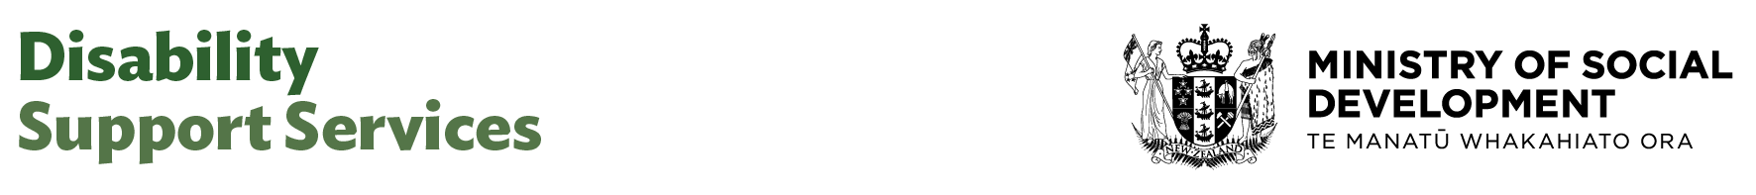

Advisor (Issues Resolution)

Our purpose
Manaaki tangata, Manaaki whānau
We help New Zealanders to be safe, strong and independent

Our commitment to Māori
As a Te Tiriti o Waitangi partner we are committed to supporting and enabling Māori, whānau, hapū, Iwi and communities to realise their own potential and aspirations.

Our strategic direction
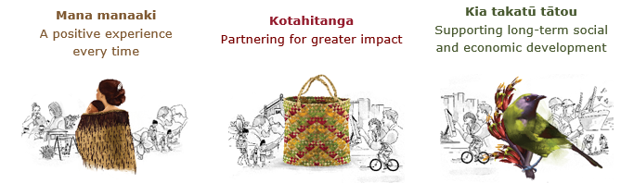

Our Values
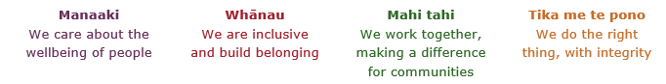

Working in the Public Service
Ka mahitahi mātou o te ratonga tūmatanui kia hei painga mō ngā tāngata o Aotearoa i āianei, ā, hei ngā rā ki tua hoki. He kawenga tino whaitake tā mātou hei tautoko i te Karauna i runga i āna hononga ki a ngāi Māori i raro i te Tiriti o Waitangi. Ka tautoko mātou i te kāwanatanga manapori. Ka whakakotahingia mātou e te wairua whakarato ki ō mātou hapori, ā, e arahina ana mātou e ngā mātāpono me ngā tikanga matua o te ratonga tūmatanui i roto i ā mātou mahi.
In the public service we work collectively to make a meaningful difference for New Zealanders now and in the future. We have an important role in supporting the Crown in its relationships with Māori under the Treaty of Waitangi. We support democratic government. We are unified by a spirit of service to our communities and guided by the core principles and values of the public service in our work.

The outcomes we want to achieve
New Zealanders get the support they require | New Zealanders are resilient and live in inclusive and supportive communities | New Zealanders participate positively in society and reach their potential

We carry out a broad range of responsibilities and functions including
- Employment, income support and superannuation
- Community partnerships, programmes and campaigns
- Advocacy for seniors, disabled people and youth
- Public Housing assistance and emergency housing
- Resolving claims of abuse and neglect in state care
- Student allowances and loans

He whakataukī*
Unuhia te rito o te harakeke  Kei hea te kōmako e kō?  Whakatairangitia, rere ki uta, rere ki tai;  Ui mai ki ahau,  He aha te mea nui o te ao?  Māku e kī atu,  He tangata, he tangata, he tangata* | If you remove the central shoot of the flaxbush  Where will the bellbird find rest?  Will it fly inland, fly out to sea, or fly aimlessly;  If you were to ask me,  What is the most important thing in the world?  I will tell you,  It is people, it is people, it is people
* We would like to acknowledge Te Rūnanga Nui o Te Aupōuri Trust for their permission to use this whakataukī

Position detail

Overview of position
This Advisor role, with a focus on quality assurance and improvement, supports the resolution of service delivery issues, working with staff and stakeholders to identify solutions and improve outcomes. They also assist with investigations, tracking issues, and process improvements.
Working closely with other team members, and having alignment with complaints and critical incidents, issues resolution will be focussed on addressing matters of dissatisfaction with service aspects such as communication, decisions made, process disruptions or early signs of service delivery concerns. The priority is for early identification, intervention and resolution, before issues escalate into more serious quality concerns.
The Advisor role plays a critical role in keeping cases on track, supporting effective internal and external stakeholder engagement, and contributing to a culture of accountability and continuous improvement.

Location
Various

Reports to
Manager Quality Assurance

Key responsibilities
- Support with investigating issues related to disability services, gathering information from all relevant parties, and ensuring due process is followed.
- Analyse data and trends to identify recurring issues or areas where service quality needs improvement, and reporting these findings to management.
- Provide high quality, balanced analysis and advice on a range of specialist issues
- Contribute to the management of issues in a way that risks are contained or mitigated
- Working with team members and stakeholders to develop and implement solutions to address identified issues.
- Contribute to a culture of quality and continuous improvement within the organisation by adopting good practice and encouraging feedback from clients and staff.
- Ensure clear and effective communication between team members and stakeholders involved in issues resolution processes, promoting transparency and understanding.
- Maintain accurate and up-to-date records of all issues, investigations, and resolutions, ensuring accountability and traceability.
- Establish positive working relationships with external stakeholders
- Establish and maintain a positive working relationship with peers and the wider MSD service areas

Embedding te ao Māori
- Embedding Te Ao Māori (te reo Māori, tikanga, kawa, Te Tiriti o Waitangi) into the way we do things at MSD.
- Building more experience, knowledge, skills and capabilities to confidently engage with whānau, hapū and iwi.

Health, safety and security
- Understand and implement your Health, Safety and Security (HSS) accountabilities as outlined in the HSS Accountability Framework.
- Ensure you understand, follow and implement all Health, Safety and Security and wellbeing policies and procedures.

Emergency management and business continuity
- Remain familiar with the relevant provisions of the Emergency Management and Business Continuity Plans that impact your business group/team.
- Participate in periodic training, reviews and tests of the established Business Continuity Plans and operating procedures.

Know-how
- An appropriate tertiary qualification or equivalent experience.
- Knowledge of the disability sector, and support services, with a solid understanding of person-centred practice, rights-based approaches, and the diverse needs of disabled people and whānau.
- Proven experience in conflict resolution and early intervention, including de-escalating concerns, facilitating discussions, and finding solutions in a respectful and culturally responsive way.
- Skilled in stakeholder engagement and relationship building, particularly with disabled people, families, service providers, advocates, and other key stakeholders.
- Experience analysing trends and themes from service feedback, concerns, and lower-level issues to inform continuous improvement and identify emerging risks.
- Knowledge of relevant legislation, quality standards, and safeguarding principles, with an ability to navigate privacy, consent, and advocacy considerations when resolving concerns.
- An understanding of Te Tiriti o Waitangi and the implications of working in partnership to achieve improved outcomes, across a diversity of population group, maintaining cultural safety across quality systems.

Attributes
- communication and interpersonal skills with the ability to relate to people at all levels, drive for resolutions of concerns, while maintaining impartiality and empathy.
- Has experience in navigating a complex and dynamic landscape, with a can-do attitude, and pro-active approach to problem solving.
- collaborative skills in working across the organisation with peers and other business groups across DSS and MSD.
- Well-developed planning and organisational skills – able to manage time effectively, multi-task and prioritise work to meet competing, and often changing, deadlines.
- Problem solving and analytical skills, seeking information from a variety of sources to identify cause and effect.
- Ability to develop trust and credibility and handle confidential and privileged information sensitively.
- Strong communication skills, both oral and written and an ability to convey information in a way that meets the needs of diverse audiences.
- Ability to identify potential risks and issues and escalate as appropriate.
- Welcomes and values diversity and contributes to an inclusive working environment where differences are acknowledged and respected.

Key relationships

Internal
- Quality Assurance & Improvement team
- DSS Operational Delivery Team
- Other DSS and MSD business groups
- Counterparts and staff across MSD and DSS

External
- Disability Support Service funded providers
- DSS contracted audit providers
- Office of the Health and Disability Commissioner
- Contracted providers delivering quality assurance and improvement activities for DSS
- Other key stakeholders involved in quality assurance and improvement activities

Other

Delegations
- Financial – No
- Human Resources - No

Direct reports - No

Security clearance - No

Children’s worker - No
Limited adhoc travel may be required

Position Description Updated: June 2025

