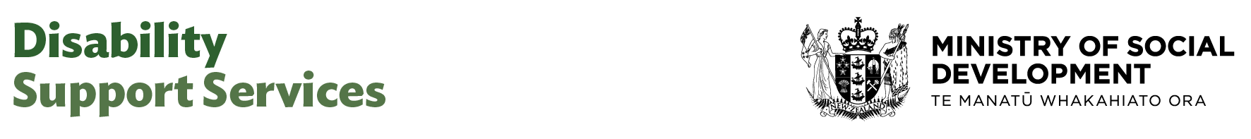

Advisor (Commissioning)

Our purpose
Manaaki tangata, Manaaki whānau
We help New Zealanders to be safe, strong and independent

Our commitment to Māori
As a Te Tiriti o Waitangi partner we are committed to supporting and enabling Māori, whānau, hapū, Iwi and communities to realise their own potential and aspirations.

Our strategic direction
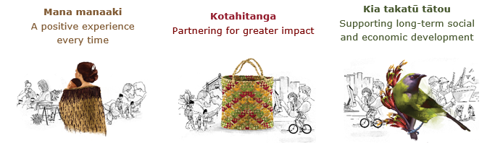

Our Values
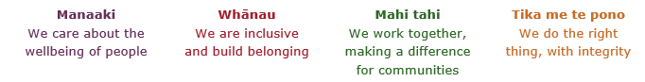

Working in the Public Service
Ka mahitahi mātou o te ratonga tūmatanui kia hei painga mō ngā tāngata o Aotearoa i āianei, ā, hei ngā rā ki tua hoki. He kawenga tino whaitake tā mātou hei tautoko i te Karauna i runga i āna hononga ki a ngāi Māori i raro i te Tiriti o Waitangi. Ka tautoko mātou i te kāwanatanga manapori. Ka whakakotahingia mātou e te wairua whakarato ki ō mātou hapori, ā, e arahina ana mātou e ngā mātāpono me ngā tikanga matua o te ratonga tūmatanui i roto i ā mātou mahi.
In the public service we work collectively to make a meaningful difference for New Zealanders now and in the future. We have an important role in supporting the Crown in its relationships with Māori under the Treaty of Waitangi. We support democratic government. We are unified by a spirit of service to our communities and guided by the core principles and values of the public service in our work.

The outcomes we want to achieve
New Zealanders get the support they require | New Zealanders are resilient and live in inclusive and supportive communities | New Zealanders participate positively in society and reach their potential

We carry out a broad range of responsibilities and functions including
- Employment, income support and superannuation
- Community partnerships, programmes and campaigns
- Advocacy for seniors, disabled people and youth
- Public Housing assistance and emergency housing
- Resolving claims of abuse and neglect in state care
- Student allowances and loans

He whakataukī*
Unuhia te rito o te harakeke  Kei hea te kōmako e kō?  Whakatairangitia, rere ki uta, rere ki tai;  Ui mai ki ahau,  He aha te mea nui o te ao?  Māku e kī atu,  He tangata, he tangata, he tangata* | If you remove the central shoot of the flaxbush  Where will the bellbird find rest?  Will it fly inland, fly out to sea, or fly aimlessly;  If you were to ask me,  What is the most important thing in the world?  I will tell you,  It is people, it is people, it is people
* We would like to acknowledge Te Rūnanga Nui o Te Aupōuri Trust for their permission to use this whakataukī

Position detail

Overview of position

This Advisor role supports the delivery of commissioning activities by providing high-quality research, analysis, and advisory support to the category management, procurement and contracts teams.

The Advisor plays a key role in ensuring commissioning processes are robust, compliant, and efficient, contributing to the achievement of organisational objectives.

This role also supports continuous improvement by identifying opportunities to streamline processes and enhance commissioning outcomes, while building foundational commissioning capability across the team.

Location
Various

Reports to
Director Commissioning

Key responsibilities
- Proactively provides high-quality, timely advice and analysis.
- Provides proactive support to the team and keeps fully up to date and aware of issues and developments.
- Provide advisory support to the category management team, ensuring smooth coordination of activities across the commissioning lifecycle.
- Support all stages of the commissioning lifecycle, including analysis of evidence and insights; design, planning and prioritisation; decision gate – investment; procuring services for outcomes; delivery; measurement and monitoring; evaluation, impact analysis and performance management; and dissemination of knowledge and translation into practice.
- Translates commissioning thinking into practical actions across the commissioning lifecycle.
- Assist in the preparation, review, and administration of commissioning documentation
- Analyse and review all available information and recommends options for planning and implementation, presenting findings in reports or memo formats as required.
- Maintain accurate and up-to-date commissioning records, ensuring data integrity and supporting effective reporting and audit processes.
- Collaborate with internal stakeholders to clarify requirements, gather information, and ensure commissioning activities align with business needs.
- Contribute to the identification and implementation of process improvements, supporting the team’s commitment to continuous improvement and best practice.
- Ensure all commissioning activities comply with relevant legislation, government procurement rules, and internal policies.
- Uses knowledge, expertise and experience to define and understand issues and to identify and anticipate needs.
- Build and maintain excellent relationships and partnerships with internal and external stakeholders and ensure that all relevant stakeholders are kept informed

Embedding te ao Māori
- Embedding Te Ao Māori (te reo Māori, tikanga, kawa, Te Tiriti o Waitangi) into the way we do things at MSD.
- Building more experience, knowledge, skills and capabilities to confidently engage with whānau, hapū and iwi.

Health, safety and security
- Understand and implement your Health, Safety and Security (HSS) accountabilities as outlined in the HSS Accountability Framework.
- Ensure you understand, follow and implement all Health, Safety and Security and wellbeing policies and procedures.

Emergency management and business continuity
- Remain familiar with the relevant provisions of the Emergency Management and Business Continuity Plans that impact your business group/team.
- Participate in periodic training, reviews and tests of the established Business Continuity Plans and operating procedures.

Know-how
- Clear and articulate communicator demonstrated by high levels of written and verbal presentations
- Sound working knowledge of commissioning processes, including government commissioning and ethical standards.
- Developing skills in research, data analysis, and critical thinking, with the ability to interpret and present information clearly.
- Experience in preparing and reviewing commissioning documentation and maintaining accurate records.
- Understanding of contract administration, risk management, and compliance requirements in a public sector context.
- Effective written and verbal communication skills, with the ability to engage confidently with colleagues and stakeholders.
- Strong organisational skills, with attention to detail and the ability to manage competing priorities.
- Write clear and concise reports at both a strategic and operational level
- Experience working in disability sector or able to build trust and confidence quickly.
- A relevant tertiary qualification or relevant equivalent experience

Attributes
- Strong communication skills, both written and verbal
- Exercises sound judgement and political sensitivity
- Strong planning and organisational skills – able to manage time effectively, work on more than one project at a time and prioritise work to meet competing deadlines
- Sound problem solving and analytical skills – seeks information from a variety of sources, identifies cause and effect, recognises trends, understands risks and is able to mitigate, thinks strategically
- Ability to identify potential risks and issues, evaluate information and apply discretion to make quality judgements, decisions and appropriate responses
- Flexible, adaptable and pragmatic
- Strong client focus
- Business acumen
- Willingly shares knowledge and contributes to a supportive environment based on co-operation and commitment to achieve goals
- Welcomes and values diversity and contributes to an inclusive working environment where differences are acknowledged and respected

Key relationships

Internal
- Category Managers – Commissioning
- Principal Advisor – Commissioning
- Senior Advisor – Commissioning
- Business Analyst – Commissioning
- Senior Project Coordinator – Commissioning
- Procurement & Commercial Team
- Contract Management Team
- Design Team
- Design & Delivery Team
- Quality Assurance & Improvement Team
- Shared Services Team

External
- Other Government Agencies
- Other stakeholders
- Third party commissioned providers

Other

Delegations
- Financial – No
- Human Resources - No

Direct reports - No

Security clearance - No

Children’s worker - No
Limited adhoc travel may be required

Position Description Updated: June 2025

