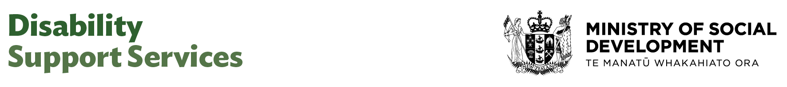

Administrator (Business Support)

Our purpose
Manaaki tangata, Manaaki whānau
We help New Zealanders to be safe, strong and independent

Our commitment to Māori
As a Te Tiriti o Waitangi partner we are committed to supporting and enabling Māori, whānau, hapū, Iwi and communities to realise their own potential and aspirations.

Our strategic direction
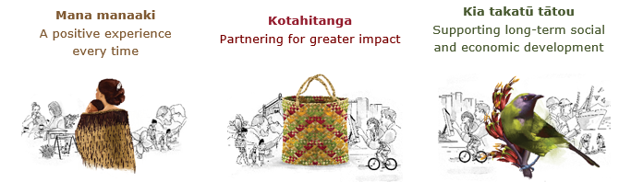

Our Values
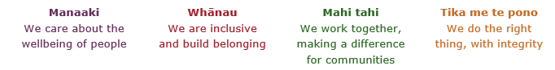

Working in the Public Service
Ka mahitahi mātou o te ratonga tūmatanui kia hei painga mō ngā tāngata o Aotearoa i āianei, ā, hei ngā rā ki tua hoki. He kawenga tino whaitake tā mātou hei tautoko i te Karauna i runga i āna hononga ki a ngāi Māori i raro i te Tiriti o Waitangi. Ka tautoko mātou i te kāwanatanga manapori. Ka whakakotahingia mātou e te wairua whakarato ki ō mātou hapori, ā, e arahina ana mātou e ngā mātāpono me ngā tikanga matua o te ratonga tūmatanui i roto i ā mātou mahi.
In the public service we work collectively to make a meaningful difference for New Zealanders now and in the future. We have an important role in supporting the Crown in its relationships with Māori under the Treaty of Waitangi. We support democratic government. We are unified by a spirit of service to our communities and guided by the core principles and values of the public service in our work.

The outcomes we want to achieve
New Zealanders get the support they require | New Zealanders are resilient and live in inclusive and supportive communities | New Zealanders participate positively in society and reach their potential

We carry out a broad range of responsibilities and functions including
- Employment, income support and superannuation
- Community partnerships, programmes and campaigns
- Advocacy for seniors, disabled people and youth
- Public Housing assistance and emergency housing
- Resolving claims of abuse and neglect in state care
- Student allowances and loans

He whakataukī*
Unuhia te rito o te harakeke  Kei hea te kōmako e kō?  Whakatairangitia, rere ki uta, rere ki tai;  Ui mai ki ahau,  He aha te mea nui o te ao?  Māku e kī atu,  He tangata, he tangata, he tangata* | If you remove the central shoot of the flaxbush  Where will the bellbird find rest?  Will it fly inland, fly out to sea, or fly aimlessly;  If you were to ask me,  What is the most important thing in the world?  I will tell you,  It is people, it is people, it is people
* We would like to acknowledge Te Rūnanga Nui o Te Aupōuri Trust for their permission to use this whakataukī

Position detail

Overview of position
The primary purpose of this position is to provide a high level of effective administrative support for the Business Support Team. This includes general administrative support to the Manager and wider team.

Location
National Office, Wellington

Reports to
Manager Business Support

Key responsibilities

Management Support
- Ensure a high level of support service is provided to the Manager and team members.
- Maintain diaries, appointments and meetings for Manager and staff as required.
- Maintain confidentiality of documentation and information as required.

Team Administrative Support
- Provide administrative support services in a timely and accurate manner.
- Set up and maintain effective electronic and paper filing systems and procedures, and develop new systems as required to ensure quick access to information.
- Manage relevant databases or inboxes daily, ensuring accuracy and consistent updating.
- Provide photocopying services, collation and distribution of papers as necessary.
- Book venues for meetings, workshops and focus groups - arrange catering and necessary resources, coordinate events.
- Arrange and update travel arrangements for managers and staff if required.
- Ensure office supplies, equipment and stationery are purchased and available as required.
- Undertake one-off projects, compile and process data for the project manager or project team where required.
- Contribute to the improvement and development of administrative process, procedures and systems.

Word Processing & Presentation Production
- Provide a high standard of desk-top design services (includes word processing, production of spreadsheets and presentation material) to support the efficient functioning of the team.
- Respond to and compose letters where required.
- Assist with the production of reports as required.
- Co-ordinate material from team members for meetings or events as required

Account and Financial Administrative Support
- Input requisitions into the relevant system when required.
- Prepare invoices for payment by the Manager when required.
- Ensure that receipts for personal expenses are accurately collated, recorded and submitted to the appropriate sources for reimbursement.

Embedding te ao Māori
- Embedding Te Ao Māori (te reo Māori, tikanga, kawa, Te Tiriti o Waitangi) into the way we do things at MSD.
- Building more experience, knowledge, skills and capabilities to confidently engage with whānau, hapū and iwi.

Health, safety and security
- Understand and implement your Health, Safety and Security (HSS) accountabilities as outlined in the HSS Accountability Framework.
- Ensure you understand, follow and implement all Health, Safety and Security and wellbeing policies and procedures.

Emergency management and business continuity
- Remain familiar with the relevant provisions of the Emergency Management and Business Continuity Plans that impact your business group/team.
- Participate in periodic training, reviews and tests of the established Business Continuity Plans and operating procedures.

Know-how
- Excellent knowledge of administrative processes, systems and technology.
- Proficiency in the Microsoft office suite of applications, specifically Word, Excel and Powerpoint and also including research tools (internet and database use).
- Able to communicate information in an accessible, clear and concise manner (including written format) appropriate to the target audiences.
- Ability to work in a team environment, adapt, demonstrate initiative, and cope with continuing change.
- Excellent time management and the ability to effectively prioritise and schedule work to meet competing deadlines and maintain the quality of services delivered.
- Data entry skills.
- Excellent attention to detail.

Attributes
- Highly organised – approaches tasks and situations pragmatically and efficiently
- Time management – ability to prioritise work, often within tight timeframes and under pressure
- Flexible, adaptable and pragmatic – ability to adapt to a busy and changing environment and take the initiative
- Resilient and able to stay calm under pressure and utilise effective problem-solving approaches
- Exercises sound judgement and discretion – able to assess individual situations to make quality judgements and decisions
- Relationship management skills – able to develop and maintain effective working relationships
- Interpersonal skills – ability to relate to people at all levels and demonstrate active listening skills
- Excellent communication skills – able to communicate clearly and concisely across multiple channels
- Willingly shares knowledge and actively contributes to a supportive environment based on co-operation and commitment to achieve goals

Key relationships

Internal
- Disability Support Services Business Unit and kaimahi
- EAs and administrators and coordinators across the DSS group

External
N/A

Other

Delegations
- Financial – No
- Human Resources - No

Direct reports - No

Security clearance - No

Children’s worker - No
Limited adhoc travel may be required

Position Description Updated: July 2025

