# Ministry of Social Development logo

# Business Analyst

# Service Delivery

## Our purpose

**Manaaki tangata, Manaaki whānau**

We help New Zealanders to be safe, strong and independent

## Our commitment to Māori

As a **Te Tiriti o Waitangi** partner we are committed to supporting and enabling Māori, whānau, hapū, Iwi and communities to realise their own potential and aspirations.

## Our strategic direction

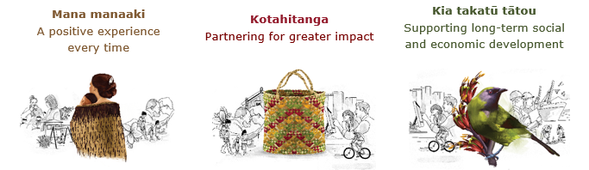

## Our Values

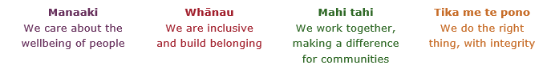

## Working in the Public Service

Ka mahitahi mātou o te ratonga tūmatanui kia hei painga mō ngā tāngata o Aotearoa i āianei, ā, hei ngā rā ki tua hoki. He kawenga tino whaitake tā mātou hei tautoko i te Karauna i runga i āna hononga ki a ngāi Māori i raro i te Tiriti o Waitangi. Ka tautoko mātou i te kāwanatanga manapori. Ka whakakotahingia mātou e te wairua whakarato ki ō mātou hapori, ā, e arahina ana mātou e ngā mātāpono me ngā tikanga matua o te ratonga tūmatanui i roto i ā mātou mahi.

In the public service we work collectively to make a meaningful difference for New Zealanders now and in the future. We have an important role in supporting the Crown in its relationships with Māori under the Treaty of Waitangi.  We support democratic government. We are unified by a spirit of service to our communities and guided by the core principles and values of the public service in our work.

## The outcomes we want to achieve

|  |  |  |
| --- | --- | --- |
| New Zealanders get the support they require | New Zealanders are resilient and live in inclusive and supportive communities | New Zealanders participate positively in society and reach their potential |

## We carry out a broad range of responsibilities and functions including

* Employment, income support and superannuation
* Community partnerships, programmes and campaigns
* Advocacy for seniors, disabled people and youth
* Public Housing assistance and emergency housing
* Resolving claims of abuse and neglect in state care
* Student allowances and loans

## **He whakataukī\***

|  |  |
| --- | --- |
| Unuhia te rito o te harakeke  Kei hea te kōmako e kō?  Whakatairangitia, rere ki uta, rere ki tai;  Ui mai ki ahau,  He aha te mea nui o te ao?  Māku e kī atu,  He tangata, he tangata, he tangata* | If you remove the central shoot of the flaxbush  Where will the bellbird find rest?  Will it fly inland, fly out to sea, or fly aimlessly;  If you were to ask me,  What is the most important thing in the world?  I will tell you,  It is people, it is people, it is people |

* We would like to acknowledge Te Rūnanga Nui o Te Aupōuri Trust for their permission to use this whakataukī

## Position detail

### Overview of position

The role of a Business Analyst within Service Delivery is a project-focused business requirements specialist. This role will work within Project team(s) to define, document and then manage through the project lifecycle (traditional or agile) business change requirements. These could capture changes required to processes, practices and/or systems which support client services across Service Delivery. Focused on ensuring client, partner, provider and user requirements are accurately reflected and then designed into new or enhanced systems, processes or practices the Business Analyst will champion requirements on behalf of the business.

### Location

National Office, Wellington

### Reports to

People Lead, Director Digital Channel Strategy and Implementation or Manager Business Enterprise Analysis

## Key responsibilities

* Gathering and preparation of documentation of business requirements and analysis of options as part of major projects and changes
* Contributing to the development of detailed functional specifications to meet business and client requirements
* Providing support for the collection and analysis of data using appropriate methodology and templates
* Identifying a range of appropriate tools for maximising efficient collection of valid information
* Collaborating with other Business Analysts and project resources to make the best use of all available skills and knowledge to achieve outcomes for clients, partners and users
* Identification and sharing of innovative ideas that may contribute to the body of knowledge enabling new benchmark improvements to client service delivery
* Assisting in the business process or system design to ensure it matches business requirements
* Contribute as part of major project teams to identification or risks, planning, team work and achieving targeted project outcomes.

## Embedding te ao Māori

* Embedding Te Ao Māori (te reo Māori, tikanga, kawa, Te Tiriti o Waitangi) into the way we do things at MSD.
* Building more experience, knowledge, skills and capabilities to confidently engage with whānau, hapū and iwi.

## Health, safety and security

* Understand and implement your Health, Safety and Security (HSS) accountabilities as outlined in the HSS Accountability Framework.
* Ensure you understand, follow and implement all Health, Safety and Security and wellbeing policies and procedures.

## Emergency management and business continuity

* Remain familiar with the relevant provisions of the Emergency Management and Business Continuity Plans that impact your business group/team.
* Participate in periodic training, reviews and tests of the established Business Continuity Plans and operating procedures.

## Know-how

* An appropriate tertiary degree (or equivalent experience) focusing on for example: business information systems, business processing re-engineering, mathematics, statistics, and/or business administration, certification in agile/safe project methodologies
* A solid foundation based on understanding business operations and having moved into project delivery roles which require sound knowledge of business, technology and client experience
* Critical thinking skills
* Problem solving and root cause identification skills
* Familiarity with working in a public sector framework
* Understands the range of tools and methodologies that enable comprehensive analysis of data and information.
* Accuracy and attention to detail including asset and documentation management.

## Attributes

* Willingly shares knowledge, fosters a supportive environment based on cooperation and commitment to achieving shared goals
* Good communication skills with the ability to communicate technical information in a business context and to operational teams
* Curious nature and focuses on creating clarity from ambiguity
* Resilient, tenacious with a propensity to persevere
* Strong analytical and problem-solving skills, ability to absorb numerous sets of data and to draw accurate conclusions
* Maintains knowledge of current trends and business technology developments
* Identifies shared issues and concerns to generate local solutions
* Appreciates the importance of developing practical applications for technology capabilities
* Builds effective relationships to ensure an understanding of business functions
* Strong interpersonal skills ability to work effectively in a team and across teams.

## Key relationships

### Internal

* Service Delivery Leads
* Technical product managers and Technical product owners
* Service Delivery business units
* Other managers and staff across the Ministry

## Other

### Delegations

* Financial – No
* Human Resources - No

### Direct reports - No

### Security clearance - No

### Children’s worker - No

Limited adhoc travel may be required

**Position Description Updated:** December 2021