# Ministry of Social Development logo

# Change Implementation Manager

# Business Enterprise Support Services

## Our purpose

**Manaaki tangata, Manaaki whānau**

We help New Zealanders to be safe, strong and independent

## Our commitment to Māori

As a **Te Tiriti o Waitangi** partner we are committed to supporting and enabling Māori, whānau, hapū, Iwi and communities to realise their own potential and aspirations.

## Our strategic direction

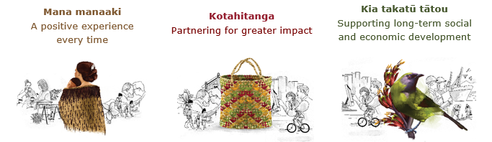

## Our Values

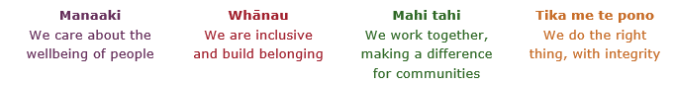

## Working in the Public Service

Ka mahitahi mātou o te ratonga tūmatanui kia hei painga mō ngā tāngata o Aotearoa i āianei, ā, hei ngā rā ki tua hoki. He kawenga tino whaitake tā mātou hei tautoko i te Karauna i runga i āna hononga ki a ngāi Māori i raro i te Tiriti o Waitangi. Ka tautoko mātou i te kāwanatanga manapori. Ka whakakotahingia mātou e te wairua whakarato ki ō mātou hapori, ā, e arahina ana mātou e ngā mātāpono me ngā tikanga matua o te ratonga tūmatanui i roto i ā mātou mahi.

In the public service we work collectively to make a meaningful difference for New Zealanders now and in the future. We have an important role in supporting the Crown in its relationships with Māori under the Treaty of Waitangi.  We support democratic government. We are unified by a spirit of service to our communities and guided by the core principles and values of the public service in our work.

## The outcomes we want to achieve

|  |  |  |
| --- | --- | --- |
| New Zealanders get the support they require | New Zealanders are resilient and live in inclusive and supportive communities | New Zealanders participate positively in society and reach their potential |

## We carry out a broad range of responsibilities and functions including

* Employment, income support and superannuation
* Community partnerships, programmes and campaigns
* Advocacy for seniors, disabled people and youth
* Public Housing assistance and emergency housing
* Resolving claims of abuse and neglect in state care
* Student allowances and loans

## **He whakataukī\***

|  |  |
| --- | --- |
| Unuhia te rito o te harakeke  Kei hea te kōmako e kō?  Whakatairangitia, rere ki uta, rere ki tai;  Ui mai ki ahau,  He aha te mea nui o te ao?  Māku e kī atu,  He tangata, he tangata, he tangata* | If you remove the central shoot of the flaxbush  Where will the bellbird find rest?  Will it fly inland, fly out to sea, or fly aimlessly;  If you were to ask me,  What is the most important thing in the world?  I will tell you,  It is people, it is people, it is people |

* We would like to acknowledge Te Rūnanga Nui o Te Aupōuri Trust for their permission to use this whakataukī

## Position detail

### Overview of position

The Change Implementation Manager will play a key role in leading activities to both identify change impacts and resulting change implementation support requirements for projects and major change activity. The Change Implementation Manager will lead teams of people from across the business to provide support which will ensure new practices, process and ways of working are embedded and enable the delivery of intended change benefits. With a strong focus on an effective and integrated change management approach that supports our people to adapt to and adopt changes, the Change Implementation Manager will co-ordinate communication, change support and training activities which will support the rapid adoption of change.

### Location

National Office, Wellington

### Reports to

Team Manager Change Implementation

## Key responsibilities

* Creation of change management plans as part of major project and change programmes
* Applies a structured change management methodology and uses appropriate analytical tools and techniques to create a strategy to support adoption of changes and to lead the change management process
* Successfully delivers and implements change management components and work streams as part of major change programmes and projects on time and on budget
* Provide support and expertise to smaller projects and business process improvement activities so they integrate change management activities into their project plans
* Draws on expertise from other teams to supports the design, development, delivery and management of change communications
* Conduct impact analyses, assess change readiness and identify key stakeholders
* Undertake thorough risk assessment and identify potential hazards or block points, including anticipating resistance
* Creation of actionable deliverables for the five change management levers: communications plan, sponsor roadmap, coaching plan, training plan, resistance management plan.

## Embedding te ao Māori

* Embedding Te Ao Māori (te reo Māori, tikanga, kawa, Te Tiriti o Waitangi) into the way we do things at MSD.
* Building more experience, knowledge, skills and capabilities to confidently engage with whānau, hapū and iwi.

## Health, safety and security

* Understand and implement your Health, Safety and Security (HSS) accountabilities as outlined in the HSS Accountability Framework.
* Ensure you understand, follow and implement all Health, Safety and Security and wellbeing policies and procedures.

## Emergency management and business continuity

* Remain familiar with the relevant provisions of the Emergency Management and Business Continuity Plans that impact your business group/team.
* Participate in periodic training, reviews and tests of the established Business Continuity Plans and operating procedures.

## Know-how

* Formal change management certification desired
* Expertise and experience in the use of change management methodologies, tools and principles within major projects and programme
* Demonstrated success in supporting the implementation of change and change adoption in client service organisations
* Excellent stakeholder and engagement capability coupled with excellent interpersonal skills
* Experience working in projects involving both technology and process changes
* Exceptional written and verbal communication skills
* Strong planning and a structured approach to risk identification and management.

## Attributes

* Proven effective coaching skills with change sponsors, managers and supervisors
* Resilience, tenacity and a propensity to persevere to achieve desired results
* Acute business acumen and understanding of organisational issues and challenges
* Proven ability to influence and build consensus to move toward a common vision or goal.

## Key relationships

### Internal

* Senior colleagues in Service Delivery and the Ministry

### External

* Service providers

## Other

### Delegations

* Financial – No
* Human Resources – No

### Direct reports - No

### Security clearance - No

### Children’s worker - No

Limited Adhoc travel may be required

**Position Description Updated:** February 2024