Training Advisor Design and Brokering People Group

Our purpose
Manaaki tangata, Manaaki whānau
We help New Zealanders to be safe, strong and independent

Our commitment to Māori
As a Te Tiriti o Waitangi partner we are committed to supporting and enabling Māori, whānau, hapū, Iwi and communities to realise their own potential and aspirations.

Our strategic direction
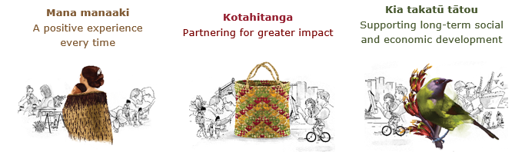

Our Values
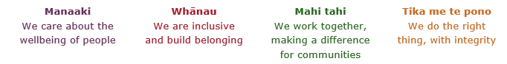

Working in the Public Service
Ka mahitahi mātou o te ratonga tūmatanui kia hei painga mō ngā tāngata o Aotearoa i āianei, ā, hei ngā rā ki tua hoki. He kawenga tino whaitake tā mātou hei tautoko i te Karauna i runga i āna hononga ki a ngāi Māori i raro i te Tiriti o Waitangi. Ka tautoko mātou i te kāwanatanga manapori. Ka whakakotahingia mātou e te wairua whakarato ki ō mātou hapori, ā, e arahina ana mātou e ngā mātāpono me ngā tikanga matua o te ratonga tūmatanui i roto i ā mātou mahi.
In the public service we work collectively to make a meaningful difference for New Zealanders now and in the future. We have an important role in supporting the Crown in its relationships with Māori under the Treaty of Waitangi. We support democratic government. We are unified by a spirit of service to our communities and guided by the core principles and values of the public service in our work.

The outcomes we want to achieve
New Zealanders get the support they require | New Zealanders are resilient and live in inclusive and supportive communities | New Zealanders participate positively in society and reach their potential

We carry out a broad range of responsibilities and functions including
- Employment, income support and superannuation
- Community partnerships, programmes and campaigns
- Advocacy for seniors, disabled people and youth
- Public Housing assistance and emergency housing
- Resolving claims of abuse and neglect in state care
- Student allowances and loans

He whakataukī*
Unuhia te rito o te harakeke  Kei hea te kōmako e kō?  Whakatairangitia, rere ki uta, rere ki tai;  Ui mai ki ahau,  He aha te mea nui o te ao?  Māku e kī atu,  He tangata, he tangata, he tangata* | If you remove the central shoot of the flaxbush  Where will the bellbird find rest?  Will it fly inland, fly out to sea, or fly aimlessly;  If you were to ask me,  What is the most important thing in the world?  I will tell you,  It is people, it is people, it is people
* We would like to acknowledge Te Rūnanga Nui o Te Aupōuri Trust for their permission to use this whakataukī

Position detail
Overview of position
The role of the Training Advisor, Design and Brokering is to work with other members of the Learning & Capability Team, and or business stakeholders to design and implement capability development solutions which meet defined organisational outcomes.
Using effective relationship management, analysis, design development and evaluation skills, the Training Advisor will provide practical support for the development of a range of capability development solutions including job aides, online, face-to-face and train-the-trainer solutions.
Location
National Office, Wellington
Reports to
Team Lead, Learning and Capability Development

Key responsibilities
Design and Production
- Interpret learning solutions and the extent to which they should be met by the design of training programmes
- Consult with stakeholder groups and learning objectives of programmes to be designed
- Research and develop methodology using leading design and publication methods
- Work closely with trainers to ensure needs are met
- Provide training and briefings for trainers and other assistance as may be required
Programme Evaluation
- Measure effectiveness of courses and materials
- Modify and adapt programme design and related materials in response to feedback etc
- Assist with the development of tools for measuring the effectiveness of knowledge and skill transfer on the job
Learning and Capability Support
- Provide support and advice to trainers in effective delivery and utilisation of trainer aids and programme materials
- Offer assistance on effective training practise and techniques
- Share ideas and best practises from a range of source
Policy and Practise Interpretation
- Network with relevant national office units to interpret and prepare for emerging training and development needs
- Provide a training and development perspective to the development of policy delivery proposals
- Develop practical training delivery options
- Advocate for adequate training resources to enable effective delivery
- Communicate developments and expectations to relevant groups in a timely, clear manner

Training and Development Projects
- Advise the Team Lead Learning and Capability Development and other managers on options for meeting training needs
- Lead and contribute to training and development projects and initiatives as and when required
- Lead and contribute to the development of workforce learning processes
- Identify, recommend, and implement improvements in training practises

Embedding Te Ao Māori
- Embedding Te Ao Māori (te reo Māori, tikanga, kawa, Te Tiriti o Waitangi) into the status quo of MSD.
- Building more experience, knowledge, skills and capabilities to confidently engage with whānau, hapū and iwi.

Health, Safety and Security
- Understand and implement your Health, Safety and Security (HSS) accountabilities as outlined in the HSS Accountability Framework
- Ensure you understand, follow and implement all Health, Safety and Security and wellbeing policies and procedures.

Emergency Management and Business Continuity
- Remain familiar with the relevant provisions of the Emergency Management and Business Continuity Plans that impact your business group/team.
- Participate in periodic training, reviews and tests of the established Business Continuity Plans and operating procedures.

Know-how
- Experience in instructional design
- Experience in the development and facilitation of face-to-face training
- Competent in the use of online authoring tools and learning management systems.
- Experience with using a range of learning technologies
- Competent in using multi-media assets within a variety of learning environments

Attributes
- Strong partnership builder
- Effective communication skills
- Flexible, adaptable and pragmatic, problem solving focus
- Strong client focus
- Inquisitive and self-directed learner
- Confidence to take on new challenges and to use new technologies
- Effective time management

Key Relationships
Internal
- Learning and Capability team members
- Human Resources team members
- Project Advisors
- Service Development Advisors
- Policy Analysts
- Service Delivery Trainers
- Qualifications assessors
- Other managers and staff
External
- External training providers and related professional networks

Other
Delegations
- Financial – Nil
- Human Resources – Nil
Direct reports – No
Security clearance – No
Children’s worker – No
Limited adhoc travel may be required.
May require after-hours work

Position Description Updated: April 2023

