# Ministry of Social Development logo

# Workplace Specialist

# Commercial Operations

## Our purpose

**Manaaki tangata, Manaaki whānau**

We help New Zealanders to be safe, strong and independent

## Our commitment to Māori

As a **Te Tiriti o Waitangi** partner we are committed to supporting and enabling Māori, whānau, hapū, Iwi and communities to realise their own potential and aspirations.

## Our strategic direction

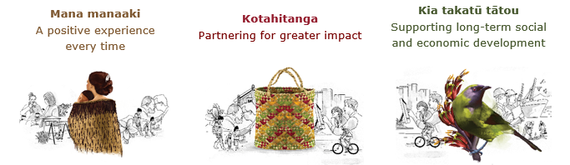

## Our Values

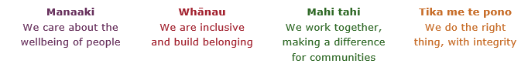

## Working in the Public Service

Ka mahitahi mātou o te ratonga tūmatanui kia hei painga mō ngā tāngata o Aotearoa i āianei, ā, hei ngā rā ki tua hoki. He kawenga tino whaitake tā mātou hei tautoko i te Karauna i runga i āna hononga ki a ngāi Māori i raro i te Tiriti o Waitangi. Ka tautoko mātou i te kāwanatanga manapori. Ka whakakotahingia mātou e te wairua whakarato ki ō mātou hapori, ā, e arahina ana mātou e ngā mātāpono me ngā tikanga matua o te ratonga tūmatanui i roto i ā mātou mahi.

In the public service we work collectively to make a meaningful difference for New Zealanders now and in the future. We have an important role in supporting the Crown in its relationships with Māori under the Treaty of Waitangi.  We support democratic government. We are unified by a spirit of service to our communities and guided by the core principles and values of the public service in our work.

## The outcomes we want to achieve

|  |  |  |
| --- | --- | --- |
| New Zealanders get the support they require | New Zealanders are resilient and live in inclusive and supportive communities | New Zealanders participate positively in society and reach their potential |

## We carry out a broad range of responsibilities and functions including

* Employment, income support and superannuation
* Community partnerships, programmes and campaigns
* Advocacy for seniors, disabled people and youth
* Public Housing assistance and emergency housing
* Resolving claims of abuse and neglect in state care
* Student allowances and loans

## **He whakataukī\***

|  |  |
| --- | --- |
| Unuhia te rito o te harakeke  Kei hea te kōmako e kō?  Whakatairangitia, rere ki uta, rere ki tai;  Ui mai ki ahau,  He aha te mea nui o te ao?  Māku e kī atu,  He tangata, he tangata, he tangata* | If you remove the central shoot of the flaxbush  Where will the bellbird find rest?  Will it fly inland, fly out to sea, or fly aimlessly;  If you were to ask me,  What is the most important thing in the world?  I will tell you,  It is people, it is people, it is people |

* We would like to acknowledge Te Rūnanga Nui o Te Aupōuri Trust for their permission to use this whakataukī

## Position detail

### Overview of position

The Workplace Specialist will bring a sound knowledge and experience in workplace management to support Workplace outcomes and Ministry objectives. This will require a clear understanding of user needs and demand, in collaboration with the Senior Workplace Specialist in order to provide options that enable everyone to make the most of our workspaces.

The Workplace Specialists will be required to provide advice, problem solve and demonstrate task leadership across a range of assigned priorities and/or services, in line with industry good practice and regulation.

### Location

National Office, Wellington

### Reports to

People and Capability Lead or Team Manager National Office Operations

## Key responsibilities

### Management and planning

* Undertake key Workplace project activities in collaboration with key stakeholders
* Assist the development of and implementation of planning, reporting and change activities in collaboration with key stakeholders
* Support the development of change management strategy, implementation planning and any relevant work planning activities.

### Relationship management

* Represent the Ministry credibly and professionally in all contractor, supplier and relationship management activities
* Ensure compliance of relevant legislation, policies, and procedures
* Provide support to the Senior Workplace Specialist, and other key Workplace stakeholders, as required
* Provide quality and timely Workplace advice to key stakeholders where required.
* Role model a culture of transparency and collaboration.

## Embedding te ao Māori

* Embedding Te Ao Māori (te reo Māori, tikanga, kawa, Te Tiriti o Waitangi) into the way we do things at MSD.
* Building more experience, knowledge, skills and capabilities to confidently engage with whānau, hapū and iwi.

## Health, safety and security

* Understand and implement your Health, Safety and Security (HSS) accountabilities as outlined in the HSS Accountability Framework.
* Ensure you understand, follow and implement all Health, Safety and Security and wellbeing policies and procedures.

## Emergency management and business continuity

* Remain familiar with the relevant provisions of the Emergency Management and Business Continuity Plans that impact your business group/team.
* Participate in periodic training, reviews and tests of the established Business Continuity Plans and operating procedures.

## Know-how

* Experience in designing and implementing workspace solutions with a focus on future proofing the work environment
* Commercial and property and / or facilities experience within government, a regulatory environment or the private sector
* Experience in change management both at a theoretical and practical level, particularly providing innovative workspace solutions
* Apply current Health and Safety practices and knowledge as it pertains to the workplace
* Ability to write clear and concise material at both a strategic and operational level for various audiences
* Proven record in establishing and maintaining relationships
* Strong decision-making skills – able to analyse information from a variety of sources, make sound judgments and assumptions based on fact
* Experience in the implementation of strategies/initiatives that align with organisational needs and long-term outcomes
* Demonstrated PC skills including Microsoft products

## Attributes

* **Respect** - At all levels including respect for colleagues, organisation, the customer and the product to maintain an appropriate work environment.
* **Collaborative** - Facilitate collaboration and communication, through tools, and behavioural norms to improve the quality and number of collaborative discussions thereby enabling efficient completion of tasks and complex problems to be solved.
* **Strive for** **Improvement** – Ensure continuous improvements through a flexible approach including problem solving, reflection and retrospection. This also applies to taking opportunities to learn and develop skills for yourself and the team.
* **Pride in Delivering Value** – Take pride in the development and delivery of work towards a shared goal that delivers value to the customer.
* **Ability to Adapt to Change** – Be comfortable with ambiguity, and flexible to adapting to changing demands and priorities.
* **Approachable** – Exhibit a friendly and open attitude to ensure people feel comfortable to speak, and confident that any concerns will be heard and taken seriously.
* **Engaged** – Display a genuine interest in your team and their individual requirements around their support, care and development.

## Key relationships

### Internal

* MSD Workplace Users and Leadership
* Workplace Services Leadership and Agile Teams
* MSD Internal Partners (Commercial Services, Finance, Health Safety and Security, People Group, Improvement Systems & Technology)

### External

* Government Property Group
* Industry Professional networks and providers
* Other government agencies
* Contracted Providers

## Other

### Delegations

* Financial – No
* Human Resources – No

### Direct reports – No

### Security clearance – No

### Children’s worker – No

### Travel - Travel may be required

**Position Description Updated:** August 2021