Building Financial Capability Fund Application Form

Information about your organisation and project

(all applicants to complete)
Supplier tips | - If an item is not applicable e.g. you do not have a MSD Provider Identification number just write N/A ‘not applicable’.  - If you need advice about your application, contact us at:  BFC_Fund@msd.govt.nz
- About your organisation
Name of your organisation (trading name)
Legal name of your organisation
Funding grants can only be made to a registered legal entity.
If your organisation is not a registered entity you will need to nominate one to act as a Fundholder on your behalf. Contact us if you require advice.
Legal status (what type of organisation are you e.g. Charitable Trust, Registered Company, Incorporated Society)
Company or Charity registration number |  | GST Number
Ministry of Social Development (MSD) ID number  If you have previously been funded by MSD, this can be found in the footer of your MSD grant/contract document |  |  | MSD Approval Level held
Organisation physical address | Postal address (if different)
Your business website address
ONLY if you are not an MSD provider -
Tell us about your organisation, who you are and what you work to achieve.

Name of contact person and title
(someone who can answer questions about this application)
Email
Phone number
Mobile number

Please indicate the region(s) and location(s) in which your project will be delivered
(please select at least one region, and indicate locations)
Region(s) | Location(s)
Te Tai Tokerau
(Far North district to Kaipara district)
Auckland

Midlands
(Thames to Opotiki district)
Central
(Gisborne to South Wairarapa district)
Southern
(Tasman district to Invercargill)
How does your organisation identify?
(please select one)
Māori provider
Pacific provider
Migrant/refugee provider
Other [please write in] ………………………………………………………………………..

Fundholder
ONLY fill in this section if you plan to use a Fundholder
Also: see the Fundholder’s declaration on the last page
Fundholder’s Legal Name
Fundholder’s Company or Charity registration number
Name of contact person and title
(someone who can answer questions about being a fundholder for this application)
Email
Phone number
Mobile number
Ministry of Social Development (MSD) ID number  If you have previously been funded by MSD, this can be found in the footer of your MSD grant/contract document |  |  | MSD Approval Level held
Fundholder’s physical address |  | Postal address (if different)

Criteria check – please answer how you fit the criteria requirements on the following:
1. | Connection with your community
2. | Your group/organisations capability to deliver the initiative
3. | How will you design and deliver the initiative and how your initiative aligns with the BFC principles (See page 5 of the application form for the BFC principles)
4. | How do you see this initiative being sustainable after the funding ends?

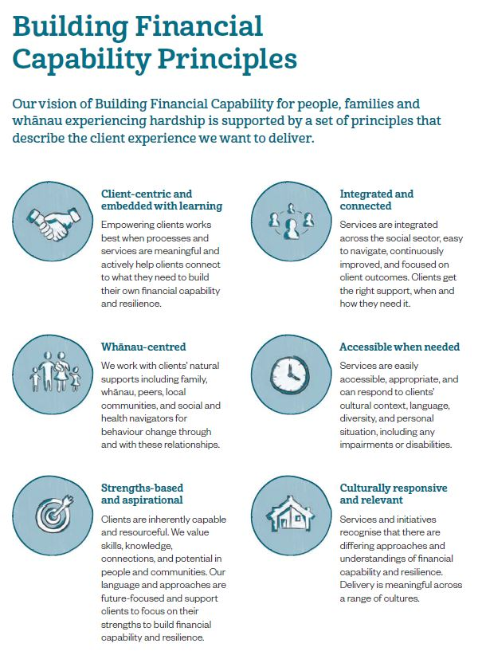

About your BFC Fund initiative
1. | Give us an outline of your initiative. How will you deliver it? What do you hope to achieve and who will benefit?
2. |  | How will your initiative build financial resilience in your community?
3. Why do you think that your initiative is currently needed?
4. | What are the potential barriers and challenges to the success of your initiative?
5. | Under-served communities  MSD may wish to use this information for monitoring purposes, and for the Building Financial Capability Evaluation. This information will help us to improve Building Financial Capability services for people, families and whānau experiencing hardship. None of the information used by MSD would identify any individual clients.
How will you engage / retain / reduce barriers for “under-served” groups/individuals?
I agree to sharing this evaluation information with MSD on request.
6. | Amount of funding requested (GST excl.) Your BFC Fund initiative must be completed by 30 June 2019
 | If your organisation is applying for $20,000.00 or over please provide a robust business case on how you will achieve long term sustainability
Enter business case here

7. | If your organisation does not receive the full amount requested, how will you make up the difference or would you be able to scale the initiative based on the panel recommendations?

8. | Details of the initiative budget  Please make sure your proposed budget is a clear and realistic breakdown of all costs. A detailed budget will better inform the panel when they are considering your application. Eg. If you are including overheads in your budget please provide a breakdown and how this was calculated, if applying for employment of staff please explain what the contract agreement will be for employment and whether they are an existing staff member in your organisation or an external appointment.
Enter budget here
Completed Documents to be attached to application |  | Tick when completed
Applicant Organisation Declaration (page 10)
Fundholder Declaration (page 11) – ONLY if needed
The most recent independently audited financial accounts of the organisation and the auditor’s report if applicable.
[If these are not available, please advise why]
ONLY attach these
      - if you don’t have a MSD registration number
      - if your Fundholder is not MSD registered

Please only provide the information requested in the application form. Additional information from applicants will not be considered.

Sending your application

Send a scan of this paper to BFC_Fund@msd.govt.nz or mail it to

BFC Fund

Building Financial Capability

Ministry of Social Development

P O Box 1556

Wellington 6140

Attention: Ilona Rozner
- We will email you a receipt to say we’ve received your application
- We will tell you the result of your application by email
If you have any questions, please contact Ilona Rozner on (04) 916 3252 or email: BFC_Fund@msd.govt.nz

Applicant Organisation Declaration
We acknowledge that:
- the details given in this application, or supplied by us in support of our application, are true and correct to the best of our knowledge
- our organisation has the necessary skills and experience to manage this initiative, and we have the authority to commit our organisation to this application
- prior to the granting of any funds, the Ministry of Social Development may disclose to, or obtain from, any other government department or agency, private person or organisation, any information about our organisation and the initiative for which we are seeking funding
- information contained in this application may be used to inform any future evaluation of the Fund that the Ministry of Social Development or contracted evaluators may conduct.

Full Name and Designation
Signatory must be authorised and hold the necessary delegated authority to fully negotiate contract terms and conditions on behalf of the above named organisation
Position in Organisation
Signature
Date

Fundholder Declaration

(only complete this section if the Fundholder is different from the organisation applying)
We acknowledge that:
- if funding is approved for this application, we agree to receive and manage the funds approved
- our organisation has an agreement with the applicant organisation to receive and manage the finances for this initiative on their behalf
- our organisation has the necessary skills and experience to manage the funding that may be received, and we have the authority to commit our organisation to this application
- prior to the granting of any funds, the Ministry of Social Development may disclose to, or obtain from, any other government department or agency, private person or organisation, any information about our organisation and the initiative for which we are seeking funding.

Full Name and Designation
Position in Organisation
Signature
Date

