Summary of the Draft Disability Employment Action Plan

How to tell us what you think of the Draft Disability Employment
Action Plan
November 2019

Before you start

This is a long document.

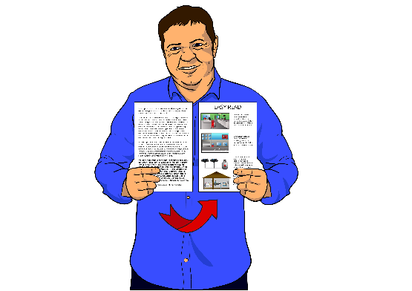
While it is written in Easy Read it can be hard for some people to read a document this long.

Some things you can do to make it easier are:

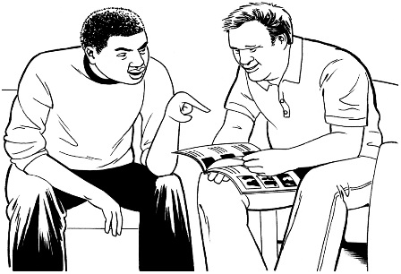
- read it a few pages at a time

- have someone help you to understand it.

About the Disability Employment Action Plan

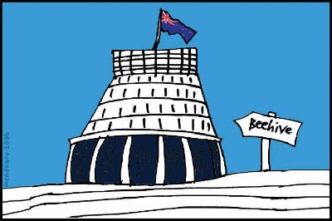
The government wants to make a plan for 2 things:

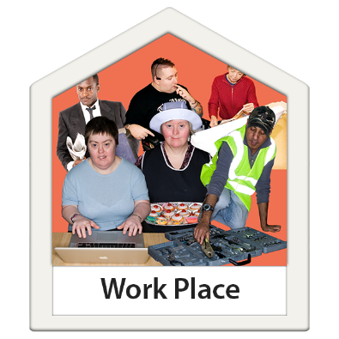
- to support disabled people to get a job

      - to support disabled people to stay in their job.

The final plan will be called the Disability Employment Action Plan.

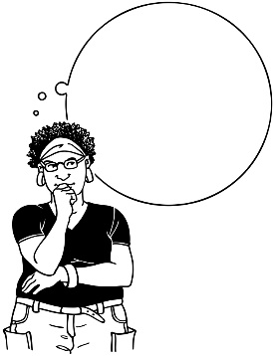
Before we finish the plan we want to know what you think of our ideas.

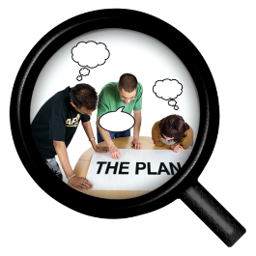
The Ministry of Social Development has written a draft plan for people to talk about.

Draft means writing something for the first time.

The draft gets changed after people say what they think about it.
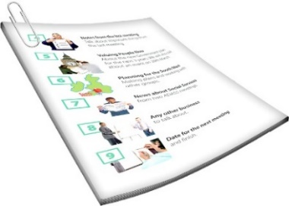
DRAFT

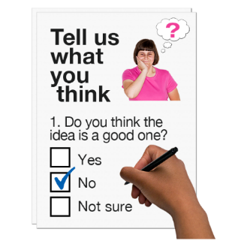
At the end of this document there is information on how you can send us your answers.

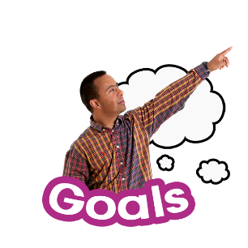
This document goes through the goals our plan wants to achieve.

A goal is something we want to make happen.
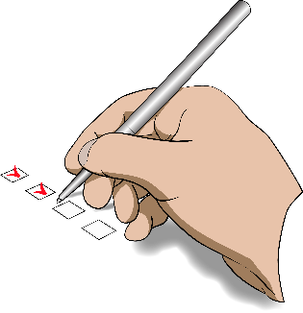
Under the goals are actions that we think will help us reach our goals.

Actions are the steps we want to take to get to the goals.

Some of the actions are about making sure:
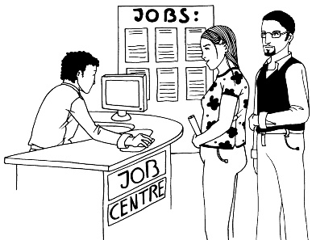
- disabled people have the same chance to get a good job as other people

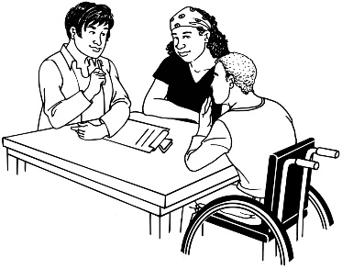
- employers are good at hiring disabled people.

People who give jobs to people are called employers.

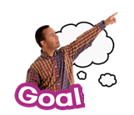
Goal 1: Disabled people should be able to choose:

      - what they want to do when they finish at school

      - what they want to do when they change jobs.

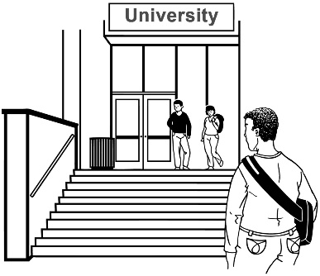
1 of the actions we are thinking about for this goal is give support to disabled students who leave school to:

            - do more education / learning

            - to find work.

Another action we are thinking about for this goal is to give disabled people more chances to do:

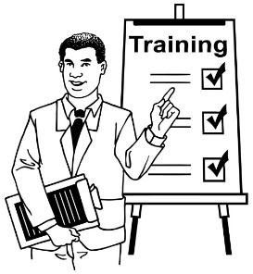
- paid work experience

- on the job training.

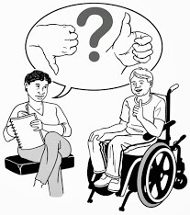
Paid work experience is doing a job for a little bit of time so you can:

- get an idea of what the job is like

- learn some new ways of working

- be paid money for your time.

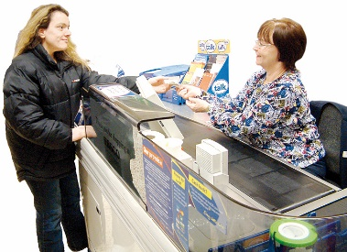
For example working for 1 week in a shop looking after people buying things.

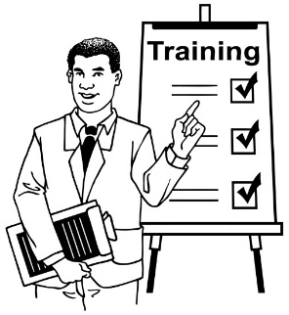
Training is what you are given when you are learning how to do a job.

We also want to have information on the internet about:

      - jobs that are looking for workers
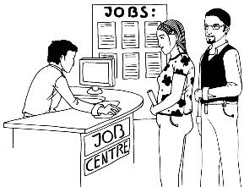

      - what help you can get to look for a job.

Goal 2: To have the right support for disabled people to get a job.

1 action we are thinking about for this goal is to support disabled people and their whānau / family to find the best employment services for them.

Employment services are government groups that help people find jobs.

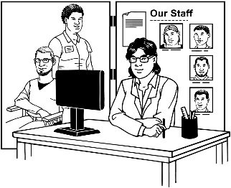
Some other actions we are thinking about for this goal are:

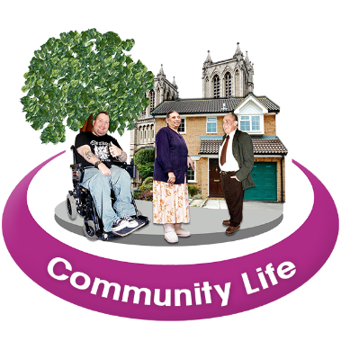
- to have more employment services for disabled people so they have more choices

- support employment services to work together with community organisations.
Goal 3: To make more jobs for disabled people.

Some of the actions we are thinking about for this goal are:
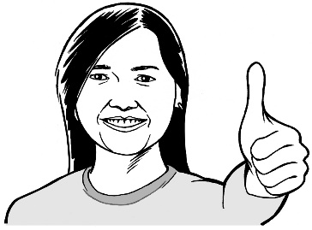
      - to make more employers understand why it is good to employ disabled people

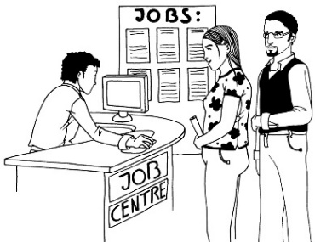
      - to make new jobs that disabled people can do

      - to support disabled people to be self-employed if they want to be.

Self-employed means working for yourself.

Goal 4: To make workplaces better for disabled people.

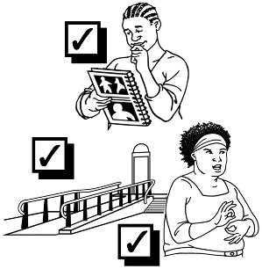
Some of the actions we are thinking about for this goal are:

      - to support workplaces to make changes so disabled workers can do their job well
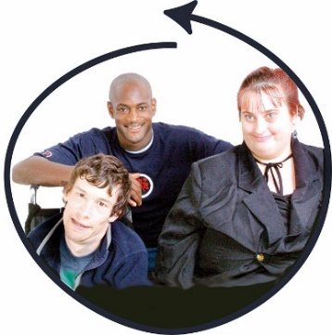

      - to support workplaces to make changes so disabled workers feel included

      - to look at ways to support people to stay in their jobs if they get a disability.

How to tell us what you think of the Disability Employment Action Plan

We want to know what you think of the draft Disability Employment Action Plan.

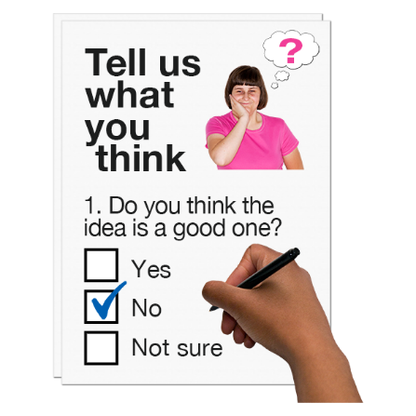
      - Which of the actions are the most important?

      - Is there anything we should change?

      - Is anything missing from this plan?

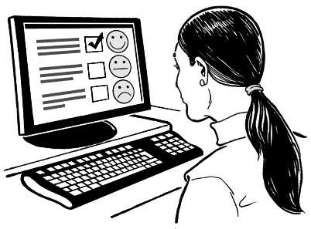
You can tell us what you think in our online survey.

An online survey is a list of questions on our website that you can fill in to tell us what you think.
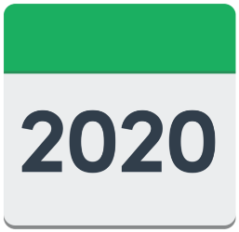
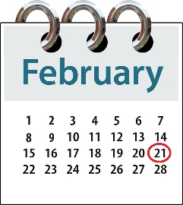
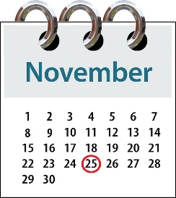

The survey will be online from:

25 November 2019

to

21 February 2020.

You can find the link to the online survey at:

www.msd.govt.nz/disability-employment

You can also tell us what you think of the plan by:

- phone: 029 200 9712

If you choose to text or call on this phone number we will organise a time to call you back.

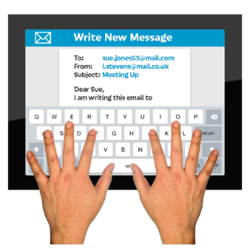
- email:

disability_employment@msd.govt.nz

When you tell us what you think you:
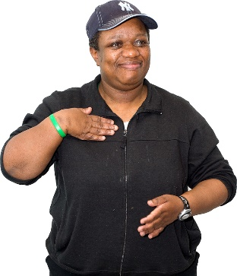
- can answer as many questions as you want

- do not need to answer all the questions.

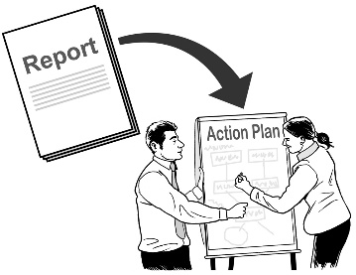
We will read all the answers that people send us.

We will think about your answers when we make the final Disability Employment Action Plan.

We will not put any information about you in the Disability Employment Action Plan.

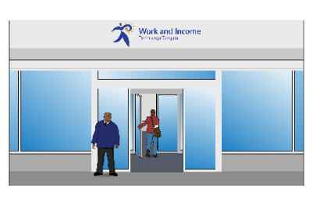
We will not give any of your information to Work and Income.

Sending us your answers will not:

- change any payments you get from government agencies.

- change any services you get from government agencies.

Feedback report

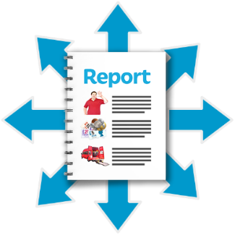
We will also write a report about the answers we get that brings together all the answers that are sent to us.

This report will go on to the Ministry of Social Development website at the same time as the final Disability Employment Action Plan.

The Ministry of Social Development website is:

www.msd.govt.nz

We may add your answers to our report.

Tell us if you do not want us to add your answers.

In the report we will not use:

- any names

- any information that lets people know who you are.

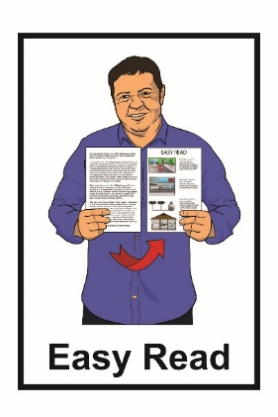
This information has been translated into Easy Read by the Make It Easy service of People First New Zealand Inc. Ngā Tāngata Tuatahi.

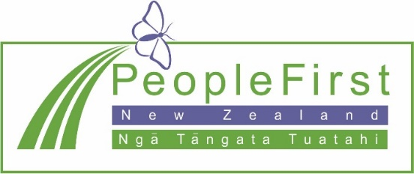
The ideas in this document are not the ideas of People First New Zealand Ngā Tāngata Tuatahi.

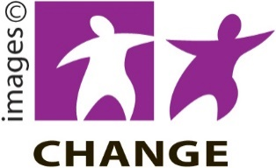
Make It Easy uses images from:
- Changepeople.org.nz

- Photosymbols.com
- Sam Corliss
- Steve Bolton

