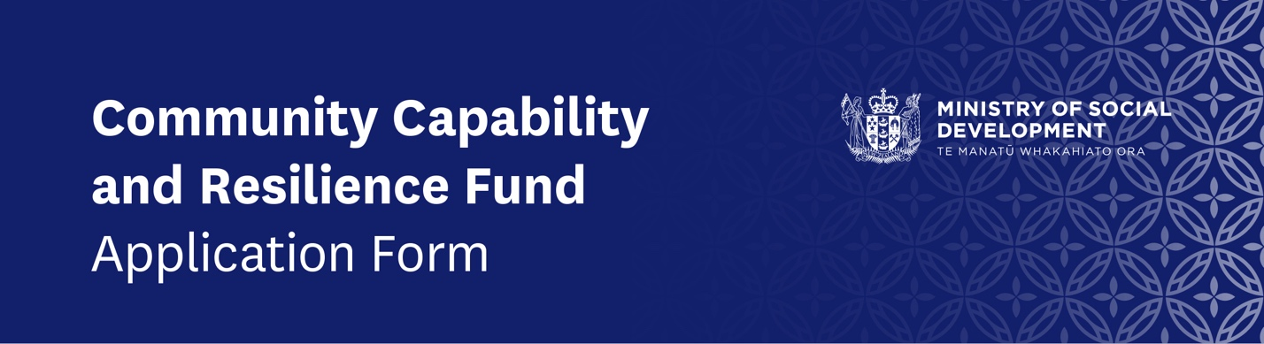

Tell us about your community group/organisation
- What is the name of your group/organisation? | Click or tap here to enter text.
- Does your group/organisation have a Charitable Trust registration number? Please check appropriate response | ☐ | Yes | Please state: | Click or tap here to enter text.
 | ☐ | No
- What is the address of your group/organisation? | Click or tap here to enter text.
- What is the main role(s) or key service(s) your group/organisation provides to your community? | Click or tap here to enter text.

Key contact details
- What is the name of the person we need to contact if we have any questions about this application? | Click or tap here to enter text.
- What position/role do they hold/perform for your group/organisation? | Click or tap here to enter text.
- What is their contact telephone/mobile number? | Click or tap here to enter text.
- What is their email address? | Click or tap here to enter text.

Priority groups/populations
- When thinking about the initiative which your group/organisation is applying to this fund for, will the initiative be of benefit to any of these priority groups/populations?  Please only check the appropriate box where more than 30% of people you are supporting fall into one of these priority groups/populations – More than one box can be checked | ☐ | Māori
 | ☐ | Pacific
 | ☐ | Ethnic/migrant/culturally & linguistically diverse
- Will your initiative be of benefit to any other groups/populations that are not mentioned above? | ☐ | Yes Other | Please state: | Click or tap here to enter text.
 | ☐ | No

Tell us about your initiative
- What is the specific initiative which your group/organisation is applying to this fund for?  For applications of up to $5,000 no more than 500 words expected. For applications of more than $5,000, a more comprehensive explanation of your initiative is required. Please use your best judgement to ensure the information within your application appropriately supports the amount you are applying for.  If you would like to submit a ‘video presentation’ to support your application, please go to www.filemail.com, follow the prompts to upload your video, and then copy and paste the ‘link’ that is assigned to your upload, with your response to this question. | Click or tap here to enter text.
- In which city/town/location(s) will your group/organisation’s initiative primarily be delivered? | Click or tap here to enter text.
- If funding is approved, when will your group/organisation start the initiative (i.e. start date)?  Please use format dd/mm/yyyy | Click or tap to enter a date.
- And when will your group/organisation expect to complete the initiative (i.e. end date)?  Please use format dd/mm/yyyy | Click or tap to enter a date.
- What will be the main benefits for your community, if your application is successful and your group/organisation is able to deliver your initiative? | Click or tap here to enter text.

Tell us about the funding you need
- What is the total amount of funding your group/organisation requires from this Capability and Resilience Fund (excluding GST)? | $ Click or tap here to enter text.
- Have you previously received any funding to support this initiative? | ☐ | Yes | Please state who? | Click or tap here to enter text.
 | ☐ | No | How much? $ | Click or tap here to enter text.
- Is your group/organisation exploring any other funding opportunities to support your initiative? | ☐ | Yes | Please state who? | Click or tap here to enter text.
 |  |  | How much? $ | Click or tap here to enter text.
 |  |  | Please state who? | Click or tap here to enter text.
 |  |  | How much? $ | Click or tap here to enter text.
 |  |  | Please state who? | Click or tap here to enter text.
 |  |  | How much? $ | Click or tap here to enter text.
 | ☐ | No

Tell us your financial details
- If your application is successful:  Note: Payments to an individual person’s bank account will not be made – details to be provided should be for your community group/organisation.  Bank account format is ‘BB-bbbb-AAAAAAA-SSS’ where B is the bank number (2 digits), b is the branch number (4 digits), A is the account number (7 digits) and S are digits of the suffix (2 or 3 digits). | What is the name of the bank account that you want is to make the payment to? | Click or tap here to enter text.
 | What is the bank number? 2 digits | Click or tap here to enter text.
 | What is the branch number? 4 digits | Click or tap here to enter text.
 | What is the account number? 7 digits | Click or tap here to enter text.
 | What is the suffix? 2 or 3 digits | Click or tap here to enter text.

Terms and conditions of the Community Capability and Resilience Fund
This section outlines the Terms and Conditions of the Fund that apply for all community groups.
- The community group/organisation will inform the Ministry of any funding your organisation receives from any other Government source for your initiatives.
- The community group/organisation agrees to acknowledge the assistance of the Ministry in any publicity about their service.
- The community group/organisation will not do or omit to do any act that brings the Ministry into disrepute.
- The community group/organisation will repay all or a portion of the funding paid by the Ministry, if the community group does not satisfactorily deliver the initiative.
- This Fund is a one-off contribution to your community group/organisation. The Ministry cannot guarantee that there will be any on-going funding for your initiative. The community group/organisation should not expect or rely on continued funding.
- Fund payments made to community groups/organisations who are GST registered will be subject to pay GST.
- The community group/organisation will not subcontract or assign the obligations of this Fund with any organisation other than an organisation/s specified in this Fund application without prior written permission from the Ministry, and no third party may enforce this Fund.
- The community group/organisation will provide a report about the initiative, including what was done, the impact and how the funds were spent. No personal information will be provided.
- The community group/organisation must maintain financial records of the Fund expenditure including the retention of receipts for auditing purposes.
- The community group/organisation acknowledges that the Ministry will publish the names of community groups that have received funding, the purpose and amount of funding.

Applicant declaration
This section needs to be signed by two people in your organisation who have authority to commit the organisation to enter into a funding agreement.
- We acknowledge that the details given in this application, or supplied by us in support of our application, are true and correct to the best of our knowledge.
- We acknowledge that before, during and after the granting of any funds, the Ministry of Social Development may disclose to, or obtain from, any other government department or agency, private person or organisation, any information about our organisation and the project for which we are seeking funding for the purpose of assessing the application, administering the Initiative, reporting tax information, evaluating the Initiative or conducting integrity inquiries.
- We will not hold any personal information for or on behalf of the Ministry of Social Development.
- We agree to provide information such as financial, statistical and/or anonymised information to the Ministry of Social Development for the purpose of evaluating, auditing, reporting and conducting integrity inquiries on the Initiative and/or funds.
- We agree to follow the Privacy Act and any other applicable rule or enactment when handling any personal information.
- We acknowledge that the Ministry of Social Development will publish the names of the community groups that receive funding, the amount of funding and its purpose.

Full name | Click or tap here to enter text.
Position/designation in group/organisation | Click or tap here to enter text.
Signature By inserting your name here you are accepting the terms and conditions of this fund | Click or tap here to enter text.
Date  Please use format dd/mm/yyyy | Click or tap to enter a date.
Full name | Click or tap here to enter text.
Position/designation in group/organisation | Click or tap here to enter text.
Signature By inserting your name here you are accepting the terms and conditions of this fund | Click or tap here to enter text.
Date  Please use format dd/mm/yyyy | Click or tap to enter a date.

Email this completed application to CCRF_2020@msd.govt.nz along with:
- An invoice for the total amount of funding your group/organisation requires from this Capability and Resilience Fund (your invoice should match the amount you have stated in Question 16). Your invoice must be addressed to the Ministry of Social Development, PO Box 1556, Wellington, 6140 noting that:
- If your group/organisation is registered for GST, you need to include your GST number and show the GST component on your invoice
- If your group/organisation is not GST registered, you need to state this on the Tax Invoice and do not need to show the GST component
- Bank verification – this can include either a pre-printed bank deposit slip, a letter from the bank or a copy of your bank statement showing your group/organisation’s account name and account number only (your bank verification should match the details you have stated in Questions 19).

