TE HURINGA Ō TE AO - SUPPORTING MEN’S BEHAVIOUR CHANGE

THE SERVICE CONCEPT
Purpose: The Service Concept aims to capture the realisation of your mahi. It reflects what you will deliver to make positive change in your community and contribute towards Te Huringa ō Te Ao. The Service Concept aims to:
- Reflect what you will deliver to make positive change in your community
- Articulate alignment to the Framework of Te Huringa ō Te Ao Framework and your whānau voice evidence base to demonstrate effectiveness
- Identify continuing service development opportunities
How to use: This service concept template is a working document that will be continually refined throughout service development. MSD will continually work alongside you to support its alignment to Te Huringa ō Te Ao, the use of whānau voice, and ensure it meets the technical requirements.
When to use: At the start of service development, some providers will elect to fill this template immediately. This will support you to identify what you’d like to design, tweak or test during service development. You may not be able to answer all the questions, just fill in what you can.
Throughout service development, your ideas will be further developed and the details in this template will be fleshed out. It is okay to write something down at the start that changes later, once you have tested your thinking with whānau and stakeholders.
At the end of service development, there will also be a final version that is submitted to MSD prior to commencing service delivery. When ready, this will be varied into your Outcome Agreement.

SERVICE CONCEPT TEMPLATE

INTRODUCTION
Te Huringa ō Te Ao is a new family violence service that supports sustainable behaviour change for men to restore whānau wellbeing. This service is for tāne and men harming and hurting their partners and children, who realise it is time for change.
Te Huringa ō Te Ao is for all tāne and men across New Zealand and offers a wide variety of flexible, proactive, and culturally responsive support that encourages men to reconnect with themselves, whānau, and community. This support is tailored to meet the holistic needs of tāne, men and whānau, while continually challenging men to own their behaviour, to be safe and to keep safe. This represents a shift away from short-term, prescribed programmes, and towards a system that puts the responsibility on men to be safe and keep safe.
Te Huringa ō Te Ao aims to create opportunities for local communities to reimagine support for men harming others by centering whānau voice. Together, we aim to think differently in how we support men on their journeys of change to break the cycles of violence, and to create and sustain intergenerational change.
The project framework has 7 Service Aspirations and 10 Underpinning Principles. All services developed for Te Huringa ō Te Ao are aligned to this framework.
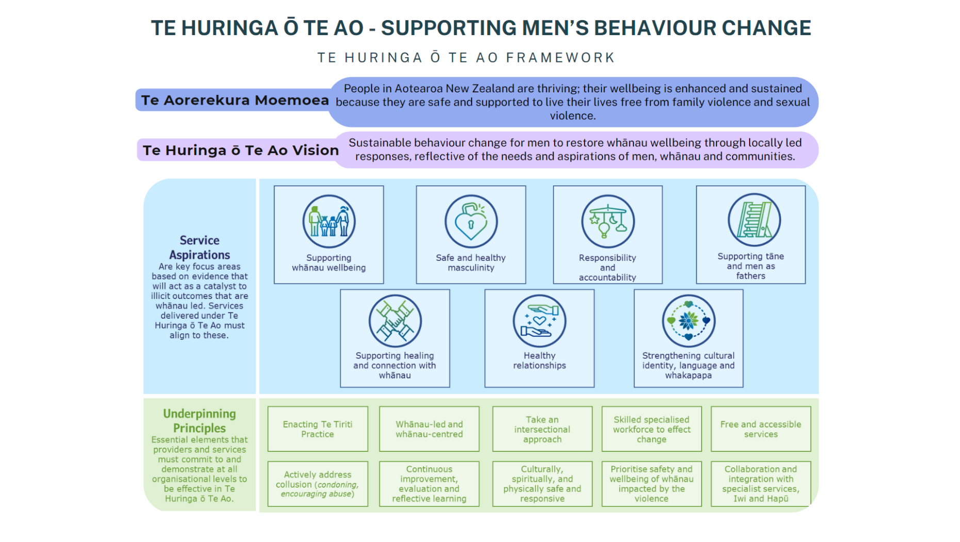

PROVIDER INFORMATION
Provider Details
- Provider Name
- Concept Author/s
- Names of those in your organisation that endorse this service concept

SECTION ONE: PERSONALISED SERVICE GUIDELINES
The purpose of this section is to create service specifications which describe what you are going to deliver for Te Huringa ō Te Ao. These prompts ensure you meet MSD service requirements and will be used to support future contract management. This will dock into the overarching “Te Huringa ō Te Ao Service Guidelines” (add link).
Please answer the questions in section one as succinctly as you can.
Service summary
- Provide a brief description of your Te Huringa ō Te Ao service (eg. 1-2 paragraphs)
- Please describe how your service will support men on their journeys of change to break the cycles of violence, while working to restore whānau and family wellbeing.
- This should include the support available, service philosophy, and identify the group that this service supports eg. target cohort and any criteria.
This will be used in MSD reporting, such as to leadership and Ministers, and may be made publicly available to publicise what support is available across Aotearoa.
Service model nuts and bolts
Describe the service model, how will the service work, including:
- What geographic area(s) will you deliver to?
- Referral pathways in and out
- Who you collaborate with?
- Other accessibility considerations
- Workforce description eg. peer support or social work
- Feel free to use a client journey to support this response.
- Who is the service not for and not doing
This will be used to support future contract management.
Ongoing service improvement
- How will you use data, feedback and whānau voice to test how your service concept, and to inform future service improvement?
This will be used to help providers develop their own service improvements, and to inform future reporting requirements for MSD for this service.

SECTION TWO: ALIGNMENT AND WHĀNAU VOICE
The purpose of this section is to describe your whānau voice evidence base and its alignment to Te Huringa ō Te Ao. This aims to demonstrate how your service is informed by evidence and designed to effectively support change with whānau in your community.
Feel free to answer these prompts directly or weave your responses into stories or pūrakau – whatever best articulates your service concept. Please try to keep this succinct where possible.
This will be reviewed by the MSD project team to ensure your service concept aligns to the intentions and Framework of Te Huringa ō Te Ao.
Evidence & Whānau Voice
MSD has a whānau voice guide available on the resource page of the website that may support you with gathering whānau voice
- What is the evidence base and whānau voice that informed your service development?
- Eg. How did you gather whānau voice?
- Eg. Summarise trends/insights from whānau that informed your service concept?
- What other evidence or research have you used to inform your concept?
- What other stakeholder feedback have you gathered (e.g. from other community organisations, agencies working in family violence, iwi, etc)?
- Eg. How were these insights incorporated into your service concept?
Alignment to Te Huringa ō Te Ao
- How will your service, practice, and organisation align to the Framework for Te Huringa ō Te Ao? (i.e. the vision, Service Aspirations and Underpinning Principles)
- What organisational shifts will make an impact for your community?

