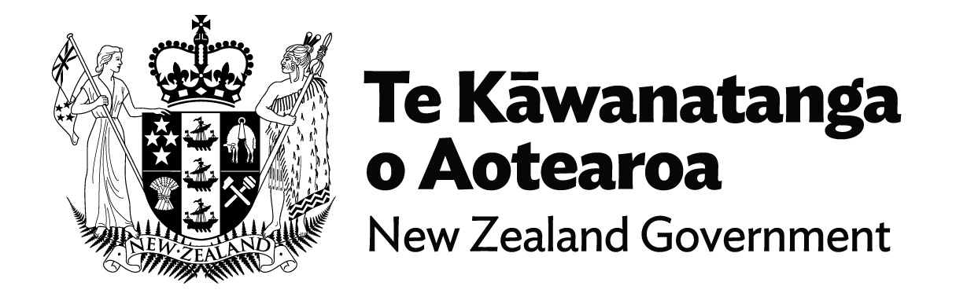

Fact Sheet – Enabling Good Lives (EGL)
Enabling Good Lives is centred on the ‘person, their strengths and aspirations’, and it’s an approach that works, as we’ve seen in the pilot regions. It enables disabled people and their family/whanau to have much more choice and control over their own lives and the supports they receive.
Government is building on an approach and system that works, and making a ‘once in a lifetime’ call to roll out Enabling Good Lives right across the entire country.
This will transform disability support services for at least 43,000 disabled people, their families, whānau and communities, and will drive better life outcomes for disabled people at both the local and national level.
For a long time, the disability sector and community have expressed concerns about disability supports not working well for disabled people and whānau. These concerns centre on the lack of choice and control disabled people have over the support they receive.

The EGL vision and principles were developed in 2011 by the disability community to underpin a new approach to disability support. The vision since day one has been for disabled children and adults and their whānau to have greater choice and control over their supports and lives.
As evidenced by the pilot projects in Christchurch, Waikato and Mid Central region, there are improved outcomes when disabled people, families and whānau have that choice and control over their supports and access.
These include increased autonomy and social connectedness, improved quality of life, and better access to education and employment opportunities.
The demonstration projects also included higher engagement and take up of disability services from the marginalised groups including disabled Māori and Pacific peoples, in comparison with the current disability support system. Engagement with the system by tāngata whaikaha Māori and Pacific disabled people increased by 60 percent in Mana Whaikaha, and by 33 percent overall.

Key Features:
The key features of a transformed disability system based on the EGL approach are:
- people are welcomed into the system in multiple ways, and can then be provided with information, linked with a Connector, peer network, government agency or disability organization,

- access to Connectors who can walk alongside disabled people and whānau if they choose, to help them identify what they want in their life, how to build their life, and the range of supports available to live their life,
- easy to use information and processes that meet the diverse needs of disabled people and their whānau,
- seamless support across government, with Government Liaisons supporting people in the background to access other government services (for example, benefit applications), and to build positive relationships with other parts of government (for example, learning support in school),
- a straightforward process for accessing funding, with flexibility about what can be purchased and how it can be administered, and easy reporting,
- capability funding for disabled people and whānau,
- outcomes-based commissioning and contracting models,
- greater system accountability to disabled people and their whānau so that disabled people and whānau are involved in monitoring and evaluating the system and making recommendations to Ministers about changes to the system.

EGL Vision
Disabled children and adults and their families will have greater choice and control over their supports and lives, and make more use of natural and universally available supports.

EGL Principles
Self-determination: Disabled people are in control of their lives.
Beginning early: Invest early in families and whānau to support them; to be aspirational for their disabled child; to build community and natural supports; and to support disabled children to become independent, rather than waiting for a crisis before support is available.
Person-centred: Disabled people have supports that are tailored to their individual needs and goals, and that take a whole life approach rather than being split across programmes.
Ordinary life outcomes: Disabled people are supported to live an everyday life in everyday places; and are regarded as citizens with opportunities for learning, employment, having a home and family, and social participation – like others at similar stage of life.
Mainstream first: Disabled people are supported to access mainstream services before specialist disability services.
Mana enhancing: The abilities and contributions of disabled people and their families and whānau are recognised and respected.
Easy to use: Disabled people have supports that are simple to use and flexible.
Relationship building: Supports build and strengthen relationships between disabled people, their whānau and community.
You can access the Cabinet paper here.
End of Fact Sheet – Enabling Good Lives

