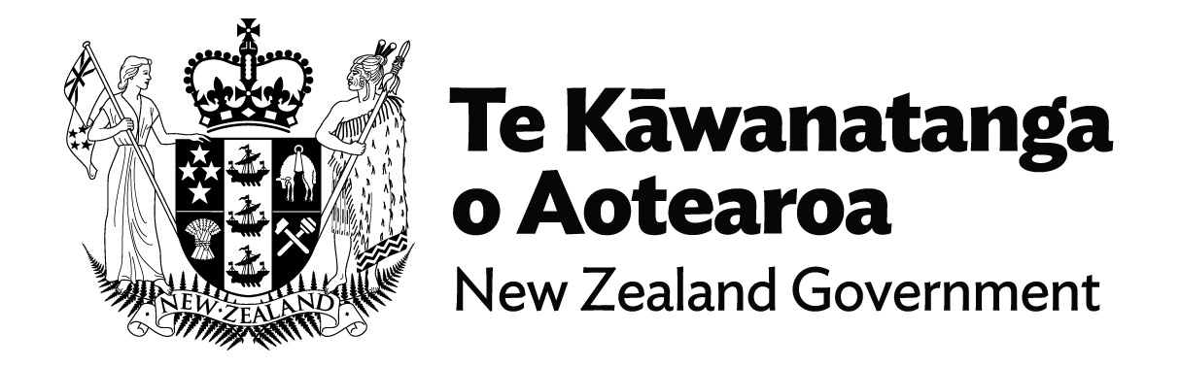

Fact Sheet - Disability System Transformation
There is growing recognition of the size of the disability community, their capability and the need to engage them in the development to ensure disability policy and services work for disabled people.
Work on Disability System Transformation has been ongoing for more than a decade and is underpinned by the Enabling Good Lives (EGL) vision that all disabled people and their families have greater choice and control over their supports and lives. There have been successes. A social model based New Zealand Disability Strategy and numerous pieces of rights-based legislation, including the promotion of NZ Sign Language as an official language. New Zealand and New Zealanders had significant input in the development of the United Nations Convention on the Rights of Persons with Disabilities (CRPD) which was finalised in 2006.
Several groups are part of disability-led Disabled People’s Organisations (DPOs), which both advocate and partner with Government.
Sir Robert Martin was elected to the UN Committee to monitor the CRPD in 2016, and in 2020 became the first learning disabled New Zealander to receive a Knighthood. His life journey – from institutionalised as a child and young person to international leader demonstrates the disability story, from segregation, with little choice and control to inclusion, to contribution, to leadership.
We acknowledge and mihi to disabled people and their allies who have led us to where we are today and seek to honour their commitment, determination, and foresight to continue to remove barriers to full participation and inclusion.
But considerable inequities remain, and for many, self-determination, and ability to full participate in society remain out of reach.
The Enabling Good Lives (EGL) vision and principles were developed by an independent working group of disabled people, their families and whānau, advocates and allies as the foundation for a transformative change to disability support.
The EGL model has been trialled for the delivery of Disability Support Services in Christchurch, the Waikato, and mid-central. However, Government recognises there needs to be a national transformation of Disability Support, in line with the EGL approach, and has an ambition for transition broader than services relating to disability issues.
Government is introducing a Ministry for Disabled People to lead the realisation of a true partnership between the disability community and government, and to help drive ongoing transformation of the disability system in line with the Enabling Good Lives (EGL) approach.
This is a once in a lifetime opportunity. A dedicated disability Ministry will enable a holistic whole-of-life, whole-of-whānau approach to addressing inequities and realising aspirations and opportunities for disabled people and whānau.
Government has been working hard with disabled people and others in the disability sector to ensure we achieve not only lasting change, but consensus, and that work will continue, ensuring that all voices that have struggled to be heard are recognised.
You can access the Cabinet paper here.

End of Fact Sheet - Disability System Transformation

