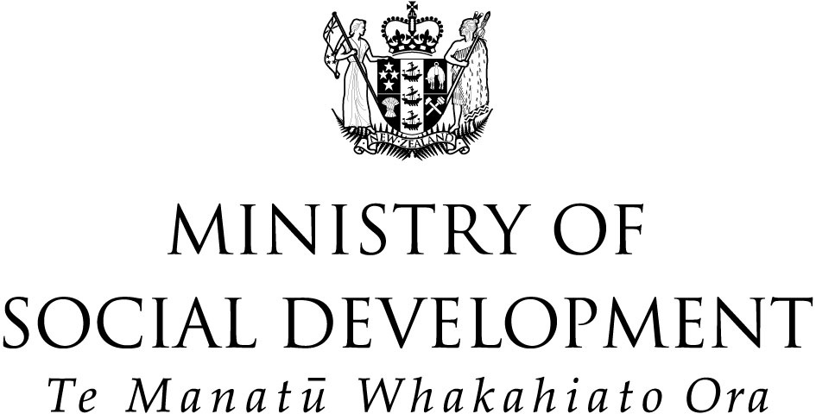

Wellbeing, Employment, Independence

The views of Sickness and
Invalids’ Benefit clients

Plain English summary

Prepared by
Robin Peace, Amanda Wolf, Simon Crack,
Iris Hutchinson, Mathea Roorda

Prepared for
Centre for Social Research and Evaluation
Te Pokapū Rangahau Arotaki Hapori

Working paper 07/04

November 2004

A research study for the Sickness and Invalids’ benefit work programme

The research used an approach that is called “Q methodology”. This approach uses what people have said or written about the research topic. The researcher writes the comments people have spoken or written onto small cards. A range of ideas about life on SB and IB are written onto the cards as short statements. Some of the statements were collected from small groups and individuals and others came from the media, speeches, books and reports. This research approach is not used very often in research that the Government does, but it is quite straightforward.

What was the research about?

The Ministry of Social Development (MSD) and Victoria University of Wellington recently finished a research project about how people feel about getting the benefit and being able to work or getting a job. We looked at:
- the different ways that people described their wellbeing
- what people thought about getting a job
- what being independent meant to people.

How did people help us decide what to do?

In February and March 2004, we started to collect information that would help us know more about how people felt about getting the benefit and being able to work. We got our information from different places:
- we went to the IHC and spoke to people about what was important to them and to people they know
- we asked Discuss (a group for people with disabilities that talk to each other on the internet) to tell us what they thought about the benefit and getting a job
- we talked with a group of people who used to be (or still were) on the benefit and asked them to tell us what they thought about the benefit and getting a job
- we looked for similar research done by researchers from Government, universities and support organisations.

What did we ask people to do?

Twenty people came forward to help us with the second step of the research. In April and May 2004, we asked these 20 people to do a task. The task was to look at a set of cards. The cards had ideas written on them. We asked people to sort the cards into piles to show how strongly they agreed or disagreed with what the cards said.

The task was not a test. There were no right or wrong answers. We just wanted to know what people thought about the ideas on the cards about the benefit, employment and independence.

At the end of the task, we asked some questions about why people put the cards where they did. We also asked some simple questions about people’s lives, such as their age and what benefit they were on.

People’s answers to the questions also helped us when we looked at all of the different ways the 20 people had sorted the cards.

What did we find?

When we started the project, we thought there were two main ways people on the Sickness or Invalids’ Benefit thought about getting a job. We knew that some people have said they would be happier if they had a job. We also knew that other people felt they did not need a job to be happy and to feel independent.

What we found was different to these two ideas. We found that there were five different ideas some people we talked to had about the benefit and getting a job. These five ideas are explained in the table on the next page.

What are we going to do with the results?

When we started this research, we did not know exactly what we would find.

This research has helped us to better understand people who receive Sickness and Invalids’ Benefits. We now know that there are several different ideas some people have about the benefit and about getting a job.

We have begun to tell people who are experts in benefits about what we found.

We are also going to tell other people who are interested about how we did the research. People are really interested in what we did and in what we found. Because the research went really well, we think that Government and universities might try to do similar work in the future.

We will also use our results to help plan future research.

We were glad so many people were able to help us with this work and would like to thank them all.
Groups of ideas | We found five ideas. What do some people in each group think about the benefit and about getting a job?
Idea 1:  Some people had a  “sense of being entitled to support” | Some people’s ideas were that:  - the benefit is something they deserve to get, rather than something they need  - they were unhappy because they feel that the Government thinks they should be working, not be on the benefit  - they were unhappy about how much they rely on the benefit in their lives.
Idea 2:  Some people had a  “sense of being ready to work” | Some people’s ideas were that:  - working is more important than being on the benefit  - working is about much more than just pay  - work makes them feel good about themselves and makes them feel independent.
Idea 3:  Some people had a  “sense of gratitude for the benefit” | Some people’s ideas were that:  - benefits are very important for people to become independent  - case managers are excellent at helping people get the benefit and would help them get a job if they wanted  - benefits help them to achieve positive change in their lives.
Idea 4:  Some people had a  “sense of being a victim of stigma” | Some people’s ideas were that:  - when on the benefit, other people treat them badly  - they are ashamed about being on the benefit  - they want to work but feel that no one will give them a chance  - because people treat them badly, it is hard to make new networks of work friends.
Idea 5:  Some people had a  “sense of hope” | Some people’s ideas were that:  - money from the benefit is really useful for funding job training courses  - benefits give them a feeling of self-worth  - sickness or disability is a hurdle that needs to be overcome, not a source of rights or of stigma.

