MSD Working Paper 02/19
Stats NZ Child Poverty Statistics release, 2 April 2019:
MSD Background and Overview
(including some Q and A on selected themes)

Bryan Perry, MSD
1 April 2019

Introduction

Stats NZ’s 2 April 2019 Child Poverty Statistics release gives the 2017/18 baseline rates that are needed for implementing the Child Poverty Reduction Act, and in particular for finalising child poverty reduction targets. It also provides some time series back to 2006/07 where possible, plus a Technical Appendix as required by the Act.

The Stats NZ release is the sole responsibility of the Government Statistician. The Act requires that the Government Statistician consult with MSD’s Chief Executive in preparing the release, which has occurred.

This MSD Background and Overview report:
- highlights key aspects of the Stats NZ release and gives some commentary on the findings and the approaches used
- sets the Stats NZ numbers in the context of the longer time series published by MSD in the annual Household Incomes Report
- provide some of the broader contexting information that is usually in the Household Incomes Report.

MSD’s 2019 Household Incomes report is scheduled for release in July 2019. It will include the 2017/18 figures for the full range of themes and topics usually covered.

Outline of this Background and Overview

- The need for 2017/18 baseline rates for the implementation of the Act.
- The meaning of ‘poverty’, the coverage of ‘poor’ households by the surveys, and sampling uncertainties.
- The relationship between the numbers in the Stats NZ release and the numbers in MSD reports.
- BHC relative rates.
- AHC relative and fixed line rates.
- Material hardship rates.
- The child poverty reduction targets – the long-run view

Abbreviations

BHC income household income before deducting housing costs
AHC income household income after deducting housing costs
MH material hardship, measured using non-income measures
HES Stats NZ’s Household Economic Survey
HLFS Stats NZ’s Household Labour Force Survey
HLPI Stats NZ’s Household Living Price Index
The Act The 2018 Child Poverty Reduction Act
The need for 2017/18 baseline rates for the implementation of the Child Poverty Reduction Act

The Act requires Stats NZ to publish child poverty figures for the measures specified in the Act, starting with the 2018/19 year (reporting early 2020).

The Act also requires the Government to set and gazette reduction targets for the primary measures by 20 June 2019. To do this, and for having start rates for the other measures too, baseline rates are needed for 2017/18. Stats NZ’s release provides these 2017/18 baseline rates.

Stats NZ’s Household Economic Survey (HES) has been the data source to date for producing child poverty estimates. The relatively small sample size means that there are sizeable uncertainties around estimates for each year. These make it difficult to know whether observed changes from year to year are real changes or just reflect the chance variation that inevitably arises from using samples.

In addition, there is evidence of some sample bias arising from the under-representation of lower income / higher material hardship households. Stats NZ, like other statistical agencies, find it more difficult to collect responses from these households.

In 2018, Stats NZ received additional funding to improve the data source for measuring child poverty. This funding allowed for:
- a substantial increase in the sample size of HES (from 3,500/5,500 to 20,000 households)
- improvements to the survey design and operation to ensure a good representation of lower socio-economic households in the survey
- a move to using administrative (admin) data for income rather than collecting income directly from respondents.

The first results based on the new larger HES are expected from Stats NZ in early 2020, based on HES 2018/19.

Estimating the 2017/18 baseline rates

The challenge for Stats NZ for the 2 April 2019 release was to use existing data sources to produce 2017/18 baseline rates that were robust enough to use in the context of the target-setting, monitoring and accountability requirements of the Act.

The Act specifies three types of measures for measuring child poverty:
- low incomes before deducting housing costs (BHC incomes)
- low incomes after deducting housing costs (AHC incomes)
- material hardship (MH).

Stats NZ’s approach to improving the robustness of the 2017/18 baseline estimates involved three elements:
- increasing the sample size by pooling the Household Labour Force Survey (HLFS) information with the HES – to reduce sample error
- using a revised set of benchmarks for calculating weights for converting sample numbers into population estimates – to better help in addressing sample bias issues at the lower end
- using admin data from IRD and MSD for income information rather than rely on survey information – to improve the accuracy of household income estimates.

Not all elements were able to be applied to each type of measure:
- The full treatment was able to be applied only to BHC income measures:
- the pooled HLFS-HES dataset created a sample of close to 20,000 and this reduced sample error from around 2.5% to 1.1% for 50% BHC rates, a significant improvement
- admin data was used as the source of income information.
- For AHC incomes:
- admin data was used for the BHC income component of the AHC income, but as there is no housing cost information in the HLFS, the sample size was limited to that of the HES (5,500 in 2017/18)
- revised weights helped somewhat in addressing under-representation due to sample bias.
- For material hardship estimates:
- the HLFS does not have material hardship information, so the sample was limited to that of the HES (5,500 in 2017/18)
- only the revised weights element could be applied to the material hardship estimates.

The meaning of ‘poverty’, the coverage of ‘poor’ households by the surveys and sampling uncertainties

‘Poverty’

Poverty is essentially about household resources being insufficient to meet basic needs. In richer countries poverty is commonly defined as exclusion from a minimum acceptable standard of living in one’s own society because of inadequate household financial and material resources.

In practice, household incomes have traditionally been used to measure resources, with low incomes used as a measure of income poverty. The limitations of this approach are well-known (eg financial and physical assets are an important part of a household resources for generating consumption, the impact of high health costs are not captured in income measures). Monitoring trends in low incomes is nevertheless an important exercise as many low-income households have very limited or no financial or other assets, and their income is therefore the main in-house resource available for survival.

Over the last two decades growing use has been made of non-income measures (NIMs) to more directly measure material standard of living, and material hardship.

Value judgments are needed to decide on what is ‘minimum acceptable’ or ‘adequate’ (ie where to draw the lines). This is an inescapable aspect of poverty measurement and debate, but does not mean that any measure will do nor that all measures are equally imperfect. Some are clearly more reasonable and defensible than others. The Child Poverty Reduction Act specifies a range of measures and thresholds to better capture the fuller picture of low-income trends and experiences of material hardship.

The surveys gather information on the usually resident population living in private dwellings

The survey therefore includes those living in retirement villages, but not those in non-private dwellings such as “rest homes”, hotels, motels, boarding houses and hostels.

Low-income (poverty) and material hardship rates based on the HES and surveys like it are about trends and relativities for the population in private dwellings. Other sorts of surveys are needed to obtain a picture of what life is like for those “living rough” or in boarding houses, hostels and so on.

This does not mean that the survey does not reach households with very limited financial resources or those in more severe hardship. For example, in 2017, 110 of the households interviewed reported receiving help from a food bank or other community organisation more than once in the previous 12 months, and 234 reported putting up with feeling cold ‘a lot’ in the previous 12 months because of needing to spend on other basics.

Findings based on sample surveys have statistical uncertainties

As the numbers in the Stats NZ release and in the MSD reports are based on data from sample surveys, there are always statistical uncertainties.
  - Some of the uncertainties arise by chance from the fact that the information is from a sample rather than the whole population (‘sampling error’). This means, for example, that most numbers are expected to bounce around either side of a trend line, especially for population sub-groups and more so for smaller than for larger ones. Sampling error exists even if a 100% response rate is achieved in a perfectly designed and implemented survey.
  - Other uncertainties and ‘noise’ arise from the fact that the response rate to the survey is always less than 100% (typically around 75-80% in recent years for the HES). If those who do not respond are on average quite different from those who do, and if this difference changes from year to year, then further fluctuations can occur that do not represent real-world fluctuations (an example of ‘non-sampling error’). Non-response bias is a challenge for all sample surveys. It can to some degree be addressed by applying carefully-designed weights to the sample.

The use of the term “sample error” can suggest that a mistake has been made; however, sample errors are not mistakes. They represent the inevitable difference (that arises by chance) between the estimate and the true value when using a sample rather than interviewing every household in the population. Even a perfectly designed survey with a 100% response rate has sample error. It is an unfortunate term, but it is well-established and widely used internationally.

Standard statistical theory provides a way of calculating and talking about sampling uncertainties in terms of “sample errors” and “confidence intervals”. A child poverty rate of 17% with a sample error of 1 percentage point means that there is a 95% chance that the true rate is between 16% and 18%. This range is called the “confidence interval”. Other confidence levels can be used but Stats NZ, in line with international practice, uses the 95% confidence interval for reporting sample errors for child poverty estimates.

Achieving lower sample errors can be valuable for improving the accuracy of an estimate in a given year. In the context of setting child poverty reduction targets and assessing progress to those targets, a lower sample error improves our ability to say whether the change from one year to another is statistically significant or is more likely to be just from chance variation. For the current HES, changes of more than 3-4 percentage points are needed before we can be sure that the observed changes are ‘real’. For the larger HES (2018/19 on) and for the pooled HES-HLFS (2017/18 baseline rates for BHC), the sample error for the change between years is more like 1.5 to 2.0 percentage points. This considerably improves the ability to reliably assess progress to targets.

Relationship between the numbers in the Stats NZ release and the numbers in MSD reports

MSD’s reports have to date been the default go-to source for low-income and material hardship trends for the population as a whole and for selected groups (including children). The numbers in the MSD reports are based on Stats NZ Household Economic Survey data, Stats NZ standard weights to convert sample numbers to population estimates, together with a range of standard definitions and assumptions.

The concepts, assumptions and definitions used in the Stats NZ release have much in common with those used in the MSD reports. Where the Stats NZ definitions differ from those used by MSD, the impact on child poverty numbers is minimal. The similarities and differences and their impact on reported rates are outlined in Appendix One.

The main drivers of any differences between rates reported by MSD to date and those in Stats NZ’s 2 April release are not at the level of concept and definition. Any differences that do exist arise in the main from differences in data sources and weights used to convert sample numbers to population estimates:
- The pooling of HES and HLFS samples for BHC incomes reduces sample errors and smoothes the trend line compared with using the HES alone.
- The use of admin data rather than survey data for income information leads to slightly higher low-income estimates in the Stats NZ 2 April release compared with the MSD numbers, especially for the 40% AHC and 50% BHC measures. This is discussed further in the BHC and AHC sections below.
- The use of revised weights for the AHC rates reduces variability as the new weights to some degree better address sample bias in relation to low-income households. These new weights make almost no difference to previously reported MH rates.

The Stats NZ figures are the official figures.
Low-income rates before deducting housing costs (BHC relative measures)

The chart below shows the Stats NZ trend from 2006/07 to 2017/18 for the fully relative BHC 50 and BHC 60 measures, with the MSD rates back to 1982 for comparison.

There is a slightly rising trend from 2006/07 on. In that period the incomes of lower-income households did not quite keep up with the rising median.

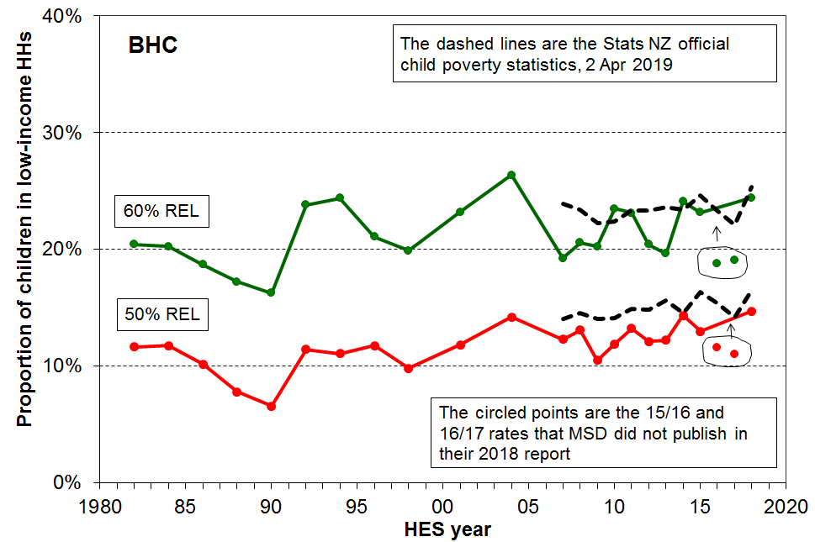

Two features stand out:

- The improvements that Stats NZ made to the BHC income data (much larger sample and new income source in the admin records) increased the stability of the lines and, in particular, addressed the concerns that MSD had about the 2015/16 and 2016/17 low-income rates. These concerns were part of the rationale for MSD not publishing 2015/16 and 2016/17 numbers in their 2018 Incomes Report.

- For BHC 50, the Stats NZ trend is a little above the trend using the HES survey data and the standard weights (as in MSD reports):
  - Stats NZ’s Technical Appendix does not give an explanation for this, but a preliminary investigation has shown that the admin data appears to have more households with implausible low incomes (below, say, 30% of the BHC median and below standard incomes from welfare benefits, housing subsidies and tax credits).
  - If this is the cause of the consistently higher BHC rates, then further investigation is warranted. If, say, the very bottom 2-3% have implausibly low incomes, then this is of nuisance value for a 16% rate, but it represents around half those under a 5% ten-year target. This would call the credibility of the measurement into account and suggests that some dataset adjustment (‘bottom coding’ as the ABS and Luxembourg Income Study and others do) may be needed in the future.
  - None of this is meant to imply that all the implausibly low income information is “incorrect”, but there is further work to do to understand the difference between the survey and the admin numbers on this matter.
.

Low-income rates after deducting housing costs (AHC relative measures)

The chart below shows the Stats NZ trend from 2006/07 to 2017/18 for the fully relative AHC measures, with the MSD rates back to 1982 for comparison.

The trends are fairly flat from 2006/07 on.

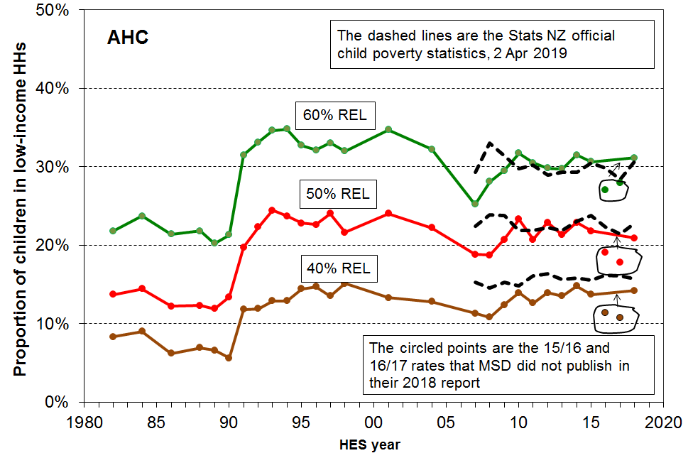

Two features stand out:

- For the AHC 40 line, the Stats NZ trend is a little above the trend using the HES survey data and the standard weights (as in MSD reports):
  - Stats NZ’s Technical Appendix does not give an explanation for this, but a preliminary investigation has shown that the admin data appears to have many more households with implausible low incomes. If this is the cause of the consistently higher AHC rates, then further investigation is warranted.

- The improvements that Stats NZ made to the income data (new income source from the admin records) and the revised weights used for the AHC and material hardship estimates increased the stability of the lines.
Low-income rates after deducting housing costs (AHC fixed-line measure)

The chart below shows the trend in the AHC 50 fixed line, using 2017/18 as the reference year. The real interest is in what the line does from 2017/18 on, but the back series are there for context.

The measure takes inflation into account, so in positive economic circumstances with re-distribution following the patterns of the last two decades, the trend would be expected to be a decline. This means that when the series is created for before the reference year, the rates will generally be higher in the early years.

The MSD and Stats NZ trends are broadly similar, showing a downward trend from around 2010/11 on, after the GFC. The differences in levels are simply due to the different income data sources (HES survey and admin respectively), different weights, and the different inflation adjustment. The MSD series can go back two more years as the CPI is available for them but the HLPI is not.

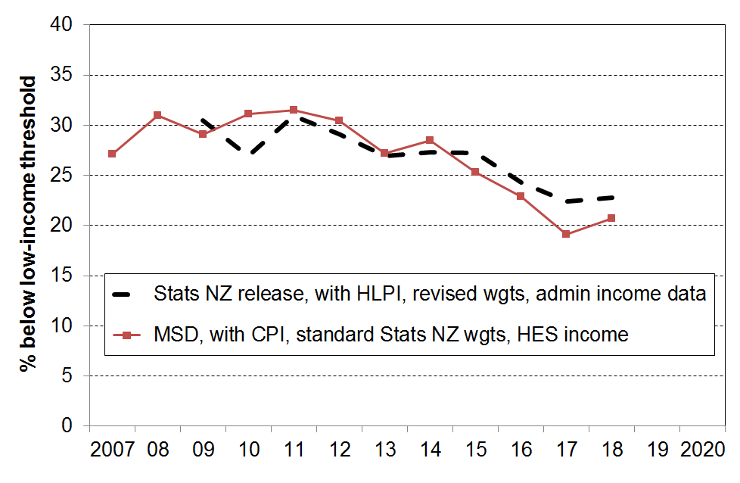

Material hardship rates (MH)

For estimating the 2017/18 baseline rates for material hardship, Stats NZ uses the HES survey data with a revised set of weights calibrated a little differently than their standard HES weights to date. A key difference is the calibration of the revised HES weights to the HLFS income distribution (ventiles or vigintiles), and the use of a different range of household types compared to those used in creating the standard HES weights (see TA pp19-21 for details).

The revised weights make a noticeable impact on AHC numbers (see above), but very little impact on MH rates. As the table below shows, the rates based on the standard and revised weights are very close.

 | 2012/13 | 2013/14 | 2014/15 | 2015/16 | 2016/17 | 2017/18
Stats NZ 2 Apr release – revised wgts | 18.1 | 16.0 | 17.5 | 12.1 | 12.7 | 13.3
MSD reports – standard wgts | 18.2 | 15.8 | 17.7 | 11.4 | 12.2 | 13.2

The lack of impact of the revised weights on hardship rates is not too surprising as material hardship rates are not correlated very strongly to (low) income (noted in TA, p20).

MSD has had concerns for some time about the large fall in observed rates from 2014/15 to 2015/16, and more generally from 2012/13 to 2014/15 on the one hand to 2015/16 to 2017/18 on the other. These concerns were a significant factor in leading to MSD’s decision to not publish 2015/16 and 2016/17 rates in the 2018 reports. Based on the sample errors using the standard weights the difference in levels exceeded what could be expected from natural variation, and there were no policy or wider economy explanations available. MSD also found evidence of some sample bias.

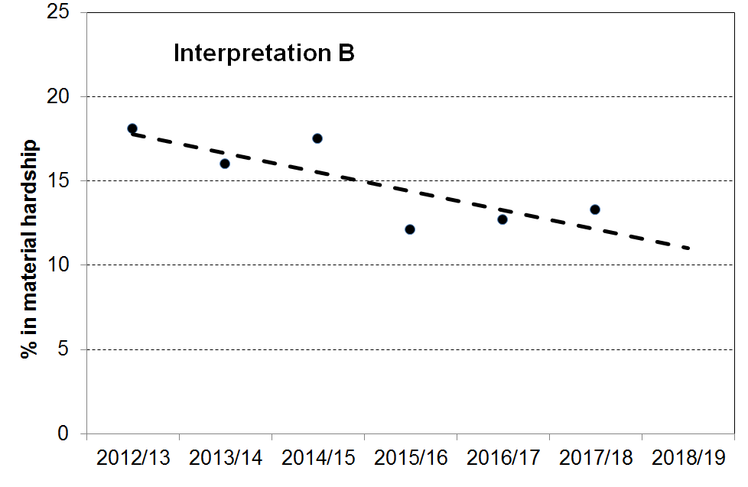
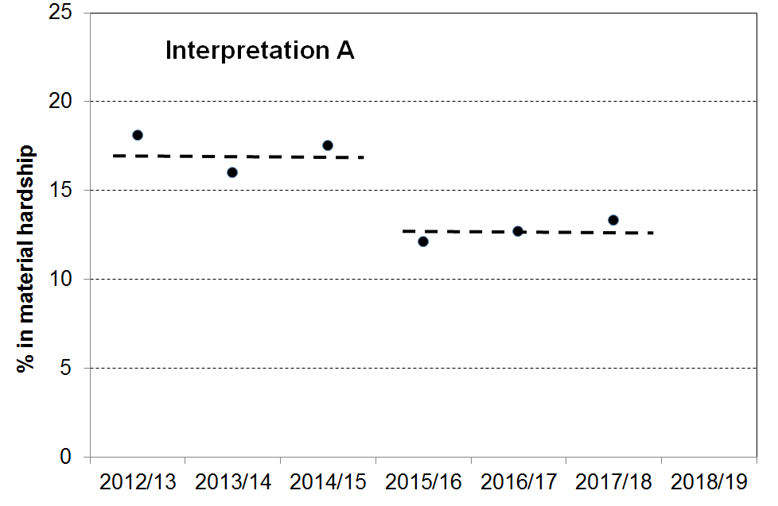
The two stylised charts below represent two plausible interpretations of the 2012/13 to 2017/18 figures. Is there are step-change, presumably driven by something very different in the data collection process (A)? Or, is there a downward trend as shown in (B), accepting that the 2015/16 survey data has indisputable bias downwards, 2016/17 some and 2017/18 much less?

Interpretation A is supported by extra information such as that provided by MSD in the 2018 reports. For example:
- the proportion of households with children reporting foodbank use fell away considerably in 2015/16 and was not much higher in 2016/17
- there was a substantially higher number of Maori households reporting ‘more than enough’ income in 15/16 and 16/17 compared with earlier years.

The available sample error information when using the standard Stats NZ weights also supports interpretation A, as noted above.

There is however support for Interpretation B in the following.

First the sample errors using the revised weights are much larger. The Technical Appendix notes this on p21 though no explanation is given. It is possibly in part an consequence of using more benchmarks in the revised weighting calculations which pushes the weighting methodology to the limit, producing higher sample error estimates. Using the larger sample errors, the large fall is within the 95% CI for the change. This is not conclusive, but it raises doubts about one of the key rationales in support of Interpretation A.

A stronger support for Interpretation B comes from independent information from the General Social Survey (GSS). The GSS does not have DEP-17 information in it, but it does have the items to construct MWI-9, a short-form of MSD’s full 24-item Material Wellbeing Index. DEP-17 and the MWI are strongly correlated at the low end. The material hardship rates for children fell from 2014/15 to 2016/17 using GSS data.

Reported foodbank usage by households with children in 2017/18 is back to what it was in 2012/13 to 2014/15. This suggests that the 2017/18 survey has less sample bias at the bottom end.

Interpretation B is also supported by the fact that, for other countries that report material hardship rates, the rates rose during the GFC then fell during the recovery (eg Ireland and Spain, as noted in MSD’s 2018 reports). The rise and fall of hardship rates are more pronounced than changes in low income rates during a recession and recovery. Although the DEP-17 time series can only go back to 2012/13 (as in the Stats NZ release), MSD has reported in the past on hardship rates prior to 2012/13 using other information, thus producing a spliced time series from 2006/07 to 2017/18. This series shows a rise and fall as in Ireland and Spain (provided 2015/16 is set aside as a survey with evidence of more-than-usual sample bias).

The information from the GSS and from the other MSD analysis is combined in the chart below. The support for Interpretation B is not conclusive, but the weight of the evidence seems to point that way.

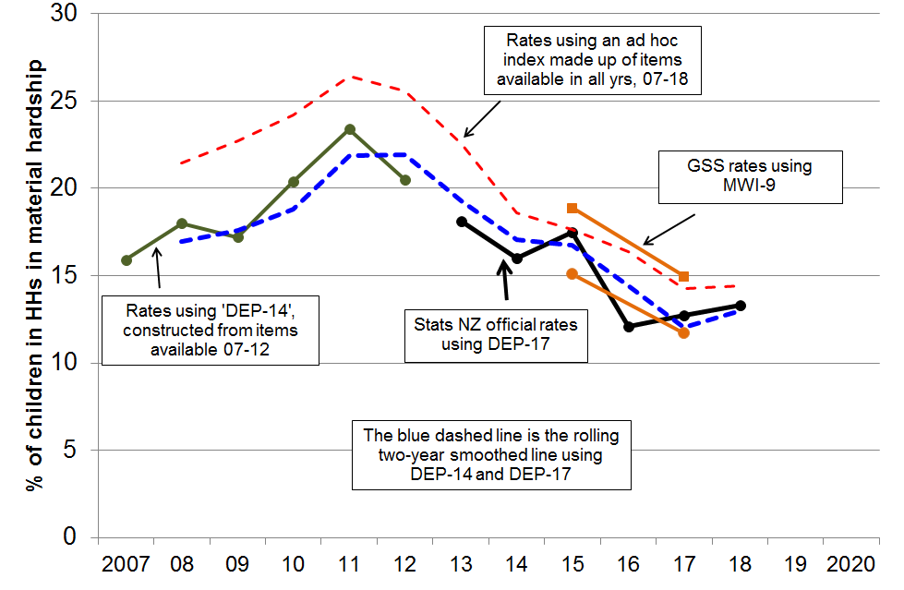

The full 2006/07 to 2017/18 trend line shows the importance of understanding the implications of choosing a particular starting point for creating a summary narrative. Starting with 2012/13 and not knowing about the trend prior to that can lead to claims of a steady downward trend which easily get elaborated into something more general as if that is what has been happening for a much longer time.

The child poverty reduction targets – the long-run view

Now that the official 2017/18 baseline rates have been released by Stats NZ, the Government will use these to set final targets and gazette them by 20 June as required by the Child Poverty Reduction Act.

The table below shows the official Stats NZ baseline rates for 2017/18, and the 10-year targets announced by the government last year based on officials best estimates in 2017 of the 17/18 baseline rates.

 | official 17/18 baseline rate | 10-year target as announced last year
BHC 50% relative | 16% | ~5%
AHC 50% fixed | 23% | ~10%
Material hardship | 13% | ~7%

The three charts below give a stylised high-level view of the required track to the 2028 10-year targets announced last year.
- The targets are represented by larger circles to indicate that sample errors at the time are likely to need to be taken into account to assess whether the targets are met or not.
- In practice, the pathways are unlikely to be linear.

50% BHC target
- The track to the 50% BHC target will require the income of low-income households with children to rise considerably faster than the median, consistently over the whole period.
- The measurement challenges for assessing progress to the BHC 50% target will become increasingly demanding as the rate falls, given the poorer quality of very low income data, as discussed above. If, say, the very bottom 2-3% have implausibly low incomes, then this represents around half those under a 5% ten-year target, and some dataset adjustment may be needed in the future to address the issue as the reported rates become smaller.

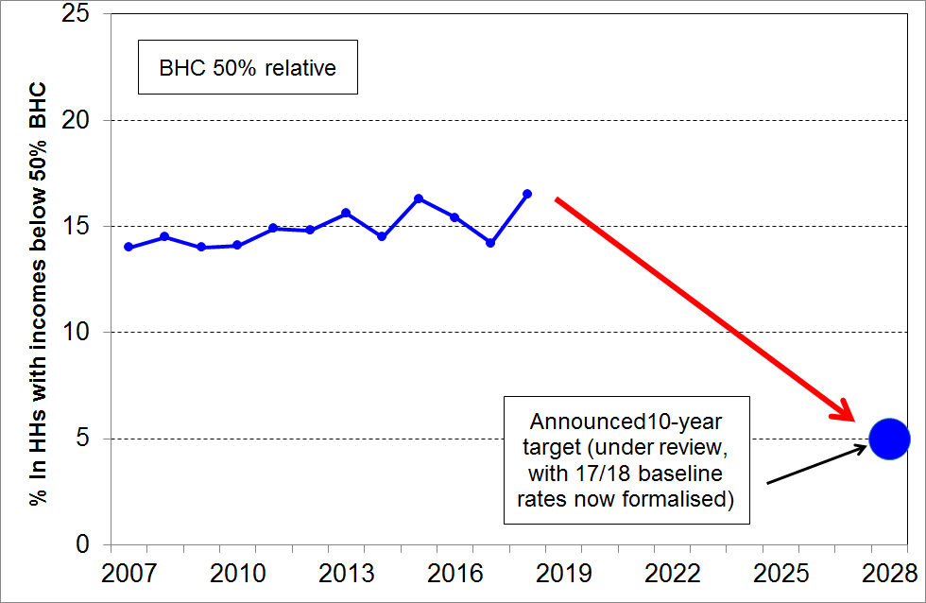

50% AHC fixed line target
- If it is assumed that the current downward trend continues, the track to the 50% AHC fixed line target looks relatively straightforward. However, it will only take a recession or even just a significant slow-down in the world economy and/or in New Zealand, and the line will quickly flatten or turn upwards.
- This feature of the fixed line measure underlines the value of having it in the suite of measures, as in recessionary circumstances the fully relative line can show a decline in low-income rates if the median falls more rapidly than low incomes, aspects of which are often (mostly) protected in real inflation-adjusted terms.

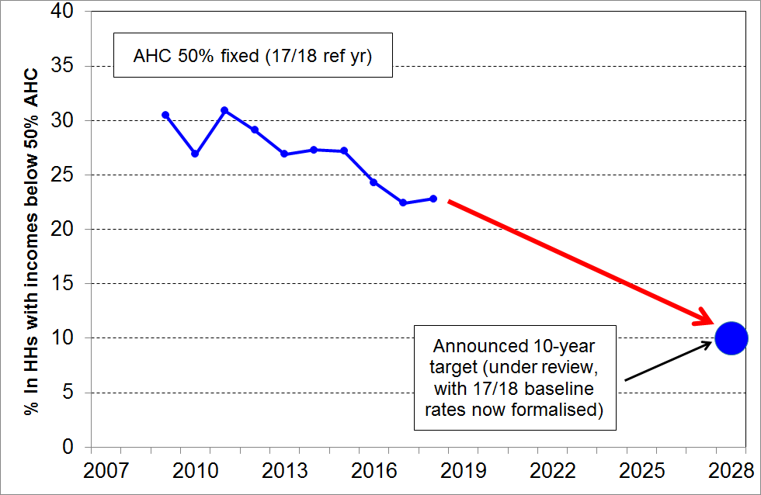

The material hardship target
- If it is assumed that the current downward trend continues (see chart on next page), the track to the material hardship target also looks relatively straightforward.
- It is however likely to be much more difficult to reduce the rate from 13% to ~7% than from 20% to 13% as occurred in the post-GFC period. The bulk of the latter fall came from improvements in the economy and employment, especially for second income earners, after the peaking of the hardship rate in around 2010/11 in the recession. 2017/18 rates are not much lower than the pre-recession rates in 2006/07.
- Further reduction (from the 2017/18 baseline rate of 13%) is likely to involve addressing not only household income needs, but other factors too. Household income levels are a major influence on material hardship rates, but other factors impact too (such as past income, financial and physical asset levels, special demands on the household budget for health costs or debt repayment, assistance from outside the household, ability to access available government and NGO services, personal skills and abilities, quality of relationships among adult household members, and so on). A government can reasonably directly change income levels, but many of the other factors are beyond its direct control.
- In addition, as for the 50% AHC fixed line measure, it will only take a recession or even just a significant slow-down in the world economy and/or in New Zealand, and the line will turn upwards very quickly. Material hardship measures are very sensitive to changes in wider economic conditions, and the upturn /downturn can be stronger than for income measures.

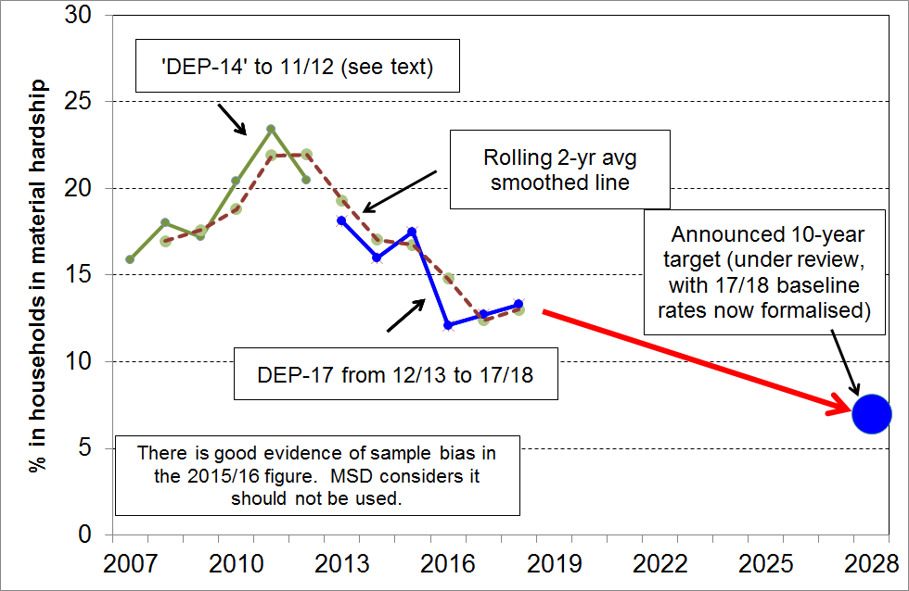

Questions and Answers

Which figures are more correct, MSD’s or Stats NZ’s?

- The Stats NZ rates are the official ones.

- What are commonly referred to as “MSD figures” are those that MSD reports in its annual Household Incomes Report and the associated reports using non-income measures. These figures are based on an analysis of Stats NZ’s Household Economic Survey (HES) with the income data enhanced by modelling by Treasury. MSD’s main low-income and material hardship figures are checked with Stats NZ each year to ensure we get the same numbers.

- What are referred to as the “Stats NZ” figures are the new ones released on 2 April 2019, based on improved data sources (especially for income) and/or revised weights to better address sample bias.

- While the short-hand description of “MSD figures” and “Stats NZ figures” is convenient, care needs to be taken to avoid leaving the mistaken impression that the two agencies come up with different numbers. Both sets are “correct” based on the datasets and weights used.

Which figures should we use, MSD’s or Stats NZ’s?

- See previous question and answer.

- For 2017/18 baseline rates, use the Stats NZ figures.

- For low-income rates for the last decade or so, use Stats NZ figures. MSD figures are needed to set the more recent trends in a longer-term context.

- For material hardship rates from 2012/13, use Stats NZ figures. MSD figures are needed to set the more recent trends the context of pre- and post the Global Financial Crisis.

- It remains important for MSD to publish its wide-ranging analysis that covers many more areas than child poverty since 2006/07.

Why has MSD published both sets of rates?

- To give a clear account of the difference the new dataset and weights make.

- To give a longer time series than is available with the figures released by Stats NZ, consistent with MSD’s normal work.

When is MSD scheduled to publish the annual Household Incomes report?

- July-August 2019.

Last year, MSD did not publish 2015/16 and 2016/17 low income and material hardship results. Will they be publishing 2017/18 results.

- Yes, in July-August 2019.

- 2017/18 survey does not have the concerning characteristics evident in 2015/16 and even to some degree in 2016/17 that led to the pause in publishing last year.
MSD has today published child poverty numbers for 2017/18 - why are the rest of the numbers for other groups not available?

- The Household Incomes Report and the companion reports using non-income measures have a very wide range of material in them and this is still being prepared and checked.

- The focus to date for MSD and Stats NZ has been on the figures for children, to ensure that the Act can be properly implemented.

Why are the new Stats NZ figures consistently one to two percentage points higher than the MSD figures? (This is particularly evident for the AHC 40% trend).

- The main driver of the differences is the use of admin data for income. The medians are not greatly changed by this change, so thresholds are around the same. It seems that the admin information has more very low-income households then the survey data. This is being further investigated.

Why do all the child poverty numbers have sample errors? Are these mistakes?

- Sample (or sampling) errors are not mistakes. “Sample error” is a technical term that statisticians use to refer to the inevitable variation and uncertainty that occurs when samples are used rather than interviewing every household.
- Standard reporting for this sort of information (low-income rates etc) is to use a 95% confidence intervals. A 15% rate with a sample error of 2pp means that there is a 95% chance of true value being between 13% and 17%.

What are the high-level trends in the latest information released by Stats NZ?

- BHC fully relative low-income: slightly rising trend from 2006/07 to 2017/18 as the median rose a little more quickly than low incomes.
- AHC fully relative low income: fairly flat trend on all three measures from 2006/07 to 2017/18.
- AHC fixed line measure (17/18 reference year): rose from 2006/07 to around 2010/11 through the Global Financial Crisis, then a declining trend from then.
- Material hardship: rose from 2006/07 through the GFC to a peak in 2010/11 then has declined since.

Are all children in low-income households experiencing material hardship?

- No.

- The overlap between those in low-income households and those experiencing material hardship is considerably less than 100%, and the actual overlap depends on the measures being compared.

- For example, only around a quarter of children in households with incomes below a 60% of median AHC threshold are in households experiencing material hardship. This is what the 9th measure reported by Stats NZ shows (the overlap measure for those in low-income and experiencing hardship). Using the 40% AHC measure, around 37% of children from poor households are in households in hardship - more than the 25% for the AHC 60% measure, but still well short of even 50%.

- Current income matters, but there are many other factors that lead to material hardship. Income in previous years, the current stock of household durables, the size of liquid asset holdings, unusually high health or debt servicing costs, help from outside the household , and so on, all work to loosen the direct link between income and the actual day-to-day lived experiences of households. .

- This is why a multi-measure approach is needed.

How many children are in poverty?

- The question assumes that there is a single poverty line that divides households clearly into the poor and the non-poor. Any measure of poverty requires judgment calls regarding what poverty means and a decision on a threshold, so there can be legitimate debate about what the appropriate threshold is. In addition, there are decisions to be made as to what the appropriate resource is that is used (BHC income, AHC income, income plus liquid assets, and so on).

- The Act specifies a range of measures and thresholds, consistent with the view that a multi-measure multi-level approach is needed to properly understand and assess progress.

- The following table is drawn from the Stats NZ release. It shows the rates and numbers for the baseline year (2017/18).

measure | rate (%) | number
BHC 50 | 16 | 183,000
BHC 60 | 25 | 281,000
AHC 40 | 16 | 174,000
AHC 50 | 23 | 254,000
AHC 60 | 31 | 341,000
Material hardship (6+/17) | 13 | 148,000
Severe material hardship (8+/17) | 6 | 65,000
Both under AHC 60 and in MH | 9 | 98,000

What impact has the Government’s Families Package had on these rates?

- The impact of the Families Package will not be seen in these latest child poverty estimates, because they are outside of the timeframe of the data collection. The 2017/18 estimates are based on data that was collected between July 2017 and June 2018. The first of the Families Package changes came in on 1 April 2018, with the final changes implemented on 1 July 2018.

Do the new Stats NZ figures have any effect on Treasury’s estimates of the expected impact of the Families Package on BHC low-income rates?

• No, Stats NZ and MSD use the HES data to monitor past levels and trends. Treasury uses HES data to model the impact of policy changes on future numbers.

• Treasury's role has been to estimate the proportional reduction of projected numbers of children in low income households due to the Families Package. Relative impact estimates are generally robust to small to moderate changes in the underlying levels of child poverty and so are unlikely to need to be reviewed in the light of the new data.

• Treasury will consider and adopt where feasible the methodological improvements Stats NZ has put in place.

What is the impact of the new Stats NZ figures on Government targets for child poverty reduction?

• The Stats NZ 2017/18 baseline figures are close to the ‘best estimates’ provided by officials in 2017 and which were the basis for the government targets announced last year.

• The government will now use these official baseline figures to set final targets and gazette them by 20 June as required by the Child Poverty Reduction Act.
Appendix One
Summary of changes to definitions compared with those used by MSD to date

The concepts, assumptions and definitions used in the Child Poverty Reduction Act itself, and in the Government Statistician’s concepts and definitions have much in common with those used in the MSD reports. The Government Statistician’s definitions do however differ at several points from those used by MSD in their latest 2018 Household Incomes Report. As noted in the table below, these changes have only a very minor impact on reported low-income rates. The only change that has a substantial impact on reported rates for children is the move to a threshold of 6+/17 from 7+/17 for the DEP-17 material hardship index. MSD’s Working Paper 01/19 has details on the rationale for this change. There are no changes to definitions of income, household and child (0-17yrs).

The main drivers of any differences between rates reported by MSD to date and those in Stats NZ’s 2 April release are:
- the pooling of HES and HLFS samples for BHC incomes – this reduces sample errors and smoothes the trend line
- the use of admin data for incomes rather than the survey data – this leads to higher low-income estimates in the Stats NZ 2 April release compared with the MSD numbers, especially for the 40% AHC and 50% BHC measures.

 | StatsNZ 2 April release | MSD (2018 reports) | Impact on reported low-income or hardship rates
Housing costs | Rent, mortgage (principal and interest), rates, building insurance | Same, except that building insurance not included to date. MSD changing in 2019 reports. | No impact on BHC rates.  A small drop for reported AHC low-income rates as the median drops because many households with income in that zone own their own home and have dwelling insurance.  No impact for hardship.
Equivalence scales | 50% BHC – modified OECD plus square root (for OECD comparisons)  60% BHC – modified OECD  All AHC – modified OECD | 50% BHC – modified OECD plus square root  60% BHC – modified OECD  All AHC – UK’s scale for AHC (starting in 2018 report), plus modified OECD in an Appendix | Using the modified OECD scale makes virtually no difference to rates or trends compared with using the Jensen scale (as done prior to 2018 report).  Using the UK’s AHC equivalence scale makes almost no difference for rates for children (but does for some households without children).
Reference year for fixed line low-income measures | 2017-18 | 2006-07 to date, with stated intent move to 2017-18 in 2019 reports | Nil, as same reference year to be used from 2019 report on.
Inflator for AHC fixed line threshold | Household Living Price Index (for lower income quintile) | CPI to date, but will use HLPI (lower quintile) starting in 2019 reports, with Appendix showing difference when using CPI | Using the HLPI gives slightly higher fixed line low-income rates than when using the CPI, as the HLPI has to date risen more than the CPI since 2009/09.  No impact for hardship rates.
Material hardship measure | DEP-17 | DEP-17 (plus EU-13 and the MWI/ELSI) | Nil, as same index used. Also, MWI and DEP-17 give virtually identical hardship rates.
DEP-17 threshold | 6+/17 | 7+/17 | The change raises the reported hardship rate for 2017/18 from ~10% to ~13% (~140k children), to be closer to the EU-13 rate of ~15%. The rates for earlier years also rise by a similar amount.

The only definitional change that has a substantial impact on reported rates for children is the move to a threshold of 6+/17 from 7+/17 for the DEP-17 material hardship index (though the 6+/17 rates are the same as what MSD has previously published as 6+ rates). The rationale for this change was set out in Stats NZ’s Concepts and Definitions release in February 2019 and in MSD’s Working Paper 01/19 released at the same time. The latter is available at https://www.msd.govt.nz/about-msd-and-our-work/publications-resources/working-papers/index.html
See also p6 above.
https://www.msd.govt.nz/about-msd-and-our-work/publications-resources/working-papers/index.html
See main text for more detail on this, especially pages 6 and 11.

