The Ministry of Social Development

The Statistical Report

for the year ending June 2004

© 2005 Ministry of Social Development

Acknowledgments:

The Ministry of Social Development is grateful for the assistance of staff from all its service lines in the production of The Statistical Report.

Published by:

Ministry of Social Development
Bowen State Building, Bowen Street
PO Box 12 136, Wellington
New Zealand

Telephone: +64 4 916 3300
Facsimile: +64 4 918 0099
Website: www.msd.govt.nz

ISSN 1176-3388
Contents

Section 1 - Introduction 1
Introduction to The Statistical Report 1
Section 2 - Assistance provided by Work and Income 2
Introduction 2
Conventions in this report 2
Benefits, pensions and hardship assistance 4
Employment services 8
Overall trends in use of financial assistance and employment services 9
Summary information on use of core benefits 11
Children dependent on core benefit recipients and on registered job seekers 20
Other income declared by recipients of core benefits 22
Section 3 - Trends in use of core benefits, pensions and employment services provided by Work and Income 25
Introduction 25
Unemployment-related benefits 25
Carers’ benefits 34
Sickness-related benefits 41
Invalids’ Benefit 48
Unsupported Child’s Benefit and Orphan’s Benefit 53
Widows’ Benefit 58
Employment services 62
Transition to Work assistance 69
Transitional Retirement Benefit 74
New Zealand Superannuation 78
Veterans’ Pension 83
Emergency Benefit 87
Section 4 - Supplementary benefits and hardship assistance 90
Introduction 90
Supplementary benefits 90
Accommodation Supplement 90
Tenure Protection Allowance 95
Special Transfer Allowance 95
Away from Home Allowance 98
Childcare Subsidy 100
OSCAR (Out-of-School Care and Recreation) Subsidy 103
Disability Allowance 107
Child Disability Allowance 112
Training Incentive Allowance 116
Residential Care Subsidy and Residential Support Subsidy 118
Hardship assistance 121
Student Allowance Transfer Grants 133
Section 5 - Students 136
Assistance available to students 136
Student Allowances 136
Student Loans 139
Section 6 - Additional information 143
Community Services Cards 143
Benefit Control 146
Debt Management 147
Social Security Agreements 149
Section 7 - Trends since 1940 in use of, and expenditure on, core benefits and pensions 156
Appendix 1 - Administration of benefits and pensions 160
Income testing 160
Work testing 160
The Personal Development and Employment Plan 161
Appendix 2 - Definition of officially unemployed, and differences
from registered job seekers 163
Appendix 3 - SWIFTT and SOLO data underlying calculation of the proportion of the population receiving Work and Income assistance 164

List of Tables

Section 2 - Assistance provided by Work and Income 2
Benefits, pensions and hardship assistance 4
Table 2.1 Weekly payment rates for core benefits 5
Table 2.2 Weekly payment rates for selected supplementary benefits 6
Table 2.3 Payment rates for New Zealand Superannuation and Veterans’ Pension 7
Overall trends in use of financial assistance and employment services 9
Table 2.4 Trends in the number of people receiving financial assistance from Work and Income and in the number of registered job seekers 10
Summary information on use of core benefits 11
Table 2.5 Trends in the types of core benefit received 12
Table 2.6 Trends in the ages of core benefit recipients 13
Table 2.7 Trends in the length of current spells receiving core benefits 13
Table 2.8 Trends in the ethnicity of core benefit recipients 14
Table 2.9 Trends in the length of period since clients granted core benefits last received
any core benefit 14
Table 2.10 Trends in the types of core benefit granted 15
Table 2.11 Trends in the types of core benefits ceased 16
Table 2.12 Trends in reasons for ceasing core benefits 16
Table 2.13 Trends in expenditure on core benefits and pensions 17
Table 2.14 Proportion of Gross Domestic Product accounted for by core benefit and
pension expenditure 18
Table 2.15 Trends in the distribution of core benefit expenditure across age groups 19
Table 2.16 Trends in the distribution of core benefit expenditure across gender groups 19
Table 2.17 Trends in the distribution of core benefit expenditure across ethnic groups 19
Children dependent on core benefit recipients and on registered job seekers 20
Table 2.18 Trends in the ages of children dependent on core benefit recipients 20
Table 2.19 Trends in the ages of children dependent on registered job seekers 21
Other income declared by recipients of core benefits 22
Table 2.20 Trends in the levels of other income declared by core benefit recipients 24
Table 2.21 Trends in the types of core benefit received by people declaring other income 24
Section 3 - Trends in use of core benefits, pensions and employment services provided by Work and Income 25
Unemployment-related benefits 25
Table 3.1 Trends in unemployment-related benefits received 28
Table 3.2 Trends in the ages of recipients of an unemployment-related benefit 29
Table 3.3 Trends in the length of current spells receiving an unemployment-related
benefit 29
Table 3.4 Trends in the length of period since clients granted an unemployment-related benefit last received any core benefit 31
Table 3.5 Trends in unemployment-related benefits granted 32
Table 3.6 Trends in reasons for cessations of unemployment-related benefits 32
Table 3.7 Trends in unemployment-related benefits ceased 33
Table 3.8 Trends in annual expenditure on unemployment-related benefits and Emergency Benefits 33
Carers’ benefits 34
Table 3.9 Trends in carers’ benefits received 36
Table 3.10 Trends in ages of the youngest child dependent on people receiving a Domestic Purposes Benefit – Sole Parents or an Emergency Maintenance Allowance 37
Table 3.11 Trends in the length of period since clients granted carers’ benefits last
received any core benefit 39
Table 3.12 Trends in ages of the youngest child dependent on people granted a
Domestic Purposes Benefit – Sole Parents or an Emergency Maintenance Allowance 39
Table 3.13 Trends in reasons for cessations of carers’ benefits 40
Table 3.14 Trends in annual expenditure on carers’ benefits 40
Sickness-related benefits 41
Table 3.15 Trends in sickness-related benefits received 43
Table 3.16 Trends in the ages of clients receiving a sickness-related benefit 43
Table 3.17 Trends in the incapacities of clients receiving a sickness-related benefit 44
Table 3.18 Trends in the length of current spells receiving a sickness-related benefit 44
Table 3.19 Trends in the length of period since clients granted a sickness-related benefit
last received any core benefit 46
Table 3.20 Trends in the incapacities of clients granted a sickness-related benefit 46
Table 3.21 Trends in reasons for cessations of sickness-related benefits 47
Table 3.22 Trends in annual expenditure on sickness-related benefits 47
Invalids’ Benefit 48
Table 3.23 Trends in the incapacities of clients receiving an Invalids’ Benefit 49
Table 3.24 Trends in the ages of clients receiving an Invalids’ Benefit 50
Table 3.25 Trends in the length of period since clients granted an Invalids’ Benefit last received any core benefits 51
Table 3.26 Trends in the incapacities of clients granted an Invalids’ Benefit 51
Table 3.27 Trends in reasons for cessations of Invalids’ Benefits 52
Table 3.28 Trends in annual expenditure on Invalids’ Benefits 52
Unsupported Child’s Benefit and Orphan’s Benefit 53
Table 3.29 Trends in the number of clients receiving an Unsupported Child’s Benefit or Orphan’s Benefit 54
Table 3.30 Trends in the ages of children covered by an Unsupported Child’s Benefit or Orphan’s Benefit 55
Table 3.31 Trends in ages of the youngest dependent child cared for by clients granted an Unsupported Child’s Benefit or Orphan’s Benefit 56
Table 3.32 Trends in reasons for cessations of Unsupported Child’s Benefits and Orphan’s Benefits 57
Table 3.33 Trends in combined annual expenditure on Unsupported Child’s Benefits and Orphan’s Benefits 57
Widows’ Benefit 58
Table 3.34 Trends in the length of current spells receiving a Widows’ Benefit 59
Table 3.35 Trends in the length of period since women granted a Widows’ Benefit last received any core benefit 60
Table 3.36 Trends in reasons for cessations of Widows’ Benefits 61
Table 3.37 Trends in annual expenditure on Widows’ Benefits 61
Employment services 62
Table 3.38 Trends in the types of core benefit or pension received by registered
job seekers 64
Table 3.39 Trends in the ages of registered job seekers 65
Table 3.40 Trends in the length of current spells registered as a job seeker 65
Table 3.41 Trends in the ethnicity of registered job seekers 66
Table 3.42 Trends in levels of the highest formal educational qualification held by
registered job seekers 66
Table 3.43 Trends in the length of period since newly registered job seekers were last
enrolled as a job seeker 67
Table 3.44 Trends in reasons for deregistrations of job seekers 68
Transition to Work assistance 69
Table 3.45 Maximum rates of Seasonal Work Assistance payable 71
Table 3.46 Trends in the types of expenditure met by Work Start Grants provided 72
Table 3.47 Trends in the number of New Employment Transition Grants provided 72
Table 3.48 Trends in the number of Seasonal Work Assistance payments provided 72
Table 3.49 Trends in the number of Pathways Payments provided 73
Table 3.50 Trends in the value of Work Start Grants provided for each expenditure type 73
Table 3.51 Trends in expenditure on New Employment Transition Grants 74
Table 3.52 Trends in expenditure on Seasonal Work Assistance payments 74
Transitional Retirement Benefit 74
Table 3.53 Trends in the length of current spells receiving a Transitional Retirement
Benefit 75
Table 3.54 Trends in the length of period since clients granted a Transitional Retirement Benefit last received any core benefit 76
Table 3.55 Trends in reasons for cessations of Transitional Retirement Benefits 77
Table 3.56 Trends in annual expenditure on Transitional Retirement Benefits 77
New Zealand Superannuation 78
Table 3.57 Trends in the ages of clients receiving New Zealand Superannuation 79
Table 3.58 Trends in the length of period since clients granted New Zealand
Superannuation last received any core benefit or pension 81
Table 3.59 Trends in annual expenditure on New Zealand Superannuation 82
Veterans’ Pension 83
Table 3.60 Trends in the ages of clients receiving a Veterans’ Pension 84
Table 3.61 Trends in the length of period since clients granted a Veterans’ Pension last received any core benefit or pension 86
Table 3.62 Trends in annual expenditure on Veterans’ Pensions 86
Emergency Benefit 87
Table 3.63 Trends in the ages of people receiving an Emergency Benefit 88
Table 3.64 Trends in the length of periods since clients granted an Emergency Benefit last received any core benefit 89
Table 3.65 Trends in reasons for cessations of Emergency Benefits 89
Section 4 - Supplementary benefits and hardship assistance 90
Accommodation Supplement 90
Table 4.1 Trends in the types of core benefit or pension paid to clients receiving an Accommodation Supplement 91
Table 4.2 Trends in the ownership status of clients receiving an Accommodation
Supplement 92
Table 4.3 Trends in the types of core benefit or pension paid to clients granted an Accommodation Supplement 93
Table 4.4 Trends in annual expenditure on Accommodation Supplements 94
Special Transfer Allowance 95
Table 4.5 Trends in the types of core benefit or pension paid to clients receiving a Special Transfer Allowance 96
Table 4.6 Trends in the types of core benefit or pension paid to clients granted a Special Transfer Allowance 97
Table 4.7 Trends in combined annual expenditure on Tenure Protection Allowances and Special Transfer Allowances 97
Away from Home Allowance 98
Table 4.8 Trends in the types of core benefit or pension paid to clients receiving an Away from Home Allowance 99
Table 4.9 Trends in the types of core benefit or pension paid to clients granted an Away
from Home Allowance 100
Childcare Subsidy 100
Table 4.10 Trends in the types of core benefit or pension paid to caregivers of children covered by a Childcare Subsidy 101
Table 4.11 Trends in the types of core benefit or pension paid to caregivers of children covered by Childcare Subsidies granted 102
Table 4.12 Trends in reasons for granting Childcare Subsidies 103
OSCAR (Out-of-School Care and Recreation) Subsidy 103
Table 4.13 Trends in the types of core benefit or pension paid to caregivers of children covered by an OSCAR Subsidy 104
Table 4.14 Trends in the types of core benefit or pension paid to caregivers of children covered by OSCAR Subsidies granted 105
Table 4.15 Trends in reasons for granting OSCAR Subsidies 106
Table 4.16 Trends in combined annual expenditure on Childcare Subsidies and OSCAR Subsidies 106
Disability Allowance 107
Table 4.17 Trends in the types of core benefit or pension paid to clients covered by a
Disability Allowance or paid to their caregivers 109
Table 4.18 Trends in the types of core benefit or pension paid to clients covered by
Disability Allowances granted or paid to their caregivers 111
Table 4.19 Trends in annual expenditure on Disability Allowances 111
Child Disability Allowance 112
Table 4.20 Trends in the types of core benefit or pension paid to caregivers of children covered by a Child Disability Allowance 113
Table 4.21 Trends in the types of core benefit or pension paid to caregivers of children covered by Child Disability Allowances granted 114
Table 4.22 Trends in annual expenditure on Child Disability Allowances 115
Training Incentive Allowance 116
Table 4.23 Trends in the types of core benefit paid to clients granted an ongoing Training Incentive Allowance 117
Table 4.24 Trends in annual expenditure on Training Incentive Allowances 117
Residential Care Subsidy and Residential Support Subsidy 118
Table 4.25 Trends in the types of core benefit or pension paid to clients receiving a Residential Care Subsidy or Residential Support Subsidy 119
Table 4.26 Trends in the types of core benefit or pension paid to clients granted a
Residential Care Subsidy or a Residential Support Subsidy 121
Hardship assistance 121
Table 4.27 Trends in the types of core benefit or pension paid to clients receiving a
Special Benefit 122
Table 4.28 Trends in the types of core benefit or pension paid to clients granted a
Special Benefit 124
Table 4.29 Trends in annual expenditure on Special Benefits 124
Table 4.30 Income limits, cash asset limits and maximum payments for the Recoverable Assistance Programme 126
Table 4.31 Trends in types of lump sum hardship assistance payments 127
Table 4.32 Trends in the types of core benefit or pension paid to clients receiving Special Needs Grants and benefit advances 128
Table 4.33 Trends in the value of Special Needs Grants and benefit advances received by clients paid each type of core benefit or pension 129
Table 4.34 Trends in the purposes of Special Needs Grants and benefit advances 130
Table 4.35 Trends in the total and average level of assistance provided under the Recoverable Assistance Programme 130
Table 4.36 Trends in annual expenditure on Special Needs Grants 131
Table 4.37 Trends in annual expenditure on benefit advances 132
Student Allowance Transfer Grants 133
Table 4.38 Asset and income limits for Student Allowance Transfer Grants 134
Table 4.39 Trends in the types of core benefit or pension received by clients granted a Student Allowance Transfer Grant 134
Table 4.40 Trends in annual expenditure on Student Allowance Transfer Grants 135
Section 5 - Students 136
Student Allowances 136
Table 5.1 Payment rates for Student Allowances 137
Table 5.2 Trends in the types of Student Allowances received 138
Table 5.3 Trends in the types of Bursaries received by students enrolled in eligible institutions 138
Table 5.4 Trends in annual expenditure on Student Allowances 139
Student Loans 139
Table 5.5 Maximum amount available by component of Student Loan 140
Table 5.6 Trends in the annual amount per student drawn against Student Loans 140
Table 5.7 Trends in the types of Student Allowances received by students making
drawings against Student Loans 141
Table 5.8 Trends in the types of institutions attended by students making drawings
against Student Loans 141
Table 5.9 Trends in the number of drawings made against Student Loan components 142
Section 6 - Additional information 143
Community Services Cards 143
Table 6.1 Trends in the groups of clients holding Community Services Cards 144
Table 6.2 Trends in issues of new Community Services Cards and in renewals of
Community Services Cards 145
Table 6.3 Trends in annual expenditure on Community Services Cards 145
Benefit Control 146
Table 6.4 Trends in benefit control statistics by source of information 146
Table 6.5 Trends in cases investigated and dollar returns 147
Debt Management 147
Table 6.6 Trends in debt established, debt repaid and outstanding debt 148
Table 6.7 Trends in the number of debtors with open debts, by category 149
Social Security Agreements 149
Table 6.8 Trends in the number of clients qualifying for New Zealand entitlements under social security agreements, by country of reciprocity 153
Table 6.9 Trends in the number of Work and Income clients receiving an overseas
pension, by country the pension is received from 155
Section 7 - Trends since 1940 in use of, and expenditure on, core benefits and pensions 156
Table 7.1 Historical summary – numbers of people receiving core benefits and pensions 1940–2004 156
Table 7.2 Historical summary – expenditure on core benefits and pensions 1940–2003 158
Appendix 3 - SWIFTT and SOLO data underlying calculation of the proportion of the population receiving Work and Income assistance 164
Table A3.1 Trends in the numbers of people aged 18 years or over receiving Work and Income assistance (used in Figure 2.1) 164
Table A3.2 Trends in the ages of children aged under 18 years who are dependent on clients receiving a core benefit (used in Figure 2.2) 164
Table A3.3 Trends in the ages of children aged under 18 years who are dependent on registered job seekers (used in Figure 2.3) 164
Table A3.4 Trends in the ages of clients aged 18–59 years receiving an
unemployment-related benefit (used in Figure 3.1) 165
Table A3.5 Trends in the number of clients aged 16–17 years receiving an Independent
Youth Benefit (used in Figure 3.2) 165
Table A3.6 Trends in the ages of clients aged 18–59 years receiving a Domestic Purposes Benefit – Sole Parent or an Emergency Maintenance Allowance (used in Figure 3.4) 165
Table A3.7 Trends in the ages of clients aged 18–59 years receiving a sickness-related
benefit (used in Figure 3.6) 165
Table A3.8 Trends in the ages of clients aged 18–59 years receiving an Invalids’ Benefit
(used in Figure 3.8) 166
Table A3.9 Trends in the ages of children aged under 18 years covered by an Unsupported Child’s Benefit or Orphan’s Benefit (used in Figure 3.10) 166
Table A3.10 Trends in the ages of women aged 18–59 years receiving a Widows’ Benefit
(used in Figure 3.12) 166
Table A3.11 Trends in the ages of registered job seekers aged 18–59 years (used in Figure 3.14) 167
Table A3.12 Trends in the numbers of 60–64 year olds receiving a Transitional Retirement Benefit (used in Figure 3.15) 167
Table A3.13 Trends in the ages of clients aged 65 years or over receiving New Zealand Superannuation (used in Figure 3.17) 167
Table A3.14 Trends in the ages of clients aged 65 years or over receiving a Veterans’
Pension (used in Figure 3.19) 167
Table A3.15 Trends in the ages of clients aged 18–59 years receiving an Emergency
Benefit (used in Figure 3.21) 168
Table A3.16 Trends in the ages of clients aged 18 years or over receiving an
Accommodation Supplement (used in Figure 4.1) 168
Table A3.17 Trends in the numbers of children aged under five years covered by a Childcare Subsidy (used in Figure 4.4) 168
Table A3.18 Trends in the ages of children aged 5–14 years covered by an OSCAR Subsidy (used in Figure 4.5) 168
Table A3.19 Trends in the ages of people covered by a Disability Allowance
(used in Figure 4.7) 169
Table A3.20 Trends in the ages of children aged under 18 years covered by a Child
Disability Allowance (used in Figure 4.9) 169
Table A3.21 Trends in the ages of clients aged 65 years or over receiving a Residential
Care Subsidy (used in Figure 4.12) 169
Table A3.22 Trends in the ages of clients aged 18 years or over receiving a Special
Benefit (used in Figure 4.13) 170

List of Graphs

Section 2 - Assistance provided by Work and Income 2
Overall trends in use of financial assistance and employment services 9
Figure 2.1 Trends in the proportion of the represented age groups who were receiving core benefits, were registered as job seekers, or were receiving one or more supplementary benefits and/or a Special Benefit 11
Children dependent on core benefit recipients and on registered job seekers 20
Figure 2.2 Trends in the proportion of children aged under 18 years dependent on core benefit recipients, by age 21
Figure 2.3 Trends in the proportion of children aged under 18 years dependent on
registered job seekers, by age 22
Section 3 - Trends in use of core benefits, pensions and employment services provided by Work and Income 25
Unemployment-related benefits 25
Figure 3.1 Trends in the proportion of 18–59 year olds receiving an unemployment-related benefit, by age 30
Figure 3.2 Trends in the proportion of 16–17 year olds receiving an Independent Youth Benefit 30
Figure 3.3 Trends in monthly expenditure on unemployment-related benefits and
Emergency Benefits 34
Carers’ benefits 34
Figure 3.4 Trends in the proportion of 18–59 year olds receiving a Domestic Purposes
Benefit – Sole Parents or an Emergency Maintenance Allowance, by age 38
Figure 3.5 Trends in monthly expenditure on carers’ benefits 41
Sickness-related benefits 41
Figure 3.6 Trends in the proportion of 18–59 year olds receiving a sickness-related benefit,
by age 45
Figure 3.7 Trends in monthly expenditure on sickness-related benefits 48
Invalids’ Benefit 48
Figure 3.8 Trends in the proportion of 18–59 year olds receiving an Invalids’ Benefit 50
Figure 3.9 Trends in monthly expenditure on Invalids’ Benefits 53
Unsupported Child’s Benefit and Orphan’s Benefit 53
Figure 3.10 Trends in the proportion of children aged under 18 years covered by an Unsupported Child’s Benefit or Orphan’s Benefit, by age 55
Figure 3.11 Trends in monthly expenditure on Unsupported Child’s Benefits and Orphan’s Benefits 58
Widows’ Benefit 58
Figure 3.12 Trends in the proportion of women aged 18–59 years receiving a Widows’
Benefit, by age 60
Figure 3.13 Trends in monthly expenditure on Widows’ Benefits 62
Employment services 62
Figure 3.14 Trends in the proportion of 18–59 year olds registered as job seekers, by age 67
Transitional Retirement Benefit 74
Figure 3.15 Trends in the proportion of 60–64 year olds receiving a Transitional Retirement Benefit 76
Figure 3.16 Trends in monthly expenditure on Transitional Retirement Benefits 78
New Zealand Superannuation 78
Figure 3.17 Trends in the proportion of people aged 65 years or over receiving
New Zealand Superannuation, by age 80
Figure 3.18 Trends in monthly expenditure on New Zealand Superannuation 83
Veterans’ Pension 83
Figure 3.19 Trends in the proportion of people aged 65 years or over receiving a Veterans’ Pension, by age 85
Figure 3.20 Trends in monthly expenditure on Veterans’ Pensions 87
Emergency Benefit 87
Figure 3.21 Trends in the proportion of 18–59 year olds receiving an Emergency Benefit, by age 88
Section 4 - Supplementary benefits and hardship assistance 90
Accommodation Supplement 90
Figure 4.1 Trends in the proportion of people aged 18 years or over receiving an Accommodation Supplement, by age 92
Figure 4.2 Trends in monthly expenditure on Accommodation Supplements 94
Special Transfer Allowance 95
Figure 4.3 Trends in combined monthly expenditure on Tenure Protection Allowances and Special Transfer Allowances 98
Childcare Subsidy 100
Figure 4.4 Trends in the proportion of children aged under five years covered by a
Childcare Subsidy 101
OSCAR (Out-of-School Care and Recreation) Subsidy 103
Figure 4.5 Trends in the proportion of children aged 5–14 years covered by an OSCAR Subsidy, by age 104
Figure 4.6 Trends in combined monthly expenditure on Childcare Subsidies and OSCAR Subsidies 107
Disability Allowance 107
Figure 4.7 Trends in the proportion of the New Zealand population covered by a
Disability Allowance, by age 110
Figure 4.8 Trends in monthly expenditure on Disability Allowances 112
Child Disability Allowance 112
Figure 4.9 Trends in the proportion of children aged under 18 years covered by a Child Disability Allowance, by age 114
Figure 4.10 Trends in monthly expenditure on Child Disability Allowances 115
Training Incentive Allowance 116
Figure 4.11 Trends in monthly expenditure on Training Incentive Allowances 118
Residential Care Subsidy and Residential Support Subsidy 118
Figure 4.12 Trends in the proportion of people aged 65 years or over receiving a
Residential Care Subsidy, by age 120
Hardship assistance 121
Figure 4.13 Trends in the proportion of people aged 18 years or over receiving a Special Benefit, by age 123
Figure 4.14 Trends in monthly expenditure on Special Benefits 125
Figure 4.15 Trends in monthly expenditure on Special Needs Grants 132
Figure 4.16 Trends in monthly expenditure on benefit advances 133
Section 6 - Additional information 143
Debt Management 147
Figure 6.1 Total composition of Crown debt at 30 June 2004 149
164

Section 1 - Introduction

Introduction to The Statistical Report

This report presents a range of information about the use of financial assistance and employment services provided by the Ministry of Social Development (MSD). Within this report, information about the use of MSD assistance is also placed into a broader population context. We anticipate that the information contained in the report will be of value to anyone working in the social services sector, whether in a policy, research or service delivery capacity.

This report is based on information held in the client databases of MSD’s service lines. To ensure consistency over time in information sources, most information in this report, other than expenditure information, has been restricted to the period since 1 July 1999. Some of the statistics presented in this report are also available for earlier years, on request from MSD’s Decision Support team.

All information on the use and uptake of financial assistance or employment assistance presented in Sections 2–6 of this report was extracted using the measures and information sources currently used by MSD in its official reporting. Due to improvements in measurements and changes in the source of information, figures published in earlier reports in this series may not be able to be replicated in this report.

Expenditure information provided in this report differs from official MSD expenditure data, and should not be cited as official MSD expenditure data.

MSD is grateful for the assistance of staff from all of its service lines in the production of The Statistical Report.
Section 2 - Assistance provided by Work and Income

Introduction

This section summarises information on the use of financial assistance and employment services offered by MSD’s Work and Income service line. Sections 3 and 4 contain more detailed information about eligibility for, and use of, assistance provided by Work and Income. Information about the use of financial assistance provided by MSD’s StudyLink service line is outlined in Section 5.

Information about income tests, work tests and client development processes that are applied when providing benefits and pensions is outlined in Appendix 1. Information on reasons for differences between the number of registered job seekers and the number of people officially unemployed is outlined in Appendix 2. Additional information about trends in the ages of people who were receiving or covered by Work and Income assistance is provided in Appendix 3.

Conventions in this report

Throughout this report, financial assistance is referred to by:

 the official name (as at 30 June 2004) of a specific type of financial assistance (eg Domestic Purposes Benefit – Sole Parents)
 broad groups of core benefits that are delivered for similar purposes (defined in Section 3).

The official names for specific types of financial assistance used in this report have been current since at least 1 July 2001. Where the official name of a financial assistance programme has changed over time (eg Unemployment Benefit to Community Wage – Job Seeker), this is noted within the relevant section of the report.

Trends over time in the numbers of people receiving assistance from Work and Income are shown as numbers receiving these services at the end of each year ended 30 June. This approach aims to give broad trends in service use over a long period of time in a way that also enables actual numbers of clients receiving services to be shown.

This approach means, however, that the trends identified give no information about the numbers of people receiving assistance or services through Work and Income at other times of the year. In particular, it should be noted that large numbers of people may be granted assistance from Work and Income, and later cease receiving that assistance, without appearing in statistics showing people receiving those services at 30 June. Assistance provided to these people will, however, be represented in statistics showing assistance granted, assistance ceased, and expenditure on assistance. Because of this, the difference between assistance granted and assistance ceased during the financial year will not correspond to the change between the beginning and end of the financial year in the numbers of people receiving assistance.

In this report, reference is made to SWIFTT and SOLO as sources for the data used in this report. SWIFTT is the system used by Work and Income to record information on financial assistance recipients and on financial assistance being paid, and it contains a comprehensive record of information collected since 1995. SOLO is the system used by Work and Income to record information on registered job seekers and on employment services being provided, and it contains a comprehensive record of information collected since 1999. Some information is also available for earlier years concerning financial services, employment services and registered job seekers.
Figures published in earlier reports in this series may not be able to be replicated from figures shown in this report. This is due to improvements in measurements and changes in the source of information.

Throughout this report, the percentages shown in tables are rounded to one decimal place. Percentages shown in tables may not add to 100.0% because of rounding.

Expenditure data shown in Section 3 summarises monthly expenditure since 1991/1992 on core benefits and pensions. This data has been adjusted for the number of payments of the core benefit or pension made in each month, and then smoothed using a moving average. A three-month moving average has been used for all core benefits and pensions except for Unsupported Child’s Benefits and Orphan’s Benefits, where a two-month moving average is used. In addition, expenditure data in Section 3:

 includes supplementary benefits payable to recipients of core benefits and pensions (except for Family Assistance payments made by Inland Revenue)
 is shown net of taxation, apart from that for:
– New Zealand Superannuation, which is shown gross of taxation
– Unsupported Child’s Benefits and Orphan’s Benefits, which are not taxed.

Expenditure data shown in Section 4 summarises monthly expenditure since 1991/1992 on supplementary benefits. This data has been adjusted for the number of payments of the supplementary benefit made each month. A two-month moving average has been used to smooth data for all supplementary benefits except for the Training Incentive Allowance, which has been left unsmoothed in order to reflect its particularly high volatility. Supplementary benefits are not subject to taxation.

Expenditure data quoted in this report differs from official MSD expenditure data, does not reflect state sector financial reporting conventions, and should not be cited as official MSD expenditure data.

Key differences between expenditure data quoted in this report and official MSD expenditure data reflect:

 the exclusion of income tax paid from expenditure on core benefits quoted in Section 2
 the inclusion in expenditure on core benefits quoted in Section 3 of expenditure on core benefits and of debt established
 the inclusion of debt established in expenditure on supplementary benefits quoted in Section 4
 the summation in Sections 3 and 4 of expenditure data that has been adjusted for the number of payments made during each month of the year (most of the expenditure data summed to calculate annual expenditure had also been smoothed)
 the inclusion of expenditure on some supplementary benefits in expenditure on core benefits quoted in Section 7.

Differences between official expenditure and expenditure data cited in The Statistical Report reflect the joint aims of showing in this report:

 the “net gain” to clients of receiving financial assistance from Work and Income
 series of expenditure data that are consistent over a period of time when there was significant change in both operational policies and accounting conventions.

Official MSD expenditure data is available from the MSD Annual Report.

All data within this report that shows the use of core or supplementary benefits excludes spouses, partners and children of people receiving these benefits. All data on the use of pensions includes non-qualified spouses receiving pensions but excludes any other dependants of the client (eg non-qualified partners or spouses who are not receiving a pension).

This report therefore indicates the number of people or the proportion of the population accounted for by numbers officially reported by MSD as receiving core benefits or pensions. However, this report does not indicate the total number of people or total proportion of the population who are dependent on benefits or pensions.

Numbers of registered job seekers shown in this report exclude work services clients who are not registered job seekers. Work services clients who are not registered job seekers comprise around 1% of all work services clients, and consist of:

 vacation workers
 people already working full time but seeking to change jobs.

This report therefore identifies the number of people and proportion of the population accounted for by the numbers of job seekers officially reported by MSD. However, this report does not indicate the total number or total proportion of the population who are receiving employment services from Work and Income.

Benefits, pensions and hardship assistance

Types of benefits
Benefits are available to people with little or no income, and are paid to enable recipients to meet their living costs and to participate in the community. Two types of benefits can be distinguished:

 core benefits
 supplementary benefits.

Core benefits
To be eligible to receive most core benefits, clients must:

 have insufficient income from all sources to support themselves and any dependants
 meet the eligibility criteria for benefits.

The level of income below which a core benefit can be provided depends on the type of core benefit applied for and the circumstances of the client. These benefits are income tested and may also be work tested.

For information on eligibility for particular types of core benefits, see Section 3 of this report. See Appendix 1 for additional general information about income testing, work testing and client development approaches applied in the provision of some benefits.

Payment rates for core benefits
The standard weekly rates of core benefits are increased yearly on 1 April, in order to reflect the change in the Consumers Price Index over the previous year. The rates for core benefits current from 1 April 2004 are listed in Table 2.1.

Please note that:

 some clients may receive their core benefit payments fortnightly, at double the amount shown in Table 2.1
 the rates shown in Table 2.1 are maximum rates unless stated otherwise (the amount a person actually receives will depend on their income from other sources)
 each partner of a couple who are married or living as married receives one-half of the core benefit payment (as noted earlier, numbers of core benefit recipients given in this report include only one partner from a couple who are married or living as married and are receiving a core benefit).

Table 2.1 Weekly payment rates for core benefits (payable from 1 April 2004)

Core benefit | Status | Weekly payment rate ^{1,2}  Number of children
Core benefit | Status | None | 1 child | 2 or more
Unemployment Benefit | Married, each  Single 25+  Single 18-24  Single 18-19 (Living at Home) | $136.79  $164.16  $136.79  $109.43 | $145.36  $235.12  $235.12 | $145.36  $256.32  $256.52
Independent Youth Benefit |  | $136.79
Sickness Benefit granted after 1 July 1998 | Married, each  Single 25+  Single 18-24  Single 18-19 (Living at Home) | $136.79  $164.16  $136.79  $109.43 | $145.36  $235.12  $235.12 | $145.36  $256.52  $256.52
Sickness Benefit granted before 1 July 1998³ | Married, each  Single 25+  Single 18-24  Single 18-19 (Living at Home) | $139.54  $164.16  $147.34  na | $145.36  $235.12  $235.12  na | $145.36  $256.52  $256.52  na
Invalids' Benefit⁴ | Married, each  Single 18+  Single 16-17 | $170.99  $205.18  $166.04 | $170.99  $269.54 | $170.99  $289.45
Domestic Purposes Benefit⁴ | Sole Parent  Women Alone | $170.99 | $235.12 | $256.52
Domestic Purposes Benefit - Caring for the Sick and Infirm^{4,5} | Single 18+  Single 16-17  Sole Parent  Half married rate | $205.18  $166.04  $170.99 | $269.54 | $289.45
Emergency Maintenance Allowance | Age 16-17 (Living at Home)  Age 16-17 (Away from Home)  18 or over |  | $109.43  $235.12  $235.12 | $109.43  $256.52  $256.52
Widows' Benefit⁴ |  | $170.99 | $235.12 | $256.52
Unsupported Child's Benefit and Orphan's Benefit (per child)⁴ | Age 14 years or over  Age 10-13 years  Age 5-9 years  Age under 5 years |  | $113.97  $105.43  $96.88  $79.77

Notes
1 Payments are shown as the net amount set by regulations. Rates shown apply from 1 April 2004. Tax at the “M” rate is calculated retrospectively and paid to Inland Revenue.
2 Rates shown are exclusive of Family Support payments. People on benefit who have children qualify for Family Support, a programme funded by Inland Revenue. See Table 2.2 for rates of Family Support.
3 People who have received a Sickness Benefit since before 1 July 1998 receive the old (higher) Sickness Benefit rates.
4 Some recipients are paid weekly, while others are paid fortnightly at double the indicated rates.
5 Only the caregiver receives payment.

Supplementary benefits
Under the Social Security Act 1964, Work and Income delivers supplementary benefits to:

• people receiving core benefits or pensions
• other people with low incomes and few assets
• people with particular needs (eg costs arising from a health issue or a medical condition).

Supplementary benefits are available to assist with accommodation, childcare, and health-related or medical-related costs, and to meet some other urgent and essential needs.

Supplementary benefits are paid on an ongoing basis or as one-off payments. Eligibility for supplementary benefits usually depends on income and assets.

For more information about eligibility for supplementary benefits, see Section 4 of this report.

Payment rates for supplementary benefits
Table 2.2 shows maximum weekly rates for a selection of the main supplementary benefits available. In some cases, the payment actually made may be less than the amount shown. This occurs because the level of supplementary benefit paid depends on the costs incurred by the client, or because other income is taken into account.

Table 2.2 Weekly payment rates for selected supplementary benefits (payable from 1 April 2004)

Supplementary benefit¹ | Status | Maximum weekly payment rate ^{2,3}
Accommodation Supplement⁴ | Living in Auckland  Living in other main provincial centres⁵  Living elsewhere in New Zealand | $150.00  $100.00  $75.00
Training Incentive Allowance | Maximum weekly rate  (Maximum per year $3,300.00) | $83.25
Disability Allowance | Maximum amount | $48.18
Child Disability Allowance | Fixed rate | $36.30
Childcare Subsidy⁶ | Maximum amount | $129.00
Family Support^{7,8} | First child or only child 15 years or under  Second or subsequent child 0-12 years  Second or subsequent child 13-15 years  Child 15 years and over | $47.00  $32.00  $40.00  $60.00

Notes
1 This is a selection of the more common types of supplementary benefits. These types of benefit may be received in combination with some core benefit or pension, and may also be available to low-income earners.
2 All rates payable from 1 April 2004.
3 Weekly amounts are shown.
4 Maximum amounts of Accommodation Supplement available are subject to household circumstances and to income and asset tests. Amounts shown are payments per family of three or more people (eg two adults and one child, one adult and two children).
5 Includes Wellington, Christchurch, Hamilton, Hastings, Napier, Palmerston North, Rotorua, Tauranga and Nelson.
6 Maximum amount shown is for the maximum number of subsidised hours (50) at the highest level of subsidy. The actual rate of subsidy received depends on hours subsidised and income.
7 Administered by Inland Revenue, but payments to Work and Income clients may be made through Work and Income.
8 Payments under this programme are not included in the expenditures reported in this publication. See the Inland Revenue Annual Report for information on expenditures under this programme.

Pensions
Most pensions are paid to people who have reached retirement age. Pensions aim in part to acknowledge the contribution to society of recipients, either as citizens or as members of the armed forces.

Two types of pensions are paid by Work and Income.

 New Zealand Superannuation – available to people who have reached a certain age (currently 65 years) and who meet other eligibility criteria (eg residency). People who do not meet these eligibility criteria but who are married to a qualified recipient of New Zealand Superannuation may receive this pension as a “non-qualified spouse”.
 Veterans’ Pension – available to ex-service personnel who are:
– aged 65 years or over and qualified for a War Disablement Pension, or
– aged under 65 years and unable to work because of a disability.

Surviving spouses of Veterans’ Pension recipients may choose to continue receiving a Veterans’ Pension at the single person rate.

Eligibility for a War Disablement Pension, and the rate at which a War Disablement Pension may be paid, are determined through an assessment of the level of disability that the client has as a result of military service. This assessment is carried out by a board of assessors who are independent of MSD. War Disablement Pensions are not income tested or asset tested, and clients may receive one along with income from any other source, including other benefits, pensions or income from employment.
Pensions are not income tested except where:

 a non-qualified spouse is receiving New Zealand Superannuation or a Veterans’ Pension, or
 a qualified Veterans’ Pension recipient is aged under 65 years.

Clients receiving pensions are eligible to receive supplementary benefits from Work and Income to assist with meeting necessary costs of living. Supplementary benefits paid to people receiving pensions are income tested, and some are also asset tested.

For more information about eligibility criteria for New Zealand Superannuation and Veterans’ Pensions, see Section 3 of this report.

Payment rates for pensions
The payment rates for New Zealand Superannuation and Veterans’ Pensions are set by legislation. At the “M” tax rate, the combined after-tax amount of New Zealand Superannuation payable to a married couple must be between 65% and 72.5% of the after-tax average ordinary time weekly wage. A single person living alone receives 65% of the rate payable to a married couple, while a single person sharing accommodation receives 60% of the rate payable to a married couple.

Table 2.3 shows rates payable for New Zealand Superannuation and Veterans’ Pensions as at 1 April 2004.

Table 2.3 Payment rates for New Zealand Superannuation and Veterans’ Pension (payable from 1 April 2004)

Status | Payment rate excluding  tax paid at "M" Rate^{1,2} | Payment rate excluding  tax paid at "S" Rate^{1,2}
Married, each, both qualify | $191.61 | $180.64
Married, each, only one qualifies³ | $182.70 | $171.73
Married, each, only one qualifies, and  Application accepted before 1 October 1991³ | $191.61 | $180.64
Single, living alone | $249.09 | $238.12
Single, living with others | $229.93 | $218.96

Notes
1 All amounts shown are weekly rates, payable from 1 April 2004. New Zealand Superannuation and Veterans’ Pension payments are made fortnightly at double the indicated rates.
2 Rates shown are exclusive of Family Support payments (if any) made by Inland Revenue.
3 Where one partner is under the qualifying age, or does not meet residency requirements, the amount paid is income tested. The qualified spouse can opt to receive the “Married” rate where only one partner qualifies. Rates shown for single people or where both partners qualify are not income tested.

Hardship assistance
Work and Income delivers hardship assistance to people who have insufficient income and assets to meet specified and necessary costs of living from their own resources. People with a low income from employment may be eligible to receive this assistance, as well as people receiving a benefit or pension from Work and Income.

Hardship assistance may be paid as:

 an ongoing payment (a Special Benefit) to people whose outgoings exceed their income on an ongoing basis, or
 one-off lump sums to meet specific essential expenses.

Hardship assistance provided as lump sums may be:

 paid to the client or to another person or organisation who provides goods or services to the client
 recoverable or non-recoverable (clients are required to repay recoverable assistance back to Work and Income).

Employment services

Work and Income provides access to a range of support services and training opportunities to assist clients to obtain ongoing paid employment. These include:

 one-to-one assistance with job search and preparation to enter employment
 employment or training programmes that assist clients to prepare for work, find a job or enter employment
 referral of clients to vacancies that are notified to Work and Income
 subsidies (paid for a limited period) that assist employers with the cost of wages paid to a work services client whom they hire
 assistance for work services clients to set up their own business, including access to business development advice and to subsidies (paid for a limited period) that assist with initial capital requirements or operating costs.

Registered job seekers
To maintain consistency with other MSD publications, this report uses the number of registered job seekers as a measure of the use of employment services provided by Work and Income. All registered job seekers must be:

 working less than 30 hours per week
 seeking to work more hours
 available for and actively seeking work.

Since 2000, between 98% and 99% of work services clients have been registered job seekers. However, some people receive employment services from Work and Income without being registered as job seekers. These people include vacation workers and people already in full-time work (ie working 30 or more hours per week) who are seeking to change jobs.

The number of registered job seekers is an administrative statistic that differs from, and is usually higher than, the number of officially unemployed. See Appendix 2 for a definition of the officially unemployed and for information about the difference between registered job seekers and the officially unemployed.

Transition to Work assistance
Through Transition to Work assistance, clients seeking paid work may be eligible for financial assistance with the costs of seeking or taking up paid work. In addition, clients who have recently taken up paid work may be eligible for financial assistance:
• to meet living costs while waiting for their first pay
• to replace lost income when:
– they are unable to engage in seasonal work because of adverse weather
– they are unable to work because of illness (their own or that of a dependant) or because of a breakdown in childcare arrangements.

Overall trends in use of financial assistance and employment services

There have been decreases since 2000 in the numbers of core benefit recipients and in the numbers of registered job seekers (see Table 2.4). These decreases reflect a number of factors, including:

 improved economic conditions (reflected in falling official unemployment levels)
 changes in MSD policies and in Work and Income operational processes, including:
– extending the range of core benefits that are work tested (this process started on 1 February 1997, and was completed on 1 February 1999; the impact on job seeker numbers of extended work testing of core benefits is particularly pronounced between 1999 and 2000)
– reviewing (in November 2000) the lapsing of job seekers who lose contact with Work and Income
– removing work test requirements for recipients of Domestic Purposes Benefits and Widows’ Benefits from 10 March 2003, and replacing these requirements with the Personal Development and Employment Plan process
– placing an increased emphasis on supporting job seekers into paid work
– placing an increased emphasis on ongoing support of clients who have obtained paid work.

Increases since 2001 in the numbers of people receiving a pension (see Table 2.4) reflect the impact of fixing (from 1 April 2001) of the eligibility age for New Zealand Superannuation.
Between 1992/1993 and 2000/2001, relatively constant numbers of cessations of New Zealand Superannuation outnumbered New Zealand Superannuation pensions granted. However, New Zealand Superannuation pensions granted have outnumbered cessations of New Zealand Superannuation since 2001/2002.

Fluctuations since 2000 in the number of people receiving one or more supplementary benefits and/or a Special Benefit (see Table 2.4) reflect the impact of:

 changes in the numbers of people receiving core benefits
 changes in economic conditions
 the reintroduction of income-related rents for state rental homes in November 2000, which reduced numbers receiving an Accommodation Supplement
 Work and Income initiatives aimed at ensuring that staff and clients are aware of the availability of and eligibility criteria for Special Benefit, which has contributed to a sharp increase over the last two years in the numbers of people receiving a Special Benefit.

Table 2.4 Trends in the number of people receiving financial assistance from Work and Income and in the number of registered job seekers

Type of assistance  received at 30 June | Clients receiving financial assistance from  Work and Income or registered as job seekers¹
 | 2000  Number | 2001  Number | 2002  Number | 2003  Number | 2004  Number
Core benefit recipients² | 379,544 | 370,089 | 359,074 | 351,459 | 327,172
Registered job seekers | 230,990 | 191,855 | 167,717 | 144,576 | 107,590
Pension recipients ^{3,4} | 460,649 | 454,131 | 458,022 | 465,150 | 473,089
Recipients of one or more supplementary benefits and/or Special Benefit | 457,429 | 434,855 | 433,699 | 438,780 | 433,350

Notes
1 Numbers of clients recorded in SWIFTT or SOLO as receiving assistance from Work and Income at 30 June.
2 All counts of core benefit recipients in this report exclude partners, spouses and children of people receiving core benefits.
3 All counts of pension recipients in this report include qualified recipients and non-qualified spouses receiving pensions, but exclude other dependants.
4 All counts of pension recipients in this report exclude recipients of the War Disablement Pension. This is to avoid double counting of people who are receiving both a War Disablement Pension and another benefit or pension.

Trends in the proportion of the New Zealand population receiving financial assistance or employment services from Work and Income
Decreases since 2000 in the proportion of 18–59 year olds receiving a core benefit and in the proportion of 18–59 year olds registered as job seekers (see Figure 2.1) reflect the economic, operational and demographic factors outlined above.

Since 2000, 18–59 year olds have been significantly more likely to be receiving a core benefit than to be registered as a job seeker (see Figure 2.1). This reflects the complexity of factors leading to a client receiving a core benefit.

Over the same period, between 14% and 16% of people aged 18 years or over have been receiving one or more supplementary benefits and/or a Special Benefit (see Figure 2.1).

Figure 2.1 Trends in the proportion of the represented age groups who were receiving core benefits, were registered as job seekers, or were receiving one or more supplementary benefits and/or a Special Benefit

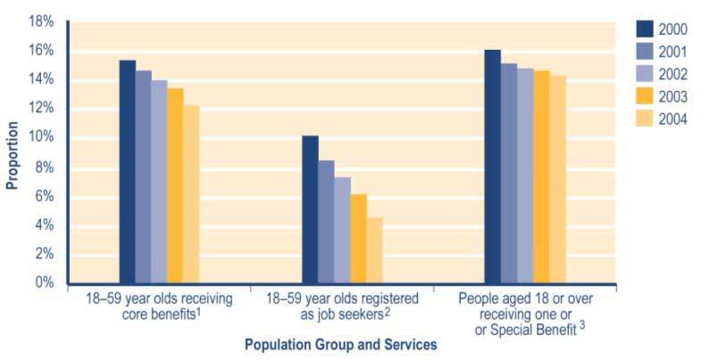
Notes
1 Proportion shows:
a numbers of 18–59 year olds recorded in SWIFTT as receiving a core benefit at 30 June, divided by
b Statistics New Zealand final estimate of the resident population aged 18–59 years at 30 June.
2 Proportion shows:
a numbers of 18–59 year olds registered in SOLO as job seekers at 30 June, divided by
b Statistics New Zealand final estimate of the resident population aged 18–59 years at 30 June.
3 Proportion shows:
a numbers of people aged 18 years or over who are recorded in SWIFTT as receiving one or more supplementary benefits and/or a Special Benefit at 30 June, divided by
b Statistics New Zealand final estimate of the resident population aged 18 years or over at 30 June.

See Table A3.1 (Appendix 3) for a summary of the SWIFTT data underlying Figure 2.1.

Since 2000, around 94% of people aged 65 years or over have been receiving New Zealand Superannuation or a Veterans’ Pension.

Summary information on use of core benefits

Trends in the number of clients receiving a core benefit
Decreases since 2000 in the number of clients receiving a core benefit (see Table 2.5) reflect the combination of economic changes, policy changes and operational factors outlined above. Over this period, there have been increases in the proportion of core benefit recipients who were receiving:

 a carers’ benefit (from 29% to 34%)
 an Invalids’ Benefit (from 15% to 22%)
 a sickness-related benefit (from 9% to 14%).

Over the same period, the proportion of core benefit recipients who were receiving an unemployment-related benefit has decreased (from 39% to 24%) (see Table 2.5).

Table 2.5 Trends in the types of core benefit received

Type of core benefit  received at 30 June | Clients receiving a core benefit¹
 | 2000  Number | 2001  Number | 2002  Number | 2003  Number | 2004  Number
Unemployment-related benefits² | 149,453 | 135,127 | 122,122 | 107,469 | 76,765
Carers' benefits³ | 108,939 | 107,821 | 108,009 | 109,295 | 109,526
Sickness -related benefits⁴ | 32,294 | 33,620 | 36,380 | 39,902 | 44,128
Invalids' Benefit | 55,392 | 59,812 | 64,529 | 68,507 | 72,342
Widows' Benefit | 9,104 | 8,900 | 8,774 | 8,659 | 8,413
Unsupported Child's Benefit/Orphan's Benefit | 5,799 | 6,075 | 6,332 | 6,789 | 7,051
Transitional Retirement Benefit | 8,856 | 9,012 | 5,118 | 2,110 | 0
Emergency Benefit | 9,707 | 9,722 | 7,810 | 8,728 | 8,947
Total | 379,544 | 370,089 | 359,074 | 351,459 | 327,172

Notes
1 Numbers of clients recorded in SWIFTT as receiving a core benefit at 30 June.
2 Includes Unemployment Benefits and Unemployment Benefits – Hardship paid to unemployed people or to those in training, and Independent Youth Benefits.
3 Includes Domestic Purposes Benefits – Sole Parents, Domestic Purposes Benefits – Caring for the Sick and Infirm, Domestic Purposes Benefits – Women Alone, and Emergency Maintenance Allowances.
4 Includes Sickness Benefits and Sickness Benefits – Hardship.

The characteristics of core benefit recipients have changed since 2000. Over this period, the proportion of core benefit recipients who had received their current core benefit for over four years has increased (from 25% to 33%) (see Table 2.7). Over the same period, between 35% and 38% of core benefit recipients were aged 25–39 years, while between 17% and 20% were aged 16–24 years and between 22% and 25% were aged 45–59 years (see Table 2.6).

These changes reflect:

 differences in the impact on groups of Work and Income clients of the economic, policy and operational factors outlined above
 demographic changes, including an ageing population, people having children later and increased migration from overseas.

Table 2.6 Trends in the ages of core benefit recipients

Age of client at 30 June | Clients receiving a core benefit¹
 | 2000  Number | 2001  Number | 2002  Number | 2003  Number | 2004  Number
16-19 years | 25,797 | 23,425 | 21,854 | 20,861 | 17,546
20-24 years | 51,135 | 47,672 | 45,306 | 43,072 | 36,803
25-29 years | 49,267 | 45,574 | 42.577 | 40,107 | 36,216
30-34 years | 47,507 | 46,070 | 44,427 | 42,717 | 38,989
35-39 years | 46,590 | 44,235 | 42,515 | 41,318 | 38,449
40-44 years | 38,015 | 37,491 | 38,027 | 38,343 | 36,732
45-49 years | 29,290 | 29,491 | 29,542 | 29,938 | 29,036
50-54 years | 26,737 | 26,602 | 26,160 | 25,936 | 25,432
55-59 years | 27,670 | 27,214 | 27,349 | 28,140 | 27,204
60-64 years | 32,420 | 36,340 | 35,346 | 34,266 | 33,288
65 years or over | 5,113 | 5,524 | 5,971 | 6,761 | 7,477
Unspecified | 3 | 1 | 0 | 0 | 0
Total | 379,544 | 370,089 | 359,074 | 351,459 | 327,172

Note
1 Numbers of clients recorded in SWIFTT as receiving a core benefit at 30 June.

Table 2.7 Trends in the length of current spells receiving core benefits

Length of current spell at 30 June | Clients receiving a core benefit¹
 | 2000  Number | 2001  Number | 2002  Number | 2003  Number | 2004  Number
Under 6 months | 89,081 | 84,681 | 82,195 | 78,671 | 69,318
6 months – 2 years | 127,469 | 112,101 | 106,876 | 103,017 | 90,445
2–4 years | 67,330 | 72,840 | 66,695 | 60,591 | 58,805
Over 4 years | 95,664 | 100,467 | 103,308 | 109,180 | 108,604
Total | 379,544 | 370,089 | 359,074 | 351,459 | 327,172

Note
1 Numbers of clients recorded in SWIFTT as receiving a core benefit at 30 June.

Since 2002, between 46% and 49% of core benefit recipients have been New Zealand Europeans, while around 30% have been Māori and between 12% and 15% have identified with “Other” ethnic groups (see Table 2.8). The reduction between 2001 and 2002 in the proportion of core benefit recipients without a coded ethnicity (see Table 2.8) largely reflects operational improvements in the recording of ethnicity. These improvements resulted in increases in the proportion of core benefit recipients recorded as identifying as Māori, as New Zealand European, and as members of “Other” ethnic groups.

Table 2.8 Trends in the ethnicity of core benefit recipients

Recorded ethnicity at 30 June | Clients receiving a core benefit¹
 |  | 2000  Number | 2001  Number | 2002  Number | 2003  Number | 2004  Number
Māori |  | 99,429 | 97,967 | 107,524 | 106,631 | 99,957
Pacific peoples |  | 27,964 | 27,449 | 26,966 | 26,501 | 24,868
Other ethnic groups |  | 34,477 | 34,413 | 41,956 | 51,194 | 48,080
New Zealand European |  | 169,040 | 165,993 | 174,032 | 162,527 | 149,036
Not coded |  | 48,634 | 44,267 | 8,596 | 4,606 | 5,231
Total |  | 379,544 | 370,089 | 359,074 | 351,459 | 327,172

Note
1 Numbers of clients recorded in SWIFTT as receiving a core benefit at 30 June.

Trends in core benefits granted
Decreases since 1999/2000 in the number of core benefits granted each year (see Table 2.9) reflect improved economic conditions and reductions in transfers between benefits resulting from policy changes.

Of the core benefits granted in each year since 1999/2000 (see Table 2.9):

• between 40% and 43% have been provided to clients who have not received a core benefit in the last 12 months
• between 25% and 28% have been provided to clients who have not received a core benefit in the last four years
• between 26% and 28% involved clients transferring between core benefits.

Table 2.9 Trends in the length of period since clients granted core benefits last received any core benefit

Period since client last received  any core benefit | Core benefits granted¹
 |  | 1999/2000  Number | 2000/2001  Number | 2001/2002  Number | 2002/2003  Number | 2003/2004  Number
None (administrative transfers of people continuing to receive core benefit |  | 82,018 | 77,580 | 75,402 | 71,315 | 70,375
Under 6 months |  | 51,572 | 52,385 | 51,730 | 49,634 | 45.821
6-12 months |  | 43,404 | 45,346 | 43,616 | 40,612 | 35,809
12-18 months |  | 13,016 | 12,940 | 12,758 | 12,622 | 11,241
18 months - 2 years |  | 12,080 | 9,883 | 10,082 | 9,950 | 8,937
2-4 years |  | 18,943 | 18,972 | 18,370 | 17,817 | 16,854
Never received core benefit in last 4 years |  | 86,912 | 83,614 | 77,553 | 73,984 | 64,483
Total |  | 307,945 | 300,720 | 289,511 | 275,934 | 253,520

Note
1 Numbers of successful applications for core benefits recorded in SWIFTT during years ended 30 June.

Since 1999/2000, the proportion of core benefits granted that were sickness-related benefits has increased from 12% to 19%, while the proportion accounted for by unemployment-related benefits has decreased from 67% to 55% (see Table 2.10).
Table 2.10 Trends in the types of core benefit granted

Type of core benefit granted | Core benefits granted¹
 |  | 1999/2000  Number | 2000/2001  Number | 2001/2002  Number | 2002/2003  Number | 2003/2004  Number
Unemployment-related benefits² |  | 206,549 | 195,963 | 184,195 | 167,080 | 139,450
Carers' benefits³ |  | 39,081 | 38,921 | 37,484 | 37,625 | 37,446
Sickness-related benefits⁴ |  | 36,656 | 38,574 | 41,842 | 44,017 | 48,355
Invalids' Benefit |  | 10,029 | 10,111 | 11,250 | 11,276 | 11,833
Widows' Benefit |  | 2,024 | 2,002 | 2,015 | 2,150 | 2,017
Unsupported Child's Benefit/Orphan's Benefit |  | 3,226 | 3,290 | 3,122 | 3,396 | 3,277
Transitional Retirement Benefit |  | 4,450 | 4,454 | 3,576 | 2,981 | 1,242
Emergency Benefit |  | 5,930 | 7,405 | 6,027 | 7,409 | 9,900
Total |  | 307,945 | 300,720 | 289,511 | 275,934 | 253,520

Notes
1 Numbers of successful applications for core benefits recorded in SWIFTT during years ended 30 June.
2 Includes Unemployment Benefits and Unemployment Benefits – Hardship paid to unemployed people or to those in training, and Independent Youth Benefits.
3 Includes Domestic Purposes Benefits – Sole Parents, Domestic Purposes Benefits – Caring for the Sick and Infirm, Domestic Purposes Benefits – Women Alone, and Emergency Maintenance Allowances.
4 Includes Sickness Benefits and Sickness Benefits – Hardship.

Trends in core benefits ceased
Reductions since 1999/2000 in the number of core benefits ceased each year (see Table 2.11) reflect:
 the reduction in administrative transfers between benefits once the implementation of policy changes was completed
 the reduction in total numbers receiving core benefits (which in turn reflects improved economic conditions and increased case management of clients following the extension of the work testing of core benefits).

Since 2000/2001, the proportion of core benefits ceased in each year accounted for by unemployment-related benefits has decreased from 68% to 62% (see Table 2.11).

Of the core benefits ceased in each year since 1999/2000 (see Table 2.12):

 around 34% have reflected clients entering paid work
 around 26% have reflected clients transferring to another core benefit.
Table 2.11 Trends in the types of core benefits ceased

Type of core benefit ceased | Core benefits ceased¹
 |  | 1999/2000  Number | 2000/2001  Number | 2001/2002  Number | 2002/2003  Number | 2003/2004  Number
Unemployment-related benefits² |  | 215,049 | 210,995 | 198,323 | 184,191 | 172,636
Carers' benefits³ |  | 40,317 | 39,413 | 37,836 | 36,929 | 37,869
Sickness-related benefits⁴ |  | 37,447 | 36,965 | 38,817 | 40,490 | 43,259
Invalids' Benefit |  | 5,916 | 5,567 | 6,392 | 7,146 | 8,129
Widows' Benefit |  | 2,141 | 2,194 | 2,127 | 2,335 | 2,307
Unsupported Child's Benefit/Orphan's Benefit |  | 2,809 | 2,968 | 2,859 | 2,895 | 3,015
Transitional Retirement Benefit |  | 4,302 | 4,332 | 7,517 | 6,050 | 3,355
Emergency Benefit |  | 6,530 | 7,453 | 7,938 | 6,302 | 9,431
Total |  | 314,511 | 309,887 | 301,809 | 286,338 | 280,001

Notes
1 Numbers of cessations of core benefits recorded in SWIFTT during years ended 30 June.
2 Includes Unemployment Benefits and Unemployment Benefits – Hardship paid to unemployed people and to those in training, and Independent Youth Benefits.
3 Includes Domestic Purposes Benefits – Sole Parents, Domestic Purposes Benefits – Caring for the Sick and Infirm, Domestic Purposes Benefits – Women Alone, and Emergency Maintenance Allowances.
4 Includes Sickness Benefits and Sickness Benefits – Hardship.

Table 2.12 Trends in reasons for ceasing core benefits

Reason core benefit ceased | Core benefits ceased¹
 |  | 1999/2000  Number | 2000/2001  Number | 2001/2002  Number | 2002/2003  Number | 2003/2004  Number
Obtained paid work |  | 110,317 | 108,247 | 105,276 | 98,603 | 95,824
Transferred to another core benefit |  | 81,894 | 78,746 | 79,050 | 74,519 | 73,522
Other |  | 122,210 | 122,894 | 117,483 | 113,216 | 110,655
Total |  | 314,511 | 309,887 | 301,809 | 286,338 | 280,001

Note
1 Numbers of cessations of core benefits recorded in SWIFTT during years ended 30 June.

Trends in core benefit and pension expenditure
Please note that expenditure data provided in Tables 2.13 and 2.14 excludes expenditure on supplementary benefits paid to recipients of the core benefit shown, while expenditure data provided in Section 3 of this report does not.
Please note also that expenditure data provided in this report for unemployment-related benefits includes expenditure on:

 Emergency Benefits paid to unemployed people and trainees, which were available after 1 October 1998
 Emergency Unemployment Benefits paid to unemployed people prior to that time.

This aims to ensure a consistent series over time for expenditure on unemployment-related benefits. Data on the numbers of clients receiving, granted or ceasing unemployment-related benefits, however, excludes information about the Emergency Benefit and the Emergency Unemployment Benefit.

Decreases since 2001/2002 in core benefit expenditure (see Table 2.13) largely reflect decreases in the number of clients receiving core benefits.

Since 1999/2000, carers’ benefits have accounted for between 33% and 36% of expenditure on core benefits (see Table 2.13). Over the same period, the proportion of annual core benefit expenditure accounted for by Invalids’ Benefits has increased (from 16% to 23%), while that accounted for by unemployment-related benefits has decreased (from 38% to 26%) (see Table 2.13).

These changes reflect the changes indicated earlier in the types of core benefits provided to core benefit recipients.

Increases since 1999/2000 in pension expenditure (see Table 2.13) reflect:

 increases in the number of clients receiving pensions (which in turn reflects an ageing population)
 adjustments of the rate at which pensions are paid.

Over this period, New Zealand Superannuation has accounted for around 98% of total expenditure on pensions (see Table 2.13).

Table 2.13 Trends in expenditure on core benefits and pensions

Type of core  benefit or pension |  | Expenditure on core benefits and pensions^{1,2}
 | 1999/2000  Amount($m) |  | 2000/2001  Amount($m) | 2001/2002  Amount($m) | 2002/2003  Amount($m) | 2003/2004  Amount($m)
Unemployment-related benefits and Emergency Benefit^{3,5} | 1,375 |  | 1,298 | 1,186 | 1,102 | 939
Carers' benefits^{3,6} | 1,192 |  | 1,201 | 1,250 | 1,260 | 1,303
Sickness-related benefits^{3,7} | 294 |  | 297 | 318 | 356 | 398
Invalids' Benefit³ | 570 |  | 627 | 698 | 766 | 817
Widows' Benefit³ | 78 |  | 77 | 77 | 79 | 78
Unsupported Child's Benefit/Orphan's Benefit³ | 35 |  | 38 | 41 | 46 | 51
Transitional Retirement Benefit³ | 105 |  | 107 | 81 | 39 | 9
Total core benefit expenditure³ | 3,649 |  | 3,646 | 3,652 | 3,650 | 3,594
New Zealand Superannuation⁴ | 4,199 |  | 4,358 | 4,531 | 4,644 | 4,837
Veterans' Pension⁴ | 70 |  | 75 | 80 | 84 | 91
Total pensions expenditure⁴ | 4,269 |  | 4,432 | 4,611 | 4,728 | 4,928
Total expenditure on core benefits and pensions | 7,918 |  | 8,078 | 8,263 | 8,377 | 8,521

Notes
1 Expenditure for years ended 30 June. Expenditure shown is calculated on an accrual basis and excludes debt established.
2 Expenditure data in this table differs from, and should not be cited as, MSD’s official measure of expenditure on financial assistance provided to clients.
3 Expenditure on core benefits excludes tax paid on core benefits and excludes supplementary benefits provided to core benefit recipients.
4 Expenditure on pensions excludes tax estimated at the “M” tax rate, and excludes supplementary benefits provided to pension recipients. Expenditure on pensions paid to recipients living in the United Kingdom is also excluded.
5 Includes Unemployment Benefits and Unemployment Benefits – Hardship paid to unemployed people and to those in training, and Independent Youth Benefits. Also includes Emergency Benefits paid to unemployed people or trainees since 1 October 1998, and Emergency Unemployment Benefits paid prior to 1 October 1998.
6 Includes Domestic Purposes Benefits – Sole Parents, Domestic Purposes Benefits – Caring for the Sick and Infirm, Domestic Purposes Benefit – Women Alone, and Emergency Maintenance Allowances.
7 Includes Sickness Benefits and Sickness Benefits – Hardship.
Trends in the proportion of Gross Domestic Product accounted for by core benefit and pension expenditure

Reductions since 1999/2000 in the proportion of Gross Domestic Product accounted for by core benefit and pension expenditure (excluding supplementary benefits) (see Table 2.14) reflect:

 increases in Gross Domestic Product
 accelerating increases in pension expenditure
 relatively static core benefit expenditure between 1999/2000 and 2002/2003, followed by a significant decrease in core benefit expenditure in 2003/2004.

Table 2.14 Proportion of Gross Domestic Product accounted for by core benefit and pension expenditure

Type of expenditure |  | Expenditure on core benefits and pensions^{1,2}
 | 1999/2000 |  | 2000/2001 | 2001/2002 | 2002/2003 | 2003/2004
Total expenditure on core benefits ($m)³ | 3,649 |  | 3,646 | 3,652 | 3,650 | 3,594
Total expenditure on pensions ($m)⁴ | 4,269 |  | 4,432 | 4,611 | 4,728 | 4,928
Total expenditure on core benefits and pensions ($m) | 7,918 |  | 8,078 | 8,263 | 8,377 | 8,521
Percentage of Gross Domestic Product⁵ | 7.2% |  | 6.9% | 6.6% | 6.4% | 6.1%

Notes
1 Expenditure on core benefits and pensions for years ended 30 June. Expenditure shown is calculated on an accrual basis and excludes debt established.
2 Expenditure data in this table differs from, and should not be cited as, MSD’s official measure of expenditure on financial assistance provided to clients.
3 Expenditure on core benefits excludes tax paid on core benefits and excludes supplementary benefits provided to core benefit recipients.
4 Expenditure on pensions excludes tax estimated at the “M” tax rate and excludes supplementary benefits provided to pension recipients. Expenditure on pensions also excludes expenditure on pensions paid to recipients in the United Kingdom.
5 Total combined core benefit and pension expenditure for years ended 30 June as a percentage of current dollar expenditure on Gross Domestic Product in years ended 30 June.

Trends in the distribution of core benefit expenditure among client groups
The distribution of core benefit expenditure among groups of clients reflects a combination of factors. These factors include patterns in:

 uptake of core benefits
 the length of spells receiving core benefits
 whether or not core benefit recipients have dependent children.

Of core benefit expenditure each year since 1999/2000:
 between 37% and 41% was received by clients who were aged 25–39 years (see Table 2.15)
 between 32% and 36% was received by clients who were aged 40–59 years (see Table 2.15)
 between 62% and 64% was received by women (see Table 2.16)
 between 45% and 48% was received by New Zealand Europeans (see Table 2.17)
 around 30% was received by Māori (see Table 2.17).
Table 2.15 Trends in the distribution of core benefit expenditure across age groups

Age of client when payment made | Percentage of expenditure on core benefits^{1,2}
 | 1999/2000  Per cent | 2000/2001  Per cent | 2001/2002  Per cent | 2002/2003  Per cent | 2003/2004  Per cent
16-19 years | 5.2 | 5.1 | 4.8 | 4.7 | 4.5
20-24 years | 12.4 | 11.9 | 11.7 | 11.5 | 11.1
25-29 years | 13.8 | 13.1 | 12.6 | 12.2 | 11.8
30-39 years | 27.2 | 26.5 | 26.1 | 25.9 | 25.6
40-49 years | 18.0 | 18.4 | 18.9 | 19.6 | 20.2
50-59 years | 14.2 | 14.5 | 14.7 | 15.0 | 15.4
60-64 years | 7.9 | 9.1 | 9.6 | 9.5 | 9.4
65 years or over | 1.2 | 1.3 | 1.5 | 1.7 | 2.0
Unspecified | 0.0 | 0.0 | 0.0 | 0.0 | 0.0
Total | 100.0 | 100.0 | 100.0 | 100.0 | 100.0

Notes
1 Percentage of expenditure on core benefits for years ended 30 June.
2 Excludes tax paid on core benefits and excludes expenditure on supplementary benefits provided to clients receiving a core benefit.

Table 2.16 Trends in the distribution of core benefit expenditure across gender groups

Gender of client | Percentage of expenditure on core benefits^{1,2}
 | 1999/2000  Per cent | 2000/2001  Per cent | 2001/2002  Per cent | 2002/2003  Per cent | 2003/2004  Per cent
Female | 61.5 | 61.9 | 62.5 | 63.2 | 64.2
Male | 38.5 | 38.1 | 37.5 | 36.8 | 35.8
Unspecified | 0.0 | 0.0 | 0.0 | 0.0 | 0.0
Total | 100.0 | 100.0 | 100.0 | 100.0 | 100.0

Notes
1 Percentage of expenditure on core benefits for years ended 30 June.
2 Excludes tax paid on core benefits and excludes expenditure on supplementary benefits provided to clients receiving a core benefit.

Table 2.17 Trends in the distribution of core benefit expenditure across ethnic groups

Ethnic group client identifies with at end of year shown | Percentage of expenditure on core benefits^{1,2}
 | 1999/2000  Per cent | 2000/2001  Per cent | 2001/2002  Per cent | 2002/2003  Per cent | 2003/2004  Per cent
Maori | 30.0 | 30.0 | 30.1 | 30.4 | 30.8
Pacific peoples | 7.6 | 7.7 | 7.8 | 7.8 | 7.8
Other ethnic groups | 13.7 | 14.1 | 14.7 | 15.3 | 15.2
New Zealand European | 47.7 | 47.5 | 46.9 | 45.6 | 44.9
Unspecified | 1.0 | 0.6 | 0.5 | 0.9 | 1.3
Total | 100.0 | 100.0 | 100.0 | 100.0 | 100.0

Notes
1 Percentage of expenditure on core benefits for years ended 30 June.
2 Excludes tax paid on core benefits and excludes expenditure on supplementary benefits provided to clients receiving a core benefit.

Children dependent on core benefit recipients and on registered job seekers

Trends in the number of children dependent on core benefit recipients
Decreases since 2000 in the number of children dependent on core benefit recipients (see Table 2.18) reflect decreases in the total number of people receiving core benefits. Since 2000, around 87% of the children dependent on core benefit recipients have been aged 14 years or under (see Table 2.18). By law, children aged under 14 years require supervision at all times.

Table 2.18 Trends in the ages of children dependent on core benefit recipients

Age of child at 30 June | Children dependent on core benefit recipients¹
 | 2000  Number | 2001  Number | 2002  Number | 2003  Number | 2004  Number
0-4 years | 86,609 | 83,146 | 80,459 | 78,638 | 76,297
5-9 years | 87,835 | 83,848 | 81,035 | 79,700 | 76,774
10-14 years | 74,027 | 74,036 | 73,442 | 72,917 | 70,505
15-17 years | 29,979 | 29,256 | 29,007 | 30,198 | 30,680
18-19 years | 1,813 | 1,631 | 1,692 | 1,695 | 1,706
20 years or over | 11 | 7 | 3 | 1 | 0
Unspecified | 0 | 0 | 0 | 0 | 0
Total | 280,274 | 271,924 | 265,638 | 263,149 | 255,962

Note
1 Numbers of children dependent on carers who were recorded in SWIFTT as receiving a core benefit at 30 June.

Trends in the proportion of all children aged under 18 years dependent on core benefit recipients

Decreases since 2000 in the proportion of all children aged under 18 years who were dependent on core benefit recipients (see Figure 2.2) reflect:

 decreases in the number of people receiving core benefits (which in turn reflect economic changes, policy changes and operational changes, as outlined above)
 the ageing of children who do remain dependent on core benefit recipients.

Since 2000, the prevalence of children aged under 18 years who were dependent on core benefit recipients has decreased slightly with the increasing age of the child (see Figure 2.2).
Figure 2.2 Trends in the proportion of children aged under 18 years dependent on core benefit recipients, by age
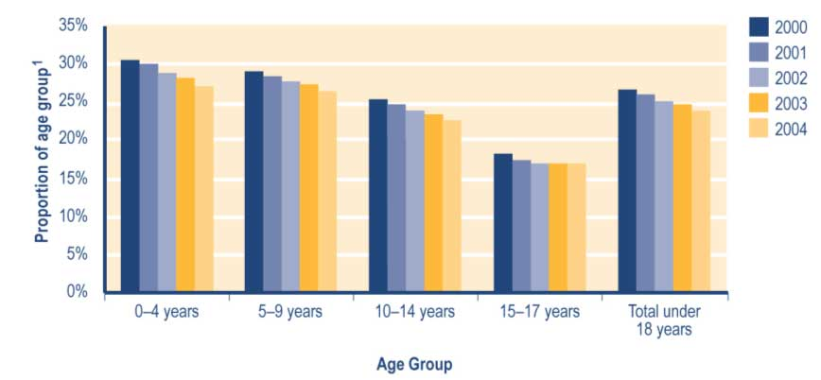

Note
1 Proportion shows:
a numbers of children in age group dependent on people recorded in SWIFTT as receiving core benefits at 30 June, divided by
b Statistics New Zealand final estimate of the resident population in age group at 30 June.

See Table A3.2 (Appendix 3) for a summary of the SWIFTT data underlying Figure 2.2.

Trends in the number of children dependent on registered job seekers
Decreases since 2000 in the number of children dependent on registered job seekers (see Table 2.19) reflect decreases in the total number of registered job seekers. Since 2000, between 84% and 86% of children dependent on registered job seekers have been aged 14 years or under (see Table 2.19). By law, children aged under 14 years require supervision at all times.

Table 2.19 Trends in the ages of children dependent on registered job seekers

Age of child at 30 June¹ | Children dependent on registered job seekers²
 | 2000  Number | 2001  Number | 2002  Number | 2003  Number | 2004  Number
0-4 years | 26,670 | 19,546 | 16,922 | 16,650 | 13,819
5-9 years | 41,938 | 32,090 | 27,035 | 22,364 | 15,790
10-14 years | 41,237 | 34,705 | 31,276 | 25,853 | 17,176
15-17 years | 16,990 | 14,310 | 13,086 | 11,328 | 7,824
18-19 years | 1,037 | 831 | 785 | 710 | 492
20 years or over | 7 | 5 | 2 | 1 | 0
Unspecified | 0 | 0 | 0 | 0 | 0
Total | 126,879 | 101,487 | 89,106 | 76,906 | 55,101

Notes
1 Information on numbers and ages of dependent children is only available for job seekers who were also receiving financial assistance from Work and Income. At each of the dates shown, around 95% of registered job seekers were receiving such assistance.
2 Numbers of children dependent on registered job seekers registered in SOLO at 30 June.

Trends in the proportion of all children aged under 18 years dependent on registered job seekers
Decreases since 2000 in the proportion of children aged under 18 years who were dependent on registered job seekers (see Figure 2.3) reflect decreases in the numbers of registered job seekers.

Figure 2.3 Trends in the proportion of children aged under 18 years dependent on registered job seekers, by age¹
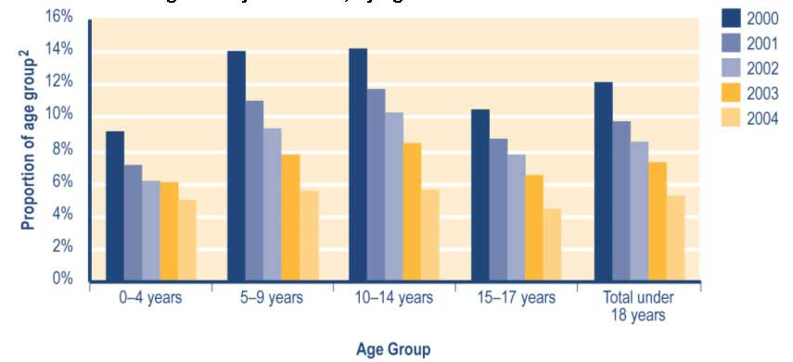

Notes
1 Information on numbers and ages of dependent children is only available for job seekers who were also receiving financial assistance from Work and Income. At each of the dates shown, around 95% of registered job seekers were receiving such assistance.
2 Proportion shows:
a numbers of children in age group dependent on job seekers registered in SOLO at 30 June, divided by
b Statistics New Zealand final estimate of the resident population in age group at 30 June.

See Table A3.3 (Appendix 3) for a summary of the SWIFTT data underlying Figure 2.3.

Other income declared by recipients of core benefits

People receiving a core benefit have historically been able to earn up to $80 per week (before tax) before their core benefit payments are reduced. In addition, from 1 July 1996, clients receiving a Domestic Purposes Benefit, a Widows’ Benefit or an Invalids’ Benefit have faced lower abatement rates than clients receiving an Unemployment Benefit or a Sickness Benefit. This aims to give those less able to take up full-time employment an incentive to take up part time employment.

The assessment period for the income test is:

 annual for Domestic Purposes Benefits, Widows’ Benefits, Invalids’ Benefits, Transitional Retirement Benefits, and income-tested New Zealand Superannuation or Veterans’ Pensions (these clients may, however, elect a weekly income assessment)
 weekly for all other core benefits (unemployment-related benefits, sickness-related benefits, Emergency Benefits, Orphan’s Benefits and Unsupported Child’s Benefits) and for all supplementary benefits.

In addition to the $80 per week (before tax) income exemption:

 people receiving an Invalids’ Benefit can earn an additional $1,040 per year of personal earnings (before tax) without having their core benefit payments reduced (special conditions apply for people receiving an Invalids’ Benefit because of blindness)
 people receiving a Widows’ Benefit or a Domestic Purposes Benefit – Sole Parents who are paying for childcare can earn an additional $1,040 (before tax) before their core benefit payments are reduced
 people with a severe disability may have some or all of their personal earnings exempted from an income test.

Between 1 February 1999 and 10 March 2003, people receiving a Domestic Purposes Benefit or a Widows’ Benefit who had no dependent children, or whose youngest dependent child was aged 14 years or over, were subject to a full-time work test. During this period, these clients also had any additional income abated under the same regime as people receiving an Unemployment Benefit.

As long as a non-qualified spouse is not included in their payment, people aged 65 years or over and receiving New Zealand Superannuation or a Veterans’ Pension are not income tested or asset tested. Veterans’ Pension recipients who are aged under 65 years are, however, subject to an income test.

Clients not subject to an income test can earn other income without having their benefit or pension abated. Some supplementary benefits (eg Accommodation Supplement) are reduced when people receive other income. This may occur even if the amount earned is too low to affect their core benefit payments, or if they are receiving a pension that is not income tested.

Adjustments in 1996 and 1998 to the rate of tax paid on income earned through secondary employment also contributed to incentives for people receiving core benefits to undertake
paid work.

Trends in the number of core benefit recipients declaring other income
Decreases since 1999/2000 in the number of core benefit recipients declaring other income (see Table 2.20) reflect decreases in the total number of people receiving core benefits. In each year since 1999/2000, about 21% of core benefit recipients have declared other income (see Table 2.20).

Since 1999/2000, there have been increases in the proportions of core benefit recipients declaring other income who:

 declared income of over $80 per week before tax (from 57% to 62%) (see Table 2.20)
 were receiving a carers’ benefit (from 32% to 39%) (see Table 2.21)
 were receiving an Invalids’ Benefit (from 16% to 23%) (see Table 2.21).

Over the same period, the proportion of core benefit recipients declaring other income who were receiving an unemployment-related benefit has decreased (from 34% to 21%) (see Table 2.21).
Table 2.20 Trends in the levels of other income declared by core benefit recipients

Level of other income declared¹ | Core benefit recipients²
 | 1999/2000  Number | 2000/2001  Number | 2001/2002  Number | 2002/2003  Number | 2003/2004  Number
None or under $1 | 291,579 | 283,409 | 276,212 | 271,902 | 252,912
Income declared
$1 - <$40 | 19,145 | 17,748 | 16,134 | 14,747 | 13,322
$40 - <$80 | 16,463 | 15,738 | 14,488 | 13,444 | 12,240
$80 - <$120 | 16,577 | 16,534 | 15,920 | 15,136 | 13,724
$120 - <$160 | 8,904 | 8,874 | 8,655 | 8,321 | 7,537
$160 - <$180 | 3,388 | 3,537 | 3,423 | 3,347 | 3,041
$180 - <$200 | 3,184 | 3,136 | 3,179 | 3,058 | 2,871
$200 or over | 14,505 | 15,038 | 14,721 | 14,715 | 14,474
Total declaring income³ | 82,166 | 80,605 | 76,530 | 72,768 | 67,209
Total | 373,745 | 364,014 | 352,742 | 344,670 | 320,121

Notes
1 Income per week before tax; based on last declaration effective in the year ended 30 June. The income declarations referred to here may include income received over part or all of the year ended 30 June, and may also include income received over parts of earlier or later years.
2 Numbers of clients recorded in SWIFTT as receiving a core benefit other than Unsupported Child’s Benefits or Orphan’s Benefits at 30 June. Clients receiving only an Unsupported Child’s Benefit or Orphan’s Benefit are excluded because the income test for these benefits applies to the child for whom the benefit is paid, not to the client receiving the benefit.
3 Numbers of core benefit recipients with one or more income declarations effective in the year ended 30 June.

Table 2.21 Trends in the types of core benefit received by people declaring other income

Type of core benefit received at time income declared¹ |  | Core benefit recipients declaring other income²
 | 1999/2000  Number |  | 2000/2001  Number | 2001/2002  Number | 2002/2003  Number | 2003/2004  Number
Unemployment-related benefits³ | 27,684 |  | 24,860 | 22,212 | 19,380 | 14,168
Carers' benefits⁴ | 26,295 |  | 26,969 | 26,951 | 26,439 | 26,087
Sickness-related benefits⁵ | 5,101 |  | 5,069 | 5,222 | 5,578 | 6,144
Invalids' Benefit | 13,109 |  | 13,883 | 14,645 | 15,328 | 15,758
Widows' Benefit | 4,228 |  | 4,120 | 4,008 | 4,008 | 3,957
Transitional Retirement Benefit | 4,855 |  | 4,913 | 2,798 | 1,094 | 0
Emergency Benefit | 894 |  | 791 | 694 | 941 | 1,095
Total | 82,166 |  | 80,605 | 76,530 | 72,768 | 67,209

Notes
1 Type of core benefit received at the time when the last income declaration effective in the year to 30 June was made.
2 Numbers of core benefit recipients with one or more income declarations effective in the years ended 30 June. The income declarations referred to here may include income received over part or all of the year ended 30 June, and may also include income received over parts of earlier or later years.
3 Includes Unemployment Benefits and Unemployment Benefits – Hardship paid to unemployed people and to people in training, and Independent Youth Benefits.
4 Includes Domestic Purposes Benefits – Sole Parents, Domestic Purposes Benefits – Caring for the Sick and Infirm, Domestic Purposes Benefits – Women Alone, and Emergency Maintenance Allowances.
5 Includes Sickness Benefits and Sickness Benefits – Hardship.
Section 3 - Trends in use of core benefits, pensions and employment services provided by Work and Income

Introduction

This section outlines trends in the use and uptake of financial assistance and employment services provided by Work and Income. It also provides information on the cessation of core benefits and on job seeker registrations.

Eligibility criteria are outlined for each core benefit or pension. Section 2 contains information about payment rates for core benefits and pensions. Additional information about income tests, work tests and other case management processes that may be applicable to recipients of core benefits and pensions is provided in Appendix 1. A definition of the officially unemployed, and a summary of how registered job seekers differ from the officially unemployed, is given in Appendix 2. Appendix 3 outlines SWIFTT and SOLO data that underlie graphs showing the proportion of the population in particular age groups who are receiving financial assistance or work services.

Unemployment-related benefits

This group of core benefits comprises Unemployment Benefits, Unemployment Benefits – Hardship and Independent Youth Benefits. Please note that the recipients of these benefits
are not necessarily officially unemployed, and in particular that some are in approved
full-time training.

Between 1 January 1998 and 30 September 1998, a Young Job Seeker Allowance was available to 18–24 year olds who had been registered as job seekers for less than 13 weeks. After 1 October 1998, Young Job Seeker Allowances were grouped with the Unemployment Benefit as a Community Wage – Job Seeker.

Unemployment Benefits were known as a Community Wage – Job Seeker between 1 October 1998 and 30 June 2001, but reverted to their former name on 1 July 2001. Unemployment Benefits – Hardship were known as a Community Wage – Emergency Job Seeker between 1 October 1998 and 30 June 2001. An Unemployment Benefit paid to a person in training was known as a Training Benefit prior to 1 October 1998, and as a Community Wage – Training between 1 October 1998 and 30 June 2001.

Clients receiving an unemployment-related benefit are subject to a full-time work test, with most being registered as job seekers. From 1 April 1997, the spouses or partners of clients receiving an unemployment-related benefit have also been subject to a full-time work test if:

 they have no dependent children
 their youngest dependent child is aged 14 years or over.

Between 1 April 1997 and 1 February 1999, the spouses or partners of clients who had received unemployment-related benefits for more than one year were required to attend an annual interview with a Work and Income case manager if their youngest dependent child was aged 7–13 years. This interview was aimed at planning the entry into paid work of the spouse or partner of the recipient of an unemployment-related benefit.

From 1 February 1999, the spouses or partners of recipients of an unemployment-related benefit whose dependent children were aged under 14 years have been subject to:

 a part-time work test if their youngest dependent child was aged 6–13 years
 a requirement to attend an annual planning interview with a Work and Income case manager if their youngest dependent child was aged under six years (the aim of this interview is to plan the entry into paid work of the spouse or partner of the recipient of an unemployment-related benefit once their youngest dependent child is aged six years).

Eligibility for unemployment-related benefits

Unemployment Benefit
An Unemployment Benefit is available to people who are:

 available for and actively seeking full-time work
 not already in full-time employment
 willing and able to undertake suitable full-time work.

To be eligible to receive an Unemployment Benefit, clients must also be:

 aged 18 years or over, or
 aged 16 or 17 years, and living with a spouse or partner and dependent children.

Residency and income tests apply. People aged 60 years or over may apply for an exemption from work testing. Those granted such an exemption continue to receive an Unemployment Benefit and must continue to seek work. They may also choose to register or to remain registered as a job seeker, although they are not obliged to do so.

Work test exemptions for clients aged 55–59 years applying for an Unemployment Benefit were removed from 8 December 2003. From January 2004, Unemployment Benefit recipients previously exempted from the work test through being aged 55–59 years had this exemption removed, unless they would have turned 60 years of age by 31 July 2004.

Other work test requirements added during the 2003/2004 financial year include a requirement to:

 take drug tests if required to by a prospective employer (from 10 October 2003)
 commute to seek and undertake paid work if there is no such work available in their local area (from 8 March 2004).

An Unemployment Benefit is also available to full-time trainees on approved training courses who are:

 aged 18 years or over, or
• aged 16 or 17 years, and living with a spouse or partner and dependent children.

Income and residency qualifications apply.

Prior to 1 January 1998, a Training Benefit was available to people aged 16 years or over who undertook approved employment-related training. Since the introduction of the youth income support policy on 1 January 1998, 16 and 17 year olds in training have not been eligible to receive an Unemployment Benefit unless they were living with a spouse or partner and dependent children, although an Independent Youth Benefit may have been available in some circumstances. This made a major contribution to the fall over the last four years in the number of young people receiving an Unemployment Benefit while in training.

Unemployment Benefit – Hardship
An Unemployment Benefit – Hardship is available to people who do not meet all of the eligibility criteria for the Unemployment Benefit but who have not been successful in supporting themselves through paid employment or other means. Income and asset tests apply.
During the 2003/2004 financial year, work-tested clients have had Government expectations about meeting the work test made clearer. Other work test requirements added during the 2003/2004 financial year include a requirement to:

 take drug tests if required to by a prospective employer (from 22 October 2003)
 commute to seek and undertake paid work if there is no such work available in their local area (from 8 March 2004).

Full-time tertiary students who are unable to secure employment over the summer vacation may be eligible for an Unemployment Benefit – Hardship. To be eligible, students must meet income and asset tests and:

 have received a Student Allowance during the academic year
 be entitled to receive a Student Allowance during the next academic year, or
 have exceptional circumstances.

Independent Youth Benefit
An Independent Youth Benefit is available to 16 and 17 year olds who, for some serious reason, cannot live with their parents, cannot get financial support from their parents or anyone else, and are:

 actively looking for work
 a full-time trainee in an approved training course
 attending secondary school, or
 temporarily unable to work through sickness or injury.

Residency and income tests apply. From 1 January 1998, an Independent Youth Benefit was no longer available to 16 and 17 year olds who had moved away from home in search of work when no family breakdown had occurred. Since 1998, most young people receiving an Independent Youth Benefit have been young job seekers.

Trends in the number of clients receiving an unemployment-related benefit
Decreases since 2000 in the number of clients receiving an unemployment-related benefit (see Table 3.1) largely reflect:

 improved economic conditions
 changes in MSD policies and in Work and Income operational practices, as outlined in Section 2.

Since 2000, between 91% and 95% of clients receiving an unemployment-related benefit have been unemployed rather than in training (see Table 3.1).
Table 3.1 Trends in unemployment-related benefits received

Benefits received by client groups at 30 June | Clients receiving an unemployment-related benefit¹
 | 2000  Number | 2001  Number | 2002  Number | 2003  Number | 2004  Number
Unemployment Benefit paid to unemployed people | 139,042 | 124,561 | 111,990 | 97,485 | 67,817
Unemployment Benefit paid to people in training | 3,646 | 3,664 | 3,867 | 4,083 | 4,222
Unemployment Benefit - Hardship paid to unemployed people | 2,995 | 3,032 | 2,997 | 2,824 | 1,954
Unemployment Benefit - Hardship paid to people in training | 109 | 102 | 123 | 208 | 252
Unemployment Benefit - Hardship paid to students | 95 | 133 | 147 | 167 | 233
Independent Youth Benefit | 3,566 | 3,635 | 2,998 | 2,702 | 2,287
Total | 149,453 | 135,127 | 122,122 | 107,469 | 76,765

Note
1 Numbers of clients recorded in SWIFTT as receiving an unemployment-related benefit at 30 June.

Of the clients receiving an unemployment benefit since 2000:

 around 20% have been aged 45–59 years (see Table 3.2)
 between 36% and 39% had been doing so for less than six months (see Table 3.3).

Since 2000, there have been increases in the proportions of recipients of an unemployment-related benefit who:

 were aged 60–64 years (from 5% to 14%) (see Table 3.2) – this largely reflects increases in the age of eligibility for New Zealand Superannuation
 had received their current benefit for over four years (from 5% to 15%) (see Table 3.3).

Over the same period, there have been decreases in the proportions of recipients of an unemployment-related benefit who:

 were aged 25–39 years (from 34% to 29%) (see Table 3.2)
 have been receiving an unemployment-related benefit for between six months and two years (from 46% to 32%) (see Table 3.3).
Table 3.2 Trends in the ages of recipients of an unemployment-related benefit

Ages of client at 30 June | Clients receiving an unemployment-related benefit^{1.2}
 | 2000  Number | 2001  Number | 2002  Number | 2003  Number | 2004  Number
15–19 years | 19,057 | 16,694 | 14,960 | 13,477 | 9,767
20–24 years | 28,476 | 24,791 | 22,136 | 19,058 | 12,695
25–29 years | 20,166 | 17,448 | 15,057 | 12,626 | 8,676
30–34 years | 16,344 | 14,543 | 12,784 | 10,747 | 7,284
35–39 years | 14,677 | 12,828 | 10,879 | 9,063 | 6,235
40–44 years | 12,511 | 11,392 | 10,054 | 8,546 | 5,821
45–49 years | 10,424 | 9,582 | 8,526 | 7,290 | 5,090
50–54 years | 9,394 | 8,740 | 7,633 | 6,452 | 4,510
55–59 years | 9,865 | 9,213 | 8,870 | 8,379 | 5,161
60–64 years | 8,122 | 9,416 | 10,454 | 10,889 | 10,526
65 years or over | 466 | 480 | 769 | 942 | 1,000
Unspecified | 1 | 0 | 0 | 0 | 0
Total | 149,453 | 135,127 | 122,122 | 107,469 | 76,765

Notes
1 Includes Unemployment Benefits and Unemployment Benefits – Hardship paid to unemployed people or to those in training, and Independent Youth Benefits.
2 Numbers of clients recorded in SWIFTT as receiving an unemployment-related benefit at 30 June.

Table 3.3 Trends in the length of current spells receiving an unemployment-related benefit

Length of current spell at  30 June | Clients receiving an unemployment-related benefit^{1.2}
 | 2000  Number | 2001  Number | 2002  Number | 2003  Number | 2004  Number
Under 6 months | 53,411 | 48,008 | 44,972 | 40,079 | 30,022
6 months - 2 years | 68,402 | 49,438 | 42,964 | 37,729 | 24,493
2-4 years | 20,574 | 28,908 | 24,071 | 14,485 | 10,395
Over four years | 7,066 | 8,773 | 10,155 | 15,176 | 11,855
Total | 149,453 | 135,127 | 122,122 | 107,469 | 76,765

Notes
1 Includes Unemployment Benefits and Unemployment Benefits – Hardship paid to unemployed people and to people in training, and Independent Youth Benefits.
2 Numbers of clients recorded in SWIFTT as receiving an unemployment-related benefit at 30 June.

Table 7.1 (see Section 7) shows trends since 1940 in the number of clients receiving an unemployment-related benefit other than the Independent Youth Benefit. This table also shows trends since 1991 in the number of people receiving an Independent Youth Benefit.

Trends in the proportion of 18–59 year olds receiving an unemployment-related benefit

The proportion of 18–59 year olds receiving an unemployment-related benefit has decreased since 2000 (see Figure 3.1). This reflects the economic, policy and operational factors outlined earlier.
Figure 3.1 Trends in the proportion of 18–59 year olds receiving an unemployment-related benefit¹, by age

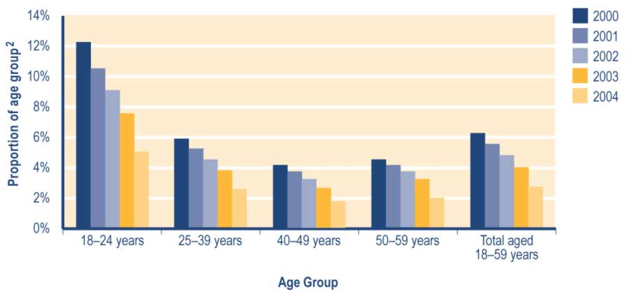
Notes
1 Includes Unemployment Benefits and Unemployment Benefits – Hardship paid to unemployed people and to people in training, and Independent Youth Benefits.
2 Proportion shows:
a number in age group who are recorded in SWIFTT as receiving an unemployment-related benefit at 30 June, divided by
b Statistics New Zealand final estimate of the resident population in age group at 30 June.

See Table A3.4 (Appendix 3) for a summary of the SWIFTT data underlying Figure 3.1.

Trends in the proportion of 16–17 year olds receiving an Independent Youth Benefit
Decreases since 2001 in the proportion of 16 and 17 year olds receiving an Independent Youth Benefit (see Figure 3.2) reflect the economic, policy and operational factors outlined earlier.

Figure 3.2 Trends in the proportion of 16–17 year olds receiving an Independent Youth Benefit
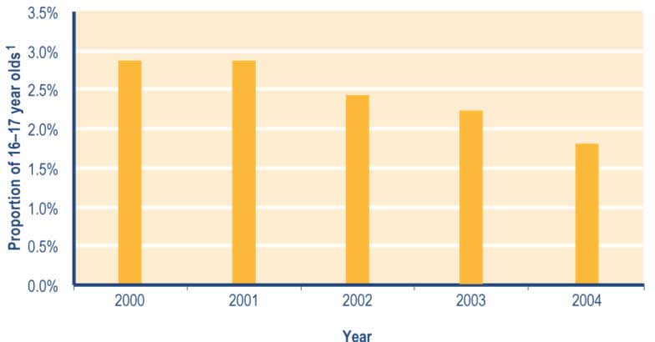
Note
1 Proportion shows:
a number of 16 and 17 year olds recorded in SWIFTT as receiving an Independent Youth Benefit at 30 June, divided by
b Statistics New Zealand final estimate of the resident population of 16 and 17 year olds at 30 June.

See Table A3.5 (Appendix 3) for a summary of the SWIFTT data underlying Figure 3.2.

Trends in unemployment-related benefits granted
Decreases since 1999/2000 in the numbers of unemployment-related benefits granted each year (see Table 3.4) reflect:
 improved economic conditions
 reduced transfers between benefits following policy changes.

Of the unemployment-related benefits granted in each year since 1999/2000:

 between 40% and 43% have been provided to clients who had not received a core benefit in the last 12 months (see Table 3.4)
 between 19% and 22% have reflected clients transferring between core benefits (see Table 3.4)
 between 75% and 77% have been Unemployment Benefits paid to unemployed people (see Table 3.5).

Table 3.4 Trends in the length of period since clients granted an unemployment-related benefit last received any core benefit

Period since client last received any core benefit | Unemployment-related benefits granted ^{1,2}
 | 1999/2000  Number | 2000/2001  Number | 2001/2002  Number | 2002/2003  Number | 2003/2004  Number
None (administrative transfer of clients who continue receiving some core benefit) | 43,508 | 39,670 | 36,381 | 31,949 | 30,249
Under 6 months | 37,705 | 36,989 | 35,936 | 32,467 | 26,719
6-12 months | 36,110 | 37,297 | 35,216 | 31,930 | 26,396
12-18 months | 8,929 | 8,709 | 8,438 | 7,935 | 6,358
18 months - 2 years | 9,101 | 6,809 | 6,904 | 6,633 | 5,385
2-4 years | 12,864 | 12,373 | 11,654 | 10,757 | 8,990
Not received a core benefit in previous four years | 58,332 | 54,116 | 49,666 | 45,409 | 35,353
Total | 206,549 | 195,963 | 184,195 | 167,080 | 139,450

Notes
1 Includes Unemployment Benefits and Unemployment Benefits – Hardship granted to unemployed people and to people in training, and Independent Youth Benefits.
2 Numbers of successful applications for unemployment-related benefits recorded in SWIFTT during years ended 30 June.
Table 3.5 Trends in unemployment-related benefits granted

Benefits granted to client groups | Unemployment-related benefits granted¹
 | 1999/2000  Number | 2000/2001  Number | 2001/2002  Number | 2002/2003  Number | 2003/2004  Number
Unemployment Benefit granted to unemployed people | 159,689 | 150,202 | 143,241 | 129,502 | 104,029
Unemployment Benefit granted to people in training | 13,149 | 12,097 | 10,291 | 9,420 | 9,634
Unemployment Benefit - Hardship granted to unemployed people | 3,635 | 3,029 | 2,685 | 2,488 | 1,854
Unemployment Benefit - Hardship granted to people in training | 300 | 308 | 270 | 308 | 403
Unemployment Benefit - Hardship granted to students | 24,903 | 25,133 | 22,992 | 20,629 | 19,052
Independent Youth Benefit | 4,873 | 5,194 | 4,716 | 4,733 | 4,478
Total | 206,549 | 195,963 | 184,195 | 167,080 | 139,450

Note
1 Numbers of successful applications for unemployment-related benefits recorded in SWIFTT during years ended 30 June.

Trends in cessations of unemployment-related benefits
Decreases since 1999/2000 in the annual number of cessations of unemployment-related benefits (see Table 3.6) reflect decreases in the numbers of recipients of unemployment-related benefits. This in turn reflects operational changes, policy changes and improved economic conditions.

Of the cessations of unemployment-related benefits each year since 1999/2000:

 around 42% have reflected clients entering paid work (see Table 3.6)
 between 20% and 22% have reflected clients transferring to another core benefit (see Table 3.6)
 about 78% have involved Unemployment Benefits that had been paid to unemployed people (see Table 3.7).

Table 3.6 Trends in reasons for cessations of unemployment-related benefits

Reason for cessation | Cessations of unemployment-related benefits^{1,2}
 | 1999/2000  Number | 2000/2001  Number | 2001/2002  Number | 2002/2003  Number | 2003/2004  Number
Obtained paid work | 92,315 | 89,115 | 85,929 | 78,537 | 72,652
Transferred to another core benefit | 43,695 | 42,312 | 39,576 | 37,672 | 37,954
Other | 79,039 | 79,568 | 72,818 | 67,982 | 62,030
Total | 215,049 | 210,995 | 198,323 | 184,191 | 172,636

Notes
1 Includes Unemployment Benefits and Unemployment Benefits – Hardship paid to unemployed people and those in training, and Independent Youth Benefits.
2 Numbers of cessations of unemployment-related benefits recorded in SWIFTT during years ended 30 June.

Table 3.7 Trends in unemployment-related benefits ceased

Benefits ceased by client groups | Cessations of unemployment-related benefits¹
 | 1999/2000  Number | 2000/2001  Number | 2001/2002  Number | 2002/2003  Number | 2003/2004  Number
Unemployment Benefit paid to unemployed people | 167,692 | 165,346 | 156,325 | 146,160 | 136,194
Unemployment Benefit paid to people in training | 14,925 | 12,147 | 10,537 | 9,260 | 9,498
Unemployment Benefit - Hardship paid to unemployed people | 2,660 | 2,971 | 2,722 | 2,743 | 2,734
Unemployment Benefit - Hardship paid to people in training | 187 | 320 | 265 | 228 | 335
Unemployment Benefit - Hardship paid to students | 24,848 | 25,138 | 23,101 | 20,716 | 19,022
Independent Youth Benefit | 4,737 | 5,073 | 5,373 | 5,084 | 4,853
Total | 215,049 | 210,995 | 198,323 | 184,191 | 172,636

Note
1 Numbers of cessations of unemployment-related benefits recorded in SWIFTT during years ended 30 June.

Trends in expenditure on unemployment-related benefits and Emergency Benefits
Annual expenditure on unemployment-related benefits and Emergency Benefits has shown a cyclical pattern since 1991/1992 (see Table 3.8).

Expenditure on unemployment-related benefits and Emergency Benefits tends to change in line with the growth of the economy. Decreased expenditure over the last four years (see Table 3.8) reflects more favourable economic conditions and a consequent decrease in unemployment.

Table 3.8 Trends in annual expenditure on unemployment-related benefits and Emergency Benefits¹

Year ended  30 June | Expenditure on  unemployment-related  benefits and Emergency Benefits^{2,3,4}  ($ million)
1991/1992 | 1,491
1992/1993 | 1,594
1993/1994 | 1,581
1994/1995 | 1,462
1995/1996 | 1,430
1996/1997 | 1,517
1997/1998 | 1,652
1998/1999 | 1,766
1999/2000 | 1,766
2000/2001 | 1,662
2001/2002 | 1,544
2002/2003 | 1,408
2003/2004 | 1,228

Notes
1 Includes Unemployment Benefits and Unemployment Benefits – Hardship paid to unemployed people and to people in training, and Independent Youth Benefits. Also includes Emergency Benefits paid to unemployed people or trainees since 1 October 1998, and Emergency Unemployment Benefits paid prior to 1 October 1998.
2 Expenditure on unemployment-related benefits or Emergency Benefits in years ended 30 June, including expenditure on supplementary benefits provided to recipients of an unemployment-related benefit or an Emergency Benefit.
3 Expenditure shown is net of taxation, adjusted for the number of payments of unemployment-related benefits or Emergency Benefits made during the year, and smoothed using a three-month moving average.
4 Expenditure data in this table differs from, and should not be cited as, MSD’s official measure of expenditure on financial assistance provided to clients.

Monthly expenditure on unemployment-related benefits shows strong seasonal increases over the summer months and weaker seasonal increases during winter (see Figure 3.3). These seasonal patterns reflect seasonal increases in demand for these benefits from:

 tertiary students registered as job seekers over the summer vacation
 workers with seasonal jobs (particularly in the agricultural/horticultural and primary processing sectors) who face a lack of work in the off season.

Figure 3.3 Trends in monthly expenditure on unemployment-related benefits and Emergency Benefits¹

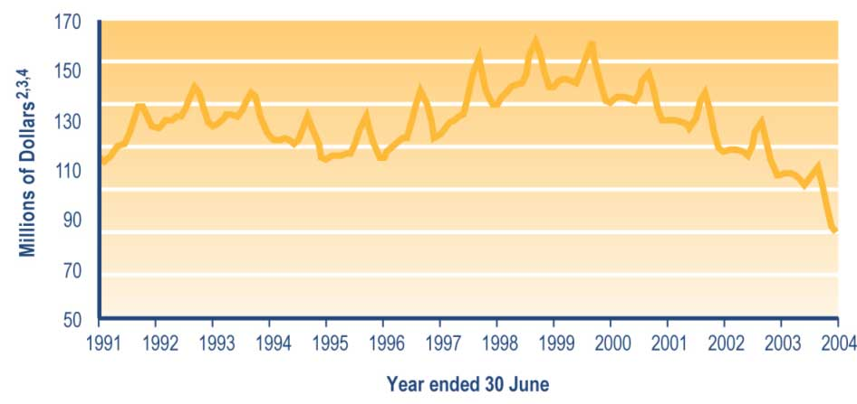

Notes
1 Includes Unemployment Benefits and Unemployment Benefits – Hardship paid to unemployed people or to trainees, and Independent Youth Benefits. Also includes Emergency Benefits paid to unemployed people or trainees since 1 October 1998, and Emergency Unemployment Benefits paid prior to 1 October 1998.
2 Monthly expenditure on unemployment-related benefits, and on supplementary benefits paid to recipients of these benefits.
3 Expenditure shown is net of taxation, adjusted for the number of payments in the month, and smoothed using a three-month moving average.
4 Expenditure data in this graph differs from, and should not be cited as, MSD’s official measure of expenditure on financial assistance provided to clients.

Table 7.2 (see Section 7) shows trends since 1940 in expenditure on unemployment-related benefits and Emergency Benefits. Please note that expenditure on unemployment-related benefits and Emergency Benefits shown in Table 7.2 includes:

 deductions for debt established from 1996, whereas the data in Table 3.8 and Figure 3.3 does not
 expenditure on supplementary benefits paid to people receiving unemployment-related benefits and Emergency Benefits.

Carers’ benefits

This group of core benefits includes Domestic Purposes Benefits – Sole Parents, Domestic Purposes Benefits – Caring for the Sick and Infirm, Domestic Purposes Benefits – Women Alone, and Emergency Maintenance Allowances. An Emergency Maintenance Allowance is an Emergency Benefit paid to carers who do not meet the eligibility criteria for a Domestic Purposes Benefit – Sole Parents but who are alone, caring for children and unable to support themselves without financial assistance.
From November 1996, carers could choose to transfer from fortnightly to weekly payments of their benefit, and a large number of clients took up this offer in 1996/1997. From November 1996, all new carers’ benefits granted were paid weekly. This movement from fortnightly to weekly payments slowed in later years.

Eligibility for carers’ benefits

Domestic Purposes Benefits
From 1 April 1997 until 10 March 2003, clients receiving a Domestic Purposes Benefit – Women Alone were subject to a part-time work test.

From 1 April 1997 until 31 January 1999, clients receiving a Domestic Purposes Benefit – Sole Parents were subject to a part-time work test if their youngest dependent child was aged 14 years or over.

From 1 February 1999 until 10 March 2003, clients receiving a Domestic Purposes Benefit – Sole Parents were subject to:

 a full-time work test if their youngest dependent child was aged 14 years or over
 a part-time work test if their youngest dependent child was aged 6–13 years
 a requirement to attend an annual interview with a Work and Income case manager if their youngest dependent child was aged under six years (the purpose of this interview was to plan how the client would enter paid work once their youngest dependent child had reached six years of age).

Since the removal of work test obligations on 10 March 2003, clients receiving a Domestic Purposes Benefit – Sole Parents or a Domestic Purposes Benefit – Women Alone have been obliged to meet the requirements of the Personal Development and Employment Plan process if required by their case manager. This process involves developing and implementing a plan that is aimed at assisting clients in moving toward employment, and therefore toward economic and social participation in society.

Domestic Purposes Benefits – Sole Parents
A Domestic Purposes Benefit – Sole Parents is available to a single person who is:

 the parent of a dependent child aged under 18 years who lives with them
 not living with the other parent or another partner.

To be eligible for a Domestic Purposes Benefit – Sole Parents, clients must:

 be aged 18 years or over, or aged 16 or 17 years and have been legally married
 meet residency and income qualifications.

Applicants for a Domestic Purpose Benefit – Sole Parents are, with some exceptions, required to:

 name the other parent of the child or children they are caring for
 apply for Child Support.

Refusal to name the other parent without good reason results in a lower level of benefit
being payable.

Child Support paid by the liable parent, up to the level of the Domestic Purposes Benefit – Sole Parents, is retained by the Crown to offset the cost of the benefit. Please refer to Inland Revenue publications for information on the collection of Child Support.

Domestic Purposes Benefit – Caring for the Sick or Infirm
A Domestic Purposes Benefit – Caring for the Sick or Infirm is available to people who are:

 aged over 16 years
 caring on a full-time basis for someone (other than a partner) who would otherwise be in hospital.

Residency and income qualifications must also be met.

Domestic Purposes Benefit – Women Alone

A Domestic Purposes Benefit – Women Alone is available to unsupported women without dependent children who became alone or lost the support of a partner after:

 turning 50 years of age
 either:
– caring for dependent children for at least 15 years
– caring full time for a sick or frail relative for at least five years, or
– being supported by their partner for at least five years.

Residency and income qualifications must also be met.

Emergency Maintenance Allowance
An Emergency Maintenance Allowance is available to people who do not meet the eligibility criteria for a Domestic Purposes Benefit – Sole Parents but who are alone, caring for children and unable to support themselves without financial assistance. In some circumstances, an Allowance can also be paid to clients who are experiencing domestic violence but who are still living with their partner or spouse. Most clients receiving an Emergency Maintenance Allowance are aged 16–17 years.

Trends in the number of clients receiving a carers’ benefit
The number of clients receiving a carers’ benefit has increased since 2001 (see Table 3.9). Since 2000, around 93% of clients receiving a carers’ benefit have been receiving a Domestic Purposes Benefit – Sole Parents (see Table 3.9).

Table 3.9 Trends in carers’ benefits received

Type of carers’ benefit received at 30 June | Clients receiving a carers’ benefit¹
 | 2000  Number | 2001  Number | 2002  Number | 2003  Number | 2004  Number
Domestic Purposes Benefit  - Sole Parents | 102,094 | 100,663 | 100,665 | 101,625 | 101,597
Domestic Purposes Benefit - Caring for the Sick or Infirm | 2,399 | 2,717 | 2,936 | 3,246 | 3,564
Domestic Purposes Benefit - Women Alone | 2,796 | 2,799 | 2,869 | 2,962 | 3,049
Emergency Maintenance Allowance | 1,650 | 1,642 | 1,539 | 1,462 | 1,316
Total | 108,939 | 107,821 | 108,009 | 109,295 | 109,526

Note
1 Numbers of clients recorded in SWIFTT as receiving a carers’ benefit at 30 June.

Since 2000, the number of clients receiving a Domestic Purposes Benefit – Sole Parents or an Emergency Maintenance Allowance has fluctuated around a downward trend (see Table 3.10). Of the clients receiving a Domestic Purposes Benefit – Sole Parents or an Emergency Maintenance Allowance since 2000 (see Table 3.10):

 around 48% have been caring for at least one dependent child aged under five years
 around 95% have been caring for at least one dependent child aged under 15 years (by law, children aged under 14 years require supervision at all times).

Table 3.10 Trends in ages of the youngest child dependent on people receiving a Domestic Purposes Benefit – Sole Parents or an Emergency Maintenance Allowance

Age of youngest dependent child at 30 June | Clients receiving a Domestic Purposes Benefit  - Sole Parents or an Emergency Maintenance Allowance¹
 | 2000  Number | 2001  Number | 2002  Number | 2003  Number | 2004  Number
0-4 years | 50,881 | 49,797 | 49,424 | 49,100 | 48,906
5-9 years | 30,716 | 30,220 | 29,855 | 29,973 | 29,218
10-14 years | 17,080 | 17,516 | 18,168 | 18,680 | 18,885
15-17 years | 4,767 | 4,537 | 4,527 | 5,060 | 5,610
18-19 years | 196 | 155 | 162 | 165 | 218
20 years or over | 0 | 0 | 0 | 0 | 0
Not caring for children² | 104 | 80 | 68 | 109 | 76
Total | 103,744 | 102,305 | 102,204 | 103,087 | 102,913

Notes
1 Numbers of clients recorded in SWIFTT as receiving a Domestic Purposes Benefit – Sole Parents or an Emergency Maintenance Allowance at 30 June.
2 Clients may continue to receive a Domestic Purposes Benefit – Sole Parents or an Emergency Maintenance Allowance for a short period after the child in respect of whom the benefit was paid has left their care.

Table 7.1 (see Section 7) shows trends since 1975 in the number of clients receiving carers’ benefits.

Trends in the proportion of 18–59 year olds receiving a carers’ benefit
Since 2000, around 4% of 18–59 year olds have been receiving a Domestic Purposes Benefit – Sole Parents or an Emergency Maintenance Allowance (see Figure 3.4). Over this period, 25–39 year olds have been more likely than 18–24 year olds or 40–59 year olds to be receiving a Domestic Purposes Benefit – Sole Parents or an Emergency Maintenance Allowance (see Figure 3.4).
Figure 3.4 Trends in the proportion of 18–59 year olds receiving a Domestic Purposes Benefit – Sole Parents or an Emergency Maintenance Allowance, by age

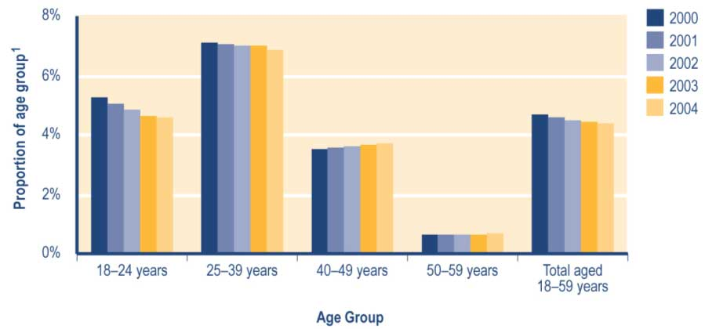

Note
1 Proportion shows:
a number of people in age group recorded in SWIFTT as receiving a Domestic Purposes Benefit – Sole Parents or an Emergency Maintenance Allowance at 30 June, divided by
b Statistics New Zealand final estimate of the resident population in age group at 30 June.

See Table A3.6 (Appendix 3) for a summary of the SWIFTT data underlying Figure 3.4.

Since 2000, very small numbers (under 0.2%) of people aged 18–59 years have been receiving a Domestic Purposes Benefit – Caring for the Sick and Infirm. Over the same period, a similar proportion (under 0.5%) of women aged 40–59 years has been receiving a Domestic Purposes Benefit – Women Alone.

Trends in carers’ benefits granted
Since 1999/2000, the number of carers’ benefits granted each year has fluctuated around a downward trend (see Table 3.11). Of the carers’ benefits granted each year since 1999/2000 (see Table 3.11):

 between 38% and 42% have been provided to clients who have not received a core benefit for at least 12 months
 between 21% and 23% have been provided to clients who have not received a core benefit in the previous four years.

Since 1999/2000, the proportion of carers’ benefits granted each year that reflected transfers between core benefits has decreased (from 35% to 30%) (see Table 3.11).
Table 3.11 Trends in the length of period since clients granted carers’ benefits last received any core benefit

Period since client last received any core benefit | Carers’ benefits granted^{1,2}
 | 1999/2000  Number | 2000/2001  Number | 2001/2002  Number | 2002/2003  Number | 2003/2004  Number
None (administrative transfers of people who continued to receive some core benefit) | 13,550 | 12,637 | 12,149 | 11,557 | 11,345
Under 6 months | 6,830 | 6,978 | 6,870 | 6,869 | 6,770
6-12 months | 3,703 | 3,781 | 3,711 | 3,781 | 3,639
12-18 months | 2,129 | 2,055 | 2,042 | 2,168 | 2,124
18 months-2 years | 1,512 | 1,563 | 1,469 | 1,504 | 1,568
2-4 years | 3,000 | 3,266 | 3,169 | 3,283 | 3,434
Not received a core benefit in previous four years | 8,357 | 8,641 | 8,074 | 8,463 | 8,566
Total | 39,081 | 38,921 | 37,484 | 37,625 | 37,446

Note
1 Includes Domestic Purposes Benefits – Sole Parents, Domestic Purposes Benefits – Caring for the Sick and Infirm, Domestic Purposes Benefits – Women Alone, and Emergency Maintenance Allowances.
2 Number of successful applications for carers’ benefits recorded in SWIFTT during years ended 30 June.

The number of Domestic Purposes Benefits – Sole Parents and Emergency Maintenance Allowances granted each year has decreased slightly since 1999/2000. Of the Domestic Purposes Benefits – Sole Parents and Emergency Maintenance Allowances granted each year since 1999/2000 (see Table 3.12):

• between 61% and 64% have been provided to clients with at least one dependent child aged under five years
• between 33% and 35% have been provided to clients with at least one dependent child aged 5–14 years.

Table 3.12 Trends in ages of the youngest child dependent on people granted a Domestic Purposes Benefit – Sole Parents or an Emergency Maintenance Allowance

Age of youngest dependent child when benefit granted | Domestic Purposes Benefits - Sole Parents  and Emergency Maintenance allowances granted¹
 | 1999/2000  Number | 2000/2001  Number | 2001/2002  Number | 2002/2003  Number | 2003/2004  Number
0-4 years | 23,674 | 22,817 | 21,451 | 21,308 | 20,996
5-9 years | 7,899 | 7,971 | 7,437 | 7,321 | 6,956
10-14 years | 4,120 | 4,462 | 4,696 | 4,760 | 4,807
15-17 years | 1,060 | 1,143 | 1,135 | 1,322 | 1,385
18-19 years | 15 | 21 | 15 | 15 | 13
20 years or over | 0 | 0 | 0 | 2 | 1
Unspecified | 2 | 1 | 0 | 0 | 0
Not applicable (no child linked to the benefit)² | 106 | 86 | 83 | 70 | 68
Total | 36,876 | 36,501 | 34,817 | 34,798 | 34,226

Notes
1 Numbers of successful applications for the Domestic Purposes Benefit – Sole Parents or the Emergency Maintenance Allowance recorded in SWIFTT during years ended 30 June.
2 Clients have been granted these benefits while the custody and care circumstances of the children involved are clarified. In most cases, these benefits are paid at a rate similar to Unemployment Benefits received by single people with no children.

Trends in cessations of carers’ benefits
The annual number of cessations of carers’ benefits has increased in the last year, after decreasing over the previous four years (see Table 3.13).

Since 1999/2000, around 49% of the annual cessations of carers’ benefits have reflected factors other than clients obtaining paid work or administrative transfers (see Table 3.13).
This most commonly reflects people receiving a Domestic Purposes Benefit – Sole Parents entering another relationship. Over the same period, the proportion of cessations of carers’ benefits each year that reflected clients entering paid work has increased (from 27% to 32%) (see Table 3.13).

Table 3.13 Trends in reasons for cessations of carers’ benefits

Reasons for cessation | Cessations of carers’ benefits^{1,2}
 | 1999/2000  Number | 2000/2001  Number | 2001/2002  Number | 2002/2003  Number | 2003/2004  Number
Obtained paid work | 10,783 | 11,075 | 11,069 | 11,289 | 12,024
Transferred to another core benefit | 9,702 | 9,010 | 8,432 | 7,636 | 7,203
Other | 19,832 | 19,328 | 18,335 | 18,004 | 18,642
Total | 40,317 | 39,413 | 37,836 | 36,929 | 37,869

Notes
1 Includes Domestic Purposes Benefits – Sole Parents, Domestic Purposes Benefits – Caring for the Sick and Infirm, Domestic Purposes Benefits – Women Alone, and Emergency Maintenance Allowances.
2 Numbers of cessations of carers’ benefits recorded in SWIFTT during years ended 30 June.

Trends in expenditure on carers’ benefits
Fluctuations since 1997/1998 in annual expenditure on carers’ benefits (see Table 3.14) largely reflect changes in the numbers of clients receiving a carers’ benefit.

Table 3.14 Trends in annual expenditure on carers’ benefits¹

Year ended 30 June | Expenditure on  carers’ benefit^{2,3,4}  ($million)
1991/1992 | 1,104
1992/1993 | 1,147
1993/1994 | 1,208
1994/1995 | 1,337
1995/1996 | 1,493
1996/1997 | 1,608
1997/1998 | 1,706
1998/1999 | 1,682
1999/2000 | 1,652
2000/2001 | 1,637
2001/2002 | 1,650
2002/2003 | 1,690
2003/2004 | 1,777

Notes
1 Includes Domestic Purposes Benefits – Sole Parents, Domestic Purposes Benefits – Caring for the Sick and Infirm, Domestic Purposes Benefits – Women Alone, and Emergency Maintenance Allowances.
2 Expenditure on carers’ benefits in years ended 30 June, including expenditure on supplementary benefits provided to recipients of a carers’ benefit.
3 Expenditure shown is net of taxation, adjusted for the number of payments of carers’ benefits made during the year, and smoothed using a three-month moving average.
4 Expenditure data in this table differs from, and should not be cited as, MSD’s official measure of expenditure on financial assistance provided to clients.

Monthly expenditure on carers’ benefits shows a small seasonal peak in the latter part of each fiscal year (see Figure 3.5). This peak results in part from the inclusion of the Training Incentive Allowance and benefit advances that are made at the start of the school/academic year to clients who are receiving a carers’ benefit and who have children attending school or who are themselves undertaking approved training.

Figure 3.5 Trends in monthly expenditure on carers’ benefits¹

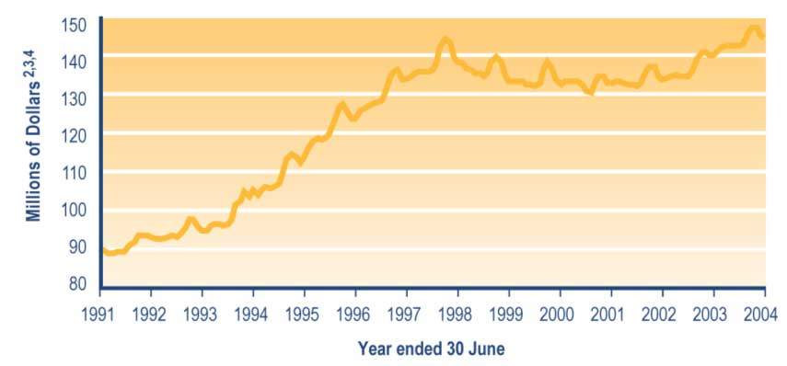

Notes
1 Includes Domestic Purposes Benefits – Sole Parents, Domestic Purposes Benefits – Caring for the Sick and Infirm, Domestic Purposes Benefits – Women Alone, and Emergency Maintenance Allowances.
2 Monthly expenditure on carers’ benefits and on supplementary benefits paid to recipients of a carers’ benefit.
3 Expenditure shown is net of taxation, adjusted for the number of carers’ benefits made during the month, and smoothed using a three-month moving average.
4 Expenditure data in this graph differs from, and should not be cited as, MSD’s official measure of expenditure on financial assistance provided to clients.

Table 7.2 (see Section 7) shows trends since 1975 in expenditure on carers’ benefits. Please note that expenditure on carers’ benefits in Table 7.2 includes:

• deductions for debt established from 1996, while the data in Table 3.14 and Figure 3.5 does not
• expenditure on supplementary benefits paid to people receiving a carers’ benefit.

Sickness-related benefits

Core benefits in this group consist of Sickness Benefits and Sickness Benefits – Hardship.
A Sickness Benefit was known as a Community Wage – Sickness between 1 October 1998 and 30 June 2001, before reverting to its former name on 1 July 2001. A Sickness Benefit – Hardship was known as an Emergency Sickness Benefit prior to 1 October 1998 and as a Community Wage – Emergency Sickness between 1 October 1998 and 30 June 2001.

From 1 October 1998, the spouses or partners of clients receiving a Sickness Benefit have been subject to:

• a full-time work test if the couple have no dependent children, or if their youngest dependent child is aged 14 years or over
• a part-time work test if the couple’s youngest dependent child is aged 6–13 years
• a requirement to attend a yearly planning meeting with a Work and Income case manager if the couple’s youngest dependent child is aged under six years (the aim of this interview is to plan the entry into paid work of the partner or spouse of the Sickness Benefit recipient once their youngest dependent child is aged six years).

During the 2003/2004 financial year, work-tested clients have had Government expectations about meeting the work test made clearer. Other work test requirements added during the 2003/2004 financial year included a requirement to:

• take drug tests if required to by a prospective employer (from 10 October 2003)
• commute to seek and undertake paid work if there is no such work available in their local area (from 8 March 2004).

From 1 July 1998, the payment rate for a new Sickness Benefit was aligned with the (lower) rate for an Unemployment Benefit. People receiving a Sickness Benefit since before 1 July 1998 have continued to receive the old (higher) rate for their Sickness Benefit that was paid immediately prior to 1 July 1998.

Types of sickness-related benefit

Sickness Benefit
From 1 October 1998, a Sickness Benefit has been available to people who are:

• unable to work full time through illness, injury or pregnancy
• limited in their capacity to seek work due to illness or injury, or
• in employment but losing earnings through illness or injury.

To receive a Sickness Benefit, clients must be aged 18 years or over, or aged 16 years or over and living with a partner and dependent child. Income and residency tests apply.
Prior to 1 October 1998, a Sickness Benefit was available to people aged 18 years or over (16 years or over until 1 January 1998) who:

• were temporarily incapacitated for work
• had suffered a loss of earnings
• met an income test.

Sickness Benefit – Hardship
People who do not meet the eligibility criteria for a Sickness Benefit but who are suffering hardship because of illness or injury may be granted a Sickness Benefit – Hardship. Women aged 16 or 17 years who are unable to support themselves because of pregnancy may also be eligible for a Sickness Benefit – Hardship. Income and asset tests apply.

Applicants prior to 1 October 1998 who did not meet all eligibility requirements may have
been granted an Emergency Benefit because of hardship. An income and asset test applied to this benefit.

From January 2004, clients receiving a sickness-related benefit have been able to access pilot programmes aimed at helping clients to:

• set goals for their future
• develop individual plans addressing their needs, strengths, barriers and key issues.

Trends in the number of clients receiving a sickness-related benefit
The number of people receiving a sickness-related benefit has increased since 2000 (see Table 3.15). Of the clients receiving a sickness-related benefit over this period:

• around 96% have been receiving a Sickness Benefit (see Table 3.15)
• between 36% and 38% have been aged 45–59 years (see Table 3.16)
• between 30% and 32% have been aged 25–39 years (see Table 3.16).
Table 3.15 Trends in sickness-related benefits received

Benefit received at 30 June | Clients receiving a sickness-related benefit^{1,2}
 | 2000  Number | 2001  Number | 2002  Number | 2003  Number | 2004  Number
Sickness Benefit | 31,076 | 32,497 | 35,259 | 38,756 | 42,873
Sickness Benefit - Hardship | 1,218 | 1,123 | 1,121 | 1,146 | 1,255
Total | 32,294 | 33,620 | 36,380 | 39,902 | 44,128

Notes
1 Includes Sickness Benefits and Sickness Benefits – Hardship.
2 Numbers of clients recorded in SWIFTT as receiving a sickness-related benefit at 30 June.

Table 3.16 Trends in the ages of clients receiving a sickness-related benefit

Age of client at 30 June | Clients receiving a sickness-related benefit^{1,2}
 | 2000  Number | 2001  Number | 2002  Number | 2003  Number | 2004  Number
15–19 years | 1,077 | 1,158 | 1,294 | 1,551 | 1,585
20–24 years | 2,843 | 3,020 | 3,300 | 3,902 | 4,032
25–29 years | 3,224 | 3,241 | 3,402 | 3,671 | 4,009
30–34 years | 3,394 | 3,569 | 3,874 | 4,170 | 4,540
35–39 years | 3,696 | 3,770 | 4,210 | 4,431 | 4,652
40–44 years | 3,791 | 3,950 | 4,391 | 4,878 | 5,284
45–49 years | 3,993 | 4,239 | 4,480 | 4,989 | 5,249
50–54 years | 4,446 | 4,547 | 4,815 | 5,050 | 5,552
55–59 years | 3,680 | 3,677 | 3,888 | 4,233 | 5,683
60–64 years | 1,881 | 2,217 | 2,476 | 2,762 | 3,243
65 years or over | 269 | 232 | 250 | 265 | 299
Unspecified | 0 | 0 | 0 | 0 | 0
Total | 32,294 | 33,620 | 36,380 | 39,902 | 44,128

Notes
1 Includes Sickness Benefits and Sickness Benefits – Hardship.
2 Numbers of clients recorded in SWIFTT as receiving a sickness-related benefit at 30 June.

Around 39% of the clients receiving a sickness-related benefit since 2000 have had systemic disorders (see Table 3.17). Since 2000, there have been increases in the proportions of recipients of sickness-related benefits who:
• have a psychological or psychiatric condition (from 29% to 34%) (see Table 3.17)
• have received their current benefit for less than two years (from 61% to 70%) (see Table 3.18).
Table 3.17 Trends in the incapacities of clients receiving a sickness-related benefit

Client incapacity at 30 June | Clients receiving a sickness-related benefit^{1,2}
 | 2000  Number | 2001  Number | 2002  Number | 2003  Number | 2004  Number
Accident, trauma, entry of foreign bodies | 4,828 | 4,919 | 5,094 | 5,294 | 5,690
Disease (circulatory system diseases, infectious or parasitic diseases) | 326 | 247 | 245 | 253 | 271
Cancer | 582 | 632 | 684 | 701 | 769
Congenital conditions | 181 | 120 | 129 | 135 | 138
Intellectual disability | 163 | 192 | 171 | 175 | 212
Pregnancy related | 1,458 | 1,452 | 1,394 | 1,480 | 1,596
Psychological or psychiatric conditions | 9,231 | 10,384 | 11,889 | 13,698 | 15,155
Sensory disorders | 359 | 304 | 324 | 390 | 435
Substance abuse | 2,179 | 2,008 | 2,137 | 2,328 | 2,418
Systemic disorders | 12,931 | 13,318 | 14,289 | 15,414 | 17,415
Unspecified/ill-defined conditions³ | 56 | 44 | 24 | 34 | 29
Total | 32,294 | 33,620 | 36,380 | 39,902 | 44,128

Notes
1 Includes Sickness Benefits and Sickness Benefits – Hardship.
2 Numbers of clients recorded in SWIFTT as receiving a sickness-related benefit at 30 June.
3 Includes uncoded incapacities and ill-defined conditions.

Table 3.18 Trends in the length of current spells receiving a sickness-related benefit

Length of current spells at 30 June | Clients receiving a sickness-related benefit^{1,2}
 | 2000  Number | 2001  Number | 2002  Number | 2003  Number | 2004  Number
Under 6 months | 10,046 | 10,875 | 12,235 | 13,324 | 15,341
6 months - 2 years | 9,616 | 10,698 | 12,316 | 14,179 | 15,419
2-4 years | 6,672 | 5,617 | 5,322 | 6,204 | 7,096
Over 4 years | 5,960 | 6,430 | 6,507 | 6,195 | 6,272
Total | 32,294 | 33,620 | 36,380 | 39,902 | 44,128

Notes
1 Includes Sickness Benefits and Sickness Benefits – Hardship.
2 Numbers of clients recorded in SWIFTT as receiving a sickness-related benefit at 30 June.

Table 7.1 (see Section 7) shows trends since 1940 in the number of people receiving a sickness-related benefit.

Trends in the proportion of 18–59 year olds receiving a sickness-related benefit
Since 2000, around 2% of 18–59 year olds have been receiving a sickness-related benefit (see Figure 3.6). Over this period, the proportion of people in each age group receiving a sickness-related benefit increased with age. In particular, 50–59 year olds have been slightly more likely to be receiving a sickness-related benefit than 18–49 year olds.
Figure 3.6 Trends in the proportion of 18–59 year olds receiving a sickness-related benefit¹, by age

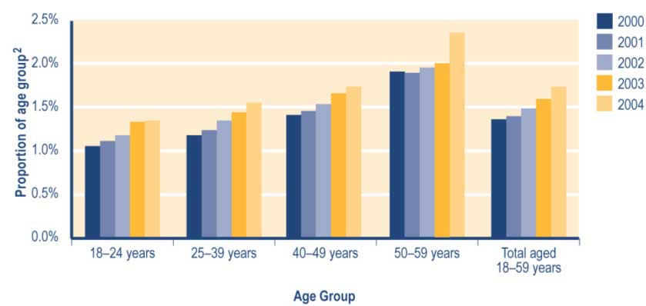

Notes
1 Includes Sickness Benefits and Sickness Benefits – Hardship.
2 Proportion shows:
a number of clients in age group recorded in SWIFTT as receiving a sickness-related benefit at 30 June, divided by
b Statistics New Zealand final estimate of the resident population in age group at 30 June.

See Table A3.7 (Appendix 3) for a summary of the SWIFTT data underlying Figure 3.6.

Trends in sickness-related benefits granted
The annual number of sickness-related benefits granted has increased since 1999/2000 (see Table 3.19).

Of the sickness-related benefits granted each year since 1999/2000 (see Table 3.19):

• between 36% and 38% reflected clients transferring from another core benefit
• between 39% and 41% have been provided to clients who had not received a core benefit in the previous 12 months
• between 24% and 27% have been provided to clients who had not received any core benefit in the previous four years.
Table 3.19 Trends in the length of period since clients granted a sickness-related benefit last received any core benefit

Period since client last received any core benefit | Sickness-related benefits granted^{1,2}
 | 1999/2000  Number | 2000/2001  Number | 2001/2002  Number | 2002/2003  Number | 2003/2004  Number
None (administrative transfers of clients who continued to receive some core benefit) | 13,941 | 14,439 | 15,588 | 16,007 | 17,343
Under 6 months | 4,909 | 5,491 | 6,328 | 6,881 | 7,812
6-12 months | 2,795 | 3,276 | 3,573 | 3,759 | 4,377
12-18 months | 1,577 | 1,701 | 1,869 | 2,098 | 2,249
18 months - 2 years | 1,201 | 1,185 | 1,419 | 1,498 | 1,597
2-4 years | 2,510 | 2,677 | 2,857 | 3,116 | 3,592
Not received a core benefit in previous four years | 9,723 | 9,805 | 10,208 | 10,658 | 11,385
Total | 36,656 | 38,574 | 41,842 | 44,017 | 48,355

Notes
1 Includes Sickness Benefits and Sickness Benefits – Hardship.
2 Numbers of successful applications for sickness-related benefits recorded in SWIFTT during years ended 30 June.

Between 32% and 34% of the sickness-related benefits granted each year since 1999/2000 have been provided to clients with systemic disorders. Over this period, the proportion of sickness-related benefits granted that were provided to clients with psychological or psychiatric conditions has increased (from 24% to 31%) (see Table 3.20).

Table 3.20 Trends in the incapacities of clients granted a sickness-related benefit

Client incapacity when benefit granted | Sickness-related benefits granted^{1,2}
 | 1999/2000  Number | 2000/2001  Number | 2001/2002  Number | 2002/2003  Number | 2003/2004  Number
Accident, trauma, entry of foreign bodies | 5,596 | 5,700 | 6,024 | 6,000 | 6,371
Disease (circulatory system diseases, infectious or parasitic diseases) | 630 | 664 | 640 | 579 | 595
Cancer | 873 | 912 | 919 | 1,000 | 1,029
Congenital conditions | 182 | 194 | 212 | 223 | 237
Intellectual disability | 64 | 80 | 84 | 81 | 121
Pregnancy related | 6,012 | 5,616 | 5,425 | 5,133 | 5,437
Psychological or psychiatric conditions | 8,849 | 10,126 | 11,823 | 13,736 | 15,081
Sensory disorders | 362 | 344 | 371 | 436 | 477
Substance abuse | 2,309 | 2,289 | 2,390 | 2,436 | 2,496
Systemic disorders | 11,550 | 12,445 | 13,740 | 14,202 | 16,294
Unspecified/ill-defined conditions³ | 229 | 204 | 214 | 191 | 217
Total | 36,656 | 38,574 | 41,842 | 44,017 | 48,355

Notes
1 Includes Sickness Benefits and Sickness Benefits – Hardship.
2 Numbers of successful applications for sickness-related benefits recorded in SWIFTT during years ended 30 June.
3 Includes uncoded incapacities and ill-defined conditions.

Trends in cessations of sickness-related benefits
The annual number of cessations of sickness-related benefits has increased since 2000/2001 (see Table 3.21). Since 1999/2000, between 12% and 14% of cessations of sickness-related benefits each year have reflected clients returning directly to work, rather than transferring to another core benefit (eg an unemployment-related benefit) and then entering paid work. Over this period, the proportion of sickness-related benefits each year that reflect (see Table 3.21):

• clients transferring to another core benefit has decreased (from 57% to 47%)
• clients ceasing sickness-related benefits for other reasons has increased (from 31% to 39%).

Table 3.21 Trends in reasons for cessations of sickness-related benefits

Reason for cessation | Cessations of sickness-related benefits^{1,2}
 | 1999/2000  Number | 2000/2001  Number | 2001/2002  Number | 2002/2003  Number | 2003/2004  Number
Obtained paid work | 4,561 | 4,879 | 5,203 | 5,516 | 6,200
Transferred to another core benefit | 21,267 | 20,313 | 20,867 | 20,811 | 20,250
Other | 11,619 | 11,773 | 12,747 | 14,163 | 16,800
Total | 37,447 | 36,965 | 38,817 | 40,490 | 43,259

Notes
1 Includes Sickness Benefits and Sickness Benefits – Hardship.
2 Numbers of cessations of sickness-related benefits recorded in SWIFTT during years ended 30 June.

Trends in expenditure on sickness-related benefits
Increases since 2000/2001 in annual expenditure on sickness-related benefits (see Table 3.22) largely reflect increases in the numbers of people receiving a sickness-related benefit.

Table 3.22 Trends in annual expenditure on sickness-related benefits¹

Year ended 30 June | Expenditure on  Sickness-related  Benefits^{2,3,4}  ($million)
1991/1992 | 234
1992/1993 | 273
1993/1994 | 323
1994/1995 | 361
1995/1996 | 394
1996/1997 | 419
1997/1998 | 452
1998/1999 | 429
1999/2000 | 405
2000/2001 | 404
2001/2002 | 432
2002/2003 | 475
2003/2004 | 537

Notes
1 Includes Sickness Benefits and Sickness Benefits – Hardship.
2 Expenditure on sickness-related benefits in years ended 30 June, including expenditure on supplementary benefits provided to recipients of a sickness-related benefit.
3 Expenditure shown is net of taxation, adjusted for the number of payments of sickness-related benefits made during the year, and smoothed using a three-month moving average.
4 Expenditure data in this table differs from, and should not be cited as, MSD’s official measure of expenditure on financial assistance provided to clients.

Little seasonal variation is evident in monthly expenditure on sickness-related benefits (see Figure 3.7).
Figure 3.7 Trends in monthly expenditure on sickness-related benefits¹

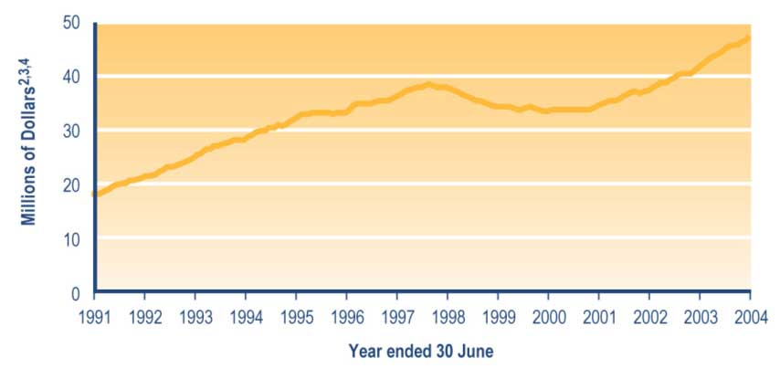
Notes
1 Includes Sickness Benefits and Sickness Benefits – Hardship.
2 Monthly expenditure on sickness-related benefits, including expenditure on supplementary benefits paid to recipients of a sickness-related benefit.
3 Expenditure shown is net of taxation, adjusted for the number of payments of sickness-related benefits made during the month, and smoothed using a three-month moving average.
4 Expenditure data in this graph differs from, and should not be cited as, MSD’s official measure of expenditure on financial assistance provided to clients.

Table 7.2 (see Section 7) shows trends since 1940 in expenditure on sickness-related benefits. Please note that expenditure on sickness-related benefits shown in Table 7.2 includes:

• deductions for debt established from 1996, whereas the data in Table 3.22 and Figure 3.7 does not
• expenditure on supplementary benefits paid to people receiving a sickness-related benefit.

Invalids’ Benefit

An Invalids’ Benefit is available to people who are 16 years or over and are either:
• permanently and severely restricted in their capacity for work because of sickness, injury or disability, or
• totally blind.

A “permanent and severe” restriction is defined in the Social Security Act 1964 as one that:

• is expected to last at least two years, or that is terminal and the client is not expected to live for more than two years
• means the client cannot regularly work more than 15 hours per week in open employment.

A residential qualification and an income test must be met in order to receive an Invalids’ Benefit.

From 1 October 1998, the partners and spouses of people receiving an Invalids’ Benefit have been subject to:

• a full-time work test if the couple have no dependent children or if their youngest dependent child is aged 14 years or over
• a part-time work test if the couple’s youngest dependent child is aged 6–13 years
• a requirement to attend an annual planning interview with a Work and Income case manager if the couple’s youngest dependent child is aged under six years (the aim of this interview is to plan the entry into paid work of the partner or spouse of the Invalids’ Benefit recipient once the couple’s youngest dependent child turns six years of age).

During the 2003/2004 financial year, work-tested clients have had Government expectations about meeting the work test made clearer. Other work test requirements added during the 2003/2004 financial year include a requirement to:

• take drug tests if required to by a prospective employer (from 22 October 2003)
• commute to seek and undertake paid work if there is no such work available in their local area (from 8 March 2004).

Trends in the number of clients receiving an Invalids’ Benefit
Increases since 2000 in the number of clients receiving an Invalids’ Benefit (see Table 3.23) reflect:

• the long-term nature of the conditions that result in people being granted an Invalids’ Benefit
• iterative increases in the age of eligibility for New Zealand Superannuation.

Of clients receiving an Invalids’ Benefit since 2000 (see Table 3.23):

• between 37% and 39% have had a systemic disorder
• around 25% have had a psychological or psychiatric condition
• between 15% and 19% have had an intellectual disability.

Table 3.23 Trends in the incapacities of clients receiving an Invalids’ Benefit

Client incapacity at 30 June | Clients receiving an Invalids' Benefit¹
 | 2000  Number | 2001  Number | 2002  Number | 2003  Number | 2004  Number
Accident, trauma, entry of foreign bodies | 3,827 | 4,185 | 4,568 | 4,804 | 4,974
Disease (circulatory system diseases, infectious or parasitic diseases) | 255 | 296 | 351 | 380 | 413
Cancer | 1,397 | 1,572 | 1,739 | 1,891 | 2,034
Congenital conditions | 2,024 | 2,244 | 2,445 | 2,691 | 2,856
Intellectual disability | 10,736 | 10,878 | 10,936 | 11,022 | 11,175
Psychological or psychiatric conditions | 13,911 | 15,148 | 16,501 | 17,850 | 19,128
Sensory disorders | 1,888 | 1,971 | 2,029 | 2,051 | 2,133
Substance abuse | 628 | 737 | 866 | 931 | 1,051
Systemic disorders | 20,315 | 22,426 | 24,824 | 26,686 | 28,384
Unspecified/ill-defined conditions² | 411 | 355 | 270 | 201 | 194
Total | 55,392 | 59,812 | 64,529 | 68,507 | 72,342

Notes
1 Numbers of clients recorded in SWIFTT as receiving an Invalids’ Benefit at 30 June.
2 Includes uncoded incapacities and ill-defined conditions.

Since 2000, around 39% of clients receiving an Invalids’ Benefit have been aged 45–59 years (see Table 3.24). Over the same period, the proportion of Invalids’ Benefit recipients who were aged 60–64 years has increased (from 13% to 17%), while the proportion aged 25–39 years has decreased (from 28% to 23%) (see Table 3.24).
Table 3.24 Trends in the ages of clients receiving an Invalids’ Benefit

Age of client at 30 June | Clients receiving an Invalids' Benefit¹
 | 2000  Number | 2001  Number | 2002  Number | 2003  Number | 2004  Number
16–19 years | 1,934 | 2,114 | 2,196 | 2,280 | 2,420
20–24 years | 2,965 | 3,108 | 3,297 | 3,512 | 3,710
25–29 years | 4,094 | 4,028 | 4,027 | 4,011 | 4,025
30–34 years | 4,993 | 5,296 | 5,508 | 5,623 | 5,670
35–39 years | 6,206 | 6,403 | 6,548 | 6,782 | 6,957
40–44 years | 6,161 | 6,690 | 7,381 | 7,909 | 8,417
45–49 years | 6,397 | 6,871 | 7,539 | 8,048 | 8,559
50–54 years | 7,146 | 7,713 | 8,318 | 8,840 | 9,345
55–59 years | 7,928 | 8,462 | 9,150 | 10,022 | 10,835
60–64 years | 7,247 | 8,776 | 10,144 | 11,067 | 11,922
65 years or over | 321 | 351 | 421 | 413 | 482
Unspecified | 0 | 0 | 0 | 0 | 0
Total | 55,392 | 59,812 | 64,529 | 68,507 | 72,342

Note
1 Numbers of clients recorded in SWIFTT as receiving an Invalids’ Benefit at 30 June.

Table 7.1 (see Section 7) shows trends since 1940 in the number of clients receiving an Invalids’ Benefit.

Trends in the proportion of 18–59 year olds receiving an Invalids’ Benefit
Increases since 2000 in the proportion of 18–59 year olds receiving an Invalids’ Benefit (see Figure 3.8) reflect the long-term nature of the conditions that result in clients being granted an Invalids’ Benefit. Over the same period, the prevalence of receipt of Invalids’ Benefits among 18–59 year olds has increased with age (see Figure 3.8).

Figure 3.8 Trends in the proportion of 18–59 year olds receiving an Invalids’ Benefit

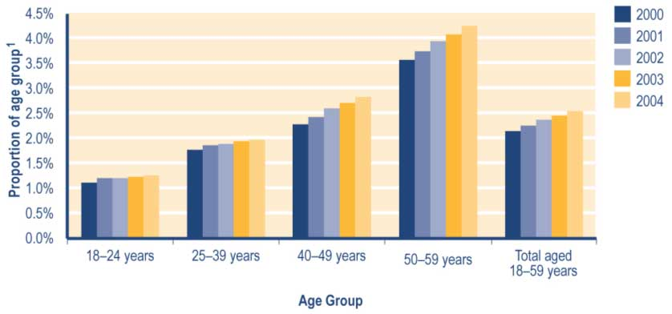

Note
1 Proportion shows:
a number of clients in age group recorded in SWIFTT as receiving an Invalids’ Benefit at 30 June, divided by
b Statistics New Zealand final estimate of the resident population in age group at 30 June.

See Table A3.8 (Appendix 3) for a summary of the SWIFTT data underlying Figure 3.8.

Trends in Invalids’ Benefits granted
The annual number of Invalids’ Benefits granted each year has increased since 1999/2000 (see Table 3.25). Of the Invalids’ Benefits granted in each year since 1999/2000:

• between 69% and 73% reflected clients transferring from other core benefits (see Table 3.25)
• between 17% and 19% were provided to clients who had not received a core benefit in the previous four years (see Table 3.25)
• between 43% and 46% were provided to clients with systemic disorders (see Table 3.26)
• around 24% were provided to clients with psychological or psychiatric conditions (see Table 3.26).

Table 3.25 Trends in the length of period since clients granted an Invalids’ Benefit last received any core benefits

Period since client last received any core benefit | Invalids’ benefits granted¹
 | 1999/2000  Number | 2000/2001  Number | 2001/2002  Number | 2002/2003  Number | 2003/2004  Number
None (administrative transfers of client who continued to receive some core benefit) | 7,309 | 7,034 | 7,917 | 8,053 | 8,180
Under 6 months | 454 | 577 | 649 | 630 | 666
6-12 months | 196 | 233 | 237 | 272 | 268
12-18 months | 94 | 117 | 128 | 111 | 114
18 months - 2 years | 68 | 80 | 97 | 78 | 85
2-4 years | 154 | 168 | 218 | 182 | 239
Not received a core benefit in previous four years | 1,754 | 1,902 | 2,004 | 1,950 | 2,281
Total | 10,029 | 10,111 | 11,250 | 11,276 | 11,833

Note
1 Numbers of successful applications for Invalids’ Benefits recorded in SWIFTT during years ended 30 June.

Table 3.26 Trends in the incapacities of clients granted an Invalids’ Benefit

Client incapacity when benefit granted | Invalids' Benefits granted¹
 | 1999/2000  Number | 2000/2001  Number | 2001/2002  Number | 2002/2003  Number | 2003/2004  Number
Accident, trauma, entry of foreign bodies | 800 | 828 | 942 | 860 | 814
Disease (circulatory system diseases, infectious or parasitic diseases) | 84 | 85 | 93 | 85 | 91
Cancer | 929 | 920 | 1,003 | 1,036 | 1,128
Congenital conditions | 368 | 366 | 371 | 397 | 408
Intellectual disability | 558 | 512 | 465 | 508 | 565
Psychological or psychiatric conditions | 2,497 | 2,416 | 2,688 | 2,827 | 2,860
Sensory disorders | 252 | 220 | 240 | 219 | 266
Substance abuse | 170 | 190 | 229 | 196 | 216
Systemic disorders | 4,357 | 4,554 | 5,195 | 5,129 | 5,405
Unspecified/ill-defined conditions² | 14 | 20 | 24 | 19 | 80
Total | 10,029 | 10,111 | 11,250 | 11,276 | 11,833

Notes
1 Numbers of successful applications for Invalids’ Benefits recorded in SWIFFT during years ended 30 June.
2 Includes uncoded incapacities and ill-defined conditions.

Trends in cessations of Invalids’ Benefits
The number of cessations each year of Invalids’ Benefits has increased since 2000/2001 (see Table 3.27), reflecting increases in the numbers of people receiving an Invalids’ Benefit. Of the Invalids’ Benefit cessations each year since 1999/2000 (see Table 3.27):

• between 28% and 36% have reflected clients transferring to other core benefits or pensions
• between 54% and 60% have reflected reasons other than clients returning to work or transferring to another core benefit or pension (the chief reason for these cessations is the death of the client).

Table 3.27 Trends in reasons for cessations of Invalids’ Benefits

Reason for cessation | Cessations of Invalids' Benefits¹
 | 1999/2000  Number | 2000/2001  Number | 2001/2002  Number | 2002/2003  Number | 2003/2004  Number
Obtained paid work | 564 | 706 | 821 | 958 | 1,109
Transferred to another core benefit | 2,111 | 1,633 | 1,762 | 2,123 | 2,609
Other | 3,241 | 3,228 | 3,809 | 4,065 | 4,411
Total | 5,916 | 5,567 | 6,392 | 7,146 | 8,129

Note
1 Numbers of cessations of Invalids’ Benefits recorded in SWIFFT during years ended 30 June.

Trends in expenditure on Invalids’ Benefits
Increases since 1991/1992 in annual expenditure on Invalids’ Benefits (see Table 3.28) reflect increases in the number of people receiving an Invalids’ Benefit.

Table 3.28 Trends in annual expenditure on Invalids’ Benefits

Year ended 30 June | Expenditure on  Invalids' Benefits^{1,2,3,4}  ($million)
1991/1992 | 329
1992/1993 | 365
1993/1994 | 414
1994/1995 | 465
1995/1996 | 501
1996/1997 | 556
1997/1998 | 624
1998/1999 | 661
1999/2000 | 703
2000/2001 | 764
2001/2002 | 846
2002/2003 | 929
2003/2004 | 1,010

Notes
1 Expenditure on Invalids’ Benefits in years ended 30 June.
2 Expenditure shown includes expenditure on supplementary benefits provided to recipients of an Invalids’ Benefit.
3 Expenditure shown is net of taxation, adjusted for the number of payments of Invalids’ Benefit made during the year, and smoothed using a three-month moving average.
4 Expenditure data in this table differs from, and should not be cited as, MSD’s official measure of expenditure on financial assistance provided to clients.

Little seasonal change is evident in monthly expenditure on Invalids’ Benefits (see Figure 3.9). Temporary reductions in monthly Invalids’ Benefit expenditure in 1995 and 2001 reflect:

• the transfer of maximised Special Benefit payments to Vote: Health in July 1995
• a fall in expenditure on the Accommodation Supplement received by Invalids’ Benefit recipients following the reintroduction of income-related rents in November 2000 (this permanent fall in Accommodation Supplement expenditure was offset by continued growth in expenditure on the Invalids’ Benefit, excluding supplementary benefits).

Figure 3.9 Trends in monthly expenditure on Invalids’ Benefits

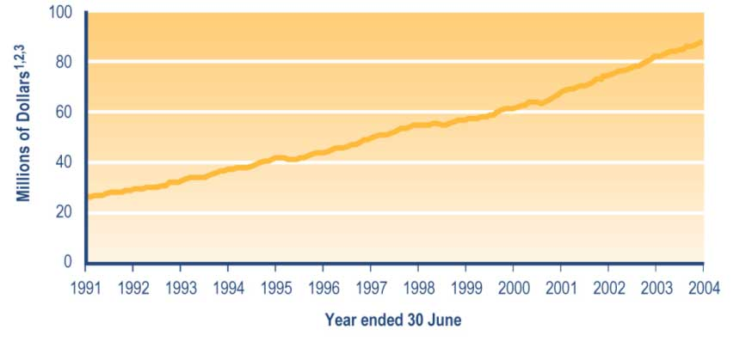

Notes
1 Monthly expenditure on Invalids’ Benefits, including expenditure on supplementary benefits paid to recipients of an Invalids’ Benefit.
2 Expenditure shown is net of taxation, adjusted for the number of payments of Invalids’ Benefit made during the month, and smoothed using a three-month moving average.
3 Expenditure data in this graph differs from, and should not be cited as, MSD’s official measure of expenditure on financial assistance provided to clients.

Table 7.2 (see Section 7) shows trends since 1940 in expenditure on Invalids’ Benefits. Please note that expenditure on Invalids’ Benefits shown in Table 7.2 includes:

• deductions for debts established since 1996, while the data in Figure 3.9 and Table 3.28 does not
• expenditure on supplementary benefits paid to people receiving an Invalids’ Benefit.

Unsupported Child’s Benefit and Orphan’s Benefit

Unsupported Child’s Benefits and Orphan’s Benefits are available to people who are caring for dependent children while those children are unable to live with or be supported by their parents.

These benefits are income tested in relation to any income the child receives other than from personal earnings, but they are not work-tested.

Eligibility for an Unsupported Child’s Benefit and Orphan’s Benefit

Unsupported Child’s Benefit
An Unsupported Child’s Benefit is available to the principal caregiver of a child whose natural, adoptive or step parents are, because of a family breakdown, unable to:

• care for the child, or
• provide for the child’s support.

Residency tests apply, and the child must be expected to be in the care of the client for at least 12 months.

Orphan’s Benefit
An Orphan’s Benefit is available to the principal caregiver of a child whose natural or adoptive parents cannot support the child because they:

• are deceased
• suffer from a serious long-term illness or incapacity that means that they cannot care for the child, or
• cannot be found.

Residency tests apply, and the child must be expected to be in the care of the client for at least 12 months.

Trends in the number of clients receiving an Unsupported Child’s Benefit or Orphan’s Benefit
Increases since 2000 in the number of clients receiving an Unsupported Child’s Benefit or Orphan’s Benefit (see Table 3.29) largely reflect the long-term nature of these benefits.

Table 3.29 Trends in the number of clients receiving an Unsupported Child’s Benefit or Orphan’s Benefit

Benefits received at 30 June | Clients receiving an Unsupported Child's Benefit  or Orphan's Benefit¹
 | 2000  Number | 2001  Number | 2002  Number | 2003  Number | 2004  Number
Unsupported Child's Benefit | 5,419 | 5,700 | 5,970 | 6,418 | 6,682
Orphan's Benefit | 380 | 375 | 362 | 371 | 369
Total | 5,799 | 6,075 | 6,332 | 6,789 | 7,051

Note
1 Numbers of clients recorded in SWIFTT as receiving an Unsupported Child’s Benefit or Orphan’s Benefit at 30 June.

Table 7.1 (see Section 7) shows trends since 1940 in the number of people receiving an Unsupported Child’s Benefit or Orphan’s Benefit.

Trends in the number of children covered by an Unsupported Child’s Benefit or Orphan’s Benefit
Please note that the number of children covered by an Unsupported Child’s Benefit or Orphan’s Benefit may differ from the number of clients receiving an Unsupported Child’s Benefit or Orphan’s Benefit. This is because clients may be receiving an Unsupported Child’s Benefit or Orphan’s Benefit for more than one child.

Increases since 2000 in the number of children covered by an Unsupported Child’s Benefit or Orphan’s Benefit (see Table 3.30) largely reflect the long-term nature of these benefits. Of the children covered by an Unsupported Child’s Benefit or Orphan’s Benefit since 2000 (see Table 3.30):

• around 76% have been aged 14 years or under
• around 39% have been aged under 10 years
• around 22% have been aged 15–17 years.

Table 3.30 Trends in the ages of children covered by an Unsupported Child’s Benefit or Orphan’s Benefit

Age of child at 30 June | Children covered by an Unsupported Child's Benefit  or Orphan's Benefit^{1,2}
 | 2000  Number | 2001  Number | 2002  Number | 2003  Number | 2004  Number
0-4 years | 956 | 946 | 986 | 1,059 | 1,107
5-9 years | 1,988 | 2,049 | 2,197 | 2,384 | 2,554
10-14 years | 2,805 | 3,052 | 3,117 | 3,309 | 3,448
15-17 years | 1,670 | 1,713 | 1,850 | 2,080 | 2,184
18-19 years | 73 | 70 | 67 | 78 | 69
20 years or over | 0 | 0 | 0 | 0 | 0
Unspecified | 0 | 0 | 0 | 0 | 0
Total | 7,492 | 7,830 | 8,217 | 8,910 | 9,362

Notes
1 Numbers of children recorded in SWIFTT as being covered by an Unsupported Child’s Benefit or Orphan’s Benefit being paid at 30 June.
2 A client can receive Unsupported Child’s Benefit or Orphan’s Benefit payments for more than one child. Therefore, the number of children covered by Unsupported Child’s Benefits or Orphan’s Benefits paid at 30 June may not equal the number of clients receiving an Unsupported Child’s Benefit or Orphan’s Benefit at the same date.

Since 2000, around 0.7% of children aged under 18 years have been covered by an Unsupported Child’s Benefit or Orphan’s Benefit (see Figure 3.10). Over this period, the prevalence of coverage by an Unsupported Child’s Benefit or Orphan’s Benefit has increased with age among children aged under 18 years (see Figure 3.10).

Figure 3.10 Trends in the proportion of children aged under 18 years covered by an Unsupported Child’s Benefit or Orphan’s Benefit, by age

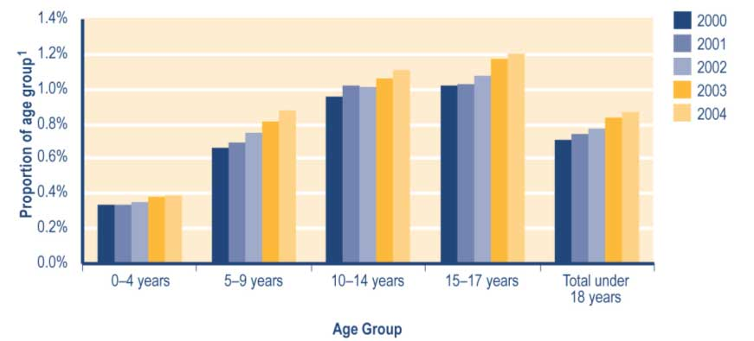
Note
1 Proportion shows:
a number of children in age group recorded in SWIFTT as being covered by an Unsupported Child’s Benefit or Orphan’s Benefit at 30 June, divided by
b Statistics New Zealand final estimate of the resident population in age group at 30 June.

See Table A3.9 (Appendix 3) for a summary of the SWIFTT data underlying Figure 3.10.

Trends in Unsupported Child’s Benefits and Orphan’s Benefits granted
The number of Unsupported Child’s Benefits and Orphan’s Benefits granted each year has fluctuated since 1999/2000 (see Table 3.31). Of the Unsupported Child’s Benefits and Orphan’s Benefits granted each year since 2000/2001 (see Table 3.31):

• around 69% have been provided to clients with at least one dependent child aged 14 years or under
• between 37% and 40% have been provided to clients with at least one dependent child aged 10–14 years
• around 30% have been provided to clients with at least one dependent child aged 15–17 years.

Table 3.31 Trends in ages of the youngest dependent child cared for by clients granted an Unsupported Child’s Benefit or Orphan’s Benefit

Age of youngest dependent child when benefit granted | Unsupported Child's Benefits and Orphan's Benefits granted¹
 | 1999/2000  Number | 2000/2001  Number | 2001/2002  Number | 2002/2003  Number | 2003/2004  Number
0-4 years | 521 | 513 | 518 | 561 | 563
5-9 years | 488 | 449 | 469 | 547 | 487
10-14 years | 1,118 | 1,319 | 1,183 | 1,260 | 1,237
15-17 years | 1,085 | 995 | 941 | 1,019 | 981
18- 19 years | 2 | 3 | 3 | 2 | 4
20 years or over | 1 | 0 | 0 | 0 | 0
Unspecified | 11 | 11 | 8 | 7 | 5
Total | 3,226 | 3,290 | 3,122 | 3,396 | 3,277

Note
1 Numbers of successful applications for Unsupported Child’s Benefits or Orphan’s Benefits recorded in SWIFTT during years ended 30 June.

Trends in cessations of Unsupported Child’s Benefits and Orphan’s Benefits
The annual number of cessations of Unsupported Child’s Benefits and Orphan’s Benefits has increased over the last three years (see Table 3.32). This reflects the combined impact of increases in the number of children covered by these benefits and the ageing of those children.

Over this period, around 98% of cessations of Unsupported Child’s Benefits or Orphan’s Benefits each year have reflected reasons other than clients obtaining paid work or clients transferring to another core benefit (see Table 3.32). The chief reason for these “other” cessations is that the child for whom the benefit is paid either has left the care of the person receiving the benefit or has otherwise become independent.
Table 3.32 Trends in reasons for cessations of Unsupported Child’s Benefits and Orphan’s Benefits

Reason for cessation | Cessations of Unsupported Child's Benefits or Orphan's Benefits¹
 | 1999/2000  Number | 2000/2001  Number | 2001/2002  Number | 2002/2003  Number | 2003/2004  Number
Obtained work | 29 | 22 | 21 | 21 | 30
Transferred to another core benefit | 30 | 42 | 41 | 26 | 26
Other | 2,750 | 2,904 | 2,797 | 2,848 | 2,959
Total | 2,809 | 2,968 | 2,859 | 2,895 | 3,015

Note
1 Numbers of cessations of Unsupported Child’s Benefits or Orphan’s Benefits recorded in SWIFTT during years ended 30 June.

Expenditure on Unsupported Child’s Benefits and Orphan’s Benefits
Increases since 1991/1992 in combined annual expenditure on Unsupported Child’s Benefits and Orphan’s Benefits (see Table 3.33) largely reflect increases in the numbers of children covered by these benefits.

Table 3.33 Trends in combined annual expenditure on Unsupported Child’s Benefits and Orphan’s Benefits

Year ended 30 June | Expenditure on  Unsupported Child's  Benefits and on  Orphan's Benefits^{1,2,3,4}  ($million)
1991/1992 | 14
1992/1993 | 16
1993/1994 | 19
1994/1995 | 21
1995/1996 | 23
1996/1997 | 27
1997/1998 | 30
1998/1999 | 33
1999/2000 | 36
2000/2001 | 39
2001/2002 | 42
2002/2003 | 47
2003/2004 | 51

Notes
1 Expenditure on Unsupported Child’s Benefits and Orphan’s Benefits in years ended 30 June.
2 Includes expenditure on supplementary benefits provided to recipients of an Unsupported Child’s Benefit and to recipients of an Orphan’s Benefit.
3 Expenditure figures shown are adjusted for the number of payments of Unsupported Child’s Benefit and Orphan’s Benefit made during the year, and are smoothed using a two-month moving average. Unsupported Child’s Benefits and Orphan’s Benefits are not subject to taxation.
4 Expenditure data in this table differs from, and should not be cited as, MSD’s official measure of expenditure on financial assistance provided to clients.

The slight decrease in monthly combined expenditure on Unsupported Child’s Benefits and Orphan’s Benefits evident at the beginning of each calendar year (see Figure 3.11) reflects a seasonal dip in applications in January, combined with ongoing cessations as children turn 18 years of age. The increase in expenditure in 1996/1997 and 1997/1998 reflects the impact of increases in the core rates of payments of these benefits in July 1996 and July 1997.
Figure 3.11 Trends in monthly expenditure on Unsupported Child’s Benefits and Orphan’s Benefits

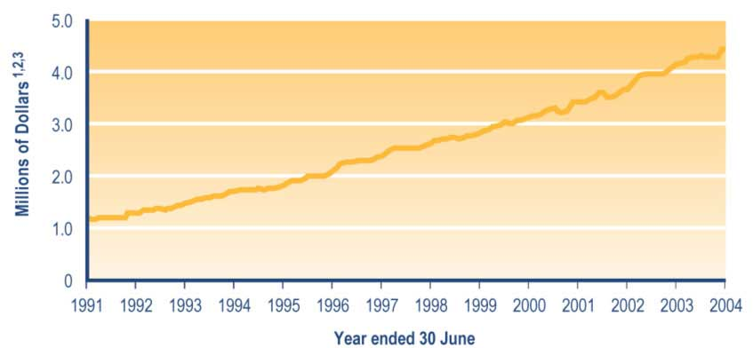

Notes
1 Monthly expenditure on Unsupported Child’s Benefits and Orphan’s Benefits, including expenditure on supplementary benefits paid to recipients of Unsupported Child’s Benefits and recipients of Orphan’s Benefits.
2 Expenditure shown is adjusted for the combined number of payments of Unsupported Child’s Benefits and Orphan’s Benefits made during the month, and smoothed using a two-month moving average. Unsupported Child’s Benefits and Orphan’s Benefits are not subject to taxation.
3 Expenditure data in this graph differs from, and should not be cited as, MSD’s official measure of expenditure on financial assistance provided to clients.

Table 7.2 (see Section 7) shows trends since 1940 in combined expenditure on Unsupported Child’s Benefits and Orphan’s Benefits. Please note that expenditure on Unsupported Child’s Benefits and Orphan’s Benefits shown in Table 7.2 includes:

• deductions for debt established since 1996, while the data in Figure 3.11 and Table 3.33 does not
• expenditure on supplementary benefits paid to people receiving Unsupported Child’s Benefits or Orphan’s Benefits.

Widows’ Benefit

A Widows’ Benefit is available to women aged 16 years or over who are living on their own or with dependent children after being widowed. Residency qualifications and income tests apply.

A Widows’ Benefit is available to a woman who has been widowed and:

• is caring for one or more dependent children
• was married and subsequently cared for dependent children for 15 years or more
• had one or more dependent children, and was married for a total of 15 years
• was married for five years or more, and became a widow after reaching 50 years of age, or
• is aged at least 50 years, was married for at least 10 years after marrying for the first time at least 15 years ago, and became a widow after reaching 40 years of age.

From 1 February 1999 until 10 March 2003, women receiving a Widows’ Benefit were subject to:

• a full-time work test if they had no dependent children or if their youngest dependent child was aged 14 years or over
• a part-time work test if their youngest dependent child was aged 6–13 years
• a requirement to attend annual planning interviews with a Work and Income case manager if their youngest dependent child was aged under six years (the aim of this interview was to plan how the client would enter paid work once her youngest dependent child was aged six years).

Since the removal of work test requirements on 10 March 2003, Widows’ Benefit recipients have been obligated to meet the requirements of the Personal Development and Employment Plan process if required to do so by their case manager. This process involves developing and implementing a plan aimed at assisting clients in moving toward employment, and therefore toward economic and social participation in society.

Trends in the number of women receiving a Widows’ Benefit
The number of women receiving a Widows’ Benefit has decreased since 2000 (see Table 3.34), reflecting an excess of Widows’ Benefit cessations over Widows’ Benefits granted. Of the women receiving a Widows’ Benefit over this period, however, between 48% and 50% had done so for over four years, while around 19% had done so for between two and four years (see Table 3.34).

Table 3.34 Trends in the length of current spells receiving a Widows’ Benefit

Length of current spell 30 June | Women receiving a Widows' Benefit¹
 | 2000  Number | 2001  Number | 2002  Number | 2003  Number | 2004  Number
Under 6 months | 791 | 799 | 793 | 860 | 787
6 months - 2 years | 1,930 | 1,886 | 1,833 | 1,953 | 1,964
2-4 years | 1,846 | 1,733 | 1,748 | 1,650 | 1,610
Over 4 years | 4,537 | 4,482 | 4,400 | 4,196 | 4,052
Unspecified | 0 | 0 | 0 | 0 | 0
Total | 9,104 | 8,900 | 8,774 | 8,659 | 8,413

Note
1 Numbers of women recorded in SWIFTT as receiving a Widows’ Benefit at 30 June.

Table 7.1 (see Section 7) shows trends since 1940 in the number of women receiving a Widows’ Benefit.

Trends in the proportion of women aged 18–59 years receiving a Widows’ Benefit
Since 2000, around 0.5% of women aged 18–59 years have been receiving a Widows’ Benefit (see Figure 3.12). The significantly higher prevalence of use of Widows’ Benefits among 40–59 year olds than among younger women (see Figure 3.12) largely reflects the eligibility criteria for a Widows’ Benefit.
Figure 3.12 Trends in the proportion of women aged 18–59 years receiving a Widows’ Benefit, by age

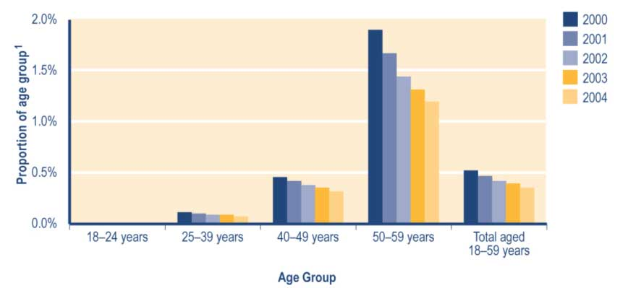
Note
1 Proportion shows:
a number of women in age group recorded in SWIFTT as receiving a Widows’ Benefit at 30 June, divided by
b Statistics New Zealand final estimate of the resident population of women in age group at 30 June.

See Table A3.10 (Appendix 3) for a summary of the SWIFTT data underlying Figure 3.12.

Trends in Widows’ Benefits granted
The number of Widows’ Benefits granted each year returned to historic levels in the last year after increasing in 2002/2003 (see Table 3.35). Of the Widows’ Benefits granted in each year since 1999/2000 (see Table 3.35):
• between 62% and 64% were provided to clients who had not received a core benefit in the previous four years
• between 11% and 14% were provided to clients transferring from another core benefit.

Table 3.35 Trends in the length of period since women granted a Widows’ Benefit last received any core benefit

Period since recipient last received any core benefit | Widows' Benefits granted¹
 | 1999/2000  Number | 2000/2001  Number | 2001/2002  Number | 2002/2003  Number | 2003/2004  Number
None (administrative transfers of client who continued to receive some core benefit) | 264 | 240 | 272 | 303 | 215
Under 6 months | 192 | 217 | 186 | 218 | 206
6-12 months | 99 | 99 | 106 | 112 | 106
12-18 months | 68 | 45 | 57 | 56 | 51
18 months - 2 years | 28 | 35 | 39 | 39 | 44
2-4 years | 97 | 90 | 111 | 93 | 131
Not received a core benefit in previous four years | 1,276 | 1,276 | 1,244 | 1,329 | 1,264
Total | 2,024 | 2,002 | 2,015 | 2,150 | 2,017

Note
1 Numbers of successful applications for Widows’ Benefits recorded in SWIFTT during years ended 30 June.

Trends in cessations of Widows’ Benefits
The annual number of cessations of Widows’ Benefits increased between 2001/2002 and 2002/2003, but remained relatively stable between 2002/2003 and 2003/2004 (see Table 3.36). Of the cessations of Widows’ Benefits each year since 1999/2000 (see Table 3.36):
• between 20% and 22% have reflected clients entering paid work
• between 43% and 47% have reflected clients transferring to other core benefits or pensions (most transfers from Widows’ Benefit are to New Zealand Superannuation).

Table 3.36 Trends in reasons for cessations of Widows’ Benefits

Reason for cessation | Cessations of Widows’ Benefits¹
 | 1999/2000  Number | 2000/2001  Number | 2001/2002  Number | 2002/2003  Number | 2003/2004  Number
Obtained work | 458 | 471 | 434 | 460 | 512
Transferred to another core benefit | 997 | 989 | 964 | 1,026 | 985
Other | 686 | 734 | 729 | 849 | 810
Total | 2,141 | 2,194 | 2,127 | 2,335 | 2,307

Note
1 Numbers of cessations of Widows’ Benefits recorded in SWIFTT during years ended 30 June.

Expenditure on Widows’ Benefits
The one-off decrease in expenditure on Widows’ Benefits in 1994/1995 (see Table 3.37) reflects the transfer of some Widows’ Benefit recipients to the then-new Transitional Retirement Benefit. The increased expenditure on Widows’ Benefits between 1995/1996 and 1997/1998, followed by fluctuation within a narrow band for the last six years (see Table 3.37), reflects patterns in the numbers of clients receiving a Widows’ Benefit.

Table 3.37 Trends in annual expenditure on Widows’ Benefits

Year ended 30 June | Expenditure on  Widows' Benefits^{1,2,3,4}  ($million)
1991/1992 | 82
1992/1993 | 84
1993/1994 | 86
1994/1995 | 82
1995/1996 | 86
1996/1997 | 92
1997/1998 | 95
1998/1999 | 95
1999/2000 | 93
2000/2001 | 91
2001/2002 | 91
2002/2003 | 92
2003/2004 | 93

Notes
1 Expenditure on Widows’ Benefits in years ended 30 June.
2 Expenditure shown includes expenditure on supplementary benefits provided to recipients of a Widows’ Benefit.
3 Expenditure shown is net of taxation, adjusted for the number of payments of Widows’ Benefit made during the year, and smoothed using a three-month moving average.
4 Expenditure data in this table differs from, and should not be cited as, MSD’s official measure of expenditure on financial assistance provided to clients.

Monthly expenditure on Widows’ Benefits shows small seasonal peaks in the latter part of each fiscal year (see Figure 3.13). This peak results from the Training Incentive Allowance and benefit advances that are made at the start of the school/academic year to women who are receiving a Widows’ Benefit and who have dependent children at school or who are themselves undertaking approved training or study. The impact of the transfer of some Widows’ Benefit recipients to the then-new Transitional Retirement Benefit is evident in early 1994/1995 (see Figure 3.13).
Figure 3.13 Trends in monthly expenditure on Widows’ Benefits

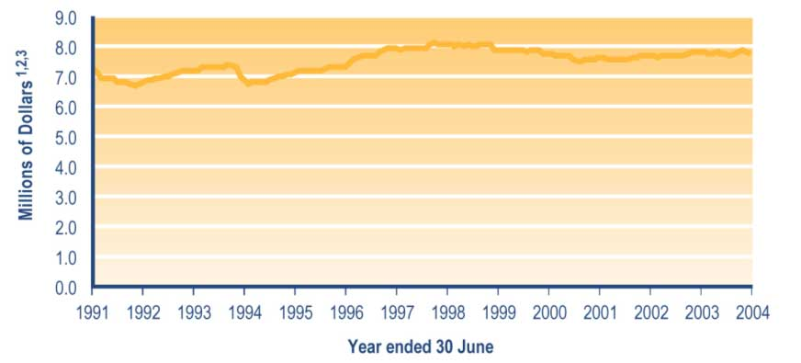
Notes
1 Monthly expenditure on Widows’ Benefits, including expenditure on supplementary benefits paid to women receiving a Widows’ Benefit.
2 Expenditure shown is net of taxation, adjusted for the number of payments of Widows’ Benefit made during the month, and smoothed using a three-month moving average.
3 Expenditure data in this graph differs from, and should not be cited as, MSD’s official measure of expenditure on financial assistance provided to clients.

Table 7.2 (see Section 7) shows trends since 1940 in expenditure on Widows’ Benefits. Please note that expenditure on Widows’ Benefits shown in Table 7.2 includes:

• deductions for debts established after 1996, while the data in Figure 3.13 and Table 3.37 does not
• expenditure on supplementary benefits paid to people receiving a Widows’ Benefit.

Employment services

Work and Income provides access to a range of support services and training opportunities to assist clients to obtain ongoing paid employment. These include:

• one-to-one assistance with job search and preparation to enter employment
• employment or training programmes that assist work services clients in preparing for work, finding a job or entering employment
• referring work services clients to vacancies that are notified to Work and Income
• subsidies (paid for a limited time) to assist employers with the cost of wages or salaries for work services clients whom they hire
• assistance for work services clients to set up their own business, including access to business development advice and subsidies (paid for a limited time) to assist with initial capital or operating costs.

Registered job seekers
All registered job seekers must be:

• working less than 30 hours per week
• seeking to work more hours
• available for and actively seeking work.

Registered job seekers comprise:

• people who are required to register as job seekers because they, or their partner or spouse, are receiving a work-tested benefit
• people who:
– choose to register to receive employment services from Work and Income as part of seeking work
– meet the definition of registered job seekers outlined above.

Clients (or their partners and spouses) receiving a range of benefits are subject to a work test and may therefore be required to register as job seekers. Work-tested benefits are:

• Unemployment Benefits – client and partners/spouses both subject to work test
• Sickness Benefits – partner or spouse subject to work test
• Invalids’ Benefits – partner or spouse subject to work test.

Between 1 February 1997 and 10 March 2003, some clients receiving a Domestic Purposes Benefit or Widows’ Benefit were also work-tested. See information earlier in this section on Domestic Purposes Benefits or Widows’ Benefits for details of which recipients of these benefits were subject to a work test.

Clients subject to a work test are required to actively seek, and make themselves available to take up, suitable paid employment. Other obligations on work-tested clients that were introduced during the 2003/2004 financial year include:

• taking pre-employment drug tests if required by a prospective employer (from 10 October 2003)
• commuting to seek and undertake paid work if there is no such work available in their local area and they are receiving an Unemployment Benefit (from 8 March 2004).

For consistency with other official reports produced by MSD, this report uses the number of registered job seekers as an indicator of the use of employment services.

Since 2000, between 98% and 99% of the clients receiving employment services from Work and Income have been registered job seekers. However, a small number of people receive employment services from Work and Income without being registered as job seekers. These people include vacation workers and people already in full-time work who are seeking to change jobs.

From 1 July 2001, all registered job seekers receiving a work-tested benefit have been required to enter into a Job Seeker Agreement with Work and Income. The Job Seeker Agreement sets out the assistance that Work and Income will provide to assist the job seeker to obtain employment, and the steps that the job seeker will take to find employment or to improve their prospects for doing so. The Job Seeker Agreement must specify the job search activities that will be undertaken, and may include employment or training programmes to be undertaken by the job seeker (eg a period of work experience or employment-related training).

The number of registered job seekers is an administrative statistic that differs from, and is usually higher than, the number of officially unemployed. See Appendix 2 for a definition of the officially unemployed and a summary of key differences between registered job seekers and the officially unemployed.

Trends in the number of registered job seekers
Decreases since 2000 in the number of registered job seekers (see Table 3.38) reflect:

• improved economic conditions
• the impact of policy and operational changes, including an increased emphasis on placing job seekers into paid work.

Of the job seekers registered since 2000:

• between 57% and 60% have been receiving unemployment-related benefits (see Table 3.38)
• between 20% and 22% have not been receiving any core benefit or pension (see Table 3.38)
• between 20% and 23% have been aged 45–59 years (see Table 3.39)
• between 37% and 41% have been aged 25–39 years (see Table 3.39)
• between 47% and 49% have had no formal educational qualifications (see Table 3.42)
• between 37% and 40% have had school qualifications (see Table 3.42).

Since 2000, there have been increases in the proportions of registered job seekers who:

• have been registered for under six months (from 35% to 40%) (see Table 40)
• have been registered for over four years (from 5% to 13%) (see Table 3.40)
• identified as Māori (from 30% to 36%) (see Table 3.41).

Over the same period, there have been decreases in the proportions of registered job seekers who:

• have been registered for between six months and two years (from 46% to 34%) (see Table 3.40)
• identified as New Zealand Europeans (from 51% to 41%) (see Table 3.41).

Table 3.38 Trends in the types of core benefit or pension received by registered job seekers

Type of core benefit or pension  received at 30 June | Registered job seekers¹
 | 2000  Number | 2001  Number | 2002  Number | 2003  Number | 2004  Number
Unemployment-related benefits² | 132,221 | 114,839 | 100,370 | 86,181 | 60,770
Carers' benefits³ | 38,399 | 30,561 | 27,847 | 24,281 | 17,005
Sickness -related benefits⁴ | 4,255 | 2,712 | 2,419 | 2,372 | 2,803
Invalids' Benefit | 2,020 | 1,027 | 1,279 | 1,490 | 1,710
Widows' Benefit | 2,386 | 1,768 | 1,475 | 1,184 | 729
Unsupported Child's Benefit/Orphan's Benefit | 255 | 192 | 167 | 163 | 125
Transitional Retirement Benefit | 72 | 23 | 14 | 6 | 0
Emergency Benefit | 1,456 | 774 | 471 | 394 | 297
New Zealand Superannuation | 63 | 37 | 34 | 51 | 68
Veterans' Pension | 2 | 0 | 3 | 2 | 2
No core benefit or pension | 49,861 | 39,742 | 33,638 | 28,452 | 24,081
Total | 230,990 | 191,855 | 167,717 | 144,576 | 107,590
Notes
1 Numbers of job seekers registered in SOLO at 30 June.
2 Includes Unemployment Benefits and Unemployment Benefits – Hardship paid to unemployed people and to trainees, and the Independent Youth Benefit.
3 Includes Domestic Purposes Benefits – Sole Parents, Domestic Purposes Benefits – Caring for the Sick and Infirm, Domestic Purposes Benefits – Women Alone, and Emergency Maintenance Allowances.
4 Includes Sickness Benefits and Sickness Benefits – Hardship.

Table 3.39 Trends in the ages of registered job seekers

Age of client at 30 June | Registered job seekers¹
 | 2000  Number | 2001  Number | 2002  Number | 2003  Number | 2004  Number
15-19 years | 23,136 | 19,817 | 17,627 | 16,195 | 12,532
20-24 years | 38,085 | 31,751 | 28,430 | 25,132 | 17,680
25-29 years | 32,068 | 26,091 | 22,442 | 19,084 | 13,786
30-34 years | 30,771 | 25,447 | 22,126 | 18,708 | 13,168
35-39 years | 30,968 | 25,223 | 21,433 | 17,730 | 12,311
40-44 years | 26,348 | 22,404 | 19,749 | 16,892 | 11,710
45-49 years | 19,881 | 17,206 | 15,454 | 13,309 | 9,500
50-54 years | 17,201 | 15,010 | 12,892 | 10,973 | 8,061
55-59 years | 9,182 | 6,846 | 5,905 | 5,142 | 7,601
60-64 years | 3,128 | 1,954 | 1,550 | 1,329 | 1,130
65 years or over | 220 | 105 | 109 | 82 | 111
Unspecified | 2 | 1 | 0 | 0 | 0
Total | 230,990 | 191,855 | 167,717 | 144,576 | 107,590

Note
1 Numbers of job seekers registered in SOLO at 30 June.

The overall shortening since 2000 of spells registered as a job seeker (see Table 3.40) reflects the impact on the job seeker register of improved economic conditions.

Table 3.40 Trends in the length of current spells registered as a job seeker

Length of current spells at 30 June | Registered job seekers¹
 | 2000  Number | 2001  Number | 2002  Number | 2003  Number | 2004  Number
Under 6 months | 76,795 | 64,158 | 58,639 | 51,740 | 42,542
6 months - 2 years | 105,231 | 74,974 | 56,484 | 50,199 | 36,019
2-4 years | 37,508 | 38,962 | 36,277 | 25,706 | 14,995
Over four years | 11,456 | 13,761 | 16,317 | 16,931 | 14,034
Total | 230,990 | 191,855 | 167,717 | 144,576 | 107,590

Note
1 Numbers of job seekers registered in SOLO at 30 June.

From 2001, job seekers have been given the option to refuse to provide ethnic information. This has led to an increase in the number of job seekers for whom ethnicity is unspecified.
Table 3.41 Trends in the ethnicity of registered job seekers

Ethnicity recorded at 30 June | Registered job seekers¹
 | 2000  Number | 2001  Number | 2002  Number | 2003  Number | 2004  Number
Māori | 70,152 | 60,561 | 56,140 | 50,829 | 38,758
Pacific peoples | 22,148 | 18,623 | 16,485 | 13,934 | 11,055
Other ethnic groups | 20,395 | 16,710 | 16,605 | 15,383 | 12,004
New Zealand Europeans | 118,295 | 95,840 | 77,077 | 62,746 | 44,046
Not specified | 0 | 121 | 1,410 | 1,684 | 1,727
Total | 230,990 | 191,855 | 167,717 | 144,576 | 107,590

Note
1 Numbers of job seekers registered in SOLO at 30 June.

Table 3.42 Trends in levels of the highest formal educational qualification held by registered job seekers

Highest educational qualification recorded at 30 June | Registered job seekers¹
 | 2000  Number | 2001  Number | 2002  Number | 2003  Number | 2004  Number
No formal educational qualifications | 108,575 | 93,231 | 79,334 | 68,474 | 52,273
School qualifications | 84,714 | 75,690 | 66,230 | 57,749 | 42,465
Post-school qualifications | 24,199 | 20,199 | 21,024 | 17,831 | 12,703
Unknown/unspecified | 13,502 | 2,735 | 1,129 | 522 | 149
Total | 230,990 | 191,855 | 167,717 | 144,576 | 107,590

Note
1 Numbers of job seekers registered in SOLO at 30 June.

Trends in the proportion of all 18–59 year olds registered as job seekers
Decreases since 2000 in the proportion of 18–59 year olds registered as job seekers (see Figure 3.14) reflect decreases over the same period in the total number of registered job seekers. These decreases in turn reflect both operational changes in Work and Income and improved economic conditions.

Figure 3.14 Trends in the proportion of 18–59 year olds registered as job seekers, by age

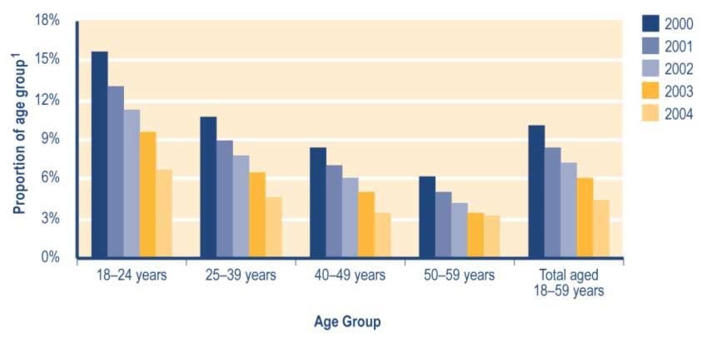

Note
1 Proportion shows:
a number of job seekers in age group registered in SOLO at 30 June, divided by
b Statistics New Zealand final estimate of the resident population in age group at 30 June.

See Table A3.11 (Appendix 3) for a summary of the SOLO data underlying Figure 3.14.

Trends in new registrations of job seekers
Decreases since 1999/2000 in the annual number of new job seeker registrations (see Table 3.43) reflects both improved economic conditions and the impact of operational changes in Work and Income.

Of the job seeker registrations in each year since 2000/2001 (see Table 3.43):
• between 50% and 54% involved clients who had not been registered as a job seeker within the previous 12 months
• between 37% and 41% involved clients who had been registered as a job seeker within the last six months.

Since 1999/2000, the proportion of job seeker registrations involving clients who had never previously registered as job seekers has decreased (from 29% to 21%) (see Table 3.43).

Table 3.43 Trends in the length of period since newly registered job seekers were last enrolled as a job seeker

Period since client was last enrolled as a job seeker | New job seeker registrations¹
 | 1999/2000  Number | 2000/2001  Number | 2001/2002  Number | 2002/2003  Number | 2003/2004  Number
Under 6 months | 114,057 | 113,097 | 108,729 | 95,155 | 76,720
6-12 months | 33,208 | 34,564 | 35,810 | 31,681 | 27,014
12-18 months | 14,934 | 13,932 | 16,634 | 14,744 | 13,347
18 months - 2 years | 11,447 | 9,353 | 10,599 | 10,929 | 9,848
2-4 years | 26,456 | 20,115 | 18,771 | 19,524 | 20,645
At least four years | 28,144 | 22,703 | 19,902 | 17,147 | 15,342
Never previously registered as a job seeker | 93,532 | 69,743 | 63,765 | 55,855 | 43,720
Total | 321,778 | 283,507 | 274,210 | 245,035 | 206,636

Note
1 Numbers of new job seeker registrations recorded in SOLO during years ended 30 June.

Trends in deregistration of job seekers
The annual number of job seeker deregistrations has decreased since 2000/2001 (see Table 3.44), reflecting decreases in the number of registered job seekers. Since 1999/2000, the proportion of job seeker deregistrations that reflect (see Table 3.44):

• clients entering paid work has increased (from 30% to 40%)
• clients leaving the labour market (eg to enter study or training) has increased (from 24% to 34%)
• clients who have lost contact with Work and Income has decreased (from 41% to 21%) – this partly reflects the impact of operational changes, including an increased emphasis on the case management of job seekers.

Table 3.44 Trends in reasons for deregistrations of job seekers

Reason for deregistration | Job seeker deregistrations¹
 | 1999/2000  Number | 2000/2001  Number | 2001/2002  Number | 2002/2003  Number | 2003/2004  Number
Entered paid work | 92,871 | 105,077 | 109,678 | 98,104 | 96,768
Entered training | 14,234 | 14,627 | 13,186 | 12,176 | 12,778
Left labour market | 72,929 | 82,965 | 82,660 | 79,245 | 83,098
Lost contact | 125,168 | 119,393 | 92,357 | 79,454 | 51,496
Other | 0 | 463 | 518 | 505 | 434
Total | 305,202 | 322,525 | 298,399 | 269,484 | 244,574

Note
1 Numbers of job seeker deregistrations recorded in SOLO during years ended 30 June.

Case management initiatives targeted to job seekers
During the 2003/2004 financial year, a number of initiatives were introduced that changed the ways Work and Income case managers dealt with registered job seekers. These initiatives aimed to help a number of groups of Work and Income clients, including:

• people with disabilities
• long-term Sickness Benefit and Invalids’ Benefit recipients
• mature job seekers
• youth
• people who have been made redundant
• sole parents
• people living in rural and remote locations
• the very long-term unemployed.

These initiatives included:

• targeting clients who had been receiving an Unemployment Benefit for eight years or more for an in-depth vocational assessment and development of realistic employment options
• enabling job seekers who have the skills and a desire to work, but who remain unemployed or fail to retain appropriate employment, to access one-on-one employment coaching (clients will receive this coaching as they seek employment and for a period of time after they gain employment)
• establishing a job partnership with industry whereby clients can be referred to industry-specific training (this partnership provides an assurance that clients completing the training will be placed in full-time paid work in the industry concerned)
• making focused case management available to 45–59 year olds receiving an Unemployment Benefit (this aims to ensure that mature job seekers receive appropriate levels of support and specialised assistance, including focused work brokerage, capability assessments, and work broker profiling services)
• enabling clients living in rural and remote areas where Work and Income has had limited presence to make face-to-face contact with Work and Income staff through mobile employment services – clients will be supported in finding ways to remain in, or gain access to, areas offering opportunities for paid work
• making sole parents transitioning from benefits to paid employment eligible for flexible and specialised employment assistance focused on their needs (this assistance will be available both when clients are seeking work and for a time after they take up paid work)
• ensuring work-tested clients are clear about Government expectations about meeting the work test – clients may fail the work test when they move to an area with low employment opportunities, or when they either refuse to take or fail a pre-employment drug test.

From January 2004, clients receiving a sickness-related benefit have been able to access pilot programmes aimed at helping clients to:

• set goals for their future
• develop individual plans addressing their needs, strengths, barriers and key issues.

Transition to Work assistance

Transition to Work assistance is paid in order to assist clients to:

• make a successful transition from benefits to employment
• remain in employment.

Transition to Work assistance may be available to clients seeking or taking up paid work. It consists of:

• Work Start Grant
• New Employment Transition (NET) Grant
• Seasonal Work Assistance
• Pathways Payment.

Eligibility for Transition to Work assistance

Work Start Grant
A Work Start Grant meets the essential costs of taking up paid employment or attending a job interview. These grants are available to clients who would not be able to enter paid employment or attend a job interview without assistance to meet the essential costs of doing so.

To receive a Work Start Grant, clients must:

• be aged 16 years of age or over
• have a verified job interview for a position involving at least 15 hours of work per week, or have a verified job offer involving at least 15 hours of work per week (excluding self-employment)
• have an essential cost because of the job interview or job offer
• be unlikely to make the transition into paid work or to be able to attend the interview without receiving a Work Start Grant.

Residency, income and cash asset tests apply.

A maximum of $250 worth of Work Start Grants is available in any 52-week period, except where the client receives a Work Start Grant for relocation, safety equipment or bridging finance. In these cases, up to $500 worth of Work Start Grants is available in any 52-week period. Work Start Grants are non-taxable and non-recoverable.
From 5 March 2004, the eligibility criteria for Work Start Grants were changed to preclude grants to clients taking up work in the sex industry.

New Employment Transition Grant
A New Employment Transition Grant is available to clients with one or more dependent children during the first six months that their benefit is stopped due to employment. To receive a New Employment Transition Grant, these clients must be unable to work because:

• the client, their partner (if any) or their dependent child becomes sick and:
– no paid sick leave is available, or
– the client has exhausted their entitlement to paid sick leave
• there is a breakdown in childcare arrangements and:
– no paid leave (including paid annual leave) is available for this purpose, or
– the client has exhausted their entitlement to paid leave (including their entitlement to paid annual leave).

Residency and cash asset tests apply. Clients in self-employment must also declare that:

• they have been unable to be involved in their business over the period because of their illness, the illness of their partner or child, or the breakdown in childcare arrangements
• there was in fact a loss of income (rather than a delay of income because work was re-scheduled)
• provision was not available from the business to cover the loss of income.

The maximum daily rate of New Employment Transition Grants is limited to the lesser of:

• the actual loss of gross income
• $52.50 per day (as at 1 April 2004).

A total of no more than $525.00 in New Employment Transition Grants may be paid to a client within the six-month period during which they are qualified for a New Employment Transition Grant. New Employment Transition Grants are non-taxable and non-recoverable.

Seasonal Work Assistance
Seasonal Work Assistance is available to clients during the first six months after their benefit
is stopped because they began seasonal horticultural work. To receive Seasonal Work Assistance, clients must have lost income through being unable to work because of adverse weather conditions.

Residency, income and cash asset tests apply. Seasonal Work Assistance is only available to clients undertaking work in a list of horticultural industries approved by MSD’s Chief Executive. At 30 June 2004, Seasonal Work Assistance was available to people working in the fruit, vegetable, flower, hops, hemp, tobacco and nursery plant industries.

The amount of Seasonal Work Assistance payable depends on the client’s family circumstances and on the actual net income lost during the week. The amount of Seasonal Work Assistance to be paid per week is the lesser of the actual net income lost for the week or the maximum weekly payment the client may be paid. The maximum weekly payments of Seasonal Work Assistance clients may receive as at 1 April 2004 are shown in Table 3.45 below.
Table 3.45 Maximum rates of Seasonal Work Assistance payable (payable at 1 April 2004)

Hours of work lost (over week) | Maximum payment (as a 1 April 2004)
 | Single person | Married person or sole parent
1-8 hours | $34.00 | $63.00
9-16 hours | $68.00 | $126.00
17-24 hours | $102.00 | $189.00
25-32 hours | $136.00 | $252.00
33-40 hours | $170.00 | $315.00
Over 40 hours | $170.00 | $315.00

A total of no more than $630.00 in Seasonal Work Assistance may be paid to a client within the six-month period during which they are qualified for Seasonal Work Assistance. Seasonal Work Assistance is non-taxable and non-recoverable.

Pathways Payment
A Pathways Payment is a one-off lump sum payment to assist clients who are entering paid employment with the living costs they encounter between the cancellation of the benefit and either of the following:

• their first wage or salary payment
• the receipt of their first payment as a self-employed person.

To receive a Pathways Payment, a client or their spouse must:

• cancel a core benefit (other than an Unsupported Child’s Benefit or Orphan’s Benefit) in order to enter paid employment
• inform Work and Income before beginning paid employment
• have a dependent child or children
• have received one or more core benefits for a continuous period of 12 months or more prior to entering paid employment.

If a client with a debt to Work and Income receives a Pathways Payment to start paid employment, their debt repayment is suspended for a period of three months.

The Pathways Payment is equal to two weeks of the core benefit received by the client (after tax) in the week before the benefit was cancelled. Pathways Payments are:

• non-taxable
• non-recoverable
• not subject to income tests or asset tests.

From 5 March 2004, the eligibility criteria for a Pathways Payment were changed to preclude grants to clients taking up work in the sex industry.

Trends in payments of Transition to Work assistance
Please note that some clients may have received more than one payment of Transition to Work assistance during the same financial year.

Trends in the number of Work Start Grants provided
The number of Work Start Grants provided each year has fluctuated since 1999/2000 (see Table 3.46). This reflects both trends in the number of registered job seekers and an increased emphasis among Work and Income staff on placing clients into paid employment. Since 1999/2000, between 70% and 73% of the Work Start Grants provided each year have met work placement costs faced by non-students (see Table 3.46).

Table 3.46 Trends in the types of expenditure met by Work Start Grants provided

Type of expenditure | Work Start Grants provided¹
 | 1999/2000  Number | 2000/2001  Number | 2001/2002  Number | 2002/2003  Number | 2003/2004  Number
Bridging Finance | 3,319 | 6,533 | 11,373 | 7,354 | 7,994
Job Search Costs | 8,835 | 10,713 | 10,881 | 8,478 | 8,313
Work Placement Costs | 29,936 | 43,153 | 53,738 | 43,904 | 47,231
Bridging Finance - Student² | - | - | 128 | 74 | 71
Job Search Costs - Student² | - | - | 104 | 122 | 73
Work Placement Costs - Student² | - | - | 511 | 599 | 686
Unspecified | 1,120 | 0 | 0 | 0 | 0
Total | 42,090 | 60,399 | 76,735 | 60,531 | 64,368

Notes
1 Numbers of Work Start Grants recorded in SWIFTT during years ended 30 June.
2 Work Start Grants covering costs faced by students were not available before 2001/2002.

Trends in the number of New Employment Transition Grants provided
The number of New Employment Transition Grants provided each year has decreased since 2001/2002 (see Table 3.47). This reflects the lower numbers of registered job seekers over the last two years, and the consequently lower numbers of deregistrations of job seekers.

Table 3.47 Trends in the number of New Employment Transition Grants provided

 | New Employment Transition Grants provided¹
 | 1999/2000  Number | 2000/2001  Number | 2001/2002  Number | 2002/2003  Number | 2003/2004  Number
Total | 605 | 396 | 530 | 397 | 362

Note
1 Numbers of New Employment Transition Grants paid in years ended 30 June.

Trends in the number of Seasonal Work Assistance payments provided
The number of Seasonal Work Assistance payments made each year has increased over the last year (see Table 3.48). This reflects in part the impact of stormy weather patterns on the availability of opportunities to undertake seasonal work.

Table 3.48 Trends in the number of Seasonal Work Assistance payments provided
 | Seasonal Work Assistance payments provided¹
 |  | 2002/2003  Number | 2003/2004  Number
Total |  | 1,472 | 2,890

Note
1 Numbers of Seasonal Work Assistance payments made in years ended 30 June.

Trends in the number of Pathways Payments made
The number of Pathways Payments made each year has increased between 2002/2003 and 2003/2004 (see Table 3.49). Of the Pathways Payments made each year since 2002/2003 (see Table 3.49):

• between 64% and 67% were provided to clients who ceased receiving a carers’ benefit
• between 28% and 31% were provided to clients who ceased receiving an unemployment-related benefit.

Table 3.49 Trends in the number of Pathways Payments provided

Type of core benefits cancelled before receiving a Pathways payment | Pathways Payments provided¹
 |  | 2002/2003  Number | 2003/2004  Number
Unemployment-related benefits |  | 1,675 | 1,736
Carers' benefits |  | 3,410 | 4,231
Sickness-related benefits |  | 139 | 135
Invalids' Benefit |  | 60 | 99
Widows' Benefit |  | 52 | 52
Emergency Benefit |  | 13 | 16
No core benefit |  | 11 | 5
Total |  | 5,360 | 6,274

Note
1 Numbers of Pathways payments made in years ended 30 June.

Trends in expenditure on Transition to Work assistance

Trends in expenditure on Work Start Grants
Fluctuations in expenditure on Work Start Grants since 1999/2000 (see Table 3.50) largely reflect fluctuations in the number of Work Start Grants paid. The average amount of each Work Start Grant has fluctuated around a relatively small range since 1999/2000 (see Table 3.50).

Table 3.50 Trends in the value of Work Start Grants provided for each expenditure type

Type of expenditure covered by Work Start Grants | Expenditure on Work Start Grants¹
 | 1999/2000  Number | 2000/2001  Number | 2001/2002  Number | 2002/2003  Number | 2003/2004  Number
Bridging Finance ($000) | 673 | 1,213 | 2,355 | 1,514 | 1,663
Job Search Costs ($000) | 852 | 975 | 967 | 732 | 699
Work Placement Costs ($000) | 3,852 | 5,097 | 6,809 | 5,556 | 5,825
Bridging Finance - Student ($000)² | - | - | 28 | 14 | 15
Job Search Costs - Student( $000)² | - | - | 12 | 13 | 8
Work Placement Costs - Student ($000)² | - | - | 65 | 76 | 84
Unspecified ($000) | 152 | 0 | 0 | 0 | 0
Total | 5,530 | 7,285 | 10,235 | 7,906 | 8,294
Average amount per payment ($) | 128 | 121 | 133 | 131 | 129

Note
1 Expenditure on Work Start Grants recorded in SWIFTT during the year ended 30 June.
2 Work Start Grants covering costs faced by students were not available before 2001/2002.

Trends in expenditure on New Employment Transition Grants
Fluctuations since 1999/2000 in expenditure on New Employment Transition Grants reflect increases in the average value of the grants paid as well as fluctuations in the number of grants made (see Table 3.51). The combination of declining total expenditure on New Employment Transition Grants combined with historically high average payments evident in the last two years (see Table 3.51) reflects in part the reduced numbers of registered job seekers over that period.
Table 3.51 Trends in expenditure on New Employment Transition Grants

 | Expenditure on New Employment Transition Grants¹
 | 1999/2000  Number | 2000/2001  Number | 2001/2002  Number | 2002/2003  Number | 2003/2004  Number
Total ($000) | 90 | 70 | 100 | 85 | 72
Average amount per payment ($) | 148 | 177 | 188 | 213 | 200

Note
1 Expenditure on New Employment Transition Grants recorded in SWIFTT in years ended 30 June.

Trends in expenditure on Seasonal Work Assistance payments
Expenditure on Seasonal Work Assistance payments increased significantly between 2002/2003 and 2003/2004 (see Table 3.52). This reflects increases in the number of Seasonal Work Assistance payments made, as the average value of payments decreased over the same period (see Table 3.52).

Table 3.52 Trends in expenditure on Seasonal Work Assistance payments

 | Expenditure on Seasonal Work Assistance payments¹
 |  | 2002/2003  Number | 2003/2004  Number
Total ($000) |  | 208 | 388
Average amount per payment ($) |  | 141 | 134

Note
1 Expenditure on Seasonal Work Assistance payments during years ended 30 June.

Transitional Retirement Benefit

Between 1 April 1994 and 31 March 2004, a Transitional Retirement Benefit was available to people who:

• were retired or had low incomes
• had not yet reached the qualifying age for New Zealand Superannuation.

Transitional Retirement Benefits were introduced on 1 April 1994 to provide financial assistance to people who were:

• retired or approaching retirement
• affected by the incremental increases in the age of eligibility for New Zealand Superannuation that occurred between 1 April 1993 and 1 April 2001.

The age of eligibility for a Transitional Retirement Benefit was raised concurrently with the age of eligibility for New Zealand Superannuation, rising three months every six months.

Transitional Retirement Benefits were abolished on 1 April 2004, when the eligibility age (which had risen incrementally since 1 April 1994) reached 65 years.

Transitional Retirement Benefits were not work-tested, but were income tested. Clients receiving a Transitional Retirement Benefit were also required to meet residential qualifications.
Trends in the number of clients receiving a Transitional Retirement Benefit
The abolition of the Transitional Retirement Benefit on 1 April 2004 meant that no-one was receiving a Transitional Retirement Benefit on 30 June 2004. Table 3.53 therefore shows trends in receipt of Transitional Retirement Benefits to 30 June 2003.

Decreases between 2001 and 2003 in the number of clients receiving a Transitional Retirement Benefit (see Table 3.53) reflect a shortening of the period between eligibility for a Transitional Retirement Benefit and eligibility for New Zealand Superannuation. This shortening of the period of eligibility for a Transitional Retirement Benefit results from:

• the age of eligibility for a Transitional Retirement Benefit being raised from 63.5 years at 1 April 2001 to 64.5 years on 1 April 2003
• the age of eligibility for New Zealand Superannuation being fixed at 65 years since 1 April 2001.

This shortening of the period between eligibility for a Transitional Retirement Benefit and eligibility for New Zealand Superannuation has also meant that, since 2002, over 99% of
clients receiving a Transitional Retirement Benefit had been doing so for under two years (see Table 3.53).

Table 3.53 Trends in the length of current spells receiving a Transitional Retirement Benefit

Length of current spell at 30 June | Clients receiving a Transitional Retirement Benefit¹
 |  | 2000  Number | 2001  Number | 2002  Number | 2003  Number
Under 6 months |  | 2,035 | 2,080 | 1,478 | 1,168
6 months - 2 years |  | 4,894 | 4,790 | 3,623 | 932
2-4 years |  | 1,914 | 2,133 | 10 | 6
Over 4 years |  | 13 | 9 | 7 | 4
Unspecified |  | 0 | 0 | 0 | 0
Total |  | 8,856 | 9,012 | 5,118 | 2,110

Note
1 Numbers of clients recorded in SWIFTT as receiving a Transitional Retirement Benefit at 30 June.

Table 7.1 (see Section 7) shows trends since 1994 in the number of clients receiving a Transitional Retirement Benefit.

Trends in the proportion of 60–64 year olds receiving a Transitional Retirement Benefit
Decreases since 2001 in the proportion of 60–64 year olds receiving a Transitional Retirement Benefit (see Figure 3.15) reflect the shortening since April 2001 of the period between eligibility for a Transitional Retirement Benefit and eligibility for New Zealand Superannuation and the consequent reduction in numbers receiving a Transitional Retirement Benefit.
Figure 3.15 Trends in the proportion of 60–64 year olds receiving a Transitional Retirement Benefit

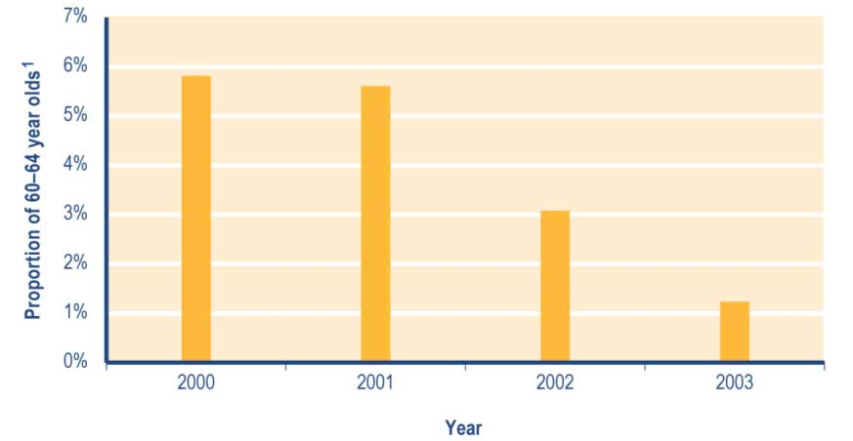
Note
1 Proportion shows:
a numbers of clients aged 60–64 years recorded in SWIFTT as receiving a Transitional Retirement Benefit at 30 June, divided by
b Statistics New Zealand final estimate of the resident population aged 60–64 years at 30 June.

See Table A3.12 (Appendix 3) for a summary of the SWIFTT data underlying Figure 3.15.

Trends in Transitional Retirement Benefits granted
The number of Transitional Retirement Benefits granted each year has reduced significantly in the last three years (see Table 3.54), reflecting the impact of incremental increases in the age of entitlement for a Transitional Retirement Benefit. Since 1999/2000, the proportion of Transitional Retirement Benefits granted that were provided to (see Table 3.54):

• clients transferring from another core benefit has increased (from 55% to 76%)
• clients who had not received a core benefit in the previous four years has decreased (from 36% to 18%).

Table 3.54 Trends in the length of period since clients granted a Transitional Retirement Benefit last received any core benefit

Period since client last received a core benefit | Transitional Retirement Benefits granted¹
 | 1999/2000  Number | 2000/2001  Number | 2001/2002  Number | 2002/2003  Number | 2003/2004  Number
None (administrative transfers of client who continued to receive some core benefit) | 2,448 | 2,481 | 2,045 | 2,039 | 942
Under 6 months | 130 | 162 | 141 | 67 | 26
6-12 months | 79 | 98 | 101 | 44 | 15
12-18 months | 40 | 50 | 38 | 21 | 15
18 months - 2 years | 46 | 43 | 37 | 27 | 4
2-4 years | 94 | 112 | 93 | 59 | 11
Not received a core benefit in previous four years | 1,613 | 1,508 | 1,121 | 724 | 229
Total | 4,450 | 4,454 | 3,576 | 2,981 | 1,242

Note
1 Numbers of successful applications for Transitional Retirement Benefits recorded in SWIFTT during years ended 30 June.

Trends in cessations of Transitional Retirement Benefits
The annual number of cessations of Transitional Retirement Benefits decreased significantly between 2001/2002 and 2003/2004 (see Table 3.55), reflecting decreases in the numbers receiving a Transitional Retirement Benefit. Higher levels of cessations between 2001/2002 and 2002/2003 than between 1999/2000 and 2000/2001 (see Table 3.55) reflect increased transfers to New Zealand Superannuation once the eligibility age for New Zealand Superannuation was fixed in April 2001.

Since 1999/2000, the proportion of Transitional Retirement Benefit cessations each year that reflect clients transferring to another core benefit or pension has increased (from 90% to 99%) (see Table 3.55). Over this period, clients transferring from the Transitional Retirement Benefit to another core benefit or pension have almost always transferred to New Zealand Superannuation.

Table 3.55 Trends in reasons for cessations of Transitional Retirement Benefits

Reason for cessation | Cessations of Transitional Retirement Benefits¹
 | 1999/2000  Number | 2000/2001  Number | 2001/2002  Number | 2002/2003  Number | 2003/2004  Number
Obtained paid work | 116 | 129 | 110 | 51 | 5
Transferred to another core benefit or pension | 3,863 | 3,831 | 7,082 | 5,859 | 3,309
Other | 323 | 372 | 325 | 140 | 41
Total | 4,302 | 4,332 | 7,517 | 6,050 | 3,355

Note
1 Numbers of cessations of Transitional Retirement Benefits recorded in SWIFTT during years ended 30 June.

Trends in expenditure on Transitional Retirement Benefits
Annual expenditure on Transitional Retirement Benefits increased between 1994/1995 and 2000/2001, but has decreased sharply over the last three years (see Table 3.56). Changes in expenditure on Transitional Retirement Benefits largely reflect changes in the number of people receiving a Transitional Retirement Benefit.

Table 3.56 Trends in annual expenditure on Transitional Retirement Benefits

Year ended 30 June | Expenditure on  Traditional Retirement  Benefits ^{1,2,3,4}  ($million)
1993/1994 | 12
1994/1995 | 78
1995/1996 | 90
1996/1997 | 96
1997/1998 | 99
1998/1999 | 105
1999/2000 | 112
2000/2001 | 113
2001/2002 | 92
2002/2003 | 46
2003/2004 | 12
Notes
1 Expenditure on Transitional Retirement Benefits in years ended 30 June.
2 Expenditure shown includes expenditure on supplementary benefits provided to clients receiving a Transitional Retirement Benefit.
3 Expenditure shown is net of taxation, adjusted for the number of payments of Transitional Retirement Benefit made during the year, and smoothed using a three-month moving average.
4 Expenditure data in this table differs from, and should not be cited as, MSD’s official measure of expenditure on financial assistance provided to clients.

Since 1994/1995, monthly expenditure on Transitional Retirement Benefits has reflected the numbers of people receiving a Transitional Retirement Benefit. The rapid decrease in Transitional Retirement Benefit expenditure over the last three years reflects the steep decrease in numbers receiving a Transitional Retirement Benefit that resulted from contraction of the period between eligibility for a Transitional Retirement Benefit and eligibility for New Zealand Superannuation following the fixing of the New Zealand Superannuation eligibility age in April 2001.

Between 1995/1996 and 2000/2001, monthly expenditure on Transitional Retirement Benefits has shown seasonal patterns that reflect peaks in applications for Transitional Retirement Benefits in April and October (see Figure 3.16). These peaks occurred as the incremental adjustments of the eligibility age for Transitional Retirement Benefits took effect, but have been more than outweighed since 2000/2001 by decreases in the number of clients receiving a Transitional Retirement Benefit.

Figure 3.16 Trends in monthly expenditure on Transitional Retirement Benefits

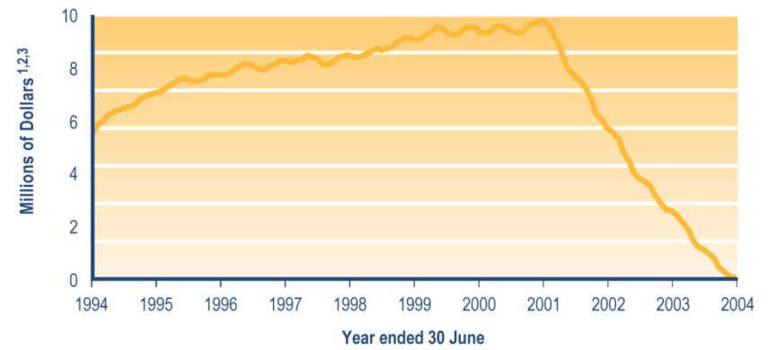

Notes
1 Monthly expenditure on Transitional Retirement Benefits, including expenditure on supplementary benefits paid to clients receiving a Transitional Retirement Benefit.
2 Expenditure shown is net of taxation, adjusted for the number of payments of Transitional Retirement Benefit made during the month, and smoothed using a three-month moving average.
3 Expenditure data in this graph differs from, and should not be cited as, MSD’s official measure of expenditure on financial assistance provided to clients.

Table 7.2 (see Section 7) shows trends since 1994 in expenditure on Transitional Retirement Benefits. Please note that expenditure on Transitional Retirement Benefits shown in Table 7.2 includes:

• deductions for debt established since 1996, while the data in Table 3.56 and Figure 3.16 does not
• expenditure on supplementary benefits paid to people receiving a Transitional Retirement Benefit.

New Zealand Superannuation

New Zealand Superannuation provides a source of income to people who have reached a qualifying age and meet a residency qualification.

On 1 April 1992, the qualifying age was increased from 60 years to 61 years. The qualifying age was then increased by three months every six months between 1 April 1993 and 1 April 2001. It has remained fixed at 65 years since 1 April 2001.

The residency requirements for New Zealand Superannuation are that the client has lived in New Zealand for 10 years since they were aged 20 years, of which five years must have been since they were aged 50 years. People who have reached the qualifying age for New Zealand Superannuation but who do not meet these residency requirements may be eligible to receive an Emergency Benefit if hardship exists.

New Zealand Superannuation may be paid to couples in which only one partner personally qualifies for New Zealand Superannuation. In these cases, the partner or spouse who does not qualify for New Zealand Superannuation in their own right is referred to as a “non-qualified spouse”. Where one partner or spouse does not meet the qualifying age or does not qualify for New Zealand Superannuation for some other reason while the other does, there are two options available:

• the qualified spouse only may receive payment at half the married couple rate of the pension
• both the qualified and the non-qualified spouse may receive the non-qualified spouse rate of the pension, subject to an income test.

Clients may at any time choose to include or exclude their non-qualifying spouse from their pension payment.

New Zealand Superannuation payments are made gross of tax. Recipients pay tax on New Zealand Superannuation at the rate appropriate to their financial circumstances.

Trends in the number of clients receiving New Zealand Superannuation

The number of clients receiving New Zealand Superannuation decreased between 2000 and 2001, but has increased for the last three years (see Table 3.57). This reflects the impact of:

• incremental increases in the eligibility age until 1 April 2001
• fixing of the eligibility age at 65 years from 1 April 2001
• relatively constant cessations over the period 2000–2004.

Since 2000, between 66% and 69% of clients receiving New Zealand Superannuation have been aged 70 years or over (see Table 3.57).

Table 3.57 Trends in the ages of clients receiving New Zealand Superannuation

Client age at 30 June | Clients receiving New Zealand Superannuation¹
 | 2000  Number | 2001  Number | 2002  Number | 2003  Number | 2004  Number
Under 60 years² | 6,303 | 5,293 | 5,038 | 4,878 | 4,507
60-64 years² | 25,472 | 14,933 | 14,140 | 13,617 | 12,815
65-69 years | 121,105 | 119,719 | 120,489 | 123,485 | 127,786
70-74 years | 111,812 | 112,963 | 112,741 | 112,069 | 111,757
75-79 years | 87,937 | 89,363 | 90,434 | 92,571 | 94,098
80 years or over | 100,750 | 104,406 | 107,593 | 110,658 | 113,661
Unspecified | 22 | 29 | 0 | 0 | 0
Total | 453,401 | 446,706 | 450,435 | 457,278 | 464,624

Notes
1 Numbers of clients recorded in SWIFTT as receiving New Zealand Superannuation at 30 June.
2 Clients receiving New Zealand Superannuation while under the qualifying age are non-qualified spouses.

Table 7.1 (see Section 7) shows trends since 1940 in the number of clients receiving New Zealand Superannuation.

Trends in the proportion of people aged 65 years or over receiving New Zealand Superannuation
Between 2000 and 2004, around 92% of people aged 65 years or over have been receiving New Zealand Superannuation (see Figure 3.17).

The proportion of people aged 65 years or over receiving New Zealand Superannuation decreased between 2000 and 2003, then increased slightly in 2004 (see Figure 3.17). The increased use of New Zealand Superannuation in 2004 was evident among 65–79 year olds, while the proportion of people aged 80 years or over receiving New Zealand Superannuation continued to decline (see Figure 3.17). As in 2000–2003, decreasing use of New Zealand Superannuation among people aged 80 years or over reflects increases in the proportion of those aged 80 years or over receiving a Veterans’ Pension.

Figure 3.17 Trends in the proportion of people aged 65 years or over receiving New Zealand Superannuation, by age

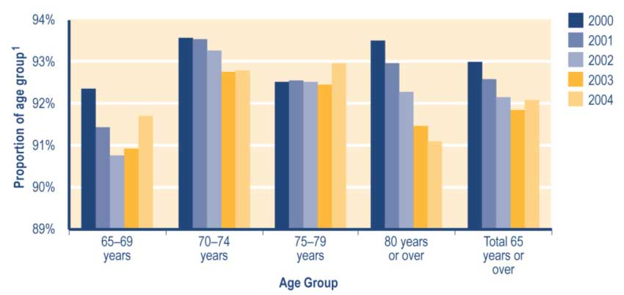
Note
1 Proportion shows:
a numbers of clients in age group receiving New Zealand Superannuation, divided by
b Statistics New Zealand final estimate of the resident population in age group at 30 June.

See Table A3.13 (Appendix 3) for a summary of the SWIFTT data underlying Figure 3.17.

Trends in New Zealand Superannuation pensions granted
The number of New Zealand Superannuation pensions granted each year increased slowly between 1999/2000 and 2000/2001, showed a rapid increase in 2001/2002, then showed slower increases over the last two years (see Table 3.58). This reflects the impact of:

• incremental increases in the age of eligibility for New Zealand Superannuation between 1 April 1993 and 1 April 2001
• the fixing of the age of eligibility for New Zealand Superannuation at 65 years since 1 April 2001.

Of the New Zealand Superannuation pensions granted each year since 1999/2000 (see Table 3.58):

• between 67% and 71% have been provided to clients who had not received a core benefit or pension within the last four years
• between 23% and 28% have involved clients transferring from another core benefit or pension.

Table 3.58 Trends in the length of period since clients granted New Zealand Superannuation last received any core benefit or pension

Period since core benefit or pension last received | New Zealand Superannuation pensions granted¹
 | 1999/2000  Number | 2000/2001  Number | 2001/2002  Number | 2002/2003  Number | 2003/2004  Number
None (administrative transfers of client who continued to receive some core benefit) | 5,068 | 4,981 | 9,031 | 8,826 | 8,216
Under 6 months | 208 | 160 | 260 | 280 | 375
6-12 months | 167 | 182 | 229 | 363 | 361
12-18 months | 146 | 136 | 211 | 332 | 268
18 months - 2 years | 111 | 110 | 220 | 267 | 240
2-4 years | 457 | 444 | 761 | 736 | 786
Not received a core benefit in previous four years | 12,524 | 13,186 | 21,769 | 23,779 | 25,312
Total | 18,681 | 19,199 | 32,481 | 34,583 | 35,558

Note
1 Numbers of successful applications for New Zealand Superannuation recorded in SWIFTT during years ended 30 June.

Trends in expenditure on New Zealand Superannuation
Expenditure on New Zealand Superannuation reflects the combined effects of the numbers receiving New Zealand Superannuation and adjustments to the rate at which New Zealand Superannuation is paid. Between 1991/1992 and 1999/2000, numbers receiving New Zealand Superannuation fell, largely because of incremental increases in the age of eligibility for New Zealand Superannuation from 1 April 1992. Over most of this period, however, adjustments to the rate at which New Zealand Superannuation is paid, combined with increased expenditure on Disability Allowances, more than offset the effect of decreasing numbers (see Table 3.59).

Rapid increases since 2000/2001 in expenditure on New Zealand Superannuation (see Table 3.59) reflect a combination of:

• increases over this period in the numbers of clients receiving New Zealand Superannuation following the fixing of the age of eligibility at 1 April 2001
• increases between 1999/2000 and 2002/2003 in the rate at which New Zealand Superannuation is paid.

Table 3.59 Trends in annual expenditure on New Zealand Superannuation

Year ended 30 June | Expenditure on  New Zealand  Superannuation^{1,2,3,4}  ($million)
1991/1992 | 5,153
1992/1993 | 5,070
1993/1994 | 5,045
1994/1995 | 5,083
1995/1996 | 5,158
1996/1997 | 5,187
1997/1998 | 5,263
1998/1999 | 5,253
1999/2000 | 5,228
2000/2001 | 5,457
2001/2002 | 5,638
2002/2003 | 5,831
2003/2004 | 6,085

Notes
1 Expenditure on New Zealand Superannuation in years ended 30 June.
2 Expenditure includes expenditure on supplementary benefits provided to recipients of New Zealand Superannuation.
3 Expenditure is gross of taxation, is adjusted for the number of payments of New Zealand Superannuation made during the year, and is smoothed using a three-month moving average.
4 Expenditure data in this table differs from, and should not be cited as, MSD’s official measure of expenditure on financial assistance provided to clients.

In general, monthly expenditure on New Zealand Superannuation (see Figure 3.18) shows a strong relationship to the number of people receiving New Zealand Superannuation pensions and adjustments in the rate of New Zealand Superannuation paid.

Seasonal peaks in New Zealand Superannuation expenditure during the second and fourth quarters of each financial year between 1992/1993 and 2000/2001 (see Figure 3.18) reflect the impact on New Zealand Superannuation expenditure of a surge of New Zealand Superannuation pensions being granted in April and October each year (as each incremental increase in eligibility age took effect). These peaks have not been in evidence over the last three years because the age of eligibility for New Zealand Superannuation has been fixed at 65 years since 1 April 2001.

Figure 3.18 Trends in monthly expenditure on New Zealand Superannuation

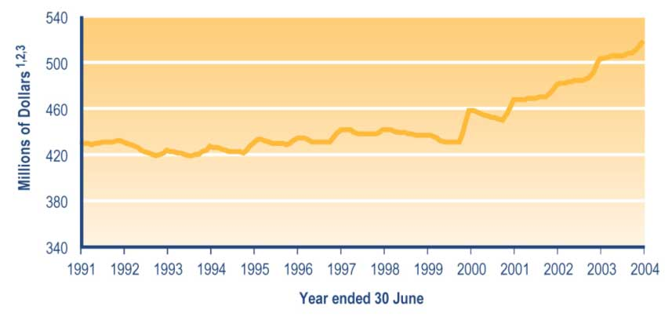

Notes
1 Monthly expenditure on New Zealand Superannuation, including expenditure on supplementary benefits paid to New Zealand Superannuation recipients.
2 Expenditure shown is gross of taxation, is adjusted for the number of payments of New Zealand Superannuation made during the month, and is smoothed using a three-month moving average.
3 Expenditure data in this graph differs from, and should not be cited as, MSD’s official measure of expenditure on financial assistance provided to clients.

Table 7.2 (see Section 7) shows trends since 1940 in expenditure on New Zealand Superannuation. Please note that expenditure on New Zealand Superannuation shown in Table 7.2 includes:

• deductions for debt established since 1996 and for overseas pensions paid directly to MSD, while the data in Table 3.59 and Figure 3.18 does not
• expenditure on supplementary benefits paid to people receiving New Zealand Superannuation.

Veterans’ Pension

Veterans’ Pensions were introduced on 1 April 1990 and replaced the former War Veterans’ Allowance, War Pension, War Service Pension and Economic Pension. A Veterans’ Pension is not income tested for qualified recipients aged 65 years or over, but is taxable. If a non-qualified spouse is receiving a Veterans’ Pension along with their qualified spouse, this is, however, subject to an income test. Clients aged under 65 years who have no spouse included in their Veterans’ Pension are subject to a personal earnings test only.

The rates of payment for a Veterans’ Pension are the same as for New Zealand Superannuation. A policy change was introduced in 1992 that allowed veterans receiving New Zealand Superannuation to transfer to a Veterans’ Pension.

Because widows of veterans are entitled to continue to receive a Veterans’ Pension, there are slightly more women than men receiving a Veterans’ Pension. From 1 July 1999, the funding of the Veterans’ Pension was transferred from Vote: Work and Income to Vote: Veterans’ Affairs: Social Development.

To qualify for a Veterans’ Pension, clients must be ex-service personnel who served in a war or emergency and:

• have reached the qualifying age for New Zealand Superannuation and receive a War Disablement Pension of at least 70%, or
• have not reached the qualifying age for New Zealand Superannuation and have a disability from any cause that means they are:
– permanently unable to work, or
– unable to work for a substantial period.

Trends in the number of clients receiving a Veterans’ Pension
The number of clients receiving a Veterans’ Pension has increased since 2000 (see Table 3.60). Since 2000, the proportion of Veterans’ Pension recipients who were aged 80 years or over has increased (from 41% to 56%), while the proportion aged 75–79 years has decreased (from 34% to 21%) (see Table 3.60). This reflects the ageing of World War Two veterans and their spouses, who are the largest group of Veterans’ Pension recipients.

Table 3.60 Trends in the ages of clients receiving a Veterans’ Pension

Age at 30 June | Clients receiving a Veterans Pension¹
 | 2000  Number | 2001  Number | 2002  Number | 2003  Number | 2004  Number
Under 60 years | 272 | 325 | 351 | 350 | 365
60-64 years | 149 | 192 | 243 | 278 | 312
65-69 years | 370 | 362 | 395 | 415 | 452
70-74 years | 1,009 | 893 | 773 | 753 | 779
75-79 years | 2,459 | 2,316 | 2,114 | 1,887 | 1,793
80 years or over | 2,988 | 3,336 | 3,711 | 4,189 | 4,764
Unspecified | 1 | 1 | 0 | 0 | 0
Total | 7,248 | 7,425 | 7,587 | 7,872 | 8,465

Note
1 Numbers of clients recorded in SWIFTT as receiving a Veterans’ Pension at 30 June.

Table 7.1 (see Section 7) shows trends since 1990 in the number of clients receiving a Veterans’ Pension.

Trends in the proportion of people aged 65 years or over receiving a Veterans’ Pension
Since 2000, around 1.5% of people aged 65 years or over have been receiving a Veterans’ Pension (see Figure 3.19). Increases in the proportion of people aged 80 years or over who are receiving a Veterans’ Pension (see Figure 3.19) largely reflect the ageing of World War Two veterans and their spouses or partners. These clients comprise the largest group of people receiving a Veterans’ Pension.

Figure 3.19 Trends in the proportion of people aged 65 years or over receiving a Veterans’ Pension, by age

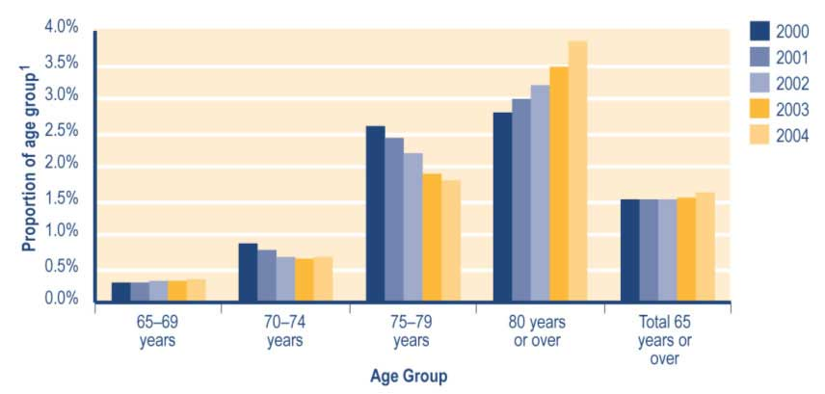
Note
1 Proportion shows:
a numbers of clients in age group recorded in SWIFTT as receiving a Veterans’ Pension at 30 June, divided by
b Statistics New Zealand final estimate of the resident population in age group at 30 June.

See Table A3.14 (Appendix 3) for a summary of the SWIFTT data underlying Figure 3.19.

Trends in Veterans’ Pensions granted
Increases since 1999/2000 in the number of Veterans’ Pensions granted each year (see Table 3.61) reflect assessments of clients as being 70% disabled or more under War Disablement Pensions criteria. Factors in the number of Veterans’ Pensions granted each year include the ageing of veterans, War Disablement Pensions criteria, and reviews of entitlement to a War Disablement Pension.

Since 1999/2000, the proportion of Veterans’ Pensions granted each year that reflected administrative transfers of clients from another core benefit or pension has increased (from 77% to 86%), while the proportion provided to clients who had not received a core benefit or pension in the previous four years has decreased (from 20% to 13%) (see Table 3.61). Veterans’ Pensions granted after an administrative transfer most frequently involved clients transferring from New Zealand Superannuation.
Table 3.61 Trends in the length of period since clients granted a Veterans’ Pension last received any core benefit or pension

Period since client last received any core benefit or pension | Veteran's Pensions granted¹
 | 1999/2000  Number | 2000/2001  Number | 2001/2002  Number | 2002/2003  Number | 2003/2004  Number
None (administrative transfers of client who continued to receive some core benefit or pension) | 371 | 586 | 651 | 769 | 1076
Under 6 months | 5 | 3 | 7 | 7 | 3
6-12 months | 1 | 4 | 5 | 4 | 2
12-18 months | 2 | 2 | 2 | 6 | 5
18 months - 2 years | 1 | 2 | 2 | 4 | 4
2-4 years | 7 | 5 | 14 | 7 | 7
Not received a core benefit or pension in previous four years | 95 | 120 | 136 | 132 | 159
Total | 482 | 722 | 817 | 929 | 1,256

Note
1 Numbers of successful applications for Veterans’ Pensions recorded in SWIFTT in years ended 30 June.

Trends in expenditure on Veterans’ Pensions
Increases since 1991/1992 in annual expenditure on Veterans’ Pensions (see Table 3.62) reflect increases in the number of people receiving a Veterans’ Pension and changes in the rate at which Veterans’ Pensions are paid.

Table 3.62 Trends in annual expenditure on Veterans’ Pensions

Year ended 30 June | Expenditure on  Veterans’ Pensions^{1,2,3,4}  ($ million)
1991/1992 | 30
1992/1993 | 47
1993/1994 | 54
1994/1995 | 56
1995/1996 | 59
1996/1997 | 64
1997/1998 | 70
1998/1999 | 72
1999/2000 | 73
2000/2001 | 77
2001/2002 | 83
2002/2003 | 87
2003/2004 | 94

Notes
1 Expenditure on Veterans’ Pensions in years ended 30 June.
2 Expenditure includes expenditure on supplementary benefits provided to clients receiving a Veterans’ Pension.
3 Expenditure shown is net of taxation, adjusted for the number of payments of Veterans’ Pensions made during the year, and smoothed using a two-month moving average.
4 Expenditure data in this table differs from, and should not be cited as, MSD’s official measure of expenditure on financial assistance provided to clients.

Relatively little seasonal variation is evident in monthly expenditure on Veterans’ Pensions (see Figure 3.20).

Figure 3.20 Trends in monthly expenditure on Veterans’ Pensions

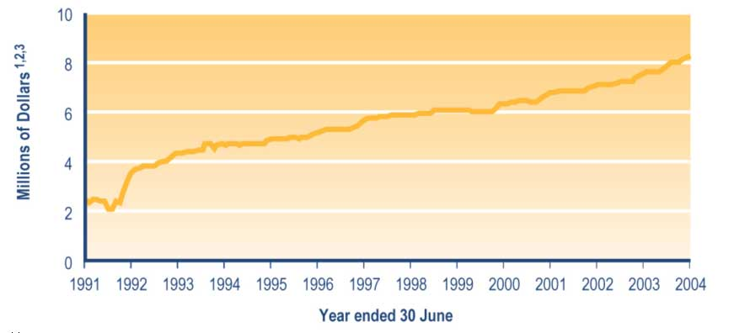
Notes
1 Monthly expenditure on Veterans’ Pensions, including expenditure on supplementary benefits paid to clients receiving a Veterans’ Pension.
2 Expenditure shown is net of taxation, adjusted for the number of payments of Veterans’ Pension made during the month, and smoothed using a two-month moving average.
3 Expenditure data in this graph differs from, and should not be cited as, MSD’s official measure of expenditure on financial assistance provided to clients.

Table 7.2 (see Section 7) shows trends since 1990 in expenditure on Veterans’ Pensions. Please note that expenditure on Veterans’ Pensions shown in Table 7.2 includes:

• deductions for debt established from 1996, while the data in Table 3.62 and Figure 3.20 does not
• expenditure on supplementary benefits paid to people receiving a Veterans’ Pension.

Emergency Benefit

An Emergency Benefit is available to people who are suffering hardship, are unable to earn enough income for themselves (and any family), and are ineligible to receive any other benefit.

In considering whether a client is eligible to receive an Emergency Benefit, the following factors are taken into account:

• why clients cannot receive another benefit (eg age, medical requirements, residency requirements, job search requirements)
• whether the client meets the hardship criteria (ie low cash assets and no income or means of supporting themselves or a family)
• whether the client has contributed to their situation in any way (eg not looking for other work in the off season from their main employment)
• whether the client could change their position to ease their hardship (eg look for work, change the focus of their business).

Income and asset tests apply.

Trends in the number of clients receiving an Emergency Benefit
The number of clients receiving an Emergency Benefit decreased between 1999 and 2002, but has risen slightly in the last two years (see Table 3.63). Since 2000, the proportion of clients receiving an Emergency Benefit who were aged 65 years or over has increased (from 35% to 53%) (see Table 3.63).

Table 3.63 Trends in the ages of people receiving an Emergency Benefit

Client age at 30 June | Clients receiving an Emergency Benefit¹
 | 2000  Number | 2001  Number | 2002  Number | 2003  Number | 2004  Number
15–19 years | 155 | 219 | 174 | 208 | 198
20–24 years | 465 | 449 | 295 | 408 | 352
25–29 years | 593 | 534 | 364 | 413 | 368
30–34 years | 676 | 649 | 438 | 480 | 422
35–39 years | 679 | 601 | 391 | 450 | 450
40–44 years | 654 | 578 | 388 | 429 | 397
45–49 years | 553 | 516 | 371 | 469 | 446
50–54 years | 619 | 558 | 394 | 391 | 397
55–59 years | 686 | 656 | 421 | 398 | 412
60–64 years | 1,255 | 1,244 | 805 | 788 | 734
65 years or over | 3,372 | 3,718 | 3,769 | 4,294 | 4,771
Unspecified | 0 | 0 | 0 | 0 | 0
Total | 9,707 | 9,722 | 7,810 | 8,728 | 8,947

Note
1 Numbers of clients recorded in SWIFTT as receiving an Emergency Benefit at 30 June.

Trends in the proportion of 18–59 year olds receiving an Emergency Benefit
Since 2000, around 0.2% of people aged 18–59 years have been receiving an Emergency Benefit (see Figure 3.21). In all age groups, the proportion receiving an Emergency Benefit was significantly higher in 2000 and 2001 than in the last three years (see Figure 3.21). This reflects the increased concentration noted earlier of Emergency Benefit receipt among people aged 65 years or over.

Figure 3.21 Trends in the proportion of 18–59 year olds receiving an Emergency Benefit, by age

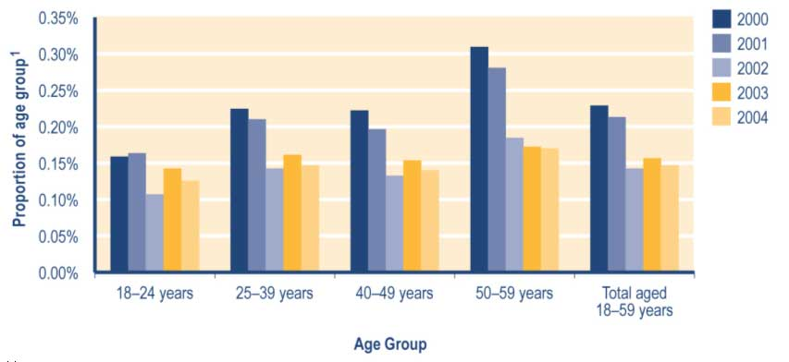
Note
1 Proportion shows:
a number of clients in age group recorded in SWIFTT as receiving an Emergency Benefit at 30 June, divided by
b Statistics New Zealand final estimate of the resident population in age group at 30 June.

See Table A3.15 (Appendix 3) for a summary of the SWIFTT data underlying Figure 3.21.

Trends in Emergency Benefits granted
The number of Emergency Benefits granted each year has increased over the last two years (see Table 3.64). Since 1999/2000, the proportion of Emergency Benefits granted each year that were provided to clients who (see Table 3.64):

• had received a core benefit within the last 12 months has increased (from 23% to 37%)
• had not received a core benefit in the previous four years has decreased (from 44% to 22%).

Table 3.64 Trends in the length of periods since clients granted an Emergency Benefit last received any core benefit

Period since client last received any core benefit | Emergency Benefits granted¹
 | 1999/2000  Number | 2000/2001  Number | 2001/2002  Number | 2002/2003  Number | 2003/2004  Number
None (administrative transfers of client who continued to receive some core benefit) | 998 | 1,079 | 1,050 | 1,407 | 2,101
Under 6 months | 1,352 | 1,971 | 1,620 | 2,502 | 3,622
6-12 months | 422 | 562 | 672 | 714 | 1,008
12-18 months | 179 | 263 | 186 | 233 | 330
18 months - 2 years | 124 | 168 | 117 | 171 | 254
2-4 years | 224 | 286 | 268 | 327 | 457
Not received a core benefit in previous four years | 2,631 | 3,076 | 2,114 | 2,055 | 2,128
Total | 5,930 | 7,405 | 6,027 | 7,409 | 9,900

Note
1 Numbers of successful applications for Emergency Benefits recorded in SWIFTT in years ended 30 June.

Trends in cessations of Emergency Benefits
The number of Emergency Benefits ceased each year increased significantly in the last year, after decreasing between 2001/2002 and 2002/2003 (see Table 3.65). Since 2000/2001, the proportion of annual Emergency Benefit cessations that reflect clients entering paid work has increased (from 21% to 35%), while the proportion reflecting transfers to another core benefit or pension has decreased (from 43% to 27%) (see Table 3.65).

Table 3.65 Trends in reasons for cessations of Emergency Benefits

Reason for cessation | Cessations of Emergency Benefits¹
 | 1999/2000  Number | 2000/2001  Number | 2001/2002  Number | 2002/2003  Number | 2003/2004  Number
Obtained paid work | 1,491 | 1,850 | 1,689 | 1,771 | 3,292
Transferred to another benefit or pension | 1,993 | 2,269 | 3,372 | 1,956 | 2,505
Other | 3,046 | 3,334 | 2,877 | 2,575 | 3,634
Total | 6,530 | 7,453 | 7,938 | 6,302 | 9,431

Note
1 Numbers of Emergency Benefit cessations recorded in SWIFTT in years ended 30 June.

Section 4 - Supplementary benefits and hardship assistance

Introduction

People with low incomes and few assets may be eligible for supplementary benefits or hardship assistance. These benefits and forms of assistance are designed to assist clients who have specific costs or who are having difficulty meeting their needs from their usual income.

This section of the report outlines trends in the use and uptake of supplementary benefits and hardship assistance. Eligibility criteria are outlined for each supplementary benefit and each form of hardship assistance. For information about payment rates for key supplementary benefits, see Section 2. Additional information about the income tests applied to recipients of some supplementary benefits is given in Appendix 1.

Supplementary benefits

Most supplementary benefits are paid on an ongoing basis, while some are paid for short periods in response to a specific need (eg childcare costs during school holidays) or as one-off lump sums.
People may receive more than one supplementary benefit, because each supplementary benefit is aimed at assisting with specific living costs. In addition, clients may receive payments of some supplementary benefits that cover more than one person (eg payments of the Childcare Subsidy that cover more than one child). Where payments of a supplementary benefit may cover more than one person, this report shows information on the people covered by payments of the supplementary benefit, rather than on the clients receiving payments of the supplementary benefit that may cover one or more people.
The number of supplementary benefits granted is affected by the number of people moving off and on core benefits, because most people receiving supplementary benefits are also receiving core benefits. This means that supplementary benefits granted are more likely to be provided to people receiving core benefits that people move off and on frequently (eg unemployment-related benefits) than to people receiving other core benefits.

Accommodation Supplement

An Accommodation Supplement is available to assist people with limited income and limited cash assets to meet their accommodation costs. Assistance is available to help pay rent, board or costs of home ownership. Accommodation Supplements replaced Accommodation Benefits on 1 July 1993.

Housing costs must be over a stated minimum, and income and asset tests must be met. An Accommodation Supplement meets 70% of rent or mortgage costs over an entry threshold, up to a maximum that varies according to region and household size. Accommodation Supplements meet 62% of boarding costs over the relevant entry threshold, up to the regional maximum.

Tenants of Housing New Zealand Corporation (HNZC) properties receive a rental subsidy from HNZC and are not eligible for an Accommodation Supplement.

Trends in the number of clients receiving an Accommodation Supplement
The number of clients receiving an Accommodation Supplement has decreased since 2000 (see Table 4.1). This reflects:

• a reduction in numbers of people receiving core benefits
• the impact of the reintroduction in November 2000 of income-related rents for state rental homes.

Since 2000, between 29% and 33% of the clients receiving an Accommodation Supplement have been receiving a carers’ benefit (see Table 4.1). Over the same period, there have been (see Table 4.1):

• increases in the proportion of Accommodation Supplement recipients who were receiving:
– a sickness-related benefit (from 8% to 13%)
– an Invalids’ Benefit (from 10% to 14%)
• a decrease in the proportion of Accommodation Supplement recipients who were receiving an unemployment-related benefit (from 33% to 21%).

Table 4.1 Trends in the types of core benefit or pension paid to clients receiving an Accommodation Supplement

Type of core benefit or pension paid at 30 June | Clients receiving an Accommodation Supplement¹
 | 2000  Number | 2001  Number | 2002  Number | 2003  Number | 2004  Number
Unemployment-related benefits² | 105,005 | 88,250 | 79,167 | 69,428 | 48,830
Carers benefits³ | 92,442 | 77,913 | 77,281 | 77,648 | 77,476
Sickness-related benefits⁴ | 23,878 | 22,152 | 24,292 | 26,917 | 29,822
Invalids’ Benefit | 30,410 | 27,360 | 29,596 | 31,649 | 33,270
Widows’ Benefit | 3,454 | 2,572 | 2,572 | 2,502 | 2,495
Unsupported Child’s Benefit/Orphan’s Benefit | 0 | 0 | 0 | 2 | 0
Transitional Retirement Benefit | 2,107 | 1,762 | 938 | 413 | 0
Emergency Benefit | 7,588 | 6,391 | 5,085 | 5,522 | 5,541
New Zealand Superannuation | 23,074 | 14,733 | 16,068 | 16,044 | 17,102
Veterans’ Pension | 339 | 205 | 245 | 250 | 281
No core benefit or pension | 27,691 | 24,544 | 22,790 | 21,566 | 21,878
Total | 315,988 | 265,882 | 258,034 | 251,941 | 236,695

Notes
1 Numbers of clients recorded in SWIFTT as receiving an Accommodation Supplement at 30 June.
2 Includes Unemployment Benefits and Unemployment Benefits – Hardship paid to unemployed people and to trainees, and Independent Youth Benefits.
3 Includes Domestic Purposes Benefits – Sole Parents, Domestic Purposes Benefits – Caring for the Sick and Infirm, Domestic Purposes Benefits – Women Alone, and Emergency Maintenance Allowances.
4 Includes Sickness Benefits and Sickness Benefits – Hardship.

Since 2001, between 56% and 58% of Accommodation Supplement recipients have been renting privately, while around 23% have been boarding and between 16% and 18% have owned a house with a mortgage (see Table 4.2). Between 2000 and 2001, the proportion of Accommodation Supplement recipients who were renting from non-private organisations has decreased (from 16% to 2%) (see Table 4.2). This reflects the impact of the reintroduction of income-related rents for state rental homes.
Table 4.2 Trends in the ownership status of clients receiving an Accommodation Supplement

Ownership status at 30 June | Clients receiving an Accommodation Supplement¹
 | 2000  Number | 2001  Number | 2002  Number | 2003  Number | 2004  Number
Renting privately | 151,470 | 148,500 | 145,032 | 142,006 | 137,038
Renting from other organisation | 48,935 | 6,505 | 6,642 | 5,921 | 5,936
Boarding | 65,567 | 62,151 | 60,801 | 61,047 | 53,988
Mortgage | 48,001 | 47,104 | 44,051 | 41,298 | 38,293
Unspecified | 2,015 | 1,622 | 1,508 | 1,669 | 1,440
Total | 315,988 | 265,882 | 258,034 | 251,941 | 236,695

Note
1 Numbers of clients recorded in SWIFTT as receiving an Accommodation Supplement at 30 June.

Trends in the proportion of people aged 18 years or over receiving an Accommodation Supplement
The proportion of people aged 18 years or over who were receiving an Accommodation Supplement has decreased since 2000 (see Figure 4.1). This reflects the impacts of:

• decreased numbers of people receiving core benefits
• the reintroduction in November 2000 of income-related rents for state rental homes.

Since 2000, the prevalence of receipt of an Accommodation Supplement has been significantly higher among 18–39 year olds than among people aged 40 years or over (see Figure 4.1).

Figure 4.1 Trends in the proportion of people aged 18 years or over receiving an Accommodation Supplement, by age

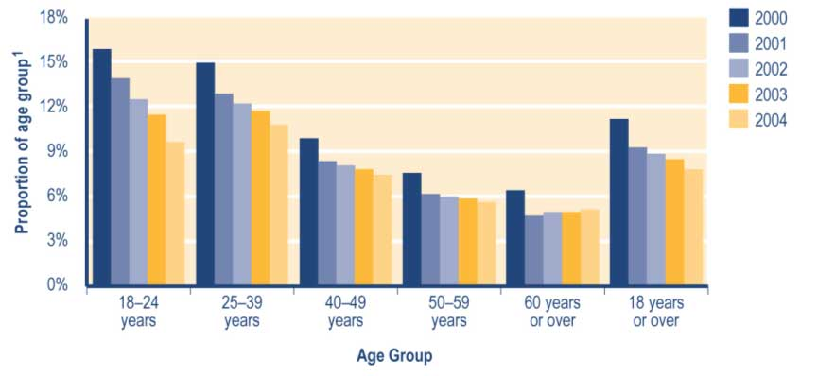

Note
1 Proportion shows:
a number of people in age group recorded in SWIFTT as receiving an Accommodation Supplement at 30 June, divided by
b Statistics New Zealand final estimate of the resident population in age group at 30 June.

See Table A3.16 (Appendix 3) for a summary of the SWIFTT data underlying Figure 4.1.

Trends in Accommodation Supplements granted
The annual number of Accommodation Supplements granted each year has decreased since 1999/2000 (see Table 4.3). This reflects the combined impact of:

• decreases in the number of people receiving core benefits
• the reintroduction in November 2000 of income-related rents for state rental homes.

Since 1999/2000, around 14% of Accommodation Supplements granted have been provided to clients receiving a carers’ benefit (see Table 4.3). Over the same period, the proportion of Accommodation Supplements granted that were provided to recipients of sickness-related benefits has increased (from 11% to 17%), while the proportion provided to clients receiving unemployment-related benefits has decreased (from 58% to 47%) (see Table 4.3).

Table 4.3 Trends in the types of core benefit or pension paid to clients granted an Accommodation Supplement

Type of core benefit or pension received when Accommodation Supplement granted | Accommodation Supplements granted¹
 | 1999/2000  Number | 2000/2001  Number | 2001/2002  Number | 2002/2003  Number | 2003/2004  Number
Unemployment-related benefits² | 159,634 | 149,290 | 136,534 | 124,627 | 106,165
Carers benefits³ | 38,977 | 37,077 | 34,462 | 34,734 | 34,666
Sickness-related benefits⁴ | 30,103 | 30,797 | 32,220 | 33,905 | 37,338
Invalids’ Benefit | 9,313 | 9,176 | 9,462 | 9,799 | 10,205
Widows’ Benefit | 1,075 | 981 | 921 | 967 | 976
Unsupported Child’s Benefit/Orphan’s Benefit | 7 | 4 | 6 | 9 | 4
Transitional Retirement Benefit | 1,243 | 1,142 | 776 | 688 | 271
Emergency Benefit | 4,962 | 5,712 | 4,493 | 5,193 | 6,805
New Zealand Superannuation | 3,911 | 3,344 | 4,620 | 4,209 | 4,633
Veterans’ Pension | 60 | 77 | 91 | 77 | 83
No core benefit or pension | 25,895 | 25,620 | 23,652 | 23,411 | 24,765
Total | 275,180 | 263,220 | 247,237 | 237,619 | 225,911

Notes
1 Numbers of successful applications for Accommodation Supplements recorded in SWIFTT during years ended 30 June.
2 Includes Unemployment Benefits and Unemployment Benefits – Hardship paid to unemployed people and to trainees, and Independent Youth Benefits.
3 Includes Domestic Purposes Benefits – Sole Parents, Domestic Purposes Benefits – Caring for the Sick and Infirm, Domestic Purposes Benefits – Women Alone, and Emergency Maintenance Allowances.
4 Includes Sickness Benefits and Sickness Benefits – Hardship.

Trends in expenditure on Accommodation Supplements
Decreases since 1999/2000 in annual expenditure on Accommodation Supplements (see Table 4.4) reflect decreases in the number of clients receiving an Accommodation Supplement. These in turn reflect decreases in the number of clients receiving core benefits and the impact of the reintroduction of income-related rents in November 2000.

Changes in 1997 to the administration of Accommodation Supplements, to payment rates and to maximum levels available contributed to increased expenditure on Accommodation Supplements between 1997/1998 and 1999/2000. This increase in expenditure was, however, more than negated by the decreases in numbers receiving Accommodation Supplements since 1999/2000 outlined above.
Table 4.4 Trends in annual expenditure on Accommodation Supplements

Year ended 30 June | Expenditure on  Accommodation  Superannuation^{1,2,3}  ($million)
1991/1992 | 174
1992/1993 | 206
1993/1994 | 337
1994/1995 | 483
1995/1996 | 551
1996/1997 | 648
1997/1998 | 777
1998/1999 | 831
1999/2000 | 852
2000/2001 | 790
2001/2002 | 711
2002/2003 | 697
2003/2004 | 691

Notes
1 Expenditure on Accommodation Supplements in years ended 30 June.
2 Expenditure shown is adjusted for the number of payments of Accommodation Supplement made each year and smoothed using a two-month moving average. Accommodation Supplements are not subject to taxation.
3 Expenditure data in this table differs from, and should not be cited as, MSD’s official measure of expenditure on financial assistance provided to clients.

Monthly expenditure on Accommodation Supplements shows small seasonal peaks in summer (see Figure 4.2). These reflect the seasonal peak in core benefit uptake that occurs around this time. The impact of the reintroduction of income-related rents for state rental homes is visible in Figure 4.2 as a drop from mid 2000/2001 in monthly expenditure on Accommodation Supplements.

Figure 4.2 Trends in monthly expenditure on Accommodation Supplements

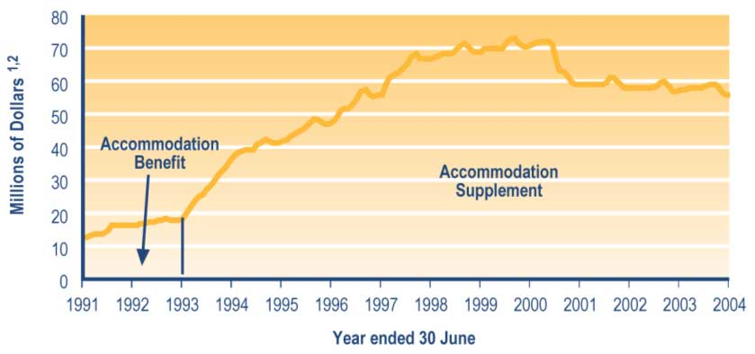

Notes
1 Expenditure is adjusted for the number of payments of Accommodation Supplements made during the month and smoothed using a two-month moving average. Accommodation Supplements are not subject to taxation.
2 Expenditure data in this graph differs from, and should not be cited as, MSD’s official measure of expenditure on financial assistance provided to clients.

Tenure Protection Allowance

Between 1992 and 2000, a Tenure Protection Allowance was available to selected tenants in HNZC or Te Puni Kökiri housing. Tenure Protection Allowances were available to tenants who would face difficulty as a result of market-related rents if they were required to move to other accommodation. The Tenure Protection Allowance was set at the difference between:

• the actual market rent payable
• the average rent for a household of the same size in the same region.

Tenure Protection Allowances were a transitional provision for eligible tenants who were residing in state rental homes on 1 October 1992. No one has become eligible to receive a Tenure Protection Allowance since 1 October 1992. The Allowance was abolished following the reintroduction of income-related rents for state rental homes in November 2000.

Trends in the number of clients receiving a Tenure Protection Allowance
The number of people receiving a Tenure Protection Allowance decreased from 5,103 to 4,413 between 30 June 1999 and 30 June 2000. This reflects:

• the ineligibility of new state rental housing tenants to apply for the Allowance after 1 October 1992
• the movement from their state rental homes of those who were eligible.

In total, about 90% of those who received a Tenure Protection Allowance did so under the special criteria for persons aged 65 years or over set up at 1 October 1992. These criteria allowed people to receive an Allowance in recognition of the fact that it was inappropriate to require these people to move from their home.

Special Transfer Allowance

Special Transfer Allowances were introduced on 1 October 1996 to provide ongoing assistance to those who had previously qualified for a Tenure Protection Allowance but who lost that entitlement when they:

• moved from their HNZC property (entitlement to a Tenure Protection Allowance was lost whether tenants moved to another HNZC property or to a property rented from a private landlord), or
• continued to live in their ex-state rental home after it had been sold by HNZC.

Entitlement to a Special Transfer Allowance was restricted to clients who had been living in state rental homes on 1 October 1992 and had previously received a Tenure Protection Allowance.

Trends in the number of clients receiving a Special Transfer Allowance
Decreases since 2000 in the number of people receiving a Special Transfer Allowance (see Table 4.5) reflect:

• attrition from the original group of clients who were eligible for a Special Transfer Allowance
• the reintroduction of income-related rents for state rental homes in November 2000.

Following the reintroduction of income-related rents for state rental homes, only those people who rented from a private landlord continued to receive a Special Transfer Allowance.

Since 2000, between 90% and 92% of the clients receiving a Special Transfer Allowance have been receiving New Zealand Superannuation (see Table 4.5). This reflects:

• the requirement that people receiving a Special Transfer Allowance previously qualified for a Tenure Protection Allowance
• the high proportion (over 90%) of clients receiving a Tenure Protection Allowance who were aged 65 years or over at 1 October 1992.

Table 4.5 Trends in the types of core benefit or pension paid to clients receiving a Special Transfer Allowance

Type of core benefit or pension paid at 30 June | Clients receiving Special Transfer Allowance¹
 | 1999/2000  Number | 2000/2001  Number | 2001/2002  Number | 2002/2003  Number | 2003/2004  Number
Unemployment-related benefits² | 0 | 0 | 0 | 0 | 0
Carers' benefits³ | 4 | 1 | 1 | 1 | 1
Sickness-related benefits⁴ | 0 | 0 | 0 | 0 | 0
Invalids' Benefit | 18 | 6 | 6 | 5 | 5
Widows' Benefit | 0 | 0 | 0 | 0 | 0
Unsupported Child's Benefit/Orphan's Benefit | 0 | 0 | 0 | 0 | 0
Transitional Retirement Benefit | 1 | 0 | 0 | 0 | 0
Emergency Benefit | 0 | 0 | 0 | 0 | 0
New Zealand Superannuation | 321 | 167 | 139 | 129 | 115
Veterans' Pension | 9 | 6 | 5 | 4 | 4
No core benefit or pension | 5 | 2 | 1 | 1 | 0
Total | 358 | 182 | 152 | 140 | 125

Notes
1 Numbers of clients recorded in SWIFTT as receiving a Special Transfer Allowance at 30 June.
2 Includes Unemployment Benefits and Unemployment Benefits – Hardship paid to unemployed people or to trainees, and Independent Youth Benefits.
3 Includes Domestic Purposes Benefits – Sole Parents, Domestic Purposes Benefits – Caring for the Sick and Infirm, Domestic Purposes Benefits – Women Alone, and Emergency Maintenance Allowances.
4 Includes Sickness Benefits and Sickness Benefits – Hardship.

Trends in Special Transfer Allowances granted
Decreases since 1999/2000 in the number of Special Transfer Allowances granted each year (see Table 4.6) reflect attrition from the original group of clients who were eligible for a Special Transfer Allowance.
Table 4.6 Trends in the types of core benefit or pension paid to clients granted a Special Transfer Allowance

Type of core benefit or pension paid when Special Transfer Allowance granted | Special Transfer Allowances granted¹
 | 1999/2000  Number | 2000/2001  Number | 2001/2002  Number | 2002/2003  Number | 2003/2004  Number
Unemployment-related benefits² | 0 | 0 | 0 | 0 | 0
Carers' benefits³ | 0 | 3 | 0 | 0 | 0
Sickness-related benefits⁴ | 0 | 0 | 0 | 0 | 0
Invalids' Benefit | 4 | 2 | 0 | 0 | 1
Widows' Benefit | 0 | 0 | 0 | 0 | 0
Unsupported Child's Benefit/Orphan's Benefit | 0 | 0 | 0 | 0 | 0
Transitional Retirement Benefit | 0 | 0 | 0 | 0 | 0
Emergency Benefit | 0 | 0 | 0 | 0 | 0
New Zealand Superannuation | 89 | 43 | 3 | 1 | 0
Veterans' Pension | 1 | 2 | 0 | 0 | 0
No core benefit or pension | 0 | 1 | 0 | 0 | 0
Total | 94 | 51 | 3 | 1 | 1

Notes
1 Numbers of successful applications for Special Transfer Allowances recorded in SWIFTT during years ended 30 June.
2 Includes Unemployment Benefits and Unemployment Benefits – Hardship paid to unemployed people and to trainees, and Independent Youth Benefits.
3 Includes Domestic Purposes Benefits – Sole Parents, Domestic Purposes Benefits – Caring for the Sick and Infirm, Domestic Purposes Benefits – Women Alone, and Emergency Maintenance Allowances.
4 Includes Sickness Benefits and Sickness Benefits – Hardship.

Trends in expenditure on Tenure Protection Allowances and Special Transfer Allowances
Decreases since 1995/1996 in combined annual expenditure on Tenure Protection Allowances and Special Transfer Allowances (see Table 4.7) reflect decreases in numbers receiving this assistance. A particularly sharp fall between 1999/2000 and 2001/2002 (see Table 4.7) largely reflects the reintroduction of income-related rents and the related abolition of the Tenure Protection Allowance programme.

Table 4.7 Trends in combined annual expenditure on Tenure Protection Allowances and Special Transfer Allowances

Year ended 30 June | Expenditure on  Tenure Protection  Allowances and Special  Transfer Allowances^{1,2,3}  ($million)
1993/1994 | 3.3
1994/1995 | 16.4
1995/1996 | 16.8
1996/1997 | 15.5
1997/1998 | 14.9
1998/1999 | 13.1
1999/2000 | 11.5
2000/2001 | 5.0
2001/2002 | <0.5
2002/2003 | <0.5
2003/2004 | <0.5
Notes
1 Expenditure on Tenure Protection Allowances and Special Transfer Allowances in years ended 30 June.
2 Expenditure shown is adjusted for the number of payments of Special Transfer Allowance or Tenure Protection Allowances that were made during the year, and is smoothed using a two-month moving average. Tenure Protection Allowances and Special Transfer Allowances are not subject to taxation.
3 Expenditure data in this table differs from, and should not be cited as, MSD’s official measure of expenditure on financial assistance provided to clients.

Combined monthly expenditure on Tenure Protection Allowances and Special Transfer Allowances shows little seasonal variation (see Figure 4.3).

Figure 4.3 Trends in combined monthly expenditure on Tenure Protection Allowances and Special Transfer Allowances

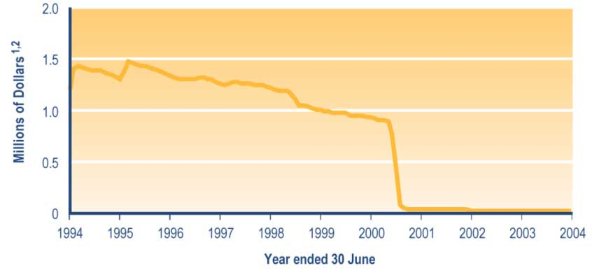

Notes
1 Expenditure is adjusted for the number of payments of Tenure Protection Allowances and Special Transfer Allowances during the month and smoothed using a two-month moving average. Tenure Protection Allowances and Special Transfer Allowances are not subject to taxation.
2 Expenditure data in this graph differs from, and should not be cited as, MSD’s official measure of expenditure on financial assistance provided to clients.

Away from Home Allowance

An Away from Home Allowance provides assistance with accommodation costs for the caregivers of dependent 16–17 year olds who move away from home to undertake tertiary study or employment-related training.

For the caregiver to receive an Away from Home Allowance, they must be:

• the principal caregiver for the child
• entitled to receive Family Support for the child.

In addition, the child must be living away from home in order to undertake a course that would qualify them for a Student Allowance or an Unemployment Benefit if they were old enough to receive one.

The amount of Away from Home Allowance payable is calculated based on:

• the same threshold for rental or boarding costs as would be applied to a single 18 year old receiving an Unemployment Benefit
• maximum accommodation costs funded, which are the same as those for an Accommodation Supplement.

All accommodation costs must be verified when applying for an Away from Home Allowance. An Away from Home Allowance is non-taxable and is not asset tested.

Trends in the number of clients receiving an Away from Home Allowance
The number of clients receiving an Away from Home Allowance has decreased since 2001 (see Table 4.8). Since 2001, the proportion of Away from Home Allowance recipients who were not receiving a core benefit has decreased (from 62% to 51%). Over the same period, the proportion of Away from Home Allowance recipients who were receiving a carers’ benefit has increased (from 20% to 32%) (see Table 4.8).

Table 4.8 Trends in the types of core benefit or pension paid to clients receiving an Away from Home Allowance

Type of core benefit or pension paid at 30 June | Clients receiving Away from Home Allowances¹
 | 2000  Number | 2001  Number | 2002  Number | 2003  Number | 2004  Number
Unemployment-related benefits² | 9 | 6 | 3 | 3 | 1
Carers' benefits³ | 21 | 19 | 24 | 22 | 13
Sickness-related benefits⁴ | 4 | 1 | 3 | 1 | 1
Invalids' Benefit | 4 | 5 | 8 | 4 | 2
Widows' Benefit | 2 | 2 | 2 | 1 | 1
Unsupported Child's Benefit/Orphan's Benefit | 0 | 0 | 0 | 0 | 0
Transitional Retirement Benefit | 0 | 0 | 0 | 0 | 0
Emergency Benefit | 0 | 2 | 0 | 0 | 0
New Zealand Superannuation | 1 | 2 | 0 | 0 | 2
Veterans' Pension | 0 | 0 | 0 | 0 | 0
No core benefits | 30 | 59 | 54 | 37 | 21
Total | 71 | 96 | 94 | 68 | 41

Notes
1 Numbers recorded in SWIFTT as receiving an Away from Home Allowance at 30 June.
2 Includes Unemployment Benefits and Unemployment Benefits – Hardship paid to unemployed people and to trainees, and Independent Youth Benefits.
3 Includes Domestic Purposes Benefits – Sole Parents, Domestic Purposes Benefits – Caring for the Sick and Infirm, Domestic Purposes Benefits – Women Alone, and Emergency Maintenance Allowances.
4 Includes Sickness Benefits and Sickness Benefits – Hardship.

Trends in Away from Home Allowances granted
The number of Away from Home Allowances granted each year has decreased since 2000/2001 (see Table 4.9). Over this period, the proportion of Away from Home Allowances granted each year that were provided to people receiving a carers’ benefit has increased (from 25% to 34%), while the proportion provided to clients not receiving any core benefit has decreased (from 52% to 44%) (see Table 4.9).

Table 4.9 Trends in the types of core benefit or pension paid to clients granted an Away from Home Allowance

Types of core benefit or pension paid when Away from Home Allowance granted | Away from Home Allowances granted¹
 | 1999/2000  Number | 2000/2001  Number | 2001/2002  Number | 2002/2003  Number | 2003/2004  Number
Unemployment-related benefits² | 35 | 25 | 9 | 13 | 6
Carers' benefits³ | 60 | 63 | 65 | 61 | 36
Sickness-related benefits⁴ | 6 | 9 | 6 | 14 | 2
Invalids' Benefit | 8 | 14 | 18 | 13 | 8
Widows' Benefit | 5 | 5 | 5 | 5 | 5
Unsupported Child's Benefit/Orphan's Benefit | 1 | 0 | 0 | 0 | 1
Transitional Retirement Benefit | 0 | 1 | 1 | 0 | 0
Emergency Benefit | 0 | 2 | 0 | 0 | 0
New Zealand Superannuation | 5 | 2 | 4 | 0 | 2
Veterans' Pension | 0 | 0 | 0 | 0 | 0
No core benefits | 72 | 129 | 126 | 100 | 47
Total | 192 | 250 | 234 | 206 | 107

Notes
1 Numbers of successful applications for Away from Home Allowances recorded in SWIFTT during years ended 30 June.
2 Includes Unemployment Benefits and Unemployment Benefits – Hardship paid to unemployed people and to trainees, and Independent Youth Benefits.
3 Includes Domestic Purposes Benefits – Sole Parents, Domestic Purposes Benefits – Caring for the Sick and Infirm, Domestic Purposes Benefits – Women Alone, and Emergency Maintenance Allowances.
4 Includes Sickness Benefits and Sickness Benefits – Hardship.

Childcare Subsidy

The Childcare Subsidy programme assists with the costs of childcare faced by low-income families. A Childcare Subsidy is available for children aged under five years, or for children
aged under six years if the caregiver also receives a Child Disability Allowance for their child.
A Childcare Subsidy provides assistance with the cost of licensed childcare, family day care projects and chartered Te Köhanga Reo.

A policy change in July 1993 restricted Childcare Subsidies for those people not in education, training or employment to a maximum of nine hours per week. This restriction applied to new applicants from that date and was extended to existing Childcare Subsidy recipients from early 1994.

Please note also that information in this section indicates the number of children covered by a Childcare Subsidy received and granted. This information may therefore differ from other published information giving the number of clients receiving or granted a Childcare Subsidy for one or more children.

Trends in the number of children covered by a Childcare Subsidy
Decreases since 2000 in the number of children covered by a Childcare Subsidy (see Table 4.10) reflect improved economic conditions and decreased numbers of clients receiving core benefits as well as decreases in the number of children aged under five years (the eligible age group).

Since 2000, there has been an increase in the proportion of children covered by a Childcare Subsidy whose caregivers are receiving a carers’ benefit (from 54% to 62%), and a corresponding decrease in the proportion whose caregivers are not receiving any core benefit or pension (from 35% to 30%) (see Table 4.10).

Table 4.10 Trends in the types of core benefit or pension paid to caregivers of children covered by a Childcare Subsidy

Type of core benefit or pension paid to caregiver at 30 June | Children covered by a Childcare Subsidy¹
 | 2000  Number | 2001  Number | 2002  Number | 2003  Number | 2004  Number
Unemployment-related benefits² | 1,924 | 1,522 | 1,240 | 976 | 698
Carers' benefits³ | 15,349 | 15,210 | 15,064 | 15,337 | 14,988
Sickness-related benefits⁴ | 412 | 357 | 373 | 428 | 438
Invalids' Benefit | 493 | 561 | 598 | 578 | 581
Widows' Benefit | 125 | 114 | 106 | 109 | 101
Transitional Retirement Benefit | 9 | 14 | 8 | 1 | 0
Emergency Benefit | 213 | 196 | 138 | 168 | 153
New Zealand Superannuation | 40 | 30 | 35 | 37 | 34
Veterans' Pension | 0 | 1 | 1 | 4 | 3
No core benefit or pension | 10,188 | 9,869 | 9,038 | 7,988 | 7,241
Total | 28,683 | 27,874 | 26,601 | 25,626 | 24,237

Notes
1 Numbers of children recorded in SWIFTT as being covered by a Childcare Subsidy at 30 June.
2 Includes Unemployment Benefits and Unemployment Benefits – Hardship paid to unemployed people and to trainees, and Independent Youth Benefits.
3 Includes Domestic Purposes Benefits – Sole Parents, Domestic Purposes Benefits – Caring for the Sick and Infirm, Domestic Purposes Benefits – Women Alone, and Emergency Maintenance Allowances.
4 Includes Sickness Benefits and Sickness Benefits – Hardship.

Trends in the proportion of children aged under five years covered by a Childcare Subsidy
Decreases since 2000 in the proportion of children aged under five years who are covered by a Childcare Subsidy (see Figure 4.4) reflect improved economic conditions combined with decreases in the number of people receiving core benefits.

Figure 4.4 Trends in the proportion of children aged under five years covered by a Childcare Subsidy

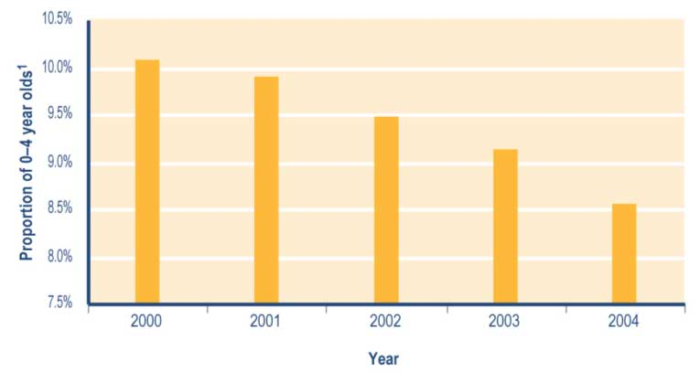
Note
1 Proportion shows:
a number of children aged under five years recorded in SWIFTT as being covered by a Childcare Subsidy at 30 June, divided by
b Statistics New Zealand final estimate of the resident population aged under five years at 30 June.

See Table A3.17 (Appendix 3) for a summary of the SWIFTT data underlying Figure 4.4.

Trends in Childcare Subsidies granted
The number of Childcare Subsidies granted each year has decreased since 1999/2000 (see Table 4.11). Please note that the number of Childcare Subsidies granted in 1999/2000 may partly reflect the impact of system changes being made over this period.

Since 1999/2000, there has been an increase in the proportion of Childcare Subsidies
granted each year that were provided to people receiving a carers’ benefit (from 56% to 64%) (see Table 4.11).

Of the Childcare Subsidies granted each year since 1999/2000, between 43% and 47% have been provided because carers were in employment, training or education (see Table 4.12).

Over the same period, there has been a decrease in the proportion of Childcare Subsidies granted each year that covered children whose caregivers:

• were not receiving any core benefit or pension (from 31% to 26%) (see Table 4.11).
• qualified to receive a Childcare Subsidy because of insufficient income to pay for childcare without assistance (from 53% to 46%) (see Table 4.12).

Table 4.11 Trends in the types of core benefit or pension paid to caregivers of children covered by Childcare Subsidies granted

Type of core benefit s or pension paid when Childcare Subsidies granted | Childcare Subsidies granted¹
 | 1999/2000  Number | 2000/2001  Number | 2001/2002  Number | 2002/2003  Number | 20032004  Number
Unemployment-related benefits² | 4,764 | 3,554 | 2,765 | 2,178 | 1,693
Carers' benefits³ | 29,837 | 26,187 | 25,245 | 24,931 | 24,665
Sickness-related benefits⁴ | 850 | 640 | 665 | 685 | 704
Invalids' Benefit | 829 | 730 | 798 | 798 | 858
Widows' Benefit | 181 | 170 | 146 | 162 | 136
Unsupported Child's Benefit/Orphan's Benefit | 115 | 127 | 154 | 109 | 127
Transitional Retirement Benefit | 14 | 21 | 9 | 2 | 0
Emergency Benefit | 429 | 415 | 317 | 277 | 281
New Zealand Superannuation | 69 | 45 | 47 | 43 | 44
Veterans' Pension | 0 | 2 | 0 | 5 | 0
No core benefit or pension | 16,591 | 13,724 | 12,120 | 10,789 | 9,972
Total | 53,679 | 45,615 | 42,266 | 39,979 | 38,480

Notes
1 Numbers of successful applications for Childcare Subsidies recorded in SWIFTT during years ended 30 June.
2 Includes Unemployment Benefits and Unemployment Benefits – Hardship paid to unemployed people or to trainees, and Independent Youth Benefits.
3 Includes Domestic Purposes Benefits – Sole Parents, Domestic Purposes Benefits – Caring for the Sick and Infirm, Domestic Purposes Benefits – Women Alone, and Emergency Maintenance Allowances.
4 Includes Sickness Benefits and Sickness Benefits – Hardship.

Table 4.12 Trends in reasons for granting Childcare Subsidies

Reason Childcare Subsidies granted | Childcare Subsidies granted¹
 | 1999/2000  Number | 2000/2001  Number | 2001/2002  Number | 2002/2003  Number | 2003/2004  Number
Disabled parent | 627 | 623 | 673 | 620 | 665
Parent in employment | 12,942 | 10,879 | 10,184 | 9,532 | 9,172
Child receiving Child Disability Allowance | 657 | 670 | 720 | 927 | 1,120
Sibling receiving Child Disability Allowance | 485 | 529 | 547 | 627 | 687
Sibling in hospital | 23 | 3 | 7 | 8 | 13
Illness of injury | 388 | 346 | 254 | 191 | 208
Parent in training or education | 10,067 | 8,922 | 8,928 | 8,693 | 8,762
Insufficient income | 28,490 | 23,643 | 20,953 | 19,381 | 17,852
Total | 53,679 | 45,615 | 42,266 | 39,979 | 38,480

Note
1 Numbers of successful applications for Childcare Subsidies recorded in SWIFTT during years ended 30 June.

OSCAR (Out-of-School Care and Recreation) Subsidy

An OSCAR Subsidy pays for out-of-school care for children aged 5–13 years.

OSCAR Subsidies were introduced in February 1999 and provide assistance with the cost of approved out-of-school care and holiday programmes.

Please note that the information given below shows the number of children covered by an OSCAR Subsidy received and by OSCAR Subsidies granted. This information may therefore differ from other published information showing the number of clients receiving or granted an OSCAR Subsidy for one or more children.

Trends in the number of children covered by an OSCAR Subsidy
The number of children covered by an OSCAR Subsidy has fluctuated since 2000 (see Table 4.13).

Of the children covered by an OSCAR Subsidy since 2000 (see Table 4.13):

• between 50% and 52% have been cared for by people receiving no core benefit or pension
• between 47% and 49% have been cared for by people receiving a carers’ benefit.
Table 4.13 Trends in the types of core benefit or pension paid to caregivers of children covered by an OSCAR Subsidy

Type of core benefit or pension paid to caregiver at 30 June | Children covered by an OSCAR Subsidy¹
 | 2000  Number | 2001  Number | 2002  Number | 2003  Number | 2004  Number
Unemployment-related benefits² | 8 | 9 | 8 | 8 | 4
Carers' benefits³ | 835 | 976 | 878 | 857 | 990
Sickness-related benefits⁴ | 5 | 2 | 0 | 3 | 5
Invalids' Benefit | 6 | 10 | 8 | 11 | 6
Widows' Benefit | 10 | 5 | 5 | 9 | 8
Transitional Retirement Benefit | 0 | 0 | 0 | 0 | 0
Emergency Benefit | 2 | 0 | 1 | 0 | 3
New Zealand Superannuation | 0 | 0 | 2 | 1 | 1
Veterans' Pension | 0 | 0 | 0 | 0
No core benefit or pension | 859 | 997 | 979 | 959 | 1,094
Total | 1,725 | 1,999 | 1,881 | 1,848 | 2,111

Notes
1 Numbers of children recorded in SWIFTT as being covered by an OSCAR Subsidy at 30 June.
2 Includes Unemployment Benefits and Unemployment Benefits – Hardship paid to unemployed people and to trainees, and Independent Youth Benefits.
3 Includes Domestic Purposes Benefits – Sole Parents, Domestic Purposes Benefits – Caring for the Sick and Infirm, Domestic Purposes Benefits – Women Alone, and Emergency Maintenance Allowances.
4 Includes Sickness Benefits and Sickness Benefits – Hardship.

Trends in the proportion of children aged 5–14 years covered by an OSCAR Subsidy
Since 2000, less than 0.4% of children aged 5–14 years have been covered by an OSCAR Subsidy (see Figure 4.5). Over the same period, children aged 5–9 years old have been more likely than children aged 10–14 years old to be covered by an OSCAR Subsidy (see Figure 4.5).

Figure 4.5 Trends in the proportion of children aged 5–14 years covered by an OSCAR Subsidy, by age

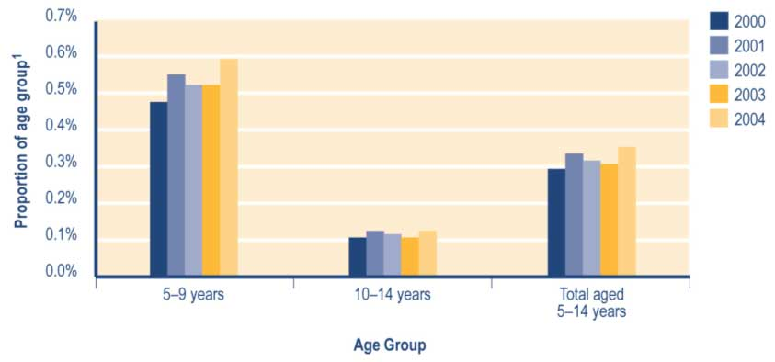
Note
1 Proportion shows:
a number of children in age group recorded in SWIFTT as being covered by an OSCAR Subsidy at 30 June, divided by
b Statistics New Zealand final estimate of the resident population in age group at 30 June.

See Table A3.18 (Appendix 3) for a summary of the SWIFTT data underlying Figure 4.5.

Trends in OSCAR Subsidies granted
The number of OSCAR Subsidies granted each year has fluctuated since 1999/2000 (see Table 4.14).

Of the OSCAR Subsidies granted each year since 2000/2001 (see Table 4.14):

• between 51% and 53% have covered children whose caregivers were receiving a carers’ benefit
• between 44% and 47% have covered children whose caregivers were receiving no core benefit or pension.

Table 4.14 Trends in the types of core benefit or pension paid to caregivers of children covered by OSCAR Subsidies granted

Types of core benefit or pension paid to caregivers when OSCAR Subsidy granted | OSCAR Subsidies granted¹
 | 1999/2000  Number | 2000/2001  Number | 2001/2002  Number | 2002/2003  Number | 2003/2004  Number
Unemployment-related benefits² | 92 | 100 | 61 | 43 | 60
Carers' benefits³ | 4,924 | 5,314 | 5,218 | 4,983 | 5,115
Sickness-related benefits⁴ | 39 | 38 | 1 | 19 | 25
Invalids' Benefit | 35 | 42 | 33 | 80 | 55
Widows' Benefit | 82 | 83 | 83 | 74 | 48
Unsupported Child's Benefit/Orphan's Benefit | 27 | 66 | 61 | 56 | 43
Transitional Retirement Benefit | 0 | 0 | 0 | 0 | 0
Emergency Benefit | 10 | 27 | 15 | 14 | 9
New Zealand Superannuation | 0 | 0 | 2 | 1 | 6
Veterans' Pension | 0 | 0 | 0 | 0 | 0
No core benefit or pension | 3,720 | 4,410 | 4,807 | 4,396 | 4,342
Total | 8,929 | 10,080 | 10,281 | 9,666 | 9,703

Notes
1 Numbers of successful applications for OSCAR Subsidies recorded in SWIFTT during years ended 30 June.
2 Includes Unemployment Benefits and Unemployment Benefits – Hardship paid to unemployed people and to trainees, and Independent Youth Benefits.
3 Includes Domestic Purposes Benefits – Sole Parents, Domestic Purposes Benefits – Caring for the Sick and Infirm, Domestic Purposes Benefits – Women Alone, and Emergency Maintenance Allowances.
4 Includes Sickness Benefits and Sickness Benefits – Hardship.

Since 2000/2001, around 74% of the OSCAR Subsidies granted each year have been provided because the child’s caregiver was in employment (see Table 4.15). The increase between 1999/2000 and 2000/2001 in the number of OSCAR Subsidies granted for this reason (see Table 4.15) partly reflects increased awareness that employed caregivers may be eligible to receive an OSCAR Subsidy.
Table 4.15 Trends in reasons for granting OSCAR Subsidies

Reason OSCAR Subsidies granted | OSCAR Subsidies granted¹
 | 1999/2000  Number | 2000/2001  Number | 2001/2002  Number | 2002/2003  Number | 2003/2004  Number
Caregiver in employment | 6,329 | 7,564 | 7,703 | 7,154 | 7,174
Caregiver in training or education | 2,600 | 2,516 | 2,578 | 2,512 | 2,529
Total | 8,929 | 10,080 | 10,281 | 9,666 | 9,703

Note
1 Numbers of successful applications for OSCAR Subsidies recorded in SWIFTT during years ended 30 June.

Trends in combined expenditure on Childcare Subsidies and OSCAR Subsidies
The decrease between 1993/1994 and 1994/1995 in combined annual expenditure on Childcare Subsidies and OSCAR Subsidies resulted from a policy change effective from 1 July 1993 that limited the Childcare Subsidy to nine hours per week for clients who were not in employment or training.

Increases since 1994/1995 in combined annual expenditure on Childcare Subsidies and OSCAR Subsidies (see Table 4.16) reflects:

• adjustment of Childcare Subsidy payments from 1 April 1996 based on the Consumers Price Index
• the introduction of the OSCAR Subsidy from 1 February 1999 (this increased the total number of children covered by childcare assistance paid by Work and Income, and hence increased combined expenditure on these subsidies)
• an increase from 1 July 2001 in the maximum number of hours per week for which subsidies may be paid (from 30 to 37 hours per week)
• a further increase from 1 July 2003 in the maximum number of hours per week for which subsidies may be paid (from 37 to 50 hours per week).

Table 4.16 Trends in combined annual expenditure on Childcare Subsidies and OSCAR Subsidies

Year ended 30 June | Expenditure on  Childcare Subsidy  and OSCAR Subsidy^{1,2,3}  ($million)
1991/1992 | 15
1992/1993 | 38
1993/1994 | 39
1994/1995 | 31
1995/1996 | 34
1996/1997 | 37
1997/1998 | 40
1998/1999 | 49
1999/2000 | 51
2000/2001 | 52
2001/2002 | 56
2002/2003 | 57
2003/2004 | 59

Notes
1 Expenditure on Childcare Subsidies and OSCAR Subsidies in years ended 30 June.
2 Expenditure shown is adjusted for the number of payments of Childcare Subsidies and OSCAR Subsidies made during the year and smoothed using a two-month moving average. Childcare Subsidies and OSCAR Subsidies are not subject to taxation.
3 Expenditure data in this table differs from, and should not be cited as, MSD’s official measure of expenditure on financial assistance provided to clients.

The strong seasonal pattern in combined monthly expenditure on Childcare Subsidies and OSCAR Subsidies (see Figure 4.6) reflects higher demand for this assistance during the school/academic year and a decrease in demand over the summer vacation period. As noted above, the underlying increases since 1994/1995 in combined monthly expenditure on Childcare Subsidies and OSCAR Subsidies reflect growth in:

• the number of children covered (eg with the introduction of OSCAR Subsidies in 1999)
• the hourly rate at which these subsidies are paid
• the maximum number of subsidised hours that are available.

Figure 4.6 Trends in combined monthly expenditure on Childcare Subsidies and OSCAR Subsidies

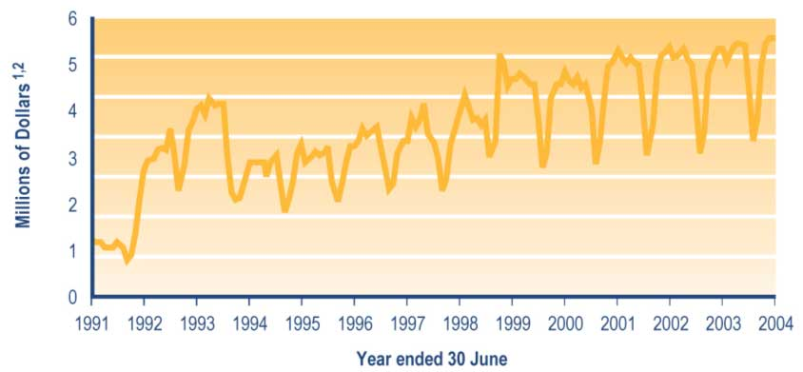
Notes
1 Expenditure is adjusted for the number of payments of Childcare Subsidies or OSCAR Subsidies made during the month and smoothed using a two-month moving average. The Childcare Subsidy and OSCAR Subsidy are not subject to taxation.
2 Expenditure data in this graph differs from, and should not be cited as, MSD’s official measure of expenditure on financial assistance provided to clients.

Disability Allowance

Please note that information reported below for the Disability Allowance combines information on the Disability Allowance, the Disability Allowance – Telephone Support, and the Disability Assistance Programme. Please note also that information on the Disability Allowance shows the number of people covered by Disability Allowances received or granted. This information may therefore differ from other published information that shows the number of clients receiving or granted a Disability Allowance that covers one or more people.

Eligibility for the Disability Allowance and related programmes

Disability Allowance
A Disability Allowance reimburses people for many types of actual and ongoing regular costs that they incur because they have a disability. In general, a Disability Allowance only covers costs that are not funded, subsidised or otherwise covered by other agencies. An income test also applies.

A Disability Allowance is available to people who have:

• a disability that:
– means they require ongoing help with normal living tasks or ongoing health care
– is likely to last at least six months
• extra ongoing costs directly related to their disability.

People receiving ACC support for extra costs related to their disability can receive a Disability Allowance for the proportion of those costs not met by ACC.

Disability Allowances – Telephone Support
A Disability Allowance – Telephone Support (also known as a Telephone Costs payment) provides a telephone subsidy to people who were in receipt of telephone subsidies as at
31 March 1999 but who would lose their entitlement to these subsidies if they were assessed under the Disability Allowance criteria effective from 1 April 1999.

Disability Assistance Programme
The Disability Assistance Programme provided assistance to people who were receiving New Zealand Superannuation or a Veterans’ Pension but who failed the income test for Disability Allowances due to the 1 April 2000 increase in the payment rates for New Zealand Superannuation and the Veterans’ Pension.

This programme preserved the entitlement of these people to assistance equivalent to a Disability Allowance. The programme ceased on 31 March 2001, due to income thresholds for the Disability Allowance being increased from 1 April 2001.

Trends in the number of people covered by a Disability Allowance
Please note that information in this section refers to the number of people covered by Disability Allowances received. This information may therefore differ from other published information concerning the number of clients receiving a Disability Allowance. This is because clients may be receiving Disability Allowance payments covering more than one person.

Increases since 2000 in the number of people covered by a Disability Allowance (see Table 4.17) reflect the ongoing nature of the costs faced by people covered by a Disability Allowance.

Of the people covered by a Disability Allowance since 2000 (see Table 4.17):

• around 47% have been receiving New Zealand Superannuation
• around 23% have been receiving an Invalids’ Benefit
• between 10% and 12% have been receiving a carers’ benefit.
Table 4.17 Trends in the types of core benefit or pension paid to clients covered by a Disability Allowance or paid to their caregivers

Type of core benefit or pension paid to the client or caregiver at 30 June | People covered by a Disability Allowance¹
 | 2000  Number | 2001  Number | 2002  Number | 2003  Number | 2004  Number
Unemployment-related benefits² | 7,812 | 7,280 | 6,786 | 6,403 | 5,131
Carers' benefits³ | 21,185 | 20,840 | 20,995 | 22,286 | 23,422
Sickness-related benefits⁴ | 14,953 | 15,744 | 16,936 | 19,057 | 21,725
Invalids' Benefit | 41,213 | 45,137 | 49,023 | 52,740 | 55,468
Widows' Benefit | 2,251 | 2,406 | 2,456 | 2,632 | 2,785
Unsupported Child's Benefit/Orphan's Benefit | 206 | 234 | 253 | 284 | 313
Transitional Retirement Benefit | 3,179 | 3,324 | 1,917 | 802 | 0
Emergency Benefit | 1,592 | 1,838 | 1,855 | 2,231 | 2,648
New Zealand Superannuation | 85,454 | 92,002 | 98,191 | 105,096 | 111,765
Veterans' Pension | 2,030 | 2,319 | 2,546 | 2,847 | 3,248
No core benefit or pension | 3,539 | 4,022 | 4,215 | 4,662 | 4,880
Total | 183,414 | 195,146 | 205,173 | 219,040 | 231,385

Notes
1 Numbers of clients recorded in SWIFTT as being covered by a Disability Allowance at 30 June.
2 Includes Unemployment Benefits and Unemployment Benefits – Hardship paid to unemployed people or to trainees, and Independent Youth Benefits.
3 Includes Domestic Purposes Benefits – Sole Parents, Domestic Purposes Benefits – Caring for the Sick and Infirm, Domestic Purposes Benefits – Women Alone, and Emergency Maintenance Allowances.
4 Includes Sickness Benefits and Sickness Benefits – Hardship.

Trends in the proportion of the New Zealand population covered by a Disability Allowance
Slight increases since 2000 in the proportion of the New Zealand population covered by a Disability Allowance (see Figure 4.7) reflect the long-term nature of many of the treatment-related costs faced by clients receiving a Disability Allowance. Since 2000, people aged 60 years or over have been significantly more likely than younger people to be covered by a Disability Allowance (see Figure 4.7), reflecting the health and medical impacts of the ageing of people aged 60 years or over.
Figure 4.7 Trends in the proportion of the New Zealand population covered by a Disability Allowance, by age

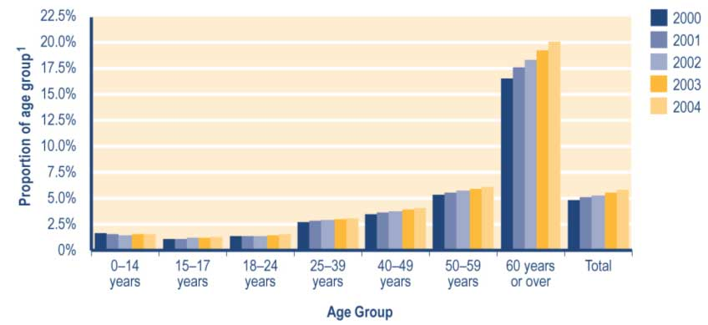

Note
1 Proportion shows:
a number of people in age group recorded in SWIFTT as being covered by a Disability Allowance at 30 June, divided by
b Statistics New Zealand final estimate of the resident population in age group at 30 June.

See Table A3.19 (Appendix 3) for a summary of the SWIFTT data underlying Figure 4.7.

Trends in Disability Allowances granted
Increases since 1999/2000 in the number of Disability Allowances granted each year (see Table 4.18) reflect increases in the number of clients receiving New Zealand Superannuation, a sickness-related benefit or an Invalids’ Benefit. Of the Disability Allowances granted each year since 1999/2000 (see Table 4.18):

• around 27% were provided to clients receiving New Zealand Superannuation
• around 13% were provided to clients receiving a carers’ benefit
• around 15% were provided to clients receiving an Invalids’ Benefit.

Over the same period, the proportion of Disability Allowances granted each year which were provided to people receiving a sickness-related benefit has increased (from 17% to 23%), while the proportion provided to people receiving unemployment-related benefits has decreased (from 15% to 9%) (see Table 4.18).
Table 4.18 Trends in the types of core benefit or pension paid to clients covered by Disability Allowances granted or paid to their caregivers

Type of core benefit or pension paid when Disability Allowance granted | Disability Allowances granted¹
 | 1999/2000  Number | 2000/2001  Number | 2001/2002  Number | 2002/2003  Number | 20032004  Number
Unemployment-related benefits² | 9,790 | 9,210 | 8,445 | 8,055 | 7,684
Carers' benefits³ | 9,325 | 9,237 | 9,385 | 10,965 | 12,029
Sickness-related benefits⁴ | 11,544 | 12,870 | 13,907 | 16,458 | 19,392
Invalids' Benefit | 10,433 | 10,844 | 11,351 | 12,046 | 12,203
Widows' Benefit | 690 | 835 | 781 | 997 | 1,133
Unsupported Child's Benefit/Orphan's Benefit | 97 | 110 | 111 | 125 | 149
Transitional Retirement Benefit | 1,842 | 1,911 | 1,564 | 1,285 | 496
Emergency Benefit | 995 | 1,195 | 1,160 | 1,280 | 1,569
New Zealand Superannuation | 18,537 | 19,387 | 20,199 | 21,909 | 22,265
Veterans' Pension | 483 | 624 | 617 | 729 | 843
No core benefit or pension | 3,683 | 4,474 | 4,624 | 5,312 | 5,934
Total | 67,419 | 70,697 | 72,144 | 79,161 | 83,697

Notes
1 Numbers of successful applications for Disability Allowances recorded in SWIFTT during years ended 30 June.
2 Includes Unemployment Benefits and Unemployment Benefits – Hardship paid to unemployed people or to trainees, and Independent Youth Benefits.
3 Includes Domestic Purposes Benefits – Sole Parents, Domestic Purposes Benefits – Caring for the Sick and Infirm, Domestic Purposes Benefits – Women Alone, and Emergency Maintenance Allowances.
4 Includes Sickness Benefits and Sickness Benefits – Hardship.

Trends in expenditure on Disability Allowances
Increases in annual expenditure on Disability Allowances since 1991/1992 (see Table 4.19) largely reflect increases in the numbers receiving a Disability Allowance.

Table 4.19 Trends in annual expenditure on Disability Allowances

Year ended 30 June | Expenditure on  Disability Allowances^{1,2,3}  ($million)
1991/1992 | 66
1992/1993 | 86
1993/1994 | 113
1994/1995 | 128
1995/1996 | 146
1996/1997 | 175
1997/1998 | 195
1998/1999 | 201
1999/2000 | 203
2000/2001 | 217
2001/2002 | 231
2002/2003 | 247
2003/2004 | 261

Notes
1 Expenditure on Disability Allowances in years ended 30 June.
2 Expenditure shown is adjusted for the number of payments of Disability Allowance made during the year and smoothed using a two-month moving average. Disability Allowances are not subject to taxation.
3 Expenditure data in this table differs from, and should not be cited as, MSD’s official measure of expenditure on financial assistance provided to clients.

Monthly expenditure on Disability Allowances shows no marked seasonal changes (see Figure 4.8). The slower increase of expenditure on Disability Allowances in 1994/1995 was due to revision (effective from 1 July 1994) of the definition of valid reasons for receiving a Disability Allowance.

Figure 4.8 Trends in monthly expenditure on Disability Allowances

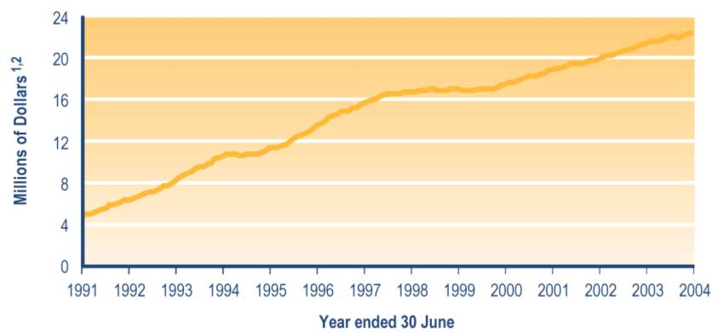

Notes
1 Expenditure is adjusted for the number of payments of Disability Allowances made during the month and smoothed using a two-month moving average. Disability Allowances are not subject to taxation.
2 Expenditure data in this graph differs from, and should not be cited as, MSD’s official measure of expenditure on financial assistance provided to clients.

Child Disability Allowance

A Child Disability Allowance is a fortnightly payment that can be made to the parent or guardian of a child with a physical or mental disability who requires constant care and attention because of that disability.

To be eligible for a Child Disability Allowance, the caregiver must be:

• a New Zealand citizen or permanent resident of New Zealand
• ordinarily resident in New Zealand.

In addition, the child covered by a Child Disability Allowance must be a dependent child of the carer receiving the Allowance and must also be ordinarily resident in New Zealand.

The Allowance is not means tested.

Since 2000, between 18% and 20% of children covered by a Child Disability Allowance have also been covered by a Disability Allowance. The Disability Allowances are paid to reimburse the direct costs arising from the child’s disability.

Trends in the number of children covered by a Child Disability Allowance
Please note that information in this section shows the number of children covered by Child Disability Allowances received. This information may therefore differ from other published information showing the number of clients receiving a Child Disability Allowance that covers one or more children.

Increases since 2000 in the number of children covered by a Child Disability Allowance (see Table 4.20) reflect the long-term nature of the medical or other conditions faced by children eligible for a Child Disability Allowance. Of the children covered by a Child Disability Allowance since 2000, between 57% and 60% have had caregivers who were not receiving any core benefit or pension (see Table 4.20).

Since 2000, the proportion of children covered by a Child Disability Allowance who had caregivers receiving a carers’ benefit has increased from 27% to 32% (see Table 4.20).

Table 4.20 Trends in the types of core benefit or pension paid to caregivers of children covered by a Child Disability Allowance

Type of core benefit or pension received at 30 June | Children covered by a Child Disability Allowance¹
 | 2000  Number | 2001  Number | 2002  Number | 2003  Number | 2004  Number
Unemployment-related benefits² | 1,253 | 1,056 | 974 | 905 | 712
Carers' benefits³ | 5,587 | 6,098 | 6,865 | 8,344 | 9,940
Sickness-related benefits⁴ | 438 | 398 | 474 | 632 | 769
Invalids' Benefit | 721 | 857 | 1,059 | 1,352 | 1,606
Widows' Benefit | 121 | 118 | 124 | 156 | 161
Unsupported Child's Benefit/Orphan's Benefit | 0 | 0 | 0 | 0 | 0
Transitional Retirement Benefit | 13 | 21 | 22 | 2 | 0
Emergency Benefit | 176 | 185 | 149 | 193 | 227
New Zealand Superannuation | 106 | 101 | 99 | 129 | 144
Veterans' Pension | 2 | 2 | 4 | 5 | 3
No core benefit or pension | 12,447 | 12,888 | 13,978 | 15,624 | 17,909
Total | 20,864 | 21,724 | 23,748 | 27,342 | 31,471

Notes
1 Numbers of children recorded in SWIFTT as being covered by a Child Disability Allowance at 30 June.
2 Includes Unemployment Benefits and Unemployment Benefits – Hardship paid to unemployed people and to trainees, and Independent Youth Benefits.
3 Includes Domestic Purposes Benefits – Sole Parents, Domestic Purposes Benefits – Caring for the Sick and Infirm, Domestic Purposes Benefits – Women Alone, and Emergency Maintenance Allowances.
4 Includes Sickness Benefits and Sickness Benefits – Hardship.

Trends in the proportion of children aged under 18 years covered by a Child Disability Allowance
Increases since 2000 in the proportion of children aged under 18 years who are covered by a Child Disability Allowance (see Figure 4.9) reflect the long-term nature of the conditions that children eligible for a Child Disability Allowance have.
Figure 4.9 Trends in the proportion of children aged under 18 years covered by a Child Disability Allowance, by age

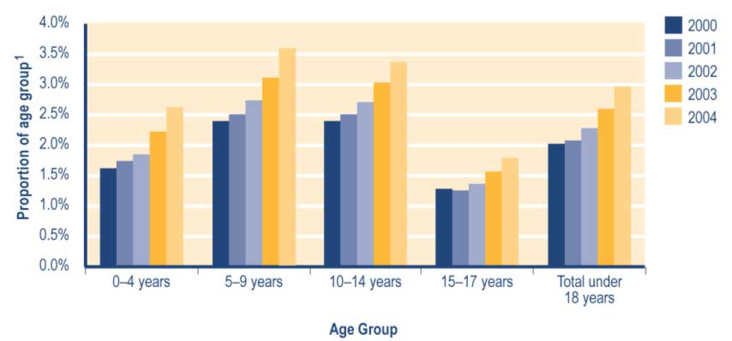
Note
1 Proportion shows:
a number of children in age group recorded in SWIFTT as being covered by a Child Disability Allowance at 30 June, divided by
b Statistics New Zealand final estimate of the resident population in age group at 30 June.

See Table A3.20 (Appendix 3) for a summary of the SWIFTT data underlying Figure 4.9.

Trends in Child Disability Allowances granted
The number of Child Disability Allowances granted each year has increased since 1999/2000 (see Table 4.21). Since 1999/2000, the proportion of children covered by Child Disability Allowances granted each year who had caregivers receiving carers’ benefits has increased (from 31% to 40%), while the proportion with caregivers who were not receiving any core benefit has decreased (from 50% to 45%) (see Table 4.21).

Table 4.21 Trends in the types of core benefit or pension paid to caregivers of children covered by Child Disability Allowances granted

Type of core benefit or pension received when Child Disability Allowance granted | Child Disability Allowances granted¹
 | 1999/2000  Number | 2000/2001  Number | 2001/2002  Number | 2002/2003  Number | 20032004  Number
Unemployment-related benefits² | 400 | 463 | 389 | 482 | 386
Carers' benefits³ | 1,465 | 2,049 | 2,222 | 3,011 | 3,512
Sickness-related benefits⁴ | 154 | 172 | 219 | 274 | 275
Invalids' Benefit | 185 | 234 | 276 | 381 | 435
Widows' Benefit | 22 | 48 | 26 | 49 | 46
Unsupported Child's Benefit/Orphan's Benefit | 60 | 58 | 73 | 89 | 98
Transitional Retirement Benefit | 5 | 2 | 8 | 3 | 0
Emergency Benefit | 56 | 62 | 69 | 72 | 88
New Zealand Superannuation | 23 | 28 | 18 | 41 | 40
Veterans' Pension | 0 | 0 | 1 | 2 | 2
No core benefit or pension | 2,373 | 3,089 | 3,040 | 3,418 | 3,996
Total | 4,743 | 6,205 | 6,341 | 7,822 | 8,878
Notes
1 Numbers of successful applications for Child Disability Allowances recorded in SWIFTT during years ended 30 June.
2 Includes Unemployment Benefits and Unemployment Benefits – Hardship paid to unemployed people and to trainees, and Independent Youth Benefits.
3 Includes Domestic Purposes Benefits – Sole Parent, Domestic Purposes Benefits – Caring for the Sick and Infirm, Domestic Purposes Benefits – Women Alone, and Emergency Maintenance Allowances.
4 Includes Sickness Benefits and Sickness Benefits – Hardship.

Trends in expenditure on Child Disability Allowances
Increases since 1991/1992 in annual expenditure on Child Disability Allowances (see Table 4.22) largely reflect increases in the number of children covered by a Child Disability Allowance.

Table 4.22 Trends in annual expenditure on Child Disability Allowances

Year ended 30 June | Expenditure on  Child Disability  Allowances^{1,2,3}  ($million)
1991/1992 | 13
1992/1993 | 15
1993/1994 | 17
1994/1995 | 18
1995/1996 | 21
1996/1997 | 25
1997/1998 | 28
1998/1999 | 32
1999/2000 | 35
2000/2001 | 39
2001/2002 | 41
2002/2003 | 47
2003/2004 | 56
Notes
1 Expenditure on Child Disability Allowances in years ended 30 June.
2 Expenditure shown is adjusted for the number of payments of Child Disability Allowances made during the year and smoothed using a two-month moving average. Child Disability Allowances are not subject to taxation.
3 Expenditure data in this table differs from, and should not be cited as, MSD’s official measure of expenditure on financial assistance provided to clients.

Little seasonal variation is evident in monthly expenditure on Child Disability Allowances (see Figure 4.10). A short halt to the increases in monthly expenditure on Child Disability Allowances during late 2000/2001 and early 2001/2002 arose from a review of overdue medical reviews, which led to a temporary fall in the number of Child Disability Allowance recipients.

Figure 4.10 Trends in monthly expenditure on Child Disability Allowances

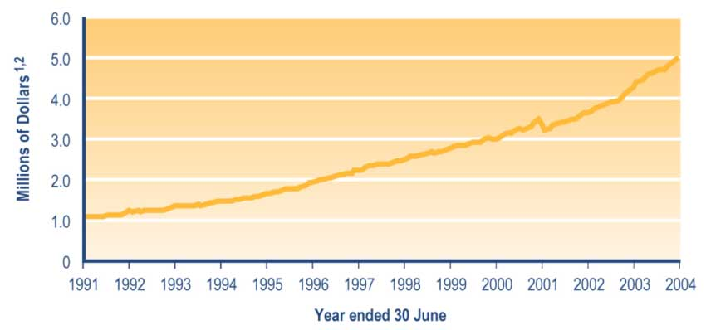

Notes
1 Expenditure is adjusted for the number of payments of Child Disability Allowances made during the month and smoothed using a two-month moving average. Child Disability Allowances are not subject to taxation.
2 Expenditure data in this graph differs from, and should not be cited as, MSD’s official measure of expenditure on financial assistance provided to clients.

Training Incentive Allowance

A Training Incentive Allowance aims to assist people undertaking training or studies that will:

• develop their skills
• improve their prospects of gaining sustainable paid employment.

A Training Incentive Allowance is available to people who are receiving a carers’ benefit, a Widows’ Benefit or an Invalids’ Benefit.

A Training Incentive Allowance contributes toward fees, course costs and associated costs (eg transport, childcare) faced by trainees and students. A Training Incentive Allowance may be paid as a lump sum, as an ongoing entitlement, or as a combination of the two.

A number of policy changes were made in the 1998/1999 fiscal year with the intention of targeting expenditure to ensure the greatest benefits for Training Incentive Allowance recipients. These changes included:

• tightening objectives of providing a Training Incentive Allowance, particularly a greater focus on training for paid employment
• introducing co-payment for fees and course costs
• excluding people who had completed a degree in the previous five years
• excluding Training Opportunities programmes and Work and Income courses
• excluding private training establishment courses outside the NZQA accreditation framework.

In the 1999/2000 fiscal year, Training Incentive Allowances were restored to their former level for people undertaking courses subject to the co-payment regime. Other policy changes in 1999/2000 were:

• adjusting the maximum amount of the Training Incentive Allowance on 1 April each year to reflect the change in the cost of living over the previous 12 months
• permitting consideration of granting a Training Incentive Allowance to people who have completed a degree in the previous five years when they intend to undertake employment-related courses that are less than 12 weeks long.

Personal Development and Employment Plans were introduced on 10 March 2003 for people receiving a Domestic Purposes Benefit or Widows’ Benefit. Training Incentive Allowances are used to fund education and training consistent with the goals of individual plans.

Please note that information provided in this section on Training Incentive Allowances granted includes ongoing Training Incentive Allowance payments only, while expenditure information includes both ongoing and lump sum payments.

Trends in the number of ongoing Training Incentive Allowances granted
Clients may commence and cease receiving an ongoing Training Incentive Allowance at any point during the year, as their courses begin and end. Ongoing Training Incentive Allowances granted therefore offer a more complete view of use of this assistance than the numbers of people who are receiving an ongoing Training Incentive Allowance at any one point in time.

Fluctuations since 1999/2000 in the number of ongoing Training Incentive Allowances granted each year (see Table 4.23) reflect the impact of the policy changes outlined above as well as the impact of changes in numbers receiving carers’ benefits, Invalids’ Benefits and Widows’ Benefits. Since 1999/2000, between 87% and 89% of ongoing Training Incentive Allowances granted each year have been provided to clients receiving a carers’ benefit (see Table 4.23).

Table 4.23 Trends in the types of core benefit paid to clients granted an ongoing Training Incentive Allowance

Type of core benefit paid when ongoing Training Incentive Allowance granted | Ongoing Training Incentive Allowances granted¹
 | 1999/2000  Number | 2000/2001  Number | 2001/2002  Number | 2002/2003  Number | 2003/2004  Number
Carers' benefits² | 18,839 | 19,078 | 18,478 | 18,250 | 19,926
Invalids' Benefit | 2,068 | 2,238 | 2,431 | 2,463 | 2,631
Widows' Benefit | 388 | 398 | 362 | 331 | 401
Other core benefits | 32 | 12 | 18 | 14 | 5
Total | 21,327 | 21,726 | 21,289 | 21,058 | 22,963

Notes
1 Numbers of successful applications for an ongoing Training Incentive Allowance recorded in SWIFTT during years ended 30 June.
2 Includes Domestic Purposes Benefits – Sole Parents, Domestic Purposes Benefits – Caring for the Sick and Infirm, Domestic Purposes Benefits – Women Alone, and Emergency Maintenance Allowances.

Trends in expenditure on Training Incentive Allowances
Please note that information below on expenditure on Training Incentive Allowances includes expenditure on one-off Training Incentive Allowances (eg those provided to assist with course fees) as well as ongoing Training Incentive Allowances.

Increases since 1998/1999 in annual expenditure on Training Incentive Allowances (see Table 4.24) reflect in part the impact of the successive policy changes referred to above.

Table 4.24 Trends in annual expenditure on Training Incentive Allowances

Year ended 30 June | Expenditure on  Training Incentive  Allowances^{1,2}  ($million)
1991/1992 | 9
1992/1993 | 13
1993/1994 | 17
1994/1995 | 21
1995/1996 | 27
1996/1997 | 29
1997/1998 | 34
1998/1999 | 30
1999/2000 | 35
2000/2001 | 36
2001/2002 | 36
2002/2003 | 37
2003/2004 | 42

Notes
1 Expenditure on Training Incentive Allowances in years ended 30 June.
2 Expenditure data shown has not been smoothed. Training Incentive Allowances are not subject to taxation.

The strong seasonal pattern evident in expenditure on Training Incentive Allowances (see Figure 4.11) arises because most Training Incentive Allowance expenditure arises from one-off payments made at the beginning of the school/academic year to cover tuition fees and similar costs.

Figure 4.11 Trends in monthly expenditure on Training Incentive Allowances

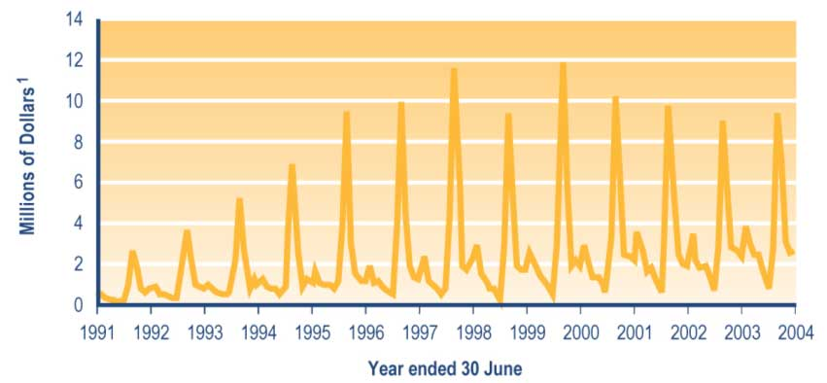
Note
1 Expenditure on Training Incentive Allowances has not been smoothed. Training Incentive Allowances are not subject to taxation.

Residential Care Subsidy and Residential Support Subsidy

These subsidies are used as a means by which clients contribute to the cost of residential care or support when they have been assessed as requiring long-term residential care or support but are unable to pay for the full cost of their care.

MSD’s Work and Income service line is responsible for income testing and asset testing clients who require long-term residential care or support, and for assessing whether the client can pay for or contribute towards the cost of their care. Client and benefit contributions to the cost of residential care or residential support are paid to the provider of those services. The Ministry of Health’s contribution (if any) to the costs of residential care and residential support required by clients is also paid to service providers.

When a client in residential care is receiving a core benefit or a pension, they may be required to contribute their core benefit or pension (less a personal allowance) toward the cost of their care.

Eligibility to receive a Residential Care Subsidy or Residential Support Subsidy

Residential Care Subsidy
A Residential Care Subsidy is a contribution to the cost of their residential care made by people who require residential care disability services indefinitely and are:

• aged 65 years or over, or
• aged 50–64 years, single with no dependent children, and assessed by the Ministry of Health as being “close in interest” to people aged over 65 years.

Residential Support Subsidy
A Residential Support Subsidy is a contribution to the cost of their residential support made by people who are:

• aged under 65 years
• assessed as having a need for support due to physical disability, intellectual disability or psychiatric disability (including drug and alcohol rehabilitation).

To be entitled to have a Residential Support Subsidy paid toward the cost of their residential support, the client must have been assessed as needing support provided by a residential care facility that has been contracted by the Ministry of Health.

Trends in the number of clients receiving a Residential Care Subsidy or Residential Support Subsidy
The number of clients receiving a Residential Care Subsidy or Residential Support Subsidy has fluctuated since 2000 (see Table 4.25). Since 2000, around 63% of clients receiving a Residential Care Subsidy or Residential Support Subsidy have been receiving New Zealand Superannuation and around 32% have been receiving an Invalids’ Benefit (see Table 4.25).

Table 4.25 Trends in the types of core benefit or pension paid to clients receiving a Residential Care Subsidy or Residential Support Subsidy

Type of core benefit or pension paid at 30 June | Clients receiving a Residential Care Subsidy or Residential Support Subsidy¹
 | 2000  Number | 2001  Number | 2002  Number | 2003  Number | 2004  Number
Unemployment-related benefits² | 15 | 9 | 19 | 12 | 19
Carers' benefits³ | 21 | 29 | 24 | 17 | 13
Sickness-related benefits⁴ | 657 | 665 | 640 | 622 | 536
Invalids' Benefit | 7,286 | 7,355 | 7,403 | 7,513 | 7,531
Widows' Benefit | 17 | 14 | 13 | 13 | 13
Transitional Retirement Benefit | 50 | 50 | 20 | 10 | 0
Emergency Benefit | 94 | 127 | 112 | 139 | 165
New Zealand Superannuation | 14,737 | 14,739 | 14,386 | 14,406 | 14,361
Veterans' Pension | 288 | 291 | 276 | 281 | 304
No core benefit or pension | 35 | 40 | 45 | 50 | 51
Total | 23,200 | 23,319 | 22,938 | 23,063 | 22,993

Notes
1 Numbers of clients recorded in SWIFTT as receiving a Residential Support Subsidy or Residential Care Subsidy at 30 June.
2 Includes Unemployment Benefits and Unemployment Benefits – Hardship paid to unemployed people and to trainees, and Independent Youth Benefits.
3 Includes Domestic Purposes Benefits – Sole Parents, Domestic Purposes Benefits – Caring for the Sick and Infirm, Domestic Purposes Benefits – Women Alone, and Emergency Maintenance Allowances.
4 Includes Sickness Benefits and Sickness Benefits – Hardship.

Trends in the proportion of people aged 65 years or over receiving a Residential Care Subsidy
Since 2000, around 3% of people aged 65 years or over have been receiving a Residential Care Subsidy (see Figure 4.12). Over this period, the proportion of people in each age group receiving a Residential Care Subsidy has increased with the increasing age of the clients (see Figure 4.12).

Figure 4.12 Trends in the proportion of people aged 65 years or over receiving a Residential Care Subsidy, by age

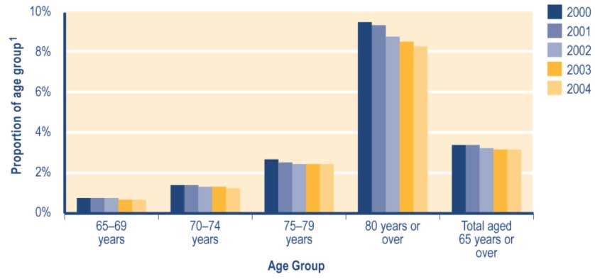

Note
1 Proportion shows:
a number of clients in age group recorded in SWIFTT as receiving a Residential Care Subsidy at 30 June, divided by
b Statistics New Zealand final estimate of the resident population in age group at 30 June.

See Table A3.21 (Appendix 3) for a summary of the SWIFTT data underlying Figure 4.12.

Trends in Residential Care Subsidies and Residential Support Subsidies granted
Since 1999/2000, the number of Residential Care Subsidies and Residential Support Subsidies granted each year has fluctuated around a downward trend (see Table 4.26).
Of the Residential Care Subsidies and Residential Support Subsidies granted each year since 2000/2001 (see Table 4.26):

• between 54% and 56% have involved clients receiving New Zealand Superannuation
• between 18% and 20% have involved clients receiving an Invalids’ Benefit
• between 20% and 22% have involved clients receiving a sickness-related benefit.

Table 4.26 Trends in the types of core benefit or pension paid to clients granted a Residential Care Subsidy or a Residential Support Subsidy

Types of core benefit or pension paid when Residential Care Subsidy or Residential Support Subsidy granted | Residential Care Subsidies and Residential Support Subsidies granted¹
 | 1999/2000  Number | 2000/2001 | 2001/2002  Number | 2002/2003  Number | 2003/2004  Number
Unemployment-related benefits² | 20 | 14 | 43 | 40 | 33
Carers' benefits³ | 130 | 136 | 136 | 125 | 81
Sickness-related benefits⁴ | 2,069 | 1,947 | 1,937 | 1,878 | 1,750
Invalids' Benefit | 2,304 | 1,716 | 1,612 | 1,820 | 1,703
Widows' Benefit | 9 | 6 | 6 | 5 | 11
Transitional Retirement Benefit | 29 | 28 | 11 | 3 | 2
Emergency Benefit | 82 | 102 | 63 | 79 | 92
New Zealand Superannuation | 5,560 | 5,010 | 4,792 | 5,104 | 4,922
Veterans' Pension | 127 | 119 | 124 | 126 | 140
No core benefit or pension | 14 | 19 | 18 | 21 | 23
Total | 10,344 | 9,097 | 8,742 | 9,201 | 8,757

Notes
1 Number of successful applications for Residential Care Subsidies or Residential Support Subsidies recorded in SWIFTT during years ended 30 June.
2 Includes Unemployment Benefits and Unemployment Benefits – Hardship paid to unemployed people or to trainees, and Independent Youth Benefits.
3 Includes Domestic Purposes Benefits – Sole Parents, Domestic Purposes Benefits – Caring for the Sick and Infirm, Domestic Purposes Benefits – Women Alone, and Emergency Maintenance Allowances.
4 Includes Sickness Benefits and Sickness Benefits – Hardship.

Hardship assistance

This consists of:

• Special Benefit
• hardship assistance paid as lump sums.

Special Benefit
A Special Benefit may be paid to people receiving core benefits or other low-income earners.

To receive a Special Benefit, clients must have:

• a deficiency between their ongoing income and their costs
• individual circumstances that warrant receiving a Special Benefit.

Trends in the number of clients receiving a Special Benefit
The number of people receiving a Special Benefit has increased since 2000, with significant increases over each of the last two years (see Table 4.27). This reflects:

• a range of initiatives aimed at ensuring that case managers and clients are aware of the availability of, and the eligibility criteria for, a Special Benefit (these initiatives include training, information dissemination and enhanced case management for clients receiving a Domestic Purposes Benefit or Widows’ Benefit)
• an increase in the number of people assessed as being in financial hardship.

Since 2000, the proportion of Special Benefit recipients who were receiving a carers’ benefit has increased (from 36% to 50%) (see Table 4.27). Over the same period, the proportion of Special Benefit recipients who are receiving unemployment-related benefits has decreased (from 14% to 9%), and the proportion receiving Invalids’ Benefits has decreased (from 26% to 18%) (see Table 4.27).

Table 4.27 Trends in the types of core benefit or pension paid to clients receiving a Special Benefit

Type of core benefit or pension paid at 30 June | Clients receiving a Special Benefit¹
 | 2000  Number | 2001  Number | 2002  Number | 2003  Number | 2004  Number
Unemployment-related benefits² | 1,539 | 1,847 | 1,993 | 4,046 | 4,514
Carers' benefits³ | 3,893 | 4,944 | 6,563 | 16,632 | 25,552
Sickness-related benefits⁴ | 1,323 | 1,565 | 1,992 | 4,279 | 6,536
Invalids' Benefit | 2,822 | 3,238 | 3,993 | 6,572 | 9,280
Widows' Benefit | 185 | 189 | 230 | 479 | 741
Unsupported Child's Benefit/Orphan's Benefit | 0 | 1 | 0 | 0 | 2
Transitional Retirement Benefit | 54 | 47 | 42 | 31 | 0
Emergency Benefit | 225 | 224 | 197 | 573 | 833
New Zealand Superannuation | 190 | 199 | 259 | 537 | 794
Veterans' Pension | 1 | 4 | 6 | 3 | 2
No core benefit or pension | 486 | 789 | 951 | 2,228 | 3,197
Total | 10,718 | 13,047 | 16,226 | 35,380 | 51,451

Notes
1 Numbers of clients recorded in SWIFTT as receiving a Special Benefit at 30 June.
2 Includes Unemployment Benefits and Unemployment Benefits – Hardship paid to unemployed people and to trainees, and Independent Youth Benefits.
3 Includes Domestic Purposes Benefits – Sole Parents, Domestic Purposes Benefits – Caring for the Sick and Infirm, Domestic Purposes Benefits – Women Alone, and Emergency Maintenance Allowances.
4 Includes Sickness Benefits and Sickness Benefits – Hardship.

Trends in the proportion of people aged 18 years or over receiving a Special Benefit
A sharp increase over the last two years in the proportion of people aged 18 years or over who are receiving a Special Benefit (see Figure 4.13) reflects the Work and Income initiatives and increased numbers of people assessed as in financial hardship outlined above. Since 2000, people aged 25–49 years have been more likely to be receiving a Special Benefit than people aged 18–24 years or people aged 50 years or over (see Figure 4.13).

Figure 4.13 Trends in the proportion of people aged 18 years or over receiving a Special Benefit, by age

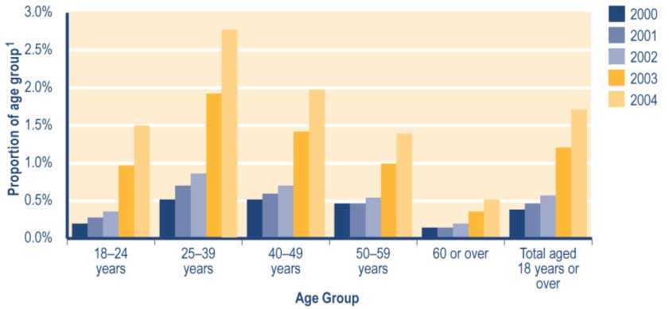

Note
1 Proportion shows:
a number of people in each age group recorded in SWIFTT as receiving a Special Benefit at 30 June, divided by
b Statistics New Zealand final estimate of the resident population in age group at 30 June.

See Table A3.22 (Appendix 3) for a summary of the SWIFTT data underlying Figure 4.13.

Trends in Special Benefits granted
The number of Special Benefits granted each year has increased since 1999/2000, with a particularly sharp increase occurring over the last two years (see Table 4.28). Of the Special Benefits granted in each year since 1999/2000, between 15% and 18% were provided to recipients of sickness-related benefits, while between 10% and 14% were provided to Invalids’ Benefit recipients.

Since 1999/2000, the proportion of Special Benefits granted each year that were provided
to recipients of carers’ benefits has increased (from 31% to 41%), while the proportion granted to people receiving unemployment-related benefits has decreased (from 27% to 19%) (see Table 4.28).

Table 4.28 Trends in the types of core benefit or pension paid to clients granted a Special Benefit

Type of core benefit or pension paid when Special Benefit granted | Special Benefits granted¹
 | 1999/2000  Number | 2000/2001  Number | 2001/2002  Number | 2002/2003  Number | 2003/2004  Number
Unemployment-related benefits² | 3,820 | 5,547 | 5,953 | 10,275 | 13,721
Carers' benefits³ | 4,365 | 6,834 | 8,307 | 21,913 | 29,521
Sickness-related benefits⁴ | 2,492 | 3,468 | 4,225 | 8,113 | 11,668
Invalids' Benefit | 1,927 | 2,781 | 3,056 | 5,811 | 7,238
Widows' Benefit | 158 | 250 | 260 | 626 | 785
Unsupported Child's Benefit/Orphan's Benefit | 1 | 4 | 0 | 1 | 6
Transitional Retirement Benefit | 52 | 71 | 58 | 66 | 36
Emergency Benefit | 277 | 413 | 393 | 865 | 1,309
New Zealand Superannuation | 162 | 197 | 222 | 609 | 750
Veterans' Pension | 1 | 7 | 6 | 5 | 4
No core benefit or pension | 1,011 | 1,749 | 2,282 | 4,696 | 7,273
Total | 14,266 | 21,321 | 24,762 | 52,980 | 72,311

Notes
1 Numbers of successful applications for Special Benefits recorded in SWIFTT during years ended 30 June.
2 Includes Unemployment Benefits and Unemployment Benefits – Hardship paid to unemployed people and to trainees, and Independent Youth Benefits.
3 Includes Domestic Purposes Benefits – Sole Parents, Domestic Purposes Benefits – Caring for the Sick and Infirm, Domestic Purposes Benefits – Women Alone, and Emergency Maintenance Allowances.
4 Includes Sickness Benefits and Sickness Benefits – Hardship.

Trends in expenditure on Special Benefits
Increases since 1999/2000 in annual expenditure on Special Benefits (see Table 4.29) reflect changes in the numbers of people receiving a Special Benefit.

Table 4.29 Trends in annual expenditure on Special Benefits

Year ended 30 June | Expenditure on  Special Benefits^{1,2,3}  ($million)
1991/1992 | 53
1992/1993 | 62
1993/1994 | 67
1994/1995 | 80
1995/1996 | 87
1996/1997 | 74
1997/1998 | 59
1998/1999 | 44
1999/2000 | 34
2000/2001 | 39
2001/2002 | 48
2002/2003 | 79
2003/2004 | 137

Notes
1 Expenditure on Special Benefits in years ended 30 June.
2 Expenditure shown is adjusted for the number of payments of Special Benefits made during the month and smoothed using a two-month moving average. Special Benefits are not subject to taxation.
3 Expenditure data in this table differs from, and should not be cited as, MSD’s official measure of expenditure on financial assistance provided to clients.

Monthly expenditure on Special Benefits shows little seasonal variation and tends to follow patterns in the numbers of people receiving a Special Benefit (see Figure 4.14). In addition, the spike in expenditure on Special Benefits around 1995 (see Figure 4.14) reflects:

• the April 1995 increase in the average rate of Special Benefits
• the July 1995 transfer to Vote: Health of “maximised” Special Benefits, to cover institutional boarding costs.

Figure 4.14 Trends in monthly expenditure on Special Benefits

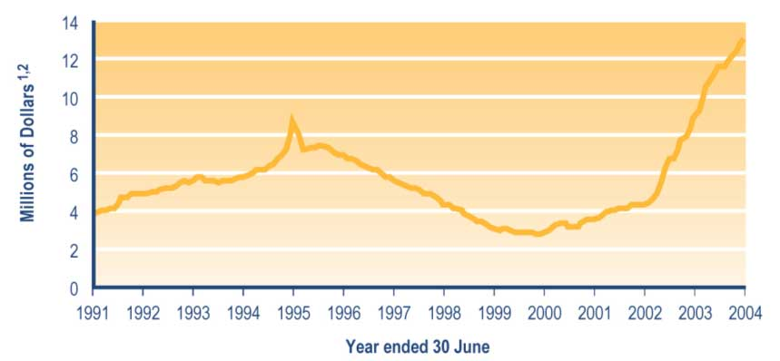

Notes
1 Expenditure is adjusted for the number of Special Benefit payments made during the month and smoothed using a two-month moving average. Special Benefits are not subject to taxation.
2 Expenditure data in this graph differs from, and should not be cited as, MSD’s official measure of expenditure on financial assistance provided to clients.

Hardship assistance available as lump sums
The hardship assistance available as lump sums consists of:

• Special Needs Grants
• Recoverable Assistance Programme payments
• benefit advances.

Eligibility for lump sum hardship assistance

Special Needs Grants
Special Needs Grants are one-off payments made to those who have an immediate need or an emergency need and have no other way of paying to meet that need. Most Special
Needs Grants are non-recoverable. Recoverable Special Needs Grants have to be repaid to Work and Income.

Special Needs Grants are available both to people who are not receiving core benefits and to people who are. Residency, income and cash asset tests apply.

As well as lump sums to meet a range of specific expenses, Special Needs Grants include re-establishment grants targeted at particular groups of clients. Clients who may be eligible for re-establishment grants include:

• released prisoners
• refugees
• sole parents who have been victims of domestic violence.

Recoverable Assistance Programme payments
The Recoverable Assistance Programme was introduced on 1 July 1996 to provide recoverable assistance to low-income earners not receiving core benefits. Any low-income earner may apply for assistance with immediate and essential expenses under the Recoverable Assistance Programme.

The Recoverable Assistance Programme provides non-taxable, interest-free recoverable financial assistance to non-beneficiaries, to enable them to meet essential immediate needs for specific items or services. Under this programme, clients may have access to Recoverable Assistance payments up to a maximum value of six weeks’ worth of an Invalids’ Benefit.

In approving a payment under the Recoverable Assistance Programme, Work and Income staff must:

• consider whether a Recoverable Assistance payment would best meet the immediate need
• investigate other sources of assistance
• investigate the client’s ability to repay the Recoverable Assistance payment.

In order to receive Recoverable Assistance payments, clients must:

• meet income and cash asset tests
• be able to identify a particular immediate need for an essential item or service
• meet residency requirements.

Income and asset limits for qualification for a Recoverable Assistance payment, and the maximum amounts available, vary according to the age and circumstances of the applicant (see Table 4.30). In exceptional circumstances, clients may be granted a Recoverable Assistance payment if their cash assets exceed the limit shown in Table 4.30.

Table 4.30 Income limits, cash asset limits and maximum payments for the Recoverable Assistance Programme (applicable from 1 April 2004)

Client category | Cash Asset Limit¹ | Income Limit^{1,2} | Maximum payment¹
Single person | $820.72 | $431 per week/$22,374 per year | $1,231.08
Married couple with or without children | $1,376.92 | $626 per week $32,536 per year | $2,051.88
Sole parent | $1,376.92 | $551 per week/$28,634 per year | $1,736.70
Notes
1 Asset limits, income limits and maximum payments applicable from 1 April 2004.
2 Income limits shown are gross of income tax.

The Recoverable Assistance Programme was designed to replace most recoverable Special Needs Grants, which had previously been available to people who were not receiving benefits.

Benefit advances
Advance payments of core benefits are made to enable people receiving a core benefit to meet one-off immediate and essential needs that the client cannot meet from their regular income. The advance is recovered from subsequent payments of the core benefit or through ongoing repayments if the client ceases to receive a benefit.

Since 9 October 1995, benefit advances of up to six weeks’ worth of the core benefit received have been available to everyone receiving a core benefit. At the same date, most recoverable Special Needs Grants provided to people receiving a core benefit were reclassified as benefit advances.

Trends in the use of lump sum hardship assistance
The annual number of payments of lump sum emergency or hardship assistance has increased since 1999/2000 (see Table 4.31). Increases are evident for both recoverable hardship assistance and non-recoverable hardship assistance.

Of the hardship assistance payments provided each year since 1999/2000 (see Table 4.31):

• between 51% and 55% have been non-recoverable Special Needs Grants
• between 42% and 44% have been benefit advances, which are recoverable.

Since 1999/2000, the number of payments made under the Recoverable Assistance Programme has increased steadily, more than doubling over this period (see Table 4.31).

Table 4.31 Trends in types of lump sum hardship assistance payments

Type of lump sum hardship assistance | Lump sum hardship payments¹
 | 1999/2000  Number | 2000/2001  Number | 2001/2002  Number | 2002/2003  Number | 2003/2004  Number
Non recoverable lump sum hardship assistance
Special Needs Grants  (non-recoverable) | 346,612 | 369,229 | 379,890 | 387,791 | 395,746
Recoverable lump sum hardship assistance
Special Needs Grants  (recoverable) | 14,372 | 15,105 | 13,274 | 14,776 | 16,615
Recoverable Assistant Programme | 7,234 | 10,193 | 12,864 | 13,905 | 16,797
Benefit advances | 268,039 | 294,996 | 309,948 | 325,590 | 343,263
Total recoverable assistance | 289,645 | 320,294 | 336,066 | 354,271 | 376,675
All lump sum hardship assistance
Total lump sum hardship assistance | 636,257 | 689,523 | 715,976 | 742,062 | 772,421

Note
1 Numbers of lump sum hardship assistance payments recorded in SWIFTT in years ended 30 June.

Trends in the use of Special Needs Grants and benefit advances
Since 1999/2000, between 38% and 42% of Special Needs Grants and benefit advances have been paid to people receiving carers’ benefits (see Table 4.32). Over the same period, the proportion of Special Needs Grants and benefit advances paid to people receiving an unemployment-related benefit has decreased (from 31% to 20%) (see Table 4.32).

Table 4.32 Trends in the types of core benefit or pension paid to clients receiving Special Needs Grants and benefit advances

Type of core benefit or pension paid when Special Needs Grant or benefit advance provided | Payments of Special Needs Grants and benefit advances¹
 | 1999/2000  Number | 2000/2001  Number | 2001/2002  Number | 2002/2003  Number | 2003/2004  Number
Unemployment-related benefits² | 195,958 | 207,477 | 195,025 | 175,568 | 150,148
Carers' benefits³ | 244,767 | 260,767 | 273,601 | 297,496 | 317,473
Sickness-related benefits⁴ | 55,295 | 61,179 | 68,808 | 74,604 | 86,756
Invalids' Benefit | 60,090 | 70,288 | 80,958 | 91,466 | 101,025
Widows' Benefit | 5,849 | 6,238 | 6,236 | 6,632 | 7,549
Unsupported Child's Benefit/Orphan's Benefit | 1,455 | 1,519 | 1,668 | 1,918 | 1,942
Transitional Retirement Benefit | 1,895 | 2,066 | 1,658 | 899 | 243
Emergency Benefit | 9,847 | 11,224 | 9,863 | 8,808 | 10,445
New Zealand Superannuation | 13,729 | 14,686 | 16,007 | 18,362 | 22,206
Veterans' Pension | 161 | 173 | 205 | 232 | 240
No core benefit or pension | 39,977 | 43,713 | 49,083 | 52,172 | 57,597
Total | 629,023 | 679,330 | 703,112 | 728,157 | 755,624

Notes
1 Numbers of Special Needs Grants and benefit advances recorded in SWIFTT in years ended 30 June.
2 Includes Unemployment Benefits and Unemployment Benefits – Hardship paid to unemployed people and to trainees, and Independent Youth Benefits.
3 Includes Domestic Purposes Benefits – Sole Parents, Domestic Purposes Benefits – Caring for the Sick and Infirm, Domestic Purposes Benefits – Women Alone, and Emergency Maintenance Allowances.
4 Includes Sickness Benefits and Sickness Benefits – Hardship.

Increases since 1999/2000 in the total value of Special Needs Grants and benefit advances provided (see Table 4.33) reflect increases in the total number of payments made. The average value of payments made shows only slight increases over the last three years, after decreasing between 1999/2000 and 2000/2001.

Since 1999/2000, between 42% and 45% of Special Needs Grants and benefit advances by value has been provided to clients receiving carers’ benefits. Over the same period, the proportion of Special Needs Grants and benefit advances by value that were provided to people receiving unemployment-related benefits has decreased (from 29% to 18%) (see Table 4.33).

Table 4.33 Trends in the value of Special Needs Grants and benefit advances received by clients paid each type of core benefit or pension

Type of core benefit or pension paid when Special Needs Grant or benefit advance provided | Value of Special Needs Grants and benefit advances¹
 | 1999/2000  Amount  ($000) | 2000/2001  Amount  ($000) | 2001/2002  Amount  ($000) | 2002/2003  Amount  ($000) | 2003/2004  Amount  ($000)
Unemployment-related benefits² | 35,069 | 36,537 | 34,401 | 31,318 | 27,529
Carers' benefits³ | 51,517 | 54,081 | 56,432 | 61,502 | 67,474
Sickness-related benefits⁴ | 9,882 | 10,930 | 12,415 | 13,808 | 16,345
Invalids' Benefit | 11,366 | 13,309 | 15,539 | 18,125 | 20,484
Widows' Benefit | 1,184 | 1,259 | 1,279 | 1,390 | 1,668
Unsupported Child's Benefit/Orphan's Benefit | 223 | 245 | 276 | 317 | 345
Transitional Retirement Benefit | 413 | 465 | 376 | 201 | 61
Emergency Benefit | 2,216 | 2,480 | 2,263 | 2,020 | 2,337
New Zealand Superannuation | 3,506 | 3,910 | 4,354 | 5,014 | 6,177
Veterans' Pension | 41 | 51 | 64 | 71 | 74
No core benefit or pension | 6,763 | 6,587 | 7,378 | 7,966 | 8,948
Total | 122,181 | 129,856 | 134,780 | 141,732 | 151,441

Notes
1 Dollar value of Special Needs Grants and benefit advances recorded in SWIFTT in years ended 30 June.
2 Includes Unemployment Benefits and Unemployment Benefits – Hardship paid to unemployed people and to trainees, and Independent Youth Benefits.
3 Includes Domestic Purposes Benefits – Sole Parents, Domestic Purposes Benefits – Caring for the Sick and Infirm, Domestic Purposes Benefits – Women Alone, and Emergency Maintenance Allowances.
4 Includes Sickness Benefits and Sickness Benefits – Hardship.

Since 1999/2000, around 40% of Special Needs Grants and benefit advances have been provided to pay for food, while between 34% and 36% have been provided to assist in “other emergency situations” (see Table 4.34). Since 1999/2000, however, assistance for “other emergency situations” has accounted for around 51% of the total value of Special Needs Grants and benefit advances, while food has accounted for around 19% of this amount.

Table 4.34 Trends in the purposes of Special Needs Grants and benefit advances

Purpose of Special Needs Grant or benefit advance | Number of Special Needs Grants and benefit advances¹
 | 1999/2000  Number | 2000/2001  Number | 2001/2002  Number | 2002/2003  Number | 2003/2004  Number
Advances | 7,402 | 8,124 | 8,669 | 9,403 | 9,883
Disabled Civilian Amputee² | 152 | 128 | 140 | 118 | 104
Food | 257,538 | 274,601 | 287,167 | 295,243 | 302,260
Funeral Grants | 24 | 13 | 31 | 21 | 23
Health-related assistance | 7,624 | 8,953 | 10,070 | 12,577 | 14,955
Home help payments² | 9 | 4 | 9 | 8 | 13
Lump sum payment on death² | 1 | 0 | 0 | 0 | 0
Medical and associated costs | 77,767 | 83,196 | 86,721 | 89,254 | 94,390
Other emergency situations | 213,292 | 237,371 | 247,961 | 259,765 | 274,081
Payments for goods or services | 3,192 | 2,186 | 1,503 | 1,127 | 904
People affected by benefit stand downs | 7,774 | 6,967 | 2,921 | 2,297 | 2,808
Re-establishment accommodation element | 631 | 649 | 588 | 659 | 612
Re-establishment grants | 11,232 | 11,440 | 11,350 | 11,365 | 11,084
Rural sector (including Civil Defence Emergencies) | 1,166 | 18 | 31 | 20 | 267
Sickness Benefit/Invalids' Benefit assessment travel | 254 | 182 | 184 | 205 | 220
School education costs | 31,727 | 35,480 | 36,437 | 38,735 | 36,835
Special Education Service³ | 5,309 | 5,910 | 5,102 | 2,711 | 16
Terminal benefit arrears² | 0 | 0 | 0 | 0 | 2,565
Transfer to New Zealand Superannuation | 834 | 513 | 684 | 723 | 626
Urgent house repairs and maintenance | 3,095 | 3,613 | 3,544 | 3,926 | 3,978
Total | 629,023 | 679,330 | 703,112 | 728,157 | 755,624

Notes
1 Numbers of Special Needs Grants and benefit advances recorded in SWIFTT in years ended 30 June.
2 These items were created as Special Needs Grants but were later transferred to other payment codes. Table 4.36 and Figure 4.15 below do not include expenditure on these items as Special Needs Grants expenditure.
3 Transferred to other payment codes from July 2002.

Trends in use of the Recoverable Assistance Programme
Increases since 1999/2000 in the total value of Recoverable Assistance payments made (see Table 4.35) largely reflect increases in the number of payments made. The average value of payments made has only shown significant increases in the last two years (see Table 4.35).

Table 4.35 Trends in the total and average level of assistance provided under the Recoverable Assistance Programme

 | Level of assistance under Recoverable Assistance Programme
 | 1999/2000 | 2000/2001 | 2001/2002 | 2002/2003 | 2003/2004
Amount ($000)¹ | 2,160 | 3,081 | 3,888 | 4,335 | 5,375
Number of payments² | 7,234 | 10,193 | 12,864 | 13,905 | 16,797
Average value of payment ($) | 299 | 302 | 302 | 312 | 320

Notes
1 Total expenditure on Recoverable Assistance payments in years ended 30 June.
2 Numbers of Recoverable Assistance payments recorded in SWIFTT in years ended 30 June.
Trends in expenditure on lump sum hardship assistance

Special Needs Grants
Please note that the expenditure data below includes expenditure on recoverable Special Needs Grants that were:

• provided to core benefit recipients prior to 9 October 1995
• subsequently reclassified as benefit advances.

Increases since 1997/1998 in expenditure on Special Needs Grants (see Table 4.36) reflect increases in the numbers of Special Needs Grants arising from:

• increases between 1998/1999 and 1999/2000 in the number of Special Needs Grants provided, including assistance to:
– students awaiting Student Allowances
– people who had made provision for possible disruption in the transition to the year 2000
• the declining real value of Family Income Assistance and Accommodation Supplement
• demand for Special Needs Grants for food, which has remained at the levels reached during transition to the year 2000.

Table 4.36 Trends in annual expenditure on Special Needs Grants

Year ended 30 June | Expenditure on  Special Needs Grants^{1,2,3}  ($million)
1991/1992 | 16
1992/1993 | 40
1993/1994 | 38
1994/1995 | 44
1995/1996 | 58
1996/1997 | 40
1997/1998 | 39
1998/1999 | 40
1999/2000 | 44
2000/2001 | 46
2001/2002 | 47
2002/2003 | 48
2003/2004 | 50

Notes
1 Expenditure on recoverable and non-recoverable Special Needs Grants in years ended 30 June. These figures may differ from expenditure on Special Needs Grants shown in other sources that are restricted to non-recoverable Special Needs Grants.
2 Expenditure shown is smoothed using a two-month moving average. Special Needs Grants are not subject to taxation.
3 Expenditure data in this table differs from, and should not be cited as, MSD’s official measure of expenditure on financial assistance provided to clients.

Monthly expenditure on Special Needs Grants shows significant variation between months (see Figure 4.15). This reflects variation in the number of Special Needs Grants made.

Figure 4.15 Trends in monthly expenditure on Special Needs Grants

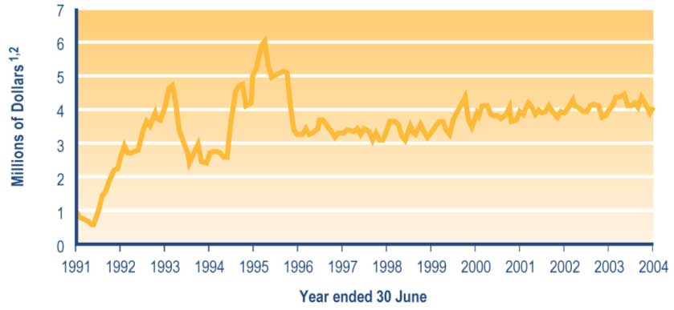
Notes
1 Expenditure on Special Needs Grants is smoothed using a two-month moving average. Special Needs Grants are not subject to taxation.
2 Expenditure data in this graph differs from, and should not be cited as, MSD’s official measure of expenditure on financial assistance provided to clients.

Benefit advances
Increases since 1998/1999 in annual expenditure on benefit advances (see Table 4.37) reflect:

• patterns in the number of people receiving core benefits or pensions
• the expanded availability of benefit advances from 9 October 1995.

Table 4.37 Trends in annual expenditure on benefit advances

Year ended 30 June | Expenditure on  benefit advances  ($million)^{1,2,3}
1991/1992 | 21
1992/1993 | 50
1993/1994 | 48
1994/1995 | 48
1995/1996 | 82
1996/1997 | 88
1997/1998 | 81
1998/1999 | 75
1999/2000 | 79
2000/2001 | 87
2001/2002 | 91
2002/2003 | 103
2003/2004 | 106

Notes
1 Expenditure on benefit advances in years ended 30 June.
2 Expenditure has been smoothed using a two-month moving average. Benefit advances are not subject to taxation.
3 Expenditure data in this table differs from, and should not be cited as, MSD’s official measure of expenditure on financial assistance provided to clients.

Significant variation in monthly expenditure on benefit advances (see Figure 4.16) reflects seasonal variation in the number of benefit advances made.

Figure 4.16 Trends in monthly expenditure on benefit advances

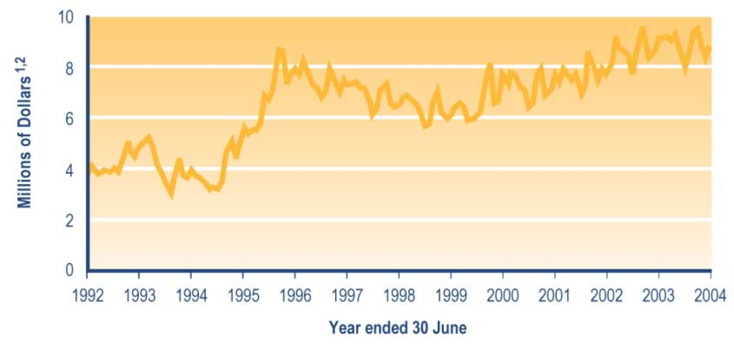

Notes
1 Expenditure is adjusted for the number of benefit advances made during the month and smoothed using a two-month moving average. Benefit advances are not subject to taxation.
2 Expenditure data in this graph differs from, and should not be cited as, MSD’s official measure of expenditure on financial assistance provided to clients.

Student Allowance Transfer Grants

Student Allowance Transfer Grants are available to clients (or their partners) if they are in hardship during the stand-down week between ceasing receiving a Student Allowance and their first payment of a core benefit. Student Allowance Transfer Grants were introduced on
1 October 2002.

Eligibility for Student Allowance Transfer Grants
To qualify for a Student Allowance Transfer Grant, clients must:

• have a dependent partner or one or more dependent children
• be in hardship (ie have cash assets less than the maximum allowed and no other means of supporting themselves)
• be applying for a core benefit because their Student Allowance will stop for one of the following reasons:
– the client is no longer a secondary or tertiary student
– the client is sick, injured or on a break of three weeks or more
– the client’s course of study has ended, or
– the tertiary provider has lost their accreditation
• apply for a Student Allowance Transfer Grant before the end date for which a Student Allowance is payable, or within five working days after this date.

Income and asset limits for the Student Allowance Transfer Grant (see Table 4.38) depend on the circumstances of the client.

Table 4.38 Asset and income limits for Student Allowance Transfer Grants (applicable from 1 April 2004)

Circumstances of client | Income limit¹ | Asset limit²
Client and dependent partner with no dependent children | $270.26 | $1,367.92
Client with a dependent child | None | $1,078.16
Client with two or more dependent children | None | $1,157.80
Client and dependent partner with dependent child | None | $1,367.92

Notes
1 Income limits (per week before tax) at 1 April 2004.
2 Asset limits at 1 April 2004.

The Student Allowance Transfer Grant is non-recoverable and non-taxable.

Number of Student Allowance Transfer Grants provided
The annual number of Student Allowance Transfer Grants provided decreased between 2002/2003 and 2003/2004 (see Table 4.39), reflecting decreases in the number of students receiving a Student Allowance. Of the Student Allowance Transfer Grants provided in each of the last two years, around 93% were provided to students who were transferring from a Student Allowance to an unemployment-related benefit (see Table 4.39).

Table 4.39 Trends in the types of core benefit or pension received by clients granted a Student Allowance Transfer Grant

Type of core benefit or pension received when Student Allowance Transfer Allowance granted | Student Allowance Transfer Grants provided¹
 |  | 2002/2003  Number | 2003/2004  Number
Unemployment-related benefits² |  | 2,518 | 2,206
Carers' benefits³ |  | 121 | 87
Sickness-related benefits⁴ |  | 45 | 33
Invalids' Benefit |  | 0 | 2
Widows' Benefit |  | 0 | 0
Unsupported Child's Benefit/Orphan's Benefit |  | 0 | 0
Transitional Retirement Benefit |  | 0 | 0
Emergency Benefit |  | 8 | 4
New Zealand Superannuation |  | 0 | 0
Veterans' Pension |  | 0 | 0
No core benefit or pension |  | 10 | 8
Total |  | 2,702 | 2,340

Notes
1 Numbers of Student Allowance Transfer Grants provided in years ended 30 June.
2 Includes Unemployment Benefits and Unemployment Benefits – Hardship paid to unemployed people and to trainees, and Independent Youth Benefits.
3 Includes Domestic Purposes Benefits – Sole Parents, Domestic Purposes Benefits – Caring for the Sick and Infirm, Domestic Purposes Benefits – Women Alone, and Emergency Maintenance Allowances.
4 Includes Sickness Benefits and Sickness Benefits – Hardship.

Expenditure on Student Allowance Transfer Grants
Between 2002/2003 and 2003/2004, total expenditure on Student Allowance Transfer Grants declined, while the average size of each grant increased (see Table 4.40). This reflects decreases in the number of students receiving a Student Allowance.

Table 4.40 Trends in annual expenditure on Student Allowance Transfer Grants

 | Expenditure on Student Allowance Transfer Grants¹
 |  | 2002/2003²  Amount | 2003/2004  Amount
Total expenditure ($m) |  | $640 | $573
Average |  | 237 | 274

Notes
1 Expenditure on Student Allowance Transfer Grants recorded in SWIFTT during the year ended 30 June.
2 Includes nine months’ expenditure on Student Allowance Transfer Grants (from 1 October 2002 to 30 June 2003).

Section 5 - Students

Assistance available to students

MSD provides assistance to students through its StudyLink service line. The eligibility of students for this assistance depends on the age and circumstances of the student as well as the nature of the course they are undertaking and of the institution they are enrolled at.

MSD assistance that is available to students comprises:

• Student Allowances
• Student Loans
• core benefit during vacation periods
• supplementary benefits
• job search assistance during vacation periods.

This report entered publication before the end of the 2004 academic year and is therefore restricted to information up to the end of the 2003 academic year.

Student Allowances

The Student Allowances Scheme was introduced in 1989 to provide living support for New Zealand students studying full time toward recognised tertiary qualifications and for adults studying full time at secondary school. The aim of the scheme is to ensure that the need to meet day-to-day living expenses does not act as a barrier to full-time education for students from low and middle socio-economic groups.

Eligibility for Student Allowances
Student Allowances are available to people who are:

• aged 18 years or over, or aged 16–17 if they meet criteria based on their circumstances
• enrolled as a full-time student
• on a recognised programme at an approved institution
• either:
– a New Zealand citizen, or
– a permanent resident of New Zealand who has lived in New Zealand for at least two years and has held “permanent residency status” for at least two years.

Income tests are applied to the income of the student and of the student’s spouse (if any).
An income test is also applied to the income of the parents of most single students aged under 25 years. Tests of academic achievement (to secure continued access to a Student Allowance) also apply.

Students who are not studying full time may be eligible for a Student Allowance if they:

• have an illness, disability or some other sufficient cause beyond their control that stops them studying full time
• have reduced their course to less than full time on academic advice, or
• are studying more than half of a full-time course and the course is required to complete a recognised programme.
If a student is eligible for a Student Allowance and is living away from home, they are entitled to an Accommodation Benefit payable under the Student Allowances Scheme. This is a contribution towards their accommodation costs, up to a maximum of $40 per week.

Bursaries (consisting of “A” and “B” Bursaries) are part of the Student Allowances Scheme. These are paid as tax-free lump sums of $200 (for an “A” Bursary) or $100 (for a “B” Bursary) once a year.

Bursaries are payable to students aged under 20 years who have passed the Bursary examinations and who continue to meet tests of academic achievement.

Payment rates for Student Allowances
Student Allowances are available at different rates depending on the circumstances of the student and on their assumed living costs. For students who are living with one or both parents, Student Allowances are paid at a discounted rate to reflect the lower living costs these students are likely to experience compared with students living away from home.
Table 5.1 shows the rates at which Student Allowances were paid between 1 April 2003 and the end of the 2003 academic year.

Table 5.1 Payment rates for Student Allowances (applicable during 2003 academic year¹)

Type of Student Allowance | Status | No children | One child | Two or more children
Single 16-24 years | Away from home  At home | $134.70  $107.76
Single 25+ years | Away from home  At home | $161.65  $129.31
Couple allowance -  Both students, no children | One eligible  Both eligible (each) | $161.65  $134.70
Couple allowance -  dependent spouse, no children |  | $269.40
Single student with dependent  Children |  |  | $231.53 | $252.60
Couples - both students with dependent children | One eligible  Both eligible (each) |  | $231.53  $143.14 | $252.60  $143.14
Couple - dependent spouses with dependent children |  |  | $286.28 | $286.28
Students in independent circumstances |  | $134.70
Earning spouse | Away from home  At home | $86.99  $58.40

Note
1 Maximum rates payable from 1 April 2003, net of tax.

Trends in the number of students receiving a Student Allowance
A decrease between 2002 and 2003 in the total number of students receiving a Student
Allowance (see Table 5.2) may reflect a number of factors, including the impact of parental income limits not having changed for a number of years and increased personal verification by StudyLink. Of the students receiving a Student Allowance since 1999, between 52% and 54% have been receiving a targeted allowance for living away from home (see Table 5.2).
Since 1999, the proportion of students receiving a Student Allowance who were receiving a targeted allowance for students:

• aged 16–24 years has decreased (from 49% to 42%) (see Table 5.2)
• aged 25 years or over has increased (from 24% to 30%) (see Table 5.2).

Table 5.2 Trends in the types of Student Allowances received

Type of Student  Allowance received | Students receiving Student Allowances¹
 | 1999  Number | 2000  Number | 2001  Number | 2002  Number | 2003  Number
Single 16-24 years - targeted away from home | 19,971 | 20,722 | 20,314 | 18,910 | 16,347
Single 16-24 years - targeted at home | 11,261 | 12,124 | 12,458 | 11,847 | 10,408
Single 25+ years – targeted away from home | 13,705 | 15,884 | 17,200 | 17,461 | 16,822
Single 25+ years - target at home | 1,984 | 2,106 | 2,260 | 2,272 | 2,129
Couple allowance –  both students, no children | 969 | 917 | 800 | 820 | 878
Couple allowance –  dependent spouse,  no children | 1,383 | 1,438 | 1,659 | 1,708 | 1,726
Single student with  dependent children | 1,199 | 1,539 | 1,771 | 1,843 | 1,846
Couples – both students  with dependent children | 812 | 830 | 796 | 735 | 749
Couples – dependent  spouses with dependent children | 4,802 | 5,031 | 4,961 | 4,677 | 4,174
Students in independent  circumstances | 5,410 | 5,970 | 6,468 | 7,087 | 7,686
Earning spouse – at home | 1,238 | 1,327 | 1,398 | 1,372 | 1,154
Earning spouse –  away from home | 154 | 196 | 146 | 136 | 117
Unknown² | 1,404 | 0 | 0 | 0 | 0
Total | 64,292 | 68,084 | 70,231 | 68,869 | 64,036

Notes
1 Numbers of students recorded as receiving Student Allowances during years ended 31 December.
2 The type of Student Allowance could not be determined for these students as a result of database development problems.

Trends in the number of students receiving Bursaries
Decreases since 2000 in the number of students enrolled at eligible institutions who are receiving Bursaries (see Table 5.3 below) reflect changing patterns in applications for Bursaries. Since 1999, around 57% of students receiving Bursaries have been receiving an “A” award (see Table 5.3).

Table 5.3 Trends in the types of Bursaries received by students enrolled in eligible institutions

Type of Bursary received | Students receiving Bursaries¹
 | 1999  Number | 2000  Number | 2001  Number | 2002  Number | 2003  Number
"A" Bursary | 7,599 | 8,403 | 8,341 | 8,089 | 7,999
"B" Bursary | 5,531 | 6,374 | 6,266 | 6,116 | 6,062
Total | 13,130 | 14,773 | 14,603 | 14,199 | 14,060

Note
1 Numbers of students at eligible institutions recorded as receiving Bursaries during years ended 31 December.

Trends in expenditure on Student Allowances
A decrease between 2002 and 2003 in expenditure on Student Allowances (see Table 5.4) reflects a decrease in the number of students receiving Student Allowances.

Table 5.4 Trends in annual expenditure on Student Allowances

 | Expenditure on Students Allowances¹
 | 1999 | 2000 | 2001 | 2002 | 2003
Total expenditure ($m) | 347 | 397 | 367 | 367 | 351

Note
1 Expenditure on Student Allowances (excluding Accommodation Benefit) during years ended 31 December.

Student Loans

The Student Loan Scheme was introduced in 1992 to assist students studying at tertiary level. The purpose of the Scheme is to ensure that the costs of study are not a barrier to students undertaking tertiary study.

Eligibility for Student Loans
Student Loans are available to people who are:

• New Zealand citizens, permanent residents or refugees
• enrolled on a tertiary course approved by the Ministry of Education that is:

– full time or limited full time
– part time and 32 weeks or longer, or
– part time and less than 32 weeks, so long as the course meets a minimum course workload value.

To receive Student Loan living costs, students must be enrolled in a full-time or limited full-time course. Students enrolled on courses that are part time and 32 weeks or longer may receive a loan for fees and course-related costs only. Students enrolled on courses that are part time and less than 32 weeks can only receive a Student Loan for fees. If a student or their partner receives a Student Allowance of $150.00 a week or more after tax, they may only receive a Student Loan for compulsory fees and course-related costs.

People who are currently bankrupt or who are on a course already paid for by the Government (such as Training Opportunities) are not eligible to receive a Student Loan.

From 1 January 2002, prisoners have been eligible to access Student Loans for compulsory fees and course-related costs, subject to the agreement of the prison authority. Prisoners are not able to receive living costs unless they are on home detention.

Accessibility of funds through Student Loans
Limits have been established that prescribe maximum drawings that students may make from their Student Loan (see Table 5.5).

Table 5.5 Maximum amount available by component of Student Loan (applicable over the 2003 academic year)

Component of Student Loan | Maximum amounts available
Course fees (annual)¹ | Total fee cost, to a maximum of $6,500 for Private Training Establishments
Course-related expenses (annual)² | $1,000.00
Living costs (weekly)³ | $150.00

Notes
1 Payment of fees is reduced by any Training Incentive Allowance (available to some core benefit recipients) that is provided to pay fees.
2 Payment of course-related expenses is reduced by some of the Training Incentive Allowance (available to some core benefit recipients) that is provided to pay course-related expenses.
3 Payment of living costs is restricted to periods when the student is studying full time and is reduced by any Student Allowance payments received.

Trends in the number of students making drawings against Student Loans
This section shows information about students making drawings against Student Loans during the calendar years (ended 31 December) indicated. It excludes information about drawings made against Student Loans in earlier calendar years, and therefore does not show the total levels of debt that students have accumulated through the Student Loan Scheme.

Increases since 2000 in the number of students making drawings against Student Loans (see Table 5.6) reflect increased uptake of Student Loans. Over the last three years, between 44% and 47% drew a total of less than $5,000 over the calendar year. Over the same period, between 36% and 40% drew between $5,000 and $10,000 (see Table 5.6).

Table 5.6 Trends in the annual amount per student drawn against Student Loans

Amount drawn against Student Loan | Students making drawings against Student Loans¹
 |  | 2000  Number | 2001  Number | 2002  Number | 2003  Number
Under $5,000 |  | 58,503 | 65,696 | 68,555 | 72,921
$5,000 - <10,000 |  | 50,628 | 58,079 | 55,829 | 56,356
$10,000 - <15,000 |  | 17,679 | 22,335 | 23,656 | 25,261
$15,000 - <20,000 |  | 889 | 1,472 | 1,584 | 1,478
$20,000 - <30,000 |  | 318 | 347 | 431 | 398
$30,000 - <40,000 |  | 73 | 68 | 118 | 145
$40,000 - <50,000 |  | 1 | 19 | 85 | 113
$50,000 or over |  | 16 | 80 | 218 | 410
Total |  | 128,107 | 148,096 | 150,476 | 156,210

Note
1 Numbers of students recorded as making drawings against Student Loans during years ended 31 December.

Of the students making drawings against Student Loans in each year since 2000 (see Table 5.8):

• between 46% and 49% have been attending a university
• between 27% and 30% have been attending a polytechnic.

Since 2000, the proportion of students making drawings against Student Loans each year who were not receiving a Student Allowance has increased (from 59% to 67%) (see Table 5.7). Over the same period, the proportion of students making drawings against Student Loans each year who were receiving a Student Allowance for living away from home has decreased (from 23% to 18%) (see Table 5.7).

Table 5.7 Trends in the types of Student Allowances received by students making drawings against Student Loans

Type of Student Allowance received when drawing made against Student Loan | Students making drawings against Student Loans¹
 | 2000  Number | 2001  Number | 2002  Number | 2003  Number
Single 16-24 years - targeted away from home | 16,377 | 16,960 | 15,936 | 13,854
Single 16-24 years - targeted at home | 7,817 | 8,508 | 8,168 | 7,358
Single 25+ years – targeted away from home | 12,823 | 14,215 | 14,017 | 13,540
Single 25+ years - target at home | 1,493 | 1,694 | 1,688 | 1,554
Couple allowance – both students, no children | 724 | 665 | 689 | 758
Couple allowance – dependent spouse, no children | 1,103 | 1,268 | 1,293 | 1,317
Single student with dependent children | 1,320 | 1,569 | 1,588 | 1,589
Couples – both students with dependent children | 689 | 684 | 649 | 639
Couples – dependent spouses with dependent children | 3,900 | 3,916 | 3,628 | 3,255
Students in independent circumstances | 4,787 | 5,444 | 6,003 | 6,642
Earning spouse – at home | 1,094 | 1,184 | 1,147 | 933
Earning spouse – away from home | 154 | 121 | 109 | 99
Not receiving any Student Allowance² | 75,826 | 91,868 | 95,560 | 104,672
Total | 128,107 | 148,096 | 150,476 | 156,210

Note
1 Numbers of students recorded as making drawings against Student Loans during years ended 31 December.

Table 5.8 Trends in the types of institutions attended by students making drawings against Student Loans

Type of institution attended when drawing made against student loan | Students making drawings against student loans¹
 | 2000  Number | 2001  Number | 2002  Number | 2003  Number
College of Education | 4,963 | 5,150 | 5,338 | 5,449
Polytechnic | 37,806 | 40,270 | 41,447 | 41,460
Private Training Establishment | 17,367 | 28,120 | 25,336 | 27,325
University | 63,329 | 67,756 | 70,902 | 73,320
Wānanga | 2,064 | 2,782 | 3,608 | 4,496
Polytechnic and university² | 997 | 1,262 | 1,224 | 1,333
Polytechnic and other institution(s)² | 479 | 1,140 | 1,149 | 1,283
University and other institution(s)² | 1,006 | 1,343 | 1,236 | 1,252
Polytechnic, university and other institution(s)² | 13 | 71 | 63 | 50
Miscellaneous combination² | 49 | 188 | 158 | 238
Unknown | 34 | 14 | 15 | 4
Total | 128,107 | 148,096 | 150,476 | 156,210

Notes
1 Numbers of students recorded as making drawings against Student Loans during years ended 31 December.
2 Students may enrol to study at more than one institution at the same time. In these cases, Table 5.8 shows all types of institutions where students are enrolled at the time of making a drawing against a Student Loan.

Trends in the purpose of drawings against Student Loans
The numbers of students making drawings against each component of their Student Loan do not add to the total number of students making one or more drawings shown in Tables 5.6–5.8 above. This is because a student may make drawings against more than one Student Loan component (eg course fees and living costs) during the same academic year.

The number of students making drawings against each Student Loan component has increased since 2000 (see Table 5.9). This reflects increases in the total number of students making drawings against Student Loans.

Table 5.9 Trends in the number of drawings made against Student Loan components

Student Loan component | Number of students making drawings against Student Loan components¹
 | 2000  Number | 2001  Number | 2002  Number | 2003  Number
Course fees | 122,833 | 138,334 | 139,323 | 144,678
Courses costs | 72,591 | 94,319 | 96,563 | 101,644
Living expenses | 70,982 | 77,405 | 77,699 | 79,373

Note
1 Numbers of students making drawings against Student Loan components during years ended 31 December.

Section 6 - Additional information

Community Services Cards

Introduction
A Community Services Card is an entitlement card that people on low to middle incomes or receiving income support may use to obtain higher subsidies on doctor’s fees and prescriptions.

From 1 February 1994, families not claiming Family Support from Inland Revenue were able to apply for a Community Services Card. (Families not receiving Family Support are indicated as “Families” in the following tables, while Family Support recipients are indicated separately.) The income limits for families with dependent children increased on 1 July 1998, and new income limits for families with more than six children were introduced.
People receiving income-tested income support, Veterans’ Pensions and the Residential Care Subsidy automatically receive a Community Services Card (and subsequent replacement cards), so they do not have to complete application forms. People receiving New Zealand Superannuation must apply for their first Community Services Card. However, card renewal for more than 80% of people receiving New Zealand Superannuation has been automated since 1 January 1996.

From 1 February 1999, the Community Services Card regulations were amended to allow families with children receiving a Child Disability Allowance to include that child in their application for a Community Services Card.

The income limits for holders of a Community Services Card were increased on 1 April 2000 to match the increase from this date in the rate of New Zealand Superannuation.

A fault was identified in August 1999 with the information transfer between Inland Revenue and the Department of Work and Income that was supposed to identify people eligible for the Community Services Card through their entitlement to Family Support. As a result, there was an increase in the number of applications received under the “Families” category while the fault was being fixed.

From 1 October 1999, processing of claims for partial reimbursement of health charges under the Community Services Card scheme was centralised to the national Community Services Card Centre. Between 1992 and 30 September 1999, claims were processed at Work and Income service centres.

The Ministry of Health commenced the implementation of Primary Health Organisations (PHOs) from 1 July 2002. The establishment of PHOs since 2002 has had an effect on the number of cards issued. People who are enrolled with a PHO rarely need their Community Services Card to access primary care services (GP visits and prescriptions), although the card is still necessary for subsidies for other health services. As PHOs spread across New Zealand, the need for the Community Services Card in order to access health services will reduce, and it is anticipated that by July 2007 the Community Services Card will be phased out. During the transition period, the Ministry of Health has charged MSD with ensuring that all people who are eligible for the Community Services Card are encouraged to apply for and retain their cards.

From June 2003, Community Services Cards have been automatically issued to most students who receive a Student Allowance and who do not have a working spouse. As this process affects an increasing number of students, the numbers of students with a Community Services Card will gradually increase.

Trends in the number of Community Services Cards on issue
Decreases since 2001 in the number of Community Services Cards on issue (see Table 6.1) largely reflect a decrease in the number of people receiving means-tested benefits.

Of the Community Services Cards on issue since 2000, around 28% have been held by people receiving New Zealand Superannuation (see Table 6.1). Since 2000, the proportion of Community Services Cards on issue that were held by people receiving a means-tested benefit has decreased (from 46% to 41%).

Table 6.1 Trends in the groups of clients holding Community Services Cards

Group cards are issued to | Community Services Cards on issue¹
 | 2000  Number | 2001  Number | 2002  Number | 2003  Number | 2004  Number
Low-income earners² | 105,822 | 108,011 | 108,430 | 104,894 | 83,791
Family Support recipients³ | 116,800 | 132,822 | 145,047 | 141,717 | 132,951
War Pension recipients | 5,467 | 5,669 | 5,395 | 5,355 | 5,389
Students² | - | - | - | 14,736 | 41,390
Means-tested benefit recipients^{4,5} | 515,799 | 500,424 | 482,031 | 463,823 | 435,009
New Zealand Superannuation recipients⁶ | 317,835 | 329,585 | 311,211 | 311,018 | 310,133
Residential Care Subsidy recipients | 19,775 | 22,730 | 19,747 | 19,743 | 19,640
Families | 39,874 | 29,359 | 26,612 | 27,674 | 24,958
Total | 1,121,372 | 1,128,600 | 1,098,473 | 1,088,960 | 1,053,261

– = not applicable
Notes
1 Number of Community Services Cards on issue at 30 June.
2 Between 1 July 1998 and June 2003, “low-income” included students receiving a Tertiary Living Allowance or Student Allowance who were granted a Community Services Card as low-income earners.
3 “Family Support” includes both Group 1 and Group 2 Family Support recipients, who have both been subsidised at Group 1 Family Support levels since 1 July 1993.
4 “Means-tested benefits” includes students receiving an Unemployment Benefit – Hardship – Student or an Emergency Benefit.
5 The number of people in receipt of a current means-tested benefit as at 30 June does not correspond with the numbers of these people issued with a Community Services Card shown above. This is because the above numbers include:
• spouses of people receiving means-tested benefits
• people who ceased receiving means-tested benefits less than 12 months previously (cards covering the 12 months after a person ceases receiving means-tested benefits are issued automatically).
6 The number of people receiving New Zealand Superannuation does not correspond with the number of New Zealand Superannuation recipients issued with a Community Services Card shown above. This is because income tests for a Community Services Card exclude some people who receive New Zealand Superannuation from receiving a Community Services Card.

Trends in the number of Community Services Cards issued and renewed
Decreases since 2001/2002 in the number of new Community Services Cards issued each year (see Table 6.2) reflect fluctuations in the numbers of people being granted core benefits or pensions. Higher average weekly wages also mean that families previously entitled to cards are now earning more than the allowable income threshold and no longer qualify.

Of the new Community Services Cards issued each year since 2000/2001 (see Table 6.2):

• between 43% and 45% have been issued to low-income earners and students
• between 32% and 36% have been issued to clients receiving Family Support.

Since 1999/2000, the proportion of the Community Services Cards reissued each year that were provided to low-income earners and students has increased from 70% to 77% (see Table 6.2).

Table 6.2 Trends in issues of new Community Services Cards and in renewals of Community Services Cards

Type of new and renewed Community Services Cards | Community Services Cards issued and renewed¹
 | 1999/2000  Number | 2000/2001  Number | 2001/2002  Number | 2002/2003  Number | 2003/2004  Number
New cards
Low-income earners and students | 61,869 | 60,119 | 63,919 | 61,762 | 50,955
Family Support recipients² | 42,273 | 50,069 | 48,664 | 45,093 | 39,682
New Zealand Superannuation recipients | 12,016 | 12,235 | 11,781 | 13,328 | 12,755
Families | 24,689 | 18,526 | 17,498 | 19,094 | 16,430
Total | 140,847 | 140,949 | 141,862 | 139,277 | 119,822
Renewed cards
Low-income earners and students | 60,311 | 59,326 | 58,076 | 57,053 | 48,598
Family Support recipients² | - | - | - | - | -
New Zealand Superannuation recipients | 14,736 | 11,351 | 12,089 | 9,921 | 7,316
Families | 11,666 | 11,176 | 8,640 | 8,452 | 7,404
Total | 86,713 | 81,853 | 78,805 | 75,029 | 63,318
Total (includes issue of renewed cards) | 227,560 | 222,802 | 220,667 | 214,685 | 183,140

– = not applicable
Notes
1 Numbers of new Community Services Cards issued and Community Services Cards renewed in years ended 30 June.
2 All cards issued to Family Support recipients (both new cards and renewals) are coded as new cards. Separate counts of renewals of cards held by Family Support recipients are not available.

Trends in expenditure on Community Services Cards
Claims for partial reimbursement of health charges by cardholders are processed and paid by MSD on behalf of the Ministry of Health. The Ministry of Health then reimburses MSD for the payments made in respect of these claims.

Fluctuations since 2000/2001 in expenditure on claims for partial reimbursement of health charges under the Community Services Card Scheme (see Table 6.3) partly reflect increased awareness among clients of the reimbursement process. However, it is also tied to seasonal variations – observations are that a mild winter tends to mean fewer claims are made than otherwise. In addition, clusters of claims from or on behalf of high users can affect trends across years.

Table 6.3 Trends in annual expenditure on Community Services Cards

 | Expenditure on Community Services Cards^{1,2}
 | 1999  Amount  ($000) | 2000  Amount  ($000) | 2001  Amount  ($000) | 2002  Amount  ($000) | 2003  Amount  ($000)
Total | 301 | 330 | 318 | 326 | 318

Notes
1 MSD expenditure on partial claims against Community Services Cards in years ended 30 June.
2 MSD expenditure on Community Services Card subsidies is reimbursed by the Ministry of Health.

Benefit Control

Background
The Benefit Control Unit covers activities to protect the integrity of the benefit system offered by MSD. Activities include:

• preventing fraud and abuse
• conducting early intervention interviews
• identifying discrepancies through data matching
• investigating suspected irregularities
• deterring abuse of the benefit system
• sanctioning persons involved in abuse of the benefit system.

Data matching is currently undertaken with Inland Revenue, the Department of Corrections and the New Zealand Customs Service. The purpose of these matches is to detect clients who are or have been in receipt of benefits or financial assistance to which they may not be entitled. There are plans to extend the range of agencies with whom MSD matches data. The first new match to be implemented will be the Deaths Match with the Department of Internal Affairs. This match will commence in September 2004.

Trends in cases investigated and overpayments identified
Data matching was involved in between 51% and 57% of Benefit Control cases over the period between1999/2000 and 2000/2001, but in less than 50% of cases over the last three years (see Table 6.4). This reflects a greater emphasis on the prevention and early intervention of fraud and abuse by the Area Benefit Control teams.

Table 6.4 Trends in benefit control statistics by source of information

Financial year¹ | Number of  cases investigated | Overpayments identified Amount ($)
Area Benefit Control teams
1999/2000 | 45,181 | 76,348,609
2000/2001 | 41,258 | 56,288,559
2001/2002² | 47,835 | 47,506,880
2002/2003 | 49,813 | 42,723,950
2003/2004³ | 53,631 | 50,048,006
Data Match
1999/2000 | 47,794 | 27,872,645
2000/2001 | 52,910 | 33,723,772
2001/2002² | 47,169 | 33,945,242
2002/2003 | 41,122 | 31,275,937
2003/2004³ | 47,079 | 28,683,298

Notes
1 Financial years ended 30 June.
2 The 2001/2002 year includes three months as part of the Department of Work and Income and nine months as part of MSD.
3 The 2003/2004 year includes overpayments of $367,353 from the Client Review Process Initiatives that are aligned to Early Intervention.

From 1999/2000 to 2002/2003, the dollar returned from Benefit Control activities has remained significantly above the target dollar returned set in MSD’s Purchase Agreement (see Table 6.5). In 2003/2004, the dollar return reduced because of the expenditure involved in the Benefit Review Project, but was still comparable with the target dollar return set for that year.

Table 6.5 Trends in cases investigated and dollar returns

Financial year¹ | Total number of cases investigated | Actual dollar  returned² | Target dollar  returned²
1999/2000 | 92,975 | $4.34 | $3.25
2000/2001 | 94,168 | $3.89 | $3.25
2001/2002³ | 95,004 | $3.32 | $2.50
2002/2003 | 90,935 | $3.41 | $2.50
2003/2004⁴ | 100,710 | $2.51 | $2.50

Notes
1 Financial years ended 30 June.
2 Target and actual dollar returned includes overheads and is GST exclusive. Target dollar returned is set in MSD’s Purchase Agreement with the Minister of Social Services and Employment. From 2002/2003, the target dollar returned in MSD’s Purchase Agreement has been extended to include the return on prospective savings as well as overpayments. For consistency with earlier years, the target and actual dollar returned indicated here excludes the return on prospective savings.
3 The 2001/2002 year includes three months as part of the Department of Work and Income and nine months as part of MSD.
4 The 2003/2004 year includes overpayments from the Client Review Process Initiatives that are aligned to Early Intervention.

Debt Management

Background
MSD’s debt management functions are an integral part of its operations, providing services, advice and debt recovery processes.

Debt is managed in two portfolio groups:
• current benefit debt
• non-current debt.

Work and Income is responsible for current benefit debt, where clients with benefit debts are currently in receipt of a benefit.

Debt Management is responsible for managing non-current debt. This includes benefit debts (owed by clients who are no longer in receipt of a benefit), Student Allowance debts, fraudulent Student Loan, work debt, and debts from programmes such as Liable Parent Contribution and Maintenance. Four Regional Debt Management Units (located in Christchurch, Lower Hutt, Hamilton and Auckland) are responsible for the operational management of non-current debt.

New debts are established as a result of:

• data matching
• fraud or abuse
• innocent overpayments
• benefit advances, recoverable grants and loans.

Trends in debt values
Debt values trended upwards between 1999/2000 and 2001/2002, but have declined in the last two years (see Table 6.6). Two factors have contributed to the reduced value of debt. These are:

• the high levels of debt write-off
• the transfer of Residential Care Loan balances to the Ministry of Health.

The value of debt repaid or adjusted on review has reduced in 2003/2004; this is due to significantly reduced write-offs compared to 2002/2003.

Table 6.6 Trends in debt established, debt repaid and outstanding debt

Financial year¹ | New debt  established  ($m) | Debt repaid or adjusted  on review  ($m) | Outstanding debt  at 30 June  ($m)
1999/2000 | 329.7 | 299.2 | 800.4
2000/2001 | 312.6 | 300.4 | 813.8
2001/2002 | 318.4 | 233.1² | 899.1²
2002/2003 | 311.8 | 444.8³ | 766.2³
2003/2004 | 303.6 | 312.7 | 757.1

Notes
1 Financial years ended 30 June.
2 Both debt adjusted on review and outstanding debt have been impacted by a reporting correction in June 2002. The total value of current benefit debt was previously understated by $72m. The correction of this error has resulted in a decrease in debt adjusted on review and a corresponding increase in outstanding debt.
3 In June 2002, MSD gained Ministerial approval to write off existing aged debt where all avenues of recovery have been proven to be exhausted. The write-off of these debts in the last two years has increased the value of debt repaid or adjusted on review and decreased the value of outstanding debt.

Trends in debtor numbers
The number of debtors increased between 1999/2000 and 2001/2002 as a result of increases in the number of benefit debtors. This trend was reversed in 2002/2003 as a large number of debts were written off. Debtor numbers increased slightly during 2003/2004 (see Table 6.7).

Table 6.7 Trends in the number of debtors with open debts, by category

Financial  year¹ | Benefit |  | Other debtors |  |  |  | Total  Debtors²
 | Current  Clients³ | Non-current  Clients⁴ | Liable Parent  Contributions⁵ | Total  Maintenance⁶ | Student  Allowances⁷ | Work debt⁸
1999/2000 | 154,241 | 113,591 | 30,861 | 10,508 | 3,066 | 584 | 312,851
2000/2001 | 170,561 | 121,613 | 28,653 | 9,792 | 3,480 | 609 | 334,708
2001/2002 | 173,296 | 127,788 | 26,639 | 8,691 | 3,729 | 624 | 340,767
2002/2003 | 176,025 | 108,709 | 10,240 | 4,825 | 3,817 | 637 | 304,253
2003/2004 | 182,491 | 114,888 | 8,341 | 3,025 | 4209 | 101 | 308,745

Notes
1 Financial years ended 30 June.
2 The total number of debtors may be overstated because of double-counting where a person has more than one type of debt.
3 Debtors who are currently receiving income support from Work and Income and have had advances, grants or overpayments of income support.
4 Debtors who are no longer receiving income support from Work and Income but who have had advances, grants or overpayments of income support.
5 The Liable Parent Contribution Scheme ended in 1992. The number represents liable parents with arrears of payments.
6 Administration of Maintenance Orders and registered agreements ended in 1992. The number represents Crown maintenance debtors with arrears of payments.
7 Debtors who have received overpayments of Student Allowance. Prior to 1 January 1999, the Ministry of Education administered Student Allowance debt.
8 Debtors who have received overpayment of employment-related grants and allowances. Prior to October 1998, the New Zealand Employment Service administered work debt.

Debt composition
In total, 88% of all Crown debt is a result of benefit overpayment, benefit advance or grant. Current benefit debt accounts for 41% of Crown debt, while non-current debt accounts for 47% (see Figure 6.1).

Figure 6.1 Total composition of Crown debt at 30 June 2004

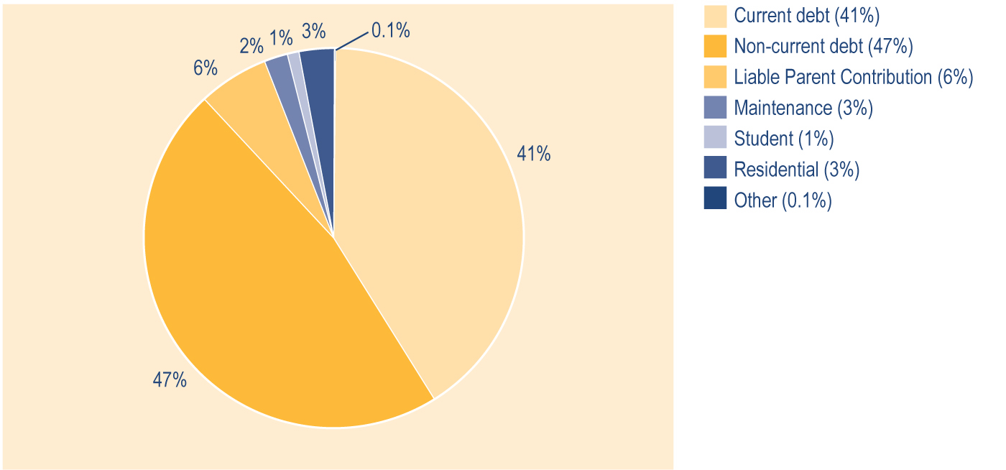

Social Security Agreements

Introduction
New Zealand currently has social security agreements with Australia, the United Kingdom (UK), the Netherlands, the Republic of Ireland, Greece (the Hellenic Republic), Canada, Denmark, and Jersey and Guernsey. There is also a special portability arrangement for specified countries of the Pacific. An agreement was signed with Italy in June 1998, but it has not yet been ratified by Italy.

Current social security agreements

Australia
A new social security agreement between New Zealand and Australia came into effect on 1 July 2002. The agreement covers New Zealand Superannuation, Veterans’ Pensions and Invalids’ Benefits for people with severe disabilities. Under this agreement, individual pensioners receive dual payments (one from each Government, according to the proportion of the individual’s working life spent in each country).

People going to Australia can use their periods of residence in New Zealand to help them qualify for an Australian pension covered by the agreement. Conversely, periods of residence in Australia will assist people coming to live in New Zealand to qualify for New Zealand benefits covered by the agreement.

Benefit reimbursements from New Zealand to Australia, which were calculated under the provisions of the previous agreement, continue to be made. Reimbursement amounts are set out in the new agreement and should phase out in approximately 2015. The reimbursement for the financial year beginning 1 July 2003 was $AUD88.9 million.

At 30 June 2004, there were 4,899 people receiving Australian pensions in New Zealand. At the same date, there were 2,700 people receiving New Zealand income services in Australia. Fourteen people were receiving a Veterans’ Pension, 416 people were receiving an Invalids’ Benefit and 2,270 were receiving New Zealand Superannuation.

The United Kingdom (UK)
People going to the UK can use their periods of residence in New Zealand to help them qualify for a UK pension and certain other social security payments. People coming from the UK to New Zealand can use periods of UK residence to help them qualify for a New Zealand benefit. In addition, UK pensions are paid to New Zealand residents under UK domestic law.

There were 40,195 people receiving UK pensions in New Zealand at 30 June 2004. At the same date, a further 26 Isle of Man pensions were also being paid into New Zealand under the current New Zealand/UK agreement.

The Netherlands
A revised social security agreement with the Netherlands came into effect on 1 November 2003. People who have lived in New Zealand for 12 months or more may, under the terms of the agreement, qualify for New Zealand Superannuation, Veterans’ Pension, Invalids’ Benefit, Widows’ Benefit or Domestic Purposes Benefit for widowers while they are living in the Netherlands. The rate of payment is based on whole months of residence in New Zealand since age 20.

Anyone arriving in New Zealand from the Netherlands may use periods of residence or contributions made in the Netherlands to meet the residence criteria for New Zealand benefits within the scope of the agreement. A person who has limited residence, or who has made a limited number of insurance contributions in the Netherlands, may use New Zealand residence to help them qualify for a pension from the Netherlands.

At 30 June 2004, there were 3,455 people receiving Netherlands pensions in New Zealand. At the same date, there were 892 people receiving New Zealand income services in the Netherlands. Three people were receiving an Invalids’ Benefit, two people were receiving a Widows’ Benefit and 887 people were receiving New Zealand Superannuation.

The Republic of Ireland
This agreement came into force on 1 March 1994. Under the agreement, former New Zealand residents who have lived or intend to live in the Republic of Ireland for more than 26 weeks may qualify for New Zealand Superannuation, Veterans’ Pension, Widows’ Benefit, Invalids’ Benefit, Domestic Purposes Benefit for widowers or Orphan’s Benefit. The rate of payment is based on whole months of residence in New Zealand since age 20. The agreement also allows payments of analogous Irish benefits to qualifying New Zealand residents.

People coming to live in New Zealand from the Republic of Ireland may use periods of contributions to Irish insurance to assist them to meet the residence criteria for New Zealand income services.

At 30 June 2004, there were 106 people receiving New Zealand Superannuation in the Republic of Ireland. At the same date, there were 131 Irish pensions being paid in New Zealand.

Greece (the Hellenic Republic)
This agreement came into force on 1 April 1994. Under the agreement, former New Zealand residents who live or intend to live in Greece may qualify for New Zealand Superannuation, Veterans’ Pension, Widows’ Benefit, Invalids’ Benefit or Domestic Purposes Benefit for widowers. The rate of payment is based on whole years of New Zealand residence since age 20. Orphan’s Benefit and funeral grants are also payable at the full New Zealand rate.

People arriving in New Zealand from Greece may use periods of residence and/or insurance in Greece to qualify for New Zealand income services within the scope of the agreement. Periods of residence in New Zealand will also assist people who have made limited Greek insurance contributions to qualify for a Greek pension.

At 30 June 2004, there were five people receiving an Invalids’ Benefit and 221 people receiving New Zealand Superannuation in Greece. At the same date, 19 Greek pensions had been granted to New Zealand residents under the agreement.

Canada
The agreement with Canada came into force in May 1997. Under the agreement, former New Zealand residents who live or intend to live in Canada may qualify for New Zealand Superannuation, Veterans’ Pension, Widows’ Benefit, Invalids’ Benefit or Domestic Purposes Benefit for widowers. The rate of payment is based on whole months of New Zealand residence since age 20.

Anyone arriving in New Zealand from Canada may use periods of residence or contributions made in Canada to meet the residence criteria for New Zealand income services within the scope of the agreement. Periods of residence in New Zealand will also assist people who have made limited contributions to the Canadian scheme, or who have insufficient periods of Canadian residence, to qualify for a Canadian pension.

At 30 June 2004, there were two people receiving a Widows’ Benefit, three people receiving an Invalids’ Benefit and 282 people receiving New Zealand Superannuation in Canada. At the same date, there were 390 Canadian pensions being paid in New Zealand.

Denmark
The agreement with Denmark came into force on 1 October 1997. Under the agreement, former New Zealand residents who live or intend to live in Denmark may qualify for New Zealand Superannuation, Widows’ Benefit, Invalids’ Benefit or Domestic Purposes Benefit for widowers. The rate of payment is based on whole months of New Zealand residence since age 20.

Anyone arriving in New Zealand from Denmark may use periods of residence or contributions made in Denmark to meet the residence criteria for New Zealand income services within the scope of the agreement. Periods of residence in New Zealand will also assist people who have made limited contributions to the Danish scheme, or who have insufficient periods of Danish residence, to qualify for a Danish pension. To qualify for a Danish pension under the agreement, a person must be either a Danish or New Zealand citizen.
At 30 June 2004, there were three people receiving an Invalids’ Benefit and 35 people receiving New Zealand Superannuation in Denmark. At the same date, there were 71 Danish pensions being paid in New Zealand.

Jersey and Guernsey
This agreement came into force on 1 April 1995. Under the agreement, former New Zealand residents who live or intend to live in Jersey or Guernsey may qualify for New Zealand Superannuation, Veterans’ Pensions, Widows’ Benefit, Invalids’ Benefit or Domestic Purposes Benefits for widowers. The rate of payment is based on whole years of New Zealand residence since age 20.

People coming to New Zealand who have made contributions to the Jersey or Guernsey social insurance schemes will be able to use those periods of insurance to qualify for New Zealand benefits within the scope of the agreement, which includes the Sickness Benefit. Periods of residence in New Zealand will also assist people who have made limited contributions to the Jersey or Guernsey insurance schemes to qualify for pensions available under those schemes.

At 30 June 2004, there were 60 people receiving New Zealand Superannuation in Jersey
and Guernsey. At the same date, there were 114 Jersey or Guernsey pensions being paid in
New Zealand.

Payments overseas under social security agreements
At 30 June 2004, around 90% of the people receiving New Zealand pensions or income services while residing overseas were receiving New Zealand Superannuation. Of the people receiving New Zealand pensions or income services at 30 June 2004 while they were residing overseas, 55% were residing in Australia and 18% were living in the Netherlands.

Trends in the number of core benefit or pension recipients in New Zealand who qualify under social security agreements
People who have come to New Zealand from overseas may qualify for some New Zealand entitlements under social security agreements because residency or social security contributions in another country are taken into account for meeting New Zealand residence requirements.

The number of people who qualified for New Zealand entitlements under the agreement with Australia increased during the period 2002–2004 (see Table 6.8), thereby diminishing the proportion represented by those qualifying under the agreement with the UK (from 62% to 42%). However, the actual number of persons qualifying overall under agreements continues to increase.

Table 6.8 Trends in the number of clients qualifying for New Zealand entitlements under social security agreements, by country of reciprocity

Country of reciprocity |  | Number of clients receiving New Zealand pensions or income services who qualified by social security agreements¹
 | 1999  Number |  | 2000  Number | 2001  Number | 2002  Number | 2003  Number | 2004  Number
Australia | 1,015 |  | 1,046 | 1,037 | 1,099 | 1,800 | 3,822
Canada | 96 |  | 131 | 160 | 197 | 235 | 282
Denmark | 42 |  | 63 | 66 | 73 | 80 | 90
Greece | 136 |  | 137 | 156 | 170 | 173 | 198
Ireland | 68 |  | 83 | 86 | 80 | 106 | 138
Jersey and Guernsey | 51 |  | 63 | 66 | 66 | 66 | 69
Netherlands | 545 |  | 610 | 661 | 705 | 781 | 812
United Kingdom | 3,374 |  | 3,424 | 3,394 | 3,524 | 3,693 | 3,899
Total | 5,327 |  | 5,557 | 5,626 | 5,914 | 6,934 | 9,310

Note
1 Numbers recorded as receiving payments at 30 June who qualified through social security agreements.

Other provisions for payment of New Zealand Superannuation and Veterans’ Pension overseas

General portability
Under the general portability provision, people eligible to receive New Zealand Superannuation or a Veterans’ Pension in their own right may receive 50% of their payment while they are living outside New Zealand, provided that they are not living in a country that has a social security agreement with New Zealand. Applications under this provision must be made while the applicant is resident in New Zealand.

The uptake of the Payment Overseas programme has largely been from single people leaving New Zealand to return to the country of their birth. The principal destinations are Europe and North America.

At 30 June 2004, 178 people were receiving pension payments under the general portability provision.

Special portability arrangement for Pacific countries
People leaving New Zealand to reside in a Pacific country can receive a rate of New Zealand Superannuation or a Veterans’ Pension that is based on their New Zealand residence since the age of 20 years. People residing in New Zealand for 10 years since the age of 20 years receive 50% of New Zealand Superannuation or a Veterans’ Pension. People residing in New Zealand for 10–20 years since the age of 20 years are entitled to an additional 5% of New Zealand Superannuation or a Veterans’ Pension for each year of residence over 10 years. At the date of application, they must be both resident and present in New Zealand, and intending to live in the islands for 52 weeks or more.

Pacific countries covered by the arrangement are: American Samoa, the Cook Islands, the Federated States of Micronesia, Fiji, French Polynesia, Guam, Kiribati, Marshall Islands, Nauru, New Caledonia, Niue, Northern Mariana Islands, Palau, Papua New Guinea, Pitcairn Island, Samoa, Solomon Islands, Tokelau, Tonga, Tuvalu, Vanuatu, and Wallis and Fortuna.
At 30 June 2004, New Zealand was paying 447 people under the special portability arrangements.

The significantly larger uptake of Special Portability as opposed to General Portability reflects the more generous payment provisions of the former, the proximity of Pacific countries and the close family links that are often maintained even after a person’s immigration to New Zealand from a Pacific country.

Trends in total payments to New Zealanders living overseas
New Zealanders living overseas may be eligible to receive New Zealand Superannuation or a Veterans’ Pension under the special and general portability provisions of the Payment Overseas programme and under social security agreements. At 30 June 2004, 4,934 New Zealanders living overseas were receiving payment from New Zealand. Of these New Zealanders, 430 were receiving Invalids’ Benefits, 15 were receiving Veterans’ Pensions and four were receiving Widows’ Benefits. However, the majority of these clients (4,485) were receiving New Zealand Superannuation. This reflects in part the fact that New Zealand Superannuation may be paid overseas to more countries than other benefits that are only paid overseas under an agreement. It may also reflect a higher propensity of retired people than of working-aged beneficiaries to live in another country, which is often their country of origin.

Foreign pensions paid into New Zealand
Some people receive a reduced rate of New Zealand benefit because they are also receiving overseas pensions paid into New Zealand under social security agreements, or from non-agreement countries.

Trends in the number of Work and Income clients receiving overseas pensions
The number of Work and Income clients also receiving overseas pensions has increased since 2000 (see Table 6.9).

The number of Work and Income clients who receive overseas pensions from Australia in New Zealand has increased proportionately since 2000 (from 0% to 10%), while the proportion of people receiving pensions from the UK in New Zealand has decreased (from 95% to 80%) (see Table 6.9).

Table 6.9 Trends in the number of Work and Income clients receiving an overseas pension, by country the pension is received from

Country pension is received from | Number of Work and Income clients receiving an overseas pension¹
 |  | 2000  Number | 2001  Number | 2002  Number | 2003  Number | 2004  Number
Austria |  | 0 | 0 | 0 | 0 | 4
Australia |  | 8 | 12 | 15 | 1,539 | 4,899
Barbados |  | 1 | 1 | 1 | 3 | 3
Belgium |  | 2 | 3 | 3 | 4 | 4
Bulgaria |  | 0 | 0 | 0 | 3 | 4
Canada |  | 103 | 142 | 210 | 308 | 390
Chile |  | 0 | 0 | 0 | 1 | 0
China, People Republic of |  | 0 | 5 | 77 | 166 | 153
Croatia |  | 0 | 0 | 0 | 0 | 1
Czechoslovakia |  | 0 | 0 | 0 | 2 | 2
Denmark |  | 7 | 20 | 29 | 62 | 71
Egypt |  | 0 | 0 | 0 | 1 | 0
Fiji |  | 0 | 3 | 8 | 45 | 56
Finland |  | 0 | 0 | 0 | 0 | 2
France |  | 0 | 1 | 2 | 5 | 8
French Polynesia |  | 0 | 0 | 0 | 0 | 2
German Democratic Republic (East) |  | 10 | 30 | 55 | 44 | 46
Germany (West) |  | 0 | 0 | 0 | 86 | 105
Greece |  | 12 | 16 | 17 | 19 | 19
Guernsey |  | 22 | 36 | 44 | 49 | 51
Hungary |  | 0 | 0 | 0 | 1 | 1
India |  | 0 | 1 | 4 | 24 | 20
Ireland |  | 38 | 57 | 71 | 91 | 131
Isle of Man |  | 22 | 22 | 23 | 24 | 26
Israel |  | 0 | 0 | 1 | 1 | 1
Italy |  | 0 | 1 | 2 | 2 | 3
Japan |  | 0 | 0 | 0 | 4 | 5
Jersey |  | 44 | 44 | 50 | 50 | 63
Malaysia |  | 0 | 1 | 0 | 2 | 3
Malta |  | 0 | 0 | 0 | 1 | 1
Marshall Islands |  | 0 | 0 | 0 | 0 | 1
Netherlands |  | 1,564 | 1,801 | 1,989 | 3,148 | 3,455
Norway |  | 2 | 2 | 2 | 3 | 3
Philippines |  | 0 | 2 | 12 | 20 | 22
Poland |  | 0 | 0 | 0 | 1 | 2
Portugal |  | 0 | 0 | 0 | 0 | 1
Singapore |  | 0 | 0 | 0 | 2 | 2
South Africa, Republic of |  | 2 | 4 | 9 | 26 | 36
Sri Lanka |  | 5 | 25 | 31 | 57 | 53
Sweden |  | 1 | 2 | 1 | 3 | 2
Switzerland |  | 9 | 28 | 40 | 82 | 110
Tahiti |  | 0 | 1 | 1 | 1 | 1
Union of Soviet Socialist Republics |  | 0 | 0 | 0 | 13 | 22
United Kingdom |  | 32,690 | 33,363 | 35,114 | 37,757 | 40,195
United States of America |  | 33 | 35 | 53 | 98 | 150
Yugoslavia |  | 0 | 0 | 2 | 7 | 9
Zimbabwe |  | 0 | 1 | 1 | 2 | 2
Total |  | 34,575 | 35,659 | 37,867 | 43,757 | 50,140

Note
1 Numbers recorded as receiving an overseas pension at 30 June.

Section 7 - Trends since 1940 in use of, and expenditure on, core benefits and pensions

Table 7.1 shows trends since 1940 in the number of clients receiving core benefits and pensions. Table 7.2 shows trends since 1940 in expenditure on core benefits and pensions.

Table 7.1 Historical summary – numbers of people receiving core benefits and pensions 1940–2004^{1,2}

Year³ | Unemployment-  Related benefits  and Emergency  Benefits⁴ | Independent  Youth Benefit | Sickness-  Related  Benefits⁵ | Invalids'  Benefit | Miners  Benefit |  | Carers'  Benefits⁶ | Widows'  Benefit | Unsupported  Child's Benefit  and Orphan's  Benefit | Family  Benefit⁷ | Transitional  Retirement  Benefit⁸ | NZ Super-  annuation⁹ | Veterans  Pensions¹⁰
1940 | 4,053 |  | 2,565 | 11,811 | 988 |  |  | 10,174 | 330 | 11,053 |  | 93,262
1945 | 198 |  | 4,233 | 12,205 | 783 |  |  | 10,965 | 421 | 24,251 |  | 158,332
1950 | 12 |  | 4,931 | 9,476 | 636 |  |  | 14,198 | 366 | 254,9207 |  | 186,512
1955 | 19 |  | 4,277 | 8,110 | 481 |  |  | 12,197 | 300 | 298,370 |  | 199,236
1960 | 312 |  | 4,064 | 8,024 | 353 |  |  | 13,049 | 277 | 343,193 |  | 204,036
1965 | 208 |  | 4,681 | 7,951 | 184 |  |  | 14,529 | 316 | 376,824 |  | 214,659
1970 | 983 |  | 5,876 | 8,342 | 98 |  |  | 15,663 | 315 | 408,397 |  | 241,772
1975 | 2,894 |  | 7,830 | 9,414 | 45 |  | 17,231 | 16,738 | 376 | 452,389 |  | 289,348
1980 | 20,850 |  | 7,504 | 15,647 | 21 |  | 37,040 | 16,120 | 413 | 460,897 |  | 405,834
1981 | 35,666 |  | 7,104 | 16,961 | 16 |  | 39,412 | 15,416 | 388 | 461,211 |  | 418,901
1982 | 32,596 |  | 7,177 | 17,891 | 16 |  | 43,447 | 14,737 | 365 | 459,994 |  | 430,175
1983 | 50,744 |  | 7,669 | 18,757 | 16 |  | 48,121 | 14,125 | 362 | 460,798 |  | 441,789
1984 | 50,136 |  | 9,452 | 20,187 | 13 |  | 53,144 | 13,921 | 384 | 460,382 |  | 451,128
1985 | 38,419 |  | 9,627 | 21,464 | 11 |  | 56,548 | 13,557 | 365 | 455,961 |  | 459,813
1986 | 42,405 |  | 9,517 | 21,993 | 10 |  | 62,570 | 13,304 | 364 | 455,330 |  | 465,079
1987 | 63,922 |  | 11,116 | 23,087 | 10 |  | 69,146 | 13,019 | 496 | 450,072 |  | 473,401
1988 | 86,782 |  | 13,132 | 24,379 | 9 |  | 74,862 | 12,862 | 1,537 | 436,066 |  | 479,985
1989 | 123,565 |  | 16,021 | 26,260 | 7 |  | 85,615 | 13,026 | 2,993 | 437,287 |  | 485,962
1990 | 149,078 |  | 19,511 | 27,824 | 6 |  | 94,823 | 12,676 | 5,239 | 446,373 |  | 495,500 | 3,428
1991 | 158,204 | 2,538 | 20,147 | 30,746 | 3 |  | 97,000 | 10,989 | 2,931 |  |  | 506,047 | 3,130
1992 | 174,542 | 3,682 | 24,093 | 31,831 | 1 |  | 96,722 | 9,873 | 3,135 |  |  | 504,561 | 5,393
1993 | 176,872 | 4,364 | 28,729 | 34,957 |  |  | 96,335 | 10,259 | 3,539 |  |  | 488,893 | 6,117
1994 | 166,703 | 3,313 | 31,535 | 37,030 |  |  | 100,256 | 9,012 | 4,093 |  | 6,540 | 477,400 | 6,278
1995 | 148,161 | 2,891 | 34,037 | 39,686 |  |  | 104,027 | 9,007 | 4,280 |  | 7,327 | 469,239 | 6,380
1996 | 142,539 | 3,020 | 33,332 | 42,423 |  |  | 108,790 | 9,043 | 4,655 |  | 7,832 | 481,565 | 6,887
1997 | 145,679 | 2,680 | 31,653 | 46,174 |  |  | 112,289 | 9,151 | 4,833 |  | 7,967 | 474,488 | 7,182
1998 | 158,412 | 2,867 | 35,291 | 49,468 |  |  | 113,329 | 9,372 | 5,078 |  | 8,151 | 469,307 | 7,277
1999 | 165,722 | 3,481 | 33,022 | 51,173 |  |  | 109,516 | 9,178 | 5,383 |  | 8,743 | 461,137 | 7,334
2000 | 155,594 | 3,566 | 32,294 | 55,392 |  |  | 108,939 | 9,104 | 5,799 |  | 8,856 | 453,401 | 7,248
2001 | 141,214 | 3,635 | 33,620 | 59,812 |  |  | 107,821 | 8,900 | 6,075 |  | 9,012 | 446,706 | 7,425
2002 | 126,934 | 2,998 | 36,380 | 64,529 |  |  | 108,009 | 8,774 | 6,332 |  | 5,118 | 450,435 | 7,587
2003 | 113,495 | 2,702 | 39,902 | 68,507 |  |  | 109,295 | 8,659 | 6,789 |  | 2,110 | 457,278 | 7,872
2004 | 83,425 | 2,287 | 44,128 | 72,342 |  |  | 109,526 | 8,413 | 7,051 |  | 0 | 464,624 | 8,465

Notes
1 A historical summary of the number of people receiving core benefits or pensions prior to 1940 is included in the 1990 Official Year Book, p. 210. Since 1975, the number of people receiving Emergency Benefits or receiving benefits granted because of hardship has been included in the numbers receiving core benefits or pensions in the group concerned.
2 All figures given exclude spouses and partners who receive a share of the core benefits paid to their partner or spouse.
3 Prior to 1990, the year ended 31 March; from 1990 onwards, the year ended 30 June.
4 Excludes people receiving an Independent Youth Benefit. Includes Unemployment Benefits and Unemployment Benefits – Hardship paid to unemployed people or trainees, and the Emergency Benefit paid to unemployed people or trainees. Includes persons aged 55 or over receiving an Unemployment Benefit. From 1991, includes Job Search Allowance. From 1998, includes Young Job Seekers’ Allowance and Emergency Benefit. From 1 July 2001, includes Unemployment Benefit – Hardship – Student. From 1 October 1998 until 30 June 2001, the main benefit in this group was known as a Community Wage – Job Seeker, and from 1 July 2001, it was known as an Unemployment Benefit.
5 Includes Sickness Benefit and Sickness Benefit – Hardship.

6 Includes Domestic Purposes Benefit – Sole Parents, Domestic Purposes Benefit – Caring for the Sick and Infirm, Domestic Purposes Benefit – Women Alone, and Emergency Maintenance Allowances.
7 Family Benefit was paid without a means test from 1 April 1946 and was abolished from 1 April 1991. Ongoing problems with data and programs used to extract the statistics relating to Family Benefit have meant that these statistics are of uncertain accuracy.
8 Transitional Retirement Benefit was introduced on 1 April 1994 and abolished on 1 April 2004.
9 Up to 1975, superannuation and age-related pensions were combined. From 1976, superannuation and age-related pensions were replaced by National Superannuation. For the period 1 April 1990 to 31 March 1992, this pension was called Guaranteed Retirement Income. Between 1 April 1992 and 31 March 1994, it was known as National Superannuation, and from 1 April 1994 onward, it has been known as New Zealand Superannuation. The age of eligibility was raised to 61 on 1 April 1992, and was raised progressively to reach 65 years on 1 April 2001. This table excludes non-qualified spouses before 1996, but includes them for 1996 and for later years.
10 From 1 July 1999, Veterans’ Pensions and War Pensions have been funded from Vote: Veterans’ Affairs: Social Development.

Please note that expenditure figures given in Table 7.2 include expenditure on supplementary benefits received by people who are receiving the core benefits, while core benefit and pension expenditure data published in some other sources does not. This may lead to differences between expenditure information in Table 7.2 and core benefit and pension expenditure information published in other sources.

Table 7.2 Historical summary – expenditure on core benefits and pensions 1940–2003 ($000)^{1,2,3,4}

Year^{5,6} | Unemployment-  related benefits  and Emergency  Benefits⁷ | Independent  Youth Benefit⁸ | Sickness-  Related  Benefits⁹ | Invalids  Benefit | Miners'  Benefit |  | Carers'  Benefits¹⁰ | Widows'  Benefit | Unsupported  Child's Benefit  and Orphan's  Benefit | Family  Benefit¹¹ | Transitional  Retirement  Benefit¹² | NZ Super-  annuation¹³ | Veterans'  Pensions¹⁴
1940 | 869 |  | 418 | 1,884 | 185 |  |  | 1,572 | 30 | 505 |  | 13,036
1945 | 56 |  | 704 | 2,145 | 149 |  |  | 1,971 | 47 | 2,810 |  | 18,974
1950 | 21 |  | 2,017 | 2,795 | 240 |  |  | 4,320 | 62 | 29,702 |  | 34,627
1955 | 11 |  | 2,554 | 3,233 | 257 |  |  | 5,329 | 58 | 36,358 |  | 58,002
1960 | 380 |  | 3,439 | 4,237 | 226 |  |  | 7,832 | 79 | 63,584 |  | 85,502
1965 | 197 |  | 3,914 | 4,830 | 153 |  |  | 10,215 | 110 | 65,925 |  | 110,314
1970 | 1,465 |  | 6,073 | 6,093 | 99 |  |  | 13,742 | 150 | 73,318 |  | 155,822
1975 | 5,155 |  | 15,887 | 13,665 | 84 |  | 30,156 | 27,967 | 381 | 153,175 |  | 365,803
1980 | 66,077 |  | 33,236 | 40,924 | 76 |  | 169,449 | 53,342 | 778 | 220,854 |  | 1,334,115
1981 | 118,757 |  | 38,553 | 49,580 | 68 |  | 198,053 | 57,815 | 865 | 306,773 |  | 1,556,518
1982 | 156,429 |  | 43,529 | 60,454 | 72 |  | 252,654 | 62,164 | 943 | 297,705 |  | 1,895,845
1983 | 195,218 |  | 52,355 | 79,074 | 95 |  | 333,617 | 73,954 | 1,114 | 293,044 |  | 2,418,930
1984 | 315,849 |  | 62,212 | 87,410 | 78 |  | 380,836 | 71,295 | 1,186 | 289,689 |  | 2,526,031
1985 | 274,689 |  | 72,550 | 105,724 | 72 |  | 460,385 | 78,495 | 1,004 | 284,167 |  | 2,743,512
1986 | 290,462 |  | 91,762 | 133,287 | 76 |  | 603,878 | 89,338 | 1,281 | 281,957 |  | 3,341,211
1987 | 459,685 |  | 124,292 | 159,823 | 74 |  | 709,568 | 94,732 | 1,700 | 273,248 |  | 3,650,165
1988 | 672,694 |  | 159,850 | 196,051 | 69 |  | 808,787 | 104,170 | 6,174 | 290,556 |  | 3,986,544
1989 | 987,275 |  | 197,745 | 226,304 | 72 |  | 962,871 | 106,062 | 14,074 | 258,445 |  | 4,314,259
1990 | 1,291,516 |  | 229,568 | 260,751 | 68 |  | 1,136,718 | 114,888 | 24,742 | 284,444 |  | 4,774,676 | 1,147
1991 | 1,483,324 |  | 248,672 | 289,212 | 39 |  | 1,207,856 | 106,070 | 20,697 | 222,996 |  | 5,173,859 | 29,639
1992 | 1,519,794 | 25,605 | 239,415 | 348,810 | 14 |  | 1,161,191 | 85,468 | 15,080 |  |  | 5,514,482 | 33,331
1993 | 1,638,905 | 28,640 | 284,597 | 372,786 |  |  | 1,159,737 | 84,977 | 16,473 |  |  | 5,315,899 | 47,793
1994 | 1,591,047 | 26,263 | 329,995 | 422,324 |  |  | 1,228,054 | 86,665 | 19,185 |  | 17,385 | 5,102,551 | 54,660
1995 | 1,407,266 | 21,547 | 352,167 | 463,598 |  |  | 1,300,173 | 81,258 | 20,557 |  | 79,167 | 5,083,119 | 57,217
1996 | 1,373,513 | 21,552 | 378,850 | 494,849 |  |  | 1,440,122 | 85,008 | 22,929 |  | 90,698 | 5,170,506 | 60,612
1997 | 1,468,178 | 20,739 | 406,164 | 555,200 |  |  | 1,563,488 | 91,249 | 26,870 |  | 96,819 | 5,239,129 | 64,963
1998 | 1,593,891 | 20,764 | 434,956 | 622,157 |  |  | 1,654,035 | 93,931 | 29,831 |  | 99875 | 5,259,198 | 70,414
1999 | 1,688,066 | 26,610 | 403,708 | 654,432 |  |  | 1,610,910 | 93,235 | 32,152 |  | 105,412 | 5,221,501 | 72,645
2000 | 1,679,544 | 29,229 | 384,680 | 700,385 |  |  | 1,590,813 | 91,592 | 35,413 |  | 112,384 | 5,227,598 | 73,801
2001 | 1,576,915 | 31,532 | 385,680 | 761,656 |  |  | 1,575,974 | 89,008 | 38,567 |  | 114,108 | 5,422,012 | 78,354
2002 | 1,456,215 | 29,782 | 415,683 | 843,535 |  |  | 1,588,381 | 88,958 | 41,953 |  | 86,567 | 5,600,488 | 83,605
2003 | 1,325,672 | 25,205 | 460,209 | 926,515 |  |  | 1,634,477 | 90,265 | 47,081 |  | 42,013 | 5,798,873 | 87,625
2004 | 1,133,429 | 23,350 | 518,943 | 996,639 |  |  | 1,716,917 | 90,252 | 50,991 |  | 9,679 | 6,059,395 | 95,803

Notes
1 Expenditure figures shown are on a cash basis until 30 June 1994, and on an accrual basis thereafter. Accrual figures exclude repayable amounts such as recoverable Special Needs Grants or benefit advances that are recorded as capital contributions. Accrual figures are also net of debts recovered.
2 Expenditure figures shown here are net of taxation, except for New Zealand Superannuation which is shown gross of taxation.
3 Expenditure figures include expenditure on Accommodation Supplement, Disability Allowance, Disability Allowance – Telephone Assistance, Disability Assistance Programme, Tenure Protection Allowance, Special Transfer Allowance, Training Incentive Allowance, Special Benefit, and non-recoverable Special Needs Grants.
4 Expenditure data in this table differs from, and should not be cited as, MSD’s official measure of expenditure on financial assistance provided to clients.
5 A historical summary of expenditure on income support prior to 1940 is included in the 1990 Official Year Book, p. 210. Expenditure since 1977 on Emergency Benefits or benefits paid on grounds of hardship has been included in expenditure on the related main income support.
6 Prior to 1990, the year ended 31 March; from 1990 onwards, the year ended 30 June.
7 Includes expenditure on Unemployment Benefits and Unemployment Benefits – Hardship paid to unemployed people and to people in training, on Emergency Benefits paid to unemployed people or to people in training, and on Independent Youth Benefits. Includes expenditure on unemployment-related benefits paid to people aged 55 years or over. From 1991, includes Job Search Allowance. From 1998, includes Young Job Seekers’ Allowance and Emergency Benefit. From 1 July 2001, includes Unemployment Benefit – Hardship – Student. From 1 October 1998, the main core benefit in this group was known as Community Wage – Job Seeker, and from 1 July 2001, it was known as the Unemployment Benefit.
8 Independent Youth Benefit began in December 1990, and expenditure is included in expenditure on unemployment-related benefits. Expenditure on Independent Youth Benefit has also been separated out as far as possible.
9 Includes expenditure on Sickness Benefit and Sickness Benefit – Hardship.
10 Includes expenditure on Domestic Purposes Benefit – Sole Parents, Domestic Purposes Benefit – Caring for the Sick and Infirm, Domestic Purposes Benefit – Women Alone, and Emergency Maintenance Allowance.
11 Family Benefit was paid without a means test from 1 April 1946, and was abolished from 1 April 1991. Ongoing problems with data and programs used to extract the statistics related to Family Benefit have meant that these figures are of uncertain accuracy.
12 Transitional Retirement Benefit was introduced on 1 April 1994 and abolished 1 April 2004.
13 Up to 1975, superannuation and age-related pensions were combined. From 1976, superannuation and age-related pensions were replaced by National Superannuation. For the period 1 April 1990 to 31 March 1992, this pension was called Guaranteed Retirement Income. From 1 April 1992 to 31 March 1994, it was known as National Superannuation, and from 1 April 1994, it has been known as New Zealand Superannuation. The age of eligibility was raised to 61 on 1 April 1992, and was raised progressively to reach 65 years on 1 April 2001. This table excludes non-qualified spouses before 1996, but includes them for 1996 and for later years.
14 From 1 July 1999, Veterans’ Pensions and War Pensions have been funded from Vote: Veterans’ Affairs: Social Development.

Appendix 1 - Administration of benefits and pensions

Income testing

Clients are subject to an income test if they are receiving:

• core benefits apart from Unsupported Child’s Benefits, Orphan’s Benefits or Invalids’ Benefits paid to totally blind people
• supplementary benefits apart from a Child Disability Allowance.

Income testing involves both of the following:

• the assessment of income over the six months previous to when a person applies for an income-tested benefit
• ongoing monitoring of income received in addition to an income-tested benefit.

Unsupported Child’s Benefits and Orphan’s Benefits are tested on the income (other than personal earnings) of the child for whom these benefits are paid.

Income is defined in section 3 of the Social Security Act 1964 as any money received (before income tax) that is not a one-off capital payment. It includes wages, salary, commission and Parental Leave payments, and the value of any interest (before income tax) acquired that is not a one-off capital payment. Whether or not income is taxed is irrelevant to identifying it as income.

As well as interest received from savings and investments, interest can refer to the value in money’s worth rather than money itself. For example, where another person is meeting expenses such as rent for the client, this can be considered as income. The value of free board or free rent is also considered as income.

Clients are required to declare other income received while they are in receipt of an income-tested benefit. Receipt of other income over a certain level (generally $80 per week before tax) leads to abatement of the income-tested core benefit received. Supplementary benefits may be abated due to receipt of other income even when the level of income received is too low to affect the client’s core benefit.

New Zealand Superannuation and Veterans’ Pensions are not income tested unless:

• non-qualified spouses are included, or
• the qualified client receiving a Veterans’ Pension is aged under 65 years.

Work testing

Depending on their circumstances, clients receiving a work-tested core benefit may be subject to:
• a full-time work test
• a part-time work test, or
• a requirement to meet Work and Income case managers to plan their entry into paid work.

Clients may be exempted from the work test on a range of grounds, including age, health issues and caring responsibilities.

For many clients who were not exempted from the work test and who had no dependent children aged under six years, fulfilling their work test requirements involved registering as job seekers.

For clients not exempted from a work test, any work or training being undertaken (whether this began before or after they became subject to a work test) may be counted toward fulfilling their obligations under the work test.

The Personal Development and Employment Plan

The Personal Development and Employment Plan process involves the development and implementation of a plan to assist the client in moving toward employment, and therefore toward economic and social participation in society. The planning process involves:

• assessing client circumstances, strengths and needs
• developing and implementing a plan based on that assessment.

The assessment of client circumstances, strengths and needs aims to identify:

• any features of individual circumstances or parenting responsibilities that may affect their ability to obtain employment
• any specific constraints on the client’s ability to obtain or retain employment that arise from the client’s individual circumstances or parenting responsibilities
• any practical assistance that the client may need in order to support themselves through employment
• the client’s own skills and experience (including those developed through unpaid work) that are relevant to helping them find the most effective path to enable them to obtain employment.

The plan should:

• include provision of information and financial assistance by Work and Income
• consider the following aspects of the client’s circumstances and needs:
– financial
– accommodation
– health
– employment
– personal needs
– education and training
– social participation
• include realistic dates by which action points are to be achieved.

The client is expected to:

• contribute to the development of their Personal Development and Employment Plan
• contribute to an annual review of progress against their plan, and to the amendment of their plan if changed circumstances require such amendments
• demonstrate commitment to fulfilling the goals of their plan.

Case managers may, with the agreement of their manager, waive the requirement that the client participate in the Personal Development and Employment Plan process:

• permanently in some restricted circumstances (terminal illness, residing overseas)
• for up to three months after consideration of:
– the ability of the client to co-operate in planning for their future
– whether it would be reasonable to expect the client to participate in the planning process at this time
– the client’s individual circumstances (eg bereavement, mental health issues, birth of a new baby, recent or difficult separation).

If a client is required to participate in the Personal Development and Employment Plan process but persistently refuses to do so, they may be sanctioned by benefit reduction or suspension.
Appendix 2 - Definition of officially unemployed, and differences from registered job seekers

Definition of the officially unemployed
The officially unemployed are people aged 15–64 years who:

• are without any paid work and without unpaid work in a relative’s business
• have actively sought work in the previous four weeks (ie done more than check newspaper advertisements)
• are available to take up work.

The number of officially unemployed is measured by the Household Labour Force Survey (HLFS) conducted quarterly by Statistics New Zealand.

Differences between the officially unemployed and registered job seekers
There are a number of differences between registered job seekers and people counted as officially unemployed. These differences contribute to these measures of unemployment being incompatible. It should be noted that the count of registered job seekers used in this report is an administrative measure only, and should not be treated as an official measure of unemployment.

The key differences between registered job seekers and the officially unemployed concern:

• whether and how much people can work before being counted as unemployed – registered job seekers may be working up to 29 hours per week, as long as they are seeking to increase their hours of work; the officially unemployed, however, must have had no paid work and no unpaid work in a relative’s business
• what job search activities the unemployed must be undertaking – there are no specific job search criteria for registered job seekers, although people who face a work test have an obligation to take reasonable steps to find suitable paid employment; the officially unemployed, however, must have actively sought work (ie done more than looking at job advertisements in the newspaper) within four weeks of having their employment status measured
• availability for work – most registered job seekers are expected to be available for work but, at any time, some (eg those caring for a sick child) may not be immediately available; all of the officially unemployed, however, must either be available to start work or have a job to start in the next four weeks.
Appendix 3 - SWIFTT and SOLO data underlying calculation of the proportion of the population receiving Work and Income assistance

Table A3.1 Trends in the numbers of people aged 18 years or over receiving Work and Income assistance (used in Figure 2.1)

Population group and assistance received at 30 June | Clients receiving Work and Income assistance
 | 2000  Number | 2001  Number | 2002  Number | 2003  Number | 2004  Number
18-59 year olds receiving a core benefit¹ | 337,300 | 323,430 | 313,324 | 306,031 | 282,397
18-59 year olds receiving work services² | 223,425 | 185,887 | 162,863 | 139,871 | 103,230
Clients aged 65 years or over receiving a pension³ | 428,430 | 433,358 | 438,250 | 446,027 | 455,090
People aged 18 or over receiving one or more supplementary benefits and/or Special Benefit | 448,511 | 425,280 | 424,553 | 429,822 | 424,851

Notes
1 Numbers of clients in stated age groups recorded in SWIFTT as receiving a core benefit at 30 June.
2 Numbers of job seekers in stated age groups registered in SOLO at 30 June.
3 Number of clients in stated age groups recorded in SWIFTT as receiving a person at 30 June. Excludes clients receiving War Disablement Pensions.

Table A3.2 Trends in the ages of children aged under 18 years who are dependent on clients receiving a core benefit (used in Figure 2.2)

Age of child at 30 June | Children under 18 years dependent on clients receiving core benefits¹
 | 2000  Number | 2001  Number | 2002  Number | 2003  Number | 2004  Number
0-4 years | 86,609 | 83,146 | 80,459 | 78,638 | 76,297
5-9 years | 87,835 | 83,848 | 81,035 | 79,700 | 76,774
10-14 years | 74,027 | 74,036 | 73,442 | 72,917 | 70,505
15-17 years | 29,979 | 29,256 | 29,007 | 30,198 | 30,680
Total children aged under 18 years | 278,450 | 270,286 | 263,943 | 261,453 | 254,256

Note
1 Numbers of children in age groups recorded in SWIFTT as dependent on clients receiving core benefits at 30 June.

Table A3.3 Trends in the ages of children aged under 18 years who are dependent on registered job seekers (used in Figure 2.3)

Age of child at 30 June¹ | Children under 18 years dependent on registered job seekers²
 | 2000  Number | 2001  Number | 2002  Number | 2003  Number | 2004  Number
0-4 years | 25,670 | 19,546 | 16,922 | 16,650 | 13,819
5-9 years | 41,938 | 32,090 | 27,035 | 22,364 | 15,790
10-14 years | 41,237 | 34,705 | 31,276 | 25,853 | 17,176
15-17 years | 16,990 | 14,310 | 13,086 | 11,328 | 7,824
Total children aged under 18 years | 125,835 | 100,651 | 88,319 | 76,195 | 54,609

Notes
1 Information on the numbers and ages of children dependent on job seekers is only available for job seekers who were also receiving financial assistance from Work and Income. At each of the dates shown, around 95% of registered job seekers were receiving such assistance.
2 Numbers of children in age groups recorded in SWIFTT as dependent on job seekers who are registered in SOLO at 30 June.

Table A3.4 Trends in the ages of clients aged 18–59 years receiving an unemployment-related benefit (used in Figure 3.1)

Age of client at 30 June | Clients aged 18-59 receiving an unemployment-related benefit^{1,2}
 | 2000  Number | 2001  Number | 2002  Number | 2003  Number | 2004  Number
18-24 years | 44,355 | 38,265 | 34,296 | 29,875 | 20,269
25-39 years | 51,137 | 44,819 | 38,720 | 32,436 | 22,195
40-49 years | 22,935 | 20,974 | 18,580 | 15,836 | 10,911
50-59 years | 19,259 | 17,953 | 16,503 | 14,831 | 9,671
Total aged 18-59 years | 137,686 | 122,011 | 108,099 | 92,978 | 63,046

Notes
1 Includes Unemployment Benefits and Unemployment Benefits – Hardship paid to unemployed people or to those in training, and Independent Youth Benefits.
2 Numbers of clients in age groups recorded in SWIFTT as receiving an unemployment-related benefit at 30 June.

Table A3.5 Trends in the number of clients aged 16–17 years receiving an Independent Youth Benefit (used in Figure 3.2)

Age of client at 30 June | Clients aged 16-17 years receiving an Independent Youth Benefit¹
 | 2000  Number | 2001  Number | 2002  Number | 2003  Number | 2004  Number
Total aged 16-17 years | 3,126 | 3,178 | 2,771 | 2,612 | 2,169

Note
1 Numbers of clients aged 16–17 years recorded in SWIFTT as receiving an Independent Youth Benefit at 30 June.

Table A3.6 Trends in the ages of clients aged 18–59 years receiving a Domestic Purposes Benefit – Sole Parent or an Emergency Maintenance Allowance (used in Figure 3.4)

Age of client at 30 June | Clients aged 18-59 years receiving a Domestic Purposes Benefit - Sole Parent or Emergency Maintenance Allowance¹
 | 2000  Number | 2001  Number | 2002  Number | 2003  Number | 2004  Number
18-24 years | 18,989 | 18,537 | 18,492 | 18,476 | 18,499
25-39 years | 62,023 | 60,338 | 59,408 | 58,929 | 57,657
40-49 years | 19,276 | 19,943 | 20,703 | 21,823 | 22,518
50-59 years | 2,715 | 2,769 | 2,850 | 3,083 | 3,451
Total aged 18-59 years | 103,003 | 101,587 | 101,453 | 102,311 | 102,125

Note
1 Numbers of clients in age groups recorded in SWIFTT as receiving a Domestic Purposes Benefit – Sole Parent or Emergency Maintenance Allowance at 30 June.

Table A3.7 Trends in the ages of clients aged 18–59 years receiving a sickness-related benefit (used in Figure 3.6)

Age of client at 30 June | Clients aged 18-59 receiving a sickness-related benefit^{1,2}
 | 2000  Number | 2001  Number | 2002  Number | 2003  Number | 2004  Number
18-24 years | 3,839 | 4,117 | 4,488 | 5,306 | 5,486
25-39 years | 10,314 | 10,580 | 11,486 | 12,272 | 13,201
40-49 years | 7,784 | 8,189 | 8,871 | 9,867 | 10,533
50-59 years | 8,126 | 8,224 | 8,703 | 9,283 | 11,235
Total aged 18-59 years | 30,063 | 31,110 | 33,548 | 36,728 | 40,455

Notes
1 Includes Sickness Benefits and Sickness Benefits – Hardship.
2 Numbers of clients in age groups recorded in SWIFTT as receiving a sickness-related benefit at 30 June.
Table A3.8 Trends in the ages of clients aged 18–59 years receiving an Invalids’ Benefit (used in Figure 3.8)

Age of client at 30 June | Clients aged 18-59 receiving an Invalids' Benefit¹
 | 2000  Number | 2001  Number | 2002  Number | 2003  Number | 2004  Number
18-24 years | 4,069 | 4,346 | 4,599 | 4,828 | 5,077
25-39 years | 15,293 | 15,727 | 16,083 | 16,416 | 16,652
40-49 years | 12,558 | 13,561 | 14,920 | 15,957 | 16,976
50-59 years | 15,074 | 16,175 | 17,468 | 18,862 | 20,180
Total aged 18-59 years | 46,994 | 49,809 | 53,070 | 56,063 | 58,885

Note
1 Numbers of clients in age groups recorded in SWIFTT as receiving an Invalids’ Benefit at 30 June.

Table A3.9 Trends in the ages of children aged under 18 years covered by an Unsupported Child’s Benefit or Orphan’s Benefit (used in Figure 3.10)

Age of child at 30 June | Children aged under 18 years covered by an Unsupported Child's Benefit or Orphan's Benefit¹
 | 2000  Number | 2001  Number | 2002  Number | 2003  Number | 2004  Number
0-4 years | 956 | 946 | 986 | 1,059 | 1,107
5-9 years | 1,988 | 2,049 | 2,197 | 2,384 | 2,554
10-14 years | 2,805 | 3,052 | 3,117 | 3,309 | 3,448
15-17 years | 1,670 | 1,713 | 1,850 | 2,080 | 2,184
Total children aged under 18 years | 7,419 | 7,760 | 8,150 | 8,832 | 9,293

Note
1 Numbers of children in age groups recorded in SWIFTT as being covered by an Unsupported Child’s Benefit or Orphan’s Benefit at 30 June.

Table A3.10 Trends in the ages of women aged 18–59 years receiving a Widows’ Benefit (used in Figure 3.12)

Age of client at 30 June | Women aged 18-59 years receiving a Widow's Benefit¹
 | 2000  Number | 2001  Number | 2002  Number | 2003  Number | 2004  Number
18-24 years | 11 | 7 | 11 | 11 | 9
25-39 years | 504 | 448 | 417 | 409 | 348
40-49 years | 1,271 | 1,189 | 1,110 | 1,067 | 996
50-59 years | 4,019 | 3,608 | 3,215 | 3,036 | 2,839
Total aged 18-59 years | 5,805 | 5,252 | 4,753 | 4,523 | 4,192

Note
1 Numbers of women in age groups recorded in SWIFTT as receiving a Widows’ Benefit at 30 June.

Table A3.11 Trends in the ages of registered job seekers aged 18–59 years (used in Figure 3.14)

Age of registered job seeker at 30 June | Registered job seekers aged 18-59 years¹
 | 2000  Number | 2001  Number | 2002  Number | 2003  Number | 2004  Number
18-24 years | 57,006 | 47,660 | 42,862 | 38,033 | 27,093
25-39 years | 93,807 | 76,761 | 66,001 | 55,522 | 39,265
40-49 years | 46,229 | 39,610 | 35,203 | 30,201 | 21,210
50-59 years | 26,383 | 21,856 | 18,797 | 16,115 | 15,662
Total aged 18-59 years | 223,425 | 185,887 | 162,863 | 139,871 | 103,230

Note
1 Numbers of job seekers registered in SOLO at 30 June.

Table A3.12 Trends in the numbers of 60–64 year olds receiving a Transitional Retirement Benefit (used in Figure 3.15)

Age of client at 30 June | Clients aged 60-64 years receiving a Transitional Retirement Benefit¹
 |  | 2000  Number | 2001  Number | 2002  Number | 2003  Number
Total aged 60-64 years |  | 8,840 | 8,974 | 5,104 | 2,094

Note
1 Numbers of 60–64 year olds recorded in SWIFTT as receiving a Transitional Retirement Benefit at 30 June.

Table A3.13 Trends in the ages of clients aged 65 years or over receiving New Zealand Superannuation (used in Figure 3.17)

Age of client at 30 June | Clients aged 65 years or over receiving New Zealand Superannuation¹
 | 1999  Number | 2000  Number | 2001  Number | 2002  Number | 2003  Number
65-69 years | 121,105 | 119,719 | 120,489 | 123,485 | 127,786
70-74 years | 111,812 | 112,963 | 112,741 | 112,069 | 111,757
75-79 years | 87,937 | 89,363 | 90,434 | 92,571 | 94,098
80 years or over | 100,750 | 104,406 | 107,593 | 110,658 | 113,661
Total aged 65 years or over | 421,604 | 426,451 | 431,257 | 438,783 | 447,302

Note
1 Numbers of clients in age groups recorded in SWIFTT as receiving New Zealand Superannuation at 30 June.

Table A3.14 Trends in the ages of clients aged 65 years or over receiving a Veterans’ Pension (used in Figure 3.19)

Age of client at 30 June | Clients aged 65 years or over receiving a Veterans’ Pension¹
 | 1999  Number | 2000  Number | 2001  Number | 2002  Number | 2003  Number
65-69 years | 370 | 362 | 395 | 415 | 452
70-74 years | 1,009 | 893 | 773 | 753 | 779
75-79 years | 2,459 | 2,316 | 2,114 | 1,887 | 1,793
80 years or over | 2,988 | 3,336 | 3,711 | 4,189 | 4,764
Total aged 65 years or over | 6,826 | 6,907 | 6,993 | 7,244 | 7,788

Note
1 Numbers of clients in age groups recorded in SWIFTT as receiving a Veterans’ Pension at 30 June.

Table A3.15 Trends in the ages of clients aged 18–59 years receiving an Emergency Benefit (used in Figure 3.21)

Age of client at 30 June | Clients aged 18-59 years receiving an Emergency Benefit¹
 | 2000  Number | 2001  Number | 2002  Number | 2003  Number | 2004  Number
18-24 years | 576 | 591 | 405 | 558 | 503
25-39 years | 1,948 | 1,784 | 1,193 | 1,343 | 1,240
40-49 years | 1,207 | 1,094 | 759 | 898 | 843
50-59 years | 1,305 | 1,214 | 815 | 789 | 809
Total aged 18-59 years | 5,036 | 4,683 | 3,172 | 3,588 | 3,395

Note
1 Numbers of clients in age groups recorded in SWIFTT as receiving an Emergency Benefit at 30 June.

Table A3.16 Trends in the ages of clients aged 18 years or over receiving an Accommodation Supplement (used in Figure 4.1)

Age of client at 30 June | Clients aged 18 years or over receiving an Accommodation Supplement¹
 | 2000  Number | 2001  Number | 2002  Number | 2003  Number | 2004  Number
18-24 years | 57,500 | 50,722 | 47,298 | 45,004 | 38,638
25-39 years | 130,083 | 109,863 | 103,891 | 98,938 | 90,945
40-49 years | 54,256 | 46,354 | 46,221 | 46,258 | 44,892
50-59 years | 32,132 | 26,497 | 26,523 | 29,958 | 26,285
60 years or over | 38,604 | 29,068 | 31,063 | 31,724 | 33,185
Total aged 18 years or over | 312,575 | 262,504 | 254,996 | 248,882 | 233,945

Note
1 Numbers of clients in age groups recorded in SWIFTT as receiving an Accommodation Supplement at 30 June.

Table A3.17 Trends in the numbers of children aged under five years covered by a Childcare Subsidy (used in Figure 4.4)

Age of client at 30 June | Children aged under five years covered by a Childcare Subsidy¹
 | 2000  Number | 2001  Number | 2002  Number | 2003  Number | 2004  Number
Total children aged under five years | 28,534 | 27,781 | 26,498 | 25,503 | 24,119

Note
1 Numbers of children aged under five years recorded in SWIFTT as being covered by a Childcare Subsidy at 30 June.

Table A3.18 Trends in the ages of children aged 5–14 years covered by an OSCAR Subsidy (used in Figure 4.5)

Age of child at 30 June | Children aged 5-14 years covered by an OSCAR Subsidy¹
 | 2000  Number | 2001  Number | 2002  Number | 2003  Number | 2004  Number
5-9 years | 1,428 | 1,631 | 1,534 | 1,529 | 1,727
10-14 years | 297 | 368 | 347 | 319 | 384
Total aged 5-14 years | 1,725 | 1,999 | 1,881 | 1,848 | 2,111

Note
1 Numbers of children in age groups recorded in SWIFTT as being covered by an OSCAR Subsidy at 30 June.

Table A3.19 Trends in the ages of people covered by a Disability Allowance (used in Figure 4.7)

Age at 30 June | People covered by a Disability Allowance^{1,2}
 | 1999  Number | 2000  Number | 2001  Number | 2002  Number | 2003  Number
0-14 years | 13,444 | 12,580 | 12,153 | 12,564 | 12,619
15-17 years | 1,628 | 1,716 | 1,807 | 1,972 | 2,226
18-24 years | 4,476 | 4,602 | 4,904 | 5,449 | 5,740
25-39 years | 22,981 | 23,309 | 23,695 | 24,821 | 25,260
40-49 years | 18,363 | 19,630 | 21,051 | 22,881 | 24,169
50-59 years | 22,601 | 23,853 | 25,047 | 26,809 | 28,705
60 years or over | 99,919 | 109,454 | 116,514 | 124,543 | 132,666
Total clients covered by a Disability Allowance | 183,412 | 195,144 | 205,171 | 219,039 | 231,385

Notes
1 Includes Disability Allowances, Disability Allowances – Telephone Support, and assistance delivered under the Disability Assistance Programme.
2 Numbers of people in age groups recorded in SWIFTT as being covered by a Disability Allowance at 30 June.

Table A3.20 Trends in the ages of children aged under 18 years covered by a Child Disability Allowance (used in Figure 4.9)

Age of child at 30 June | Children aged under 18 covered by a Child Disability Allowance¹
 | 2000  Number | 2001  Number | 2002  Number | 2003  Number | 2004  Number
0-4 years | 4,525 | 4,794 | 5,149 | 6,177 | 7,367
5-9 years | 7,191 | 7,363 | 7,947 | 9,010 | 10,360
10-14 years | 6,940 | 7,434 | 8,257 | 9,317 | 10,411
15-17 years | 2,072 | 2,036 | 2,317 | 2,749 | 3,221
Total children aged under 18 years | 20,728 | 21,627 | 23,670 | 27,253 | 31,359

Note
1 Numbers of children in age groups recorded in SWIFTT as being covered by a Child Disability Allowance at 30 June.

Table A3.21 Trends in the ages of clients aged 65 years or over receiving a Residential Care Subsidy (used in Figure 4.12)

Age of client at 30 June | Clients aged 65 years or over receiving a Residential Care Subsidy¹
 | 1999  Number | 2000  Number | 2001  Number | 2002  Number | 2003  Number
65-69 years | 952 | 912 | 915 | 910 | 906
70-74 years | 1,602 | 1,630 | 1,519 | 1,515 | 1,483
75-79 years | 2,524 | 2,395 | 2,374 | 2,383 | 2,392
80 years or over | 10,184 | 10,415 | 10,194 | 10,255 | 10,302
Total aged 65 years or over | 15,262 | 15,352 | 15,002 | 15,063 | 15,083

Note
1 Numbers of clients in age groups recorded in SWIFTT as receiving a Residential Care Subsidy at 30 June.

Table A3.22 Trends in the ages of clients aged 18 years or over receiving a Special Benefit (used in Figure 4.13)

Age of client at 30 June | Clients aged 18 years or over receiving a Special Benefit¹
 | 2000  Number | 2001  Number | 2002  Number | 2003  Number | 2004  Number
18-24 years | 618 | 1,027 | 1,314 | 3,886 | 6,038
25-39 years | 4,560 | 5,889 | 7,293 | 16,291 | 23,400
40-49 years | 2,729 | 3,167 | 3,997 | 8,313 | 11,881
50-59 years | 1,902 | 2,015 | 2,420 | 4,562 | 6,633
60 years or over | 892 | 922 | 1,176 | 2,270 | 3,400
Total aged 18 years or over | 10,701 | 13,020 | 16,200 | 35,322 | 51,352

Note
1 Numbers of clients in age groups recorded in SWIFTT as receiving a Special Benefit at 30 June.

To maintain a consistent expenditure series since 1991/1992, Table 3.8 includes expenditure on Emergency Unemployment Benefits, which were available until 1 October 1998, and expenditure on Emergency Benefits thereafter.
The majority of tertiary students use Student Job Search to assist in finding employment during long study breaks.
With the introduction of NCEA level 3 in 2004, Bursary examinations will no longer be held. Because of this: • no new bursaries will be awarded after 2003 • no students will be eligible to receive Bursary payments from 2005 except where they are claiming an entitlement relating to an award made during or before 2003. “A” and “B” Bursaries will be replaced by the new Top Scholar Scheme in 2005.
In June 2002, MSD gained Ministerial approval to write off existing aged debt where all avenues of recovery have been proven to be exhausted. The majority of these debts were written off in 2002/2003. In April 2003, Residential Care Loan balances transferred to the Ministry of Health.

