Supported Living Payment – September 2015 Quarter
Supported Living Payment (SLP) is for people who have, or care for someone with, a health condition, injury or disability that severely limits their ability to work on a long-term basis.


Key Facts
At the end of September 2015:
- 93,850 working-age people* were receiving Supported Living Payment
- three percent of the working-age population of New Zealand** were receiving Supported Living Payment
- a large majority of Supported Living Payment recipients were aged between 40 and 64 years
- ninety-five percent of Supported Living Payment recipients had been receiving a benefit continuously for more than one year. This is due to the chronic nature of their condition or disability
- one third (33%) of those receiving Supported Living Payment – Health Condition or Disability had a psychological or psychiatric disorder.
Comparing September 2015 with September 2014:
- the number of recipients of Supported Living Payment remained stable, decreasing by two, or zero percent
- there was a small percentage increase in recipient numbers for Māori (2%)
- there was a small percentage increase in Supported Living Payment numbers in the 55-64 year age group, while numbers in younger age groups remained stable or decreased slightly
- the proportion of the working–age population on Supported Living Payment remained stable.
Characteristics of working-age recipients of Supported Living Payment
at the end of September 2010, 2014 and 2015
 | Sep-2010 | Sep-2014 | Sep-2015 | Annual change
Benefit subgroup
Supported Living Payment - Health Condition or Disability (HCD) | 85,305 | 85,216 | 85,166 | -50 | -0.1%
Supported Living Payment - Caring | 6,744 | 8,636 | 8,684 | 48 | 0.6%
Gender
Male | 47,009 | 47,493 | 47,426 | -67 | -0.1%
Female | 45,040 | 46,359 | 46,424 | 65 | 0.1%
Ethnic group
NZ European | 48,997 | 48,497 | 48,292 | -205 | -0.4%
Māori | 21,045 | 23,142 | 23,509 | 367 | 1.6%
Pacific people | 5,474 | 6,042 | 6,077 | 35 | 0.6%
All other ethnicities*** | 13,941 | 13,528 | 13,404 | -124 | -0.9%
Unspecified ethnicity | 2,592 | 2,643 | 2,568 | -75 | -2.8%
Age group
18-24 years | 7,072 | 7,007 | 6,922 | -85 | -1.2%
25-39 years | 17,888 | 17,051 | 17,011 | -40 | -0.2%
40-54 years | 35,098 | 36,079 | 35,421 | -658 | -1.8%
55-64 years | 31,991 | 33,715 | 34,496 | 781 | 2.3%
Continuous duration on any benefit
One year or less | 5,736 | 5,067 | 4,913 | -154 | -3.0%
More than one year | 86,313 | 88,785 | 88,937 | 152 | 0.2%
Incapacity groups (for HCD clients)
Psychological or psychiatric condition | 25,077 | 27,257 | 27,768 | 511 | 1.9%
Intellectual disability | 11,001 | 10,451 | 10,209 | -242 | -2.3%
Musculo-skeletal system disorders | 10,025 | 9,147 | 9,065 | -82 | -0.9%
Nervous system disorders | 6,458 | 6,521 | 6,444 | -77 | -1.2%
Cardio-vascular disorders | 6,485 | 5,810 | 5,679 | -131 | -2.3%
Accidents | 3,979 | 3,726 | 3,763 | 37 | 1.0%
Cancer and congenital conditions | 6,006 | 6,469 | 6,625 | 156 | 2.4%
Other disorders and conditions | 16,274 | 15,835 | 15,613 | -222 | -1.4%
Total number of recipients of Supported Living Payment | 92,049 | 93,852 | 93,850 | -2 | 0.0%
Percentage of working-age main benefit population receiving Supported Living Payment | 27.2% | 31.9% | 32.7%
Percentage of working-age population receiving Supported Living Payment | 3.4% | 3.4% | 3.3%
*Working-age clients are aged 18-64 years. This definition reflects the minimum age of eligibility for most main benefits and the age of qualification for New Zealand Superannuation.
**Based on Statistics NZ National Population Estimate year ended June for relevant years.
***Includes Other Europeans, Asian peoples and Middle Eastern/Latin American/African peoples.

Five-year trend
The number of clients receiving Supported Living Payment at the end of September remained relatively stable between 2010 and 2015, increasing only slightly. The long-term nature of conditions for those on Supported Living Payment mean that very few people move from Supported Living Payment into paid work or on to another benefit.
The small increase between 2010 and 2015 in numbers receiving Supported Living Payment may reflect an ageing population, as well as an increasing prevalence of health conditions and disabilities among older people.
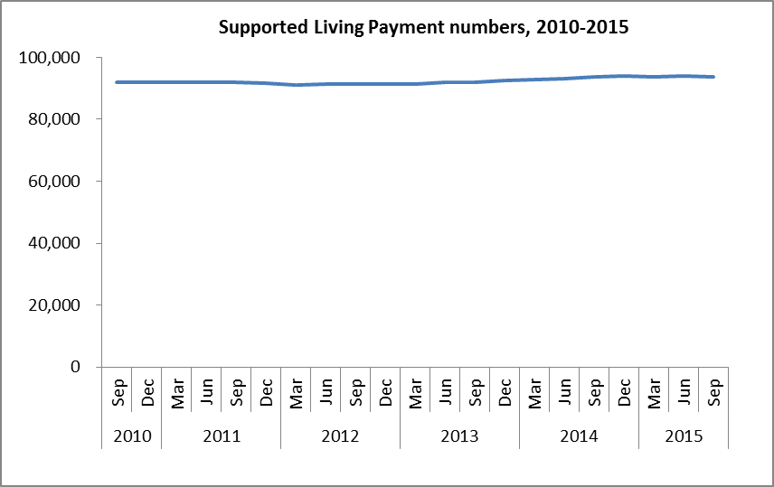
The proportion of the working-age population receiving Supported Living Payment at the end of September each year remained stable between 2010 and 2015.
