Supported Living Payment – June 2015 Quarter
Supported Living Payment (SLP) is for people who have, or care for someone with, a health condition, injury or disability that severely limits their ability to work on a long-term basis.


Key Facts
At the end of June 2015:
- 93,959 working-age people* were receiving Supported Living Payment
- three percent of the working-age population of New Zealand** were receiving Supported Living Payment
- a large majority of Supported Living Payment recipients were aged between 40 and 64 years
- ninety-five percent of Supported Living Payment recipients had been receiving a benefit continuously for more than one year. This is due to the chronic nature of their condition or disability
- around one third (32%) of those receiving Supported Living Payment – Health Condition or Disability had a psychological or psychiatric disorder.
Comparing June 2015 with June 2014:
- the number of recipients of Supported Living Payment increased by 702, or one percent
- there were small percentage increases in recipient numbers for all ethnicities apart from unspecified ethnicity
- there was a small percentage increase in Supported Living Payment numbers in the 55-64 year age group, while numbers in younger age groups remained relatively stable
- the proportion of the working–age population on Supported Living Payment remained stable.
Characteristics of working-age recipients of Supported Living Payment
at the end of June 2010, 2014 and 2015
 | Jun-2010 | Jun-2014 | Jun-2015 | Annual change
Benefit subgroup
Supported Living Payment - Health Condition or Disability (HCD) | 85,382 | 84,711 | 85,322 | 611 | 0.7%
Supported Living Payment - Caring | 6,630 | 8,546 | 8,637 | 91 | 1.1%
Gender
Male | 46,970 | 47,153 | 47,492 | 339 | 0.7%
Female | 45,042 | 46,104 | 46,467 | 363 | 0.8%
Ethnic group
NZ European | 49,129 | 48,336 | 48,347 | 11 | 0.0%
Māori | 21,014 | 22,866 | 23,448 | 582 | 2.5%
Pacific people | 5,414 | 5,954 | 6,086 | 132 | 2.2%
All other ethnicities*** | 13,910 | 13,483 | 13,491 | 8 | 0.1%
Unspecified ethnicity | 2,545 | 2,618 | 2,587 | -31 | -1.2%
Age group
18-24 years | 7,077 | 7,053 | 6,977 | -76 | -1.1%
25-39 years | 18,036 | 16,960 | 17,059 | 99 | 0.6%
40-54 years | 34,977 | 35,789 | 35,573 | -216 | -0.6%
55-64 years | 31,922 | 33,455 | 34,350 | 895 | 2.7%
Continuous duration on any benefit
One year or less | 5,849 | 7,598 | 4,887 | -2,711 | -35.7%
More than one year | 86,163 | 85,659 | 89,072 | 3,413 | 4.0%
Incapacity groups (for HCD clients)
Psychological or psychiatric condition | 24,968 | 26,892 | 27,676 | 784 | 2.9%
Intellectual disability | 11,041 | 10,500 | 10,290 | -210 | -2.0%
Musculo-skeletal system disorders | 10,143 | 9,172 | 9,101 | -71 | -0.8%
Nervous system disorders | 6,443 | 6,501 | 6,478 | -23 | -0.4%
Cardio-vascular disorders | 6,539 | 5,808 | 5,743 | -65 | -1.1%
Accidents | 4,011 | 3,706 | 3,773 | 67 | 1.8%
Cancer and congenital conditions | 6,041 | 6,432 | 6,548 | 116 | 1.8%
Other disorders and conditions | 16,196 | 15,700 | 15,713 | 13 | 0.1%
Total number of recipients of Supported Living Payment | 92,012 | 93,257 | 93,959 | 702 | 0.8%
Percentage of working-age main benefit population receiving Supported Living Payment | 27.6% | 31.8% | 32.9%
Percentage of working-age population receiving Supported Living Payment | 3.5% | 3.4% | 3.4%
*Working-age clients are aged 18-64 years. This definition reflects the minimum age of eligibility for most main benefits and the age of qualification for New Zealand Superannuation.
**Based on Statistics NZ National Population Estimate year ended June for relevant years.
***Includes Other Europeans, Asian peoples and Middle Eastern/Latin American/African peoples.

Five-year trend
The number of clients receiving Supported Living Payment at the end of June has remained relatively stable between 2010 and 2015, increasing only slightly. The long-term nature of conditions for those on Supported Living Payment mean that very few people move from Supported Living Payment into paid work or on to another benefit.
The small increase between 2010 and 2015 in numbers receiving Supported Living Payment may reflect an ageing population, as well as an increasing prevalence of health conditions and disabilities among older people.
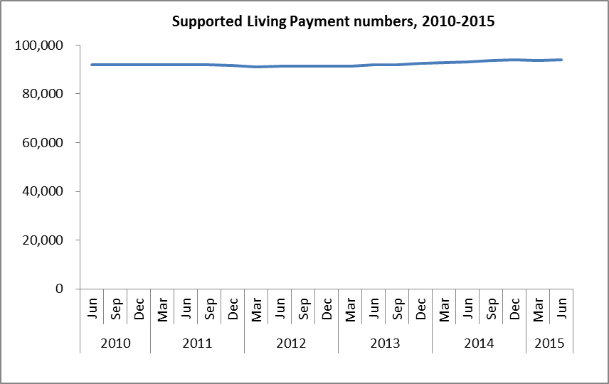
The proportion of the working-age population receiving Supported Living Payment at the end of June each year remained stable between 2010 and 2015.
