Sole Parent Support – March 2015 Quarter
Sole Parent Support (SPS) is for sole parents with dependent children under 14 years who can look or prepare for part-time work.

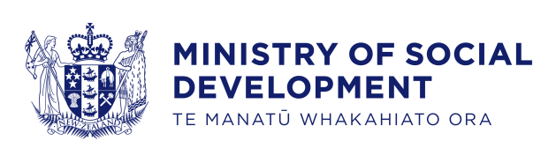
Key Facts
At the end of March 2015:
- 70,373 working-age* people were receiving Sole Parent Support
- three percent of the working-age population of New Zealand** were receiving Sole Parent Support
- the majority of Sole Parent Support recipients were female and aged between 25 and 39 years
- seventy-eight percent of Sole Parent Support recipients had been receiving a benefit continuously for more than one year.
Comparing March 2015 with March 2014:
- the number of recipients of Sole Parent Support decreased by 5,471, or seven percent
- there were decreases in benefit receipt across all ethnic groups
- there were decreases in Sole Parent Support numbers across all age groups
- the proportion of the working-age population on Sole Parent Support remained stable.
Characteristics of working-age recipients of Sole Parent Support
at the end of March 2010, 2014 and 2015
 | Mar-2010 | Mar-2014 | Mar-2015 | Annual change
Gender
Male | 8,327 | 6,476 | 5,936 | -540 | -8%
Female | 78,620 | 69,368 | 64,437 | -4,931 | -7%
Ethnic group
NZ European | 32,093 | 25,934 | 23,317 | -2,617 | -10%
Māori | 37,506 | 34,942 | 32,932 | -2,010 | -6%
Pacific peoples | 8,810 | 7,447 | 6,898 | -549 | -7%
All other ethnicities*** | 7,044 | 6,443 | 6,257 | -186 | -3%
Unspecified ethnicity | 1,494 | 1,078 | 969 | -109 | -10%
Age group
18-24 years | 19,325 | 16,951 | 15,228 | -1,723 | -10%
25-39 years | 46,725 | 40,714 | 38,700 | -2,014 | -5%
40-54 years | 19,933 | 17,177 | 15,485 | -1,692 | -10%
55-64 years | 964 | 1,002 | 960 | -42 | -4%
Continuous duration on any benefit
One year or less | 19,729 | 14,406 | 15,193 | 787 | 5%
More than one year | 67,218 | 61,438 | 55,180 | -6,258 | -10%
Caring for a dependent child
Under 5 years | 47,057 | 42,924 | 40,054 | -2,870 | -7%
5-13 years | 39,711 | 32,834 | 30,253 | -2,581 | -8%
Total number of recipients of Sole Parent Support | 86,947 | 75,844 | 70,373 | -5,471 | -7%
Percentage of working-age main benefit population receiving Sole Parent Support | 27% | 26% | 25%
Percentage of working-age population receiving Sole Parent Support | 3% | 3% | 3%
*Working-age clients are aged 18-64 years. This definition reflects the minimum age of eligibility for most main benefits and the age of qualification for New Zealand Superannuation.
**Based on Statistics NZ National Population Estimate year ended June 2014.
***Includes Other Europeans, Asian people and Middle Eastern/Latin American/African peoples.

Five-year trend
The number of clients receiving Sole Parent Support at the end of March increased between 2010 and 2011, then decreased over the last four years. This pattern reflects changes in economic conditions.
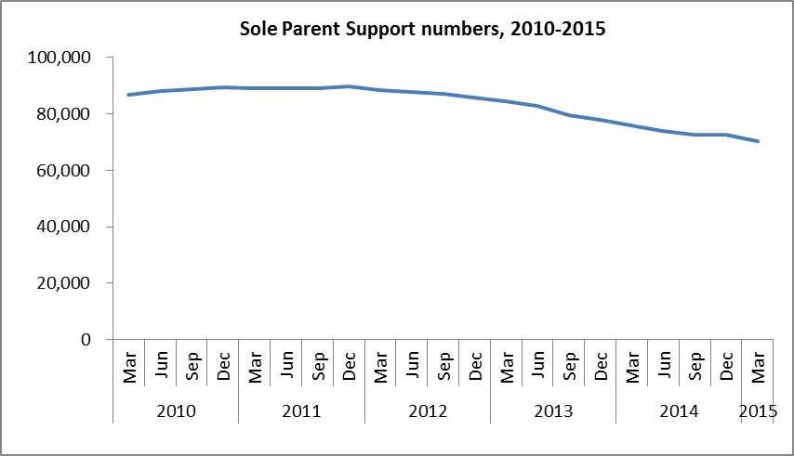
The proportion of the working-age population who were receiving Sole Parent Support at the end of March remained relatively stable between 2010 and 2012, but decreased over the last three years.
