Jobseeker Support – June 2015 Quarter

Jobseeker Support (JS) is for people who can usually look or prepare for work. It also includes people who can only work part-time or cannot look for work at the moment, for example because they have a health condition, injury or disability.

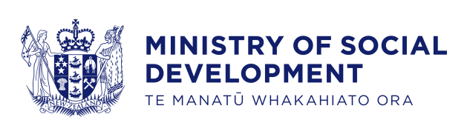
Key Facts
At the end of June 2015:
- 118,072 working-age* people were receiving Jobseeker Support
- four percent of the working-age population of New Zealand** were receiving Jobseeker Support
- fifty-six percent of Jobseeker Support recipients were male
- fifty-six percent of Jobseeker Support recipients had been receiving a benefit continuously for more than one year.
Comparing June 2015 with June 2014:
- the number of recipients of Jobseeker Support decreased by 3,059, or three percent
- there were decreases in Jobseeker Support numbers across all age groups except the 25-39 year age group. The 40-54 year age group had the largest percentage decrease
- there were decreases in Jobseeker Support numbers across all ethnic groups except Māori which were relatively unchanged
- the proportion of the working-age population in New Zealand receiving Jobseeker Support decreased slightly.
Characteristics of working-age recipients of Jobseeker Support
at the end of June 2010, 2014 and 2015
 | Jun-2010 | Jun-2014 | Jun-2015 | Annual change
Benefit subgroup
Jobseeker Support – Work Ready | 87,941 | 65,321 | 63,255 | -2,066 | -3.2%
Jobseeker Support – Health Condition or Disability (HCD) | 58,444 | 55,810 | 54,817 | -993 | -1.8%
Gender
Male | 85,029 | 66,997 | 65,612 | -1,385 | -2.1%
Female | 61,356 | 54,134 | 52,460 | -1,674 | -3.1%
Ethnic group
NZ European | 64,359 | 50,572 | 48,481 | -2,091 | -4.1%
Māori | 44,817 | 41,103 | 41,299 | 196 | 0.5%
Pacific peoples | 12,562 | 9,128 | 8,553 | -575 | -6.3%
All other ethnicities*** | 20,430 | 17,777 | 17,347 | -430 | -2.4%
Unspecified ethnicity | 4,217 | 2,551 | 2,392 | -159 | -6.2%
Age group
18-24 years | 32,281 | 24,342 | 23,656 | -686 | -2.8%
25-39 years | 40,217 | 30,748 | 30,853 | 105 | 0.3%
40-54 years | 46,954 | 39,917 | 38,042 | -1,875 | -4.7%
55-64 years | 26,933 | 26,124 | 25,521 | -603 | -2.3%
Continuous duration of any benefit
One year or less | 68,706 | 53,600 | 52,517 | -1,083 | -2.0%
More than one year | 77,679 | 67,531 | 65,555 | -1,976 | -2.9%
Incapacity groups for HCD clients
Psychological or psychiatric condition | 23,926 | 23,426 | 23,669 | 243 | 1.0%
Musculo-skeletal system disorders | 8,518 | 9,123 | 9,030 | -93 | -1.0%
Accidents | 4,543 | 4,310 | 3,859 | -451 | -10.5%
Cardio-vascular disorders | 3,202 | 2,718 | 2,700 | -18 | -0.7%
Pregnancy-related conditions | 1,251 | 859 | 760 | -99 | -11.5%
Other disorders and conditions | 17,004 | 15,374 | 14,799 | -575 | -3.7%
Total number of recipients of Jobseeker Support | 146,385 | 121,131 | 118,072 | -3,059 | -2.5%
Percentage of working-age main benefit population receiving Jobseeker Support | 44.0% | 41.3% | 41.4%
Percentage of working-age population receiving Jobseeker Support | 5.5% | 4.5% | 4.3%
*Working-age clients are aged 18-64 years. This definition reflects the minimum age of eligibility for most main benefits and the age of qualification for New Zealand Superannuation.
**Based on Statistics NZ National Population Estimate year ended June for relevant years.
***Includes Other Europeans, Asian peoples and Middle Eastern/Latin American/African people.

Five-year trend
The number of clients receiving Jobseeker Support at the end of June has decreased over the last five years.
Changes between 2010 and 2015 which have affected the number of clients receiving Jobseeker Support include changes in economic conditions. The decrease in Jobseeker Support numbers over the last five years reflects a slowly recovering employment situation and an increased focus by Work and Income on moving job seekers into paid work.
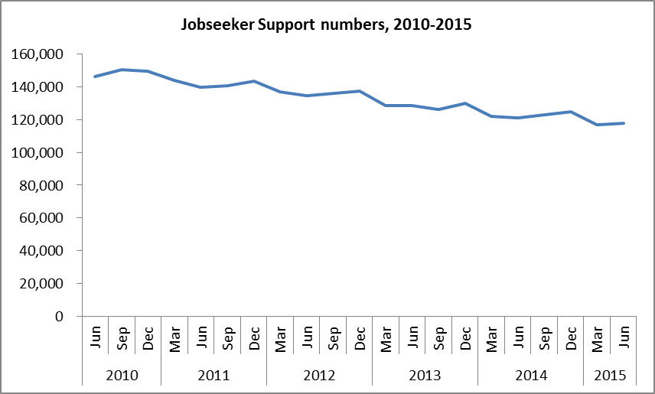

The proportion of the working-age population who were receiving Jobseeker Support at the end of June has decreased over the last five years.
