All Main Benefits – June 2015 Quarter

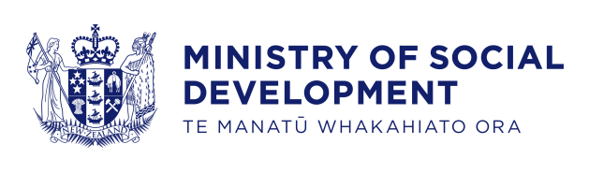
Key Facts
At the end of June 2015:
- 285,349 working-age* people were receiving a main benefit
- ten percent of the working-age population of New Zealand** were receiving a main benefit
- over half (58%) of main benefit recipients were female, and 42 percent were male
- forty-one percent of main benefit recipients were receiving Jobseeker Support, 33 percent were receiving Supported Living Payment and 24 percent were receiving Sole Parent Support
- around three-quarters (74%) of main benefit recipients had been receiving a benefit continuously for more than one year.
Comparing June 2015 with June 2014:
- the number of main benefit recipients decreased by 8,237, or three percent. This decrease was largely driven by decreases in Sole Parent Support and Jobseeker Support numbers. In contrast, Supported Living Payment numbers increased slightly
- Jobseeker Support numbers decreased in all Work and Income regions except Northland, Waikato, Taranaki, Wellington and Nelson. Sole Parent Support numbers decreased in all regions, while Supported Living Payment numbers increased or remained relatively unchanged in all regions except Nelson
- the proportion of the working-age population in New Zealand receiving a main benefit fell slightly (from 10.8% to 10.3%).
Summary of working-age recipients of main benefits
at the end of June 2010, 2014 and 2015
Benefit | Jun-2010 | Jun-2014 | Jun-2015 | Annual change
Jobseeker Support (JS) | 146,385 | 121,131 | 118,072 | -3,059 | -2.5%
Sole Parent Support (SPS) | 88,110 | 74,027 | 69,240 | -4,787 | -6.5%
Supported Living Payment (SLP) | 92,012 | 93,257 | 93,959 | 702 | 0.8%
Youth Payment/Young Parent Payment (YP/YPP)*** | 1,442 | 1,147 | 1,110 | -37 | -3.2%
Other**** | 4,975 | 4,024 | 2,968 | -1,056 | -26.2%
Total working-age recipients | 332,924 | 293,586 | 285,349 | -8,237 | -2.8%
Percentage of working-age population on main benefits | 12.5% | 10.8% | 10.3%
*Working-age clients are aged 18-64 years. This definition reflects the minimum age of eligibility for most main benefits and the age of qualification for New Zealand Superannuation.
**Based on Statistics NZ National Population Estimate year ended June for relevant years.
***YP/YPP recipients who are 18+ years. There were 1,998 YP/YPP recipients aged 16-17 years at the end of June 2015. YP/YPP was introduced in August 2012; figures prior to this are estimates.
****Other includes Emergency Maintenance Allowance (EMA), Emergency Benefit (EB), Jobseeker Student Hardship (JSSH) and Widow’s Benefit Overseas (WBO).

Five-year trend
Main benefit numbers in June 2015 were lower than in June 2010. Changes in benefit numbers over this period largely reflect changes in economic conditions.
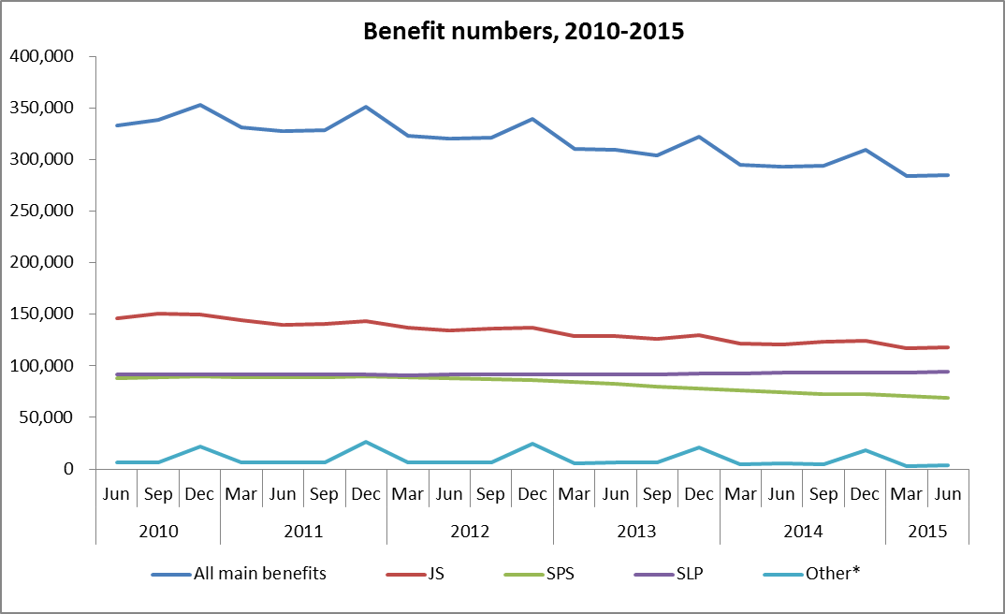
*Other includes Emergency Maintenance Allowance (EMA), Emergency Benefit (EB), Jobseeker Student Hardship (JSSH), Widow’s Benefit Overseas (WBO) and Youth Payment/Young Parent Payment (YP/YPP).

The proportion of the working-age population who were receiving a main benefit at the end of June decreased over the last five years. The main driver for this pattern has been changes in economic conditions.
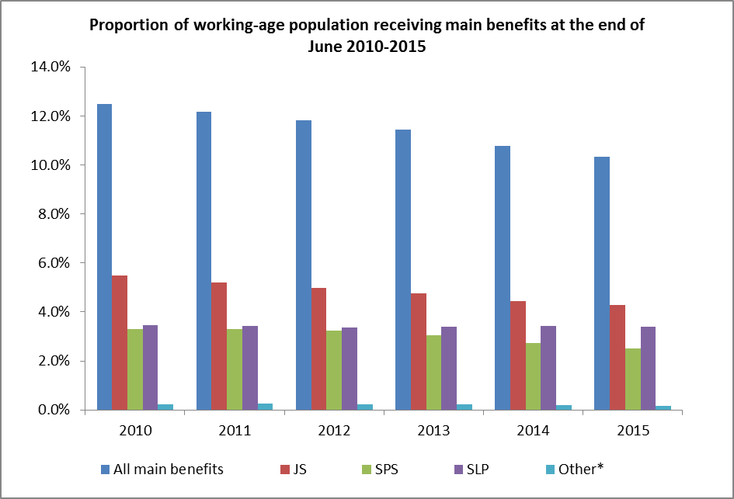
*Other includes EMA, EB, JSSH, WBO and YP/YPP.

