Supported Living Payment - September 2014 quarter
Supported Living Payment (SLP) is for people who have or care for someone with a health condition, injury or disability that severely limits their ability to work on a long-term basis.

Key Facts

At the end of September 2014:
- 93,852 working-age people were receiving Supported Living Payment.
- 3.4 percent of the working-age population of New Zealand were receiving Supported Living Payment.
- Supported Living Payment recipients were more likely to be aged 40 years or over.
- 95 percent of recipients of Supported Living Payment had been receiving a benefit continuously for more than one year. This is due to the chronic nature of their condition or disability.
- Nearly a third (32%) of those receiving Supported Living Payment – Health Condition or Disability had a psychological or psychiatric disorder.

Comparing September 2013 with September 2014:
- The number of recipients of Supported Living Payment increased by 1,780, or 2 percent.
- There were small percentage increases in benefit receipt for Mäori and Pacific peoples, while New Zealand European numbers remained relatively stable.
- There was a small proportional increase in Supported Living Payment numbers in the 55-64 year age group, while numbers in younger age groups remained relatively stable.
- The proportion of the working–age population on Supported Living Payment remained stable.

Characteristics of working-age recipients of Supported Living Payment, at the end of September 2009, 2013 and 2014
 | Sep-2009 | Sep-2013 | Sep-2014 | Annual change
Supported Living Payment - Health Condition or Disability (HCD) | 85,015 | 83,880 | 85,216 | 1,336 | 2%
Supported Living Payment - Caring | 6,327 | 8,191 | 8,636 | 445 | 5%
Male | 46,562 | 46,932 | 47,493 | 561 | 1%
Female | 44,780 | 45,140 | 46,359 | 1,219 | 3%
NZ European | 49,163 | 47,976 | 48,497 | 521 | 1%
Mäori | 20,786 | 22,293 | 23,142 | 849 | 4%
Pacific people | 5,189 | 5,803 | 6,042 | 239 | 4%
All other ethnicities* | 13,914 | 13,416 | 13,528 | 112 | 1%
Unspecified ethnicity | 2,290 | 2,584 | 2,643 | 59 | 2%
18-24 years | 6,960 | 7,097 | 7,007 | -90 | -1%
25-39 years | 18,287 | 16,921 | 17,051 | 130 | 1%
40-54 years | 34,697 | 35,522 | 36,079 | 557 | 2%
55-64 years | 31,398 | 32,532 | 33,715 | 1,183 | 4%
Continuous duration on any benefit
One year or less | 6,143 | 7,642 | 5,067 | -2,575 | -34%
More than one year | 85,199 | 84,430 | 88,785 | 4,355 | 5%
Incapacity groups (for HCD clients)
Psychological or psychiatric condition | 24,666 | 26,325 | 27,257 | 932 | 4%
Intellectual disability | 11,109 | 10,626 | 10,451 | -175 | -2%
Musculo-skeletal system disorders | 10,269 | 9,059 | 9,147 | 88 | 1%
Nervous system disorders | 6,457 | 6,372 | 6,521 | 149 | 2%
Cardio-vascular disorders | 6,478 | 5,822 | 5,810 | -12 | 0%
Accidents | 4,221 | 3,682 | 3,726 | 44 | 1%
Cancer and congenital conditions | 5,920 | 6,391 | 6,469 | 78 | 1%
Other disorders and conditions | 15,895 | 15,603 | 15,835 | 232 | 1%
Total number of recipients of SLP | 91,342 | 92,072** | 93,852 | 1,780 | 2%
Percentage of working-age main benefit population receiving SLP | 28% | 30% | 32%
Percentage of working-age population receiving SLP | 3.4% | 3.4% | 3.4%
* Includes Other Europeans, Asian peoples and Middle Eastern/Latin American/African peoples.
** For September 2013, total Supported Living Payment (SLP) recipients include one client who is yet to be assigned a subcategory.

Five-year trend
The number of clients receiving Supported Living Payment at the end of September has remained relatively stable between 2009 and 2014, increasing only slightly. The long-term nature of conditions for those on Supported Living Payment mean that very few people move from SLP into paid work or on to another benefit.
The slight increase between 2009 and 2014 in numbers receiving SLP may reflect an ageing population as well as an increasing prevalence of health conditions and disabilities among older people.

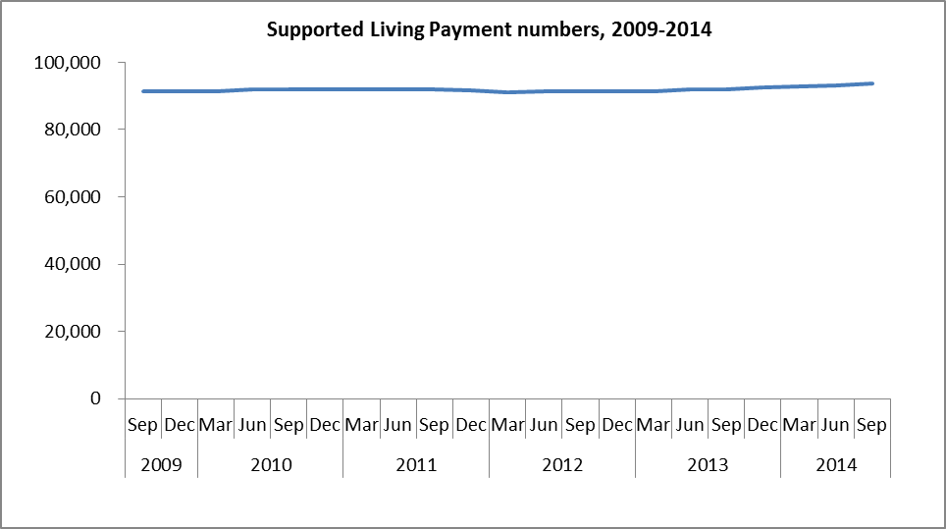

The proportion of the working-age population receiving SLP at the end of September each year remained stable between 2009 and 2014.

