Supported Living Payment - March 2014 quarter
Supported Living Payment (SLP) is for people who have or care for someone with a health condition, injury or disability that severely limits their ability to work on a long-term basis.

Key Facts

At the end of March 2014:
- 92,960 working-age people were receiving Supported Living Payment.
- 3.3 percent of the working-age population of New Zealand were receiving Supported Living Payment.
- Supported Living Payment recipients are more likely to be aged over 40.
- 92 percent of recipients of Supported Living Payment had been receiving any benefit continuously for more than one year. This is due to the chronic nature of their condition or disability.
- Nearly a third (32%) of those receiving Supported Living Payment – Health Condition or Disability had a psychological or psychiatric disorder.

Between March 2013 and March 2014:
- The number of recipients of Supported Living Payment remained relatively stable, increasing by 1,593, or 2 percent.
- There were small percentage increases in benefit receipt for Mäori and Pacific peoples, while New Zealand European numbers remained stable.
- There was a small proportional increase in Supported Living Payment numbers in the 55-64 year age group.
- The percentage of the working–age population on Supported Living Payment remained stable.

Characteristics of working-age recipients of Supported Living Payment, at the end of March 2009, 2013 and 2014
 | Mar-2009 | Mar-2013 | Mar-2014 | Annual change
Supported Living Payment - Health Condition or Disability (HCD) | 83,961 | 83,409 | 84,548 | 1,139 | 1%
Supported Living Payment - Caring | 5,749 | 7,958 | 8,412 | 454 | 6%
Male | 45,645 | 46,770 | 47,108 | 338 | 1%
Female | 44,065 | 44,597 | 45,852 | 1,255 | 3%
NZ European | 48,597 | 47,749 | 48,251 | 502 | 1%
Mäori | 20,162 | 21,892 | 22,689 | 797 | 4%
Pacific people | 4,990 | 5,741 | 5,900 | 159 | 3%
All other ethnicities* | 13,764 | 13,432 | 13,514 | 82 | 1%
Unspecified ethnicity | 2,197 | 2,553 | 2,606 | 53 | 2%
18-24 | 6,738 | 7,138 | 7,089 | -49 | -1%
25-39 | 18,161 | 16,873 | 16,920 | 47 | 0%
40-54 | 34,084 | 35,278 | 35,795 | 517 | 1%
55-64 | 30,727 | 32,078 | 33,156 | 1,078 | 3%
Continuous duration on any benefit
One year or less | 5,952 | 4,736 | 7,576 | 2,840 | 60%
More than one year | 83,758 | 86,631 | 85,384 | -1,247 | -1%
Incapacity groups (for HCD clients)
Psychological or psychiatric condition | 23,995 | 25,927 | 26,731 | 804 | 3%
Intellectual disability | 11,106 | 10,713 | 10,552 | -161 | -2%
Musculo-skeletal system disorders | 10,409 | 9,115 | 9,140 | 25 | 0%
Nervous system disorders | 6,473 | 6,345 | 6,453 | 108 | 2%
Cardio-vascular disorders | 6,368 | 5,910 | 5,813 | -97 | -2%
Accidents | 4,457 | 3,639 | 3,709 | 70 | 2%
Cancer and congenital conditions | 5,844 | 6,292 | 6,418 | 126 | 2%
Other disorders and conditions | 15,309 | 15,468 | 15,732 | 264 | 2%
Total number of recipients of SLP | 89,710 | 91,367 | 92,960 | 1,593 | 2%
Percentage of working-age main benefit population receiving SLP | 31% | 29% | 31%
Percentage of working-age population receiving SLP | 3.4% | 3.3% | 3.3%
* Includes Other Europeans, Asian peoples and Middle Eastern/Latin American/African peoples.

Five-year trend
The number of clients receiving Supported Living Payment at the end of March has remained relatively stable between 2009 and 2014, increasing only slightly. The long-term nature of conditions for those on Supported Living Payment mean that very few people move from SLP into paid work or on to another benefit.
The slight increase in numbers receiving SLP between 2009 and 2014 may reflect an ageing population as well as the increasing movement of people living with long-term health conditions and disabilities into the community.

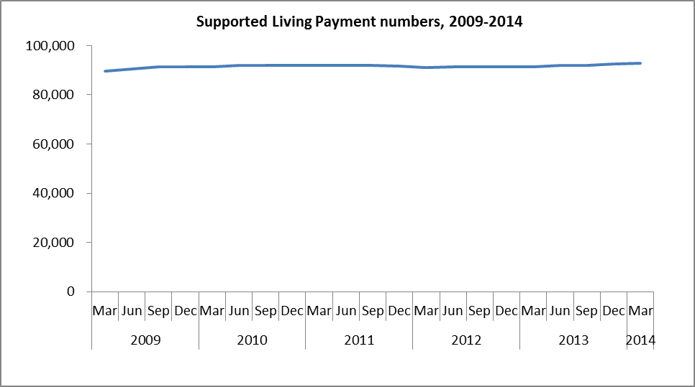

The proportion of the working-age population receiving SLP at the end of March each year remained stable between 2009 and 2014.

