Sole Parent Support - March 2014 quarter
Sole Parent Support (SPS) is for sole parents with dependent children under 14 who can look or prepare for part-time work.
Key Facts

At the end of March 2014:
- 75,844 working-age people were receiving Sole Parent Support.
- 2.7 percent of the working-age population of New Zealand were receiving Sole Parent Support.
- Sole Parent Support recipients are more likely to be aged between 25 and 39, and to be female.
- 81 percent of recipients of Sole Parent Support had been receiving any benefit continuously for more than one year.

Between March 2013 and March 2014:
- The number of recipients of Sole Parent Support decreased by 8,618, or 10 percent.
- There were decreases in benefit receipt across all ethnic groups. Pacific peoples and NZ Europeans had the largest percentage decrease.
- There were decreases in SPS numbers across all age groups.
- The percentage of the working-age population on Sole Parent Support fell.

Characteristics of working-age recipients of Sole Parent Support, at the end of March 2009, 2013 and 2014
 | Mar-2009 | Mar-2013 | Mar-2014 | Annual change
Male | 7,367 | 7,689 | 6,476 | -1,213 | -16%
Female | 74,436 | 76,773 | 69,368 | -7,405 | -10%
NZ European | 30,374 | 29,627 | 25,934 | -3,693 | -12%
Mäori | 35,105 | 37,950 | 34,942 | -3,008 | -8%
Pacific peoples | 8,296 | 8,415 | 7,447 | -968 | -12%
All other ethnicities* | 6,637 | 7,167 | 6,443 | -724 | -10%
Unspecified ethnicity | 1,391 | 1,303 | 1,078 | -225 | -17%
18-24 | 17,827 | 18,913 | 16,951 | -1,962 | -10%
25-39 | 44,643 | 44,734 | 40,714 | -4,020 | -9%
40-54 | 18,435 | 19,735 | 17,177 | -2,558 | -13%
55-64 | 898 | 1,080 | 1,002 | -78 | -7%
Continuous duration on any benefit
One year or less | 19,822 | 15,311 | 14,406 | -905 | -6%
More than one year | 61,981 | 69,151 | 61,438 | -7,713 | -11%
Caring for a dependent child
Under 5 years | 44,014 | 46,402 | 42,924 | -3,478 | -7%
5-13 years | 37,629 | 37,939 | 32,834 | -5,105 | -13%
Total number of recipients of SPS | 81,803 | 84,462 | 75,844 | -8,618 | -10%
Percentage of working-age main benefit population receiving SPS | 28% | 27% | 26%
Percentage of working-age population receiving SPS | 3.1% | 3.1% | 2.7%
* Includes Other Europeans, Asian peoples and Middle Eastern/Latin American/African peoples.

Five-year trend
The number of clients receiving Sole Parent Support at the end of March increased between 2009 and 2011, then decreased over the last three years. This pattern reflects changes in economic conditions.

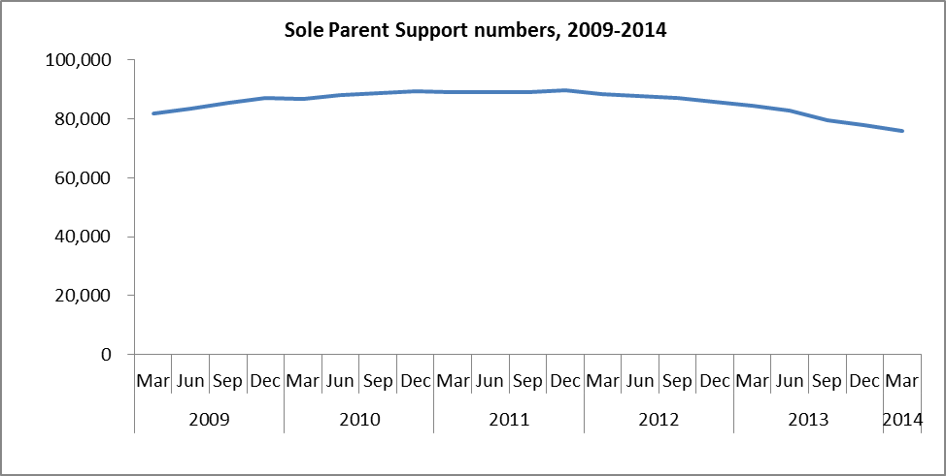

The proportion of the working-age population who were receiving Sole Parent Support at the end of March trended upward between 2009 and 2011, but decreased over the last three years.

