Sole Parent Support - December 2014 quarter
Sole Parent Support (SPS) is for sole parents with dependent children under 14 who can look or prepare for part-time work.
Key Facts

At the end of December 2014:
- 72,534 working-age people were receiving Sole Parent Support.
- Three percent of the working-age population of New Zealand were receiving Sole Parent Support.
- The majority of Sole Parent Support recipients were female and aged between 25 and 39 years.
- Seventy-nine percent of Sole Parent Support recipients had been receiving a benefit continuously for more than one year.

Comparing December 2013 with December 2014:
- The number of recipients of Sole Parent Support decreased by 5,309, or seven percent.
- There were decreases in benefit receipt across all ethnic groups.
- There were decreases in Sole Parent Support numbers across all age groups.
- The proportion of the working-age population on Sole Parent Support fell slightly.

Characteristics of working-age recipients of SPS at the end of December 2009, 2013 and 2014
 | Dec-2009 | Dec-2013 | Dec-2014 | Annual change
Male | 8,391 | 6,823 | 6,093 | -730 | -11%
Female | 78,676 | 71,020 | 66,441 | -4,579 | -6%
NZ European | 32,378 | 26,976 | 24, 329 | -2,647 | -10%
Mäori | 37,275 | 35,662 | 33,940 | -1,722 | -5%
Pacific peoples | 8,797 | 7,536 | 7,052 | -484 | -6%
All other ethnicities* | 7,059 | 6,552 | 6,196 | -356 | -5%
Unspecified ethnicity | 1,558 | 1,117 | 1,017 | -100 | -9%
18-24 years | 19,005 | 17,346 | 15,685 | -1,661 | -10%
25-39 years | 46,720 | 41,712 | 39,785 | -1,927 | -5%
40-54 years | 20,305 | 17,729 | 16,077 | -1,652 | -9%
55-64 years | 1,037 | 1,056 | 987 | -69 | -7%
Continuous duration on any benefit
One year or less | 20,751 | 14,652 | 15,325 | 673 | 5%
More than one year | 66,316 | 63,191 | 57,209 | -5,982 | -9%
Caring for a dependent child
Under 5 years | 46,424 | 43,620 | 41,004 | -2,616 | -6%
5-13 years | 39,817 | 34,122 | 31,402 | -2,720 | -8%
Total number of recipients of SPS | 87,067 | 77,843 | 72,534 | -5,309 | -7%
Percentage of working-age main benefit population receiving SPS | 25.2% | 24.2% | 23.5%
Percentage of working-age population receiving SPS | 3.3% | 2.9% | 2.6%
* Includes Other Europeans, Asian peoples and Middle Eastern/Latin American/African peoples.

Five-year trend
The number of clients receiving Sole Parent Support at the end of December increased between 2009 and 2011, then decreased over the last three years. This pattern reflects changes in economic conditions.
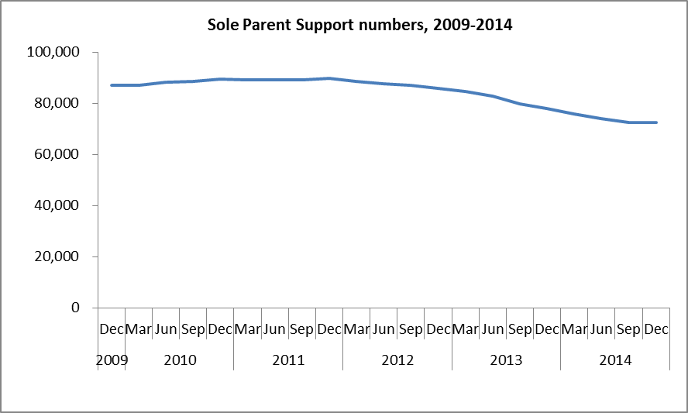

The proportion of the working-age population who were receiving Sole Parent Support at the end of December remained relatively stable between 2009 and 2011, but decreased over the last three years.
