Jobseeker Support - September 2014 quarter
Jobseeker Support (JS) is for people who can usually look or prepare for work. It also includes people who can only work part-time or cannot look for work at the moment, for example because they have a health condition, injury or disability.

Key Facts

At the end of September 2014:
- 123,133 working-age people were receiving Jobseeker Support.
- 4.5 percent of the working-age population of New Zealand were receiving Jobseeker Support.
- Jobseeker Support recipients were more likely to be male.
- 55 percent of recipients of Jobseeker Support had been receiving a benefit continuously for more than one year.

Comparing September 2013 with September 2014:
- The number of recipients of Jobseeker Support decreased by 3,337, or 3 percent.
- There were decreases in JS numbers across all age groups. The 40-54 year age group had the largest percentage decrease.
- There were decreases in JS numbers across all ethnic groups except Maori.
- The proportion of the working-age population in New Zealand receiving Jobseeker Support fell.

Characteristics of working-age recipients of Jobseeker Support, at the end of September 2009, 2013 and 2014
 | Sep-2009 | Sep-2013 |  | Sep-2014 | Annual change
Jobseeker Support – Work Ready | 87,259 | 68,605 |  | 66,754 | -1,851 | -3%
Jobseeker Support – Health Condition or Disability (HCD) | 56,369 | 57,865 |  | 56,379 | -1,486 | -3%
Male | 84,914 | 70,614 |  | 68,768 | -1,846 | -3%
Female | 58,714 | 55,856 | 54,365 |  | -1,491 | -3%
NZ European | 62,934 | 53,815 |  | 50,752 | -3,063 | -6%
Mäori | 44,599 | 42,277 |  | 42,775 | 498 | 1%
Pacific peoples | 12,293 | 9,546 |  | 9,163 | -383 | -4%
All other ethnicities* | 19,503 | 18,162 |  | 17,925 | -237 | -1%
Unspecified ethnicity | 4,299 | 2,670 |  | 2,518 | -152 | -6%
18-24 years | 33,643 | 24,712 |  | 24,640 | -72 | 0%
25-39 years | 39,775 | 31,861 |  | 31,605 | -256 | -1%
40-54 years | 44,686 | 42,689 |  | 40,434 | -2,255 | -5%
55-64 years | 25,524 | 27,208 |  | 26,454 | -754 | -3%
Continuous duration on any benefit
One year or less | 82,803 | 54,715 |  | 55,417 | 702 | 1%
More than one year | 60,825 | 71,755 |  | 67,716 | -4,039 | -6%
Incapacity groups (for HCD clients)
Psychological or psychiatric condition | 22,810 | 24,470 |  | 23,698 | -772 | -3%
Musculo-skeletal system disorders | 8,208 | 9,300 |  | 9,240 | -60 | -1%
Accidents | 4,492 | 4,569 |  | 4,302 | -267 | -6%
Cardio-vascular disorders | 3,179 | 2,903 |  | 2,790 | -113 | -4%
Pregnancy-related conditions | 1,306 | 869 |  | 855 | -14 | -2%
Other disorders and conditions | 16,374 | 15,754 |  | 15,494 | -260 | -2%
Total number of recipients of JS | 143,628 | 126,470 |  | 123,133 | -3,337 | -3%
Percentage of working-age main benefit population receiving JS | 44% | 42% |  | 42%
Percentage of working-age population receiving JS | 5.4% | 4.7% |  | 4.5%
* Includes Other Europeans, Asian peoples and Middle Eastern/Latin American/African peoples.

Five-year trend
The number of clients receiving Jobseeker Support at the end of September increased between 2009 and 2010, followed by a decrease over the last four years.
Changes between 2009 and 2014 which have affected the number of clients receiving Jobseeker Support include changed economic conditions. The decrease in JS numbers over the last four years reflects a slowly recovering employment situation and an increased focus by Work and Income on moving job seekers into paid work.

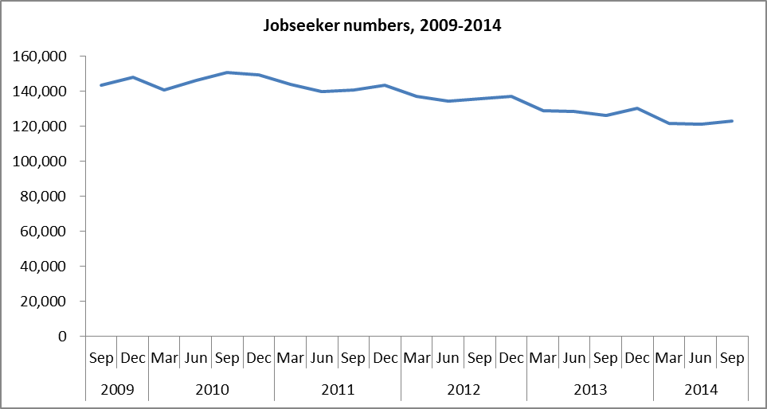

The proportion of the working-age population who were receiving Jobseeker Support at the end of September increased between 2009 and 2010 before decreasing over the last four years.

