All main benefits - September 2014 quarter
Key Facts

At the end of September 2014:

- 294,321 working-age* people were receiving a main benefit.
- 10.7 percent of the working-age population of New Zealand were receiving a main benefit.**
- Over half (58%) of main benefit recipients were female, and 42 percent were male.
- 42 percent of main benefit recipients were receiving Jobseeker Support (JS), 32 percent were receiving Supported Living Payment (SLP) and 25 percent were receiving Sole Parent Support (SPS).
- Nearly three quarters (74%) of recipients of main benefits had been receiving their current benefit continuously for more than one year.

Comparing September 2013 with September 2014:
- The number of recipients of main benefits decreased by 10,073, or 3 percent. This decrease was largely driven by decreases in Sole Parent Support and Jobseeker Support numbers.
- Supported Living Payment numbers increased slightly.
- JS numbers decreased in all Work and Income regions except Northland, Waikato, Bay of Plenty, Central and Wellington. SPS numbers decreased in all regions, and SLP numbers increased slightly or remained stable in all regions.
- The proportion of the working-age population in New Zealand receiving a main benefit fell.

Summary of working-age* clients receiving main benefits, end of September 2009, 2013 and 2014
Benefit | Sep-2009 | Sep-2013 | Sep-2014 | Annual Change
Jobseeker Support (JS) | 143,628 | 126,470 | 123,133 | -3,337 | -3%
Sole Parent Support (SPS) | 85,319 | 79,699 | 72,589 | -7,110 | -9%
Supported Living Payment (SLP) | 91,342 | 92,072 | 93,852 | 1,780 | 2%
Youth Payment/Young Parent Payment (YP/YPP)*** | 1,486 | 1,293 | 1,335 | 42 | 3%
Other**** | 5,036 | 4,860 | 3,412 | -1,448 | -30%
Total working-age recipients | 326,811 | 304,394 | 294,321 | -10,073 | -3%
Percentage of working-age population on main benefits | 12.3% | 11.2% | 10.7%

*Working-age clients are aged 18-64. This definition reflects the minimum age of eligibility for most main benefits and the age of qualification for New Zealand Superannuation.
**Based on Statistics NZ National Population Estimates as at 31 March 2014.
***Youth Payment/Young Parent Payment recipients who are 18+ years. There were 2,013 YP/YPP recipients aged 16-17 years at the end of September 2014. YP/YPP was introduced in August 2012; figures prior to this are estimates.
****Other includes Emergency Maintenance Allowance (EMA), Emergency Benefit (EB), Jobseeker Student Hardship (JSSH) and Widow’s Benefit Overseas (WBO).

Five-year trend
Main benefit numbers in September 2014 were lower than in September 2009. Changes in benefit numbers over this period largely reflect changes in economic conditions.

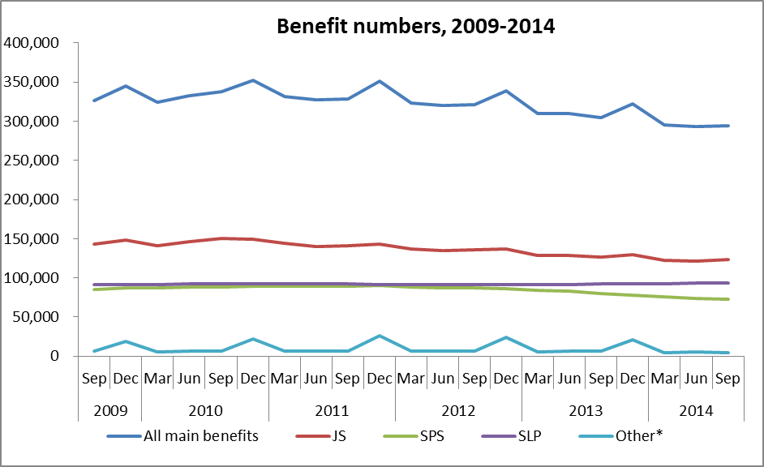
* Other includes Emergency Maintenance Allowance (EMA), Emergency Benefit (EB), Jobseeker Student Hardship (JSSH), Widow’s Benefit Overseas (WBO) and Youth Payment and Young Parent Payment (YP/YPP).

The proportion of the working-age population who were receiving a main benefit at the end of September increased between 2009 and 2010, but has decreased over the last four years. The main driver for this pattern has been changes in economic conditions.

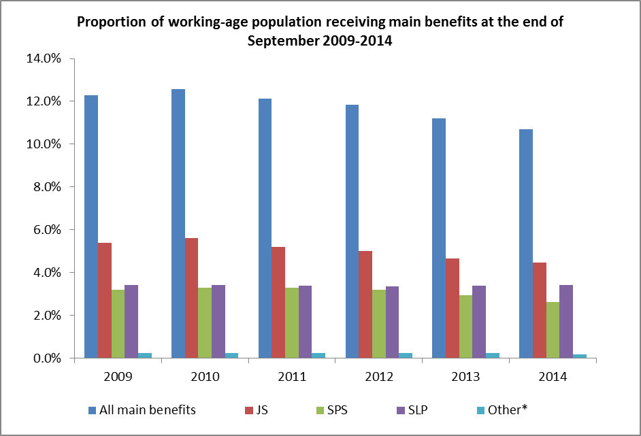
* Other includes Emergency Maintenance Allowance (EMA), Emergency Benefit (EB), Jobseeker Student Hardship (JSSH), Widow’s Benefit Overseas (WBO) and Youth Payment and Young Parent Payment (YP/YPP).

