All main benefits - March 2014 quarter
Key Facts

At the end of March 2014:

- 295,320 working-age* people were receiving a main benefit.
- 10.6 percent of the working-age population of New Zealand were receiving a main benefit.**
- Over half (58%) of main benefit recipients were female, and 42 percent were male.
- 41 percent of main benefit recipients were receiving Jobseeker Support (JS), 31 percent were receiving Supported Living Payment and 26 percent were receiving Sole Parent Support.
- Nearly three quarters (74%) of recipients of main benefits had been receiving their current benefit continuously for more than one year.

Between March 2013 and March 2014:
- The number of recipients of main benefits decreased by 14,826, or 5 percent. This decrease was largely driven by decreases in Sole Parent Support and Jobseeker Support numbers.
- Supported Living Payment (SLP) numbers remained relatively stable.
- JS numbers decreased in all Work and Income regions except Waikato. SPS numbers decreased in all regions, and SLP numbers increased slightly in all regions except the Southern region.
- The percentage of the working-age population in New Zealand receiving a main benefit fell.

Summary of working-age* clients receiving main benefits, end of March 2009, 2013 and 2014
Benefit | Mar-2009 | Mar-2013 | Mar-2014 | Annual Change
Jobseeker Support (JS) | 111,886 | 128,784 | 121,953 | -6,831 | -5%
Sole Parent Support (SPS) | 81,803 | 84,462 | 75,844 | -8,618 | -10%
Supported Living Payment (SLP) | 89,710 | 91,367 | 92,960 | 1,593 | 2%
Youth Payment/Young Parent Payment (YP/YPP)*** | 1,460 | 1,034 | 949 | -85 | -8%
Other**** | 4,100 | 4,499 | 3,614 | -885 | -20%
Total working-age recipients | 288,959 | 310,146 | 295,320 | -14,826 | -5%
Percentage of working-age population on main benefits | 10.9% | 11.3% | 10.6%

*Working-age clients are aged 18-64. This definition reflects the minimum age of eligibility for most main benefits and the age of qualification for New Zealand Superannuation.
**Based on Statistics NZ National Population Estimates as at 30 September 2013.
***Youth Payment/Young Parent Payment recipients who are 18+ years. There were 1,860 YP/YPP recipients aged 16-17 years at the end of March 2014. YP/YPP was introduced in August 2012; figures prior to this are estimates.
****Other includes Emergency Maintenance Allowance (EMA), Emergency Benefit (EB), Jobseeker Student Hardship (JSSH) and Widow’s Benefit Overseas (WBO).

Five-year trend
Main benefit numbers increased between March 2009 and March 2014, though they have fallen from their peak in 2011. The main driver for this pattern has been changes in economic conditions.

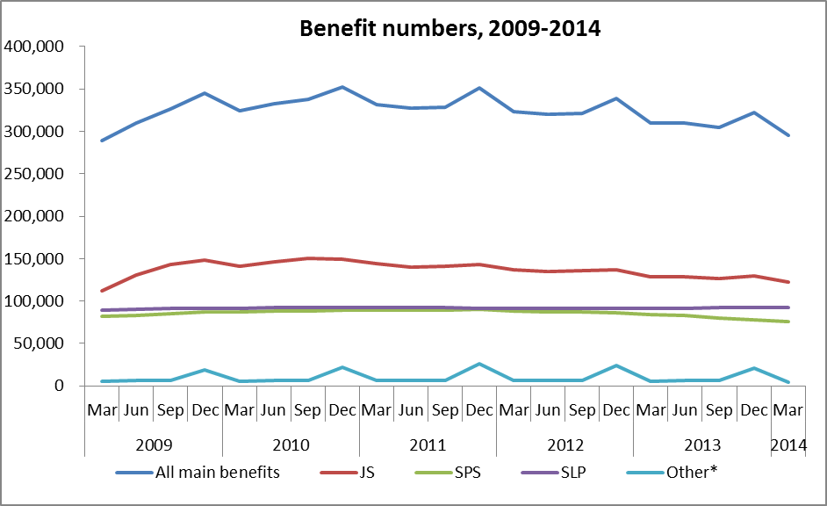
*Includes Youth Payment and Young Parent Payment

The proportion of the working-age population who were receiving a main benefit at the end of March increased between 2009 and 2011, but has decreased over the last three years. The main driver for this pattern has been changes in economic conditions.

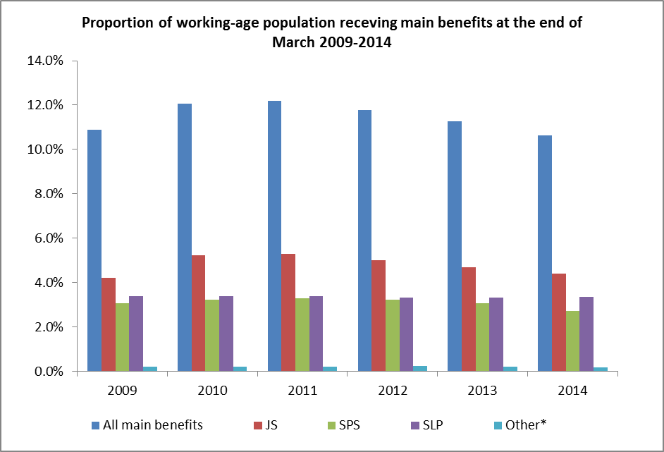*Includes Youth Payment and Young Parent Payment

