All main benefits - December 2014 quarter
Key Facts

At the end of December 2014:

- 309,145 working-age* people were receiving a main benefit.
- Eleven percent of the working-age population of New Zealand were receiving a main benefit.**
- Over half (58%) of main benefit recipients were female, and 42 percent were male.
- Forty percent of main benefit recipients were receiving Jobseeker Support (JS), 30 percent were receiving Supported Living Payment (SLP) and 23 percent were receiving Sole Parent Support (SPS).
- Over two-thirds (70%) of main benefit recipients had been receiving their current benefit continuously for more than one year.

Comparing December 2013 with December 2014:
- The number of main benefit recipients decreased by 12,724, or four percent. This decrease was largely driven by decreases in Sole Parent Support and Jobseeker Support numbers. In contrast, Supported Living Payment numbers increased slightly.
- Jobseeker Support numbers decreased in all Work and Income regions except Taranaki and Wellington. Sole Parent Support numbers decreased in all regions, and Supported Living Payment numbers increased in all regions except Northland and Nelson.
- The proportion of the working-age population in New Zealand receiving a main benefit fell slightly.

Summary of working-age* clients receiving main benefits at the end of December 2009, 2013 and 2014
Benefit | Dec-2009 | Dec-2013 | Dec-2014 | Annual Change
Jobseeker Support (JS) | 148,274 | 130,225 | 124,631 | -5,594 | -4%
Sole Parent Support (SPS) | 87,067 | 77,843 | 72,534 | -5,309 | -7%
Supported Living Payment (SLP) | 91,525 | 92,661 | 93,867 | 1,206 | 1%
Youth Payment/Young Parent Payment (YP/YPP)*** | 1,421 | 1,091 | 889 | -202 | -19%
Other**** | 17,189 | 20,049 | 17,224 | -2,825 | -14%
Total working-age recipients | 345,476 | 321,869 | 309,145 | -12,724 | -4%
Percentage of working-age population on main benefits | 13.0% | 11.8% | 11.2%

*Working-age clients are aged 18-64 years. This definition reflects the minimum age of eligibility for most main benefits and the age of qualification for New Zealand Superannuation.
**Based on Statistics NZ National Population Estimates of the relevant year.
***YP/YPP recipients who are 18+ years. There were 1,967 YP/YPP recipients aged 16-17 years at the end of December 2014. YP/YPP was introduced in August 2012; figures prior to this are estimates.
****Other includes Emergency Maintenance Allowance (EMA), Emergency Benefit (EB), Jobseeker Student Hardship (JSSH) and Widow’s Benefit Overseas (WBO).

Five-year trend
Main benefit numbers in December 2014 were lower than in December 2009. Changes in benefit numbers over this period largely reflect changes in economic conditions.
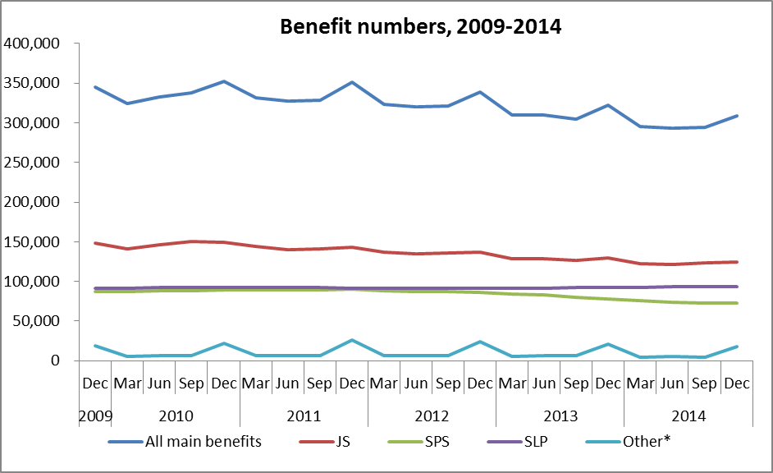
* Other includes Emergency Maintenance Allowance (EMA), Emergency Benefit (EB), Jobseeker Student Hardship (JSSH) , Widow’s Benefit Overseas (WBO) and YP/YPP.

The proportion of the working-age population who were receiving a main benefit at the end of December increased between 2009 and 2010, but has decreased over the last four years. The main driver for this pattern has been changes in economic conditions.

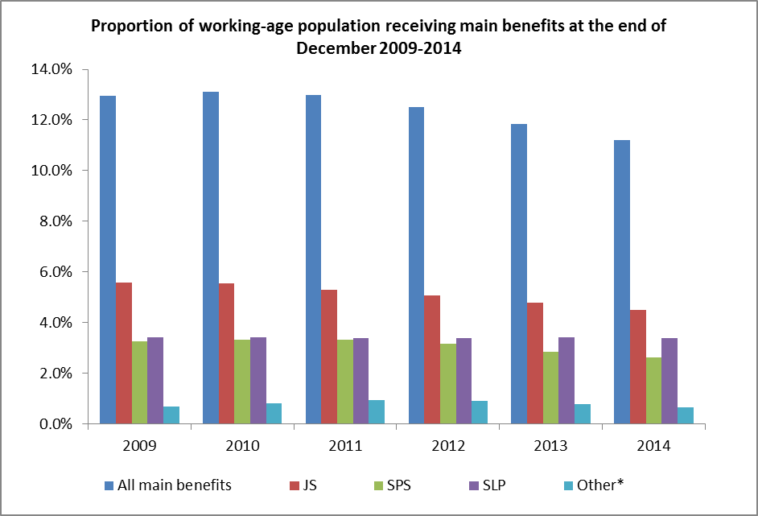
* Other includes EMA, EB, JSSH, WBO and YP/YPP.

