Key Facts at the end of June 2013

Unemployment Benefit

Current state

At the end of June 2013, 48,000 working-age people (aged 18–64 years) were receiving an Unemployment Benefit. Over the year to June 2013, the number of recipients of an Unemployment Benefit decreased by 1,000, or 2 percent.

Of the clients receiving an Unemployment Benefit at the end of June 2013:
      - two in three (68 percent) were male
      - two in five (42 percent) were mature job seekers (aged 40–64 years)
- 13 percent had a current earnings declaration for their current spell on benefit. This indicates some participation in paid work (during the last 12 months) while receiving a main benefit.

Characteristics of working-age Unemployment Benefit recipients (aged 18–64 years), at the end of June 2008 and at the end of June 2013
Percentage of recipients who were: | Jun-2008 | Jun-2013
Male | 68.5 | 67.8
Female | 31.5 | 32.2
Māori | 37.2 | 39.3
Pacific people | 7.9 | 8.4
18–24 years | 20.5 | 28.8
25–39 years | 33.6 | 29.5
40–54 years | 26.2 | 28.0
55–64 years | 19.6 | 13.7
Declaring earnings | 13.5 | 13.0
Caring for a dependent child aged under 6 years | 7.6 | 7.0
Number of working-age Unemployment Benefit recipients (aged 18–64 years) | 17,710 | 48,438
Source: IAP, numbers of working-age Unemployment Benefit recipients at the end of June.
Note: Numbers receiving an Unemployment Benefit exclude the partners, spouses and dependents of Unemployment Benefit recipients.

Five year trend

The number of clients receiving an Unemployment Benefit at the end of June increased from 18,000 to 62,000 between 2008 and 2010, followed by a decrease to 48,000 over the last three years. This pattern largely reflects changes in economic conditions.

Between June 2008 and June 2013, Unemployment Benefit recipients have become more likely to be aged 18–24 years, and slightly more likely to be aged 40–54 years. They also became more likely to be male.

Changes between 2008 and 2013 which have affected the number of clients receiving an Unemployment Benefit include changed economic conditions, and an increased focus by Work and Income on moving job seekers into paid work.

Proportion of the working-age population receiving an Unemployment Benefit

The proportion of the working-age population who were receiving an Unemployment Benefit at the end of June decreased each year from 2003 to 2008, then increased to 2010 and decreased over the last three years.

Trends in proportion of the working-age population receiving Unemployment Benefits at the end of June, between 2003 and 2013.

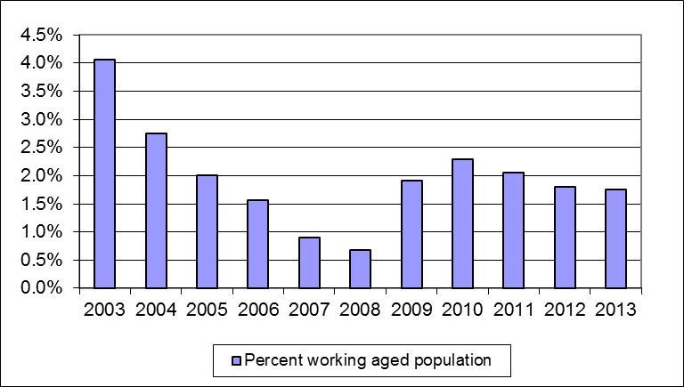

Source: IAP, numbers of working-age Unemployment Benefit recipients at the end of June.
Statistics New Zealand, final population estimates, resident population aged 18–64 years, at 31 December. At the publication of this fact sheet, December 2012 was the most recent quarter for which final population estimates were available.

Duration receiving an Unemployment Benefit

Of the clients receiving an Unemployment Benefit at the end of June 2013:
- three in four (77 percent) had received an Unemployment Benefit continuously for under one year
- 0.1 percent had received an Unemployment Benefit continuously for 10 years or more.

Clients who had received an Unemployment Benefit continuously for 10 years or more made up less than 0.05 percent of the total working-age population at the end of June 2013.

Three percent of Unemployment Benefit recipients at the end of June 2013 had received a main benefit continuously for 10 years or more.

Duration receiving an Unemployment Benefit as a proportion of all working-age Unemployment Benefit recipients and of the working-age population (aged 18–64 years)
 | Proportion of working- age Unemployment Benefit recipients | Proportion of working-age population (aged 18–64 years)
Proportion continuously receiving current benefit:
Less than one year | 76.9 | 1.4
Between one and four years | 19.7 | 0.3
Between four and ten years | 3.2 | 0.1
10 years or more | 0.1 | 0.0
Proportion continuously receiving any benefit:
Less than one year | 60.9 | 1.1
Between one and four years | 27.5 | 0.5
Between four and ten years | 9.0 | 0.2
10 years or more | 2.6 | 0.0
Source: IAP, proportion of working-age Unemployment Benefit recipients at the end of June 2013.
Statistics New Zealand, final population estimates, resident population aged 18–64 years, at 31 December 2012. At the publication of this fact sheet, this was the most recent month for which final population estimates were available.

This fact sheet defines the working-age population as aged 18–64 years to reflect the minimum age of entitlement to most benefits and the age of eligibility for New Zealand Superannuation. All information in this fact sheet refers to working-age recipients of Unemployment Benefits.
In this fact sheet, “Unemployment Benefit” includes Unemployment Benefits and Unemployment Benefits – Hardship (excludes Unemployment Benefits – Student Hardship).
Please note that trends in numbers receiving Unemployment Benefits are more reliably shown by comparisons between the same quarter 12 months apart than by comparisons between consecutive quarters.

