Key Facts at the end of June 2013

Domestic Purposes Benefit

Current state

At the end of June 2013, 104,000 working-age people (aged 18–64 years) were receiving a Domestic Purposes Benefit. Over the year to June 2013, the number of Domestic Purposes Benefit recipients decreased by 8,000, or 7 percent.

Of the clients receiving a Domestic Purposes Benefit at the end of June 2013:
- nearly one in two (47 percent) were aged between 25 and 39 years, while one in five (19 percent) were aged 18–24 years
- 18 percent had a current earnings declaration for their current spell on benefit. This indicates some participation in paid work (during the last 12 months) while receiving a main benefit
- nearly two in three (63 percent) had a youngest child aged six years or under, while 10 percent had a youngest child aged 14 years or over.

Characteristics of working-age Domestic Purposes Benefit recipients (aged 18–64 years), at the end of June 2008 and at the end of June 2013
Percentage of recipients who were: | Jun-2008 | Jun-2013
Male | 10.8 | 12.0
Female | 89.2 | 88.0
Māori | 41.6 | 43.3
Pacific people | 9.9 | 10.1
18–19 years | 3.5 | 1.5
20–24 years | 15.5 | 17.0
25–39 years | 48.8 | 46.6
40–54 years | 27.2 | 28.4
55–64 years | 5.0 | 6.4
Declaring earnings | 18.9 | 18.3
Caring for a dependent child aged 6 years or under* | 60.8 | 62.9
Caring for a dependent child aged 7–13 years* | 29.2 | 27.6
Caring for a dependent child aged 14 years or over* | 10.0 | 9.5
Caring for two or more dependent children* | 49.9 | 49.9
Number of working-age Domestic Purposes Benefit recipients (aged 18–64 years) | 96,440 | 104,446
Source: IAP, numbers of working-age Domestic Purposes Benefit recipients at the end of June.
Note: * proportions shown are for clients receiving a Domestic Purposes Benefit – Sole Parents only.
Five year trend

The number of clients receiving a Domestic Purposes Benefit at the end of June increased from 96,000 to 113,000 between 2008 and 2011, and then decreased to reach 104,000 in 2013. This pattern reflects changes in administration of Domestic Purposes Benefits as well as changes in economic conditions.

Between June 2008 and June 2013, Domestic Purposes Benefit recipients have become slightly more likely to be aged 40 years or over or to be aged 18–24 years.

Proportion of the working-age population receiving a Domestic Purposes Benefit

The proportion of the working-age population who were receiving a Domestic Purposes Benefit at the end of June trended downward between 2003 and 2008, then trended upward until 2011, but has decreased over the last two years.

Trends in proportion of the working-age population receiving Domestic Purposes Benefits at the end of June, between 2003 and 2013

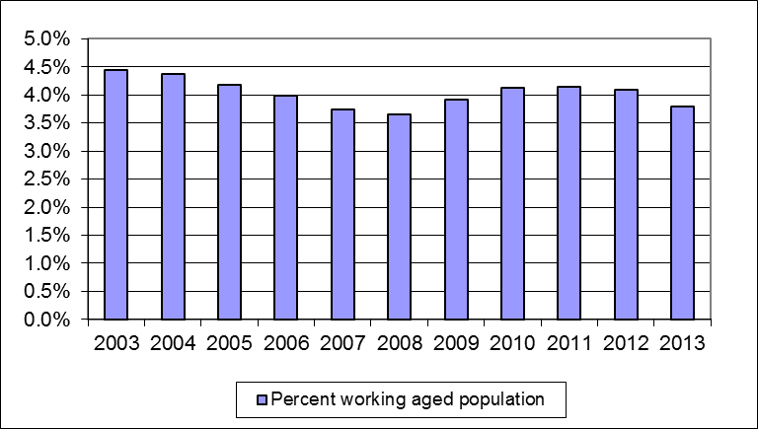

Source: IAP, numbers of working-age Domestic Purposes Benefit recipients at the end of June.
Statistics New Zealand, final population estimates, resident population aged 18–64 years, at 31 December. At
the publication of this fact sheet, December 2012 was the most recent quarter for which final population
estimates were available.

Duration receiving a Domestic Purposes Benefit

Of the clients receiving a Domestic Purposes Benefit at the end of June 2013:
- around one in four (23 percent) had received a Domestic Purposes Benefit continuously for less than one year
- two in five (39 percent) had received a Domestic Purposes Benefit continuously for between one and four years
- 10 percent had received a Domestic Purposes Benefit continuously for ten years or more.

Clients who had received a Domestic Purposes Benefit continuously for 10 years or more made up 0.4 percent of the total working-age population at the end of June 2013.

Duration receiving a Domestic Purposes Benefit as a proportion of all working-age Domestic Purposes Benefit recipients and of the working-age population (aged 18–64 years)
 | Proportion of working-age Domestic Purposes Benefit recipients | Proportion of working-age population (aged 18–64 years)
Proportion continuously receiving current benefit:
Less than one year | 23.2 | 0.9
Between one and four years | 39.0 | 1.5
Between four and ten years | 27.6 | 1.0
10 years or more | 10.1 | 0.4
Proportion continuously receiving any benefit:
Less than one year | 17.7 | 0.7
Between one and four years | 36.2 | 1.4
Between four and ten years | 30.8 | 1.2
10 years or more | 15.3 | 0.6
Source: IAP, proportion of working-age Domestic Purposes Benefit recipients at the end of June 2013.
Statistics New Zealand, final population estimates, resident population aged 18–64 years, at 31 December 2012. At the publication of this fact sheet, this was the most recent quarter for which final population estimates were available.

This fact sheet defines the working-age population as aged 18–64 years, to reflect the minimum age of entitlement to most benefits and the age of eligibility for New Zealand Superannuation. All information in this fact sheet refers to working-age recipients of Domestic Purposes Benefits.
In this fact sheet, “Domestic Purposes Benefit” includes Domestic Purposes Benefits – Sole Parent, Domestic Purposes Benefits – Women Alone, Domestic Purposes Benefits – Care of Sick or Infirm, and Emergency Maintenance Allowances.
Please note that trends in numbers receiving Domestic Purposes Benefits are more reliably shown by comparisons between the same quarter 12 months apart than by comparisons between consecutive quarters.

