**Social Sector Trials**

**Geospatial impact analysis**

**Authors**

David Rea, Josephine Ryan and Darko Petrovic

**Acknowledgements**

The New Zealand Police, the Ministry of Health, the Ministry of Education, the Ministry of Social Development and Statistics New Zealand provided data. The authors are grateful for comments and assistance from a number of individuals in these agencies, and in particular would like to thank Tim Maloney, Anne Howard, Hailong Sun, Carl Crafar, Michelle Liu, Jackie Fawcett, Jenny Vickers, David Lambie, Glen Morrison, Martin Hillier, Gavin Knight, Craig Croft, Geoff Cook, Helen Presland, Amanda Hinkley and Steven Johnson.

**Disclaimer**

The Ministry of Social Development has made every effort to ensure the information in this report is reliable, but does not guarantee its accuracy and does not accept liability for any errors.

**Dates**

Report completed 12 June 2015 and published in MSD’s Research Archive in December 2019.

**ISBN**

978-0-9951240-6-6

# Contents

Contents 3

Executive summary 4

The Social Sector Trials 5

Methodology to identify the impacts of the trials 8

Overview 8

Outcomes and indicators 8

Difference-in-difference methodology 10

Analysis 12

Benefit receipt 12

Police apprehensions of young people aged 12-18 years 13

Police referrals of young people aged 10-17 years to Child Youth and Family 15

Births to women aged 15-19 years 16

Leaving school before age 17 years 17

School leavers achieving less than level 2 NCEA 18

Conclusion 20

Appendix 1: Description of the trials 23

Appendix 2: Geospatial undercount for area unit indicators 24

Appendix 3: Maps of trial and comparison area units and schools 25

Appendix 4: Formal impact analysis 31

References 33

# Executive summary

Social Sector Trials commenced in six locations across New Zealand in early 2011. The trials aimed to test a new means of coordinating government service delivery in disadvantaged communities.

This report assesses the early impacts of the first six trials using geocoded administrative data measuring youth benefit receipt, police apprehensions, police youth justice referrals to Child, Youth and Family, births to women aged 15-19 years, and the percentage of students leaving school before 17 or with less than NCEA level 2 qualifications.

The analysis attempts to estimate the impact of the trials in the first two years after implementation.

These impacts are estimated using a difference-in-difference strategy for trial geographical areas and schools. For each trial similar comparison areas and schools were identified in the same broad locality. The difference in outcomes between trial and comparison areas and schools prior to implementation of the trials was then compared with the difference after implementation in order to identify any possible impacts.

The formal analysis finds no statistically significant impacts across the range of outcomes measured.

It should be noted that the findings of this report represents only the first two years of operation of the Social Sector Trials. Future analysis using a longer time period and an increased number of trial locations should be able to assess the impacts of the trials more precisely.

# The Social Sector Trials

The Social Sector Trials were designed to test a new way of coordinating, funding and prioritising government social service delivery in local communities. They were established to “test the ability of an appropriately mandated individual or Non-Government Organisation/community structure to use their own knowledge and application of community and government resources to customise community responses to specific issues, while increasing community responsibility and ownership of solutions.”[1]

In March 2011 Kawerau, Taumarunui, Te Kuiti, Tokoroa, Levin, and Gore were selected as sites for phase 1 of the Social Sector Trials. Initially the trials focussed on the discrete communities within each town. From March 2013 the coverage of the Te Kuiti, Tokoroa, Levin, and Gore trials was extended to the wider territorial authority area in which they were located. Ten new phase 2 trials in other locations started after June 2013.

The six phase 1 trials were initially tasked with achieving better outcomes for young people 12-18 years in the areas of:

* truancy;
* offending;
* alcohol and drug abuse; and
* education, training and employment.

The trials involved the appointment of either an NGO (the ‘lead NGO’ model) or a public servant (the ‘committed individual’ model) to foster collaborative activity to improve outcomes.

There was a requirement for each trial lead to consult and create an action plan to improve youth outcomes in partnership with the local community. As well as funding for the trial and associated activities there was also a requirement for local and government agencies to support the implementation of the plan.

At the national level the trials were governed by a Joint Venture Board consisting of the Chief Executives of the Ministry of Social Development, Ministry of Health, Ministry of Education, Ministry of Justice and the Commissioner of the New Zealand Police. A Director, Programme Manager and later Programme Office were also established to support and manage the day-to-day operation of the trials.

Figure 1 provides a broad representation of the underlying programme logic of the first phase of the Social Sector Trials. It describes the inputs, activities and outcomes, and provides a framework for the selection of outcome indicators.

Figure 1: Intervention logic of the phase 1 Social Sector Trials



Up until June 2013 approximately $4.6 million of central government funding was directly invested in the six phase 1 trials.

Each of the trials generated a considerable level of collaborative planning involving local and central government agencies, NGO providers, business leaders and young people. Action plans for each trial detailed a range of actions aimed at improving specific outcomes for young people. In the following two years almost all of the actions in these plans were implemented, and there continued to be on-going collaboration among local stakeholders.

To respond to gaps and duplication in local service delivery, new programmes were implemented, funding was redirected from historic programmes to better meet local needs, better access to existing local and regional services was facilitated, service specifications for pre-existing programmes were amended, and a new cross-agency picture of social sector programmes and services was developed.

Reducing truancy was a particularly strong focus of the trials during this period, with many sites running public campaigns emphasising the importance of continued school attendance for young people, as well as reconfiguring the local approach to attendance services. Trials also supported the development of a number of youth hubs, trialled new service delivery approaches for wrap-around support, implemented new alcohol and other drug programmes, worked closely with schools to provide new options for senior students, invested in mentoring programmes, provided youth participation and youth leadership programmes, and formed links with youth workers supporting at risk young people in the community.

Appendix 1 provides a more detailed overview of the activity in each of the trial areas.

The first six trials were the subject of extensive monitoring and review. As well as regular reporting of plan activities and outcomes, there has also been a range of reports on the progress of the wider initiative. The Final Evaluation Report (2013) reviewed the implementation of the trials, highlighted key achievements (including indicators of increased collaboration), and made a number of recommendations for the future.[2]

Important context for the first phase of the Social Sector trials was that there was also considerable change and expansion in many other government-funded services for young people. Major initiatives included:

* an expansion in fees-free tertiary education for young people as part of the Youth Guarantee;
* more funded places for students in secondary-tertiary partnership programmes (often in Trades and Service Academies);
* the industry training system was reformed;
* the Integrated Attendance Service was established in early 2013;
* the youth transition services were reconfigured with the establishment of the new Youth Service;
* welfare reform created new income support payments and obligations for young people;
* the implementation of Whānau Ora;
* there was an expansion of youth health services in schools
* Government increased investment in youth mental health initiatives as part of the Prime Minister’s Mental Health project (eg Check and Connect and Youth Workers in Schools)
* the Social Workers in Schools service was expanded to all decile one to three primary schools from 2012/2013
* there were a variety of other changes in school based services including new services for teen parents and the expansion of the Positive Behaviour for Learning (PB4L) programme

Activities in the trial areas often built on these wider initiatives. However crucially, the Government’s wider range of youth initiatives were not just focussed on the trial areas, and also changed the nature of services for young people in areas where the trials were not located.

# Methodology to identify the impacts of the trials

## Overview

This report seeks to identify whether the social sector trials improved outcomes for young people in the two years to June 2013. To identify the causal impacts of the trials, the paper measures what actually occurred in the trial areas and schools both before and after the trials were implemented. We then compare these with the outcomes of comparison areas and schools in a manner designed to create a counterfactual of what might have occurred had the trials not been operating.

## Outcomes and indicators

This report uses new datasets based on geocoded administrative data (ie observations in the datasets are given the location coordinates of an address). The datasets enable analysis of six different indicators that provide geographically specific information on youth outcomes that are broadly similar to the outcomes the trials sought to influence. As described in Table 1 below, each indicator is derived from available population level administrative data which can be attributed to a specific geographic location.

Table 1: Measures of youth outcomes

|  |  |  |  |
| --- | --- | --- | --- |
| Indicator | Numerator | Denominator | Time period |
| Area unit measures* | | | |
| Percentage of 16-18 year olds in receipt of a main benefit as at June | Benefit receipt (all types) of young people 16-18 year geocoded to individual residential address (Ministry of Social Development SWIFTT) | Statistics New Zealand area unit population estimates of population 16-18 years | 2008-2013 |
| Police apprehensions per 100 young people aged 12-18 | Police apprehensions geocoded to place of apprehension by age over June year (Police) | Statistics New Zealand area unit population estimates of population 12-18 years | 2008-2013 |
| Youth justice referrals to Child Youth and Family per 100 10-17 year olds | Police youth justice referrals to CYF in the year to June, geocoded to place of residence (Ministry of Social Development CYRAS) | Statistics New Zealand area unit population estimates of population 10-17 years | 2008-2013 |
| Birth rate of women aged 15-19 years (year to June) | Births to women aged 15-19 in year to June by area unit of residence (Statistics New Zealand) | Statistics New Zealand area unit population estimates of women 15-19 years as at June | 2008-2013 |
| School measures |  | | |
| Proportion of students leaving school before age 17 | Total number of school leavers aged under 17 years in a given year excluding foreign fee-paying students (Ministry of Education ENROL) | Total number of school leavers in a given year excluding foreign fee-paying students (Ministry of Education ENROL) | 2009-2013 |
| Proportion of students leaving school who have not achieved NCEA level 2 or above | The number of school leavers who achieved below NCEA level 2 (Ministry of Education ENROL) | The total number of school leavers for a given school year (Ministry of Education ENROL) | 2009-2013 |
| * Area units are aggregations of meshblocks which in main or secondary urban areas are often suburbs or parts of suburbs. Area units within urban areas normally contain 3,000 to 5,000 people, although this may vary where there is an industrial area or port. A number of area units in rural areas have a very low population count. In total New Zealand is divided into 2020 area units. | | | |
|  |  |  |  |

Benefit receipt, teen births, Police apprehensions of young people, and youth justice referrals to CYF are all expressed as a percentage or rate related to the estimated usually resident youth population within each area unit. Reducing teen births were not an explicit goal of the trials but have been included because the indicator provides useful information on outcomes for young people.

The proportion of school leavers aged less than 17 years or with less than NCEA level 2 qualifications are school based measures. These indicators are expressed as a percentage of young people leaving school.

We also investigated a range of other indicators which for various reasons were not able to provide reliable measures of youth outcomes. Indicators that were investigated but not used included the percentage of young people enrolled in a Primary Healthcare Organisation within each area unit, as well as school based measures of truancy (the frequent truant rate and the unjustified absence rate). These indicators were not included in the analysis because the data was either not geographically reliable or not comprehensively recorded.

## Limitations of the data

It is important to note that indicators derived from administrative data, while they have the advantage of measuring population as opposed to sample outcomes, are sensitive to the underlying administrative practices that create the data. The data arises in the course of service delivery activities, and sometimes unrecorded changes in service delivery strategies or different ways of recording information reduce the reliability of the data.

The area unit based measures rely on each record being geocoded to a specific geographic address. Across all measures the proportion of records without a geocoded address has been decreasing. This means that the trend in the area unit based measures of outcomes is biased upwards. The analysis in this report assumes that the level of bias is not systematically different across area units. Appendix 2 provides information on the magnitude of the geospatial undercount and the implications for the analysis.

Statistics New Zealand area unit population estimates of the youth population means there is some measurement error because of the inherent difficulty of estimating a small highly mobile population between each Census. The dataset uses the population estimates updated to the 2013 Census.

Widespread geocoding of administrative data has only recently become available, and because of this the analysis in this report should be treated as somewhat experimental. This is particularly the case in relation to police apprehensions and police youth justice referrals to CYF where the use of the data to produce area unit specific measures is somewhat novel.

## Difference-in-difference methodology

In order to assess the impact of the Social Sector Trials it is necessary to create a counterfactual of what would have occurred had the trials not been implemented.

The most robust way of creating a counterfactual would have been to randomise which high need areas received funding for the trials. This would have created a control group of areas that were equivalent to the trial areas. Outcomes for the control group areas and schools would have represented what would have happened had the trials not been implemented. The impact of the trial would then have been what was observed in the trial areas compared to what occurred in the control group.

The Social Sector Trials did not use a randomised control methodology, so instead it is necessary to retrospectively identify comparison areas, and this inevitably makes the measurement of impacts less robust.

The analysis in this report uses a matched difference-in-difference method to construct the counterfactual of what would have happened if the Social Sector Trials had not been implemented. Our matching involved both area units and schools.

To implement the approach we defined the area units and schools that were covered by each of the six trials in the two years to June 2013. This definition of trial coverage was based on information provided by the national program office for the trials.

We created a group of comparison area units by exact matching each of the social sector trial area units to two similar area units nearby. The logic behind the matching was to ensure that there was some similarity in the characteristics and regional influences for the treatment and comparison area units.

To perform the area unit matching, all area units in the country were allocated to six blocks based on the combination of the number of young people 12-18 in the area unit (low, medium, high), and the level of deprivation of the area unit as measured by NZDEP 2013 (low or high). For each area unit in a trial we identified the nearest nearby area units of the same block type where no more than 5 per cent of the youth population were attending schools associated with the trial. The largest distance between a trial and matched comparison area unit was 166 kilometres.

We also created a matched comparison group of schools. To do this we identified the secondary schools that were either located in the trial area units, or in one case, associated with the trial but outside the trial area. We then matched each trial school by finding the two closest nearby secondary schools with approximately the same Ministry of Education school decile ratings (plus or minus one). To be included in the comparison group, the schools also needed to have no more than 5 per cent of their student roll living in the trial area units.

For both the area unit and school analysis an important dimension for the selection of comparators was that they were relatively close to the trial site. This was to ensure that unmeasured local factors might equally impact on both trial and comparison area units or schools.

Appendix 2 sets out maps of the trial and comparison area units and schools.

Information on young people in the trial and comparison area units and schools at baseline is set out in Table 2. Overall the trial area units covered 5,700 young people 12-18 years and slightly fewer school enrolments. Table 2 shows that the comparison area units contained slightly more young people on average, and were on average slightly more socioeconomically advantaged than the Social Sector Trial area units. Similarly the comparison schools were slightly larger and slightly more advantaged than the trial schools. At baseline in 2011 young people in the comparison area units and schools had slightly better outcomes than those in the trial area units and schools (the one exception being a slightly higher rate of Police youth justice referrals to CYF).

Table 2: Trial and comparison area units and schools at baseline in 2011

|  |  |  |
| --- | --- | --- |
|  | Social sector trial areas | Comparison areas |
| Area units | 25 | 50 |
| Estimated total number of young people aged 12-18 in 2011 | 5,715 | 11,775 |
| Estimated average number of young people in each area unit aged 12-18 in 2011 | 229 | 236 |
| Average deprivation score (NZDEP 2013) of area units | 8.6 | 8.0 |
| Percentage of working age population in receipt of a main benefit in June 2011 | 21.8% | 19.4% |
| Percentage of young people 16-18 in receipt of a main benefit in June 2011 | 9.0% | 8.1% |
| Police apprehensions per 100 young people aged 12-18 in 2011 | 28.0% | 26.3% |
| Police youth justice referrals to CYF per 100 10-17 year olds in 2011 | 1.5% | 1.6% |
| Births per 100 women 15-19 in 2011 | 5.5% | 4.8% |
| Schools | 10 | 20 |
| Total school enrolments in 2011 | 4,765 | 10,052 |
| Average school roll in 2011 | 477 | 503 |
| Ministry of Education School Decile in 2011 | 3.6 | 4.2 |
| Percentage leaving school before age 17 in 2011 | 27.6 | 23.8 |
| School leavers with less than NCEA 2 in 2011 | 36.5 | 32.0 |
| Note: The school data combines Kawerau College which closed in 2012 and Tarawera High School which opened in 2013 | | |

The difference-in-difference estimate of programme impacts compares trial area units (or schools) with comparison area units (or schools) both before and after the implementation of the trial. The method assumes that the differences in outcomes observed prior to the trial would have continued had the trial not occurred. The assumed impact of the trial is the difference observed after implementation less the difference observed before implementation.

Appendix 3 sets out the two formal statistical methods used to calculate the difference-in-difference estimate of the impact of the trials. It is important to note that the analysis uses area units or schools as the unit of analysis, with the results weighted using the relevant population variable.

Interpreting the difference-in-difference measure as a reasonable estimate of the impact of the trials requires two important assumptions.

First, it is important that the trials only influenced outcomes in the trial regions, and did not impact on youth outcomes in the comparison areas. In most cases we are confident that this assumption is correct as the geocoded data refers to a young person’s residential address (one exception is the apprehension data which is geocoded to the location of the offence).

Second, it is also necessary to assume that in the absence of the trials the difference in outcomes between the trial and comparison area units would have remained constant through time. If this assumption is correct, any change in the magnitude of the difference in the outcomes between the trial and comparison areas can be attributed to the impact of the intervention. However if this assumption is not correct (for example if there were unmeasured factors separately influencing outcomes in either the trial or comparison areas), then the difference-in-difference estimator is not a valid measure of the causal impact of the trials.[3]

An important consideration in relation to this second assumption relates to whether the choice of the phase 1 trial sites was based on information about the likelihood of worse or better future outcomes for the areas selected. Analysis of the Cabinet paper and other documentation suggests that this was not case. Instead, past measures of poor social outcomes appear to have been an important input into the selection process.

Another more important limitation related to the second assumption of the difference-in-difference analysis is that it is not possible to identify and control for the impacts of a wider range of new youth policy initiatives implemented by Government. As mentioned, there were a considerable number of new initiatives for young people implemented within communities and schools over the period 2008 to 2013. Changes in measured outcomes may reflect these new services rather than the Social Sector Trials. For the difference-in-difference estimator to represent the impact of the social sector trials, it is necessary to assume that other initiatives were implemented equally across trial and comparison area units and schools. Unfortunately this may not be an entirely plausible assumption, and the absence of a comprehensive dataset covering initiatives at the area or school level means that the analysis does not adequately control for other policy changes.

# Analysis

In what follows we look at average outcomes for young people in the trial and comparison area units or schools both before and after the implementation of the Social Sector Trials. A difference-in difference approach is used to calculate the impact of the trial. For each indicator we provide a graphical analysis, as well as more formal estimates of the size and statistical significance of the estimated impact.

## Benefit receipt

Between 2009 and 2013 the overall prevalence of benefit receipt among young people aged 16-18 declined across New Zealand.

Between the periods 2008-2011 and 2012-2013 benefit receipt among young people in the social sector trial area units increased marginally. Benefit receipt among young people in the comparison area units was lower before the trials, and then fell after the trials commenced.

This suggests that the trials may have been associated with a small increase in the prevalence of youth benefit receipt. Table 3 sets out formal estimates of the magnitude and statistical significance of this possible impact using two differences-in-differences models. As can be seen, the estimated impact of the trial is around half a percentage point, although this is not statistically significant at conventional levels in either model.

Fig 2: Percentage of young people 16-18 years in receipt of a main benefit (June years)



Source: SWIFTT data on benefit receipt and Statistics New Zealand estimates of the youth population.

Table 3: Difference-in-difference estimates of the impact of social sector trials on the percentage of young people in receipt of a main benefit

|  |  |  |  |
| --- | --- | --- | --- |
|  | Percentage point estimated impact | Robust standard error | p-value |
| Simple difference-in-difference estimator | 0.47 | 0.99 | 0.635 |
| Fixed effect difference-in-difference estimator | 0.56 | 0.64 | 0.380 |
| Note: The estimate is the percentage point change. Area unit results are weighted for youth population 16-18 years. N=449. The adjusted R2 for the regressions were 0.01 and 0.48. Fixed effects are specific to the area unit. Standard errors are adjusted for heteroscedasticity. The p-value is the probability of observing an estimate of this magnitude by chance given that the real estimate is zero. The traditional level of statistical significance for a p-value is 0.05. | | | |

## Police apprehensions of young people aged 12-18 years

The national rate of police apprehensions of young people fell between 2010 and 2013.

In both the trial as well as comparison area units the rate of apprehensions of young people was above the national average, with the comparison areas units registering a higher rate.

During the first two years of the trials in 2012-2013 the rate of apprehensions of young people 12-18 years in the trial areas declined from 27 apprehensions to just under 25 apprehensions per 100 young people per year. Over the same period the rate of apprehensions of young people in the comparison areas also declined, but by a slightly larger amount than in the trial areas.

Fig 3: Police apprehensions of young people aged 12-18 years (per 100 per year)



Source: Police apprehensions and Statistics New Zealand population estimates by area unit.

The formal analysis suggests that the trial areas experienced a relative increase in the rate of apprehensions equal to approximately 1.6 apprehensions per 100 young people per year. This increase was not, however, statistically significant in either model.

Table 4: Difference-in-difference estimates of the impact of social sector trials on the rate of Police apprehensions of young people 12-18 years

|  |  |  |  |
| --- | --- | --- | --- |
|  | Rate per 100 estimated impact | Robust standard error | p-value |
| Simple difference-in-difference estimator | 2.02 | 5.61 | 0.719 |
| Fixed effect difference-in-difference estimator | 1.60 | 2.04 | 0.435 |
| Note: The estimate is the change in the rate of apprehensions per 100 young people per year. Area unit results are weighted for youth population 12-18 years. N=450. The adjusted R2 for the regressions were 0.00 and 0.79. Fixed effects are specific to the area unit. Standard errors are adjusted for heteroscedasticity. The p-value is the probability of observing an estimate of this magnitude by chance given that the real estimate is zero. The traditional level of statistical significance for a p-value is 0.05.  As set out in Annex 4, it is also important to note that for this indicator there does not appear to have been a constant difference between the trial and comparison areas prior to the trial being implemented. This suggests that the difference-in-difference methodology is not able to provide a plausible measure of impact. | | | |

## Police youth justice referrals of young people aged 10-17 years to Child Youth and Family

Nationally the rate of Police youth justice referrals to Child Youth and Family has been declining since 2009. This decline was also observed in both the trial and comparison areas.

Over the period 2008-2011 to 2012-2013 the rate of referrals of young people 10-17 years in the trial areas declined from just over 1.6 to just over 1.5 per 100 young people per year. Over the same time periods the rate of referrals in the comparison areas fell by a larger amount.

Fig 4: Police referrals of young people aged 10-17 years to Child Youth and Family (per 100 young people per year)



**Source: CYRAS data and Statistics New Zealand population estimates by area unit**

The formal analysis suggests that the rate of referrals in the trial areas rose relative to the comparison areas with the implementation of the trial. However the estimated impact on the rate of Police referrals using the two models was small and not statistically significant.

Table 5: Difference-in-difference estimates of the impact of social sector trials on the rate of Police youth justice referrals to Child Youth and Family

|  |  |  |  |
| --- | --- | --- | --- |
|  | Rate per 100 estimated impact | Robust standard error | p-value |
| Simple difference-in-difference estimator | 0.21 | 0.28 | 0.450 |
| Fixed effect difference-in-difference estimator | 0.24 | 0.16 | 0.209 |
| Note: The estimate is the change in the annual rate of Police youth justice referrals to CYF per 100 young people. Area unit results are weighted for youth population 10-17 years. Fixed effects are specific to the area unit. N=450. The adjusted R2 of the regressions were 0.01 and 0.54. Standard errors are adjusted for heteroscedasticity. The p-value is the probability of observing an estimate of this magnitude by chance given that the real estimate is zero. The traditional level of statistical significance for a p-value is 0.05. | | | |

## Births to women aged 15-19 years

The trials were not tasked with reducing rates of teen births. However given the education, employment and health focus of the trials it is possible that the trials may have influenced young people’s choices about fertility and parenting. The teen birth rate is also an important indicator given the association with later adverse outcomes.[4]

Fig 5: Rate of births per 100 women aged 15-19 years (June years)



Source: Statistics New Zealand data on births and population estimates by area unit.

Nationally the rate of teen births has been declining since 2008. A similar decline has also occurred in a number of other OECD countries, and research has pointed to a range of causes including the increased use of long acting reversible contraception.[5]

In both the trial as well as comparison area units the measured rate of teen births declined between 2008-2011 and 2012-2013. In the trial area units the birth rate declined from 7.0 to 5.9 births per 100 women aged 15-19. This decline in the birth rate in the trial areas was marginally larger than the decline in the comparison area units.

The relative faster decline in the trial areas may indicate that the trials reduced teen births. The formal analysis indicates that the impact may have been around 0.5 births per 100 women. However this estimate is not statistically significant at the traditional 5% level of significance.

Table 6: Difference-in-difference estimates of the impact of social sector trials on the rate of birth among women 15-19 years (births per 100 women)

|  |  |  |  |
| --- | --- | --- | --- |
|  | Rate per 100 estimated impact | Robust standard error | p-value |
| Simple difference-in-difference estimator | -0.48 | 0.73 | 0.511 |
| Fixed effect difference-in-difference estimator | -0.48 | 0.56 | 0.387 |
| Note: The estimate is the change in the annual rate of births per 100 women 15-19 years. Area unit results are weighted for the population of women 15-19 years. N=447. The adjusted R2 for the regressions were 0.05 and 0.38. Fixed effects are specific to the area unit. Standard errors are adjusted for heteroscedasticity. The p-value is the probability of observing an estimate of this magnitude by chance given that the real estimate is zero. The traditional level of statistical significance for a p-value is 0.05. | | | |

## Leaving school before age 17 years

Nationally the proportion of young people leaving school before turning 17 years of age has declined since 2009.

This decline in early school leaving also occurred in the social sector trial schools. Over the period 2009-2011 almost 27 per cent of school leavers in the trial schools were aged less than 17 years. By 2012-2013 this percentage had fallen to just over 23 per cent. A similar, but slightly smaller decline occurred in the comparison schools with school leavers younger than 17 years of age reducing from 27 per cent to 24 per cent over the same period.

The formal analysis suggests the trials may have reduced early school leaving by around one percentage point. This decline was not, however, statistically significant.

Fig 7: Percentage of school leavers aged less than 17 years



Table 8: Difference-in-difference estimates of the impact of Social Sector Trials on the percentage of young people leaving school before age 17 years

|  |  |  |  |
| --- | --- | --- | --- |
|  | Estimated percentage point impact | Robust standard error | p-value |
| Simple difference-in-difference estimator | -1.04 | 3.19 | 0.746 |
| Fixed effect difference-in-difference estimator | -1.16 | 1.64 | 0.480 |
| Note: The estimate is the percentage point change in the early leaving rate. School results are weighted by the school roll. Fixed effects are specific to the school. N=150. The adjusted R2 for the regressions were 0.01 and 0.57. Standard errors are adjusted for heteroscedasticity. The p-value is the probability of observing an estimate of this magnitude by chance given that the real estimate is zero. The traditional level of statistical significance for a p-value is 0.05. | | | |

## School leavers achieving less than level 2 NCEA

Nationally the proportion of young people leaving school with less than a level 2 NCEA qualification has declined since 2009.

A decline in under-achievement also occurred in the trial schools. Over the period 2009-2011 just over 38% of school leavers in the trial schools left with qualifications less than NCEA level 2. By 2012-2013 this percentage had fallen to 32%. A smaller decline occurred in the comparison schools. In the comparison schools young people leaving with low qualifications declined from just under 37% to 32%.

Fig 8: Percentage of school leavers achieving less than level 2 NCEA



The formal analysis suggests that the trials may have reduced educational under achievement of school leavers by up to 1.6 percentage points. This estimated impact was not, however, statistically significant.

Table 9: Difference-in-difference estimates of the impact of social sector trials on the percentage of school leavers with less than level 2 NCEA qualifications

|  |  |  |  |
| --- | --- | --- | --- |
|  | Estimated percentage point impact | Robust standard error | p-value |
| Simple difference-in-difference estimator | -1.24 | 4.18 | 0.768 |
| Fixed effect difference-in-difference estimator | -1.59 | 2.23 | 0.478 |
| Note: The estimate is the percentage point change in the early leaving rate. School results are weighted by the school roll. Fixed effects are specific to the school. N=150. The adjusted R2 for the regressions were 0.02 and 0.59. Standard errors are adjusted for heteroscedasticity. The p-value is the probability of observing an estimate of this magnitude by chance given that the real estimate is zero. The traditional level of statistical significance for a p-value is 0.05. | | | |

# Conclusion

The aim of this study is to assess the impacts of the first phase of the Social Sector Trials in their first two years. The report uses six different indicators that provide geographically-specific information on youth outcomes.

Important context for the analysis is that in recent years there has been a general improvement in youth outcomes nationally. Compared to 2010, in 2013 there were fewer young people receiving benefits, lower rates of young people being apprehended by the police, fewer young people being referred by police to CYF for youth justice reasons, fewer teen births, there were fewer young people leaving school before age 17, and fewer young people left school without achieving NCEA level 2 or above.

In most cases an improvement in youth outcomes also occurred in the local communities and schools that were part of the first phase of the Social Sector Trials.

This study has attempted to isolate whether the changes in outcomes that were observed in the trials areas and school were the direct result of the trials, or simply reflecting other wider changes that were occurring for young people. To identify whether the trials made a difference, the study has compared what occurred in the trial areas units and school with those of matched comparison groups of area units and schools. The differences in youth outcomes before the trials were implemented have been compared with the difference in the two years after the trials were implemented.

The analysis suggests that the trials were associated with a mix of positive and negative improvements in relative outcomes, but none of the measured changes were statistically significant. Compared to the benchmarks provided by the comparison area units and schools, the trials were associated with small increases in school achievement, young people staying at school, and fewer births to 15-19 year olds. However the trials were also associated with small increases in youth benefit receipt, police apprehensions of young people, and also police youth justice referrals to CYF.

The figure below summarizes the impact results from the study, using the preferred fixed effects estimates and the associated 95% confidence interval.

The graph shows the central estimate of the impact, as well as the most important element which is the confidence interval which represents the range of plausible values for the real ‘impact’ of the trial. In all cases the small size of the study and the underlying variability across areas and schools means that there are relatively wide confidence intervals, and in each case it is possible that the real impact may have been zero.

Fig 9: Summary of estimated early impacts of the first phase of the Social Sector Trials



Note: The estimate of impact is the percentage point or absolute rate change using the fixed effects model. The error bars show the 95% confidence intervals based on Huber/White errors, which have not been adjusted for the analysis of multiple outcomes (eg Bonferroni adjustment)

To understand these results it is useful to acknowledge the factors that limit the ability of this current study to robustly detect any impacts from the trials.

First, the study has analysed early results after just two years of the trials operating. It is possible that there may be different outcomes observed in subsequent years.

Second, as discussed the sample size for the study is small.

These limitations might be partially addressed in the future with a similar analysis encompassing the second phase of the Social Sector Trials, as well as the expanded areas of the phase one trials. This analysis would provide a longer follow-up period, increased geographical coverage, a larger sample of trials, and possibly a wider range of indicators.

A third limitation of the current study is that it relies on a difference-in-difference method which requires a number of assumptions, some of which are not always plausible. A key issue here is that the method assumes that the differences that were observed prior to the trial being implemented would have continued had the trial not been implemented. These may not be plausible, particularly as there was considerable reform of wider youth services at the same time as the trials were being conducted.

Lastly, the findings of this study provide an opportunity to reflect on how best to trial service delivery innovation. One of the key issues that arises with learning about ‘what works’ is the need to identify, prior to any trial commencing, what outcomes can be measured, and the method by which impacts will be assessed. The Social Sector Trials provide a good example of why early consideration of these issues are important.

If there is early consideration of measurement and evaluation then a randomised control trial approach is often the preferred method. Creating a benchmark using a randomly selected control group provides by far the best way of providing robust evidence about causal impacts. Importantly there have been a number of recent advances in how to use randomised trials to test community level interventions,[6] and these methods are now cheaper and quicker because of the ability to use administrative data to measure outcomes. However a key issue is that a randomised trial cannot be retrofitted after a new service delivery innovation has been implemented. Instead, the design and implementation of the evaluation has to occur prior to implementation of the new service delivery innovation.

# Appendix 1: Description of the trials

The Tokoroa Trial was led by the Raukawa Charitable Trust. The trial coordinated or was involved in initiatives such as the "it's not ok to miss a day" truancy campaign, the re-establishment of the CLUBS youth mentoring programme, the youth workers in school program, the Tokoroa Youth Media and Music Hub, and a Broadcasting, Media and Music Technology training programme targeted at disengaged 16 and 17 year olds.

The Te Kuiti Trial was associated with a number of initiatives including the Waitomo youth hub 'Number 12' which supervises probation work for 17 to 19 year olds. There was an agreement with local retailers to not sell synthetic cannabinoids and to create a truant-free business district. There was also considerable work undertaken to reduce truancy through the trial managed Attendance Service. The trial also helped sponsor the growth of youth leadership and youth projects such as the inaugural Youth Council for the Waitomo District and the Tuia Māori Young Leaders Programme. There was an increase in regular holiday programmes and activities for young people, and the development of a youth mentoring programme for at-risk young people. Te Kuiti High School had a national pilot sports programme and was also involved with the Waikato Trades Academy.

In Taumarunui the trial was associated with a multiagency approach to improving attendance at school, coordinating support for young people accessing Alternative Education, and a mentoring programme for recidivist youth offenders funded through the Fresh Start Innovation Programme. The Social Sector Trials provided activities and holiday programmes, as well as a Breakfast Club. A full-time truancy officer was employed and a new youth activity co-ordinator position created.

The Kawerau trial was run using the ‘committed individual’ model. A full-time local truancy officer, new health and social services, and new case management approaches all contributed to more joined-up social services, and greater community engagement. The trial reconfigured KEY (Kawerau Engaging Youth) as a forum to help get disengaged young people back into education.

The Levin Trial was led by Life to the Max Horowhenua. As part of the trial there were 13 youth coordinators providing support for at-risk young people to remain or engage in education, training or employment. The Activating Youth Fund helped to pay for sports fees, uniforms, or school camp fees so more young people can participate in sports and other positive activities. New health services (including health services within holiday programmes) have been introduced, and a ‘truancy free CBD’ has also been established.

The Gore Trial was led by the Community Networking Trust. The trial was involved with developing the Hokonui Tertiary High School, which included St Peter’s College (Gore), Gore High School, Menzies College, Blue Mountain College, Northern Southland College, and Fiordland College. It was also an important part of the delivery of the Longford Intermediate Breakfast Club, the ROCK ON truancy approach, new holiday programmes, more tailored health services, and increased support for transition from school to tertiary education and work.

# Appendix 2: Geospatial undercount for area unit indicators

Table A.1 sets out trends in the extent to which administrative measures have missing geographical information. As can be seen, in general the proportion of records missing geographical identifiers has reduced. This is as a result of efforts of agencies to improve this aspect of their administrative data.

The area unit analysis presented in this report is sensitive to this changing undercount.

The report finds adverse outcomes declining overtime when analysing area unit based measures. The reducing undercount means that the measured decline in adverse outcomes is slightly understated.

The declining undercount should not affect the estimate of trial impacts if it is assumed that changes in the undercounts were distributed equally across the trial and comparison area units.

Table A.1: Percentage of records that could not be attributed to an area unit

|  |  |  |  |  |
| --- | --- | --- | --- | --- |
| **Year to 30 June** | **Main Benefit 16-18 years** | **Police Apprehensions** | **Police Youth Justice Referrals to CYF** | **Teen Births** |
| 2007-08 | 9.4% | Not available | 20% | 0.2% |
| 2008-09 | 14.1% | Not available | 16% | 0.1% |
| 2009-10 | 3.9% | Not available | 11% | 0.1% |
| 2010-11 | 3.2% | Not available | 9% | 0.1% |
| 2011-12 | 3.1% | Not available | 7% | 0.0% |
| 2012-13 | 3.5% | Not available | 5% | 0.0% |

# Appendix 3: Maps of trial and comparison area units and schools

Trial area units are shaded in orange and matched comparison area units are shaded purple. The location of schools in both the trial and comparison area units are also shown as dots.

Map 1: Kawerau Social Sector Trial pre July 2013 (comparison and trial area units and schools)

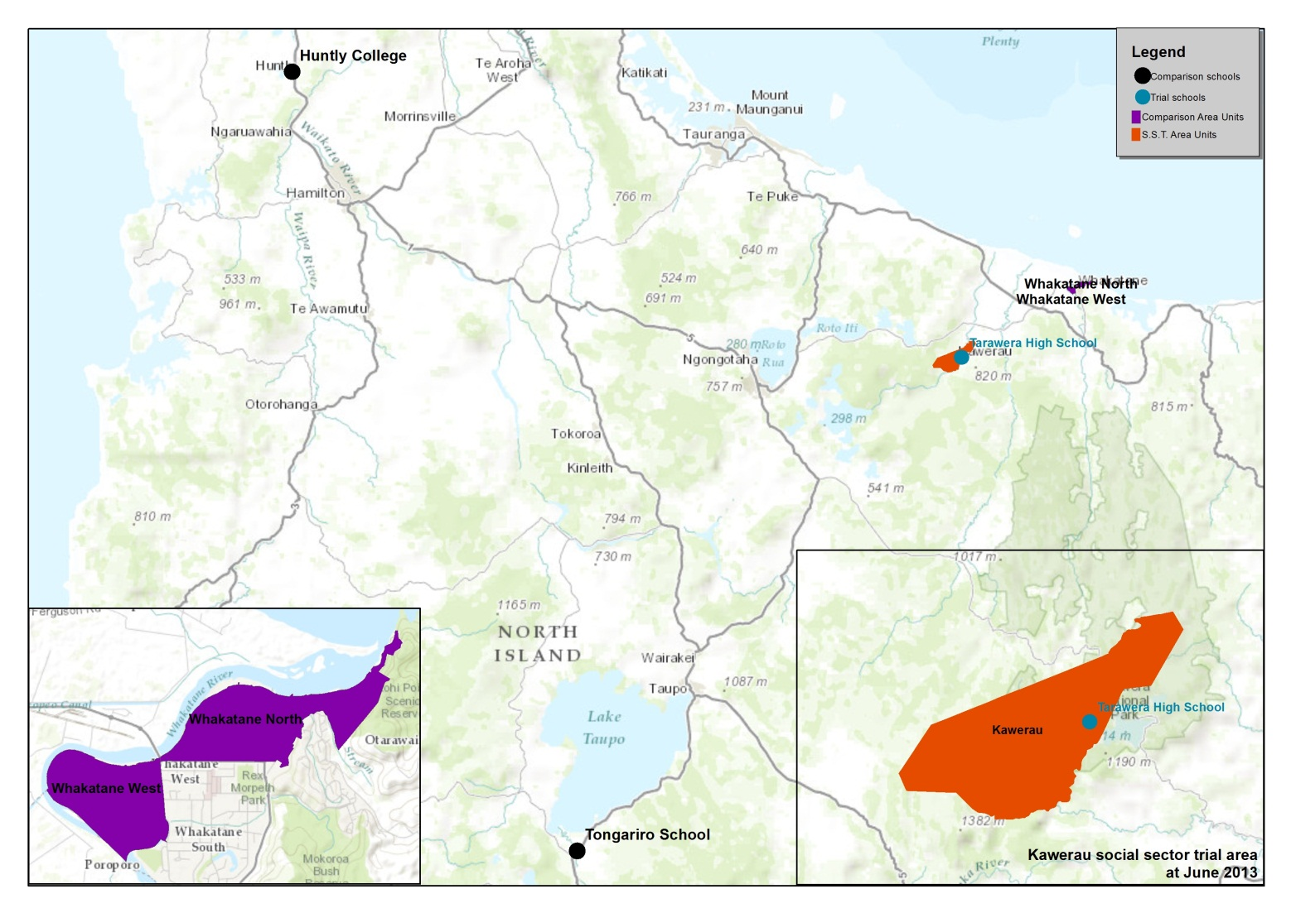

Map 2: South Waikato Social Sector Trial based in Tokoroa pre July 2013 (comparison and trial area units)

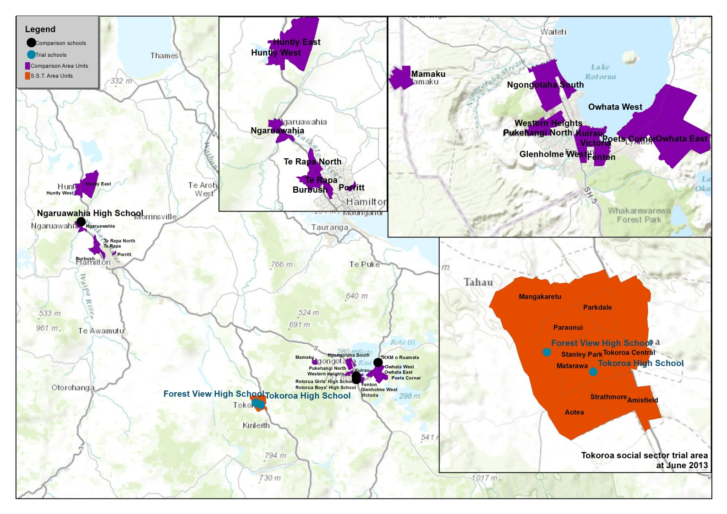

Map 3: Social Sector Trial based in Te Kuiti pre July 2013 (trial and comparison area units and schools)

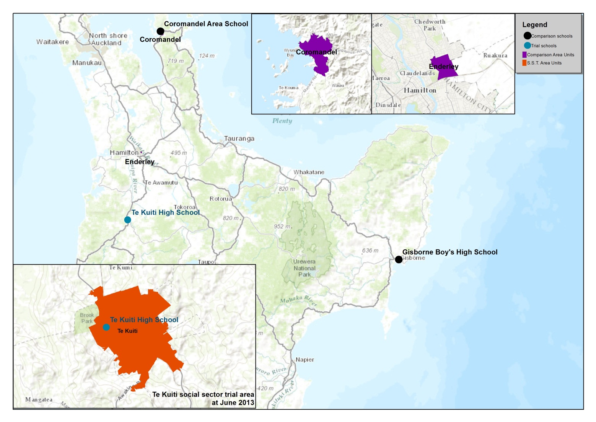

Map 4: Taumarunui Social Sector Trial pre July 2013 (trial and comparison area units and schools)

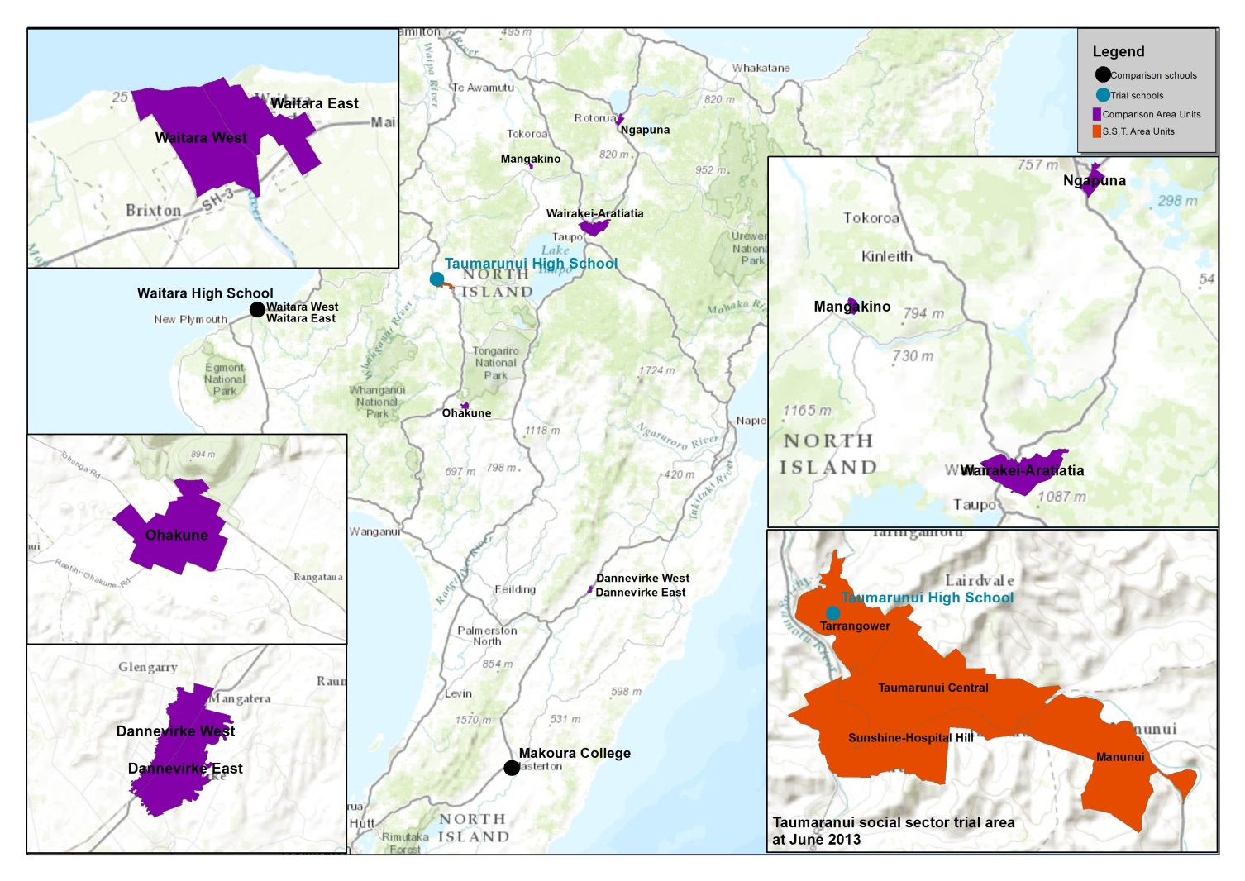

Map 5: Social Sector Trial based in Levin pre July 2013 (trial and comparison area units and schools)

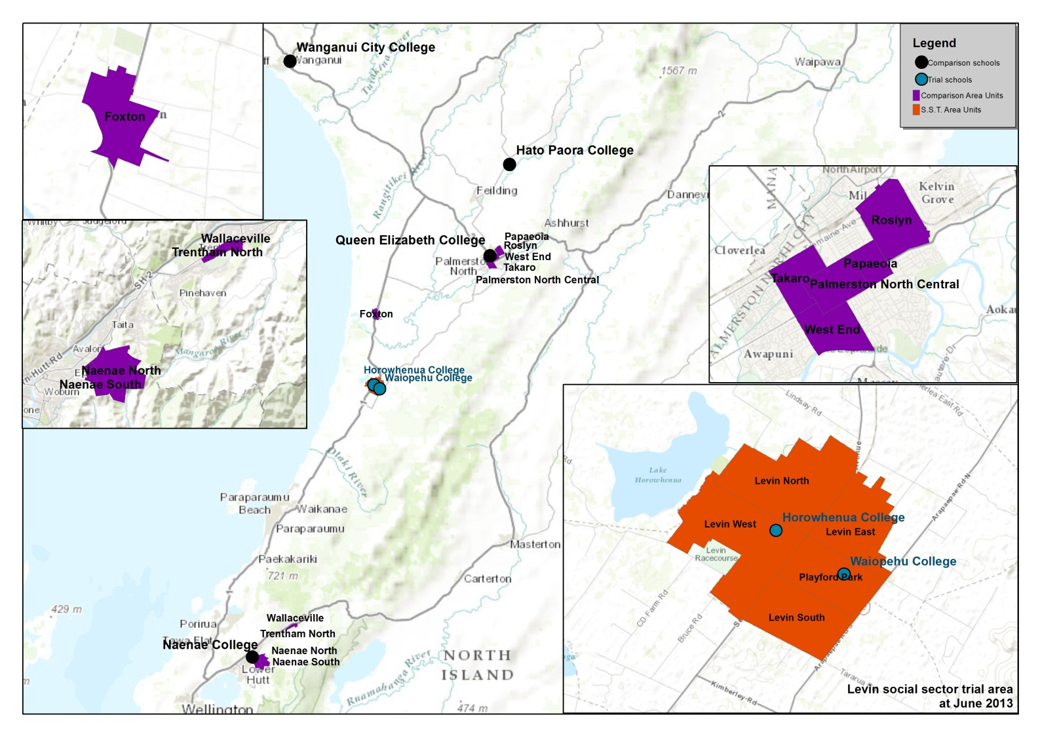

Map 6: Gore Social Sector Trial pre July 2013 (trial and comparison area units and schools)

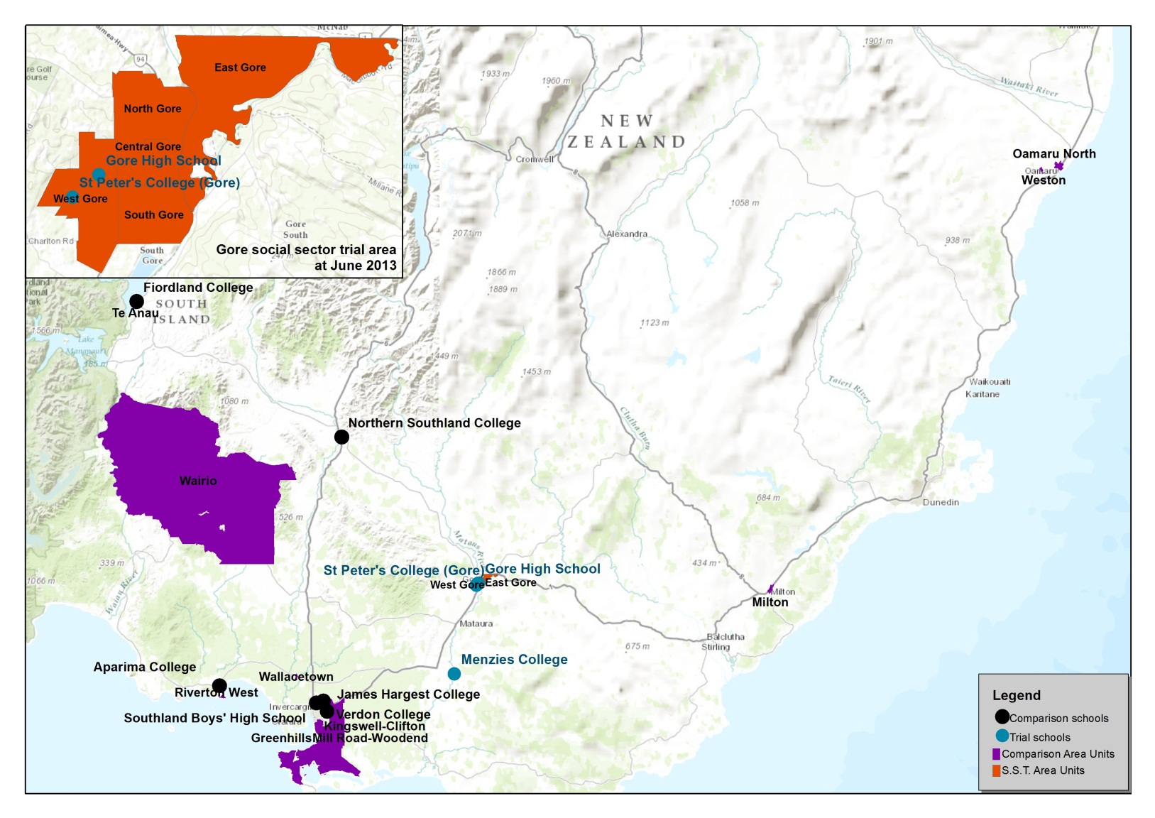

# Appendix 4: Formal impact analysis

The analysis in this report estimates the difference-in-difference estimate of the impact of the social sector trials using both a simple and fixed effects models.[7]

The simple difference-in-difference estimator is the difference of the difference of average outcomes for area units or schools in the pre and post periods. This is estimated in a regression model in order to calculate standard errors for the estimator. The standard model we use for this approach is:

Outcomeit = β1 + β2Triali + β3Timet + β4TrialiTimet + eit

Where:

Outcomeit is the outcome of area unit or school i at time t

Triali is a dummy variable indicating the area unit or school is part of the social sector trials (ie not a comparison)

Timet is a dummy variable for the pre or post time period in which the trial was operating

eit are unobserved disturbances

β4 is the difference-in-difference estimator of the impact of the trial

The fixed effects difference-in-difference estimator also includes a dummy variable for

each area unit or school in order to account for each area or schools characteristics. The model estimated is:

Outcomeit = β1 + β2Triali + β3Timet + β4TrialiTimet + β5Fixedi + eit

The regression uses annual data over the period 2008 to 2013 for the area units, and 2009 to 2013 for the schools. The analysis is weighted using the relevant population or school roll. This means that the outcomes being modelled account for the differing numbers of young people in the area units or schools.

Additional analysis also included a time varying covariate of the proportion of the adult population in receipt of a main benefit in the area unit. The addition of this control in both the area unit and school regressions did not change the overall results of the analysis.

The significance tests reported in this paper are not adjusted for the analysis of multiple outcomes.

In each of the area unit or school regressions we also tested the assumption of a constant difference between the trial and comparison areas or schools prior to the trial being implemented. This test was of the form of the parameter estimate from the regression of the trial average outcomes explained by those in the comparison area units in the years prior to the trial commencing.

AverageTrialOutcomet = β1 + β2AverageComparisonOutcomet + et

To be a constant difference the parameter β2 should be close to unity (ie parallel lines). In most cases this appears plausible with the exception of the rate of police apprehensions.

Table A.4 Test of the parallel lines assumption

|  |  |  |
| --- | --- | --- |
|  | Estimated coefficient | Standard error |
| Youth benefit receipt | 0.96 | 0.37 |
| Police apprehensions | -0.44 | 0.63 |
| Police youth justice referrals to CYF | 0.70 | 0.72 |
| Teenage births | 1.3 | 1.65 |
| Proportion of school leavers aged less than 17 years | 0.26 | 1.40 |
| Proportion of school leavers with less than NCEA level 2 | 0.45 | 0.95 |

# References

Girma, S. and Paton, D. (2014) Is Education the Best Contraception? The Case of Declining Teenage Pregnancy in England, NUBS Research Paper Series No. 2014-04.

Glennerster, R. and Takavarasha, K (2013) Running randomized evaluations: A practical guide, Princeton University Press.

Guttmacher Institute (2014) Use of Highly Effective Contraceptives in the U.S. Continues to Rise, with Likely Implications for Declines in Unintended Pregnancy and Abortion <https://www.guttmacher.org/article/2014/12/use-highly-effective-contraceptives-us-continues-rise-likely-implications-declines>

Hawkins, J., [Oesterle S](http://www.ncbi.nlm.nih.gov/pubmed/?term=Oesterle%20S%5BAuthor%5D&cauthor=true&cauthor_uid=24322060)., Brown, E., Abbott, R. and Catalano, R. (2014) Youth problem behaviours 8 years after implementing the communities that care prevention system: a community-randomized trial, JAMA Paediatrics Feb;168(2):122-9. doi: 10.1001/jamapediatrics.2013.4009.

Imbens, Guido W. and Jeffrey M. Wooldridge. 2009. ‘Recent developments in the econometrics of program evaluation’. Journal of Economic Literature 47, no. 1: 5-86.

Ministry of Social Development (2013) Final Evaluation of the Social Sector Trials [www.msd.govt.nz/about-msd-and-our-work/work-programmes/initiatives/social-sector-trials/](http://www.msd.govt.nz/about-msd-and-our-work/work-programmes/initiatives/social-sector-trials/).

1. Cabinet Social Policy Minute (10) 21/1.
2. Ministry of Social Development (2013) Final Evaluation of the Social Sector Trials https://www.msd.govt.nz/about-msd-and-our-work/work-programmes/initiatives/social-sector-trials/
3. A key issue for the identification of comparison areas and schools was to balance the need to ensure they both were similar, but also in the same broad locality (so as to ensure unmeasured local factors were held constant). The strategy adopted was to prioritize similar characteristics before distance.
4. Gibb, S. et al., (2014) Early Motherhood and Long-Term Economic Outcomes: Findings From a 30-Year Longitudinal Study Journal of Adolescence, Online version.
5. Guttmacher Institute (2014) Use of Highly Effective Contraceptives in the U.S. Continues to Rise, with Likely Implications for Declines in Unintended Pregnancy and Abortion <http://www.guttmacher.org/media/inthenews/2014/12/12/index.html>. See also Girma, S. and Paton, D. (2014) Is Education the Best Contraception? The Case of Declining Teenage Pregnancy in England, NUBS Research Paper Series No. 2014-04.
6. Glennerster, R. and Takavarasha, K (2013) Running randomized evaluations: A practical guide, Princeton University Press; Hawkins, J., [Oesterle S](http://www.ncbi.nlm.nih.gov/pubmed/?term=Oesterle%20S%5BAuthor%5D&cauthor=true&cauthor_uid=24322060)., Brown, E., Abbott, R. and Catalano, R. (2014) Youth problem behaviours 8 years after implementing the communities that care prevention system: a community-randomized trial, JAMA Paediatrics Feb;168(2):122-9. doi: 10.1001/jamapediatrics.2013.4009.
7. Imbens, Guido W. and Jeffrey M. Wooldridge. 2009. Recent developments in the econometrics of program evaluation. Journal of Economic Literature 47, no. 1: 5-86.