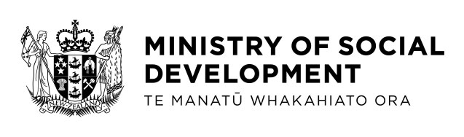

Social cohesion
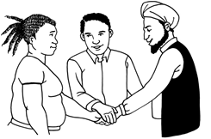

Have your say
about social cohesion in
Aotearoa New Zealand

July 2021

What you will find in here

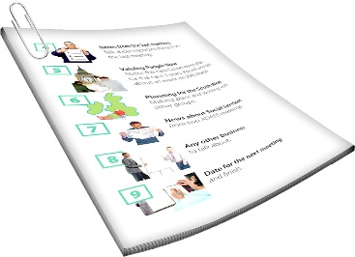
Page number:
Before you read this document….………2

What is this document about?.................3

Part A: What is social cohesion?.............8
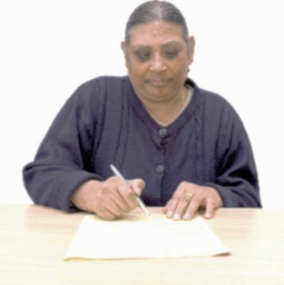

Part B: Have your say about what
social cohesion means to you…........…17

What happens next?..............................20

Where to find more informaton…………25

Before you read this document

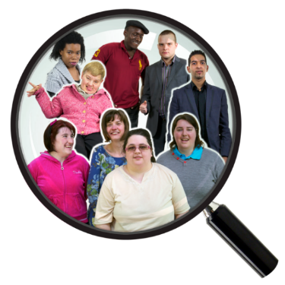
This document has some information about the Royal Commission of Inquiry into the terrorist attack on Christchurch mosques on 15 March 2019.

We look more closely at what this is on pages 3 to 7.
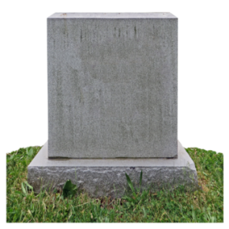

There are some things in here about what happened in the attack in Christchurch.

There may be some things in here that upset people.

If you feel upset you can talk to someone you trust about how you are feeling.
What is this document about?

The Ministry of Social Development wants to know what people in Aotearoa New Zealand think of social cohesion.

On pages 8 to 16 we take a look at some ideas of what social cohesion means.

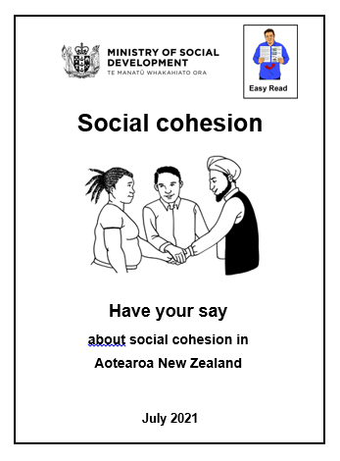
There are two parts to this Easy Read translation:

- Part 1: What is social cohesion?

- Part 2: Have your say about what social cohesion means to you.

This work about social cohesion is being done as part of the work from the:

Royal Commission of Inquiry into the terrorist attack on Christchurch mosques on 15 March 2019.

A Royal Commission is a group of people who come together to look at:
- something that happened
- why it happened.

In this document we will call this Commission the Royal Commission.

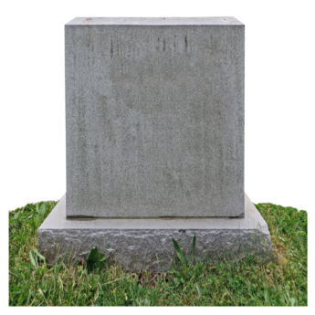
A terrorist attack is when a person or a group of people do something to hurt or kill a lot of people.
A mosque is a place of worship for Muslim people.

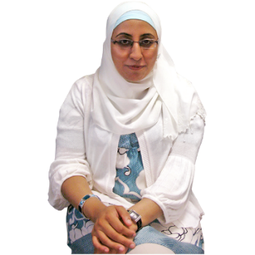
Muslim people are people who are part of the religion called Islam.

The Royal Commission looked at what happened on 15 March 2019 in Christchurch when a terrorist killed 51 Muslim people in 2 mosques.

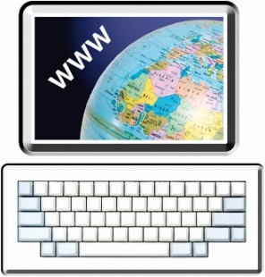
You can find more information about the Royal Commission at this website:

https://christchurchattack.royalcommission.nz/

The information on this website is not in Easy Read.

The Royal Commission wrote a report about some of the things they think needs to happen.

In the report 1 of the things the Royal Commission asked was for the Government to look at ways of having better social cohesion in Aotearoa New Zealand.

Part 1: What is social cohesion?
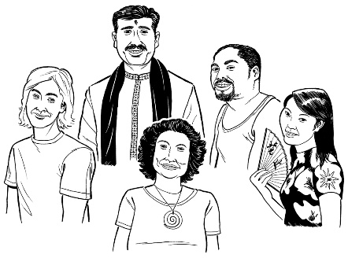
Aotearoa New Zealand is home to many people of different:

- ethnicities
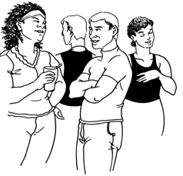
- cultures

- genders
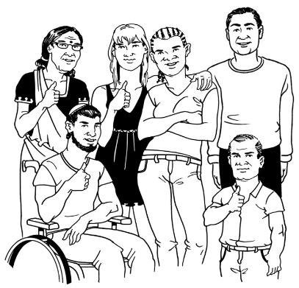
- religions

- ages

- disabilities
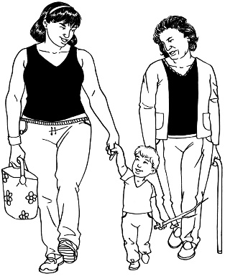
- LGBTTIQ+

- whānau / family ways of life.

Culture is a way of:

- thinking that a group shares

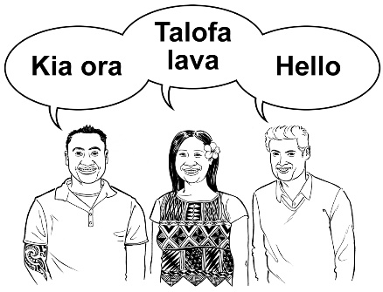
- doing things as a group.

There are many different cultures in
Aotearoa New Zealand.
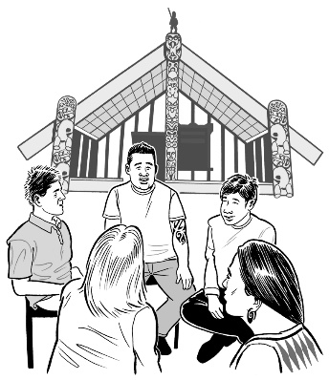

Some examples of the different cultures are:

- Māori culture
- Pacifica culture

- Deaf culture.

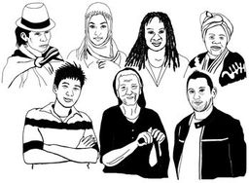
Gender means different things:

- to different people

- in different cultures.

The genders we hear about most are:

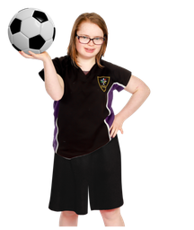
- boy or man

- girl or woman.

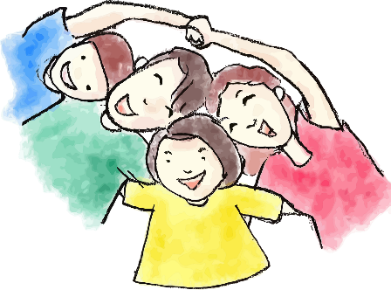
Some people are not a man or a woman.

They may call themselves non-binary.

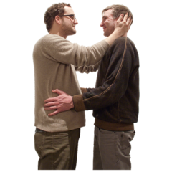
LGBTTIQ+ stands for people who are:

- Lesbian

- Gay

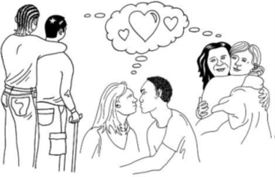
- Bisexual

- Transgender

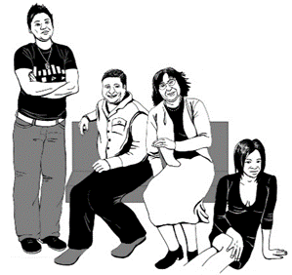
- Takatāpui

- Intersex

- Queer

- and others.

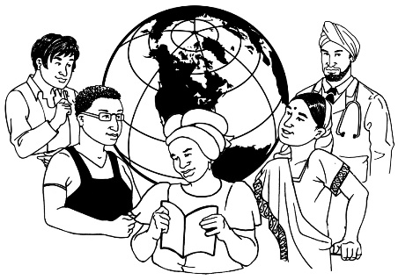
Aotearoa New Zealand is home to people from over 2 hundred and 13 different ethnic groups who:

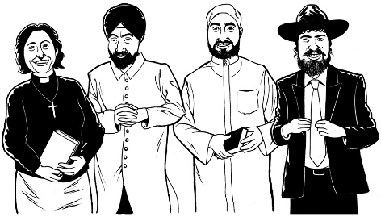
- speak over 1 hundred and 50 different languages

- belong to many different religious communities.

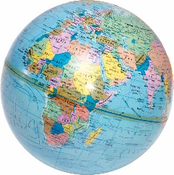
We know that about 1 in 4 people living in Aotearoa New Zealand were born overseas.
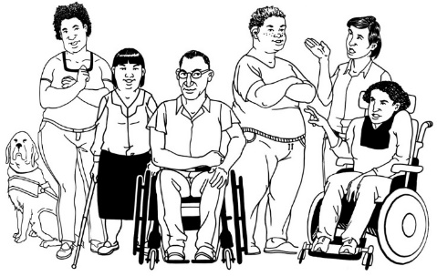

We also know that about 1 in 4 people in Aotearoa New Zealand have a disability.

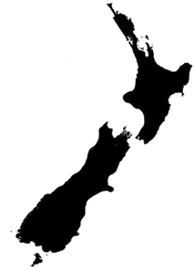
Having good social cohesion is important for our way of life in Aotearoa New Zealand.
The Royal Commission wrote in their report about what they think social cohesion means.

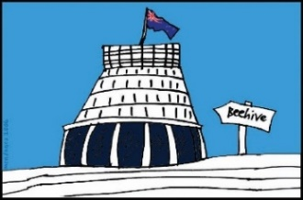
We are using these Royal Commission meanings as part of finding out from New Zealanders what they think of social cohesion.

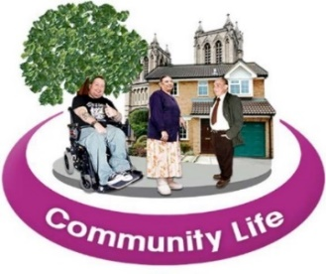
The Royal Commission said that social cohesion is when everyone feels they:

- belong as part of the community
- have trust in the Government to look after everyone.
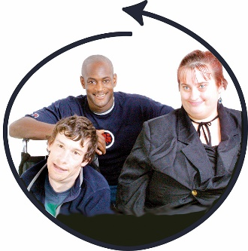
The Royal Commission also said that social cohesion is when everyone feels:

- valued by others

- that there is good inclusion.

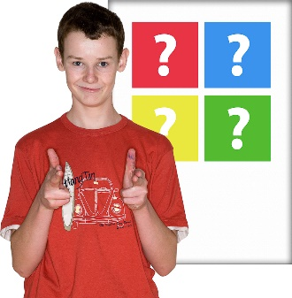
Feeling valued is when other people care about:
- you
- what you think.

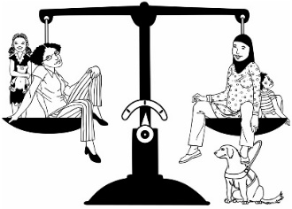
Inclusion is when everyone can have fair access to things like:
- work
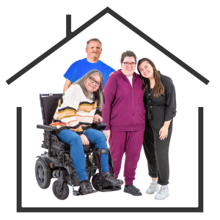
- education like school or university

- housing.
The Royal Commission also said that social cohesion is when everyone feels they are able to take part in their community like:
  - events with other people

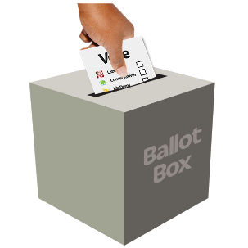
  - playing sports
  - civic life which is things like voting.

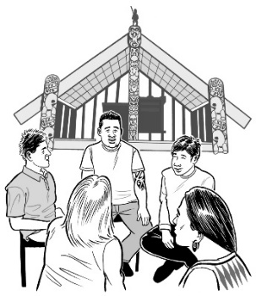
Social cohesion for Māori is when:

- their culture is valued
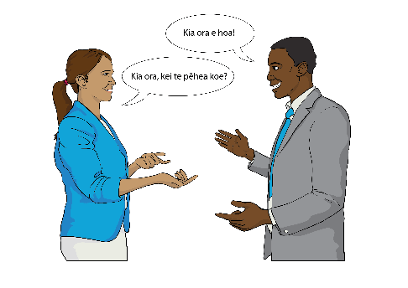
- they feel they belong

- there is manaakitanga.

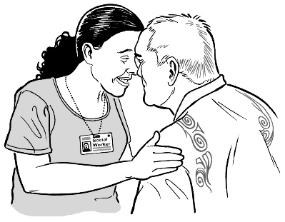
Manaakitanga means showing other people:

- respect
- care.

Part 2: Have your say about what

social cohesion means to you

We want to know:

- what does social cohesion mean to you?
- why is social cohesion important to you?

- what do you think needs to happen for there to be better social cohesion in Aotearoa New Zealand?

- how will we know when we have better social cohesion in Aotearoa New Zealand?
.

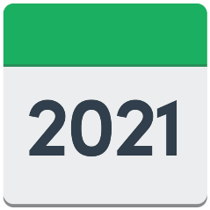
You have until Tuesday 6 August 2021 to have your say about social cohesion.

You can let us know what you think by filling in our online survey:
https://bit.ly/3jtncaa

Online means using the internet to do things like:

- looking at websites

- sending emails.

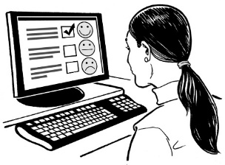
A survey is when we ask questions to get information.

The online survey is not in Easy Read.

You can also let to us know about what you think of social cohesion by:

- writing to us at:
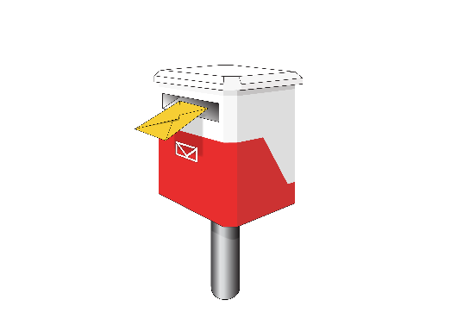
Social Cohesion Survey

Ministry of Social Development
PO Box 1556
Wellington 6140

- by emailing us at:

social_cohesion@msd.govt.nz

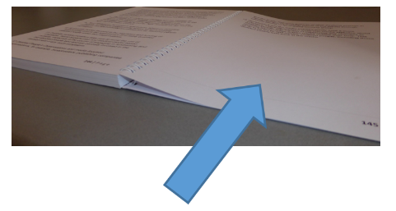
It is important that you read pages 20 to 24 before:

- writing to us

- emailing us.

What happens next?

We will use the information you give us to write our own report about how to make social cohesion better in Aotearoa New Zealand.
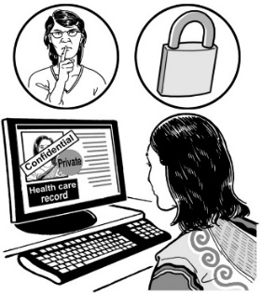

We will follow the rules of the Privacy Act 2020 when we:

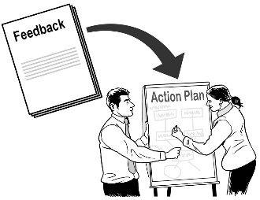
- use your ideas
- share your ideas.
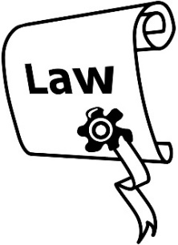
The Privacy Act 2020 is a law about protecting your personal information.

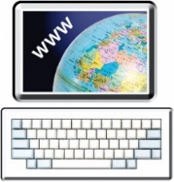
This report will go on Ministry of Social Development website:.
https://bit.ly/3x4kv2S

The report will also be given to the:

- Ministry of Justice
- Department of Internal Affairs.

The report will be given to these Government departments because they are also working on the things that the Royal Commission would like to see happen.

We will not use your name in the report.

Please tell us if you do not wish for your ideas to be shared in the report.

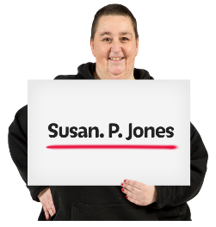
Please do not tell us your personal details like your:
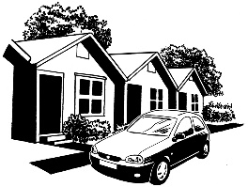
            - name
            - address
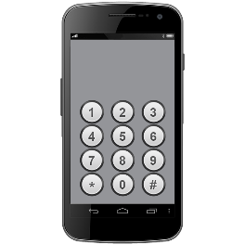
            - phone number.

Please also do not tell us the personal details of anyone else.

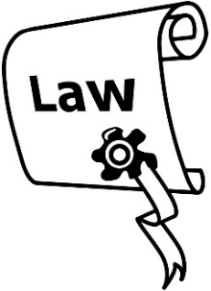
We will also follow the rules of the Official Information Act 1982.

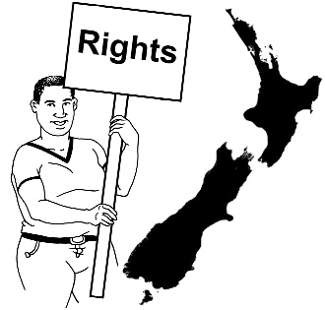
The Official Information Act 1982 is a law that allows everyone in New Zealand the right to access personal information that the Government has about them.
This means you have the right to:

- see the information the Government has about you
- ask for changes to the information the Government has about you.

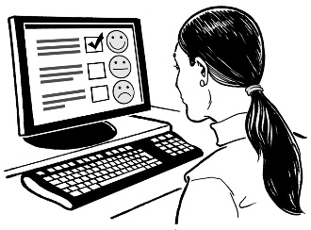
We will also record your IP address when you send us information online.

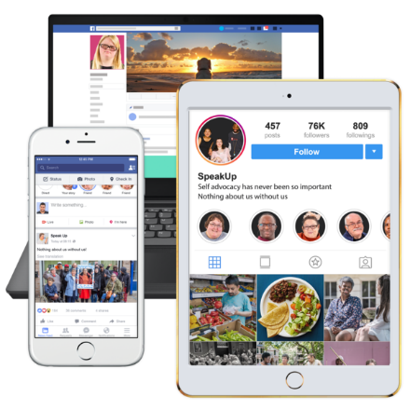
An IP address is a code that shows the device that you use the internet on like a:
- computer
- phone
- tablet.
This will help us know if something goes wrong with our:
- internet
- computers.

Where to find more information

You can find more information about this social cohesion work on the Ministry of Social Development website:
https://bit.ly/3wcNtw5

You can also contact us to ask for more information by:

- email:

social_cohesion@msd.govt.nz

- phone:

04 916 3300
This information has been written by the Ministry of Social Development.

It has been translated into Easy Read by the Make It Easy service of People First New Zealand Inc. Ngā Tāngata Tuatahi.

The ideas in this document are not the ideas of People First New Zealand Inc. Ngā Tāngata Tuatahi.
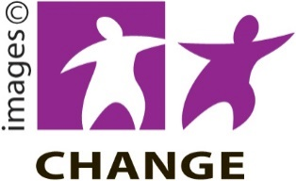

Make It Easy uses images from:

- Changepeople.org

- Photosymbols.com

- Sam Corliss.

All images in this Easy Read document are subject to copyright rules and cannot be used without permission.

