Material hardship of children in households with a disabled person

Authors

Moira Wilson (MSD) and Keith McLeod (Keith McLeod Consulting).

Acknowledgements

We are grateful to members of an Expert Reference Group for invaluable discussion, advice, and detailed feedback on earlier drafts. Expert Reference Group members were Donna Matahaere-Atariki, Claire Bretherton, Moira Crispe, Karen Davidson, Angela Desmarais, Ofa Dewes, Lauren Donnan, Jonathan Godfrey, Bernadette Jones, Tracey McIntosh, Mary Silcock and Cathy Stephenson. Helpful peer review was also provided by officials from the Child Wellbeing and Poverty Reduction Group, the Ministry of Health, the Ministry of Social Development, Oranga Tamariki – Ministry for Children, Statistics New Zealand, and Whaikaha – Ministry of Disabled People.

Disclaimer

These results are not official statistics. They have been created for research purposes from the Integrated Data Infrastructure which is carefully managed by Stats NZ. For more information about the Integrated Data Infrastructure please visit <https://www.stats.govt.nz/integrated-data/>.

The results are based in part on tax data supplied by Inland Revenue to Stats NZ under the Tax Administration Act 1994 for statistical purposes. Any discussion of data limitations or weaknesses is in the context of using the Integrated Data Infrastructure for statistical purposes, and is not related to the data’s ability to support Inland Revenue’s core operational requirements.

The views, opinions, findings, and recommendations expressed in this report are those of the authors. They do not necessarily reflect the views of the Ministry of Social Development, or all the views and advice given by people involved in advisory or peer review process. The Ministry of Social Development takes responsibility for how it uses the advice given. Any errors or omissions are those of the authors.

Published

Published Ministry of Social Development

PO Box 1556

Wellington

www.msd.govt.nz/insights

ISBN

978-1-99-110596-7

# Contents

Executive summary 6

Key findings 9

Insights for policy and research 17

Introduction 22

Purpose 22

Background 22

Approach 26

Definitions 27

Strengths and limitations 31

Children in households with a disabled person 35

Number of disabled people in the household 35

Ages of disabled people in the household 36

Material hardship, income poverty, incomes, and housing costs for children with and without a disabled person in their household 39

The rate of material hardship 39

What material hardship looks like 48

Income-based poverty rates 54

Incomes and housing costs 58

Household and other characteristics for children with and without a disabled person in their household 63

Household size and composition 63

Housing 69

Geographic location and neighbourhood deprivation 72

The circumstances of adults in the household 74

Receipt of Disability Support Services 77

Receipt of benefits and other transfers 79

Receipt of Ongoing Resource Scheme funding 86

Children’s characteristics 87

Material hardship rates by adults’ paid employment and sources of income 89

Non-employment and/or transfers the main source of income 89

Employment and/or market income the main source of income 92

Main benefit receipt compared with ACC receipt 93

Insights for policy and research 95

References 103

Appendix 1: Strengths and limitations 108

Appendix 2: What material hardship looks like by ethnic group 114

Appendix 3: Child-related restrictions by ethnic group 119

Appendix 4: Rural-urban location 124

# Executive summary

The New Zealand Government uses three primary measures to track progress on reducing child poverty. Stats NZ reports on these measures each year.

* One measure tracks the proportion of children aged under 18 who live in households experiencing material hardship. This is based on a set of questions about whether the household can afford items that most people regard as essential, or whether they experience financial stress or vulnerability.
* Two measures track the proportions of children aged under 18 in households with income below income-based poverty lines. These include a measure that looks at income before deducting housing costs, and a fixed-line measure that looks at income after deducting housing costs (relative to the baseline year ended June 2018).

These measures have been reported for children living in households with a disabled person since 2019/20. In that reporting, whether a person is disabled or not has been based on international Washington Group questions on functioning. These questions have been used to derive disability indicators where:

* people aged 18 or over are considered disabled based on the amount of difficulty they have with seeing, hearing, walking or climbing stairs, remembering or concentrating, self-care, communication (expressive and receptive), upper body activities, and affect (depression and anxiety)[1]
* children and young people aged 5 to 17 are considered disabled based on the amount of difficulty they have with seeing (even with glasses), hearing (even with hearing aids), walking, feeding or dressing themselves, communicating, learning, remembering, concentrating, accepting change, controlling their own behaviour, making friends, anxiety, or depression[2]
* children aged 2 to 4 are considered disabled based on the amount of difficulty they have with seeing (even with glasses), hearing (even with hearing aids), walking, manual dexterity, communicating, learning, playing, or controlling their own behaviour.[3]

Children living in households where there is a disabled person according to these indicators (either the child themselves or another person) account for just over half of all children living in households experiencing material hardship.

The aim of this study is to help build a better understanding of this over-representation to inform possible policy responses. It provides a data resource that:

* looks at differences between children in households with a disabled person (adult or child) and other children who do not live in households with a disabled person, by ethnic group
* allows children in different ethnic groups living in households with a disabled person to be compared.

We use combined data from three years of the Statistics New Zealand (Stats NZ) Household Economic Survey (survey years 2019/20, 2020/21, and 2021/22). These data are linked with administrative data on income support payments, employment and support services.

Stats NZ provides official statistics on child poverty as required under the Child Poverty Reduction Act. Because we pool data across multiple years[4] and because of slight variations in approach, we obtain slightly different child poverty rates to the Stats NZ official statistics.

The study is limited to providing a descriptive data resource. It does not explore causal relationships. Nor does it explore independent associations (for example, between having a disabled household member and material hardship) after holding constant all other measurable factors (such as differences in education level or employment).

Alongside this study, a multi-strand qualitative study has invited disabled people, people with long-term health conditions, and people in families and whānau with a disabled person or a person with a long-term health condition to share their experiences. These interviews provide deeper insights into the context of peoples’ lives, the costs they face, and their income support experiences.

Other studies in the work programme:

* look at the feasibility of using the Household Economic Survey data to estimate how much extra income households with a disabled person would need to have the same living standards as households with no disabled person, on average
* examine awareness and understanding of the income support that is available to help with extra costs for disabled people and people with disabled children.

This report describes the results from the present study. Accompanying tables allow readers to look in more detail at the data behind the results.

## Key findings

Differences between groups highlighted in this summary are statistically significant differences.

**Based on the disability measure used in child poverty reporting, almost three in every ten children (29.2 percent, around 335,000 children) lived in a household with a disabled person:**

* 14.2 percent lived with one or more disabled adults aged 18-64
* 1.4 percent lived with one or more disabled adults aged 65 or over
* 19.0 percent lived in a household with one or more disabled children
* 5.0 percent lived in a household with both one or more disabled children and one or more disabled adults.

**Māori and Pacific children were more likely than children in other ethnic groups to live in a household with a disabled person.**

The proportions of children in each ethnic group living in a household with at least one disabled person (adult or child) were:

* 38.5 percent for Māori children
* 36.4 percent for Pacific children
* 28.9 percent for European children
* 18.6 percent for Asian children, compared with
* 29.2 percent for all children.

**Māori and Pacific children were more likely to live in multi-generational households with an older disabled person, and with multiple disabled people in their household.**

Māori children were more likely than non-Māori children to live in a household with an older disabled person (2.2 percent compared with 1.3 percent). The proportion was 3.2 percent for Pacific children.

Māori children were more likely than non-Māori children to live in a household with two or more disabled people (13.0 percent compared with 6.9 percent). The proportion was 11.8 percent for Pacific children.

**Children living in households with a disabled person (adult or child) were much more likely than other children to experience material hardship.**

Compared to children in households with no disabled person, children in households with a disabled person were 3.1 times more likely to be in a household experiencing material hardship (21.2 percent compared to 6.9 percent).

**In households with a disabled person, Pacific and Māori children had much higher rates of material hardship than children in other ethnic groups.**

The proportions of children in households with a disabled person in a household experiencing material hardship were:

* 35.8 percent for Pacific children
* 28.8 percent for Māori children
* 17.5 percent for European children
* 11.5 percent for Asian children, compared with
* 21.2 percent for all children.

**The difference in material hardship rates, comparing those in and not in households with a disabled person, was less pronounced for Māori and Pacific children.**

This was partly due to a higher rate of material hardship among Māori and Pacific children not in households with a disabled person.

Compared to Māori children in households with no disabled person, Māori children in households with a disabled person were 2.0 times more likely to be in a household experiencing material hardship (28.8 percent compared to 14.1 percent).

Compared to Pacific children in households with no disabled person, Pacific children in households with a disabled person were 1.8 times more likely to be in a household experiencing material hardship (35.8 percent compared to 19.8 percent).

**In general, the more disabled people in a child’s household, the more likely it was that their household was in material hardship.**

The material hardship rate for children was:

* 17.4 percent where there was one disabled person in the household,
* 30.6 percent where there were two or more disabled people in the household.

**Each of the 17 restrictions that are used to measure material hardship were more likely to occur for children in a household with a disabled person (adult or child) than for other children.**

The measure of material hardship used for child poverty monitoring is the percentage of children living in households reporting six or more of 17 restrictions that indicate that they can’t afford items that most people regard as essential or experience financial stress and vulnerability.

Children living in a household with a disabled person were more likely to have each of these 17 restrictions compared to other children. Their households were, for example:

* 2.8 times more likely to report putting off visits to the doctor a lot to keep costs down (16.3 percent compared to 5.8 percent)
* 1.7 times more likely to report putting off visits to the dentist a lot to keep costs down (37.9 percent compared to 22.0 percent)
* 2.0 times more likely to report that they would be unable to pay an unexpected and unavoidable expense of $500 within a month without borrowing (35.0 percent compared to 17.9 percent).

**Children in households with a disabled person were more likely than other children to experience severe material hardship, defined as experiencing nine or more of the 17 restrictions.**

Comparing with children in households with no disabled person, children in households with a disabled person were 3.7 times more likely to be in a household experiencing severe hardship (9.6 percent compared to 2.6 percent).

For Māori children in a household with a disabled person, the proportion in severe hardship was 13.8 percent. This compared to 7.4 percent for non-Māori children in a household with a disabled person.

For Pacific children, the proportion in severe material hardship was 15.8 percent.

**In addition, more children aged 6-17 in households with a disabled person faced child-related expenditure restrictions and needed to economise compared to other children in this age group.**

For example, they were:

* 3.0 times more likely to not have fresh fruit and vegetables daily (7.9 percent compared to 2.6 percent)
* 2.6 times more likely to have had to go without music, dance, kapa haka, art, swimming or other special interest lessons a lot to keep down costs (7.5 percent compared to 2.9 percent).

**Children living in a household with a disabled person were more likely to be living in poverty measured using the income-based poverty measures, but this over-representation was not as marked as it was for material hardship.**

Children in households with a disabled person were:

* 1.5 times more likely to be in a household with income below the before-housing-costs poverty line (15.7 percent compared to 10.3 percent)
* 1.2 times more likely to be in a household with income below the after-housing-costs poverty line (20.7 percent compared to 16.6 percent).

They accounted for:

* 38.6 percent of all children in households with income below the before-housing-costs poverty line
* 33.9 percent of all children in households with income below the ‘after-housing-costs’ poverty line.

In contrast they accounted for 55.9 percent of children in households experiencing material hardship.

**Average household income was only slightly lower for children in households with a disabled person than for children in households with no disabled person.**

* Average household disposable income (after tax and transfers such as benefits and Working for Families tax credits) for children in a household with a disabled person was 94.2 percent of that for other children ($103,017 compared with $109,386 in 2022-dollar terms).
* Average equivalised household disposable income (after tax and transfers *and* after adjusting for household size and composition) for children in a household with a disabled person was 85.4 percent of that for other children ($40,938 compared with $47,915 in 2022-dollar terms).

Although average household disposable income was only slightly lower, the effect of equivalisation increased the size of the income gap. This indicates the income needed to meet the needs of more people, reflecting the larger average size of households with disabled people.

For context, one-person households are the reference point for equivalisation. This means that $40,938 should be thought of relative to the needs of a one-person household in terms of value.

While income support payments that help with additional costs experienced by households with a disabled person are included in income, equivalisation does not adjust for these costs. This means that less of the equivalised disposable income will be available for spending on other everyday needs in households with a disabled person, on average.

**Results suggest economising on housing and home heating costs.**

Children in households with a disabled person were more likely live in housing that was crowded (19.6 percent compared to 10.5 percent). They were also more likely to live in a household that reported putting up with feeling cold to save on heating costs.

**Children in households with a disabled person (adult or child) were more likely to have a range of other circumstances that are associated with higher-than-average rates of material hardship.**

Compared to other children, children in households with a disabled person were more likely to:

* live in a household made up of a sole parent and their children, usually a sole mother
* be in a household that was renting or in social housing
* live outside regions containing the main centres, and in more deprived neighbourhoods
* live with adults with low educational qualifications or no paid employment, and/or who were receiving income support payments.

**Only a small proportion of children in households with a disabled person lived in households where disability-related income support payments and support services were received.**

Looking at children in households with a disabled person in any age group:

* 12.0 percent were in a household where Disability Allowance was received
* 8.1 percent were in a household where a child or adult had received Disability Support Services.

Looking at children in households with a disabled child:

* 22.9 percent were in a household where Child Disability Allowance was received
* 8.0 percent were in a household where a child was receiving Ongoing Resource Scheme funding.

**Material hardship rates were particularly high for children in households where no adults were in paid employment.**

Where no adults were in paid employment, children in households with a disabled person had a material hardship rate of 53.5 percent, compared with 31.6 percent for other children in these circumstances.

Children in households where no adults were in paid employment with a disabled person made up:

* 15.9 percent of children in a household with a disabled person
* 40.1 percent of children in a household with a disabled person in material hardship
* 22.4 percent of all children in material hardship.

**Where no adults were in employment, rates of material hardship for children in households with a disabled person were broadly similar across ethnic groups.**

Māori children in a household with a disabled person where no adult was employed had a material hardship rate of 55.4 percent compared to 51.0 for non-Māori children in these circumstances. For Pacific children, the proportion was 61.0 percent. Differences between these rates were not statistically significant.

**Among children in households where adults were in paid employment, being in a household with a disabled person substantially increased the risk of material hardship.**

Children in a household with a disabled person where at least one adult was employed had a material hardship rate of 15.1 percent compared with 4.6 percent for other children in a household where adults are employed.

Among children in households with a disabled person, those in households where at least one adult was employed were more numerous than those in jobless households.

This meant that despite having a lower rate of material hardship, the children in households where at least one adult was employed accounted for a larger share of children in material hardship than the children in households where no adults were in employment.

Children in a household with a disabled person where at least one adult was employed made up:

* 84.1 percent of children in a household with a disabled person
* 59.9 percent of children in a household with a disabled person in material hardship
* 33.5 percent of all children in material hardship.

**Where there were adults in paid employment, Māori and Pacific children in households with a disabled person had higher rates of material hardship than European and Asian children in households with a disabled person.**

Māori children in a household with a disabled person where adults were employed had a material hardship rate of 20.2 percent compared with 12.9 percent for non-Māori children in these circumstances. For Pacific children, the proportion was 30.0 percent.

## Insights for policy and research

**So long as they lead to improved income after factoring in the costs of working such as transport costs and costs of alternative care arrangements, policies that improve support for paid employment and improved earnings of disabled adults and adults who care for disabled children and adults are likely to reduce income-based child poverty rates and material hardship.**

In households with children where there is a disabled person, there are higher than average rates of receipt of main benefits and lower than average rates of paid employment among the adults.

Policies that support employment and improved earnings are likely to reduce income-based child poverty and material hardship rates if they lead to improved income, after taking into account the costs of working.

**Such policies need to be mindful that many children living in households with a disabled person are in families where there is only one parent, generally a sole mother, to meet the family’s care and economic needs.**

Almost three in ten children in households with a disabled person live with a sole parent. Support for employment needs to be flexible and tailored. Employment may not always be possible or economically feasible, especially where the disabled person is the sole parent or a child has a disability requiring significant additional care and attention.

**Policies that support increased paid employment and earnings, on their own, will not fully address the high rates of material hardship among children in households with a disabled person.**

Most children in households with a disabled person and in material hardship live with adults who are employed. In most cases market income is already the household’s main source of annual income. Average household incomes of children in households with a disabled person, although lower, are already fairly close to the average household incomes of other children.

**An important factor likely to contribute to high rates of material hardship among children in households with a disabled person is the extra costs households with a disabled person face.**

There is a larger gap in material hardship than in average incomes and income-based poverty rates comparing children in households with a disabled person to other children. This indicates that other factors, in addition to lower incomes, contribute to the higher rates of material hardship among children in households with a disabled person.

Additional costs associated with disability are likely to be an important factor. International and New Zealand evidence points toward households with a disabled person having extra costs that can be sizeable. These costs reduce the resources available to spend on other essential items.

**Improving income support payments such as Disability Allowance and Child Disability Allowance and Whaikaha-funded supports that help with the additional costs of disability would be a useful focus for future child poverty reduction efforts.**

Policies that reduce or compensate for additional costs would be useful to explore as mechanisms for reducing rates of material hardship among children and addressing inequities in material hardship rates.

For most children in households with a disabled person, there is no receipt of disability-related income support payments and support services in the household. This is important because it implies that simply increasing the generosity of these payments and supports for people currently in receipt of them would not be enough to address the over-representation of children in households with a disabled person among children in material hardship.

**More research on rates of receipt of health- and disability-related income support payments and support services would be useful.**

Our analysis could be extended by further research that looks in more detail at rates of receipt for those with potential eligibility, taking into account income tests and other qualifying criteria. This could include estimating rates of receipt at the individual level. This would be important to do in order to understand equity of receipt given that Māori and Pacific children would be expected to have more potentially eligible people in their households.

This would provide a better understanding of whether increasing rates of receipt of existing income support payments and support services, and improving equality of receipt of these supports across groups, could contribute to meeting child poverty reduction goals.

**Households with a disabled person are more likely than other households to be crowded and economise on home heating. This is likely to be harmful to children’s health and development, and to the health and wellbeing of other household members.**

This suggests that policies that reduce or compensate for additional costs could improve the health and wellbeing of disabled children and their families and whānau, in addition to reducing material hardship.

**Addressing other factors that contribute to inequalities between Māori and non-Māori in children’s experiences of material hardship is also important.**

Policies could include, for example, improving support for the employment of Māori disabled people, and for Māori who care for disabled children and adults, enabling Māori-led employment strategies, and reducing inequalities in housing and in access to health and other services faced by Māori disabled people.

**Pacific children need to be a key population for focus given their very high rates of material hardship.**

Policies that address housing, educational, economic, and health and disability inequalities experienced by Pacific people will also help address large inequities in Pacific children’s experiences of material hardship. This includes policies that are Pacific-led and targeted for the unique cultural needs of different Pacific ethnic groups.

**The over-representation of children in households with a disabled person among children in material hardship could be explored further.**

Our descriptive results highlight associations between whether there is a disabled person in a household and factors such as adults’ education levels, employment and housing. These factors also have independent associations with material hardship. Further research could seek to disentangle the independent effects of having a disabled person in the household on children’s risk of material hardship from the effects of these other factors, and explore causal relationships.

In addition, detailed expenditure data collected in the Household Economic Survey could be analysed to explore the relationship between costs incurred by households with and without a disabled person, and their income and experiences of material hardship.

**The next step for our research is to look at the feasibility of estimating how much extra income households with a disabled person would need to have the same living standards as households with no disabled person, on average**.

Internationally, research studies have estimated the scale of the additional costs of disability using statistical methods. These studies aim to provide estimates that can help inform:

* policy settings for income support payments and other publicly-funded supports
* methods used to equivalise incomes when tracking income-based poverty measures.

The statistical methods used in international studies look at how much more income families with a disabled person would need to have the same standard of living as similar families without a disabled person. The amount arrived at can be taken as an indication of the average additional costs families with a disabled person have.

We will look at the feasibility of producing such estimates for New Zealand.

# Introduction

## Purpose

This study explores the data behind child poverty monitoring results that show high rates of material hardship for children living in a household where there is one or more disabled person.

It provides a data resource for children overall, and for Māori and non-Māori children. This helps provide evidence on the degree to which there is protection and equitable outcomes for Māori. Data are also presented for European, Pacific and Asian children. Sample size does not allow data to be presented for children in different Pacific ethnic groups, or for children in Middle Eastern, Latin American, African, or other ethnic groups.

## Background

The Child Poverty Reduction Act (2018) requires current and future Governments to set three-year and ten-year targets for reducing child poverty. It also establishes measures for tracking progress on reducing child poverty. This includes reporting on material hardship and income-based poverty measures from the annual Household Economic Survey (HES) (Department of Prime Minister and Cabinet, 2022).

Statistics New Zealand’s (Stats NZ’s) reporting for the year ended June 2023 showed that one in five children in households with a disabled person lived in a household experiencing material hardship. This rate had not changed since reporting for year ended June 2020, the first year questions were asked about whether there were disabled people in the household.

In the year ended June 2023, children in households with a disabled person were three times more likely to experience material hardship than children in households with no disabled people. They accounted for just over half of all children living in a household experiencing material hardship.

Across all children, the proportion in a household experiencing material hardship was one in five for Māori children and one in four for Pacific children in the year ended June 2023. These rates were substantially higher than the overall average rate of one in eight children experiencing material hardship.

Little of the standard output from Stats NZ allows results for Māori disabled people to be compared with those for non-Māori disabled people. One of the aims of this study is to address this evidence gap for child poverty data.

Our study adds to the research and data resources available that contain data for disabled people (Box 1).

____________________________________________

Box 1: Research and resources with data for disabled people

Stats NZ’s 1996, 2001, 2006 and 2013 Disability Surveys provide data on the characteristics of disabled people, including the nature and cause of impairments, the type of support they need, and how well they are faring compared with non-disabled people (Stats NZ, 2014). Results from the 2023 Disability Survey will be released in November 2024.

The Ministry of Health’s annual Health Survey reports on measures for disabled adults and children (Ministry of Health, 2023). Data for disabled people are also available from the Household Labour Force Survey, the General Social Survey and the Household Economic Survey (Office of Disability Issues, 2022). Stats NZ (2020) compares a range of housing, economic, and social outcomes from selected survey data sources and the 2018 Census. Analysis of Household Economic Survey data by Stephens (2022) includes breakdowns of poverty rates for families with disabled people.

In 2022, Ingham et al. (2023) conducted an accessible and culturally grounded survey with 7,230 adult participants that explored Māori health, wellbeing and disability. The survey uses a Kaupapa Māori Research methodology and was codesigned with tāngata whaikaha Māori (Māori with lived experience of disability). It includes Māori measures of disability.

Reports prepared for the Waitangi Tribunal inquiry Wai 2575 include analysis of data for Māori and non-Māori disabled people from Stats NZ’s 1996, 2001, 2006 and 2013 Disability Surveys, SOCRATES (the Disability Support Services client database) and Blind Foundation data (Himona et al., 2019), and examine other data sources (King, 2019).

Murray (2018) presents unpublished data for disabled children aged 0-14 from the 2013 Disability Survey and data from the Ministry of Education’s Ongoing Resourcing Scheme (for students with high learning support needs). Wynd (2015) collates available data on disabled children and receipt of disability-related income support payments including Child Disability Allowance. A working paper prepared for the Expert Advisory Group on Solutions to Child Poverty (2012) provides an overview of the relationship between disability and child poverty, and disability data available at that time.

A report and associated interactive web application prepared for the IHC by Beltran-Castillon and McLeod (2023) compares outcomes for intellectually disabled people and other New Zealanders.

A research snapshot from the Growing Up in New Zealand (GUiNZ) longitudinal study looks at the characteristics and experiences of disabled children and children with a disabled person in their family (Marks et al., 2023). ___________________________________________

## Approach

We combine data from the first three years of the Household Economic Survey that asked questions about whether people are disabled ((2019/20, 2020/21, and 2021/22).

Combining data across years provides a sample of 103,383 people[5] living in 39,777 households.[6] This allows us to look at smaller population sub-groups than we would be able to if we used a single year of the Household Economic Survey. We re-weight the data to represent the average New Zealand population across the three years.

We then look at differences between children in households with a disabled person (either the child or another person) and other children in households without a disabled person. Differences between children in different ethnic groups in households with a disabled person are also examined.

Some of the comparisons are based on data collected from the household in the Household Economic Survey. Other comparisons are based on administrative data able to be linked with the Household Economic Survey in the Stats NZ Integrated Data Infrastructure.

The Integrated Data Infrastructure is a database containing linked individual-level data (Milne et al., 2019). The data comes from a range of government and non-government administrative and survey sources and are probabilistically linked and de-identified before being made available for approved research.

Administrative data in the Integrated Data Infrastructure allow us to look at, for example, the income and employment status of adults in the household and receipt of income support payments and disability-related services.

Accompanying tables provide the full set of results produced.

## Definitions

### Disability

Since 2019/20, international Washington Group questions on functioning have been asked of all Household Economic Survey respondents aged two and over.[7] These are used to derive disability indicators where:

* people aged 18 or over are considered disabled based on the amount of difficulty they have with one or more of the following: seeing (even with glasses), hearing (even with hearing aids), walking or climbing stairs, remembering or concentrating, self-care, communication (expressive and receptive), upper body activities, and affect (depression and anxiety) – The ‘Washington Group Short Set on Functioning – Enhanced’ indicator (Washington Group, 2020a)
* children and young people aged 5 to 17 are considered disabled based on the amount of difficulty they have with one or more of the following: seeing (even with glasses), hearing (even with hearing aids), walking, feeding or dressing themselves, communicating, learning, remembering, concentrating, accepting change, controlling their own behaviour, making friends, anxiety, or depression – The ‘Washington Group/UNICEF Child Functioning Module – Ages 5-17 Years’ indicator (Washington Group, 2020b)
* children aged 2 to 4 are considered disabled based on the amount of difficulty they have with one or more of the following: seeing (even with glasses), hearing (even with hearing aids), walking, manual dexterity, communicating, learning, playing, or controlling their own behaviour – The ‘Washington Group/UNICEF Child Functioning Module – Ages 2-4 Years’ indicator (Washington Group, 2020c).

These indicators are not suitable for counting the disabled population. Their main intended use is to support comparisons between groups, rather than support discussion of the size of those groups. The official measure of the disabled population is derived from the Disability Survey.

### Child poverty

We examine the three primary child poverty measures set out in the Child Poverty Reduction Act (2018) and used in Stats NZ’s child poverty monitoring.

These include a measure of material hardship and two income-based poverty measures. The methods Stats NZ uses to calculate these measures is set out in more detail in Stats NZ (2024).

### 

### Material hardship

The measure of material hardship is the percentage of children aged under 18 living in households reporting six or more of 17 items.[8] These items are based on questions in the Household Economic Survey that ask about four types of restrictions for the respondent or household as a whole:

* enforced lack of essentials
* economising, cutting back or delaying purchases ‘a lot’ (because money was needed for other essentials, not just to be thrifty or to save for a trip or other non-essential)
* being in arrears for expenses more than once in last 12 months (because of shortage of money at the time, not through forgetting)
* experiencing financial stress and vulnerability.

One randomly selected adult in the household is asked the questions about these restrictions.

The Household Economic Survey also asks this adult whether their income meets their everyday needs. We present the proportion reporting that they do not have enough money to meet their everyday needs.

### Income-based child poverty monitoring measures

The income-based measures examine the equivalised disposable income of the household. This means the household income, after tax, and after adjusting for the number of people in the household and their ages.

The two income-based measures that are primary measures of child poverty are:

* the percentage of children aged under 18 living in households with less than 50 percent of median equivalised disposable household income before housing costs are deducted
* the percentage of children aged under 18 living in households with less than 50 percent of median equivalised disposable household income after housing costs are deducted (where the median is calculated for the 2017/2018 base financial year and then adjusted for inflation using the household living-costs price index).

The medians are calculated across all households, not just households with children.[9]

Stats NZ provides official statistics on child poverty as required under the Child Poverty Reduction Act. Because we pool data across multiple years and because of slight variations in approach,[10] we obtain slightly different child poverty rates to the Stats NZ official statistics.

## Strengths and limitations

It is important to acknowledge that the data and measures available, and our analysis of them, all have strengths and limitations. These are summarised in Box 2 and discussed in more detail in Appendix 1.

__________________________________________________________

Box 2: Strengths and limitations of this study

### The combined Household Economic Survey data:

Strengths:

* large sample size and a consistent question set over time
* a rich source of information on the composition of households and their economic circumstances and whether household members are disabled.

Limitations:

* the survey is cross-sectional so cannot provide information on the length of time households have been in material hardship or income poverty (note that work is underway by Stats NZ to measure persistent income poverty)
* estimates are based on sample data and are therefore subject to sampling error which introduces imprecision, particularly for small population groups
* there is potential for non-response bias due to uneven participation across groups
* although weighting seeks to address uneven participation across groups, some detailed counts (eg. by main benefit type) may be affected by differences in response rates for which the weighting is unable to correct[11]
* questions focus on the household based on co-residence and misses relationships of care and financial support for people who do not reside in the same household
* results relate July 2019 to June 2022, reflect the economic, social and service landscape of that period, and may not be generalisable to other periods
* 2021/22 was a time of peak disruptions to caring arrangements, access to services, mental health, and economic life due to Covid-19
* sample size is not large enough to present results for children in different Pacific ethnic groups, or for children in Middle Eastern, Latin American, African, or other ethnic groups, or to examine whether households included children in care
* includes no information on whether people in the household are carers
* does not capture factors such as attitudes, spending priorities, or debt repayments which can influence measured poverty rates
* includes no Māori measures of disability or connection to culture
* while the survey includes information on the nature and severity of functional limitations as indicated by answers to the Washington Group question set, these data are not made available for analysis in the Integrated Data Infrastructure.

### Linkage with administrative data in the Integrated Data Infrastructure

Strengths:

* allows examination of characteristics and receipt of income support payments and services not captured by the Household Economic Survey while avoiding non-response and recall bias.

Limitations:

* data linking is generally probabilistic and some errors and missed links are inevitable with some known biases
* does not provide all the measures that are of interest.

### The poverty measures

Strengths:

* standardised definitions that allow comparisons with other statistics and research.

Limitations:

* the measures assume that there is resource sharing across members of the household which will not always be the case (for example a family and unrelated adults living in the same household may not share resources)
* equivalence scales do not take account of disability-related costs
* material hardship questions have been developed within a Eurocentric and non-disabled world view and results may be subject to some bias depending on how different socio-cultural groups and disabled versus non-disabled people conceive of everyday consumption needs and normal spending constraints.

### 

### The measures of disability

Strengths:

* a standardised definition that allows comparisons with other statistics and research
* good at picking up age-related impairments.

Limitations:

* not developed to capture Māori or Pacific concepts of disability
* questions may have different responses for different groups due to differences in cultural or age- or gender-specific norms
* does not capture data on disabled people with functional limitations or impairments not captured by the questions
* may miss those with fluctuating levels of impairment
* provides no information on whether impairment is permanent or transient
* age of onset and severity of disability not captured.

### Our analysis

Strengths:

* a new data resource that fills evidence gaps.

Limitations:

* does not explore independent associations after holding other factors constant
* unable to say anything about causal relationships between disability and material hardship.

____________________________________________

# Children in households with a disabled person

The section sets out the proportion of children who live in households with a disabled person and examines the number and ages of disabled people in their households.

## Number of disabled people in the household

**Based on the disability indicators used in child poverty reporting, almost three in every ten children live in a household with a disabled person**

There were an estimated 1,148,000 children in the population on average across the three years to June 2022. Overall, 29.2 percent of these children (around 335,000) lived in a household with a disabled person:

* 20.7 percent lived in a household with one disabled person
* 8.5 percent lived in a household with two or more disabled people (Figure 1).

Māori children were more likely than non-Māori children to live in a household with a disabled person (38.5 percent compared with 25.9 percent). They were more likely than non-Māori children to live in a household with two or more disabled people (13.0 percent compared with 6.9 percent). Māori children made up 34.2 percent of all children living in a household with a disabled person.

Of Pacific children, 36.4 percent lived in a household with a disabled person, and 11.8 percent lived in a household with two or more disabled people. Pacific children made up 16.1 percent of all children living in a household with a disabled person.

Figure 1: Proportion of children living in households (HHs) with a disabled person

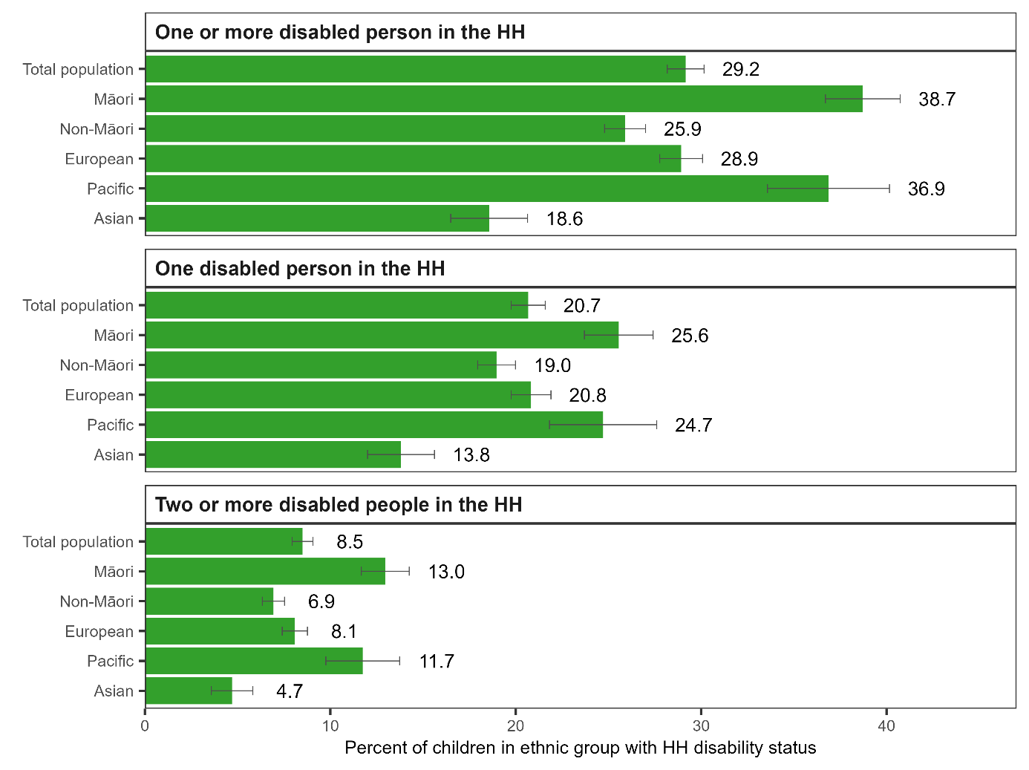

## Ages of disabled people in the household

**For most children living with a disabled adult, that adult was working-aged.**

Of children overall:

* 14.2 percent lived in a household with one or more disabled adult aged 18-64
* 1.5 percent lived in a household with one or more disabled adult aged 65 or over (Figure 2).

Māori children were more likely than non-Māori children to live in a household with an older disabled person (2.2 percent compared with 1.3 percent). Māori children made up 37.3 percent of all children living in a household with an older disabled person.

Of Pacific children, 3.2 percent lived in a household with an older disabled person. Pacific children made up 27.1 percent of all children living in a household with an older disabled person.

Figure 2: Proportion of children in living households (HHs) with working age (18-64 years) and older (65+) disabled adults

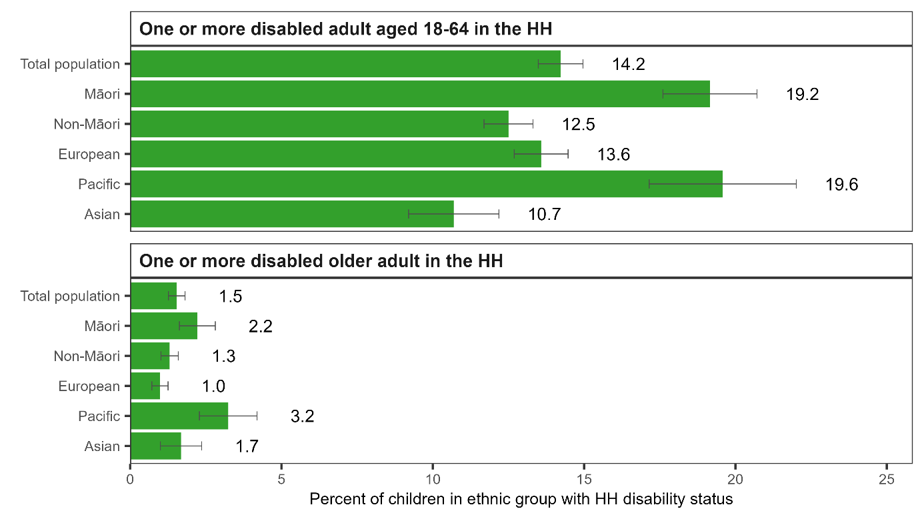

**Out of all children, around one in five lived in a household with a disabled child:**

* 15.3 percent lived in a household with one disabled child
* 3.7 percent lived in a household with two or more disabled children
* 5.0 percent lived in a household with both a disabled child and a disabled adult (Figure 3).

Māori children were more likely than non-Māori children to live in a household with one disabled child (19.9 compared with 13.6 percent) or two or more disabled children (6.1 percent compared with 2.9 percent).

Across ethnic groups, the proportion living in a household with a disabled child was lowest for Asian children.

Māori children were more likely than non-Māori children to live in a household with both a disabled adult and a disabled child (8.0 percent compared with 4.0 percent).

Of Pacific children, 6.5 percent lived in a household with both a disabled adult and a disabled child.

Figure 3: Proportion of children living in households (HHs) with a disabled child

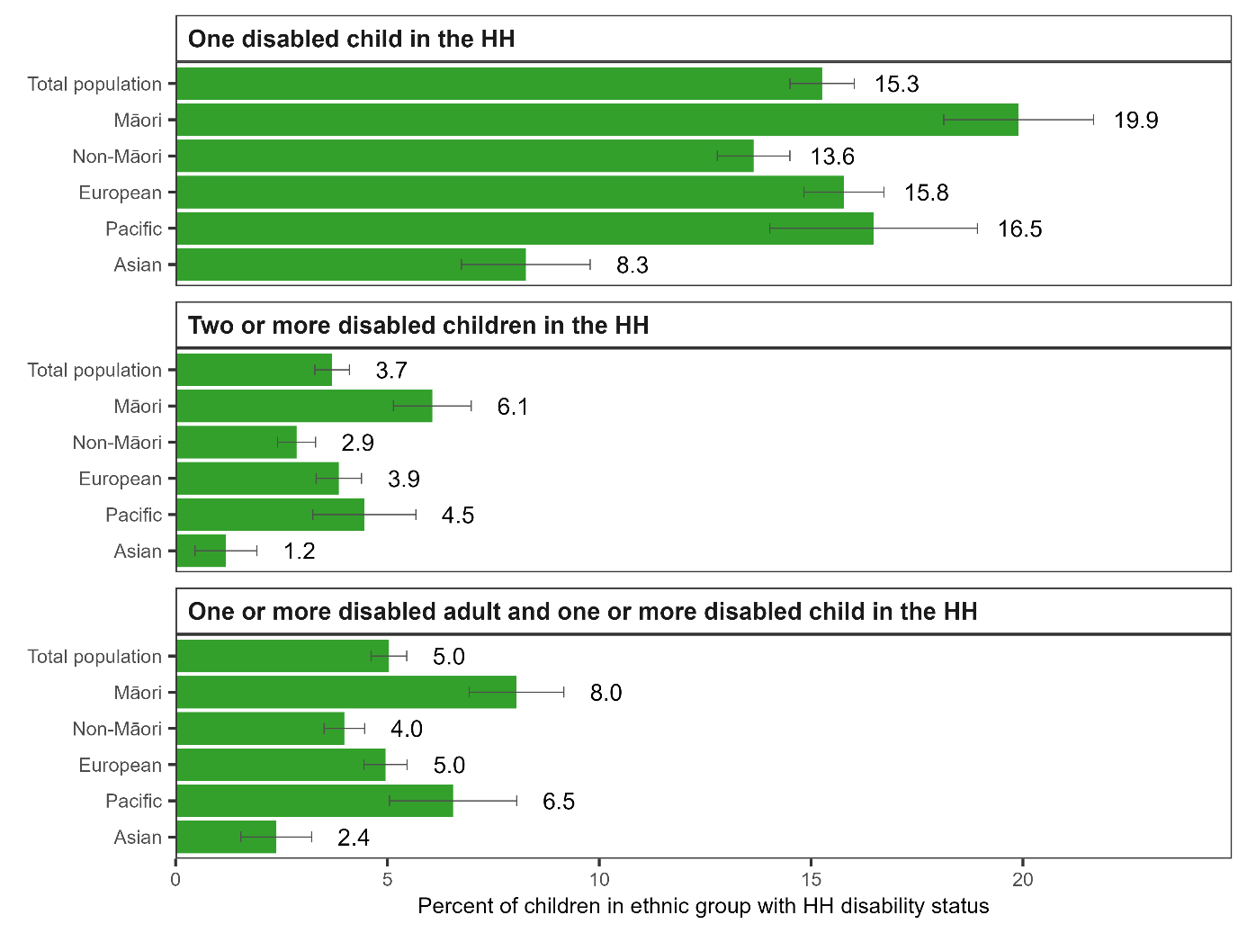

# Material hardship, income poverty, incomes, and housing costs for children with and without a disabled person in their household

This section examines the material hardship and income-poverty measures used to track progress on reducing child poverty, and the income and housing cost measures that sit behind the income-poverty measures.

## The rate of material hardship

**Consistent with Stats NZ’s reporting for the year ended June 2023, the pooled data show children living in households where there was a disabled person had a higher rate of material hardship than those children living with no disabled person.**

The survey respondents in households with a disabled person were also more likely to say they did not have enough money to meet their everyday needs.

Compared to children in households with no disabled person, children in households with a disabled person were:

* 3.1 times more likely to be in a household experiencing material hardship (21.2 percent compared to 6.9 percent) (Figure 4)
* 2.3 times more likely to be in a household where the survey respondent said they did not have enough money to meet their everyday needs (18.7 percent compared to 8.1 percent) (Figure 5).

**There were higher-than-average rates of material hardship and income insufficiency among Māori and Pacific children in households with a disabled person.**

There were also higher-than-average rates of material hardship among Māori and Pacific children in households with no disabled person. Compared to the total population, the difference in material hardship rates comparing those in and not in households with a disabled person was less pronounced for these ethnic groups:

* compared to Māori children in households with no disabled person, Māori children in households with a disabled person were 2.0 times more likely to be in a household experiencing material hardship, (28.8 percent compared to 14.1 percent)
* compared to Pacific children in households with no disabled person, Pacific children in households with a disabled person were 1.8 times more likely to be in a household experiencing material hardship, (35.8 percent compared to 19.8 percent) (Figure 4).

Figure 4: Proportion of children in material hardship by whether or not there is a disabled person in the household (HH)

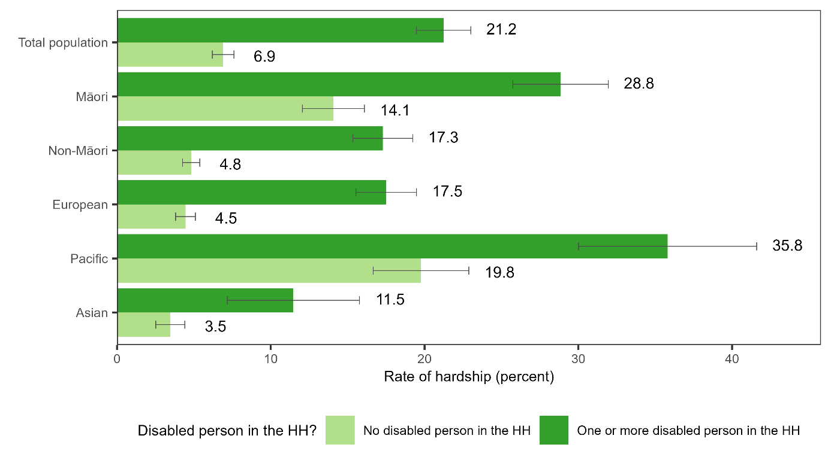

Figure 5: Proportion of children in a household reporting income insufficiency by whether or not there is a disabled person in the household (HH)

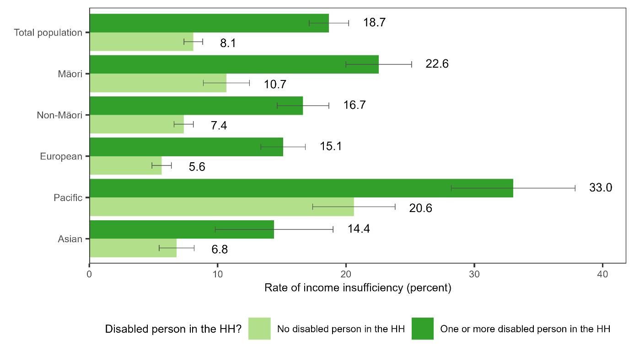

**Children living in households with a disabled person were disproportionately represented among children in households experiencing material hardship and income insufficiency.**

Children in households with a disabled person accounted for 29.2 percent of all children. However, they made up:

* 55.9 percent of all children in households experiencing material hardship
* 48.7 percent of all children in households where the survey respondent said they did not have enough money to meet their everyday needs (Figure 6).

The over-representation was most pronounced for Māori children and Pacific children in households with a disabled person.

Figure 6: Proportion (share) of all children, children in households (HH) in material hardship and children in HH reporting income insufficiency who are in HHs with a disabled person

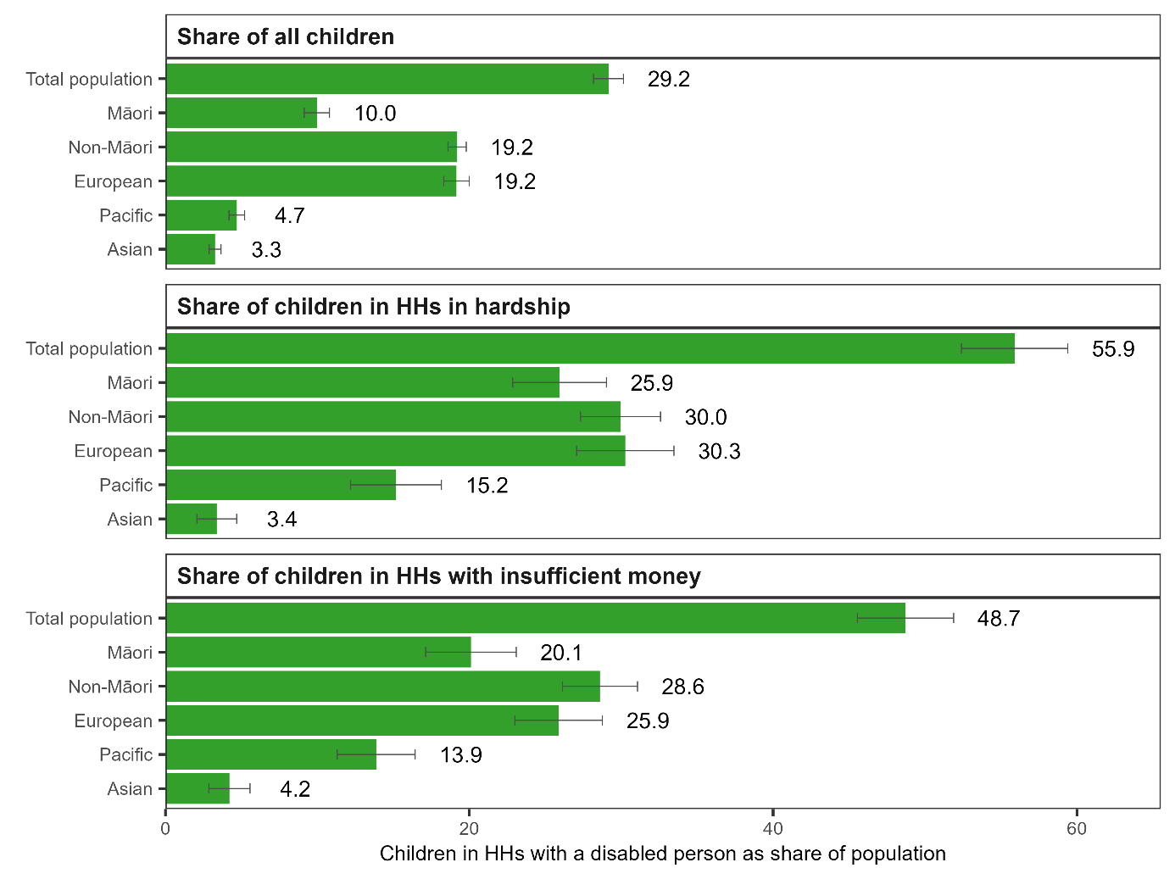

In general, the more disabled people there were in the child’s household, the more likely it was that the child’s household was in material hardship.

The proportions of children in material hardship were:

* 17.4 percent for children in households with one disabled person
* 30.6 percent for children in households with two or more disabled people (Figure 7)
* 18.6 percent for children in households with one disabled child
* 33.7 percent for children in households with two or more disabled children (Figure 8).

Figure 7: Proportion of children in material hardship by number of disabled people in the household (HH)

However, there was no significant difference between the proportions of children in material hardship where there was one disabled adult in the household and where there were two or more disabled adults. The proportions were:

* 24.7 percent for children in households with one disabled adult
* 25.0 percent for children in households with two or more disabled adults (Figure 8).

Figure 8: Proportion of children in material hardship by number of disabled adults and children in the household (HH)

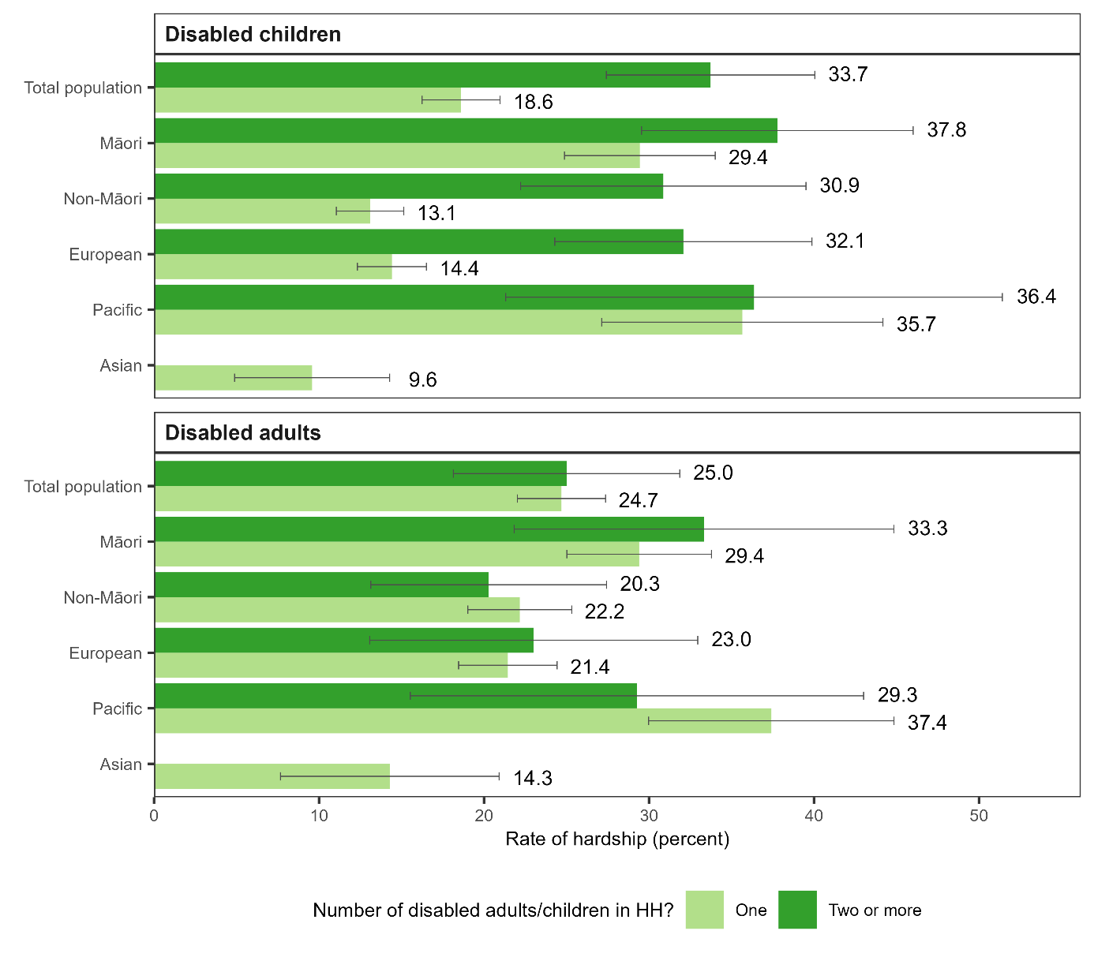

Note: Hardship rates for Asian children living in households with two or more disabled adults or children were suppressed for confidentiality reasons.

Material hardship rates were high for children who lived in a household with both one or more disabled child and one or more disabled adult.

For children who lived in a household with both a disabled child and a disabled adult, the proportion in material hardship was:

* 33.0 percent overall
* 42.5 percent for Māori children
* 30.8 percent for European children
* 39.2 percent for Pacific children (Figure 9).

Differences in these proportions across ethnic groups were not statistically significant.

For reference, for children who lived in a household with no disabled person, the proportion in material hardship was 6.9 percent.

Figure 9: Proportion of children in material hardship where there are both one or more disabled adult and one or more disabled child in the household

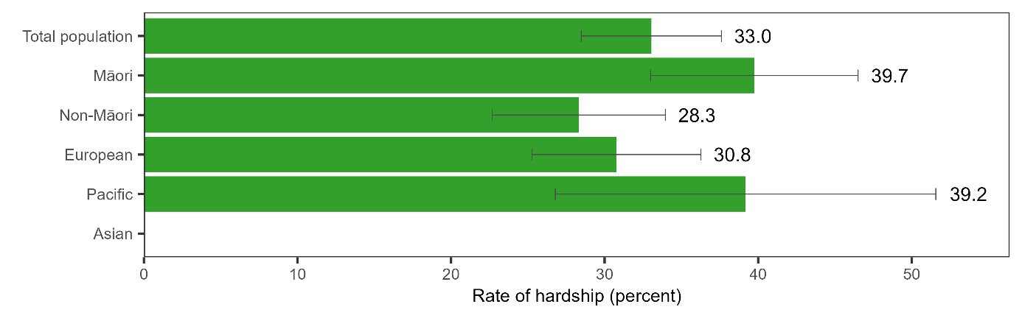

Note: Hardship rates for Asian children living in households with both a disabled adult and a disabled child were suppressed for confidentiality reasons.

**Material hardship rates appeared lower for children who lived with older disabled adults than for children who lived with disabled adults in working age groups.**

These differences were not statistically significant, however. The proportions in material hardship were:

* 16.4 percent for children in a household with one or more disabled adult aged 65 or over
* 25.3 percent for children in a household with one or more disabled adult aged 18-64 (Figure 10).

Figure 10: Proportion of children in material hardship by whether there are working age (18-64 years) and older (65+) disabled adults in the household (HH)

Note: Hardship rates for Asian and Pacific children living in households with one or more disabled older adult were suppressed for confidentiality reasons.

**Children in households with a disabled person were more likely than other children to experience severe hardship.**

Severe hardship is defined as experiencing nine or more of the 17 restrictions (Perry 2022).

Compared with children in households with no disabled person, children in households with a disabled person were 3.7 times more likely to be in a household experiencing severe hardship (9.6 percent compared to 2.6 percent) (Figure 11).

The rate ratios were:

* 2.2 for Māori children (i.e. Māori children in households with a disabled person were 2.2 times more likely to be in a household experiencing severe hardship than Māori children in households with no disabled person) (13.8 percent compared to 6.2 percent)
* 4.9 for non-Māori children (7.4 percent compared to 1.5 percent)
* 5.5 for European children (7.6 percent compared to 1.4 percent)
* 1.9 for Pacific children (15.8 percent compared to 8.4 percent)
* 3.4 for Asian children (3.7 percent compared to 1.1 percent).

Figure 11: Proportion of children in severe hardship by whether or not there is a disabled person in the household (HH)

## What material hardship looks like

**Children in households with a disabled person were more likely than other children to be living in a household experiencing all of the 17 types of restrictions that are used to assess material hardship**

Compared to children in households with no disabled person, children in households with a disabled person were, for example:

* 2.2 times more likely to be in a household reporting putting up with feeling cold a lot to keep costs down (11.4 percent compared to 5.1 percent)
* 2.8 times more likely to be in a household reporting putting off visits to the doctor a lot to keep costs down (16.3 percent compared to 5.8 percent)
* 1.7 times more likely to be in a household reporting putting off visits to the dentist a lot to keep costs down (37.9 percent compared to 22.0 percent)
* 2.5 times more likely to be in a household reporting not being able to pay electricity, gas, rates or water bills on time more than once in the last 12 months because of a shortage of money (15.0 percent compared to 6.0 percent)
* 2.5 times more likely to be in a household reporting borrowing from friends or family to meet everyday living costs (18.8 percent compared to 7.6 percent)
* 2.0 times more likely to be in a household reporting that they would be unable to pay an unexpected and unavoidable expense of $500 within a month of borrowing (35.0 percent compared to 17.9 percent) (Figure 12).

These rates are presented for Māori, non-Māori, European, Pacific and Asian children in Appendix 2. The patterning of results generally mirrors the overall differences in hardship rates between the groups. For example, the proportions of children in households with a disabled person where the household reported putting off visits to the dentist a lot to keep costs down were:

* 37.9 percent overall
* 45.5 percent for Māori children
* 33.9 percent for non-Māori children
* 35.9 percent for European children
* 54.9 percent for Pacific children
* 23.7 percent for Asian children.

Figure 12: Proportion of children in households (HHs) reporting each of the 17 items used to measure material hardship by whether or not there is a disabled person in the household

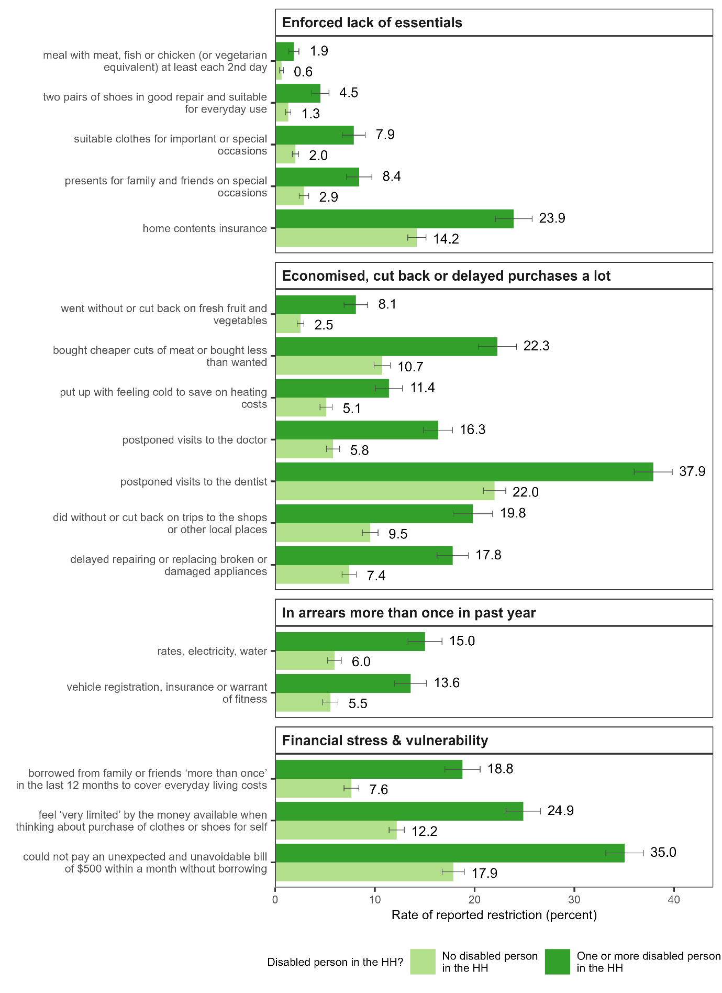

**Children aged 6-17 in households with a disabled person faced more disadvantages because of child-related expenditure restrictions and economising than other children.**

Child-specific questions in the Household Economic Survey are asked in reference to children aged between 1 and 17. Because some are more relevant to school aged children, we only report results for this age group. This aligns with the approach taken in Perry (2022).

Based on the responses of the respondent in their household to questions about their children, they were, for example:

* 3.0 times as likely to not have fresh fruit and vegetables daily (7.9 percent compared to 2.6 percent).
* 2.5 times as likely to have had to go without music, dance, kapa haka, art, swimming or other special interest lessons a lot to keep down costs (7.5 percent compared to 3.0 percent) (Figure 13).

These rates are presented for Māori, non-Māori, European, Pacific and Asian children in Appendix 3. The proportions of children aged 6-17 in households with a disabled person where children did not have fresh fruit and vegetables daily were:

* 7.9 percent overall
* 11.3 percent for Māori children
* 6.0 percent for non-Māori children
* 5.1 percent for European children
* 17.2 percent for Pacific children
* 5.2 percent for Asian children.

The proportions of children aged 6-17 in households with a disabled person where children had to go without music, dance, kapa haka, art, swimming or other special interest lessons a lot to keep down costs were:

* 7.5 percent overall
* 9.2 percent for Māori children
* 6.6 percent for non-Māori children
* 6.5 percent for European children
* 11.3 percent for Pacific children
* Not reported for Asian children due to small numbers.

Figure 13: Proportion of children aged 6-17 in households (HHs) reporting restrictions on child-related items by whether or not there is a disabled person in the household

## Income-based poverty rates

**The proportions with income below income-based poverty lines were higher for children in households with a disabled person than for other children.**

Compared to children in households with no disabled person, children in households with a disabled person were:

* 1.5 times more likely to be in a household with income below the before-housing-costs poverty line (15.7 percent compared to 10.3 percent) (Figure 14)
* 1.2 times more likely to be in a household with income below the after-housing-costs poverty line (20.7 percent compared to 16.6 percent) (Figure 15).

**However, the size of the gap in income-based poverty rates was not as large as the gap in material hardship rates, particularly for the after-housing-costs measure.**

In fact, the percentage with income below the after-housing-costs income-based poverty lines was slightly lower for Pacific children in households with a disabled person than for other Pacific children (but with no statistically significant difference) (Figure 15).

Figure 14: Proportion of children in a household (HH) with income below the before-housing-costs poverty line by whether or not there is a disabled person in the HH

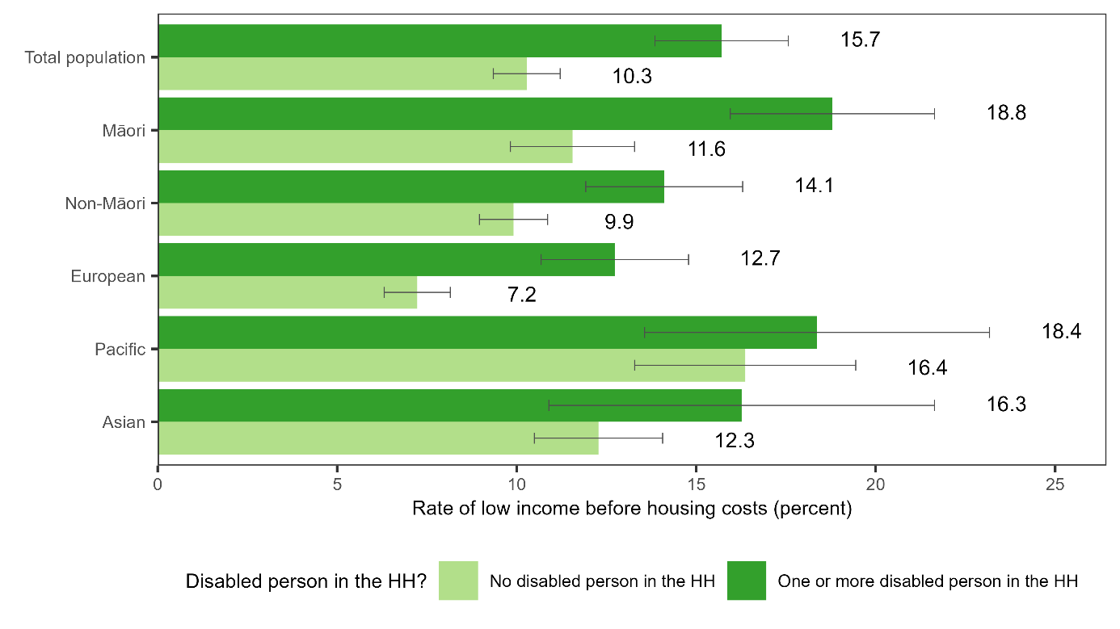

Figure 15: Proportion of children in a household (HH) with income below the after-housing-costs poverty line by whether or not there is a disabled person in the HH

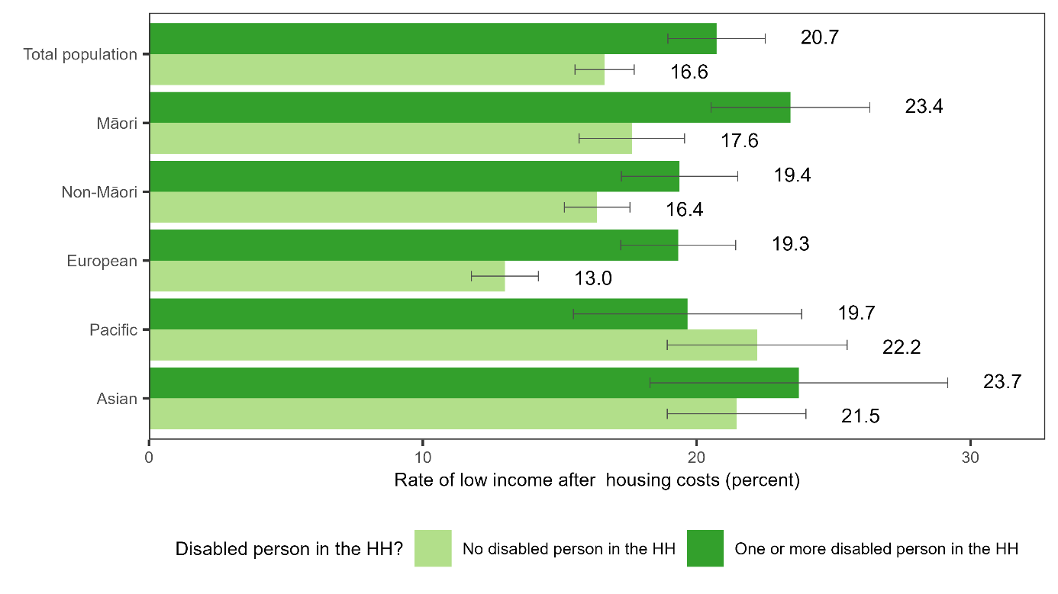

**Children living in households with a disabled person were disproportionately represented among children in households with income below income-based poverty lines, but this over-representation was not as marked as it was for material hardship.**

Children in households with a disabled person accounted for:

* 38.6 percent of all children in households with low equivalised household disposable income before housing costs were taken out
* 33.9 percent of all children in households with low equivalised household disposable income after housing costs were taken out (Figure 16).

This compared with children in a household with a disabled person accounting for:

* 29.2 percent of all children
* 55.9 percent of all children in households experiencing material hardship.

Figure 16: Proportion (share) of all children and children in households (HH) with income below before- and after-housing-cost poverty lines who are in HHs with a disabled person

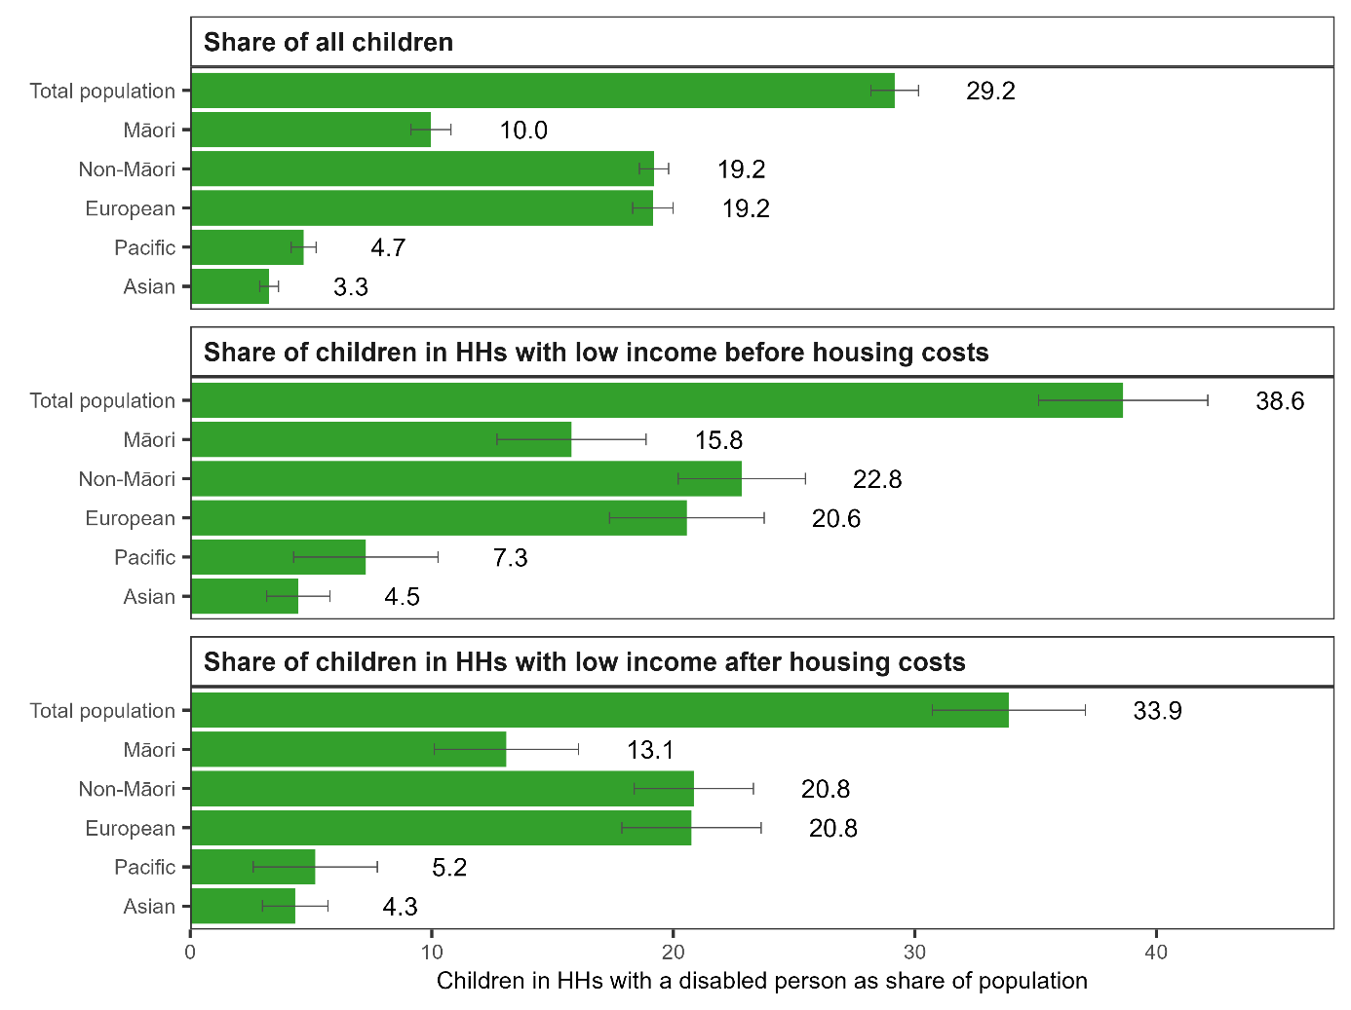

## Incomes and housing costs

**Average household disposable income was only slightly lower for households of children living with a disabled person, compared to households of other children.**

Average household disposable income (after tax and transfers such as benefits and Working for Families tax credits) for children in a household with a disabled person was 94.2 percent of that for other children ($103,017 compared with $109,386 in 2022-dollar terms) (Figure 17).

Figure 17: Mean household (HH) disposable income ($2022) for children by whether or not there is a disabled person in the HH

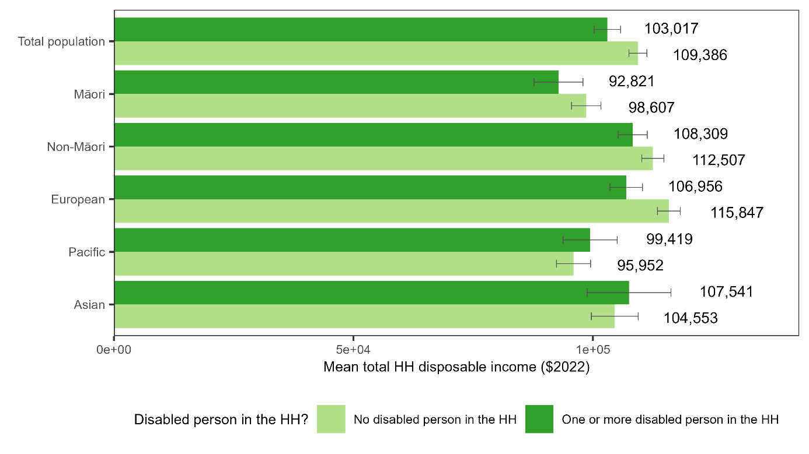

**However, the effect of equivalisation on income was larger (indicating the income needed to meet the needs of more people in households with a disabled person).**

Average equivalised household disposable income (after tax and transfers *and* after adjusting for household size and composition) for children in a household with a disabled person was 85.4 percent of that for other children ($40,938 compared with $47,915 in 2022-dollar terms) (Figure 18).

For context, one-person households are the reference point for equivalisation. This means that $40,938 should be thought of relative to the needs of a one-person household in terms of value.

It is important to note that while income support payments that help with additional costs experienced by households with a disabled person are included in income, equivalisation does not adjust for these costs.

This means that less of the equivalised disposable income is available for spending on other everyday needs in households with a disabled person, on average.

Figure 18: Mean equivalised household (HH) disposable income ($2022) for children by whether or not there is a disabled person in the HH

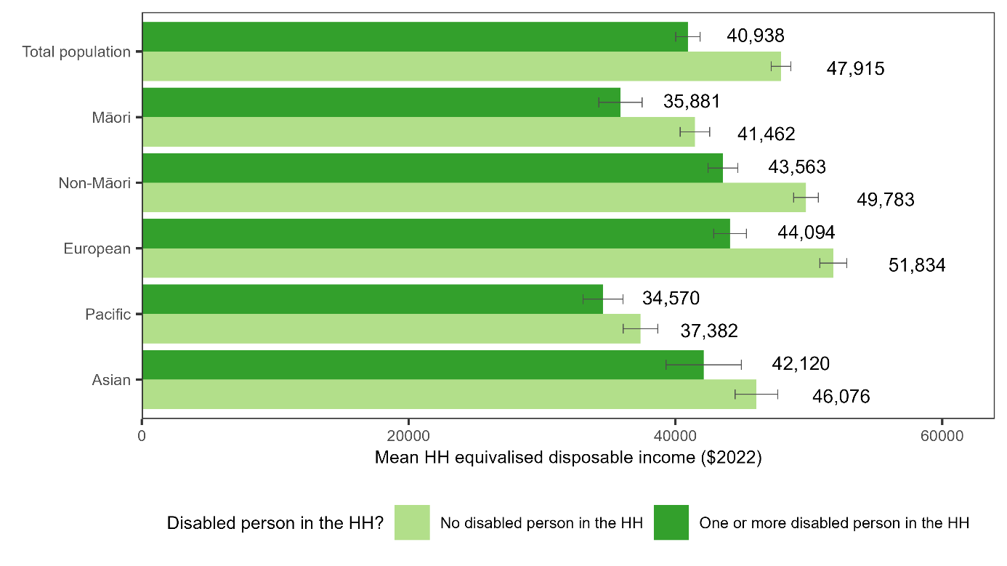

**Average housing costs were lower in households with a disabled person.**

Compared to children in households with no disabled person, children in households with a disabled person had:

* lower average household housing costs ($21,548 compared with $24,629 per annum) (Figure 19)
* lower average equivalised household housing costs ($9,120 compared with $11,252 per annum) (Figure 20).

This will partly reflect higher proportions living in social housing (see ‘Housing’ below).

Figure 19: Mean household (HH) housing costs ($2022) for children by whether or not there is a disabled person in the HH

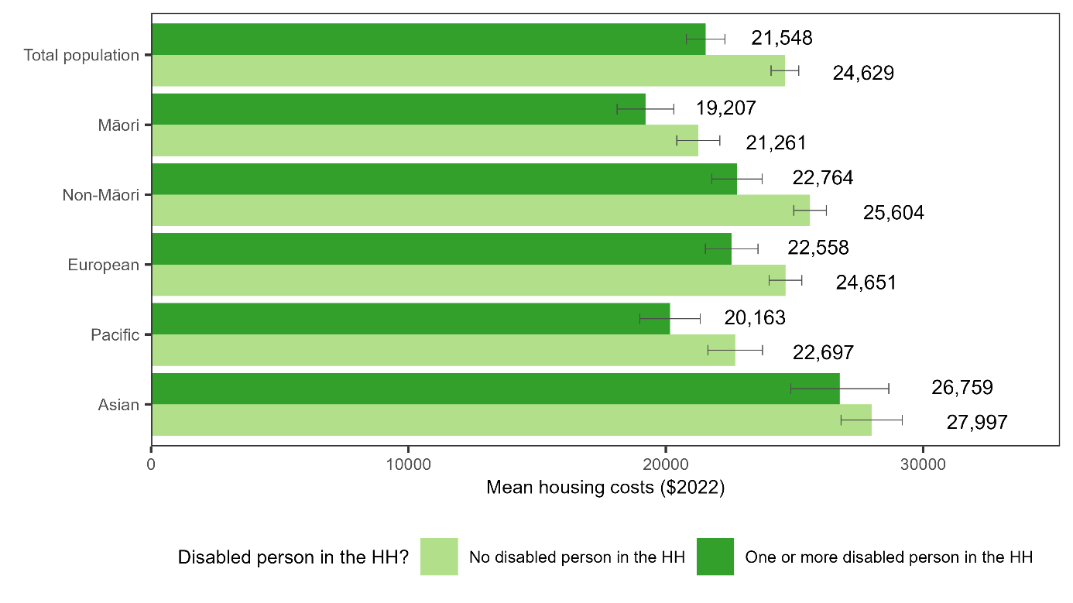

Figure 20: Mean equivalised household (HH) housing costs ($2022) for children by whether or not there is a disabled person in the HH

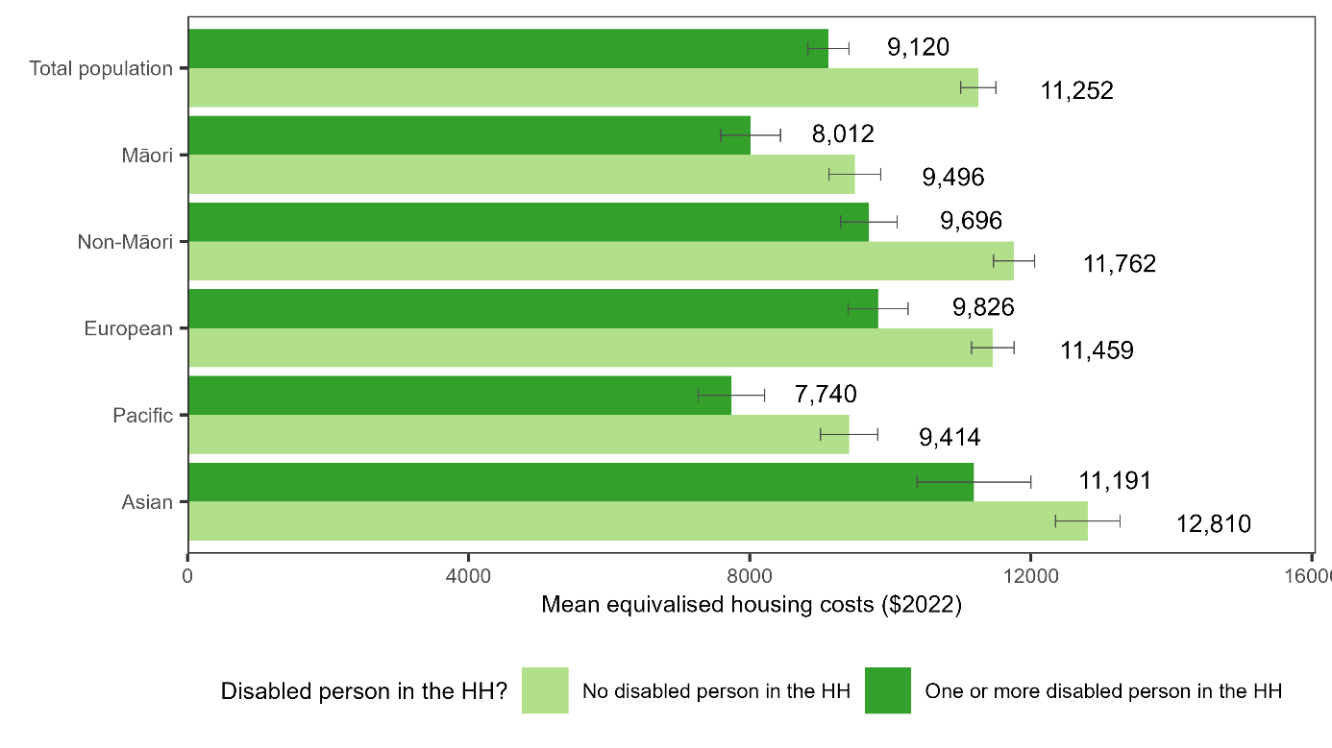

**Combined, these factors led to a smaller difference in average equivalised household disposable income after housing costs were taken out than in average household disposable income.**

Average equivalised household disposable income, after housing costs, for children in a household with a disabled person was 86.9 percent of that for other children ($31,920 compared with $36,751 in 2022-dollar terms) (Figure 21).

Figure 21: Mean equivalised household (HH) income after housing costs ($2022) for children by whether or not there is a disabled person in the HH

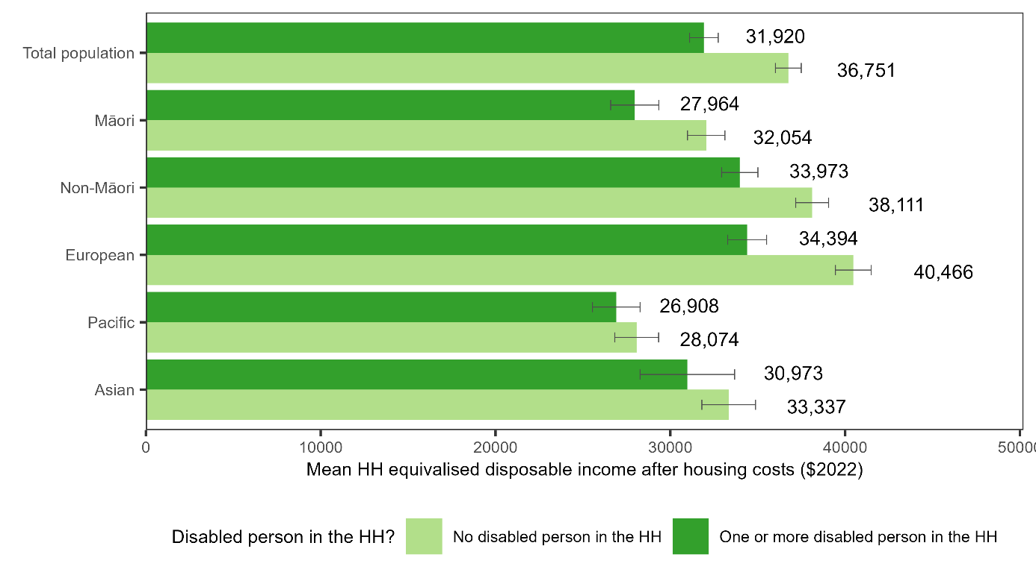

# Household and other characteristics for children with and without a disabled person in their household

This section compares the household and other characteristics of children in households with a disabled person and children in households with no disabled person.

Accompanying tables allow readers to look in more detail at the data behind the results and examine material hardship rates broken down by household and other characteristics.

## Household size and composition

**For children in households with a disabled person, household size was larger on average, and the household was more likely to include older people.**

Compared to children in households with no disabled person, children in households with a disabled person were more likely to:

* have five or more people (adults and children) in the household (50.3 percent compared to 36.4 percent)
* have three or more adults in the household (26.7 percent compared to 16.8 percent)
* have three or more children in the household (43.2 percent compared to 30.8 percent)
* have one or more person aged 65 or over (7.9 percent compared to 4.3 percent) (Figure 22).

This was the case across all ethnic groups.

Pacific children in households with a disabled person were the most likely to have five or more people (adults and children) in the household (68.3 percent) and three or more children in the household (58.4 percent).

Pacific and Asian children in households with a disabled person were the most likely to have three or more adults in the household (40.6 and 39.2 percent respectively) and to have an older person in the household (14.7 and 13.1 percent respectively).

Children in households with a disabled person were more likely than average to live in a household made up of a sole parent and their children, and less likely than average to be living with two parents.

Compared to children in households with no disabled person, children in households with a disabled person were less likely to live in a household made up of a two-parent family with their dependent children only (Figure 23).

They were more likely to:

* live in a household made up of a sole parent and their dependent children only (20.6 percent compared to 13.4 percent)
* live in a household made up of another combination of people (including multiple families, or families with dependent children living with adult children, elders, or other adults (21.3 percent compared to 13.0 percent) (Figure 23).

Figure 22: Proportion of children with different household (HH) size and composition by whether or not there is a disabled person in the HH

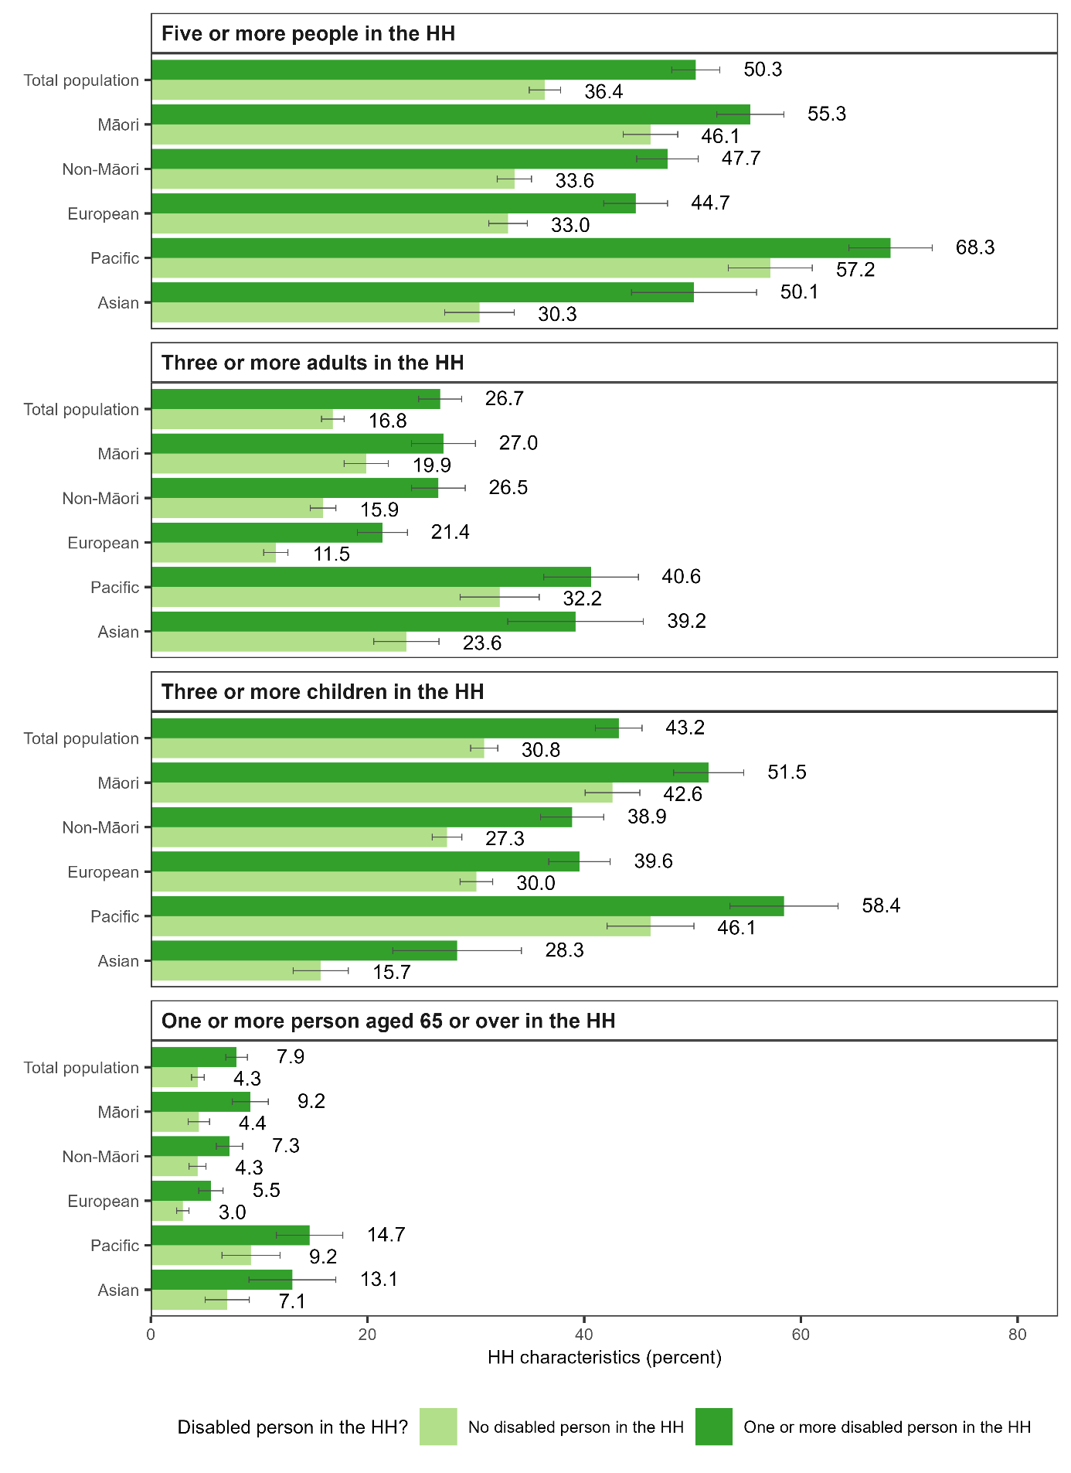

Figure 23: Proportion of children in two-parent, sole parent, and other household (HH) types by whether or not there is a disabled person in the HH

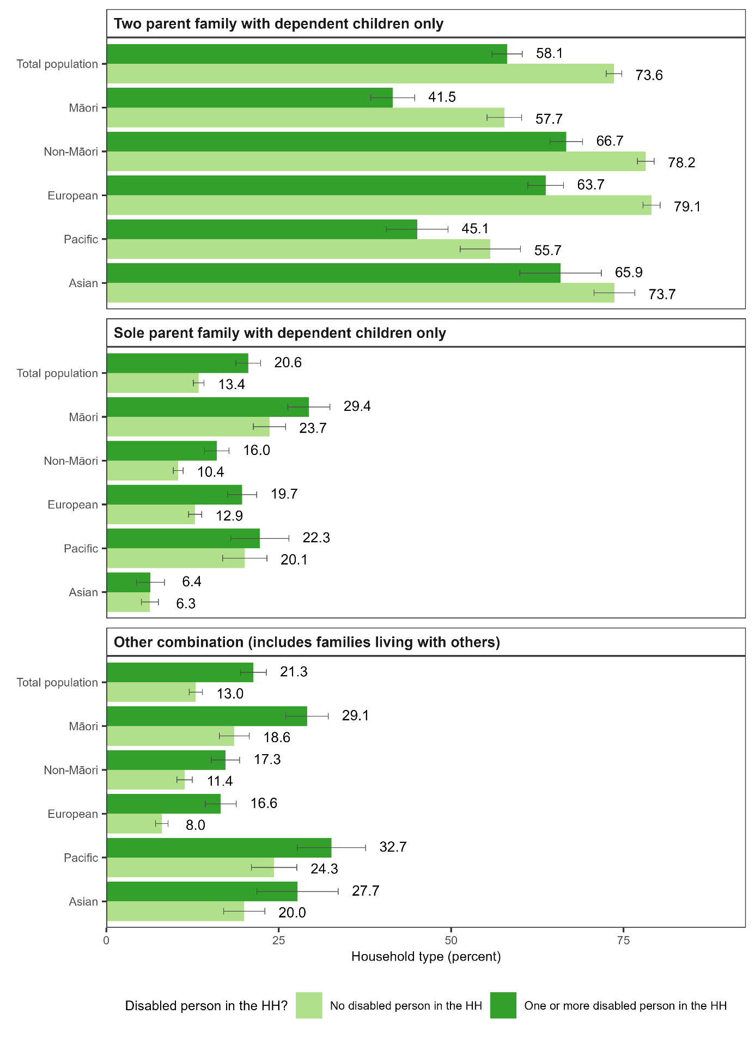

Across all ethnic groups, and across both children in households with a disabled person and other children, most children lived in a family with two parents (Figure 24). The data available from the Household Economic Survey do not let us explore differences by whether there are shared care arrangements for children.

The proportions living in a sole-parent family (either living in their own household or living with others) were higher for children in households with a disabled person than for other children (28.8 percent compared to 17.4 percent). This was the case across all ethnic groups, except for Asian children (for whom the proportions were the same) and Pacific children (for whom the higher rate among children in households with a disabled person was not statistically significant).

In most cases, children in households with a disabled person living in a sole parent family lived with a sole mother – 25.5 percent lived with a sole mother, compared with 14.1 percent of children in households with no disabled person).

Figure 24: Proportion of children in two- and sole parent families and living with a sole mother by whether or not there is a disabled person in the household (HH)

## Housing

**For children in households with a disabled person, the household was more likely to be crowded, to be renting, and to be living in social housing.**

Compared to children in households with no disabled person, children in households with a disabled person were more likely to:

* have accommodation that was crowded or severely crowded (1 or more extra bedrooms needed) (19.6 percent compared to 10.5 percent)
* have accommodation that was severely crowded (2 or more extra bedrooms needed) (6.3 percent compared to 2.5 percent)
* be renting (48.7 percent compared to 36.9 percent)
* be in social housing (11.7 percent compared to 4.8 percent) (Figure 25).

The proportions living in a crowded household, renting, and living in social housing were highest for Māori children and Pacific children.

Compared to Māori children in households with no disabled person, Māori children in households with a disabled person were more likely to:

* have accommodation that was crowded or severely crowded (1 or more extra bedrooms needed) (26.3 percent compared to 16.9 percent)
* have accommodation that was severely crowded (2 or more extra bedrooms needed) (8.1 percent compared to 5.1 percent)
* be renting (60.7 percent compared to 51.8 percent)
* be in social housing (16.3 percent compared to 9.7 percent).

Compared to Pacific children in households with no disabled person, Pacific children in households with a disabled person were more likely to:

* have accommodation that was crowded or severely crowded (1 or more extra bedrooms needed) (39.9 percent compared to 27.1 percent)
* have accommodation that was severely crowded (2 or more extra bedrooms needed) (16.7 percent compared to 10.2 percent)
* be renting (75.7 percent compared to 67.6 percent)
* be in social housing (33.4 percent compared to 19.0 percent).

Figure 25: Proportion of children with crowded housing, rented housing and social housing by whether or not there is a disabled person in the household (HH)

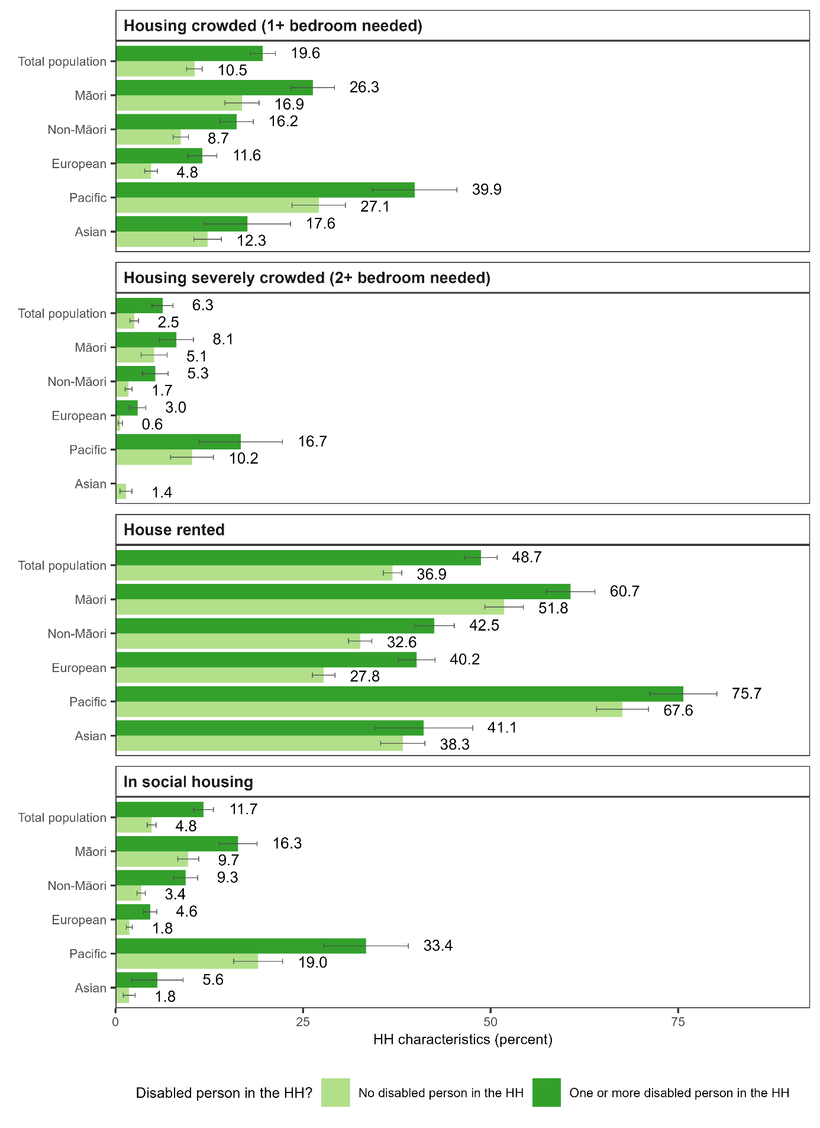

## Geographic location and neighbourhood deprivation

Children in households with a disabled person were more likely to live outside regions containing the main centres, and more likely to live in a more deprived neighbourhood.

Compared to children in households with no disabled person, children in households with a disabled person were more likely to live:

* outside regions containing the main centres (i.e. outside the Auckland, Wellington, Canterbury and Waikato regions) (37.1 percent compared to 31.9 percent) (refer to accompanying tables)
* in a neighbourhood with high deprivation (based on being in a neighbourhood in the top New Zealand Index of Deprivation (NZDep) quintile (Atkinson et al., 2018)) (30.0 percent compared to 18.0 percent) (Figure 26).

There were no statistically significant differences in the proportions living in major, large, medium or small urban areas, or in rural settlements or other rural areas (Appendix 4).

Māori and European children in households with a disabled person were more likely than Pacific and Asian children in households with a disabled person to live outside regions containing the main centres (refer to accompanying tables).

Figure 26: Proportion of children in each NZDep quintile by whether or not there is a disabled person in the household

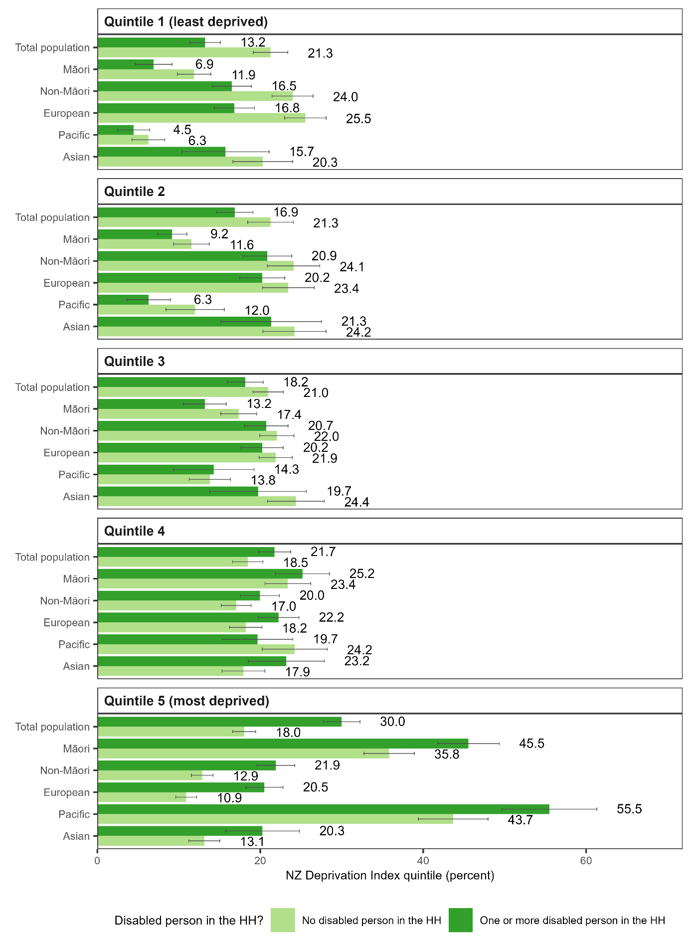

## The circumstances of adults in the household

**Adults in the households of children living with a disabled person were more likely than those of children living with no disabled person to have characteristics associated with low earnings or low earning potential.**

Compared to children in households with no disabled person, children in households with a disabled person were more likely to live:

* with an adult with no qualifications (49.5 percent compared to 29.3 percent)
* in a ‘jobless’ household with no adult in paid employment (15.9 percent compared to 8.4 percent)
* with no adult with employment income in at least 48 of the last 60 months (i.e. four out of five years) – indicating long-term joblessness (32.3 percent compared to 24.9 percent) (Figure 27).

Proportions living with adults with these characteristics were higher among Māori and Pacific children.

Among Māori children, the households of children with a disabled person were more likely than those with no disabled person to live:

* with an adult with no qualifications (60.2 percent compared to 43.3 percent)
* in a jobless household with no adult in paid employment (24.5 percent compared to 18.6 percent)
* with no adult with employment income in at least 48 of the last 60 months (44.3 percent compared to 31.5 percent).

Among Pacific children, the households of children with a disabled person were more likely than those with no disabled person to live:

* with an adult with no qualifications (62.2 percent compared to 45.0 percent)
* in a jobless household with no adult in paid employment (18.6 percent compared to 16.8 percent – but this was not a statistically significant difference)
* with no adult with employment income in at least 48 of the last 60 months (38.8 percent compared to 32.0 percent – but this was not a statistically significant difference).

Figure 27: Proportion of children with adults in the household (HH) with no qualifications, who are jobless, and who are jobless long-term, by whether or not there is a disabled person in the HH

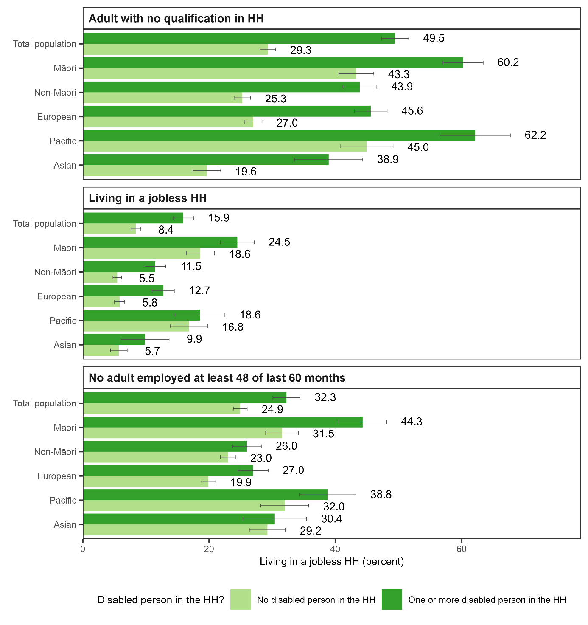

## Receipt of Disability Support Services

Receipt of Disability Support Services was examined using linked data from SOCRATES.[12] This is a national database of Whaikaha’s Disability Support Services clients and service providers. Information for SOCRATES is supplied by Needs Assessment and Service Co-ordination agencies. Whaikaha-funded Disability Support Services are available to people who have a physical, intellectual or sensory disability (or a combination of these) where:

* the disability is likely to continue for at least six months
* the person needs ongoing support to live independently, to the extent that ongoing support is required.

Limitations of the Washington Group questions on functioning mean some households that appear to have no disabled person according to the Washington Group indicators receive Disability Support Services. The Washington Group questions do not identify all disabled people. For example, people with neurodivergence such as Autism and people who have an intellectual disability may be excluded (see Appendix 1).

Of children in households with a disabled person, 8.1 percent lived with a person (child or adult) who had received Disability Support Services – indicating high support needs (Figure 28).

Although the data suggest lower rates of receipt of Disability Support Services by disabled people in the households of Māori and Pacific children, the differences were not statistically significant.

Figure 28: Proportion of children in a household (HH) where an adult or child has received Disability Support Services by whether or not there is a disabled person in the HH

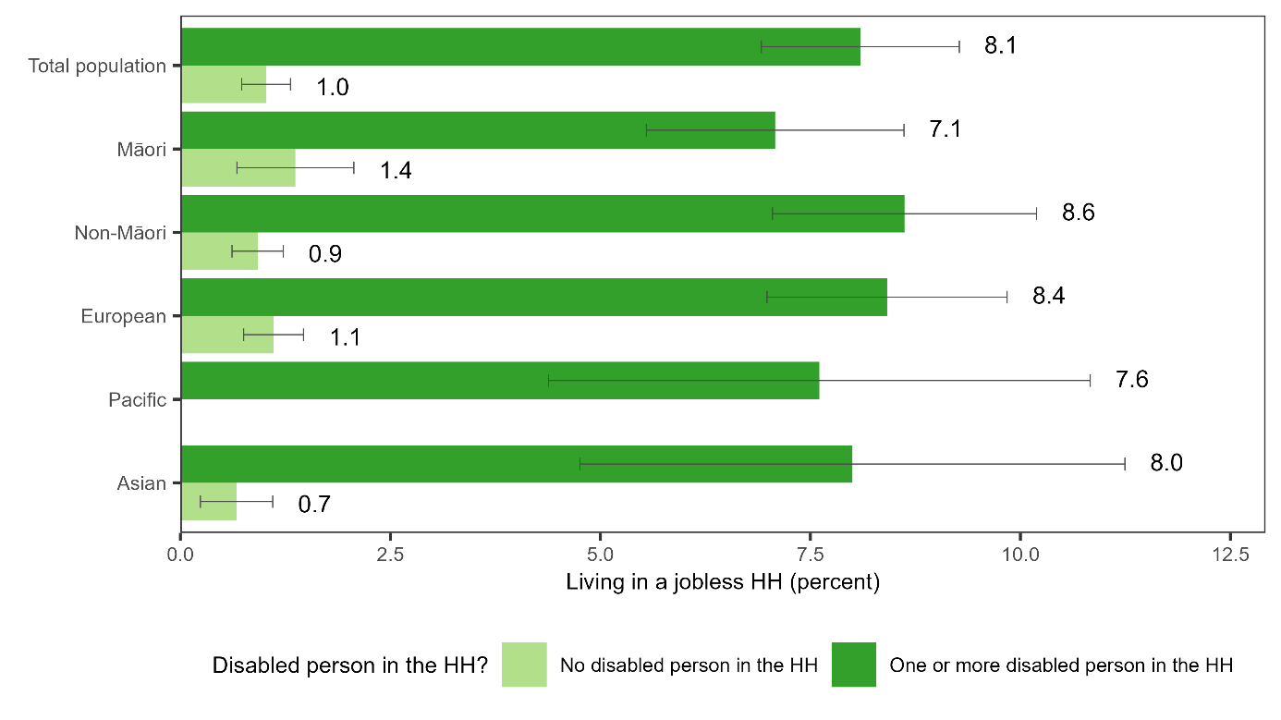

Note: Defined as ever having been assessed as eligible for Disability Support Services.

Receipt of Disability Support Services for Pacific children living in households with no disabled people were suppressed for confidentiality reasons.

## Receipt of benefits and other transfers

**Adults in the households of children living with a disabled person were more likely than those of children living with no disabled person to be receiving main benefits and ACC weekly compensation, but most did not receive these payments. One in four had transfer payments as their main source of annual household income.**

Compared to children in households with no disabled person, children in households with a disabled person were more likely to live:

* in a household where transfer payments (which include all benefits, pensions and Working for Families tax credits but exclude ACC weekly compensation) were the main source of annual income (25.3 percent compared to 11.5 percent)
* with an adult in the household receiving ACC weekly compensation – indicating injury-related incapacity for work (7.9 percent compared to 5.1 percent)
* with an adult in the household receiving a main working-age benefit (37.8 percent compared to 18.2 percent) (Figure 29).

Among Māori children, the households of children living with a disabled person were more likely than those with no disabled person to have:

* transfer payments as the main source of annual income (40.4 percent compared to 24.4 percent)
* an adult in the household receiving a main working-age benefit (55.7 percent compared to 38.7 percent).

Among Māori children, the households of children with a disabled person were not significantly more likely than those with no disabled person to live with an adult in the household receiving ACC weekly compensation (7.5 percent compared to 7.6 percent).

Among Pacific children, 56.8 percent of the households of children living with a disabled person had an adult in the household receiving a main working-age benefit (compared to 37.8 percent for children living with a disabled person overall). However only 35.4 percent had transfer payments as the main source of annual income (compared to 25.3 percent for children living with a disabled person overall).

**For close to half of the children in households with a disabled person where an adult received a main benefit, the benefit received was Sole Parent Support. Receipt of health- and disability-related benefits was less common.**

Compared to children in households with no disabled person, children in households with a disabled person were more likely to live with an adult receiving:

* Sole Parent Support (17.8 percent compared to 9.7 percent)
* Job-seeker support – Work ready (13.3 percent compared to 6.8 percent)
* Job-seeker support – Health Conditions and Disability (6.7 percent compared to 2.0 percent)
* Supported Living Payment as a person with a health condition, injury or disability (4.7 percent compared to 1.2 percent)
* Supported Living Payment as a carer (1.9 percent compared to 0.3 percent) (Figure 30).

Few people on benefits other than Sole Parent Support have children.

Figure 29: Proportion of children with transfer payments the main source of household (HH) income, with adults receiving ACC weekly compensation, and with adults receiving a main working-age benefit, by whether or not there is a disabled person in the HH

Figure 30: Proportion of children with adults in the household (HH) receiving main working-age benefits by whether or not there is a disabled person in the HH

**Adults in the households of children with a disabled person were more likely than those of children living with no disabled person to receive supplementary income support payments and hardship assistance.**

Compared to children in households with no disabled person, children in households with a disabled person were more likely to live with an adult receiving:

* Disability Allowance (12.0 percent compared to 3.1 percent)
* Temporary Additional Support (12.2 percent compared to 6.6 percent)
* other supplementary payments (these include Working for Families tax credits paid by MSD and Accommodation Supplement, but do not include Working for Families tax credits paid by Inland Revenue) (50.0 percent compared to 27.3 percent)
* at least one Special Needs Grant in the last 12 months to pay an essential or emergency cost (31.2 percent compared to 13.8 percent) (Figure 31).

Figure 31: Proportion of children with adults in the household (HH) receiving supplementary and hardship payments by whether or not there is a disabled person in the HH

**Looking just at children in households with a disabled child, 22.9 percent were in a household where Child Disability Allowance was received**

There were no statistically significant differences in the proportion receiving Child Disability Allowance across ethnic groups for children in households with a disabled child (Figure 32). However, there were some statistically significant differences in the small amount of receipt in households where no child was disabled according to the Washington Group indicator. These could reflect, for example, a higher rate of disability and health conditions not captured by the indicator among Māori children.

Figure 32: Proportion of children in a household (HH) where someone receives Child Disability Allowance by whether or not there is a disabled child in the HH

## Receipt of Ongoing Resource Scheme funding

**Looking at children in households with a disabled child, 8.0 percent were in a household where Ministry of Education Ongoing Resource Scheme funding was received in respect of a child.**

There were no statistically significant differences in the rate of receipt of Ongoing Resource Scheme funding across ethnic groups, with the exception of a higher rate among Asian than European children (Figure 34).

Figure 34: Proportions of children in a household (HH) where at least one person has Ongoing Resource Scheme funding by whether or not there is a disabled child in the HH

Note: Receipt of Ongoing Resourcing Scheme funding for Pacific and Asian children living in households with no disabled people were suppressed for confidentiality reasons.

## Children’s characteristics

**Compared to children in households with no disabled person, children in households with a disabled person were more likely to be in older age groups.**

The proportion of children aged 10 to 14 was 31.7 percent for children in households with a disabled person compared to 27.8 percent for children in households with no disabled person. The proportion of children aged 15 to 17 was 22.5 percent compared to 13.6 percent.

The proportions of children who were male were similar (52.6 percent and 51.0 percent respectively).

These general patterns were apparent for most ethnic groups (Figure 33).

Figure 33: Proportions of children in different age groups and male by whether or not there is a disabled by whether or not there is a disabled person in the HH

# Material hardship rates by adults’ paid employment and sources of income

## Non-employment and/or transfers the main source of income

**The proportion in a household experiencing material hardship was particularly high for children in households where no adults were employed and where transfer payments were the main source of income.**

Children in a jobless household (with no adult in paid employment) with a disabled person had a material hardship rate of 53.5 percent compared with 31.6 percent for other children in jobless households (Figure 35). Children in a jobless household with a disabled person made up:

* 15.9 percent of children in a household with a disabled person
* 40.1 percent of children in a household with a disabled person in material hardship
* 22.4 percent of all children in material hardship.

Children in a household with a disabled person where transfer payments were the main source of annual income had a material hardship rate of 46.0 percent compared with 29.7 percent for other children in a household where transfer payments were the main source of annual income (Figure 36). Children in a household with a disabled person where transfer payments were the main source of annual income made up:

* 25.3 percent of children in a household with a disabled person
* 54.9 percent of children in a household with a disabled person in material hardship
* 30.7 percent of all children in material hardship.

Figure 35: Proportion of children in households (HH) in material hardship by whether all adults jobless or one or more employed, by whether or not there is a disabled person in the HH

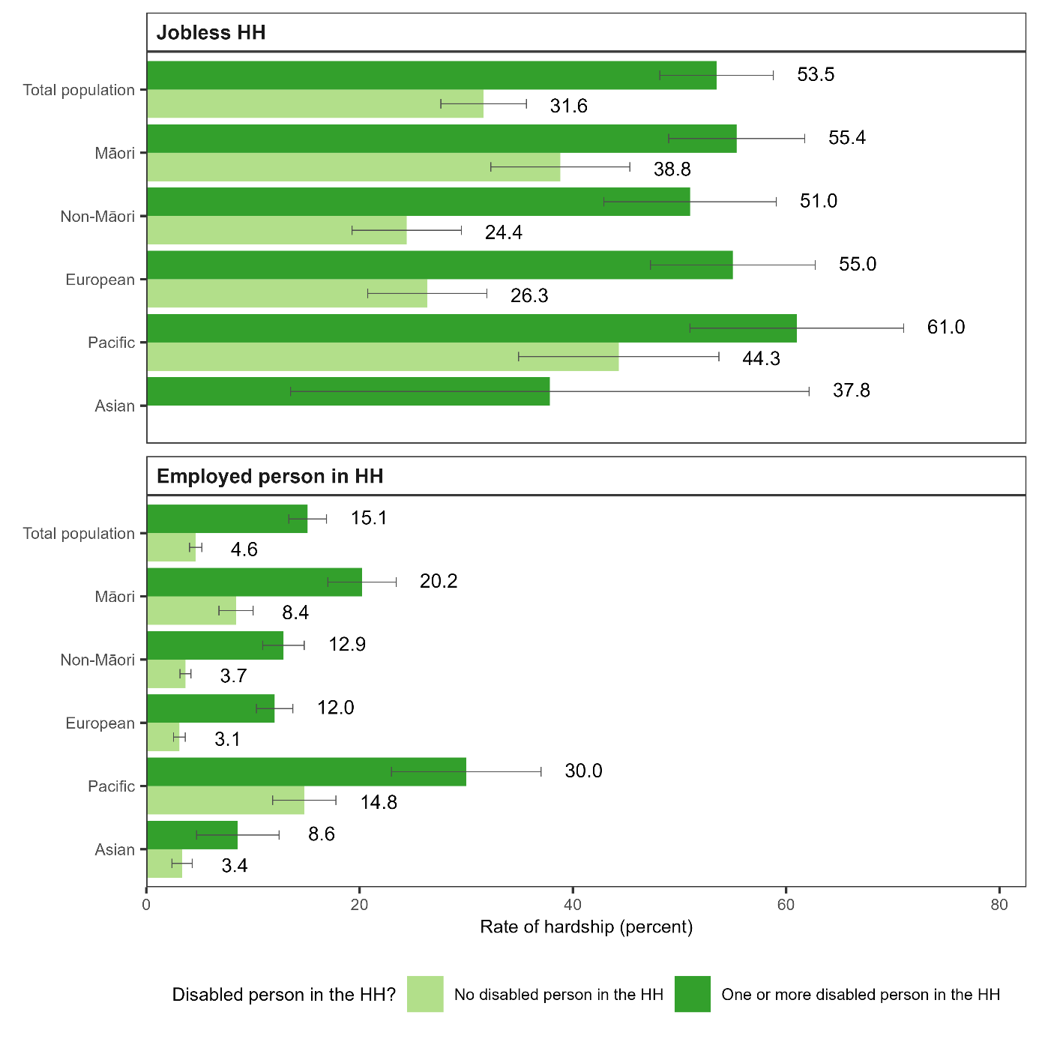Note: Rate of hardship for Asian children living in jobless households with no disabled people were suppressed for confidentiality reasons.

Figure 36: Proportion of children in households (HHs) in material hardship by main source of annual household income, by whether or not there is a disabled person in the HH

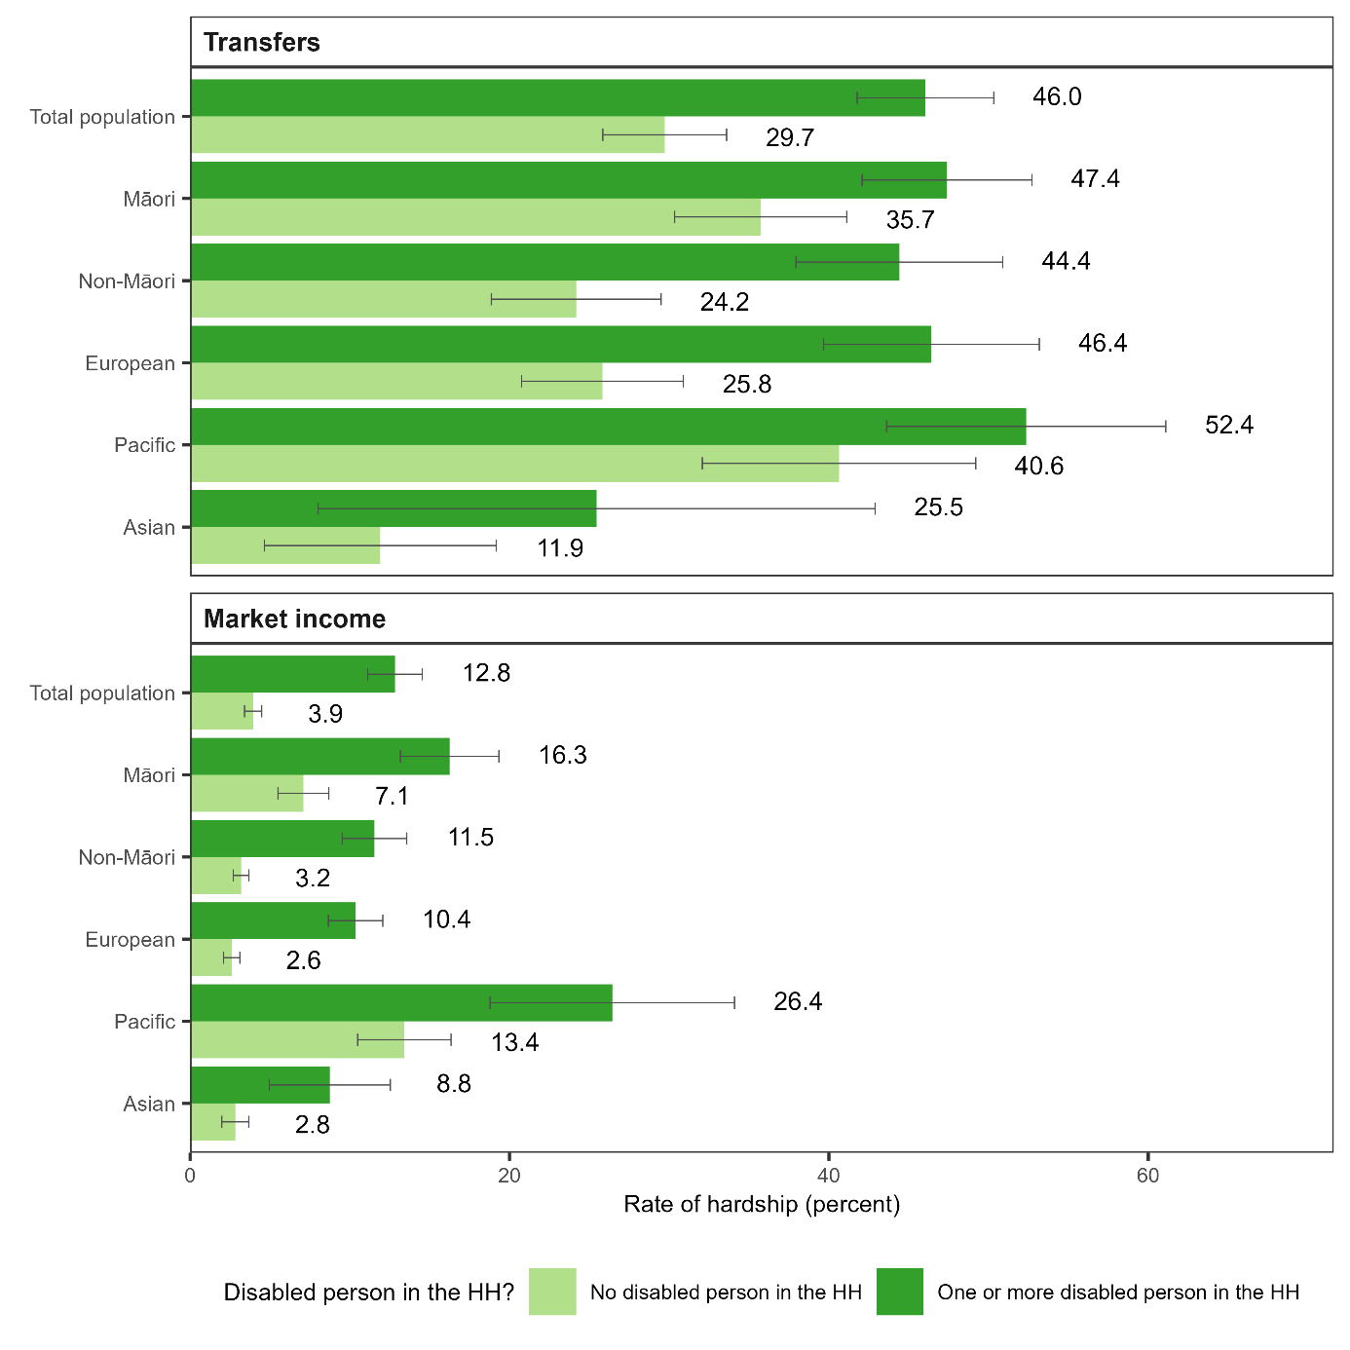

Note: Rate of hardship for Asian children living in households with one or more disabled people and transfers as the main source of income were suppressed for confidentiality reasons.

## Employment and/or market income the main source of income

**But even among children in households where adults were employed and market income was the main source of income, being in a household with a disabled person substantially increased the risk of material hardship.**

In addition, children in these circumstances where material hardship rates were lower accounted for a larger share of children in material hardship than children in circumstances where material hardship rates were high.

Children in a household with a disabled person where at least one adult was employed had a material hardship rate of 15.1 percent compared with 4.6 percent for other children in a household where at least one adult was employed (Figure 35). Children in a household with a disabled person where at least one adult was employed made up:

* 84.1 percent of children in a household with a disabled person
* 59.9 percent of children in a household with a disabled person in material hardship
* 33.5 percent of all children in material hardship.

Children in a household with a disabled person where market income was the main source of annual income had a material hardship rate of 12.8 percent compared with 3.9 percent for other children in a household where market income was the main source of annual income (Figure 36). Children in a household with a disabled person where market income was the main source of annual income made up:

* 74.7 percent of children in a household with a disabled person
* 45.1 percent of children in a household with a disabled person in material hardship
* 25.2 percent of all children in material hardship.

**Comparing children in different ethnic groups living in households with a disabled person, the differences in material hardship rates were less marked in circumstances where material hardship rates were high.**

For children in jobless households, the material hardship rate was above 50 percent across children in all ethnic groups with the exception of Asian children, with no statistically significant differences in rates (Figure 35).

For children in households where adults were employed, material hardship rates were higher for Māori and Pacific children than for children in other ethnic groups.

For children in households where transfers were the main source of annual income, the material hardship rate was high across most ethnic groups, with the only statistically significant difference being between the material hardship rates of Asian and Pacific children (Figure 36).

## Main benefit receipt compared with ACC receipt

**Children in households with a disabled person where at least one adult received a main benefit had higher rates of material hardship than those in households where an adult received ACC weekly compensation.**[13]

Children in a household with a disabled person where an adult received a main benefit had a material hardship rate of 37.6 percent (compared with 22.0 percent for other children in a household where an adult received a main benefit) (Figure 37).

Children in a household with a disabled person where an adult received ACC weekly compensation had a material hardship rate of 18.6 percent (compared with 5.8 percent for other children in a household where an adult received ACC weekly compensation).

Figure 37: Proportion of children in households (HHs) in material hardship by main benefit receipt and receipt of ACC weekly compensation by adults in the HH, by whether or not there is a disabled person in the HH

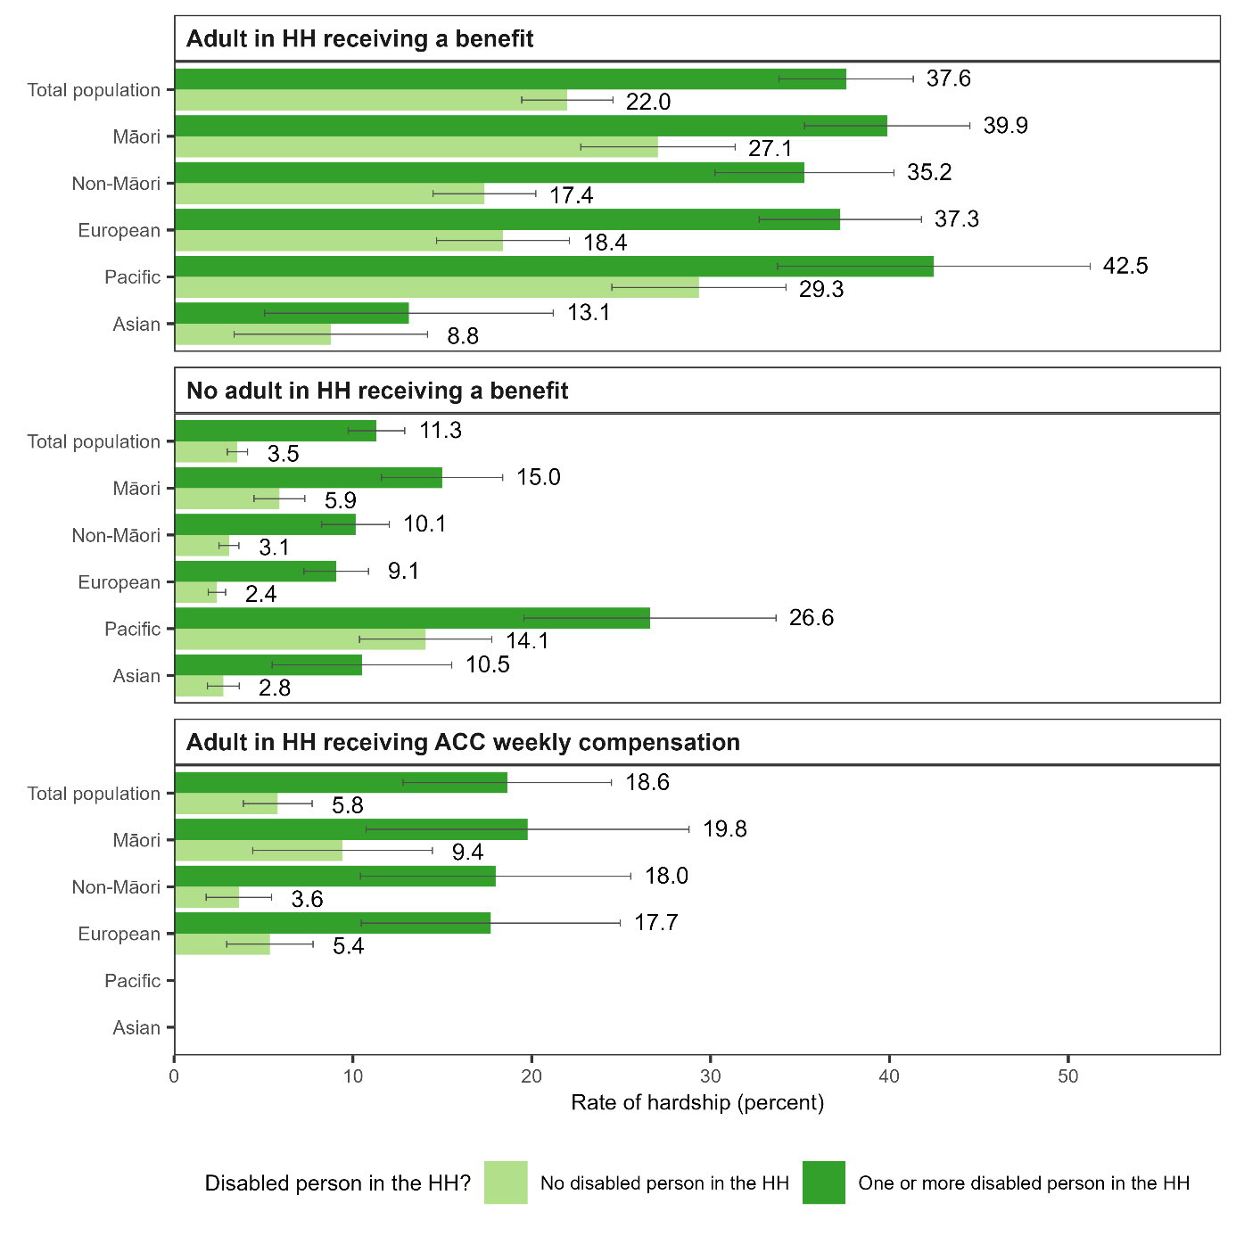

# Insights for policy and research

This section outlines key insights for policy and research.

**Policies that improve support for paid employment and increased earnings of disabled adults and adults who care for disabled children and adults, will reduce income-based child poverty rates, so long as they lead to improved income after factoring in the costs of working.**

In households with children where there is a disabled person, there are higher than average rates of receipt of main benefits, and a greater proportion live with no adults in paid employment.

In qualitative interviews undertaken in 2023 and 2024 in parallel with this study, disabled people and people in families and whānau with a disabled person talked about how disability limited their hours of work and earnings, about wanting more paid employment, and about the financial and other barriers to employment they face.

Supporting employment and increasing earnings can reduce income-based child poverty and material hardship rates. However, this will only be the case if it is associated with improved income after any increased costs from moving into paid work or increasing hours of paid work are taken into account (such as increased transport costs, or any increased costs of caring for the disabled child or adult).

The income from work would also need to cover health- and disability-related costs. This is because most people receiving Disability Allowance would lose this payment when they move into work. They may also be no longer eligible for the Community Services Card.

**Such policies need to be mindful that many children living in households with a disabled person are in families where there is only one parent to meet the family’s care and economic needs.**

Consistent with other data and research, our results show an association between children having a disabled family or household member, and being in a sole parent family. Almost three in ten children in households with a disabled person live with a sole parent, usually a sole mother. This association likely reflects the unique financial, time, and relationship stressors associated with being disabled, or having a disabled child (Murray, 2018).

New research shows that New Zealand sole parents who have disabled children are less likely than other sole parents to have shared care arrangements for their children (Prickett and Bennet, 2024). Evidence from other countries shows that children living full time with a single parent are more likely to experience poor economic conditions, social relations and health outcomes compared to those in shared care arrangements (Nieuwenhuis, 2021).

Sole parent families are diverse. Some have support from children’s other parents or from whānau or family living in the same or another household that enables employment. Others are the sole adult available to meet the family’s care and economic needs.

Support for employment needs to be flexible and tailored. Employment may not always be possible or economically feasible, especially where caring needs are high and/or the parent has a health condition or disability.

**Supporting increased employment, on its own, will not fully address the high rates of material hardship among children in households with a disabled person.**

Most children in households with a disabled person and in material hardship live with adults who do not receive main benefits, and in most cases their households already have market income as their main source of annual income.

The rate of material hardship is 3.1 times higher for children in households with a disabled person than other children, despite their average household incomes being above 85 percent of the average household incomes of other children.

**An important factor likely to contribute to high rates of material hardship among children in households with a disabled person is the extra costs households with a disabled person face.**

There is a larger gap in material hardship than in average incomes and income-based poverty rates comparing children in households with a disabled person with other children.

This indicates that other factors, in addition to lower incomes, contribute to the higher rates of material hardship among children in households with a disabled person.

Additional costs associated with disability are likely to be an important factor. International and New Zealand evidence points toward households with a disabled person having extra costs that can be sizeable (Mitra et al., 2017; Godfrey and Brunning, 2009; Disability Resource Centre, 2010). These costs reduce the resources available to spend on other essential items.

In the qualitative interviews undertaken in parallel with this study, disabled people and people in families and whānau with a disabled person talked about the costs they face. These costs range from disability-related care and equipment and health costs, to extra costs associated with transport, housing that meets accessibility needs and special food. People talked about the ways these costs limited the amount they can spend on other essentials, including other food, other healthcare (including dental treatment) and educational resources and activities for children.

**Households with a disabled person economise on housing costs in a way that is likely to be harmful to children’s health and development, and to the health and wellbeing of other household members.**

For children in households with a disabled person, there is more likely to be economising on home heating. In addition, housing is more likely to be crowded for these children compared to children in households with no disabled person (19.6 percent compared to 10.5 percent). For Māori children in households with a disabled person, the proportion in crowded housing is 26.3 percent. For Pacific children in households with a disabled person, the proportion is 39.9 percent.

There can be many positive aspects to living in large households. These include enabling culturally valued living arrangements, increasing access to relationships of care and natural supports, and reducing social isolation for disabled people. However, there can be negative aspects if housing is crowded or of poor quality, and if households cannot afford to heat their homes adequately. These include risks to health and wellbeing (Howden-Chapman et al., 2023).

**Improving income support payments such as Disability Allowance and Child Disability Allowance and Whaikaha-funded supports that help with the additional costs of disability for people both in and out of work would be a useful focus for future child poverty reduction efforts.**

These are likely to be useful policies for reducing rates of material hardship among children and addressing inequities in material hardship rates.

They are also likely to be important mechanisms for improving the health and wellbeing of disabled people and their families and whānau.

Results from this study suggest that targeting additional help only to groups with the highest material hardship (such as those whose income comes mainly from transfer payments or those with no employed adult in the household) would miss many of those in material hardship and miss many of those for whom disability imposes additional costs. Even for sub-groups of the population with low average rates of material hardship, being in a household with a disabled person increases the risk of material hardship.

It is notable that for most children in households with a disabled person, there is no receipt of disability-related income support payments (such and Disability Allowance and Child Disability Allowance) and support services (such as Disability Support Services and Ongoing Resource Scheme funding) in the household.

This is important because it implies that simply increasing the generosity of these payments and supports for people currently in receipt would not be enough to address the over-representation of children in households with a disabled person among children in material hardship.

**More research on rates of receipt of health- and disability-related income support payments and support services would be useful.**

Rates of receipt can vary for a range of reasons. These include differences in access to natural supports within the household or community, and differences in cultural preferences. But they also include barriers to service access, such as those related to lack of awareness and understanding of what is available, financial or transaction costs of seeking support and diagnoses, racism, and negative experiences engaging with services. These barriers are of policy concern where they exist.

In this report, we examine the proportion of households who received Disability Allowance, Child Disability Allowance, Disability Support Services, and Ongoing Resource Scheme funding. In addition to finding that for most children in households with a disabled person there is no receipt of these payments, we find few statistically significant differences across ethnic groups in rates of receipt.

However, our analysis does not account for the rate of receipt for each potentially qualifying disabled person in the household, or control for the nature and severity of impairments or whether people meet the income test requirements for Disability Allowance. Estimating rates of receipt for each potentially eligible disabled person is important given that Māori and Pacific children would be expected to have more potentially eligible people in their households.

More quantitative research with a larger sample, and more detailed information on responses to Washington Group questions would be useful. This would allow better estimates of rates of receipt of payments and services to be derived and provide a better basis for examining equality of these rates. It could examine whether disabled people living with others receive services at the same rate as disabled people living in other situations.

This would help build understanding of whether increasing receipt and improving equality of receipt of these payments and supports could contribute to meeting child poverty reduction goals.

**Addressing other drivers of inequities is also important.**

There are very high rates of material hardship for Pacific children in households with a disabled person, and a high proportion of Pacific children live in households with a disabled person. Policies that address housing, educational, employment, and health and disability inequalities experienced by Pacific people will help address inequities in children’s experiences of material hardship. This includes policies that are Pacific-led and targeted for the unique cultural needs of different Pacific ethnic groups.

The results from this study also highlight high rates of material hardship for Māori children in households with a disabled person, and the high proportion of Māori children who live in households with a disabled person.

The drivers of these differences have historical roots, including the legacy of colonialism and loss of lands and other resources (Jones et al., 2023). Inter-related contemporary inequities also play a role. These include lower educational participation and attainment, greater vulnerability to unemployment, concentration in regions and neighbourhoods with fewer economic opportunities, higher rates of sole parenthood, and inequities in health service access. They also include employment barriers and challenges to physical and mental health that are associated with high rates of early removal from whānau and justice system involvement (Gibson et al, 2017).

Policies that address these inequities will help address inequities in children’s experiences of material hardship. These include, for example, enabling Māori-led employment strategies and policies that improve equality of outcomes in education, employment, housing quality and tenure, justice, disability and health and improve access to services.

**The over-representation of children in households with a disabled person among children in material hardship could be explored further.**

Our results highlight associations between whether there is a disabled person in a household and factors such as adults’ education levels, employment and housing. These factors also have independent associations with material hardship. Further research could seek to disentangle the independent effects of having a disabled person in the household on children’s risk of material hardship from the effects of these other factors and explore causal relationships.

In addition, detailed expenditure data collected in the Household Economic Survey could be analysed to explore the relationship between costs incurred by households with and without a disabled person, their income levels, and their experiences of material hardship.

**The next step for our research is to look at the feasibility of estimating how much extra income households with a disabled person would need to have the same living standards as households with no disabled person, on average.**

Internationally, research studies have estimated the scale of the additional costs of disability using statistical methods (Mitra et al., 2017; Solmi et al, 2017). These studies aim to provide estimates that can help inform:

* policy settings for income support payments and other publicly-funded supports
* methods used to equivalise incomes when tracking income-based poverty measures.

The statistical methods used in international studies look at how much more income families with a disabled person would need to have the same standard of living as similar families without a disabled person. The amount arrived at can be taken as an indication of the average additional costs families with a disabled person have.

We will look at the feasibility of producing such estimates for New Zealand.

When interpreting the estimates, it will be important to be mindful that they may partly capture other possible differences between families with and without a disabled person that we are not able to take account of given the data available to us. These could include, for example, lower savings and fewer assets (which may be associated with the effect of having a disabled person in the family on employment over a period of time).

# References

Atkinson, J., Salmond, C., & Crampton P. (2019). *NZDep2018 Index of Deprivation: interim research report*. University of Otago. <https://www.otago.ac.nz/__data/assets/pdf_file/0025/327481/nzdep2018-index-of-deprivation-research-report-interim-dec-2019-730394.pdf>

Beltran-Castillon, L., & McLeod, K. (2023). *From Data to Dignity: Health and Wellbeing Indicators for New Zealanders with Intellectual Disability*. IHC. <https://www.ihc.org.nz/publications/from-data-to-dignity-health-and-wellbeing-indicators-for-new-zealanders-with-intellectual-disability>

Jones, B., King, P.T., Baker, G., Nikora, L, W., Hickey, H., Perry, M., Pouwhare, R., & Ingham, T. R. (2023). Karanga rua, karanga maha: Māori with lived experience of disability self-determining their own identities. *Kōtuitui: New Zealand Journal of Social Sciences Online*. <https://doi.org/10.1080/1177083X.2023.2224422>

Department of Prime Minister and Cabinet. (2022). *Reducing child Poverty.* <https://www.dpmc.govt.nz/our-programmes/reducing-child-poverty> .

Disability Resource Centre. (2010). The Cost of Disability - Final Report. Report prepared for the Ministry of Social Development and the Office for Disability Issues. <https://view.officeapps.live.com/op/view.aspx?src=https%3A%2F%2Fcarers.net.nz%2Fwp-content%2Fuploads%2F2013%2F02%2F2010Cost-of-Disability-Report.doc&wdOrigin=BROWSELINK>

Expert Advisory Group on Solutions to Child Poverty. (2012). *Working paper no.21: child poverty and disability* (Report No. 21). [Expert Advisory Group on Solutions to Child Poverty working paper no.21 | Mana Mokopuna](https://www.manamokopuna.org.nz/publications/reports/expert-advisory-group-on-solutions-to-child-poverty-working-paper-no21/)

Gibson, K., Abraham, Q., Asher, I., Black, R., Turner, N., Waitoki, W., & McMillan, N. (2017). *Child poverty and mental health: A literature review.* [researchcommons.waikato.ac.nz/bitstream/handle/10289/11484/170516 CPAGChildPovertyandMentalHealthreport-CS6_WEB.pdf?sequence=2&isAllowed=y](https://researchcommons.waikato.ac.nz/bitstream/handle/10289/11484/170516%20CPAGChildPovertyandMentalHealthreport-CS6_WEB.pdf?sequence=2&isAllowed=y)

Godfrey, J.R., & Brunning, D.M. (2009). Reconciling True and Incurred Costs of Blindness in New Zealand. Social Policy Journal of New Zealand, 36, 208-216. <https://www.msd.govt.nz/about-msd-and-our-work/publications-resources/journals-and-magazines/social-policy-journal/spj36/36-reconciling-true-and-incurred-costs.html>

Himona, P., Talamaivao, N., Yeh, L., & Paterson, L. (2019). *Māori Health Disability Statistical Report.* Report prepared for the Waitangi Tribunal (Report No, Wai 2575, #B24). <https://forms.justice.govt.nz/search/Documents/WT/wt_DOC_151847905/Wai%202575%2C%20B024.pdf>

Howden-Chapman, P. Viggers, H., Keall, M., Bierre, S., Grimes, A., & Pierse, N. (2023). Research-informed Public Policy a case study of housing. *Policy Quarterly,* 19(4), 3-9.<https://doi.org/10.26686/pq.v19i4.8649>

Ingham, T.R., Jones, B., Perry, M., von Randow, M., Milne, B., King, P.T., Nikora, L.W., Sporle, A., Te Ao Mārama Study Group. (2023). Measuring Māori Health, Wellbeing, and Disability in Aotearoa Using a Web-Based Survey Methodology. *Int J Environ Res Public Health,* 20(18):6797. doi: 10.3390/ijerph20186797. PMID: 37754656; PMCID: PMC10530808.

King, P, T. (2019). *Māori With Lived Experience of Disability Part I*. Report prepared for the Waitangi Tribunal (Report No. Wai 2575, #B22). <https://forms.justice.govt.nz/search/Documents/WT/wt_DOC_150437272/Wai%202575%2C%20B022.pdf>

Marks, E.J., Tait, J., Miller, D., Liang, R., Bullen, P., Fenaughty, J., Grant, C., & Paine S. (2023). *Growing up in New Zealand. Now we are 12. Life in early adolescence. Disability – The impact of disability on young people and their family.* [The impact of disability on young people and their family (growingup.co.nz)](https://www.growingup.co.nz/growing-up-report/the-impact-of-disability-on-young-people-and-their-family)

Milne, B.J., Atkinson, J., Blakely, T., Day, H., Douwes, J., Gibb, S., Nicolson, M., Shackleton, N. Sporle, A. & Teng, A. (2019). Data resource profile: the New Zealand Integrated Data Infrastructure (IDI). *International Journal of Epidemiology*, 48(3), 677–677e. <https://doi.org/10.1093/ije/dyz014>

Ministry of Health (2023). *New Zealand Health Survey Annual Data Explorer*. [minhealthnz.shinyapps.io/nz-health-survey-2022-23-annual-data-explorer/](https://minhealthnz.shinyapps.io/nz-health-survey-2022-23-annual-data-explorer/_w_e5a4f437/#!/home)

Mitra, S., Palmer, M., Kim, H., Mont D., & Groce, N. (2017). Extra costs of living with a disability: a review and agenda for research. *Disability and Health Journal*, 10(4), 475-484. <https://doi.org/10.1016/j.dhjo.2017.04.007>

Murray, S. (2018). Breaking the link between disability and child and whānau poverty. Policy Quarterly, 14(4), 68-77. <https://doi.org/10.26686/pq.v14i4.5151>

Nieuwenhuis, R. (2021). [Directions of thought for single parents in the EU. *Community*](https://www.tandfonline.com/doi/full/10.1080/13668803.2020.1745756)*, Work & Family*. 24(5), 559-566.

Office of Disability Issues (2022). *Disability data and evidence resources*. [Disability data and evidence resources - Office for Disability Issues (odi.govt.nz)](https://www.odi.govt.nz/guidance-and-resources/disability-data-and-evidence-resources/)

Perry, B. (2022). *Child Poverty in New Zealand.* Ministry of Social Development. [Child Poverty in New Zealand - Ministry of Social Development (msd.govt.nz)](https://www.msd.govt.nz/about-msd-and-our-work/publications-resources/research/child-poverty-in-nz/index.html)

Prickett, K.C., & Bennett, P. (2024) Shared care arrangements and wellbeing among families in Aotearoa New Zealand. Victoria University of Wellington.

Solmi, F., Melnychuk, M. & Morris, S. (2017). The cost of mental and physical health disability in childhood and adolescence to families in the UK: findings from a repeated cross-sectional survey using propensity score matching. *BMJ Open* en 2018;8:e018729. <https://doi.org/10.1136/bmjopen-2017-018729>

Stats NZ. (2014). *Disability Survey: 2013.* Disability-Survey-2013 (1).pdf

Stats NZ. (2020). *Measuring inequality for disabled New Zealanders: 2018*. <https://www.stats.govt.nz/reports/measuring-inequality-for-disabled-new-zealanders-2018>

Stats NZ. (2023). *Child Poverty Statistics – Year ended June 2022.* <https://www.stats.govt.nz/information-releases/child-poverty-statistics-year-ended-june-2022/>

Stats NZ. (2024). *How we measure child poverty.* <https://www.stats.govt.nz/infographics/how-we-measure-child-poverty#text>

Stephens, M. (2022). *Insights from New Zealand child poverty data.* Treasury Analytical Note 22/04. <https://www.treasury.govt.nz/publications/an/an-22-04>

Washington Group on Disability Statistics (2020a). *The Washington Group Short Set on Functioning – Enhanced (WG-SS Enhanced).* <https://www.washingtongroup-disability.com/resources/the-washington-group-short-set-on-functioning-enhanced-wg-ss-enhanced-167/>

Washington Group on Disability Statistics (2020b). *The Washington Group / UNICEF Child Functioning Module (CFM) – Ages 5-17 years.* [Child Functioning Module (CFM) – Ages 5-17 years - The Washington Group on Disability Statistics (washingtongroup-disability.com)](https://www.washingtongroup-disability.com/resources/child-functioning-module-cfm-ages-5-17-years-179/)

Washington Group on Disability Statistics (2020c). *The Washington Group / UNICEF Child Functioning Module (CFM) – Ages 2-4 Years.* <https://www.washingtongroup-disability.com/resources/the-washington-group-/-unicef-child-functioning-module-cfm-ages-2-4-years-169/>

Wynd, D. (2015). *‘It shouldn’t be this hard’: children, poverty and disability*. Auckland: Child Poverty Action Group. <https://static1.squarespace.com/static/60189fe639b6d67b861cf5c4/t/619336e5be00373d34f77df6/1637037798624/150317ChildDisability.pdf>

# Appendix 1: Strengths and limitations

## The Household Economic Survey data

The Household Economic Survey is a survey of people living in private households. Its strengths include a large sample size and a consistent question set over time.

The survey is cross-sectional so a key limitation is that it cannot provide information on the length of time households have been in material hardship or income poverty.

As with all surveys, estimates are based on sample data and are therefore subject to sampling error which introduces imprecision, particularly for small population groups. Confidence intervals presented in the paper show the extent of this error for different estimates.

In addition, a proportion of households selected to participate in the Household Economic Survey do not take part. Non-response bias may be present if participation is uneven across groups.

Although weighting seeks to address uneven participation across groups, some detailed counts (eg. by main benefit type) may be affected by differences in response rates for which the weighting is unable to correct.[14]

Restriction of the survey coverage to people living in private households means people who are sleeping rough or living in, for example, boarding houses, motels or institutions are excluded.

Questions in the Household Economic Survey focus on the household based on co-residence. This misses relationships of care and financial support for disabled people who do not reside in the household, or reside in the household part of the time. This includes care and financial support for a whānau or family member who is in residential support or long-term hospital care, for a relative who lives in another household, or for a child whose care is shared.

Within our study window, the 2021/22 period was a time of peak disruptions to caring arrangements, access to services, mental health, and economic life due to Covid-19 and the associated lockdowns. It was also a period in which Stats NZ was restricted in its ability to conduct face-to-face interviewing. We include data from this period to maximise the sample size for analysis. A downside of this choice is that the findings may to some extent capture a specific set of circumstances, and not be generalisable to the current period. In future, an update of our analysis excluding 2021/22 and including new 2022/2023 data would be a useful check on this.

More generally, our results relate to a particular period of time (July 2019 to June 2022). They therefore reflect the economic, social and service landscape of that period and may not be generalisable to other periods. For example, this was a period of high employment when labour force participation and employment of non-disabled people increased faster than that of disabled people.

Despite pooling data, sample size was not large enough to present results for children in different Pacific ethnic groups, or for children in Middle Eastern, Latin American, African, or other ethnic groups, or to examine whether households included children in care.

Data in the Household Economic Survey provide a rich source of information on the composition of households and their economic circumstances and whether any household members are disabled. However, there are some data gaps that limit this study.

* It includes no information, for example, on whether people in the household are carers, or connection to culture for Māori.
* It does not capture factors such as attitudes, spending priorities, or debt repayments which can influence measured poverty rates.
* As noted, it includes no information about how long material hardship or income poverty has been experienced by the household.
* While it includes information on the nature and severity of functional limitations as indicated by answers to the Washington Group question set, these data are not made available for analysis in the Integrated Data Infrastructure.

## Linkage with administrative data in the Integrated Data Infrastructure

A particular strength of our study was the ability to examine characteristics and receipt of income support payments and services not captured by the Household Economic Survey, using linked administrative data in the Integrated Data Infrastructure. These data allow a longitudinal perspective (in examination of long-term joblessness), and avoid non-response and recall bias.

Integrated Data Infrastructure data linking is generally probabilistic. Some errors and missed links are inevitable in this process. Health data for Pacific and Asian people and older Māori are linked to the Integrated Data Infrastructure spine at a lower-than-average rate, for example. This suggests inconsistent rates of missing data due to missed links across population sub-groups (Milne et al., 2019), and these may affect some of our results.

Data linkage does not provide us with all the measures we are interested in. For example we are not able to examine assets.

## The poverty measures

The Stats NZ income poverty and material hardship measures relate to the household. Implicit in this is an assumption that resources are pooled across household members. This will not always be the case.

For example, the Stats material hardship measure relies on the responses of a single randomly selected adult in the household who is asked questions about their own situation and that of their household. The material hardship score is then applied to all household members, including children. In generalising their responses to the children in the household, there is an assumption that people in the household share resources and have similar material wellbeing. This will not always be the case.

Equivalence scales take account of household size and composition, but do not take account of other factors that influence how the demands on household income vary across households, including disability-related costs.

Limitations of the measurement of material hardship are that the questions are developed within a non-disabled world view. Results presenting material hardship measures, and results from the question asked about how well income meets people’s everyday needs, may be subject to some bias depending on how different socio-cultural groups and disabled versus non-disabled people conceive of everyday consumption needs and normal spending constraints.

## The measures of disability

The Washington Group question set aims to define disability in a culturally neutral way. This informs its focus on a person’s functions rather than the presence of impairment or self-identification as disabled.

A key strength of using standardised definitions based on the Washington Group questions is that it allows comparisons with other statistics and research, including international comparisons. It also allows replication and updating at a later date using a consistent measure.

At the same time, it means the definitions used have not been developed to capture concepts of disability that are relevant to a Māori world view (Jones et al., 2023) or to the world views of Pacific or ethnic groups.

This limits our ability to explore possible differences in experiences in the New Zealand context. These might occur, for example, due to different cultural norms and practices that could influence both the way that people conceive of disability and the way that people respond to the Washington Group questions set which may be influenced by attitudes and the way that disabled people are supported within whānau, aiga and families.

Due to different cultural or age or gender-related norms, people in different groups may respond differently to the Washington Group questions. This may affect the proportion appearing as disabled using the Washington Group indicators and influence our results.

The Washington Group indicator we analyse for adults is good at picking up age-related impairments.

However, it does not capture data on those with mental health issues that do not include anxiety and depression, or those who have long-term but intermittent impairment, neurodivergence such as Autism, are culturally deaf, or have an intellectual disability (unless they have one of the functional limitations that is captured by the questions).

It may not include people who have or are frequently affected by disabling health conditions (e.g. children with frequent respiratory conditions) or people who have experienced significant trauma and have complex health and social needs.

Where there is flux in people’s impairment, the Washington Group indicator gives us a view of that impairment at a point in time, but no information on whether impairment is permanent or transient.

Differences by age of onset and severity of disability are not captured. Onset during childhood, for example, can affect educational attainment and therefore employment prospects and lifetime income and asset accumulation. In contrast if disability has onset at older ages then it has less of an impact on education and employment trajectories, and lifetime income and asset accumulation may be less affected.

## Our analysis

Our analysis provides a new descriptive data resource exploring the rate and experience of material hardship for different groups, and fills some information gaps identified in the WAI2575 stage 2 inquiry to date (Ministry of Justice, 2019).

A key limitation is that we are unable to say anything about causal relationships behind the differences found.

Another limitation is that we do not explore the independent associations between, for example, ethnic group and the experience of material hardship for children in households with a disabled person after holding all other observable factors (such as parental employment and household composition) constant.

# Appendix 2: What material hardship looks like by ethnic group

**

**Figure A2.2: Proportion of non-Māori children in households reporting each of the 17 items used to measure material hardship by whether there is a disabled person in the household**

**Figure A2.3: Proportion of European children in households reporting each of the 17 items used to measure material hardship by whether there is a disabled person in the household**

**Figure A2.4: Proportion of Pacific children in households reporting each of the 17 items used to measure material hardship by whether there is a disabled person in the household**

**Figure A2.5: Proportion of Asian children in households reporting each of the 17 items used to measure material hardship by whether there is a disabled person in the household** A screenshot of a graph

Note: Some rates for Asian children were suppressed for confidentiality reasons.

# Appendix 3: Child-related restrictions by ethnic group

**Figure A3.2: Proportion of non-Māori children aged 6-17 in households reporting restrictions on child-related items by whether there is a disabled person in the household**

**Figure A3.3: Proportion of European children aged 6-17 in households reporting restrictions on child-related items by whether there is a disabled person in the household**

**Figure A3.4: Proportion of Pacific children aged 6-17 in households reporting restrictions on child-related items by whether there is a disabled person in the household**

**Figure A3.5: Proportion of Asian children aged 6-17 in households reporting restrictions on child-related items by whether there is a disabled person in the household**

Note: Some rates for Asian children were suppressed for confidentiality reasons.

# Appendix 4: Rural-urban location

**Figure A4.1: Rural-urban location of children’s households (HH) by whether or not there is a disabled person in the HH**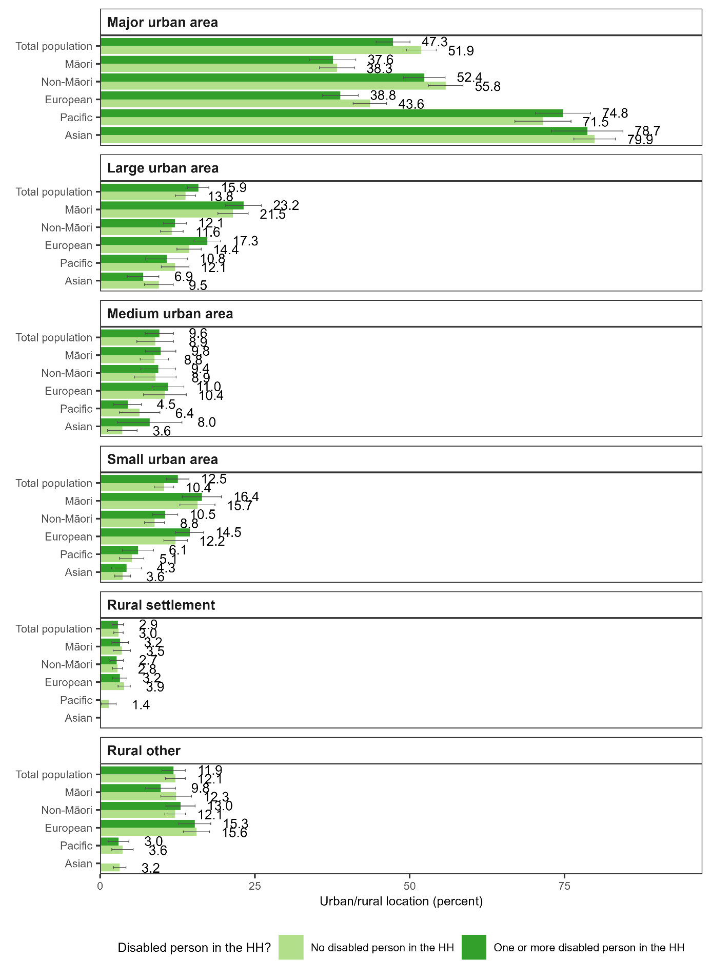

1. The ‘Washington Group Short Set on Functioning – Enhanced’ indicator.
2. The ‘Washington Group / UNICEF Child Functioning Module – Ages 5-17 Years’ indicator.
3. The ‘Washington Group / UNICEF Child Functioning Module – Ages 2-4 Years’ indicator.
4. In addition, our analysis did not include revisions to the 2021/22 Household Economic Survey data made by Stats NZ in March 2024.
5. 40,707 in the year ended June 2020; 41,136 in the year ended June 2021; and 21,540 in the year ended June 2022. The smaller sample in the year ended June 2022 reflects reduced data collection for that year due to COVID-19 alert level restrictions, lockdowns, and other disruptions.
6. 15,636 in year ended June 2020; 15,654 in year ended June 2021; and 8,487 in the year ended June 2022.
7. The Washington Group questions were designed to provide comparable data cross-nationally for populations living in a variety of cultures with varying economic resources.
8. See page 30 of Perry (2022) and Figure 12 below for the list of items.
9. Specifically, the medians are calculated from the total person population, after household equivalised disposable incomes have been applied to all members of a household.
10. We only include people we have material wellbeing responses for in our analysis so that the population analysed is the same across the material hardship and income-based poverty measures. In contrast, Stats NZ includes people for whom there is no material wellbeing response in the sample they calculate income-based poverty rates for. In calculating the baseline year poverty threshold for the after-housing-costs measure, we use data from the Household Economic Survey only. In contrast, Stats NZ uses pooled data from the Household Economic Survey and the Household Labour Force Survey. In addition, our analysis does not include revisions to the 2021/22 Household Economic Survey data made by Stats NZ in March 2024.
11. The accompanying tables should not, therefore, be used as a data source for counts of children included in main benefits. Ministry of Social Development data are the official source for these counts. (See the ‘Other – last 5 years’ table in National Level Data Tables available at <https://www.msd.govt.nz/about-msd-and-our-work/publications-resources/statistics/benefit/index.html>.)
12. SOCRATES does not include information on people older than 65 years of age. Disability supports for this age group and people with mental health needs are in most cases, funded by Te Whatu Ora (formerly District Health Boards).
13. ACC weekly compensation pays an injured person 80 percent of their previous earnings. As at 1 April 2024 the minimum rate of weekly compensation payable was 80% of the adult minimum wage and the maximum rate payable was $2,257.17.
14. The accompanying tables should not, therefore, be used as a data source for counts of children included in main benefits. Ministry of Social Development data are the official source for these counts. (See the ‘Other – last 5 years’ table in National Level Data Tables available at <https://www.msd.govt.nz/about-msd-and-our-work/publications-resources/statistics/benefit/index.html>.)