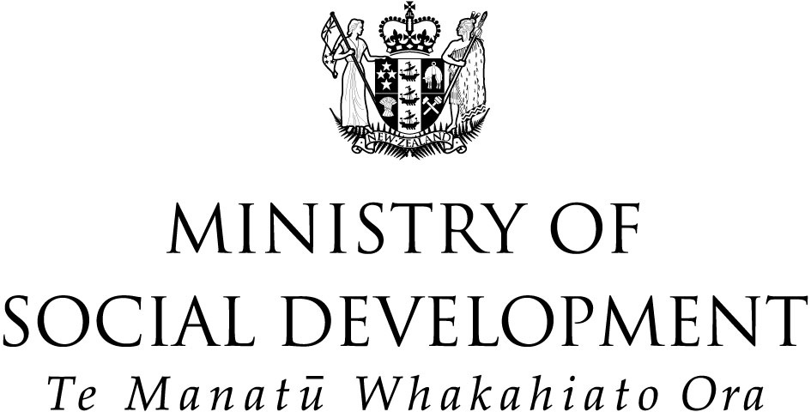
P

Evaluation of the

Youth Horizons Trust

SCD Bridging Programme

Executive Summary

Prepared by
Kay Saville-Smith
Julie Warren
Kevin Ronan
Diane Salter

Prepared for

Centre for Social Research and Evaluation

Te Pokapū Rangahau Arotaki Hapori

February 2005

This report presents the findings of an evaluation of the process, outcomes and economic components of the Bridging Programme delivered by the Youth Horizons Trust (YHT). The Bridging Programme is a residentially based therapeutic programme for young people aged 11–15 years who are diagnosed as suffering Severe Conduct Disorder (SCD). These are a small, costly group of young people who behave aggressively and violently towards people and animals, behave destructively towards property, act deceitfully and persistently violate behavioural rules, and for whom other interventions have failed. Early Onset SCD is a persistent and intractable condition previously considered untreatable.

The evaluation was designed to provide an evidence base for policy development and programme funding by:
- establishing the quality of the Bridging Programme
- assessing the extent to which the Bridging Programme is achieving positive outcomes for the young people participating in it.

Process evaluation – findings

The Bridging Programme is providing effective service delivery to a group of young people whom multiple other interventions have failed to keep safe and manage.

Admissions

The Bridging Programme effectively targeted Early Onset SCD young people. However, some difficulties were evident in ensuring that adequate levels of accurate information were provided by referring agencies and Child, Youth and Families (CYF) case managers. Initial problems with YHT’s admission and decision-making processes appear to have been resolved.

There is no evidence of YHT attempting to “cream-skim” by selecting less difficult clients. Indeed, stakeholders have commented on the willingness of YHT to actively support them during the referral processes of extremely difficult young people.

Quality

The Bridging Programme demands very high levels of skill and staff support and, therefore, faces difficulties recruiting staff with appropriate management and service credentials and experience. YHT has managed these demands through a combination of support for staff, close supervision, a strong management and accountability structure, and the development and delivery of a structured training programme. These activities are supported by a strong professional ethos and a commitment to evidence-based practice in YHT. The organisation is held in high esteem by the stakeholders and other agencies with whom it works.

Breaking new ground

YHT has been able both to establish itself as a new programme and to develop and deliver a programme in a new sector of operation. YHT has achieved this despite initial organisational challenges and its adoption of an innovative practice model that continues to evolve in response to the experience of international and New Zealand practitioners.

Of course, the extent to which YHT can innovate within the context of the Bridging Programme is limited by contractual restraints and the restraints of providing a residential service in the community. Even so, YHT has worked to integrate an ecological approach using multi-systemic therapy (MST) principles in the programme. This reflects increasing research evidence that MST provides increased opportunities for maximising longer-term, as well as shorter-term, outcome improvement in antisocial young people.

Views of parents and caregivers

Most parents and caregivers said that YHT staff were responsive and available. They generally felt included and, for the most part, felt that staff were actively attempting to engage them in treatment. Parents and caregivers also noted the attention given to young people’s school and vocational progress through the Learning Centre and YHT’s liaison with schools and employers.

Outcomes evaluation – findings

There can be some optimism for the Bridging Programme’s ability to generate improved outcomes in the medium term. The clinical assessment results, in conjunction with other outcome data, indicate that YHT has served a useful purpose for some young people and for the community.

Highlights from the outcomes evaluation of the Bridging Programme provide a consistent picture characterised by:
- an overall reduction in the severity of reported incidents serious enough to be recorded on the YHT in-house database
- individual improvements across the range of domains for the 26 young people participating in the programme at the end of the last calendar year
- educational outcomes that testify to the effectiveness of the Learning Centre
- widespread stakeholder confidence in the YHT team and the programme
- parental advocacy for more support and skill development.

Stakeholders’ views

Stakeholders generally believed that if positive outcomes are possible for SCD young people, then YHT is well placed to achieve them as the only provider that can effectively address the needs of SCD young people.

However, stakeholders are very concerned about the unmet needs of young SCD young people in Auckland and nationally, especially regarding:
- the needs of SCD children under 12 years
- the needs of SCD young people once they reach 17 years
- the limited capacity of the Bridging Programme to take on more young people and meet the demand for effective SCD treatment.

Some stakeholders also felt that many CYF social workers, especially the less senior ones, are unaware of the programme or resistant to referring young people to it, so that young people who they felt could benefit from the programme were not being referred.

Survey of programme clients’ prior and current competencies and behaviours

This survey was administered through YHT staff and showed:
- a reduction in the seriousness of disruptive, antisocial or aggressive behaviour (although the number of incidents may have remained static)
- improved concentration, educational, language and communication skills, school attendance, and self-care and independence
- some resilient change in areas including self-esteem, peer relationships, family life and relationships, and (for some) alcohol and substance/solvent misuse and heavy smoking.

Clinical assessment of a limited number of YHT clients

The clinical assessments indicated that change varied across time and reporters. However, there was a significant reduction in self-reported delinquency across time. Some youths’ functioning deteriorated, but not substantially.

Economic evaluation – findings

The current costs to society of young people with Early Onset SCD are high, whether they are in a programme such as the Bridging Programme or in the usual range of services under CYF case management. Given the intractable nature of SCD, costs have previously been assumed to be lifelong. These young people typically come to the notice of CYF during their early childhood years and have been exposed to multiple interventions that have failed. While the costs of these multiple services are not currently known, the costs of YHT are. The process evaluation has shown the efficient and effective delivery of a quality programme, while the outcomes evaluation shows achievements across a range of domains.

Achieving optimal delivery of the Bridging Programme

One of the fundamental questions of the evaluation related to YHT’s ability to adequately deliver the Bridging Programme. While the process evaluation concluded that YHT was, indeed, competently delivering the programme, it touched upon areas that could lead to optimal delivery of the programme.

More flexible contracting of the Bridging Programme

There are contractual and funding restraints to YHT moving the programme to a short-term residential intervention (to both stabilise the young people and give their often demoralised families some respite), with a subsequent home-based focus (conforming to a more ecologically based treatment model).

The problems of delivering a community-based residential programme inherent to the model are exacerbated by the lack of a Stage 1 facility (ie a special residential facility allowing intensive and contained supervision). Thus, the problems of antisocial peer influence in the residential houses and the Learning Centre are increased. Young people who are still in the mode of extreme acting out and who have not been subject to systematic behavioural modification techniques or skill development are, at least in the Stage 2 environment (ie a network of 6-bed, structured community homes), mixing with young people who are making some degree of behavioural improvement and self-management.

More effective relationships with Māori agencies

Effective relationships with Māori agencies are necessary to assist with Māori young people, and their whānau or carers. Our view is that YHT’s preoccupation with partnership building with other providers may be inhibiting other, possibly more important, relationship building with Māori. For instance, opportunities for building partnerships at marae level may provide more support, including positive role models, for both Māori and YHT staff than the currently sought initiatives.

In general, Māori stakeholders recognised the need for specialised skills in SCD treatment to meet the needs of SCD Māori young people. They did not necessarily advocate delivery of treatment programmes by Māori providers. Rather, they advocated the inclusion of kuia or kaumātua (with a preference for kuia) in programmes as a way of providing Māori young people with strong role models, teaching them tikanga or cultural knowledge and helping the service operate in a culturally safe way that meets the needs of Māori young people and staff.

A more robust and sustainable delivery

The robustness and sustainability of YHT’s delivery was discussed at some length in Section 7 of Process Evaluation of the Youth Horizons Trust Severe Conduct Disorder Bridging Programme (May 2002), and the issues remain largely the same. One issue that has emerged since, however, is the extent to which YHT will remain committed to a residential model of service delivery when:
- it still does not have a Stage 1 facility
- it wishes, in line with the emerging international evidence, to take a more ecological approach to SCD service delivery
- the current model in New Zealand, as well as elsewhere, does not seem to be meeting the needs of young women as effectively as those of young men.

Developing the practice model further

YHT has the necessary foundations (eg practice ideals, protocols, professional acumen, experience and support from stakeholders) to shift its management focus to a more ecological approach. This approach encourages targeting known risk and protective factors across contexts, including family management skills and peer association. Staff, parents and young people involved with the Bridging Programme all reported less than optimal levels of contact with prosocial peers/activities. Parents also reported lower levels of assistance than they would like with parenting and family management skills such as behaviour management skills and encouragement around monitoring and supervision of peer contact. These two factors have been found to be significant mediators of SCD treatment responsiveness and are primary areas of attention in treatments that have been found to work

For Māori, SCD treatment approaches need to be developed in the context of whānau and hapū as well as community-based residential services such as the Bridging Programme.

Developing a Centre of Excellence

National, cross-agency strategies are needed if New Zealand is to effectively treat its small but costly population of SCD young people. In a country the size of New Zealand, building centres of excellence around specialised areas of practice is an effective way to make best use of the limited number of specialist practitioners in any given area.

The Bridging Programme has provided an opportunity to establish a small team with a core set of skills and experience in New Zealand for addressing the needs of young people with Early Onset SCD and their families. Equally importantly, YHT has demonstrated a commitment and ability to go beyond the single model of SCD management constituted in the Bridging Programme. The flexibility shown by YHT, the accretion of skills and competencies, and its commitment to evidence-based and international best practices are important. In addition, given its governance and management structure, training and supervisory system and clinical skills, YHT is well placed to further develop as the centre of excellence for the treatment of SCD young people.

Specific encouragement and support is needed from funders. There appears to be considerable opportunities for Government and other agencies to use the team’s expertise more widely in health, education, justice and social services targeting high-risk young people.

